# Abstract **(Most important part)**

NASA Control Room concept is an innovation strategy in Construction under the digital transformation strategy of smart city paradigm. By utilizing the NASA Control Room concept in Construction Industry, a remote working platform can be provided to enhance the collaboration between different stakeholders, managed the data effectively and provided insight to managers to set-up strategies and policy to enhance the construction safety during different stages of a construction project.

Model/Construction quality data….

With the emerging technology IoT (Internet-of-Things), the sensory data of the environment can be captured for making effective decision. The sensor data is collected from xx-July-2020 to xx-Aug-2020 in a local factory in Hong Kong to demonstrate the entire control room concept.

This dissertation researches different ways to visualise the data, which can act as a prototype to show how different parties in the AEC industry to make decisions in an innovative way.

It shows that the BIM360 working platform and web viewer can demonstrate the real time environment and collaboration of the site in a simple way. The VR Viewer can let us identify the site constraint remotely. And the power BI dashboard can provide insight from the construction quality and safety data.

The potential development of the control room can be much further investigated.

The purpose of this paper is to ….

# Introduction

# Overview of Construction Sector

-> How big and its importance to economy?

Construction has long been one of the largest sectors in the global economy. There is about $10 trillion spent on construction-related activities globally every year, which is equivalent to 13 percent of GDP and about 7 percent of working population over the world are working for the construction industry (McKinsey & Company, 2017). However, 98% of infrastructure projects are over budget or delayed around the world. The productivity of Construction industry is also lagging the global productivity by over 30% (Changali et al., 2015).

-> Collaboration

Construction sector is complex and dynamic in nature (Mohd Nawi et al., 2014), it consists of multiple disciplines and teams at various stages such as planning, design, construction, and operation. The parties are mainly client, designer, contractor, and manufacturer who are involved from the beginning until the completion of the project. Over the years, construction project delivery practice among these parties are poor in collaboration such as isolation of working and inadequate co-ordination. As the project is delivered in a sequential manner, it would significantly affect the quality and the progress of the works in future stages.

Information Management

Apart from poor collaboration, information management is very poor in construction sector. The construction sector is labour-intensive and generates enormous amounts of information. It mainly includes calculation, drawings, project reports, tender documents, ...etc which are produced in the planning stage to the operation stage.

According to a research in China (Xu & Luo, 2014), it has identified and discussed many consequence on the communication and information transfer among different parties, such as the loss and inconsistent of information caused by fragmentation of parties and unorganised information system. There is a comprehensive statistic shows that around 43%, 12%, 3% of the project time lost due to inconsistent information, dislocation, and ambiguity respectively on a construction project in average.

Safety

Safety is also one of the main concerns as compared to other sectors. The construction sector has long been recorded with the highest number of fatalities and accident rate among all industry sectors globally. For example, it is about 79,000 construction workers suffered from work-related ill health (new or long-standing) and 30 fatal injuries in 2018/19 (HSE, 2019). There was also about 2.1% of construction workers suffering from a musculoskeletal disorder that they believed they got it during working. This rate is statistical significantly higher than the rate for workers across all industries (1.2%) [ibid]

# Smart City and Digital Transformation

Nowadays, the development of smart city is a fundamental basis of our city. The smart city framework focus on integrating all these systems effectively with linking the interrelationships between multiple city systems, the output can be efﬁciency multiplied (Cosgrave, 2017). Besides, there are 3 elements highlighted for smart cities (Harrison et al., 2010), which are instrumented, interconnected and intelligent. Instrumentation means capturing the data from the physical world by sensors; interconnection means the data should be integrated from different source and they can communicate each other, while intelligent means the data should be visualised and provide insight for making better decision.

To resolve the long-established barriers in Construction sector, an initiative Project 13 has been risen under the smart city paradigm to develop a new business model for the infrastructural projects. It is an industry-led response to delivery models that fail not just the stakeholders as mentioned before, but also the operators and the citizens of economic infrastructure. It aims to develop a new business model to increase certainty, productivity and improve outcomes from the project life cycle. Digital transformation is a key enabler of this new business model. (Radford, Jamie; Macdonald, 2020)

The construction process should have a revolutionary change to solve the to build a smart city under this initiative.

# Scope of Research

Therefore, an integrated solution such as Control Room in construction will be investigated in this dissertation to optimise and effectively control the information generated and improve the project delivery in construction stage.

The scope of research of this dissertation is as follows:

* How the control room works in construction stage to solve the long-lasting problems of a construction project in different stages?
* What types of visualisation technique should be used to give insight and improve project delivery?
* What types of data should be captured and what data standard should be formulated?
* Easy to adopt?

# Literature Review

# Technology Implementation in Construction

Construction sector is slowly to adopt new technology and digitalisation compared with other industry. The digitalisation index of construction is very low as shown on below figure (McKinsey, 2015).

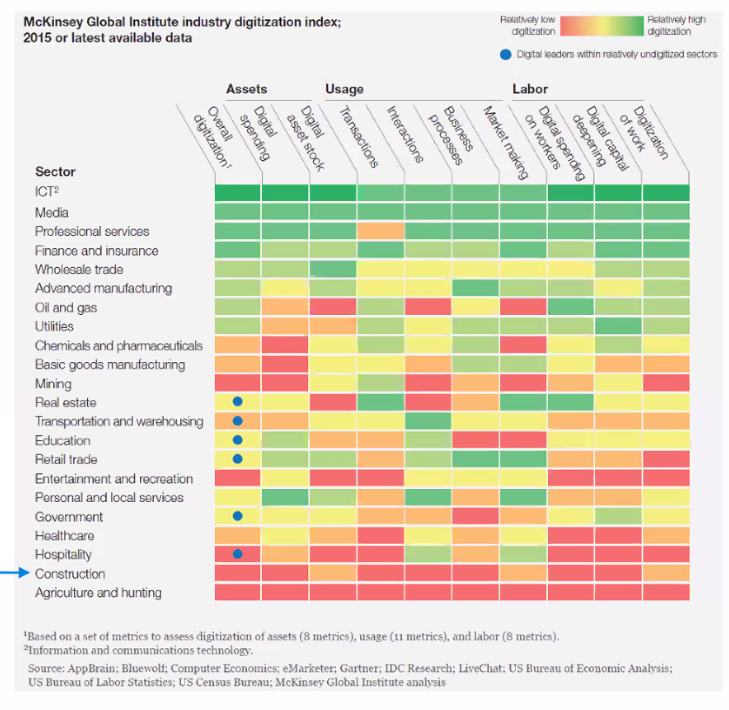

Although the sector has recognised the need for change and adopted many technological solutions, they are fragmented point solutions and disorganised (Woodhead et al., 2018). Instead, a key to improve the construction project delivery with a long-term advantage is to recognize a “planned IoT ecosystem” rather than combining different “point solutions”. Ecosystem means an integrated “layer” of hardware, software, connectivity, and information ﬂows linked to key decision-making activities.

Not so many technical expertise , so use clound solution, easy to adopt , plug-n-play

Besides, the explosion of global pandemic COVID-19 is accelerating the development of digital transformation in different industry. With unprecedented consequences such as the disruption of manufactures and supply chains, the mitigation of the impact by COVID-19 requires new approaches and new forms of collaboration like a virtual platform for working from home to increase overall resilience.

# Control Room

There are so many researches focusing on facilities management at operational stage on the urban infrastructures but only few studies focusing on the construction stage, which is the fundamental part in the life cycle of an urban infrastructure. In response to this situation and the smart city paradigm, a Control Room concept for the construction stage is an integrated solution to fulfil this gap.

The control room concept was first applied in the 1970s during the Apollo 13 program by NASA, where engineers on the ground needed to be able to rapidly account for changes to their vehicle while exposed to the extreme conditions in space, and with lives on the line. When life support failed, NASA found they could no longer base corrective decisions on the original model because the actual module had undergone significant changes as the result of exposure to an extremely hostile environment. The original model needed to be updated to closely simulate the current state of the module. As a result, they use the “pairing technology” to simulate the outer space with the mathematical models so that the engineers and different professional can collaborate in the control room and make decision based on the mathematical model (Jarrett Hendricks, 2020). The same dynamics can also apply in different industries.

# Control Room in other Industry

There is an example in the financial services industry using the control room concept[1]. The Head of The Compliance Control Room at one of Africa's leading banks suggested that there's a growing awareness in the financial services industry have a need for a control room function as part of the larger compliance function due to the increased regulation and increased complexity in the day-to-day operations of the institutions" (StarCompliance, 2019).

The purpose of the Control Room in this case is to manage the flow of sensitive corporate information in a multi-service financial institution. Control rooms can act as a company’s nerve centre to monitoring the deals data such as mergers and acquisitions, equity offerings, debt offerings, …etc. The deals themselves are very complex and generate a deluge of data that must be rigorously monitored, and the deal data must be organized, recorded, and analysed. The volume of this deal data is immense and there is a need to keep track of who's involved in what and who said what to whom can be overwhelming, there is very little room for error and a premium placed on clearing deals quickly (ibid).

One of the importance of control-room is to use automated software to keep them working effectively in the fast-paced environment and there is a lot to keep track of data. Software can automate much of what previously could only be done manually but it also keeps data organized and up to date. If they are not cleared and response quickly enough, and lost reputation, if conflicts result in regulatory action (ibid).

During the construction stage of an infrastructural project, it generates enormous amount of information (Literature). A control room should also be used to enhance project management to reduce risk of project delay, within budget, and minimise contractual implication. Health and safety in construction are particularly important as the industry is prone to hazardous situations. The Control Room can help in making sure that all aspects of health and safety have been considered before and during the construction works.

# Digital Twins

Digital twins create a virtual asset to represent the physical assets, which helps organisations to make better-informed decisions, leading to improved outcomes (Bolton et al., 2018).

Construction process can be simulated with a digital twin to provide insight of how the project allocate the cost throughout the construction stage. This is useful for planning resources of the project. A construction simulation is also useful for managing subcontractors, since project managers can get a better idea of when and where they will be working from the digital model. Delay and poor productivity caused by lack of coordination between trades in construction projects can be improved by the digital twins (Tobias, 2020).

In this approach, simulation and analytics from the digital model can be tightly coupled with execution, which enable a cycle of continuous improvement and innovation. Measure performance, design based on current, data-driven observations continuously adjusting and course-correcting to adapt to changing market conditions and to exploit emergent, potentially fleeting opportunities. It sets a basis for the control room.

# IoT

# Components of Control Room

Although there are so many existing reports or platforms to describe how to leverage building a digital twin for an infrastructure, there is a lack of clear and entire manual to describe how to build it. This section is to outline the framework of the control room under this principle and investigate its essential components and visualisation techniques.

# Cloud & Collaboration Platform

A cloud-based common data environment should be used as a centralised collaboration platform to foster the collaboration and information exchange between different disciplines. Cloud computing changes the traditional way businesses to manage IT resources, which the delivery of computing services including servers, databases, analytics, and intelligence over the Internet (“the cloud”) and ensuring data security (Microsoft, 2020).

Besides, traditional tools such as email, project management software and telephone are just one-way communication activities. They lack the real-time collaboration elements which is for connected engagement, discussion and approval process (Levine, 2016). If different parties in the project can submit updates of information on a simple and real-time manner on a single platform to create a single source of truth, it will be easier for all project team members as one and remain on the same pace as the project proceeds, so it would not make the progress delay in terms of scheduling and over-budget due to rework.

# Virtual Reality

Virtual Reality, known as VR, is widely used in the education and training purpose due to its potentials to stimulate interactivity and motivation (Freina & Ott, 2015). Furthermore, it offers an ideal approach to study and learn for those who prefer experiencing a visual or auditory learning style (Leite et al., 2010). VR can also be used in meeting with team members to work together within a 3D model for discussion, which is benefit for remote working (Brandon, 2020).

# Dashboard

Key performance indicators (KPIs) is commonly used to gauge and compare performance in terms of meeting both strategic goals with a dashboard in different industry. Construction industry can also make use of the objective benchmarks and to measure excellence across the industry. The analysis result can help to improve the processes and lead to better performance and project delivery. It is the first priority for Project Directors, Project Engineers or any other person responsible for planning management to implement a better planning process by having a clear view of the project’s status.

# Real-time Model Viewer

The viewer enables users to visualise 3D (and 2D) models in a browser. The digital twin of the building model created can be probably displayed it using this technology.

# Others

Apart from that, the data strategy of Control Room should consist of a common data exchange standards and Application Program Interfaces (API) for third-party developers to develop external applications so that many solution can be connected together and links to form a ‘bigger picture’ such as a connected smart city (Woodhead et al., 2018).

# Methodology

# Integration framework of NASA Control Room in Construction

For the purpose of this study, existing solution and software available on the market will be used to build the conceptual integration framework of the control room. The functionality and visualisation techniques of them will be evaluated to investigate what functionality of a control room should be provided and how it can be improved.

The hierarchy of the framework are the data repository, data services and Application layer and the ecosystem is shown as the below figure:

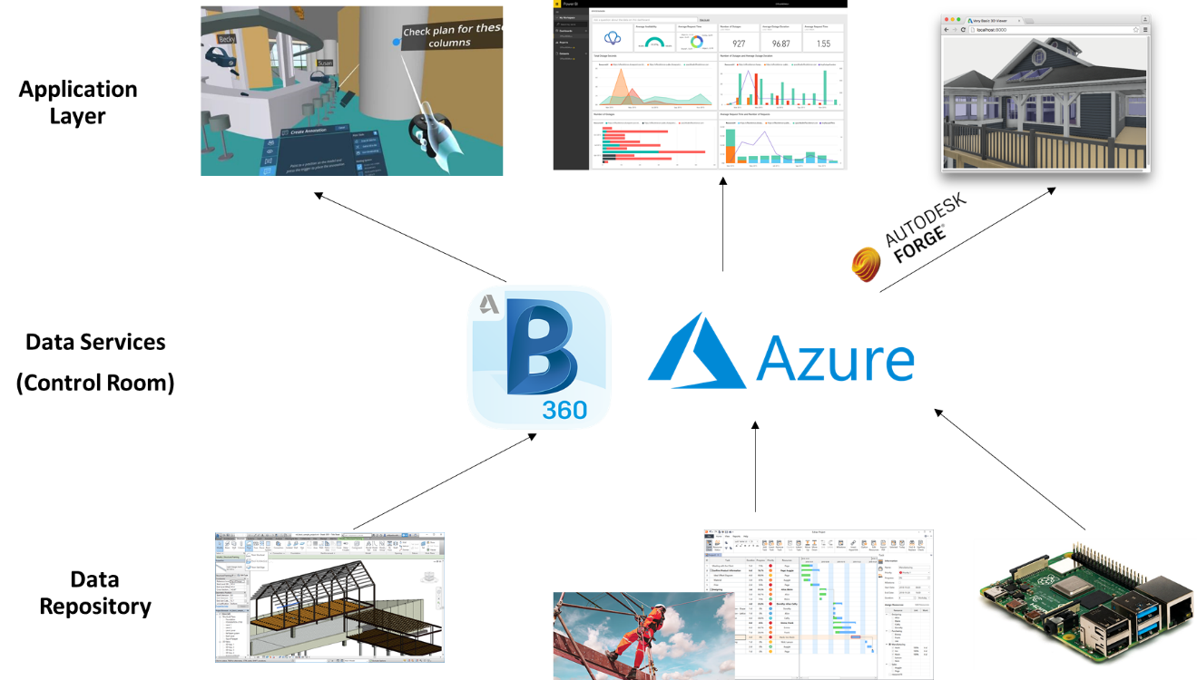

1. For data repositories, three types of data are considered:

Model Data: the virtual model of the physical configuration of the considered location

Construction Data: Safety and Progress Data

Sensory data: Working condition of the construction site

1. For Data services, BIM360 as well as Microsoft Azure Cloud Service will be used to provide an integration service interface for the Control Room
2. For Application layer, it focuses on three visualisation techniques with the data: VR, Dashboard and Web Application.

Each of the component of data repository represents an aspect of the construction site and has a reflection on the construction performance. The data will then be published in a standardised format using web services for collaboration, analysis and visualisation. External API with Autodesk Forge will be used to retrieve data from BIM360 to build the specific applications for visualise by VR/ Dashboard or real-time web viewer.

# Source of Data

# Revit Model Data

Different team members will be simulated to form a BIM models as .rvt file by Autodesk Revit.

In order to provide information support for the development of the RBIVS prototype, we mainly have worked on two tasks. First, we created the BIM for the BA building using AutoDesk Revit 2012 based the 2D floor plan.

->LOD,xxx, model info (ref to some execution plan)

# Project Performance Data

-> Data obtained from Project Hack5

# Sensor Data

Low cost sensors raspberry pi has been selected as the prototype to capture the construction environment data. The technical details are given in the below Table:

-> how the sensor to collect the data (mechanism)

-> How the sensor send to microcontroller works

Table: Technical specification of Raspberry Pi

|  |  |  |
| --- | --- | --- |
| **Sensor** | **Image** | **Technical Data** |
| SHT20 | SHT20 溫濕度傳感器模組I2C 通訊- 台灣物聯科技TaiwanIOT Studio | Cost  Operating Voltage  Working Current |
| PMS3003 | Laser Particle Concentration Dust Sensor Pm2.5 Plantower Pms3003 ... | Cost  Operating Voltage  Working Current |
| MH-Z19 | 100% New&original MH Z19 MHZ19| | - AliExpress | Cost  Operating Voltage  Working Current |

Temperature and humidity data can be captured with the SHT20 sensor, which utilized the ….. to determine the temperature and humidity of a working environment.

PM2.5 can be captured by PMS3003,

CO2 concentration can be captured by MH-Z19 sensor, the CO2 concentration is directly proportional to the ventilation of a working environment

Figure Final Configuration of the Raspberry Pi with sensor installed.

Table Required devices, sensor and material

|  |  |  |
| --- | --- | --- |
| **Item** | **Quantity** | **Cost** |
|  |  |  |
|  |  |  |
|  |  |  |

# Field Info

-Field Test and Data Collection of sensor **(physical)**

->Site Description

->how sensor set up and collect data in the factory

->Revit Model Specification

# Collaboration Platform

# BIM360 Collaboration

(Model data)

BIM360 will be used to simulate real-time collaboration, the modules of this cloud platform such as Document Management, Design Collaboration and Project Management modules will be used for exploring the functionality on multi-disciplinary coordination on all project information. Drawings, model data and relevant files uploaded on BIM360 support version control with the help of module Document Management. Design Collaboration module can show the different drawing packages at different time created by different parties and will allow them to decide whether to consume that package for their further amendment. The data also supports requests for information (RFIs), submittals, inspections and more will the module Project Management. The platform also features a powerful insight and analytics layer that includes interactive dashboards and reporting, for making decision and predictive analysis.

# How your works related to ISO19650 workflow

# Cloud Services

Microsoft Azure offers cloud service in three main categories: Infrastructure as a Service (IaaS), Platform as a Service (PaaS), and Software as a Service (SaaS). PaaS will be focused on this study. Azure can provide platform services for hosting databases in the cloud.

# Data Capture and Storage

Data has been sent over to Azure for interception and storage in a database for management, analysis and visualisation. By using the IoThubs services on Azure, the Raspberry Pi can act as an IoT devices and transfer the data to the cloud server. The Python script adopted from online documentation was executed on the RPI to send the data captured at real-time (Appendix xx). The script was modified to get the temperature, humidity, PM2.5 and CO2 data from the sensor.

# Database Management

Azure SQL Database is a fully managed PaaS database engine that handles most of the database management functions such as upgrading, patching, backups, and monitoring without user involvement. With Azure SQL Database, a highly available and high-performance data storage layer for the applications and solutions can be created. It also allows to process both relational data and non-relational structures, such as graphs, JSON, spatial, and XML. Data in file format like .csv can be moved to an Azure SQL Database using a Bulk Insert SQL Query.

# Streaming of Sensory Data

Besides, Azure Stream Analytics is a real-time analytics engine that is designed to analyse and process high volumes of fast streaming data from multiple sources simultaneously.

Relationships can be formed between input sources the Raspberry Pi in IoTHubs and output sources such as SQL Database to trigger the streaming of real-time sensory data from IoT device to SQL Database.

Chart to show the IoT relationship

In summary, there are 3 tables which are the model data, performance data and sensory data of the data layer for the control room.

|  |  |  |  |
| --- | --- | --- | --- |
| Table Name | Field | Type | Description |
| MODEL |  |  |  |
| PERFORMANCE |  |  |  |
| SENSORY |  |  |  |

# HTTP Endpoint

Azure Functions is a serverless compute service for executing code on-demand without having to manage the server infrastructure explicitly. It comes with a collection of built-in HTTP triggers and bindings, which is easy to author an endpoint in a variety of languages such as node.js. The AZURE Function define a HTTP end point for the tables in SQL database for triggering GET requests and returned as a ]SON object within a rendered HTML file. It helps to provide live data visualisation and analytics for the data.

<https://www.youtube.com/watch?v=J593Tak3tCg>

# Visualisation

# VR

-> How VR plug-in to be built and works on BIM360 platform

=> Information of InsiteVR

# PowerBI

# -> How PowerBI Dashboard to be built and get data

# Forge Viewer

# -> How Forge Viewer works + D3/Chart.js to be build (API to connect with BIM360,…..)

(->deployment of web to Azure)

# Result

(Originated from the Control Room as the center!!)

(Put video and the link of the Control Room)

-Description of your data collected for 3 types data first

-focus on how the visualization technique and control room give some surprise things

# BIM360: (how to collaborate with the BIM model)

give figure for the control room layout (create card with the model on home)

# Benefits of using BIM360 for collaboration

**How’s the model to be built to achieve certain task by** BIM360 based on the 3 modules

Team members were able to work remotely and still collaborate with their team members from their different locations.

All project data are centralized in a single data repository connecting all workflows from design to construction to operations

# Management of Workflow

->ISO19650 WIP workflow

-RFI

🡪Issue Tracking

-Create Checklist to report status of works

# VR (what insight can get from the VR)

# Visualisation in VR

# Function of VR

How VR enhance virtual meeting

<https://bim360resources.autodesk.com/connect-construct/how-paric-uses-virtual-reality-in-construction-to-streamline-workflow-and-reduce-risk>

<https://www.youtube.com/watch?v=vb7SmNdU8zo>

• Be fully immersed in complete 3D models of a potential construction site to identify potential risks and hazards;

• Walk-through the potential deployment of large on-site equipment such as a large crane to fully understand the impact for workers;

• Understand the various phases of building development and where the greatest level of health and safety risks may be evident;

• Visually explore in 3D how a particularly difficult engineering or build process might be delivered and managed.

# PowerBI Dashboard

# Construction Performance Data Information

-Visualisation of Dashboard

# Insight from Dashboard

Describe what insight on safety / progress data provided by PowerBI

*a) To monitor handover of room status:*

**-**area code, hold points, completion date , status, overall completion date, floor plane

These stakeholders will, for the first time, be able to objectively compare 'what was planned' versus 'what has been delivered'.

*b) Safety Data*

-Data, location, activity, riskcat ,body part , injury_type, serversity_label, description

# Sensory Data

# Visualisation of sensory data

Publish the sensor data (e.g. temperature, lighting, noise, infrared etc.) through the Azure IoTHubs service as part of the implementation of the integration information service framework.

The forge viewer is acting as a client application of our integrated information service framework. It accesses sensor readings through cloud services and links the sensor information in the factory defined in BIM model. The humidity /temperature/Concentration of CO2, PM2.5 of indoor element is visualised in model in real-time as shown in below figure:

It can dynamically display sensor readings using colour coding based on rooms with the default changing frequency of 5 seconds. The system also supports individual sensor query in text by clicking a sensor in the 3D model or choosing a sensor from a list. The system can display individual sensor and room’s historical reading in charts as shown in Figure 3.

# Function of Sensory Data

(what insight to get from it , e.g. CO2 , PM2.5,… )

To test whether the working condition is safe for the workers.

We produced the BIM with details of the room/wall/window/door elements and sensors within the building which are sufficient for monitoring the building energy performance.

# Discussion

(talk more your experience in BIM360, how it shd be improved)

(what existing solution provide, what not provided)

# Drawbacks

-depends on so much external plug-in

-weak in support for sensory data

-no plug and play enough 🡪 many manual customisation

-learning path is quite long -🡪 not instant improvement

-workflow will be updated and different for different company, it should be highly customizable

-weak in management construction quality data

the platform is not without a few technical difficulties that must be improved upon for a

better experience.

# Limitation

# Recommendation

-Talk more about how the integrity can be improved

=> forge is difficult to use, less documentation

=> PowerBI cannot insert as card on the BIM360 platform

=> BIM360 shd with plug-in to display the sensory data /SQL data

# Future can do

->expansion of sensory data (capture by camera)

->Natural Language Processing from data

->Mobile apps function

# Conclusion

A good building process to build a connected city.

19650 standard shd extend to smart city

# Reference

Bolton, A., Butler, L., Dabson, I., Enzer, M., Evans, M., Fenemore, T., & Harradence, F. (2018). The Gemini Principles. *University of Cambridge, UK 2018*. https://doi.org/10.17863/CAM.32260

Brandon, J. (2020). *VR is the future of remote working*. https://www.techradar.com/news/vr-is-the-future-of-remote-working

Changali, S., Mohammad, A., & Van Nieuwland, M. (2015). The construction productivity imperative. *McKinsey Quarterly*.

Cosgrave, E. (2017). The smart city: challenges for the civil engineering sector. *Proceedings of the Institution of Civil Engineers - Smart Infrastructure and Construction*. https://doi.org/10.1680/jsmic.17.00012

Freina, L., & Ott, M. (2015). A literature review on immersive virtual reality in education: State of the art and perspectives. *Proceedings of ELearning and Software for Education (ELSE)(Bucharest, Romania, April 23--24, 2015)*. https://doi.org/10.12753/2066-026X-15-020

Harrison, C., Eckman, B., Hamilton, R., Hartswick, P., Kalagnanam, J., Paraszczak, J., & Williams, P. (2010). Foundations for Smarter Cities. *IBM Journal of Research and Development*. https://doi.org/10.1147/JRD.2010.2048257

HSE. (2019). Work-related stress , anxiety or depression statistics in Great Britain , 2019. *Annual Statistics*.

Jarrett Hendricks. (2020). *Rise of the Digital Twin: How Lessons Learned from NASA Are Changing the Way Supply Chains Are Managed*. https://info.expeditors.com/horizon/rise-of-the-digital-twin

Leite, W. L., Svinicki, M., & Shi, Y. (2010). Attempted validation of the scores of the VARK: Learning styles inventory with multitrait-multimethod confirmatory factor analysis models. *Educational and Psychological Measurement*. https://doi.org/10.1177/0013164409344507

Levine, T. (2016). *Using Communication and Collaboration Technology to Keep Construction Projects On Schedule and On Budget*.

McKinsey. (2015). The MGI Industry Digitization Index. *McKinsey Global Institute*.

McKinsey & Company. (2017). Reinventing Construction: A Route To Higher Productivity. *McKinsey & Company*.

Microsoft. (2020). *Azure Cloud Services*. https://azure.microsoft.com/en-us/overview/what-is-cloud-computing/

Mohd Nawi, M. N., Baluch, N., & Bahauddin, A. Y. (2014). Impact of fragmentation issue in construction industry: An overview. *MATEC Web of Conferences*. https://doi.org/10.1051/matecconf/20141501009

Radford, Jamie; Macdonald, J. (2020). *Project 13 Digital Transformation Workstream: Infrastructure industry benchmarking report*.

StarCompliance. (2019). *Compliance Control Room: What Is It And Who Needs It?* https://blog.starcompliance.com/control-room-what-is-it-and-who-needs-it

Tobias, M. (2020). *WHY A DIGITAL TWIN IS THE BEST WAY TO START A BUILDING PROJECT, PART 2*. https://www.ny-engineers.com/blog/why-a-digital-twin-is-the-best-way-to-start-a-building-project-part-2

Woodhead, R., Stephenson, P., & Morrey, D. (2018). Digital construction: From point solutions to IoT ecosystem. *Automation in Construction*. https://doi.org/10.1016/j.autcon.2018.05.004

Xu, S., & Luo, H. (2014). The information-related time loss on construction sites: A case study on two sites. *International Journal of Advanced Robotic Systems*. https://doi.org/10.5772/58444

# Appendix

Coding, github

1. https://www.youtube.com/watch?v=oYzqpfinyvc