# Abstract

NASA Control Room concept is an innovation strategy in Construction under the digital transformation strategy of smart city paradigm. By utilizing the NASA Control Room concept in Construction Industry, a remote working platform can be provided to enhance the collaboration between different stakeholders, managed the data effectively and provided insight to managers to set-up strategies and policy to enhance the construction safety during different stages of a construction project.

Model/Construction quality / Safety data….

With the emerging technology IoT (Internet-of-Things), the sensory data of the environment can be captured for making effective decision. The sensor data is collected from xx-July-2020 to xx-Aug-2020 in a local factory in Hong Kong to demonstrate the entire control room concept.

This dissertation researches different ways to visualise the data, which can act as a prototype to show how different parties in the AEC industry to make decisions in an innovative way.

It shows that the BIM360 working platform and web viewer can demonstrate the real time environment and collaboration of the site in a simple way. The VR Viewer can let us identify the site constraint remotely. And the power BI dashboard can provide insight from the construction quality and safety data.

The potential development of the control room can be much further investigated.

# Introduction

-Overview

-> How big and its importance to economy?

Construction has long been one of the largest sectors in the global economy. There is about $10 trillion spent on construction-related activities globally every year, which is equivalent to 13 percent of GDP and about 7 percent of working population over the world are working for the construction industry (McKinsey & Company, 2017). However, 98% of infrastructure projects are over budget or delayed around the world. The productivity of Construction industry is also lagging the global productivity by over 30% (Changali et al., 2015).

-> Collaboration

Construction sector is complex and dynamic in nature (Mohd Nawi et al., 2014), it consists of many parties at various stages such as planning, design, construction, and operation. The parties are mainly client, designer, contractor, and manufacturer who are involved from the beginning until the completion of the project. Over the years, construction project delivery practice among these parties are poor in collaboration such as isolation of working and inadequate co-ordination. As the project is delivered in a sequential manner, it would significantly affect the quality and the progress of the works in future stages.

Information Management

Apart from poor collaboration, information management is very poor in construction sector. The construction sector is labour-intensive and generates enormous amounts of information. It mainly includes calculation, drawings, project reports, tender documents, ...etc which are produced in the planning stage to the operation stage.

According to a research in China (Xu & Luo, 2014), it has identified and discussed many consequence on the communication and information transfer among different parties, such as the loss and inconsistent of information caused by fragmentation of parties and unorganised information system. There is a comprehensive statistic shows that around 43%, 12%, 3% of the project time lost due to inconsistent information, dislocation, and ambiguity respectively on a construction project in average.

Safety

Safety is also one of the main concerns as compared to other sectors. The construction sector has long been recorded with the highest number of fatalities and accident rate among all industry sectors globally. For example, it is about 79,000 construction workers suffered from work-related ill health (new or long-standing) and 30 fatal injuries in 2018/19 (HSE, 2019). There was also about 2.1% of construction workers suffering from a musculoskeletal disorder that they believed they got it during working. This rate is statistical significantly higher than the rate for workers across all industries (1.2%) [ibid]

-Objectives

Smart City Context, Digital Transformation

Nowadays, the development of smart city is a fundamental basis of our city. The construction process should also have a revolution change to solve the abovementioned consequence to build a smart city.

Optimisation, efﬁciency and control are the core elements of smart city (Cosgrave, 2017). The main point is **the smart city framework can integrate** all these systems effectively with linking the interrelationships between multiple city systems, the output can be efﬁciency multiplied.

The initiative Project 13 under the smart city paradigm has risen to develop a new business model for the construction projects. It is an industry-led response to delivery models that fail not just the stakeholders as mentioned before, but also the operators and the citizens of economic infrastructure. It aims to develop a new business model to increase certainty, productivity and improve outcomes from the project life cycle. Digital transformation is a key enabler of this new business model. (Radford, Jamie; Macdonald, 2020)

Besides, the emergence of global pandemic COVID-19 is accelerating the development of digital transformation in different industry. With unprecedented consequences such as the disruption of manufactures and supply chains, the mitigation of the impact by COVID-19 requires new approaches and new forms of collaboration to increase overall resilience.

NASA Control Room

Therefore, an integrated control room solution in construction will be investigated in this dissertation to optimise and effectively control the information generated and improve the project delivery effectively. In the past, people using the NASA control room to response to the changes swiftly with the astronaut and space vehicle exposed to the extreme conditions in outer space. They use the “pairing technology” to simulate the outer space with the mathematical models so that the engineers and different professional can collaborate in the control room and make decision based on the mathematical model (Jarrett Hendricks, 2020).

Scope of Research

The scope of research of this dissertation is as follows:

* How to implement a control room in construction industry to solve the long-lasting problems of a construction project in different stages?
* What types of visualisation technique should be used to give insight and improve project delivery?
* What types of data should be captured and what data standard should be formulated?

This dissertation frames the setting of the control room that contribute in different stages of construction project and use a case study to visualise the data from sensors and mock anonymous data. It provides an overview of the core visualisation technique of a control room that can be used in the construction industry. It focuses on three visualisation techniques with the data: Online model viewer, Dashboard, AR/VR

It also illustrates what data standard should be formulated to improve the data management, which makes a sustainable development of a construction project. This can act as a reference in the construction industry.

# Literature Review

(Technology gap in construction, why everyone knows this problem, but less to implement)

(Gap of Construction Industry to technology)

Regarding the population growth, urbanisation and climate change further increase the pressure for productivity and quality improvements and the global pandemics also raise questions about how affected businesses and world economies can continue to deliver efficiently. However, construction is slow in development compared with other industry. According to McKinsey Global report, the digitalisation index of construction is very low, (lack of technological expertise)

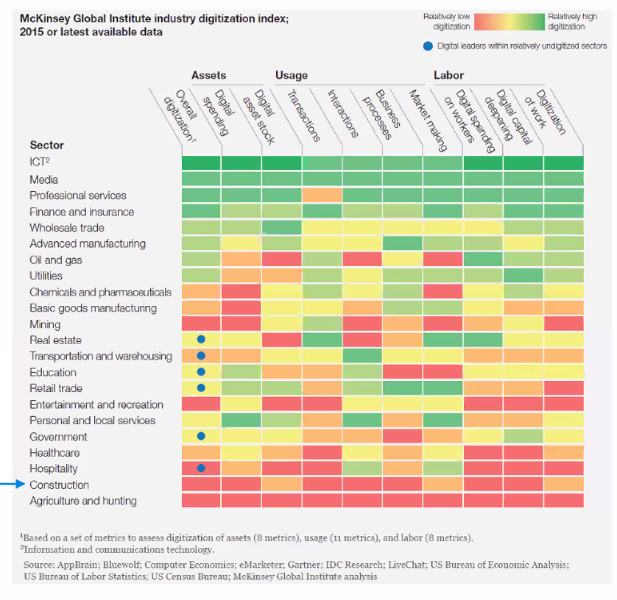

Although the industry has recognised the need for change and adopted many technological solutions, they are fragmented point solution and disorganised (Woodhead et al., 2018). Instead, a key to improve the construction project delivery with a long-term advantage is to recognize a “planned IoT ecosystem” rather than combining different “point solutions”. Ecosystem means an integrated “layer” of hardware, software, connectivity, and information ﬂows linked to key decision-making activities.

Besides, construction sector has a lack of real-time application (Literatere). If different parties in the project submits updates of deliverables on a simple and timely manner, it will be easier for all project team members as one and remain on the same pace as the project proceeds, so it would not make the progress delay in terms of scheduling and over-budget due to rework.

many Literature for FM, but for construction, so focus on construction stage in this dissertation!!!

(What and why we need control room)

In response to such situation, control room concept is an integrated solution and a single platform to fulfil this gap.

The control room concept was first applied in the 1970s during the Apollo 13 program by NASA, where engineers on the ground needed to be able to rapidly account for changes to their vehicle while exposed to the extreme conditions in space, and with lives on the line. When life support failed, NASA found they could no longer base corrective decisions on the original model because the actual module had undergone significant changes as the result of exposure to an extremely hostile environment. The original model needed to be updated to more closely mirror the current state of the module.

<https://info.expeditors.com/horizon/rise-of-the-digital-twin>)

how control room works in other Industry e.g. Banking

There is another example in the financial services industry using the control room concept. <https://www.youtube.com/watch?v=oYzqpfinyvc>

According to (StarCompliance, 2019),

the Head Of The Compliance Control Room at one of Africa's leading banks suggested that there's a growing awareness in the financial services industry have a need for a control room function as part of the larger compliance function due to the increased regulation as well as increased complexity in the day-to-day operations of the institutions"

Control rooms can act as a firm's nerve centre to monitoring the deals data such as mergers and acquisitions, equity offerings, debt offerings, …etc. The deals themselves are very complex and generate a deluge of data that must be rigorously monitored, and the deal data must be organized, recorded, and analysed. The volume of this deal data is immense and there is a need to keep track of who's involved in what and who said what to whom can be overwhelming, there is very little room for error and a premium placed on clearing deals quickly.

Some control room members said that one of the importance of control-room is to use automated software to keep them working effectively in the fast-paced environment and there is a lot to keep track of data. Software can automate much of what previously could only be done manually but it also keeps data organized and up to date.

if they aren't cleared and response quickly enough, and lost reputation, if conflicts result in regulatory action. Again, our veteran compliance officer: "Control room is a compliance function, the purpose of which is to manage the flow of sensitive corporate information in a multi-service financial institution, like ours. The more services you offer the greater chance for conflicts, and the more the need for a control room. You need to manage the flow of information in every respect."

Cost / Safety in construction is also very important, a similar control room concept should be adopted in construction.

(Components of control room)

Digital Twin

To build the control room, we must need the digital twin concept as the basis,

In the past, NASA used a combination of physical and mathematical models to monitor the activities in outer space, today’s information technology allows for pure virtual renderings with amazing precision. The same dynamics can also apply to construction.

A Digital Twin creates a digital representation of a physical building asset. It exists in the plan and design phase of a project as a method for better planning, design and construction of a project. It also plays a role at later phases of the lifecycle, especially after commissioning and provide long-term benefits for asset performance, optimisation, and reliability opportunities. Alternatively, Digital Twins can also be created after a physical version of it already exists, during its use phase. Physical assets can, therefore, be digitised when in operation.

In this approach, simulation and analytics from the digital representation can be tightly coupled with execution, which enable a cycle of continuous improvement and innovation. Measure performance, design based on current, data-driven observations, execute to design, and then measure execution to design; continuously adjusting and course-correcting to adapt to changing market conditions and to exploit emergent, potentially fleeting opportunities.

According to <https://www.intellias.com/digital-twin-technology-a-guide-for-2019/>, the three key factors that have made digital twin technology possible are:

**Velocity:** IoT devices can relatively easily collect massive volumes of data and transfer it to a digital twin in almost real time.

**Resolution:** Digital information helps us get a close look at the finest details of physical assets.

**Learning:**

Machine learning algorithms can analyze gathered data and make predictions, refining the digital twin based on gathered information and calibrating the general model and its details.

Although there are so many report/marketing to describe the advantage of digital twin concept, it is a lack of clear and entire manual to describe how to use it. This paper is to research how to utilise this concept to build a control room and investigate its essential components and possible function: With the development of technology become more mature, it is more easy for use to build the digital twin, this paper serve as a guildline to discuss what essential components are required.

Lack of framework or industrial standard of a hubs to connect the solutions!

There are some fundamental components of the digital twins:

Cloud & Collaboration Platform

A cloud-based common data environment should be used as a centralised collaboration platform, project data can be exchanged between different parties and software.

Visualisation Techniques

To illustrate the form of visualisation of the Control Room, the following types of data and the respective visualisation techniques will be used:

* Dashboard (Progress/Safety Data)

The companies use key performance indicators (KPIs) to gauge and compare performance in terms of meeting both strategic and operational goals in a dashboard. Construction industry can also make use of the objective benchmarks and find a way to measure excellence across the industry. KPIs of different size companies can also make use of this technology to digitize the information and integrate them in a centralised platform. The analysis result of the data across the industry can help to improve processes and lead to better performance and project delivery. It is the number one priority for Project Managers, Project Directors or any other person in charge of project planning to implement a planning process which will subsequently allow them to gain a clear view of each project’s status.

(data in traditional workflow in construction (to get construction quality data) , so why we want to illustrate it)

* Web viewer (Sensor Data)

The viewer enables users to visualise 3D (and 2D) models in a browser or smartphone app. The digital twin of the building model created can be probably displayed it using this technology.

* VR/AR (Model Data)

We also have experience of solutions that use Virtual Reality (VR) to help operatives understand hazards in a physical location they have not yet visited.

(what has been assumed in the result, how reliable is the analysis, why choose these visualisation technique you chosen??)

🡪 We need a hub to work tgt and visualisation, to connect the things tgt

Apart from that, the reality is that challenges such as common data exchange standards, inconsistent metadata, Application Program Interfaces (API) not working as well as they could, and asynchronous performance issues are already being grappled with through National BIM Standards (NBIMS), Construction and Operations Building Information Exchange (COBie) and National CAD Standard (NCS) to name a few. It shows that there is a missing data strategy that links to a ‘bigger picture’ such as a smart city. (Woodhead et al., 2018)

Lack of industry standard, so this dissertation to investigate

# Methodology

(Main point 🡪 demonstrate how to build a practical case study)

**-----A integration framework of NASA Control Room in Construction --------**

To illustrate the idea of the NASA Control Room, some service and software available on the market has been used to build the conceptual integration framework as shown on the below figure. System components regarding the data repository, data services and application layer are investigated in this section.

In the framework, three data repositories are considered:

Model Data: the virtual model of the physical configuration of the considered location

Construction Data: Safety and Progress Data

Sensory data: Working condition of the construction site

-> How the ecosystem works (charts)

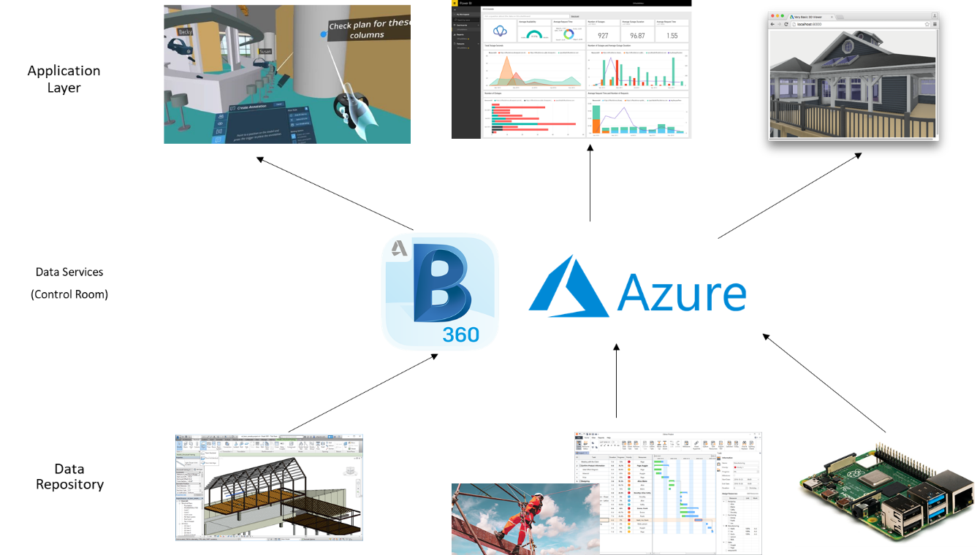

Each of these data repository represents an aspect of the construction site and has a reflection on the construction performance. This dissertation focuses on providing an extensible framework for the Control Room to make it possible to add on other information whenever necessary. This enables the author to carry out my work even without capturing the detailed data requirements. The data will then be published in a standardised format using web services.

The construction of this information framework using Web services as Microsoft Azure Cloud Service to provide an integration service interface for the Control Room.

The engineers and managers can assess these web services to get the required data in a standardised format like in IFC,rvt and collaboration in BIM360. It is up to the client to process the retrieved data to feed into their specific applications for visualise by VR/ Dashboard or real-time web viewer.

**-----------------------Source of Data----------------------------**

-Revit Model Data

->LOD,xxx, model info (ref to some execution plan)

-Construction Quality Data

->

-Sensor Data

Low cost sensors raspberry pi has been selected as the prototype to capture the construction environment data. The technical details are given in the below Table:

-> how the sensor to collect the data (mechanism)

-> How the sensor send to microcontroller works

Table: Technical specification of Raspberry Pi

|  |  |
| --- | --- |
|  |  |
|  |  |

**------------------------------------Collaboration Platform (Backend)----------------------------------**

BIM360 Collaboration

BIM 360 Design allows multi-users to work on the same model simultaneously on the cloud which can be extends worksharing to any parts of the world. Both modules must be activated in the Project services to allow proper implementation. When selected, Design Collaboration module will show the different drawing packages in a timeline format created by other Consultants and will allow them to decide whether to consume that package for their use.

->How your works related to ISO 19650 workflow

**----------------------------Data Capture and Storage(Backend)--------------------------------------**

-Web Server

Transmitting sensor data over the network can be used with the Microsoft Azure Cloud Services

-> How the Azure database build

->Table 1: Construction Data, Table 2 Revit Model Data, Table 3: Sensory

->How the endpoint to be build

-> how the cloud to get the sensory data

(->deployment of web to Azure)

**--------------------Collaboration / Visualisation (Front End)--------------------**

Infrastructure for visualisation

-> How VR plug-in to be built and works on BIM360 platform

=> Joystick to control

-> How PowerBI Dashboard to be built

-> How Forge Viewer works + D3/Chart.js to be build (API to connect with BIM360,…..)

**-----------------------Field Info-----------------------------------**

-Field Test and Data Collection **(physical)**

->Site Description

->how sensor set up and collect data in the factory

->Revit Model Specification

# Result

(Originated from the Control Room as the center!!)

-Description of data first

-focus on how the visualization technique and control room give some surprise things

Revit Model: (how to collaborate with the BIM model)

In order to provide information support for the development of the RBIVS prototype, we mainly have worked on two tasks. First, we created the BIM for the BA building using AuotDesk Revit 2012 based the 2D floor plan.

We produced the BIM with details of the room/wall/window/door elements and sensors within the building which are sufficient for monitoring the building energy performance.

VR (what insight can get from the VR)

<https://bim360resources.autodesk.com/connect-construct/how-paric-uses-virtual-reality-in-construction-to-streamline-workflow-and-reduce-risk>

<https://www.youtube.com/watch?v=vb7SmNdU8zo>

PowerBI Dashboard

Sensory Data ( what insight to get from it , e.g. CO2 , PM2.5,… )

Second task is to publish the sensor data (e.g. temperature, lighting, noise, infrared etc.) through the? REST web service as part of the implementation of the integration information service framework.

The initial RBIVS prototype was developed as a desktop application using Visual C++ programming language and Openscenegraph (for 3D rendering). The RBVIS is acting as a client application of our integrated information service framework. It accesses sensor readings through web services and links the sensor information with the room/corridor defined in BIM. The energy consumption/temperature/lighting of indoor element is visualised in 3D in real-time as shown in Figure 2.

The system can monitor the building’s energy performance by both room-based query and sensor-based query.

It can dynamically display sensor readings using colour coding based on rooms with the default changing frequency of 5 seconds. The system also supports individual sensor query in text by clicking a sensor in the 3D model or choosing a sensor from a list. The system can display individual sensor and room’s historical reading in charts as shown in Figure 3.

# Discussion

-Talk more about how the integratity can be improved

e.g. forge shd be more easily to use

e.g. PowerBI can not insert as card on the BIM360 platform

-BIM360 shd with plug-in to display the sensory data

-Standardised database for all 3 types of data

-Limitation

# Conclusion

Reference

Changali, S., Mohammad, A., & Van Nieuwland, M. (2015). The construction productivity imperative. *McKinsey Quarterly*.

Cosgrave, E. (2017). The smart city: challenges for the civil engineering sector. *Proceedings of the Institution of Civil Engineers - Smart Infrastructure and Construction*. https://doi.org/10.1680/jsmic.17.00012

Hollands, R. G. (2008). Will the real smart city please stand up? *City*. https://doi.org/10.1080/13604810802479126

HSE. (2019). Work-related stress , anxiety or depression statistics in Great Britain , 2019. *Annual Statistics*.

Jarrett Hendricks. (2020). *Rise of the Digital Twin: How Lessons Learned from NASA Are Changing the Way Supply Chains Are Managed*. https://info.expeditors.com/horizon/rise-of-the-digital-twin

McKinsey & Company. (2017). Reinventing Construction: A Route To Higher Productivity. *McKinsey & Company*.

Mohd Nawi, M. N., Baluch, N., & Bahauddin, A. Y. (2014). Impact of fragmentation issue in construction industry: An overview. *MATEC Web of Conferences*. https://doi.org/10.1051/matecconf/20141501009

Radford, Jamie; Macdonald, J. (2020). *Project 13 Digital Transformation Workstream: Infrastructure industry benchmarking report*.

StarCompliance. (2019). *Compliance Control Room: What Is It And Who Needs It?* https://blog.starcompliance.com/control-room-what-is-it-and-who-needs-it

Woodhead, R., Stephenson, P., & Morrey, D. (2018). Digital construction: From point solutions to IoT ecosystem. *Automation in Construction*. https://doi.org/10.1016/j.autcon.2018.05.004

Xu, S., & Luo, H. (2014). The information-related time loss on construction sites: A case study on two sites. *International Journal of Advanced Robotic Systems*. https://doi.org/10.5772/58444