ETHlogo

**Lecture with Computer Exercises:**

**Modeling and Simulating Social Systems with MATLAB**

Project Report

|  |
| --- |
| Simulation of Trading  in an Artificial Stock Market |

Nicholas Eyring & Youri Popoff

Zürich

14.12.2012

**Table of Contents**

**0 Abstract 5**

1. **Introduction 6**
   1. Motivation 6
   2. Goals 6
   3. Fundamental Research Questions 7
2. **The Model 8**
   1. Price Formation 8
   2. The Market 10
   3. Measuring Market Volatility 11
   4. Taking Past Market Volatility into Account 12
   5. Price Regulation 13
   6. Modeling Financial Bubbles 13
3. **Implementation 15**
   1. Simulation 15
   2. Program Structure 18
   3. Parameter Sweep 19
   4. Automatic File System 20
4. **Simulation Results and Analysis 23**
   1. Volatility Feedback 23
   2. Price Regulation 27
   3. Financial Bubbles 28
5. **Discussion 30**
   1. Shortcomings/Limitations 30
   2. Possible improvements 31
   3. Conclusion 31
6. **Appendix 33**
   1. Default Parameters 33
   2. Source Code 34
   3. References
7. **Abstract**

This paper describes and presents our implementation of an analytical model of a stock market as well as research into three specific areas: market volatility feedback, price regulation, and financial bubbles. We show that when past market volatility is taken into account by traders, fat tails appear in the investment return plots and the market tends towards instability. We also demonstrate that price regulation policies are very effective in stabilizing a given financial market. However, there is a potential trade-off between market stability and economic welfare when such policies are put into place. Furthermore, we show that it is possible to reproduce the transaction price plot characteristics of a financial bubble using an analytical model of the stock market. In conclusion, we indicate that given enough investment in research, the financial services industry may soon put analytical models to use in order to make better decisions and ultimately circumvent financially unfavorable situations.

1. **Introduction**

Over the past decades the financial services industry has firmly established itself as a key player in modern society. Its successes and, more importantly, its failures have persisted to have broad repercussions all over the world. History has shown us time and again that markets do crash and that the price of picking up the pieces is a serious burden on economic growth and human progress.

* 1. **Motivation**

At the heart of the financial system lies the stock market. It can be used as a general indicator of the state of an economy. By analyzing the evolution of the stock market over time, insight into overall investor confidence, individual firm performances and the economy as a whole can be gained. We therefore believe that a good analytical model of trading on the stock market could be used to foresee and ultimately prevent financially unfavorable situations.

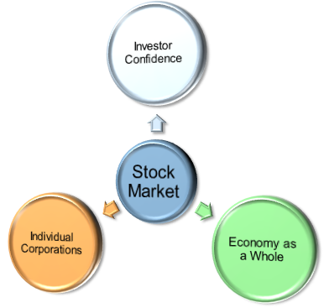

Figure 1: Using the stock market as an economic indicator

* 1. **Goals**

The primary goal of this project is to create a realistic model of a stock market which can simulate the evolution of the market transaction price over time depending on a number of appropriately chosen parameters. Given such a model, we can carry out a number of useful experiments. We identified volatile markets as an extremely undesirable feature of any modern economy and therefore decided to focus our experiments on market stabilization.

* 1. **Fundamental Research Questions**
* *How does past market volatility affect the future price of a stock?*
* *To what extent can price regulation be used to stabilize a volatile market?*
* *How accurately can financially unfavorable situations be modeled?*

Our first research question is equivalent to that which is handled in a paper we read whilst researching the topic ([1]). Our main model is based on the model described in the paper. Therefore, we wanted to confirm the results presented by the authors in order to validate our implementation of their model before using it for further research. The question itself concerns market volatility. It aims to determine the volatility feedback mechanism which needs to be implemented into the model in order to simulate real-world trading more accurately.

The second research question investigates the effectiveness of price regulation as a tool for government intervention in volatile markets. It aims to show if/how price regulation could be used to stabilize a market.

Our third and final research question involves using our model to simulate financially unfavorable situations. More specifically, we decided to attempt a simulation of a financial bubble using our model.

In order to meet our ambitions, we needed to find a good model which could accurately reproduce the dynamics of a real stock market.

1. **The Model**

Since the beginning of the project, we realized that modeling the entire stock market would be a monumental task. We had to start small. The model we implemented involves one single publically traded firm on the stock market. It executes an “agent-based” simulation. The “agents” are represented by the traders, each of which have an initial set of shares and liquidities which evolve over time. The “playground” is the market in which the different traders interact. For our simulations, we keep the number of traders finite and constant. We also give each trader the same initial number of shares and liquidities.

* 1. **Price Formation**

The engine driving any market model is the price formation process. It determines the market price of a good at a specific point in time. In our initial research, we discovered that there are two primary mechanisms used for price formation in artificial financial markets: The “clearing house” mechanism, and the “limit order book” mechanism. The “clearing house” mechanism operates on basic economic theory. Supply and demand data is accumulated over time in order to set up the familiar supply and demand curves. When supply matches demand we have the equilibrium price: “The market is cleared at the intersection of demand and supply curves” (Raberto, 2005):

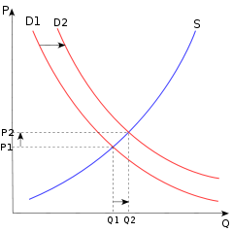

Figure 2: Supply and demand curves with a shift in demand (D1->D2). Source: Wikipedia

On the other hand, the “limit order book” mechanism works similarly to a double-auction. Interested buyers place bids for a good whilst sellers place asking prices. The bid and asking prices are stored in separate “order books”. A transaction will occur at either the highest bid price or the lowest asking price (depending on the situation) if there is a price overlap between the two books.

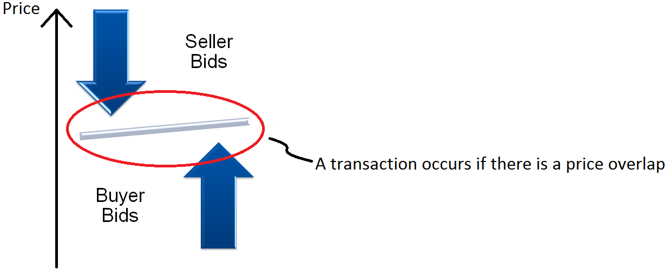

Figure 3: Limit order book mechanism

After an in-depth consideration of these two possibilities we determined that the “limit order book” mechanism for price formation is better suited to the specific market we are modeling:

“The clearing house is an unrealistic description of the way stock exchanges operate around the world. Progress in information technology and the increasing deregulation of exchanges have led to a wide adoption of the limit order book for price formation.” (Raberto, 2005)

In this market structure, the potential buyers and sellers are individually responsible for setting the price of their respective bids.

*“Modeling and simulation of a double auction artificial financial market”* ([1]) is a paper written in 2005 which describes a model using the limit order book mechanism for price formation. The model we implemented is firmly based on the model described in the paper.

Example:

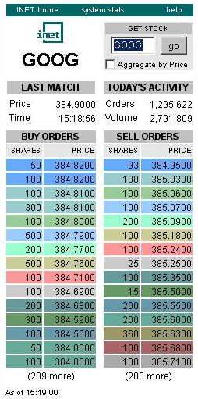

Figure 4: Real world example of a limit order book (Google stock). Source: ece.cmu.edu

* 1. **The Market**

Time is separated into days in order to imitate a real-world stock exchange. Every day, the market is open for a specific number of hours. Traders can only enter orders into the buyer or seller order books when the market is open. At the end of the day, the market closes. This means that all remaining buyer and seller bids are cleared from the books. Bids which are older than a given age also get cleared and the respective traders issue new bids immediately.

Once the market is open for the day, traders are randomly chosen for issuing orders. The time period between two orders follows an exponential distribution. Once a trader is chosen (following a uniform distribution), it issues either a “buy” or “sell” order with a predetermined probability. The price of the new order follows a Gaussian distribution with the price of the most competitive valid order currently in the respective book as the mean. The number of shares to buy/sell follows a uniform distribution ranging from one single share to the maximum number of shares the trader can buy/sell without ending up with negative asset values. A transaction will occur if there is an overlap between bid and asking prices. Otherwise, the order is stored in the respective book and no transaction occurs. If the trader is a buyer, the transaction occurs at the most competitive (lowest) selling price below the trader’s bid price. If the trader is a seller, the transaction occurs at the most competitive (highest) buying price above the trader’s bid price.

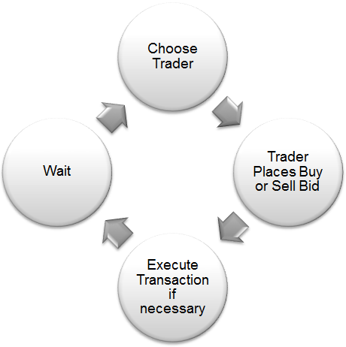

Figure 5: Sequence of events once the market is open

Since the number of shares is likely to be different for the overlapping orders, multiple transactions may occur at the same point in time. There can be one seller for multiple buyers or one buyer for multiple sellers whenever this is the case. We therefore calculate the weighted average of the individual transaction prices in order to determine the current market transaction price of the stock whenever this is the case:

$$current market price=\frac{\sum{shares*price}}{\sum{shares}}$$

It is also possible that a bid cannot fully be executed. For example, a buyer can ask for more shares than are currently available at the bid price. In this case, the buyer purchases the number of shares which are available and a new bid for the remaining shares gets placed in the buyer order book.

* 1. **Measuring Market Volatility**

In finance, the “rate of return” (ROR) on an investment is an indicator which represents the ratio of money gained or lost on an investment relative to the amount of money invested. It is usually expressed as a percentage. In a stable market, we would expect that the return values (ROR values) would not change very much over time. On the other hand, in a volatile market, fluctuation of return values is expected. Therefore, we can calculate return values as an indicator of the volatility of the market in the past.

Return values are usually calculated either with respect to a single time period (“single-period returns”), or averaged over multiple time periods (“multi-period average returns”). In our model, we take the standard deviation of multiple single-period return values and use the result as an indicator of past market volatility.

The single-period return values are calculated logarithmically using the following formula:

$$r_{log}=100∙\ln\left[\frac{P_{final}}{P_{initial}}\right] , where: \left\{\begin{aligned}P_{final}= final transaction price \\ P_{initial}= initial transaction price\end{aligned}\right.$$

$$→ σ_{T}=stdev(r_{log})$$

This is the same method that the authors of the paper which our model is based on ([1]) used to measure market volatility.

In our model we apply a constant time window with a constant number of single periods in it when calculating the standard deviation ($σ_{T})$ of the logarithmic returns ($r_{log})$. If the market is stable, we would expect a small $σ_{T}$ whereas if the market is volatile, we would expect a larger $σ_{T}$.

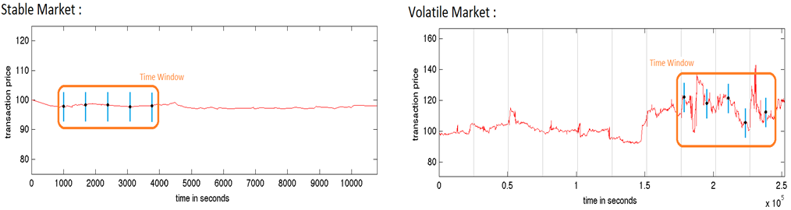

Figure 6: Stable market vs. volatile market

* 1. **Taking Past Market Volatility into Account**

In our model, volatility feedback occurs solely in the prices of new bids. Heavy fluctuations in the transaction price in the past imply that traders are less confident in their estimations of the real value of the good. The stock had been frequently under- and overvalued in the past. Since the traders are less sure of the true value of the stock, this results in a larger price spread in the new bid prices for both buyers and sellers. We therefore have a positive feedback loop built into the system. This means that fluctuations in the present market transaction price get amplified and turn up in the future transaction price. This again causes prices to deviate more from the latest bid values and the market tends towards instability.

We can implement the volatility feedback into our model by dynamically modifying the variance of the Gaussian distribution that the new bid prices are based upon. We use our volatility measure $σ_{T}$ in order to do this:

$$σ_{new}=k∙σ_{T} , k=const. ; σ=α∙σ_{new}+\left(1-α\right)∙σ , α∈\left]0,1\right] ; new variance= σ^{2}$$

When volatility feedback is turned on, a new variance is calculated every time a trader makes a new bid. Otherwise, a constant variance is used throughout the simulation.

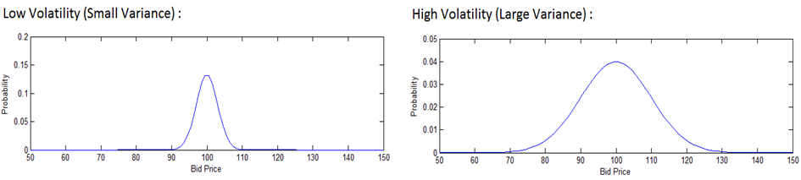

Figure 7: Bid price probability distributions for markets with different volatility

* 1. **Price Regulation**

Price regulation is a policy which consists of implementing a combination of price floors and price ceilings into the market. It inhibits the transaction price from going below a price floor or above a price ceiling at any point in time. When price regulation is turned on in the model, prices which would be out of bounds are simply set to the nearest legal limit. For example, if a buyer tries to place a bid with a price below the current price floor, the bid price gets adjusted so that it equals the value of the price floor.

For a given simulation, price regulation can be turned on or off. The price regulation consists of a price floor and a price ceiling which are valid throughout the entire simulation. When turned on, three parameters are needed: the initial value of the price floor ${(p}_{f0})$, the initial value of the price ceiling $(p_{c0})$, and the percentage growth per day (*g*). By allowing growth, the values of both the price floor and ceiling can change over time. We did this in order to account for economic growth (which is desired). The resulting price ceiling and price floor become linear functions of time (*t* [seconds]):

* 1. **Modeling Financial Bubbles**

A financial bubble is a phenomenon where stock is consistently overvalued by traders over a period of time. Trading occurs at prices which are considerably inflated. Prices keep rising until at some point an awareness of the overvaluation occurs. Once this happens, the bubble bursts. Prices fall rapidly and consistently until equilibrium is regained. Real-world examples of financial bubbles are numerous. The “Roaring Twenties” stock-market bubble (1922-1929), the Dot-com bubble (1995-2000), and the U.S. real estate bubble (as of 2007) are prominent examples.

After much discussion, we decided to use non-symmetric probability distributions for bid prices in order to simulate financial bubbles using our model. At a specific point in time, the mean of the Gaussian distribution which new bid prices are based upon increases significantly. Instead of using the most competitive valid bid price as the mean, we set the mean to a value which is considerably higher. This indicates that prices are much more likely to increase than decrease. Later, we reverse the trend by setting the mean to a value which is considerably lower than the most competitive valid bid price. This makes prices extremely likely to fall and keep falling, essentially bursting the bubble. At some point thereafter the model switches back to the regular probability distributions for bid prices, thereby inducing equilibrium once again.

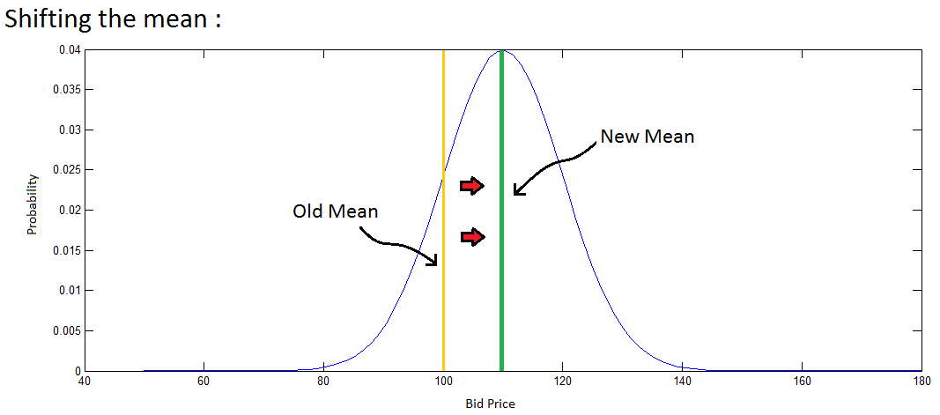

Figure 8: Shifting the mean for new bid prices causing bubble

1. **Implementation**

The program is divided into three main sections:

- Section 1: input

- Section 2: computations

- Section 3: plotting

The implementation of the model itself is found in the computational section. This is where the stock market gets simulated. The other two sections were created for organizational reasons. The input section (section 1) sets values for all relevant parameters needed for a simulation. The computations section (section 2) carries out a simulation for one set of input parameters. The plotting section (section 3) organizes the results of every simulation for analysis. Given that the three sections work time-independently from one another, they can be called separately. However, they must be called in order.

* 1. **Simulation**

In order to keep the implementation as clear and convenient as possible, the model is separated into numerous MatLab functions. Each function carries out a specific task. MatLab structs are used to group all relevant parameters and variables together, simplifying function inputs and outputs. At the beginning of a simulation, the function *init.m* is called and creates these structs:

function [ SSM, SP, SPL ] = init( )

*init.m* output:

- SSM: System state matrices (previous transaction prices, trader assets, etc…)

- SP: System parameters (probability distribution parameters, number of days to simulate, etc…)

- SPL: System plotting parameters

Once all parameters have been defined, the actual simulation can begin: The function *main.m* gets called:

function [ SSM, SP, SPL ] = main( SSM, SP, SPL )

*main.m* is the heart of the model. It contains a for-loop which iterates through each simulation second. For every simulation second, *main.m* has a number of tasks:

1. Shift bid price mean if necessary (for bubble)
2. Update ages of all current bids
3. Calculate the logarithmic returns if necessary (end of a period)
4. Determine when the next trader gets chosen
5. Empty the books if the day is over
6. Choose a trader and create a book entry if necessary
7. Check the ages of existing bids and create new book entries if necessary
8. Update the weighted transaction price values

Most of the tasks above do not get completed inside the function *main.m*. Instead, various other important functions get called:

* 1. If the bubble simulation is turned on, the function *shiftMean.m* gets called to shift the mean of the bid price distributions:

%% Shift the mean

SP = shiftMean( SP, m );

* 2. In order to update the ages of all current bids, *main.m* calls the function *ageUpdate.m*:

%% Age Update

SSM.bookbpaging = ageUpdate( SSM.bookbpaging, SSM.sbbp );

SSM.bookspaging = ageUpdate( SSM.bookspaging, SSM.sbsp );

* 3. Logarithmic returns are needed to measure past market volatility. They are calculated with respect to a time period (*dt*) using the function *logReturns.m*:

%% Calculate Log Returns

if i == lrt % time to calculate log returns?

[ SSM ] = logReturns( SSM, SP ); % calculate log returns

lrt = lrt + SP.dt; % increment lrt for next log returns calculation

end

* 4. The time to wait until the next trader gets chosen follows an exponential distribution. The time at which a new trader gets chosen is calculated using the following code:

%% New Book Entry Section

if i == t % time to choose a trader?

Tau = 1+round(exprnd(SP.lambda)); % step between two book entries

% (random number; exponential distribution)

t = t + Tau; % new time at which to choose next trader!

* 5. In order to empty the books when the day is over, *main.m* calls the function *emptyBook.m*:

if t - m * SP.T > SP.T % t - m * T = actual time in the trading day m

m = m + 1; % increment number of days past

[ SSM ] = emptyBook( SSM, SP );

end

* 6. A trader must now be chosen to make a bid. Since we distinguish between buyer and seller bids, *main.m* will either call the function *buyer.m* or *seller.m* in order to create a book entry and execute a transaction if necessary:

%% Book entry

ind = randi(SP.tnum, 1, 1); % index of the chosen trader

stat = randi(2, 1, 1) - 1; % choose between buyer (0) or seller (1)

if stat == 0 % we have a buy order (0)

[ SSM ] = buyer(SSM, SP, m, i, ind, arefresh, orind);

else % we have a sell order (1)

[ SSM ] = seller(SSM, SP, m, i, ind, arefresh, orind);

end

*buyer.m* and *seller.m* call various functions including those which execute the transactions. This is also where bid prices are determined. Both *buyer.m* and *seller.m* call the function *volatilityFeedback.m* in order to account for volatility in the market (if turned on):

if SP.volfeed == 1

[ SSM ] = volatilityFeedback( SSM, SP, ind );

end

If price regulation is turned on, the bid price gets adjusted (if necessary) by calling the function *regulatePrice.m*:

if SP.regulate == 1

p = regulatePrice(p, SP, t); % regulate price if applicable

end

Once the bid price and number of shares has been set, the order gets executed if possible. *buyer.m* calls the function *buyerTransaction.m* whilst *seller.m* calls the function *sellerTransaction.m*. These are the only functions which actually execute transactions.

* 7. The ages of all the bids which are still stored in their respective books must now be checked to determine if they have expired or not. This is done by calling the functions *ageCheckBuyer.m* and *ageCheckSeller.m* respectively:

%% Age Check

[ SSM ] = ageCheckBuyer(SSM, SP, m, i);

[ SSM ] = ageCheckSeller(SSM, SP, m, i);

* 8. Since multiple transactions may have occurred during the current simulation second, the weighted average must be calculated. The function *weightedTP.m* is called in order to do so:

[ SSM ] = weightedTP( SSM, i ); % update weighted transaction price matrix

Once the for-loop has ended (every second has been simulated), the plotting section (section 3) of the program uses the generated data to create results and the simulation is complete.

* 1. **Program Structure**

*-Input* (folder *code/Input*):

This section generates the input files used in a simulation. A standard set of parameters is initialized in the function *init.m*. These values correspond to those which were chosen in the paper which we based our model on ([1]). Additionally, a parameter sweep is implemented. Section 3.3 of this paper (page!!!) discusses the purpose and implementation of the parameter sweep.

-*Computations* (folder *code/Computation*):

The computations section is the heart of the model. It carries out a simulation for a given set of input parameters. See section 3.1 of this paper (page!!!) for a detailed description of the computational part of the program.

-*Plotting* (folder *code/Plot*):

The results generated from various simulations can be plotted using the third and final section. Several plots are created for every set of output data, including plots of random variables. The random variable plots are present for debugging purposes. They can be used to verify that random variables are following their respective intended distributions.

-*Results* (folder *code/Data*):

Every set of results generated gets saved in the folder *code/Data*. This includes all plots as well as general simulation information (such as parameter choice and execution time).

-*Additional functions* (folders *code/Other* and *code/Test functions*):

The repository *code/Other* contains old versions of key functions. It serves as an internal back-up for functions which are either important or which we had often modified.

In addition, the code in the folder *code/Test functions* was written in order to experiment with various built-in MatLab functions as well as to compare ideas without having to modify the work done so far.

* 1. **Parameter Sweep**

When using a model to simulate a real social system, it is essential to run it on different sets of parameters as the model will react in various ways when exposed to different initial conditions. Consequently, the choice of appropriate parameter values is crucial.

A parameter sweep involves taking a parameter and varying it according to a sweep rule. The computations section then simulates the stock market for each specific value of the parameter. Sweeping through multiple parameters is also possible. In that case, a simulation will run for every allowed combination of parameters specified by the sweep.

The sweep rule of the parameter sweep is defined in the file *code/Input/param.txt*. This file has a specific structure that needs to be maintained for the program to function.

An example of a valid parameter sweep file is shown below:



Figure 9: Example of *code/Input/param.txt*

In this example, the parameter sweep is defined as follows:

* SP.p0 (initial price) ranging from 100 to 110 with an increment of 1
* SP.k (correlation coefficient) starting at 1.40 and incremented by 0.01 until 1.60
* SP.volfeed (volatility feedback toggle) ranging from 0 (off) to 1 (on)

The sweep is implemented in the folder *code/Input* (input section of the model). At first, the function *paramSweepCall.m* is called, which in turn calls the recursive function *paramSweep.m*. The parameter sweep file *param.txt* is read by *paramSweep.m* which automatically generates each set of values. All parameters which do not appear in the sweep are set to their default values as described in *code/Input/init.m*.

The parameter files generated by *paramSweep.m* are saved as MatLab-specific files in various subfolders with the following general name:

*code/Data/Simulation*/sim**/sim**parameter.mat*

Later on, the computations section runs a simulation for each of the individual parameter sets.

To facilitate finding the results of running the model on a specific set of parameters generated by the sweep, the file *code/Data/Simulation*/structure.txt* is created. This file can be consulted once an entire sweep is complete in order to find the results of a specific simulation.

* 1. **Automatic File System**

A typical parameter sweep generates thousands of parameter combinations which all need to be simulated individually. Since each simulation usually takes several minutes to complete, it would be very inefficient for users to have to start every simulation themselves. Clear organization of the output data is also desired to ease the analysis of results. Therefore, an automated system is needed.

The simulation is started by running the script *code/control.m*. At first, a file structure for the results needs to be created. To do this, the file *code/path.txt* is read. This file contains the definition of all the folder names of the file structure.

An example of a valid file containing these definitions is shown below:

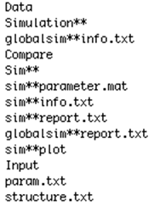

Figure 10: Example of a valid file system definition file

In this example, the first line defines the name of the result folder (*Data*). The second line is a definition of the global simulation folder (*Data/Simulation\*\**) whose info-file is called *Data/globalsim**info.txt* (third line). The corresponding report file is named *Data/globalism**report.txt* (ninth line). Note: the “**” are automatically replaced by the program with the simulation number.

These definitions are passed on to the folder management function *code/Input/foldermg.m* and the different subfolders are created. This function also calls the parameter sweep to generate the input. Thereafter, the control script (*control.m*) runs the simulation, plots the results, and saves them back to their respective folders.

Due to the number of random variables used, the model is prone to instability if certain initial values are chosen. Therefore, the control script contains a try and catch section in which the implemented model is called. This way, if one of the sub-simulations fails, the program simply notifies it in the report file and continues.

-*The compare folder:*

Comparing the results of a large number of simulations can be an overwhelming task. A comparison folder *code/Data/Simulation*/sim**/Compare* was created to solve this problem. The code can automatically take a single plot from each simulation and copy it into the compare folder. This facilitates data analysis when regarding a specific output variable of the model.

As an optimization, a condition was added which determines whether or not a plot should be copied to the compare folder. For example, if the transaction price exceeds 500 (five times the default initial value), then the simulation should not be included in the comparison. This way, potentially uninteresting results could be filtered out before comparison.

*Further aspects:*

Being able to reproduce results is very important when modeling. Therefore, the random generators use a fixed random stream. This is done using the following code:

%% Initialisation

s = RandStream('mt19937ar','Seed',0);% choosing & resetting random stream

%RandStream.setDefaultStream(s);

RandStream.setGlobalStream(s);

Report files (also called logfiles) containing the list of errors (if occurred), the execution time, and various other simulation details are also implemented into the model. Furthermore, each simulation generates an information file containing a list of all parameter values used.

1. **Simulation Results and Analysis**

When running simulations, all three of our research questions were handled separately. By turning on/off different functions of the model, specific aspects could be investigated in order to obtain conclusive results. Although the general focus of our experiments is market stabilization, we chose to examine features of volatile markets and approaches to market stabilization separately in order to gain clear and pertinent results.

* 1. **Volatility Feedback**

Our first research question reads as follows:

*“How does past market volatility affect the future price of a stock?”*

As mentioned earlier, the question is equivalent to that which is handled in the research paper which our model is based upon ([1]). Our goal was to confirm the results presented by the authors in order to validate our implementation of their model. They had first simulated the market without taking past market volatility into account (no volatility feedback mechanism) before comparing the results with those obtained when past market volatility was taken into account. Below are the primary results which they presented in their paper:

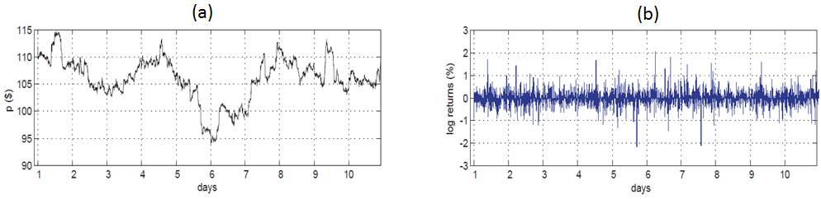

Figure 11: Results without volatility feedback as presented in paper ([1])

(a): Transaction price over time (b): Logarithmic return values over time

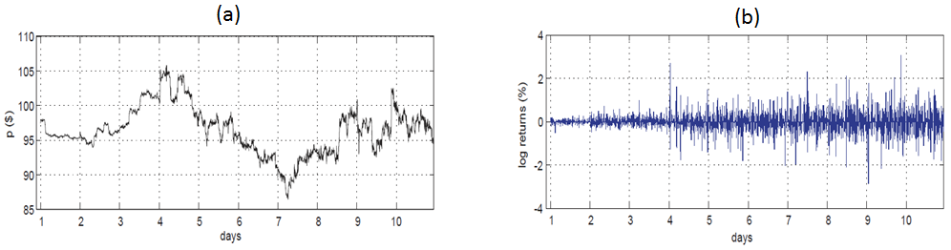

Figure 12: Results with volatility feedback as presented in paper ([1])

(a): Transaction price over time (b): Logarithmic return values over time

It is clear that when volatility feedback was not incorporated, the market behaved consistently over the entire simulation period. On the other hand, when volatility feedback was taken into account, the market was clearly more stable at the beginning of the simulation and fluctuated more and more as the simulation continued. This is clearly characterized by the “fat tail” which can be observed in the logarithmic return values plot. Wikipedia identifies “excessive investor optimism or pessimism leading to large market moves” as behavioral origins of fat tails in market return distributions. Below are results from our model of simulations with and without volatility feedback. Note that all parameters took their default values (see appendix 6.1 – page!!!) unless otherwise specified. This is valid for all results presented in this paper.

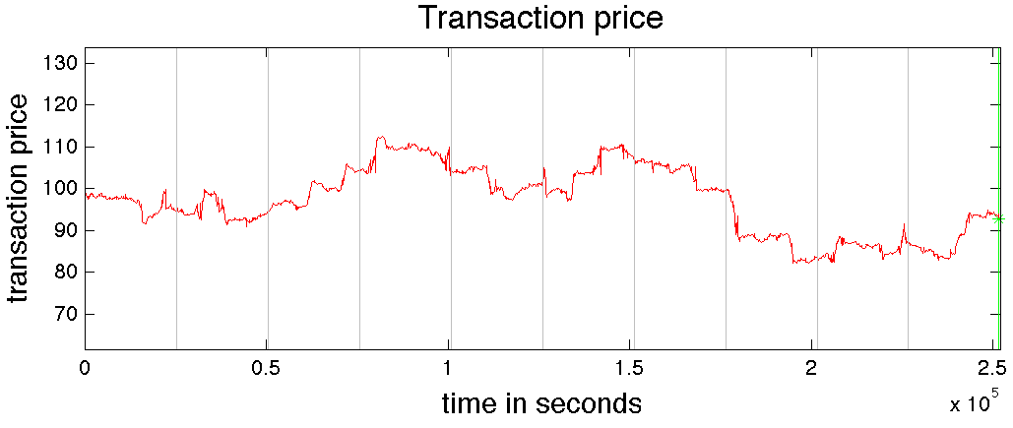

Figure 13: Our results without volatility feedback – Transaction price over time

Non-default parameters: SP.sigma = 0.0048

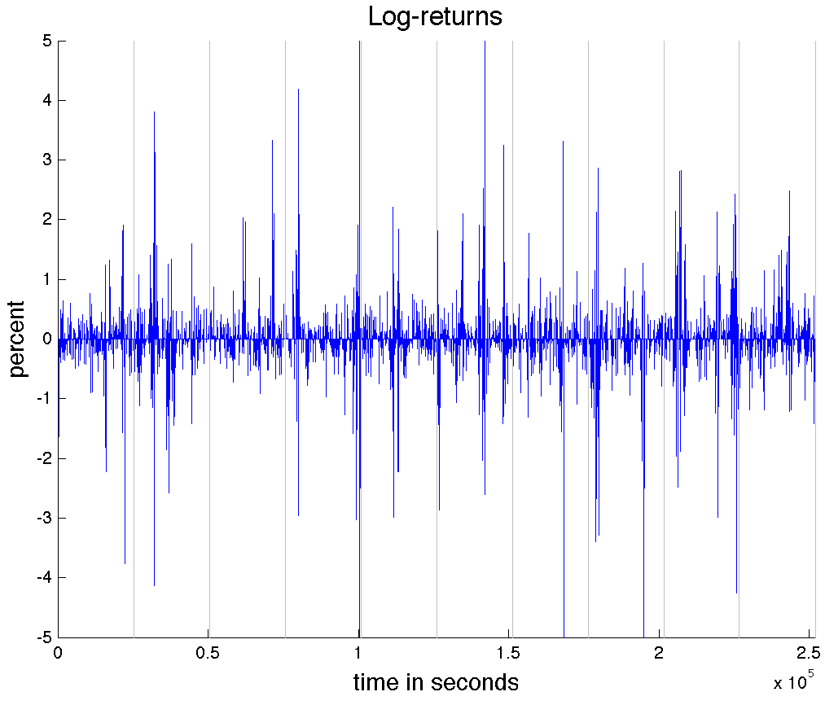

Figure 14 : Our results without volatility feedback – Logarithmic return values over time

Non-default parameters: SP.sigma = 0.0048

The vertical lines in both plots represent days gone past. This makes it easier to compare our results to those presented in Figure 11. Looking at the transaction price plot (Figure 13), we see that the market was more or less consistent throughout the simulation. This confirms what is seen in Figure 11a.

Concerning logarithmic return values, there clearly is jitter in our results. If we ignore the jitter, our results are remarkably similar to those presented in Figure 11b: the logarithmic returns appear to be independent of time. It seems we have succeeded in reproducing the results without volatility feedback. We believe that the jitter we see is simply a consequence of the random number generators used in the implementation of the model.

Following are the results of our model when volatility feedback is turned on:

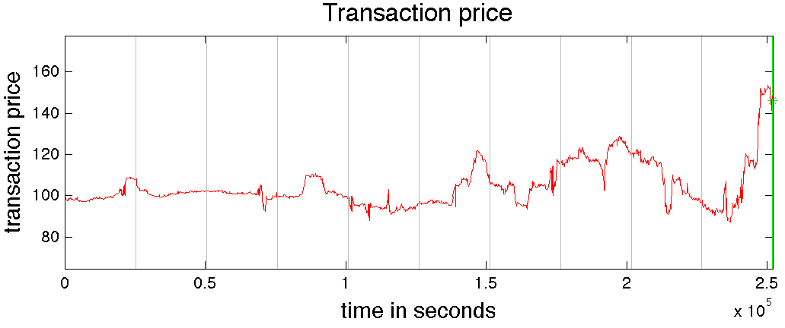

Figure 15: Our results with volatility feedback – Transaction price over time

Non-default parameters: SP.volfeed = 1 , SP.k = 1.66 , SP.korrk = 0.00043

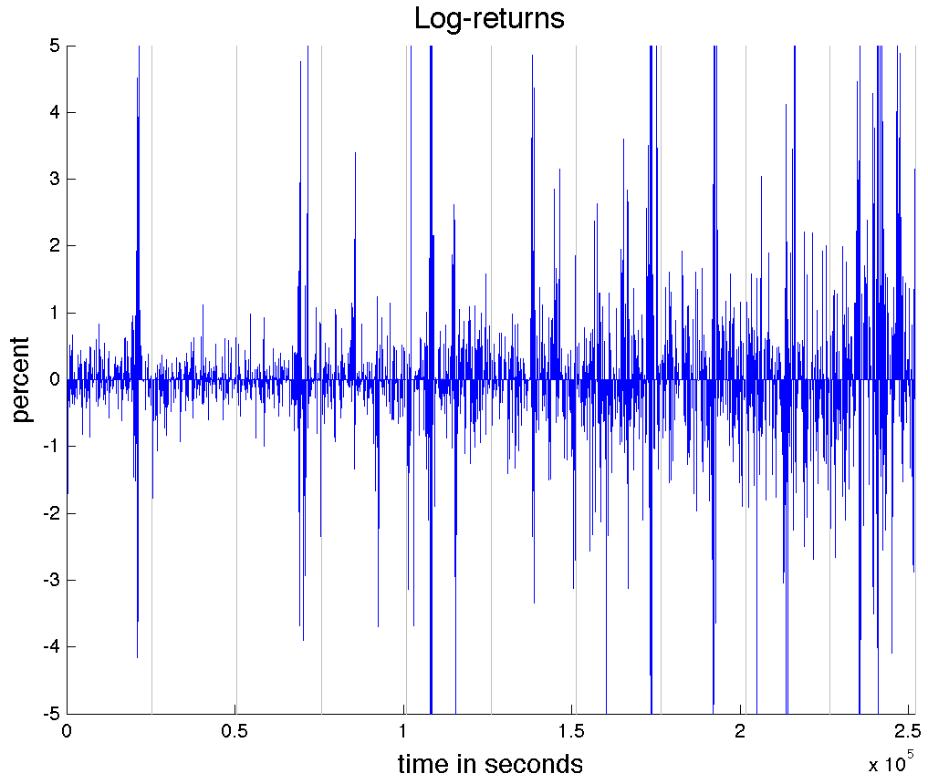

Figure 16: Our results with volatility feedback – Logarithmic return values over time

Non-default parameters: SP.volfeed = 1 , SP.k = 1.66 , SP.korrk = 0.00043

Looking at Figure 15, it is clear that the volatility feedback mechanism is working. The market transaction price is very stable at the beginning of the simulation and fluctuates more and more as time goes on. This is consistent with the results in Figure 12a.

Regarding logarithmic return values over time, a “fat tail” is clearly noticeable in Figure 16. This is a direct consequence of increasing fluctuation of the transaction price as time goes on. Once again there seems to be jitter in the results. However, the underlying volatility feedback mechanism is behaving consistently with the results in Figure 12a and Figure12b.

When presenting our project, we were asked if the market stays unstable even after a long period of time. Below are the results of the same simulation which generated Figure 15 and Figure 16, except the simulation period is increased from 10 days to 20 days:

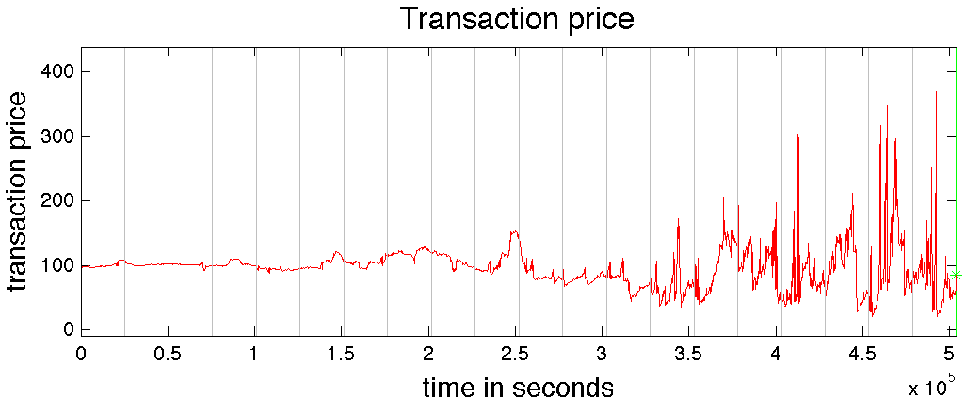

Figure 17: Long simulation results with volatility feedback (20 days) – Transaction price over time

Non-default parameters: SP.volfeed = 1 , SP.M = 20 , SP.k = 1.66 , SP.korrk = 0.00043

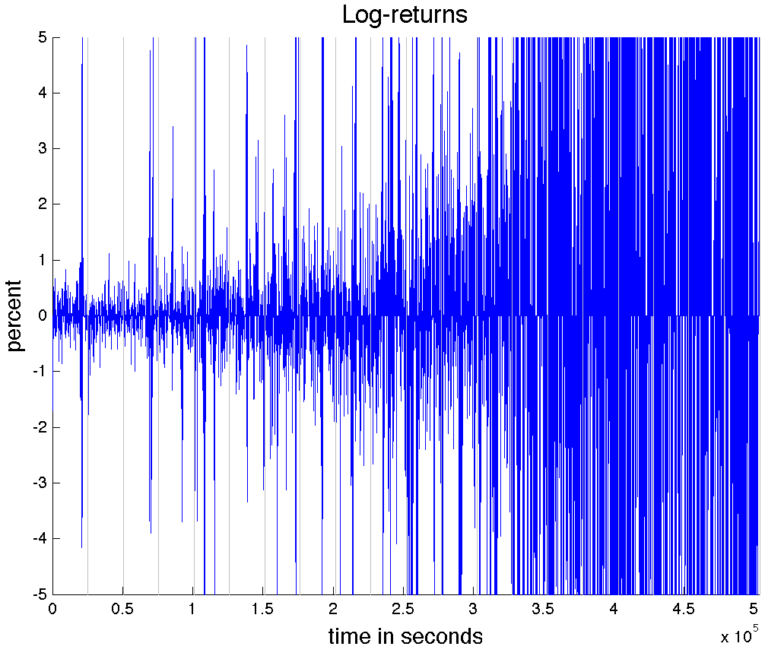

Figure 18: Long simulation results with volatility feedback (20 days) – Logarithmic return values over time

Non-default parameters: SP.volfeed = 1 , SP.M = 20 , SP.k = 1.66 , SP.korrk = 0.00043

As expected, it appears that the market does indeed tend towards instability. The “fat tail” in Figure 18 is extremely noticeable, and the transaction price plot in Figure 17 displays consistently increasing price fluctuation as time goes on.

* 1. **Price Regulation**

Our research question concerning price regulation reads as follows:

*“To what extent can price regulation be used to stabilize a volatile market?”*

In order to use price regulation in our model, three parameters are needed. The first two are the initial values of the price floor and price ceiling. The last parameter is the allowed growth per day (expressed as a percentage). Below are the results of a simulation when the allowed growth is set to 0% per day (no growth):

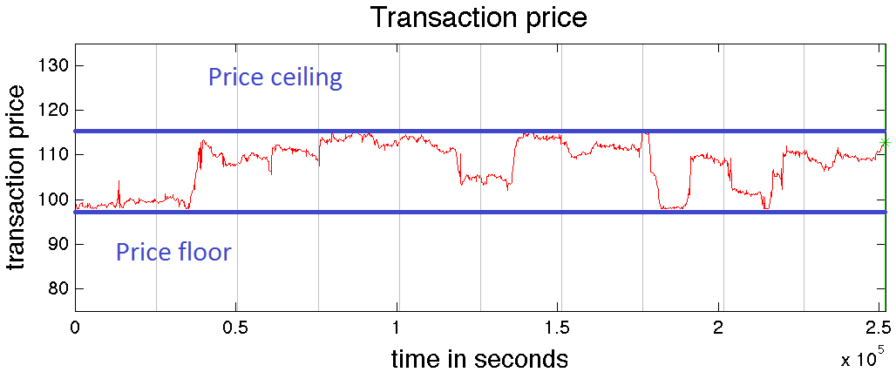

Figure 19: Price regulation results with zero growth

Non-default parameters: SP.growth = 0 , SP.regulate = 1 , SP.pF = 98 , SP.pC = 115

When growth is allowed ( $g≠0$), the following results are obtained:

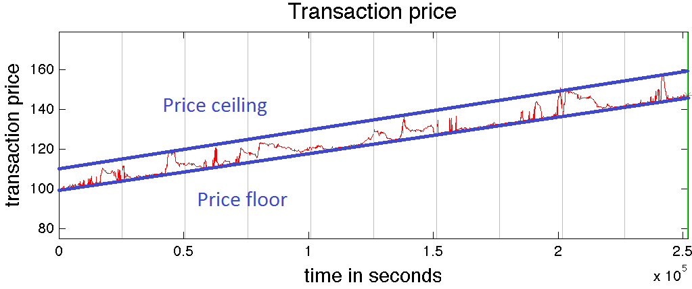

Figure 20: Price regulation results with non-zero growth

Non-default parameters: SP.growth = 16 , SP.regulate = 1

It is clear that the regulation works. By setting bounds on the transaction price, the market is forced into stability. However, we no longer have a free market. If the true (equilibrium) price of the good lies outside the legal bounds, economic welfare is lost. Price regulation therefore results in a possible trade-off between market stability and a free market environment. The challenge is choosing the right parameters so that as little economic welfare as possible is lost.

* 1. **Financial Bubbles**

Our final research question reads as follows:

*“How accurately can financially unfavorable situations be modeled?”*

Specifically, we attempted to simulate a financial bubble using our model. We wanted to reproduce the transaction price plot characteristics of real-world examples of financial bubbles using our model. Below is a plot of the NASDAQ Composite index illustrating the Dot-com bubble:

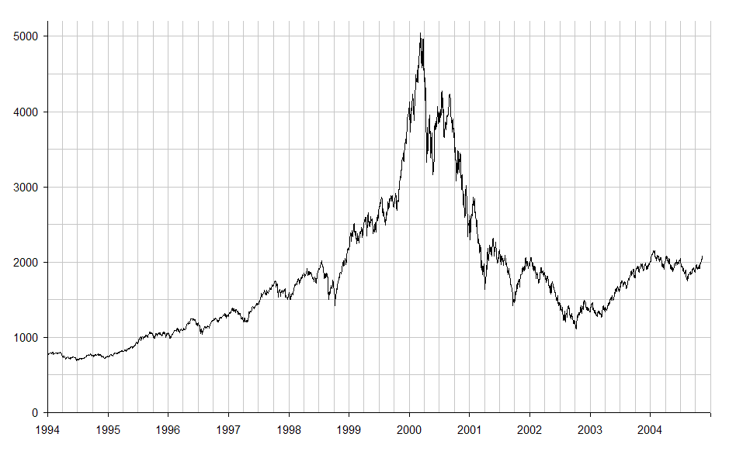

Figure 21: NASDAQ index illustrating the Dot-com bubble. Source: mathmajor.org

Following are the results obtained using our model:

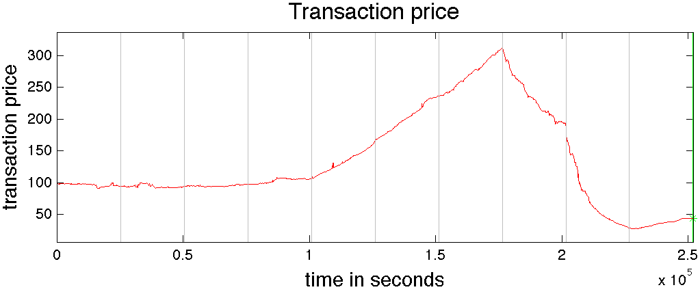

Figure 22: Financial bubble results

Non-default parameters: SP.devon = 1 , SP.t1 = 3 , SP.mu1 = 1.01 , SP.mu2 = 0.96

Clearly, the results shown in Figure 22 do have the characteristics of a financial bubble to an extent. We see a steady increase in price, then a peak, and then a steady decrease in price before flattening out again. However, the rates of change in price before and after the peak seem to be almost constant. This is not the case in the NASDAQ plot of the Dot-com bubble (Figure 21). The index seems to increase exponentially before the peak and decrease exponentially afterwards. This result is, however, not surprising. Our model simply shifts the mean of the bid price distributions by a constant amount whenever there is a change. It appears that a gradual change in the mean would result in a transaction price plot which better represents the bubble in Figure 21. Despite this, our results do show promise for analytical models of financial bubbles. We show in Figure 22 that it is possible to reproduce at least some of the characteristics of financial bubbles using an analytical model. We can safely say that we achieved our goals concerning our third and final research question.

1. **Discussion**

It is clear that much work can still be done on the subject matter of this project. The results of our experiments are interesting, however much more time and effort would be needed to draw truly valuable conclusions from this kind of project. The main obstacle is the complexity of the system we are trying to model. Despite significant advances in information technology over the past couple of decades, no current model is sophisticated enough to be very accurate. As a result, traders still do not rely on analytic models of the stock market when investing. Further research needs to be done and the model which we implemented can serve as a basis for future research concerning this subject.

* 1. **Shortcomings/Limitations**

One of the most evident shortcomings of our model is that it is a closed system which only handles a single firm. The market is isolated. This means that the model does not take into account anything which happens outside of it. Being that the real-world stock market is undoubtedly affected by countless world-wide events, this is a serious limitation.

When implementing price regulation into our model, we simply forced traders to adjust their prices to be within the legal bounds imposed on the market. It is highly debatable whether or not this would actually be the reaction of real-world traders to an equivalent real-world market policy. An alternative possibility would be to simply wait until traders place legal bids. This may result in fewer transactions and perhaps a slowdown in trading activity. Either way, more research would be required to determine a more accurate bid mechanism for traders in these particular situations.

A significant general limitation of this type of model is that there are just too many important parameters involved in real-world stock market prices to model without a tremendous amount of research. There are simply too many factors which may affect the stock market which are not incorporated into our model. This fact imposes a severe shortcoming of our model. It would be hard to convince someone of the accuracy of results generated from our simulations given the number of parameters which are not taken into account.

One must be very aware of the shortcomings and limitations of such a model in order to correctly interpret the meaning of results generated by simulations. As the complexity of the model increases, this becomes harder to do. Generally speaking, a realistic model of a stock market will be inherently complex due to the high complexity of the real-world system. As a result, most stock market models bear the mutual shortcoming of having a long learning curve. This is potentially a serious barrier to the future adoption of analytic models of the stock market by members of the financial community.

* 1. **Possible Improvements**

An evident possible improvement to our model would be to complete the research on price regulation and causes of financial bubbles and build more accurate mechanisms into the model. This would better the credibility of our results and conclusions drawn with respect to our research questions.

Another obvious improvement would be to incorporate further parameters into the model. For example, so-called “landscape event” parameters could potentially be built into our model. As a result, the influence of real-world events outside of the market itself could be modeled to an extent. Clearly, a large amount of research would be involved.

A very interesting addition to our model would be to write a program where real-world stock market data could be fed into the model or analyzed against various simulation results. This could prove to be a useful tool when analyzing various market stabilization methods. Building an intuitive graphical user interface (GUI) to go with it would make the model easier to use and potentially attract more users.

Lastly, a natural continuation of the model would be to have multiple single-firm stock markets interacting with each other all in the same model. Entire real-world stock markets could potentially be modeled whilst tweaking certain parameters for each individual market.

* 1. **Conclusion**

Given what we have learned throughout this project, it seems to us that it will be some time before stock market models are taken seriously by members of the financial services industry. In spite of this, we consider our project a success with respect to our fundamental research questions. We did achieve our primary goal of creating a realistic model of a stock market which can simulate the evolution of the market transaction price over time. Furthermore, we were able to reproduce results from previous research using our own version of the model.

The experiments which we carried out on the topic of price regulation did yield interesting albeit non-surprising results. We showed that our model could be used to investigate potential market policies. This could be very valuable when undergoing further research.

Concerning financial bubbles, we are able to mimic the transaction price plot characteristics of real-world examples of the phenomenon using our model. However, there is no mechanism built into the model which causes a bubble without explicit non-provoked outside intervention. In conclusion, we showed that it is possible to reproduce the characteristics of a financial bubble using an analytical model of the stock market. As a result, it seems feasible that financially unfavorable situations can be modeled analytically. This is a terrific result as it clearly opens the door for further research into this topic.

Taking into consideration all which has been imparted by this project, there appears to be enormous potential for analytical models of financial markets with regard to managing financially unfavorable situations. We believe that if there is enough investment in research, the financial services industry may soon put analytical models to use in order to make better decisions and ultimately circumvent financially unfavorable situations.

1. **Appendix**
   1. **Default Parameters**

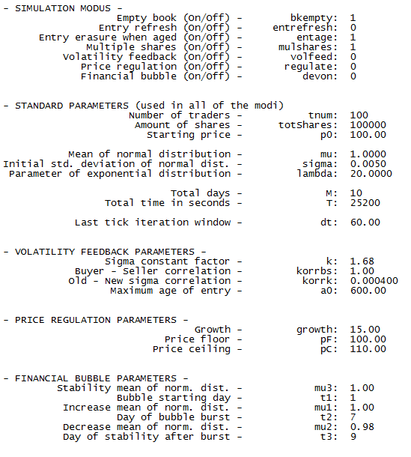

* 1. **Source Code**

*code/*

*- code/control.m*

%©2012 ETH Zürich

%Bambolei

%Nicholas Eyring, Youri Popoff

%Simulation of trading in an artificial stock market

clear all; clf; close all; clc;

%% Get path information

pathfile = fopen('path.txt','r');

frewind(pathfile);

mf = fscanf(pathfile, '%s', 1 ); % main folder

sf = fscanf(pathfile, '%s', 1 ); % simulation folder

gsin = fscanf(pathfile, '%s', 1 ); % global simulation info file

comp = fscanf(pathfile, '%s', 1 ); % compare folder name

simf = fscanf(pathfile, '%s', 1 ); % sim folder name

spa = fscanf(pathfile, '%s', 1 ); % sim parameter file

sin = fscanf(pathfile, '%s', 1 ); % sim info file

srep = fscanf(pathfile, '%s', 1 ); % sim report file

gsrep = fscanf(pathfile, '%s', 1 ); % global simulation report

plt = fscanf(pathfile, '%s', 1 ); % sim plot files (more than one)

parfold = fscanf(pathfile, '%s', 1 ); % parameter sweep instruction folder

spr = fscanf(pathfile, '%s', 1 ); % parameter sweep file

stru = fscanf(pathfile, '%s', 1 ); % tree structure file

fclose(pathfile);

newfolder = 0; % create new folder

%% Create input

cd('Input');

[simpath, simnum, amount] = foldermg( mf, sf, gsin, comp, simf, spa, sin, newfolder, parfold, spr, stru );

cd('../');

%% Load input & simulate

startdate = date;

starttime = clock;

ticID2 = tic;

i = 0;

%digit = floor(log10(amount-1))+1; % amount of digits needed for numerotation

%simustr = sprintf('%0*.0f', digit, i);

paramfile = sprintf( '%s/%s/%s', simpath, simf, spa );

tparamfile = regexprep( paramfile, '**', num2str(i) );

fs = 0;

failsim = zeros( 1, 1000 );

while ( exist(tparamfile, 'file' ) ~= 0 )

try % in case of error, the global simulation

% continues but the subsimulation stops

% and the error is reported

ticID1 = tic; % start timer

%% Start simulation

load( tparamfile );

cd( 'Computation/' );

[ SSM, SP, SPL ] = main( SSM, SP, SPL );

cd( '../' );

%% Plot section

cd( 'Plot/' );

plotpath = sprintf( '%s/%s/%s', simpath, simf, plt );

plotpath = regexprep( plotpath, '**', num2str(i) );

plotpath = regexprep( plotpath, 'plot', '' );

comparepath = sprintf( '%s/%s/%s', simpath, comp, plt );

comparepath = regexprep( comparepath, '**', num2str(i) );

comparepath = regexprep( comparepath, 'plot', '' );

plotCall( SSM, SP, SPL, plotpath, comparepath );

cd( '../' );

rstat = 'Simulation was succesful!';

errmsg = '-';

catch ME

fs = fs + 1;

failsim( fs, : ) = i;

rstat = 'Simulation failed!';

errmsg = ME.message;

cd( '../' );

end

ctime = toc(ticID1);

%% Create report file

reportfilename = sprintf( '%s/%s/%s', simpath, simf, srep );

reportfilename = regexprep( reportfilename, '**', num2str(i) );

file = fopen( reportfilename, 'w' );

% overhead

dstr = date;

cstr = clock;

fprintf(file, '©2012 ETH Zuerich\nBambolei\nNicholas Eyring, Youri Popoff\nSimulation of trading in an artificial stock market\n\n\n\n');

fprintf(file, ' **** SIMULATION %u ****\n\n', i);

fprintf(file, ' Report file\n\n');

fprintf(file, ' Date: %s\n', dstr);

fprintf(file, ' Time: %02.0f:%02.0f:%02.0f\n\n', cstr(4), cstr(5), cstr(6));

% text

fprintf(file, ' Computation duration - ctime: %f\n', ctime);

fprintf(file, ' Report status - rstat: %s\n', rstat);

fprintf(file, ' Error message - errmsg: %s\n\n', errmsg);

fclose(file);

i = i + 1;

tparamfile = regexprep( paramfile, '**', num2str(i) );

end

enddate = date;

endtime = clock;

dur = toc(ticID2);

%% Global simulation report

grepfilename = sprintf('%s/%s', mf, gsrep);

grepfilename = regexprep(grepfilename, '**', num2str(simnum));

rep = fopen(grepfilename, 'w');

% overhead

dstr = date;

cstr = clock;

fprintf(rep, '©2012 ETH Zuerich\nBambolei\nNicholas Eyring, Youri Popoff\nSimulation of trading in an artificial stock market\n\n\n\n');

fprintf(rep, ' **** Global SIMULATION %u ****\n\n', simnum);

fprintf(rep, ' Report file\n\n');

fprintf(rep, ' Date: %s\n', dstr);

fprintf(rep, ' Time: %02.0f:%02.0f:%02.0f\n\n', cstr(4), cstr(5), cstr(6));

% text

fprintf(rep, ' Amount of failed simulations - fs: %u\n\n', fs);

fprintf(rep, ' Starting date - startdate: %s\n', startdate);

fprintf(rep, ' Sarting time - starttime: %02.0f:%02.0f:%02.0f\n\n', starttime(4), starttime(5), starttime(6));

fprintf(rep, ' Ending date - enddate: %s\n', enddate);

fprintf(rep, ' Ending time - endtime: %02.0f:%02.0f:%02.0f\n\n', endtime(4), endtime(5), endtime(6));

fprintf(rep, ' Duration - dur: %f\n\n\n', dur);

% Failed simulation index list

if fs > 0

fprintf(rep, ' Index of failed simulations\n\n');

end

for n = 1:1:fs

fprintf(rep, ' - %u\n', failsim(n));

end

fclose(rep);

*- code/path.txt*Data

Simulation**

globalsim**info.txt

Compare

Sim**

sim**parameter.mat

sim**info.txt

sim**report.txt

globalsim**report.txt

sim**plot

Input

param.txt

structure.txt

*code/Computation*

*- code/Computation/ageCheckBuyer.m*%©2012 ETH Zürich

%Bambolei

%Nicholas Eyring, Youri Popoff

%Simulation of trading in an artificial stock market

function [ SSM ] = ageCheckBuyer( SSM, SP, m, t )

%AGECHECKBUYER checks if the entry in the book is older than a0 (lifespan)

% If aged: trader makes new offer

%% Find auction to be refreshed

pagedind = find( SSM.bookbpaging( [1:1:SSM.sbbp], 5 ) <= 0 );

if isempty(pagedind) ~= 1 && SP.entage == 1

lgt = length( pagedind );

if lgt > 1 % queue of traders who want to refresh auction

warning('W05 Buyer: Number of entries to be renewed: %d', lgt);

end

%just refresh the first element

%pagedind = pagedind(1);

%% Get data from bid to be refreshed

% Book Format:

% day, time, seller/buyer id, s/b price, shares, dirty bit, age bit, new

% entry number, index of aged entry

for i = 1:1:lgt

% loop for each auction to be refreshed

%orind = SS.bookbpaging( i, 4 ); % get original auction index

orind = SSM.bookbpaging( pagedind(i), 4 ); % get original auction index

auction = SSM.bookb( orind, : );

ind = auction(3); % index of the chosen trader

arefresh = auction(8) + 1; % amount of refresh

SSM.bookb( orind, [6, 7] ) = [0, 1]'; % old entry invalid

% old entry aged

SSM.bookbpaging( pagedind(i), : ) = []; % erase old entry in paging matix

SSM.sbbp = SSM.sbbp - 1;

pagedind = pagedind(:,1) -1; % update index of entries to renew (shifted due

% to actual renewal)

if SP.entrefresh == 1

[ SSM ] = buyer( SSM, SP, m, t, ind, arefresh, orind );

end

end

end

end

* *code/Computation/ageCheckSeller.m*

%©2012 ETH Zürich

%Bambolei

%Nicholas Eyring, Youri Popoff

%Simulation of trading in an artificial stock market

function [ SSM ] = ageCheckSeller( SSM, SP, m, t )

%AGECHECKSELLER checks if the entry in the book is older than a0 (lifespan)

% If aged: trader makes new offer

%% Find bid to be refreshed

pagedind = find( SSM.bookspaging( [1:1:SSM.sbsp], 5 ) <= 0 );

if isempty(pagedind) ~= 1 && SP.entage == 1

lgt = length( pagedind );

if lgt > 1 % queue of traders who want to refresh auction

warning('W06 Seller: Number of entries to be renewed: %d', lgt);

end

%just refresh the first element

%pagedind = pagedind(1);

%% Get data from bid to be refreshed

% Book Format:

% day, time, seller/buyer id, s/b price, shares, dirty bit, age bit, new

% entry number, index of aged entry

for i = 1:1:lgt

% loop for each auction to be refreshed

%orind = SS.bookspaging( i, 4 ); % get original auction index

orind = SSM.bookspaging( pagedind(i), 4 ); % get original auction index

auction = SSM.books( orind, : );

ind = auction(3); % index of the chosen trader

arefresh = auction(8) + 1; % amount of refresh

SSM.books( orind, [6, 7] ) = [0, 1]'; % old entry invalid

% old entry aged

SSM.bookspaging( pagedind(i), : ) = []; % erase old entry in paging matix

SSM.sbsp = SSM.sbsp - 1;

pagedind = pagedind(:,1) -1; % update index of entries to renew (shifted due

% to actual renewal)

if SP.entrefresh == 1

[ SSM ] = seller( SSM, SP, m, t, ind, arefresh, orind );

end

end

end

end

*- code/Computation/ageUpdate.m*%©2012 ETH Zürich

%Bambolei

%Nicholas Eyring, Youri Popoff

%Simulation of trading in an artificial stock market

function [ bookpaging ] = ageUpdate( bookpaging, sb )

%AGEUPDATE updates age of bid

if sb > 0

bookpaging( 1:1:sb, 5 ) = bookpaging( 1:1:sb, 5 ) - ones( sb, 1 ); %maximal age column minus 1 in paging matrix

end

end

*- code/Computation/buyer.m*%©2012 ETH Zürich

%Bambolei

%Nicholas Eyring, Youri Popoff

%Simulation of trading in an artificial stock market

function [ SSM ] = buyer( SSM, SP, m, t, ind, arefresh, orind )

%BUYER Completes the tasks of the buyer (stat = 0)

% Calculates the price of the bid and executes the transaction if there

% is a price overlap

if SP.volfeed == 1

[ SSM ] = volatilityFeedback( SSM, SP, ind ); % account for past market volatility

end

n = normrnd(SP.mu, SSM.sigma, 1, 1); % factor ni used to calculate price

SSM.sd3 = SSM.sd3 + 1;

SSM.debug( SSM.sd3, 3 ) = n;

%if arefresh ~= 0

% n = SS.mu + abs( SS.mu - n ); % more interesting price: higher for buyer

%end

%% Compute new price in function of old price

if SSM.sbbp ~= 0 && SSM.sbsp ~= 0

d = SP.korrbs * SSM.bookbpaging(1, 1) + ( 1 - SP.korrbs ) * SSM.bookspaging(1, 1);

% take actual best bid price in book d(th-1)

p = d * n;

else

% book empty but already transactions

if SSM.sbp ~= 0

%p = SS.tprice(SS.sbp, 1) * n; % if book empty, take last best price

p = SSM.d * n;

else

p = SP.p0;

end

warning('W03 Buyer book empty!');

end

%% Price regulation 1

% variations of more than varwidth are not allowed

varwidth = 0.06*SSM.sigma/0.005;

if SSM.sbp ~= 0

tpr = SSM.tprice( SSM.sbp, 1 );

else

tpr = SP.p0;

end

highlim = ( 1 + varwidth ) * tpr;

lowlim = ( 1 - varwidth ) * tpr;

if p < lowlim || p > highlim

p = tpr;

end

%% Price regulation 2

% regulates price with ceiling/floor if applicable

if SP.regulate == 1

p = regulatePrice(p, SP, t); % regulate price if applicable

end

%% Transaction section

% Compute amount of shares (buy) & write entry in book

maxShares = floor((SSM.treg(ind,1))/p); % maximum number of shares trader can buy

if maxShares > 0 && p > 0 % otherwise no order

%% Maximum & minimum price ever occurred

if p > SSM.pmax

SSM.pmax = p;

end

if p < SSM.pmin

SSM.pmin = p;

end

%% Shares

if SP.mulshares == 1

shares = randi(maxShares); % random fraction of maximum

else

shares = 1;

end

SSM.sbb = SSM.sbb + 1; % increment number of elements in buy order book

SSM.bookb( SSM.sbb, : ) = [ m, t, ind, p, shares, 1, 0, arefresh, orind ];

% new entry in buyer book

[ SSM ] = buyerTransaction( SSM, SP, ind, shares, p, SP.a0, t );

% execute the order if possible

end

end

*- code/Computation/buyerTransaction.m*%©2012 ETH Zürich

%Bambolei

%Nicholas Eyring, Youri Popoff

%Simulation of trading in an artificial stock mark

function [ SSM ] = buyerTransaction( SSM, SP, ind, shares, p, a0, t )

%BUYERTRANSACTION Checks if a transaction should occur when a new buyer

% entry is created and carries it out if need be (eventually with

% multiple sellers)

if SSM.sbsp > 0

%% Information fetch

priceS = SSM.bookspaging(1,1); % mimimum sell order unit price

pCounter = 1; % incremented when buyerid = sellerid

% the seller is then skipped

%% Transaction loop

% (until no more money or no more interesting auction)

while( p >= priceS && SSM.sbsp >= pCounter ) % buyerTransaction -> price == asking price !

priceS = SSM.bookspaging(pCounter,1); % new mimimum sell order unit price

EntryIndexS = SSM.bookspaging(pCounter,4); % index of entry in books

sellerID = SSM.books(EntryIndexS,3); % ID of the seller

%% Both involved traders distinct

if sellerID ~= ind

sharesS = SSM.bookspaging(pCounter,3); % desired number of shares for seller

%% Shares control

% seller wants to sell shares but may have already sold

% some shares due to another transaction

if sharesS > SSM.treg(sellerID,2)

sharesS = SSM.treg(sellerID,2); % negative shares not allowed ! -> set to maximum allowed

warning('W02 Seller lacks shares');

end

trshares = min(shares, sharesS); % amount of shares involved in transaction

trliq = priceS * trshares; % cash to debit / credit

%% Holdings update

SSM.treg(sellerID,1) = SSM.treg(sellerID,1) + trliq; % update seller's account

SSM.treg(sellerID,2) = SSM.treg(sellerID,2) - trshares; % udpate seller's share holdings

SSM.treg(ind,1) = SSM.treg(ind,1) - trliq; % update buyer's account

SSM.treg(ind,2) = SSM.treg(ind,2) + trshares; % update buyer's share holdings

%% Seller book & paging seller book update

% seller not sold all

if sharesS > trshares

SSM.bookspaging(pCounter,3) = sharesS - trshares; % update seller order shares

else

SSM.bookspaging(pCounter,:) = []; % delete seller entry from paging book

SSM.sbsp = SSM.sbsp - 1;

SSM.books(EntryIndexS,6) = 0; % set dirty-bit to 0 in books

end

%% Buyer book update

shares = shares - trshares; % buyer remaining shares

% buyer bought all

if shares == 0

SSM.bookb(SSM.sbb, 6) = 0; % set valid bit to 0 in bookb

break;

end

%% New entry in tprice

SSM.sbp = SSM.sbp + 1; % increment number of entries in tprice

SSM.tprice(SSM.sbp,:) = [priceS, sharesS, sellerID, EntryIndexS, ind, SSM.sbb, t];

else

pCounter = pCounter + 1; % skip trader next loop

end

end % end of while loop

end

%% Buyer still desires shares

% - A new auction appears in the bookb

% - If the buyer has already bought all of the desired shares,

% then there is no new entry in the bookb paging

if shares > 0

SSM.sbbp = SSM.sbbp + 1; % increment number of elements in paging book

SSM.bookbpaging( SSM.sbbp, : ) = [ p, t, shares, SSM.sbb, a0 ]; % new entry in the paging book

SSM = sortBookb( SSM ); % sort the paging book

end

end

*- code/Computation/shiftMean.m*%©2012 ETH Zürich

%Bambolei

%Nicholas Eyring, Youri Popoff

%Simulation of trading in an artificial stock market

function [ SP, m ] = shiftMean( SP, m )

%SHIFTMEAN changes the mean of the price

if SP.devon == 1

if m > SP.t1 && m < SP.t2

SP.mu = SP.mu1;

elseif m > SP.t2 && m < SP.t3

SP.mu = SP.mu2;

else

SP.mu = SP.mu3;

end

end

end

*- code/Computation/emptyBook.m*%©2012 ETH Zürich

%Bambolei

%Nicholas Eyring, Youri Popoff

%Simulation of trading in an artificial stock market

function [ SSM ] = emptyBook( SSM, SP )

%EMPTYBOOK empties book if needed

if SP.bkempty == 1

SSM.bookbpaging(1:1:SSM.sbbp, :) = []; % book emptying

SSM.sbbp = 0;

SSM.bookspaging(1:1:SSM.sbsp, :) = [];

SSM.sbsp = 0;

SSM.bookb( 1:1:SSM.sbb, 6 ) = zeros( SSM.sbb, 1 ); % valid bit to zero

SSM.books( 1:1:SSM.sbs, 6 ) = zeros( SSM.sbs, 1 );

end

end

*- code/Computation/logReturns.m*%©2012 ETH Zürich

%Bambolei

%Nicholas Eyring, Youri Popoff

%Simulation of trading in an artificial stock market

function [ SSM ] = logReturns( SSM, SP )

%LOGRETURNS computes log returns each dt = 60s

% returns logreturns in the SSM.ret matrix

%Matrix format:

% Column 1 Column 2 (Time intervall)

% 1 price p. tick log-ret 1 - 60s

% 2 price p. tick log-ret 61 - 120s

% 3 price p. tick log-ret 121 - 180s

% ...

tindex = SSM.sbp;

SSM.retsize = SSM.retsize + 1; % increment retsize

%% Find last tick (previous-tick interpolation)

if tindex > 0 % we have transaction values

SSM.ret(SSM.retsize,1) = SSM.tprice( tindex, 1 ); % write tick price into matrix

%% Compute log-return

% in percent

if SSM.retsize > 1

SSM.ret(SSM.retsize, 2) = 100 * log(SSM.ret(SSM.retsize,1) / SSM.ret(SSM.retsize - 1,1) );

else

SSM.ret(SSM.retsize, 2) = 0; % set return to zero if we don't have enough entries

end

else

SSM.ret(SSM.retsize, 1) = SP.p0; % use initial price if no transactions have occured (previous tick ?)

SSM.ret(SSM.retsize, 2) = 0; % set return to zero (nothing has changed yet!)

end

end

*- code/Computation/main.m*%©2012 ETH Zürich

%Bambolei

%Nicholas Eyring, Youri Popoff

%Simulation of trading in an artificial stock market

function [ SSM, SP, SPL ] = main( SSM, SP, SPL )

%MAIN Determines trading period and calls buyer or seller function to create

% entries in the Stock Market book

% Liveplot

if SPL.liveplot == 1

cd('../Plot');

liveplot;

cd('../Computation');

end

% Debug coefficient: time evolution

coeff = 1/(SP.M*SP.T)*100;

pe = -1;

% Function scope

m = 0;

%tic;

%% Initialisation

s = RandStream('mt19937ar','Seed',0); % choosing & resetting random stream

%RandStream.setDefaultStream(s);

RandStream.setGlobalStream(s);

t = 1+round(exprnd(SP.lambda)); % time of first entry

lrt = SP.dt; % used for log returns calculation intervals

%% Simulation section

for i = 1:1:(SP.M)*(SP.T)

%% Shift the mean

SP = shiftMean( SP, m );

%% Age Update

SSM.bookbpaging = ageUpdate( SSM.bookbpaging, SSM.sbbp );

SSM.bookspaging = ageUpdate( SSM.bookspaging, SSM.sbsp );

%% Calculate Log Returns

if i == lrt

[ SSM ] = logReturns( SSM, SP ); % calculate log returns

lrt = lrt + SP.dt; % increment lrt for next log returns calculation

end

%% New Book Entry Section

if i == t

Tau = 1+round(exprnd(SP.lambda)); % step between two book entries

% (random number; exponential distribution

SSM.st = SSM.st + 1; % saving event occurrence

SSM.tocc( SSM.st, 1 ) = Tau;

t = t + Tau;

if t - m * SP.T > SP.T % t - m * T = actual time in the trading day m

m = m + 1; % increment number of days past

[ SSM ] = emptyBook( SSM, SP );

end

%% Book entry

ind = randi(SP.tnum, 1, 1); % index of the chosen trader

stat = randi(2, 1, 1) - 1; % choose between buyer (0) or seller (1)

arefresh = 0; % bit to tell whether the entry is new or refreshed

orind = 0; % new auction: no aged entry line

if stat == 0 % we have a buy order (0)

[ SSM ] = buyer(SSM, SP, m, i, ind, arefresh, orind);

else % we have a sell order (1)

[ SSM ] = seller(SSM, SP, m, i, ind, arefresh, orind);

end

end

%% Age Check

[ SSM ] = ageCheckBuyer(SSM, SP, m, i);

[ SSM ] = ageCheckSeller(SSM, SP, m, i);

[ SSM ] = weightedTP( SSM, i ); % update weighted transaction price matrix

%% Plot section live

if SPL.liveplot == 1

cd('../Plot');

plotPrice( i, SSM, SP, SPL, fig1 );

cd('../Computation');

end

%% Percentage (evolution)

npe = floor(coeff * i);

if npe > pe

pe = pe + 1;

disp(['Completed to ', num2str(pe), ' percents!']);

end

end

%% Control

if sum(SSM.bookb(:,6)) ~= SSM.sbbp

warning('W07 Buyer bookb & bookbpaging do not coincide!');

end

if sum(SSM.books(:,6)) ~= SSM.sbsp

warning('W08 Seller books & bookspaging do not coincide!');

end

%ctime = toc;

end

*- code/Computation/regulatePrice.m*

%©2012 ETH Zürich

%Bambolei

%Nicholas Eyring, Youri Popoff

%Simulation of trading in an artificial stock market

function [ p ] = regulatePrice( p, SP, t )

% Returns regulated price p using given price

% regulation parameters

pCeiling = SP.pC + (SP.growth*SP.pC/(100*24*60*60))*t; % calculate current price ceiling

pFloor = SP.pF + (SP.growth*SP.pF/(100*24*60*60))*t; % calculate current price floor

if p > pCeiling

p = pCeiling; % set price to nearest legal limit

else

if p < pFloor

p = pFloor; % set price to nearest legal limit

end

end

end

*- code/Computation/seller.m*%©2012 ETH Zürich

%Bambolei

%Nicholas Eyring, Youri Popoff

%Simulation of trading in an artificial stock market

function [ SSM ] = seller( SSM, SP, m, t, ind, arefresh, orind )

%SELLER Completes the tasks of the seller (stat = 1)

% Calculates the asking price and executes the transaction if there if a

% price overlap

if SP.volfeed == 1

[ SSM ] = volatilityFeedback( SSM, SP, ind ); % account for past market volatility

end

n = normrnd(SP.mu, SSM.sigma, 1, 1); % factor ni to calculate the price

SSM.sd3 = SSM.sd3 + 1;

SSM.debug( SSM.sd3, 3 ) = n;

%if arefresh ~= 0

% n = SS.mu - abs( SS.mu - n ); % more interesting price: lower for seller

%end

%% New price in function of old price

if SSM.sbsp ~= 0 && SSM.sbbp ~= 0

a = SP.korrbs * SSM.bookspaging(1, 1) + ( 1 - SP.korrbs ) * SSM.bookbpaging(1, 1);

% take actual best ask price in book a(th-1)

p = a * n;

else

% book empty but already transactions

if SSM.sbp ~= 0

%p = SS.tprice(SS.sbp, 1) * n; % if book empty, take last best price

p = SSM.a * n;

else

p = SP.p0;

end

warning('W04 Seller book empty!');

end

%% Price regulation 1

% variations of more than varwidth are not allowed

varwidth = 0.06*SSM.sigma/0.005;

if SSM.sbp ~= 0

tpr = SSM.tprice( SSM.sbp, 1 );

else

tpr = SP.p0;

end

highlim = ( 1 + varwidth ) * tpr;

lowlim = ( 1 - varwidth ) * tpr;

if p < lowlim || p > highlim

p = tpr;

end

%% Price regulation 2

% regulates price with ceiling/floor if applicable

if SP.regulate == 1

p = regulatePrice(p, SP, t); % regulate price if applicable

end

%% Transaction section

% Compute amount of shares (sell) & write entry in book

if SSM.treg(ind,2) > 0 && p > 0 % otherwise no order

%% Maximum & minimum price ever occurred

if p > SSM.pmax

SSM.pmax = p;

end

if p < SSM.pmin

SSM.pmin = p;

end

%% Shares

if SP.mulshares == 1

shares = randi(SSM.treg(ind,2)); % random fraction of quantity of stocks owned by trader

else

shares = 1;

end

SSM.sbs = SSM.sbs + 1; % increment number of elements in seller order book

SSM.books( SSM.sbs, : ) = [ m, t, ind, p, shares, 1, 0, arefresh, orind ];

% new entry in seller book

[ SSM ] = sellerTransaction( SSM, SP, ind, shares, p, SP.a0, t );

% execute the order if possible

end

end

*- code/Computation/sellerTransaction.m*%©2012 ETH Zürich

%Bambolei

%Nicholas Eyring, Youri Popoff

%Simulation of trading in an artificial stock mark

function [ SSM ] = sellerTransaction( SSM, SP, ind, shares, p, a0, t )

%SELLERTRANSACTION Checks if a transaction should occur when a new seller

% entry is created and carries it out if need be (eventually with

% multiple buyers)

if SSM.sbbp > 0

%% Information fetch

priceB = SSM.bookbpaging(1,1); % maximum buy order unit price

pCounter = 1; % used if buyer index == seller index

%% Transaction loop

% (until buyer no more money or price too high)

while( p <= priceB && SSM.sbbp >= pCounter ) % sellerTransaction -> price == bid price !

priceB = SSM.bookbpaging(pCounter,1); % new maximum buy order unit price

EntryIndexB = SSM.bookbpaging(pCounter,4); % index of entry in bookb

buyerID = SSM.bookb(EntryIndexB,3); % ID of the buyer

%% Traders distinct

if buyerID ~= ind

sharesB = SSM.bookbpaging(pCounter,3); % desired number of shares for buyer

%% Shares control

% buyer desires to buy shares but may already have given

% away his money due to a newer auction

maxBshares = floor((SSM.treg(buyerID,1))/priceB); % maximum number of shares buyer can buy

if maxBshares < sharesB

sharesB = maxBshares; % negative liquidities not allowed ! -> set to maximum allowed

warning('W01 Buyer lacks liquidities');

end

trshares = min(shares, sharesB); % amount of maximum shares involved in transaction

trliq = priceB * trshares; % cash involved

%% Holdings update

SSM.treg(buyerID,1) = SSM.treg(buyerID,1) - trliq; % update buyer's account

SSM.treg(buyerID,2) = SSM.treg(buyerID,2) + trshares; % udpate buyer's share holdings

SSM.treg(ind,1) = SSM.treg(ind,1) + trliq; % update seller's account

SSM.treg(ind,2) = SSM.treg(ind,2) - trshares; % update seller's share holdings

%% Buyer book & paging buyer book update

% buyer not bought all

if sharesB > trshares

SSM.bookbpaging(pCounter,3) = sharesB - trshares; % update buyer order shares

else

SSM.bookbpaging(pCounter,:) = []; % delete buyer entry from paging book

SSM.sbbp = SSM.sbbp - 1; % decrement number of entries in bookbpaging

SSM.bookb(EntryIndexB,6) = 0; % set dirty-bit to 0 in bookb

end

%% Seller book update

shares = shares - trshares; % remaining seller shares (cannot be negative)

if shares == 0

SSM.books(SSM.sbs, 6) = 0; % set valid bit to 0 in books

break;

end

%% New entry in tprice

SSM.sbp = SSM.sbp + 1; % increment number of entries in tprice

SSM.tprice(SSM.sbp,:) = [priceB, sharesB, ind, SSM.sbs, buyerID, EntryIndexB, t];

else

pCounter = pCounter + 1; % skip trader next loop

end

end

end

%% Seller still desires to sell shares

% - New auction in books

% - If all the shares were sold, then no new entry in seller paging

% book

if shares > 0

SSM.sbsp = SSM.sbsp + 1; % increment number of elements in paging book

SSM.bookspaging( SSM.sbsp, : ) = [ p, t, shares, SSM.sbs, a0 ]; % new entry in the paging book

SSM = sortBooks( SSM ); % sort the paging book

end

end

*- code/Computation/sortBookb.m*%©2012 ETH Zürich

%Bambolei

%Nicholas Eyring, Youri Popoff

%Simulation of trading in an artificial stock market

function [ SSM ] = sortBookb( SSM )

%SORTBOOKB sorts the paging book (buyer)

% - The highest price is i the first row

% - The sorting is in decreasing order

% - If 2 or more entries have the same price, the oldest one comes first

% (increasing order)

A = SSM.bookbpaging( 1:1:SSM.sbbp, : );

sortedpart = sortrows( A, [ -1 2 ] ); % 1. sort: decreasing for price

% 2. sort: increasing for time

SSM.bookbpaging( 1:1:SSM.sbbp, : ) = sortedpart;

if SSM.sbbp ~= 0

SSM.d = SSM.bookbpaging(1, 1);

end

end

*- code/Computation/sortBooks.m*%©2012 ETH Zürich

%Bambolei

%Nicholas Eyring, Youri Popoff

%Simulation of trading in an artificial stock market

function [ SSM ] = sortBooks( SSM )

%SORTBOOKS sorts the paging book (seller)

% - The lowest price is i the first row

% - The sorting is in increasing order

% - If 2 or more entries have the same price, the oldest one comes first

% (increasing order)

A = SSM.bookspaging( 1:1:SSM.sbsp, : );

sortedpart = sortrows( A, [ 1 2 ] ); % 1. sort: increasing for price

% 2. sort: increasing for time

SSM.bookspaging( 1:1:SSM.sbsp, : ) = sortedpart;

if SSM.sbsp ~= 0

SSM.a = SSM.bookspaging(1, 1);

end

end

*- code/Computation/volatilityFeedback.m*

%©2012 ETH Zürich

%Bambolei

%Nicholas Eyring, Youri Popoff

%Simulation of trading in an artificial stock market

function [ SSM ] = volatilityFeedback( SSM, SP, ind )

% updates sigma value depending on past market volatility

SSM.sd4 = SSM.sd4 + 1;

%% Time window

% Randomly initialised for each trader

%T = 599 + randi(5401); % determine time window

T = SSM.treg( ind, 3 );

baseIndex = SSM.retsize - floor(T/SP.dt); % calulate base index

if baseIndex < 1

baseIndex = 1; % take entire history into account

end

if SSM.retsize > 0 % we can only affect sigma once log returns are available

logRet = SSM.ret(baseIndex:SSM.retsize,2)./100; % extract wanted vector from ret matrix

sigmaT = std(logRet); % determine the standard deviation of log returns in period T

sigmaN = SP.k * sigmaT; % sigmaN is a function of sigmaT

SSM.sigma = SP.korrk * sigmaN + ( 1 - SP.korrk ) * SSM.sigma; % set new value for sigma

%% Evolution of sigma

SSM.se = SSM.se + 1;

SSM.sige( SSM.se, 1 ) = SSM.sigma;

end

end

* *code/Computation/weightedTP.m*

%©2012 ETH Zürich

%Bambolei

%Nicholas Eyring, Youri Popoff

%Simulation of trading in an artificial stock mark

function [ SSM ] = weightedTP( SSM, i )

%WEIGHTEDTP Updates the weighted average transaction price matrix used for plotting

index = SSM.sbp; % get number of elements in tprice

if index > 0

lastTtime = SSM.tprice(index,7); % get the most recent transaction time

if lastTtime == i % only needs updating if a transaction

% has been carried out during the current loop

% initialize totals

totalV = 0; % total amount of money involved in transactions

% at time i

totalS = 0; % total amount of shares in transactions

while( index > 0 && SSM.tprice(index,7) == i)

totalS = totalS + SSM.tprice(index,2);

totalV = totalV + SSM.tprice(index,1)*SSM.tprice(index,2);

index = index - 1; % decrement index

end

avgP = totalV/totalS; % calculate weighted average

SSM.savtp = SSM.savtp + 1; % increment number of elements in avgtprice

SSM.avgtprice(SSM.savtp,:) = [avgP, i]; % add element to avgtprice

end

end

end

*code/Input*

*- code/defaultInfo.txt*©2012 ETH Zuerich

Bambolei

Nicholas Eyring, Youri Popoff

Simulation of trading in an artificial stock market

**** Default parameter values ****

Information file

Date: 13-Dec-2012

Time: 22:03:18

- SIMULATION MODUS -

Empty book (On/Off) - bkempty: 1

Entry refresh (On/Off) - entrefresh: 0

Entry erasure when aged (On/Off) - entage: 1

Multiple shares (On/Off) - mulshares: 1

Volatility feedback (On/Off) - volfeed: 0

Price regulation (On/Off) - regulate: 0

Financial bubble (On/Off) - devon: 0

- STANDARD PARAMETERS (used in all of the modi)

Number of traders - tnum: 100

Amount of shares - totShares: 100000

Starting price - p0: 100.00

Mean of normal distribution - mu: 1.0000

Initial std. deviation of normal dist. - sigma: 0.0050

Parameter of exponential distribution - lambda: 20.0000

Total days - M: 10

Total time in seconds - T: 25200

Last tick iteration window - dt: 60.00

- VOLATILITY FEEDBACK PARAMETERS -

Sigma constant factor - k: 1.68

Buyer - Seller correlation - korrbs: 1.00

Old - New sigma correlation - korrk: 0.000400

Maximum age of entry - a0: 600.00

- PRICE REGULATION PARAMETERS -

Growth - growth: 15.00

Price floor - pF: 100.00

Price ceiling - pC: 110.00

- FINANCIAL BUBBLE PARAMETERS -

Stability mean of norm. dist. - mu3: 1.00

Bubble starting day - t1: 1

Increase mean of norm. dist. - mu1: 1.00

Day of bubble burst - t2: 7

Decrease mean of norm. dist. - mu2: 0.98

Day of stability after burst - t3: 9

*- code/Input/foldermg.m*%©2012 ETH Zürich

%Bambolei

%Nicholas Eyring, Youri Popoff

%Simulation of trading in an artificial stock market

function [ simpath, simnum, amount ] = foldermg( mainfolder, simulationfolder, simulationinfo, comp, simfold, sparam, sinfo, newfolder, parfold, spr, stru )

%FOLDERMG Creates simulation file structure

% Returns actual simualtion folder and amount of sim to execute

cd('../'); % change to main folder

%% Remove old folder if existing

if ( exist(mainfolder,'dir') == 7 )

warning('Folder already existing');

if newfolder == 1

rmdir(mainfolder,'s');

end

else

mkdir(mainfolder);

end

%% Simulation folder

i = 0;

prefix = sprintf('%s/%s', mainfolder, simulationfolder);

tprefix = regexprep(prefix, '**', num2str(i));

while ( exist(tprefix, 'dir') == 7 )

i = i + 1;

tprefix = regexprep(prefix, '**', num2str(i));

end

mkdir(tprefix);

simpath = tprefix;

simnum = i;

%% Create compare folder

cf = sprintf( '%s/%s', tprefix, comp );

mkdir(cf);

%% Simulation file

cd( 'Input/' );

[SSM, SP, SPL] = init(); % call standard parameters

[ amount ] = paramSweepCall( SSM, SP, SPL, simpath, simfold, sparam, sinfo, parfold, spr, stru );

cd( '../' );

%% Create info file

infofilename = sprintf('%s/%s', mainfolder, simulationinfo);

infofilename = regexprep(infofilename, '**', num2str(i));

simfile = fopen(infofilename, 'w');

% overhead

dstr = date;

cstr = clock;

fprintf(simfile, '©2012 ETH Zuerich\nBambolei\nNicholas Eyring, Youri Popoff\nSimulation of trading in an artificial stock market\n\n\n\n');

fprintf(simfile, ' **** Global SIMULATION %u ****\n\n', simnum);

fprintf(simfile, ' Info file\n\n');

fprintf(simfile, ' Date: %s\n', dstr);

fprintf(simfile, ' Time: %02.0f:%02.0f:%02.0f\n\n', cstr(4), cstr(5), cstr(6));

fprintf(simfile, ' Number of simulations: %u\n', amount);

fprintf(simfile, ' Simulation info: %s/%s/%s\n', tprefix, simfold, sinfo);

fprintf(simfile, ' Simulation parameters: %s/%s/%s\n\n', tprefix, simfold, sparam);

fclose(simfile);

cd( 'Input/' ); % go back to function folder

end

*- code/Input/init.m*

%©2012 ETH Zürich

%Bambolei

%Nicholas Eyring, Youri Popoff

%Simulation of trading in an artificial stock market

function [ SSM, SP, SPL ] = init( )

%INIT Summary of this function goes here

% Detailed explanation goes here

%% Initialisation

% Contains all initial parameters

% Creates trader matrix & empty book matrixes

bkempty = 1; % book emptying parameter

% 0: Off, 1: On

lambda = 20; % mean of the exponential distribution

mu = 1; % deviation

sigma = 0.005; % mean of the gaussian (normal) distribution

M = 10; % number of days

%M = 10;

m = 0; % starting at day 0

h = 7; % hours in one trading day

%h = 2;

T = 60*60*h; % number of seconds in one trading day

t = 0; % global time variable

%% Trader & liquidities

% initial trader matrix (treg) is determined

% treg format: liquidities, shares -> row number is trader ID

tnum = 100; % number of traders

tliq = 10^5; % individual trader liquidity

totShares = 1000*tnum; % total number of distributed shares

p0 = 100; % starting unit price

tshares = totShares/tnum; % individual trader shares

a = p0; % asking price: seller

d = p0; % bid price: buyer

one = ones(tnum,1);

treg = [tliq*one, tshares*one, one * 0]; % trader matrix (2 columns)

for i = 1:1:tnum

treg( i, 3 ) = 599 + randi(5401); % determine time window

end

%% Books initialisation section (seller & buyer book)

% - Book format:

% day, time, seller/buyer id, s/b price, shares, dirty bit, age bit, new

% entry number, index of aged entry

%

% - For practical purposes, the book entries are never erased

% - A dirty bit is added to each entry, to inform whether the entry

% is active or not

% - The number of the entry is the index of the matrix row)

% - The age bit is 1 if the entry was made inactive due to its age

% - The new entry bit is 1 if the auction was added by a trader who wants

% to refresh his auction

books = zeros(20000, 9); % seller book

sbs = 0; % actual amount of elements in books

bookb = zeros(20000, 9); % buyer book

sbb = 0; % actual amount of elements in bookb

%% Book paging section

% - The paging of the book is used to sort the still valid book entries

% without changing the actual book order (sorted chronologically)

% - The paging book is sorted after the price

% i.e. 1. row : lowest price, time, amount of shares, index of entry

% in book, lifespan

% 2. row : second lowest price, time, amount of shares, index of entry

% in book, lifespan

% 3 ...

% - When transaction is done: the amount of shares is decreased, or the

% whole entry is ereased if amount of shares == 0

bookspaging = zeros(2000, 5); % seller book paging

sbsp = 0; % actual #elements in bookspaging

bookbpaging = zeros(2000, 5); % buyer book paging

sbbp = 0; % actual #elements in bookbpaging

%% Transaction initialisation section

% - Transaction format:

% transaction price, amount of shares, seller id, index of entry in seller book,

% buyer id, index of entry in buyer book, transaction time

% - Weighted Transaction format:

% weighted transaction price, transaction time

tprice = zeros(1000, 7); % transaction price matrix

sbp = 0; % actual amount of elements in tprice

avgtprice = zeros(1000, 2); % weighted transaction price matrix

savtp = 0; % actual number of elements in avgtprice

%% Plot parameter section

ymin = p0 - 25;

ymax = p0 + 25;

%% Log returns

ret = zeros( 1000, 2 );

retsize = 0;

dt = 60;

%% Debug

debug = zeros( 1000, 4 );

sd1 = 0; sd2 = 0; sd3 = 0; sd4 = 0;

%% Maximum & minimum price ever occuring

pmax = p0;

pmin = p0;

entrefresh = 0;

volfeed = 0;

entage = 1;

mulshares = 1;

korrbs = 1.0;

korrk = 0.0004;

a0 = 600;

k = 1.5*1.12;

tocc = zeros( 1000, 1 );

st = 0;

sige = zeros( 1000, 1 );

se = 0;

liveplot = 0;

retymin = -5;

retymax = 5;

tregB4 = treg; % initial trader matrix used for comparison

tnumB4 = tnum;

%% Price Regulation

regulate = 0; % toggle price regulation : 1 - on , 0 - off

pC = 110; % price ceiling

pF = 100; % price floor

% allowing growth

growth = 15; % constant allowed growth : % per day

%% Financial bubble

t1 = 1; % growth start

t2 = 7; % crash

t3 = 9; % back to stability

mu1 = 1.003; % increase

mu2 = 0.980; % crash

mu3 = 1; % stability

devon = 0;

%% Plot label caption!!!

xfs = 14;

yfs = 14;

tfs = 16;

%% Define and initialize current system state structure variable

% Group system parameters in a single structure for convenience and

% clarity

global SSM;

SSM = struct( 'treg', treg, ...

'bookbpaging', bookbpaging, ...

'sbbp', sbbp, ...

'bookspaging', bookspaging, ...

'sbsp', sbsp, ...

'bookb', bookb, ...

'sbb', sbb, ...

'books', books, ...

'sbs', sbs, ...

'a', a, ...

'd', d, ...

'sigma', sigma, ...

'tprice', tprice, ...

'sbp', sbp, ...

'ret', ret, ...

'retsize', retsize, ...

'avgtprice', avgtprice, ...

'savtp', savtp, ...

'sige', sige, ...

'se', se, ...

'tocc', tocc, ...

'st', st, ...

'debug', debug, ...

'sd1', sd1, ...

'sd2', sd2, ...

'sd3', sd3, ...

'sd4', sd4, ...

'pmax', pmax, ...

'pmin', pmin );

%% System parameters

% Structure containing the parameters of the system

global SP;

SP = struct( 'tnum', tnum, ...

'totShares', totShares, ...

'bkempty', bkempty, ...

'mu', mu, ...

'lambda', lambda, ...

'p0', p0, ...

'T', T, ...

'M', M, ...

'dt', dt, ...

'korrbs', korrbs, ...

'korrk', korrk, ...

'a0', a0, ...

'k', k, ...

'entage', entage, ...

'entrefresh', entrefresh, ...

'mulshares', mulshares, ...

'volfeed', volfeed, ...

'regulate', regulate, ...

'pC', pC, ...

'pF', pF, ...

'growth', growth, ...

'devon', devon, ...

't1', t1, ...

't2', t2, ...

't3', t3, ...

'mu1', mu1, ...

'mu2', mu2, ...

'mu3', mu3 );

%% Plot parameters

global SPL;

SPL = struct( 'liveplot', liveplot, ...

'retymax', retymax, ...

'retymin', retymin, ...

'ymax', ymax, ...

'ymin', ymin, ...

'tregB4', tregB4, ...

'tnumB4', tnumB4, ...

'xfs', xfs, ...

'yfs', yfs, ...

'tfs', tfs );

end

*- code/Input/param.txt (example)*

SP.growth 0 1 0

SP.regulate 1 1 1

SP.pF 95 1 100

SP.pC 110 1 115

*- code/Input/paramSweep.m*%©2012 ETH Zürich

%Bambolei

%Nicholas Eyring, Youri Popoff

%Simulation of trading in an artificial stock market

function [ ctrl ] = paramSweep( SSM, SP, SPL, path, simfold, sparam, sinfo, ctrl, file, depth, space, tree )

%PARAMSWEEP Parameter sweep recursion function

depth = sprintf( '%s%s', depth, space ); % tree line spacing

if feof(file) == 0

pos1 = ftell(file); % save actual position in file

var = fscanf(file, '%s', 1 ); % read line

startval = fscanf(file, '%f', 1);

incval = fscanf(file, '%f', 1);

endval = fscanf(file, '%f', 1);

%% Loop of parameter set

for i = startval:incval:endval

exec = sprintf( '%s = %u', var, i ); % change to execute

eval( [ exec, ';' ] ); % evaluate expression

%% Tree

stru = sprintf( '%s%s\n', depth, exec );

fprintf( tree, stru ); % add line in tree

%% Recursion

[ ctrl ] = paramSweep( SSM, SP, SPL, path, simfold, sparam, sinfo, ctrl, file, depth, space, tree );

end

fseek(file,pos1,'bof');

else

%% Tree

stru = sprintf( '%s=> simulation %u\n', depth, ctrl );

fprintf( tree, stru ); % add line in tree

%% Saving input file

savefile( SSM, SP, SPL, path, simfold, sparam, sinfo, ctrl );

ctrl = ctrl + 1; % increment simulation index

end

end

*- code/Input/paramSweepCall.m*%©2012 ETH Zürich

%Bambolei

%Nicholas Eyring, Youri Popoff

%Simulation of trading in an artificial stock market

function [ ctrl ] = paramSweepCall( SSM, SP, SPL, path, simfold, sparam, sinfo, parfold, spr, stru )

%PARAMSWEEPCALL Creates the simulation input files

cd( '../' );

parampath = sprintf( '%s/%s', parfold, spr );

file = fopen( parampath, 'r' ); % file containing sweep information

treepath = sprintf( '%s/%s', path, stru );

tree = fopen( treepath, 'w' ); % file with simulation structure

cd( 'Input/' );

%% Initialise simulation structure

depth = '';

space = ' ';

%% Paramater sweep recursion

ctrl = 0; % index of simulation

frewind( file );

[ ctrl ] = paramSweep( SSM, SP, SPL, path, simfold, sparam, sinfo, ctrl, file, depth, space, tree );

fclose( tree );

fclose( file );

end

*- code/Input/savefile.m*%©2012 ETH Zürich

%Bambolei

%Nicholas Eyring, Youri Popoff

%Simulation of trading in an artificial stock market

function [ ] = savefile( SSM, SP, SPL, path, simfold, sparam, sinfo, ctrl )

%SAVEFILE Save input file

cd( '../' );

%% Actual simulation folder

simufolder = sprintf( '%s/%s', path, simfold );

simufolder = regexprep( simufolder, '**', num2str(ctrl) );

mkdir( simufolder );

%% Create parameters file

filename = sprintf( '%s/%s', simufolder, sparam );

filename = regexprep( filename, '**', num2str(ctrl) );

save( filename, 'SSM', 'SP', 'SPL' );

%% Create info file

infofilename = sprintf( '%s/%s', simufolder, sinfo );

infofilename = regexprep( infofilename, '**', num2str(ctrl) );

file = fopen( infofilename, 'w' );

%% Overhead

dstr = date;

cstr = clock;

fprintf(file, '©2012 ETH Zuerich\nBambolei\nNicholas Eyring, Youri Popoff\nSimulation of trading in an artificial stock market\n\n\n\n');

fprintf(file, ' **** SIMULATION %u ****\n\n', ctrl);

fprintf(file, ' Information file\n\n');

fprintf(file, ' Date: %s\n', dstr);

fprintf(file, ' Time: %02.0f:%02.0f:%02.0f\n\n', cstr(4), cstr(5), cstr(6));

%% Parameters

fprintf(file, ' - SIMULATION MODUS - \n');

fprintf(file, ' Empty book (On/Off) - bkempty: %u\n', SP.bkempty);

fprintf(file, ' Entry refresh (On/Off) - entrefresh: %u\n', SP.entrefresh);

fprintf(file, ' Entry erasure when aged (On/Off) - entage: %u\n', SP.entage);

fprintf(file, ' Multiple shares (On/Off) - mulshares: %u\n', SP.mulshares);

fprintf(file, ' Volatility feedback (On/Off) - volfeed: %u\n', SP.volfeed);

fprintf(file, ' Price regulation (On/Off) - regulate: %u\n', SP.regulate);

fprintf(file, ' Financial bubble (On/Off) - devon: %u\n\n\n', SP.devon);

fprintf(file, ' - STANDARD PARAMETERS (used in all of the modi) \n');

fprintf(file, ' Number of traders - tnum: %u\n', SP.tnum);

fprintf(file, ' Amount of shares - totShares: %u\n', SP.totShares);

fprintf(file, ' Starting price - p0: %.2f\n\n', SP.p0);

fprintf(file, ' Mean of normal distribution - mu: %.4f\n', SP.mu);

fprintf(file, ' Initial std. deviation of normal dist. - sigma: %.4f\n', SSM.sigma);

fprintf(file, ' Parameter of exponential distribution - lambda: %.4f\n\n', SP.lambda);

fprintf(file, ' Total days - M: %u\n', SP.M);

fprintf(file, ' Total time in seconds - T: %u\n\n', SP.T);

fprintf(file, ' Last tick iteration window - dt: %.2f\n\n\n', SP.dt);

fprintf(file, ' - VOLATILITY FEEDBACK PARAMETERS - \n');

fprintf(file, ' Sigma constant factor - k: %.2f\n', SP.k);

fprintf(file, ' Buyer - Seller correlation - korrbs: %.2f\n', SP.korrbs);

fprintf(file, ' Old - New sigma correlation - korrk: %.6f\n', SP.korrk);

fprintf(file, ' Maximum age of entry - a0: %.2f\n\n\n', SP.a0);

fprintf(file, ' - PRICE REGULATION PARAMETERS - \n');

fprintf(file, ' Growth - growth: %.2f\n', SP.growth);

fprintf(file, ' Price floor - pF: %.2f\n', SP.pF);

fprintf(file, ' Price ceiling - pC: %.2f\n\n\n', SP.pC);

fprintf(file, ' - FINANCIAL BUBBLE PARAMETERS - \n');

fprintf(file, ' Stability mean of norm. dist. - mu3: %.2f\n', SP.mu3);

fprintf(file, ' Bubble starting day - t1: %u\n', SP.t1);

fprintf(file, ' Increase mean of norm. dist. - mu1: %.2f\n', SP.mu1);

fprintf(file, ' Day of bubble burst - t2: %u\n', SP.t2);

fprintf(file, ' Decrease mean of norm. dist. - mu2: %.2f\n', SP.mu2);

fprintf(file, ' Day of stability after burst - t3: %u\n\n\n', SP.t3);

fclose(file);

cd( 'Input/' );

end

*code/Plot*

*- code/Plot/comparePlot.m*

%©2012 ETH Zürich

%Bambolei

%Nicholas Eyring, Youri Popoff

%Simulation of trading in an artificial stock market

function [ ] = comparePlot( SSM, SP, SPL, fig9 )

%COMPAREPLOT Plots the log returns, the price and the sigma versus time

% Used for result comparison

set( 0, 'CurrentFigure', fig9 );

%% Log returns plot

subplot(2,2,1);

xmax = SP.M * SP.T;

T = SP.dt:SP.dt:SP.dt*SSM.retsize;

hold on;

plot( T, SSM.ret(1:1:SSM.retsize,2));

xlim([0 xmax]);

ylim([SPL.retymin SPL.retymax]);

xlabel('time in seconds', 'fontsize', SPL.xfs);

ylabel('percent', 'fontsize', SPL.yfs);

title('Log-returns', 'fontsize', SPL.tfs);

for j = 1:1:SP.M

line( [ j*SP.T j*SP.T ], [ SPL.retymin SPL.retymax ], 'Color', [0.75, 0.75, 0.75] );

end

hold off;

%% Sigma plot

subplot(2,2,2);

if SP.volfeed == 0

plot([ones(SP.M*SP.T,1),SSM.sigma * ones(SP.M*SP.T,1)]);

xlim([0 SP.M*SP.T]);

xlabel('time in seconds', 'fontsize', SPL.xfs);

for j = 1:1:SP.M

line( [ j*SP.T j*SP.T ], [ 0.0 0.2 ], 'Color', [0.75, 0.75, 0.75] );

end

else

plot([ones(SSM.se,1),SSM.sige(1:SSM.se,1)]);

xlim([0 SSM.se]);

xlabel('time (trading occurence)', 'fontsize', SPL.xfs);

end

ylim([0.0 0.2]);

title('Sigma', 'fontsize', SPL.tfs);

ylabel('sigma', 'fontsize', SPL.yfs);

%% Transaction price plot

[ SPL.ymin, SPL.ymax ] = dynamicLimity( SSM.pmax, SSM.pmin, SPL.ymin, SPL.ymax );

xmax = SP.M * SP.T;

%% Transaction price subplot

subplot(2,2,[3 4]);

hold on;

Ap3 = [ 0; SSM.avgtprice( 1:1:int32(SSM.savtp), 2 ) ];

Bp3 = [ SP.p0; SSM.avgtprice( 1:1:int32(SSM.savtp), 1 ) ];

plot( Ap3, Bp3, 'r' );

hold off;

xlim([0 xmax]);

ylim([SPL.ymin SPL.ymax]);

xlabel('time in seconds', 'fontsize', SPL.xfs);

ylabel('transaction price', 'fontsize', SPL.yfs);

title('Transaction price', 'fontsize', SPL.tfs);

%% Vertical day line

for j = 1:1:SP.M

subplot( 2, 2, [3 4] );

line( [ j*SP.T j*SP.T ], [ SPL.ymin SPL.ymax ], 'Color', [0.75, 0.75, 0.75] );

end

end

* *code/Plot/dynamicLimity.m*

%©2012 ETH Zürich

%Bambolei

%Nicholas Eyring, Youri Popoff

%Simulation of trading in an artificial stock market

function [ ymin, ymax ] = dynamicLimity( pmax, pmin, ymin, ymax )

%DYNAMICLIMITY computes the limit of the price graph

% The limits adapt itself to the min & max price

margin = 20;

max1 = pmax + margin;

min1 = pmin - margin;

if max1 > ymax

ymax = max1;

end

if min1 < ymin

ymin = min1;

end

end

*- code/Plot/graphics.m*%©2012 ETH Zürich

%Bambolei

%Nicholas Eyring, Youri Popoff

%Simulation of trading in an artificial stock market

%% Graphics setup section

% Computes figure size depending on screen size

close all; % close opened figures

set(gcf,'doublebuffer', 'on'); % remove flicker

scrsize = get( 0, 'ScreenSize' ); % get screen dimensions (main, secondary screen)

wd = scrsize( 3 );

hg = scrsize( 4 );

scrratio = hg / wd; % compute ratio; 4/3, 16/10, etc.

fig1wd = wd * 0.75; % fig1 75% of the screen

fig1hg = fig1wd * scrratio;

fig1 = figure( 1 ); % select figure for plot

set( fig1, 'OuterPosition', [ 0, hg, fig1wd, fig1hg ] ); % position & size of the figure

fig2wd = wd * 0.25; % fig2 25% of the screen

fig2hg = fig2wd * scrratio;

fig2 = figure( 2 ); % position & size of the figure

set( fig2, 'OuterPosition', [ fig1wd, hg, fig2wd, fig2hg ] );

fig3wd = wd * 0.25;

fig3hg = fig3wd * scrratio;

fig3 = figure( 3 );

set( fig3, 'OuterPosition', [ 0.75/2 * wd, hg, fig3wd, fig3hg ] );

fig4 = figure( 4 );

fig5 = figure( 5 );

fig6 = figure( 6 );

fig7 = figure( 7 );

fig8 = figure( 8 );

fig9 = figure( 9 ); % compare plot

set( fig9, 'OuterPosition', [ 0, hg, fig1wd, fig1hg ] ); % same size as fig1

*- code/Plot/liveplot.m*%©2012 ETH Zürich

%Bambolei

%Nicholas Eyring, Youri Popoff

%Simulation of trading in an artificial stock market

set(gcf,'doublebuffer', 'on'); %remove flicker

scrsize = get( 0, 'ScreenSize' ); %get screen dimensions (main, secondary screen)

wd = scrsize( 3 );

hg = scrsize( 4 );

scrratio = hg / wd; %compute ratio; 4/3, 16/10, etc.

fig1wd = wd * 0.75; %fig1 75% of the screen

fig1hg = fig1wd * scrratio;

fig1 = figure( 1 ); %select figure for plot

set( fig1, 'OuterPosition', [ 0, hg, fig1wd, fig1hg ] ); %position & size of the figure

*- code/Plot/plotAssets.m*%©2012 ETH Zürich

%Bambolei

%Nicholas Eyring, Youri Popoff

%Simulation of trading in an artificial stock market

function [ ] = plotAssets( SSM, SP, SPL )

%PLOTASSETS Plot trader assests & estimated firm value

%% Plot trader assets

subplot(3,2,1)

bar(1:1:SPL.tnumB4, SPL.tregB4(:,1)) % initial trader liquidities

xlabel('trader ID', 'fontsize', SPL.xfs);

ylabel('initial trader liquidities', 'fontsize', SPL.yfs);

subplot(3,2,2)

bar(1:1:SPL.tnumB4, SPL.tregB4(:,2)) % initial trader share holdings

xlabel('trader ID', 'fontsize', SPL.xfs);

ylabel('initial trader share holdings', 'fontsize', SPL.yfs);

subplot(3,2,3)

bar(1:1:SP.tnum, SSM.treg(:,1)) % final trader liquidities

xlabel('trader ID', 'fontsize', SPL.xfs);

ylabel('final trader liquidities', 'fontsize', SPL.yfs);

subplot(3,2,4)

bar(1:1:SP.tnum, SSM.treg(:,2)) % final trader share holdings

xlabel('trader ID', 'fontsize', SPL.xfs);

ylabel('final trader share holdings', 'fontsize', SPL.yfs);

%% Plot Estimated firm value

subplot(3,2,[5 6])

inds = 1 + (SSM.savtp - mod(SSM.savtp,3))/3;

Value = [SP.totShares*SP.p0,SP.totShares*SSM.avgtprice(inds,1),SP.totShares*SSM.avgtprice(2*inds,1), SP.totShares*SSM.avgtprice(SSM.savtp,1)];

bar([0,SSM.avgtprice(inds,2),SSM.avgtprice(2*inds,2), SSM.avgtprice(SSM.savtp,2)],Value)

xlabel('time (s)', 'fontsize', SPL.xfs);

ylabel('estimated firm value', 'fontsize', SPL.yfs);

end

*- code/Plot/plotCall.m*%©2012 ETH Zürich

%Bambolei

%Nicholas Eyring, Youri Popoff

%Simulation of trading in an artificial stock market

function [ ] = plotCall( SSM, SP, SPL, plotpath, comparepath )

%PLOTCALL Calls the different plotting functions

graphics;

i = SP.M * SP.T; % ending time

%% Evolution of price

[ SPL ] = plotPrice( i, SSM, SP, SPL, fig1 );

%% Assets

set( 0, 'CurrentFigure', fig2 );

plotAssets( SSM, SP, SPL );

%% Log returns

plotLogReturns( SSM, SP, SPL, fig4 );

%% Evolution of occurrence

set( 0, 'CurrentFigure', fig5 );

hist(SSM.tocc(1:SSM.st,1));

xlabel('time b/t 2 occurences', 'fontsize', SPL.xfs);

ylabel('amount of occurences', 'fontsize', SPL.yfs);

title('Trade occrrence', 'fontsize', SPL.tfs);

%% Evolution of the normal distribution

set( 0, 'CurrentFigure', fig6 );

hist(SSM.debug(1:SSM.sd3,3));

xlabel('price coefficient', 'fontsize', SPL.xfs);

ylabel('amount', 'fontsize', SPL.yfs);

title('Price distribution', 'fontsize', SPL.tfs);

%% Evolution of sigma

set( 0, 'CurrentFigure', fig7 );

if SP.volfeed == 0

plot([ones(SP.M*SP.T,1),SSM.sigma * ones(SP.M*SP.T,1)]);

xlim([0 SP.M*SP.T]);

xlabel('time in seconds', 'fontsize', SPL.xfs);

for j = 1:1:SP.M

line( [ j*SP.T j*SP.T ], [ 0.0 0.2 ], 'Color', [0.75, 0.75, 0.75] );

end

else

plot([ones(SSM.se,1),SSM.sige(1:SSM.se,1)]);

xlim([0 SSM.se]);

xlabel('time (trading occurence)', 'fontsize', SPL.xfs);

end

ylim([0.0 0.2]);

title('Sigma', 'fontsize', SPL.tfs);

ylabel('sigma', 'fontsize', SPL.yfs);

%% Wealth of taders

set( 0, 'CurrentFigure', fig8 );

hist(SSM.treg(1:SP.tnum,1) + SP.p0 * SSM.treg(1:SP.tnum,2));

xlabel('total wealth (liquidities + price * shares)', 'fontsize', SPL.xfs);

ylabel('amount', 'fontsize', SPL.yfs);

title('Wealth of the traders', 'fontsize', SPL.tfs);

%% Debug info

Ubooks = unique(SSM.books(1:1:SSM.sbs,2));

length(Ubooks);

SSM.sbs;

Ubookb = unique(SSM.bookb(1:1:SSM.sbb,2));

length(Ubookb);

SSM.sbb;

%% Compare plot

comparePlot(SSM, SP, SPL, fig9);

%% Saving section

cd('../');

if SPL.ymax < 400

figname = sprintf('%sprice', comparepath );

saveas(fig9, figname, 'png' );

end

figname = sprintf('%sprice', plotpath );

saveas(fig1, figname, 'png' );

figname = sprintf('%sassets', plotpath );

saveas(fig2, figname, 'png' );

figname = sprintf('%slogreturns', plotpath );

saveas(fig4, figname, 'png' );

figname = sprintf('%seventocc', plotpath );

saveas(fig5, figname, 'png' );

figname = sprintf('%spricedist', plotpath );

saveas(fig6, figname, 'png' );

figname = sprintf('%ssigma', plotpath );

saveas(fig7, figname, 'png' );

figname = sprintf('%swealth', plotpath );

saveas(fig8, figname, 'png' );

cd('Plot/');

end

* *code/Plot/plotLogReturns.m*

%©2012 ETH Zürich

%Bambolei

%Nicholas Eyring, Youri Popoff

%Simulation of trading in an artificial stock market

function [ ] = plotLogReturns( SSM, SP, SPL, fig4 )

%PLOTLOGRETURNS Plots log-returns over time

% Uses previous-tick interpolation

set(0, 'CurrentFigure', fig4 );

xmax = SP.M * SP.T;

T = SP.dt:SP.dt:SP.dt*SSM.retsize;

hold on;

plot( T, SSM.ret(1:1:SSM.retsize,2));

xlim([0 xmax]);

ylim([SPL.retymin SPL.retymax]);

xlabel('time in seconds', 'fontsize', SPL.xfs);

ylabel('percent', 'fontsize', SPL.yfs);

title('Log-returns', 'fontsize', SPL.tfs);

for j = 1:1:SP.M

line( [ j*SP.T j*SP.T ], [ SPL.retymin SPL.retymax ], 'Color', [0.75, 0.75, 0.75] );

end

hold off;

end

* *code/Plot/plotPrice.m*

%©2012 ETH Z?rich

%Bambolei

%Nicholas Eyring, Youri Popoff

%Simulation of trading in an artificial stock market

function [ SPL ] = plotPrice( i, SSM, SP, SPL, fig1 )

%PLOTPRICE Plots every deltat the price evolution

set( 0, 'CurrentFigure', fig1 );

% Plot intervall

deltat = 50; % plot every 50s

if mod(i, deltat) == 0

[ SPL.ymin, SPL.ymax ] = dynamicLimity( SSM.pmax, SSM.pmin, SPL.ymin, SPL.ymax );

xmax = SP.M * SP.T;

%% Get last transaction infos & plot in green

if SSM.sbp ~= 0

info = SSM.tprice( SSM.sbp, : );

ent1 = info( 4 );

ent1info = SSM.books( ent1, : );

ent2 = info( 6 );

ent2info = SSM.bookb( ent2, : );

x = ent2info( 2 ); y = ent2info( 4 );

subplot(2,2,1); plot( x, y, 'g*');

line( [ x x ], [ SPL.ymin SPL.ymax ], 'Color', 'g' );

x = ent1info( 2 ); y = ent1info( 4 );

subplot(2,2,2); plot( x, y, 'g*' );

line( [ x x ], [ SPL.ymin SPL.ymax ], 'Color', 'g' );

x = info( 7 ); y = info( 1 );

subplot(2,2,[3 4]); plot( x, y, 'g*' );

line( [ x x ], [ SPL.ymin SPL.ymax ], 'Color', 'g' );

end

%% Buyer price subplot

subplot(2,2,1);

hold on;

Ap1 = [ 0; SSM.bookb(1:1:int32(SSM.sbb),2) ];

Bp1 = [ SP.p0; SSM.bookb(1:1:int32(SSM.sbb),4) ];

plot(Ap1, Bp1, 'b');

hold off;

xlim([0 xmax]);

ylim([SPL.ymin SPL.ymax]);

xlabel('time in seconds', 'fontsize', SPL.xfs);

ylabel('buyer entry price', 'fontsize', SPL.yfs);

title('Buyer price', 'fontsize', SPL.tfs);

%% Seller price subplot

subplot(2,2,2);

hold on;

Ap2 = [ 0; SSM.books(1:1:int32(SSM.sbs),2) ];

Bp2 = [ SP.p0; SSM.books(1:1:int32(SSM.sbs),4) ];

plot(Ap2, Bp2, 'b');

hold off;

xlim([0 xmax]);

ylim([SPL.ymin SPL.ymax]);

xlabel('time in seconds', 'fontsize', SPL.xfs);

ylabel('seller entry price', 'fontsize', SPL.yfs);

title('Seller price', 'fontsize', SPL.tfs);

%% Transaction price subplot

subplot(2,2,[3 4]);

hold on;

Ap3 = [ 0; SSM.avgtprice( 1:1:int32(SSM.savtp), 2 ) ];

Bp3 = [ SP.p0; SSM.avgtprice( 1:1:int32(SSM.savtp), 1 ) ];

plot( Ap3, Bp3, 'r' );

hold off;

xlim([0 xmax]);

ylim([SPL.ymin SPL.ymax]);

xlabel('time in seconds', 'fontsize', SPL.xfs);

ylabel('transaction price', 'fontsize', SPL.yfs);

title('Transaction price', 'fontsize', SPL.tfs);

%% Vertical day line

for j = 1:1:SP.M

subplot( 2, 2, 1 );

line( [ j*SP.T j*SP.T ], [ SPL.ymin SPL.ymax ], 'Color', [0.75, 0.75, 0.75] );

subplot( 2, 2, 2 );

line( [ j*SP.T j*SP.T ], [ SPL.ymin SPL.ymax ], 'Color', [0.75, 0.75, 0.75] );

subplot( 2, 2, [3 4] );

line( [ j*SP.T j*SP.T ], [ SPL.ymin SPL.ymax ], 'Color', [0.75, 0.75, 0.75] );

end

drawnow;

end

end

*Other*

* *code/Other/defaultParam.m*

%©2012 ETH Zürich

%Bambolei

%Nicholas Eyring, Youri Popoff

%Simulation of trading in an artificial stock market

% This code creates an info file with the default (generic) parameter

% values

cd('../Input');

[SSM, SP, SPL] = init();

infofilename = 'defaultInfo.txt';

file = fopen( infofilename, 'w' );

%% Overhead

dstr = date;

cstr = clock;

fprintf(file, '©2012 ETH Zuerich\nBambolei\nNicholas Eyring, Youri Popoff\nSimulation of trading in an artificial stock market\n\n\n\n');

fprintf(file, ' **** Default parameter values ****\n\n');

fprintf(file, ' Information file\n\n');

fprintf(file, ' Date: %s\n', dstr);

fprintf(file, ' Time: %02.0f:%02.0f:%02.0f\n\n', cstr(4), cstr(5), cstr(6));

%% Parameters

fprintf(file, ' - SIMULATION MODUS - \n');

fprintf(file, ' Empty book (On/Off) - bkempty: %u\n', SP.bkempty);

fprintf(file, ' Entry refresh (On/Off) - entrefresh: %u\n', SP.entrefresh);

fprintf(file, ' Entry erasure when aged (On/Off) - entage: %u\n', SP.entage);

fprintf(file, ' Multiple shares (On/Off) - mulshares: %u\n', SP.mulshares);

fprintf(file, ' Volatility feedback (On/Off) - volfeed: %u\n', SP.volfeed);

fprintf(file, ' Price regulation (On/Off) - regulate: %u\n', SP.regulate);

fprintf(file, ' Financial bubble (On/Off) - devon: %u\n\n\n', SP.devon);

fprintf(file, ' - STANDARD PARAMETERS (used in all of the modi) \n');

fprintf(file, ' Number of traders - tnum: %u\n', SP.tnum);

fprintf(file, ' Amount of shares - totShares: %u\n', SP.totShares);

fprintf(file, ' Starting price - p0: %.2f\n\n', SP.p0);

fprintf(file, ' Mean of normal distribution - mu: %.4f\n', SP.mu);

fprintf(file, ' Initial std. deviation of normal dist. - sigma: %.4f\n', SSM.sigma);

fprintf(file, ' Parameter of exponential distribution - lambda: %.4f\n\n', SP.lambda);

fprintf(file, ' Total days - M: %u\n', SP.M);

fprintf(file, ' Total time in seconds - T: %u\n\n', SP.T);

fprintf(file, ' Last tick iteration window - dt: %.2f\n\n\n', SP.dt);

fprintf(file, ' - VOLATILITY FEEDBACK PARAMETERS - \n');

fprintf(file, ' Sigma constant factor - k: %.2f\n', SP.k);

fprintf(file, ' Buyer - Seller correlation - korrbs: %.2f\n', SP.korrbs);

fprintf(file, ' Old - New sigma correlation - korrk: %.6f\n', SP.korrk);

fprintf(file, ' Maximum age of entry - a0: %.2f\n\n\n', SP.a0);

fprintf(file, ' - PRICE REGULATION PARAMETERS - \n');

fprintf(file, ' Growth - growth: %.2f\n', SP.growth);

fprintf(file, ' Price floor - pF: %.2f\n', SP.pF);

fprintf(file, ' Price ceiling - pC: %.2f\n\n\n', SP.pC);

fprintf(file, ' - FINANCIAL BUBBLE PARAMETERS - \n');

fprintf(file, ' Stability mean of norm. dist. - mu3: %.2f\n', SP.mu3);

fprintf(file, ' Bubble starting day - t1: %u\n', SP.t1);

fprintf(file, ' Increase mean of norm. dist. - mu1: %.2f\n', SP.mu1);

fprintf(file, ' Day of bubble burst - t2: %u\n', SP.t2);

fprintf(file, ' Decrease mean of norm. dist. - mu2: %.2f\n', SP.mu2);

fprintf(file, ' Day of stability after burst - t3: %u\n\n\n', SP.t3);

fclose(file);

cd('../Other');

* 1. **References**

[1] M.Raberto, S. Cincotti, Modeling and simulation of a double auction artificial financial market,

Physica A 355 (2005) 34-45, 2005