**Browser Object Model**:

The Browser Object Model (BOM) is used to interact with the browser. The default object of browser is window means you can call all the functions of window by specifying window or directly. For example:

1. window.alert("hello javatpoint");

2. alert("hello javatpoint");

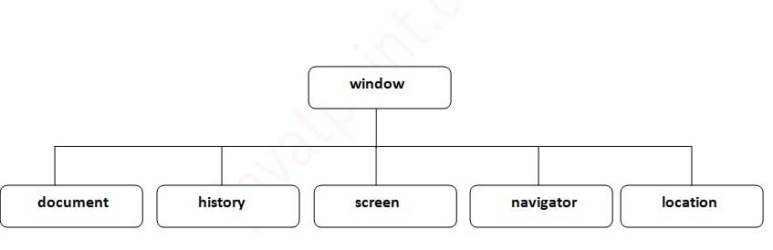

#### The document object represents an html document. It forms DOM (Document Object Model).

**Window Object:**

The windowobject represents a window in browser. An object of window is created automatically by the browser. Window is the object of browser; it is not the object of JavaScript. The JavaScript objects are string, array, date etc.

Note: If html document contains frame or iframe, browser creates additional window objects for each frame.

**Methods of window object:**

The important methods of window object are as follows:

|  |  |
| --- | --- |
| **Method** | **Description** |
| alert() | Displays the alert box containing message with ok button. |
| confirm() | Displays the confirm dialog box containing message with ok and cancel button. |
| prompt() | Displays a dialog box to get input from the user. |
| open() | Opens the new window. |
| close() | closes the current window. |
| setTimeout() | performs action after specified time like calling function, evaluating expressions etc. |