Title: Analyzing Student Financial Habits

1. Problem Statement
This project seeks to answer several key research questions:
- What are the primary drivers of student spending?
- Is there a significant difference in saving habits between students who budget and those who do not?
- Are there observable differences in spending patterns based on gender?
- Which financial variables are most strongly correlated with month-end savings?

2. Objectives
Here are the objectives for our DMA project:
- To import and clean the raw student_finance_dataset_balanced.csv file.
- To perform data preprocessing, including mean imputation for missing values, outlier removal using the IQR method, and encoding categorical variables (Gender, Budget).
- To create meaningful visualizations (histograms, scatter plots, heatmaps) that explain relationships between student income, expenses, and savings.
- To analyze how budgeting habits, monthly allowance, and discretionary spending categories (like Shopping_Expenses) influence Month_End_Leftover savings.
- To derive insights that identify the key drivers of student financial health, specifically comparing the impact of income level versus active budgeting.

3. Tools and Technologies Used
Tool / Library | Description
R Programming Language | Used for statistical analysis, data transformation, and visualization.
tidyverse (Package) | A suite of libraries used for the core analysis.
» readr | To read the student_finance_dataset_balanced.csv file efficiently.
» dplyr | For data cleaning, filtering, and creating new columns (e.g., mutate).
» tidyr | Used for reshaping data (e.g., pivot_longer) for the expense boxplot.
» ggplot2 | For creating all advanced visualizations (histograms, scatter plots, boxplots).
corrplot (Package) | To generate the correlation heatmap to visualize variable relationships.
gridExtra (Package) | For arranging the "Before vs. After" outlier plots side-by-side.
Project Repository | Contains all R code, datasets, and visualizations. Link: https://github.com/ypramod25/DMA_mini_project

4. Dataset Description
The dataset was collected through an online Google Form survey from students of various branches and years. It includes both qualitative and quantitative data about monthly income, expenditures, and saving habits of a group of students.

Final Dataset Attributes
Attribute | Description
Age | The age of the student.
Gender | The gender of the student (Male, Female).
Monthly_Allowance | The fixed amount of money the student receives, typically from parents.
PartTime_Income | Additional income earned by the student (e.g., from a job).
Food_Beverages_Expenses | Amount spent on food and drinks.
Transportation_Expenses | Amount spent on transport (bus, auto, fuel, etc.).
Entertainment_Expenses | Amount spent on movies, outings, and other leisure activities.
Academic_Resources_Expenses | Amount spent on books, stationery, and other academic needs.
Shopping_Expenses | Amount spent on clothes, gadgets, and other personal shopping.
Budget | Whether the student actively maintains a budget (Yes / No).
Month_End_Leftover | The total amount of money remaining with the student at the end of the month.
Gender_Encoded | Numeric representation of gender (e.styles, 0 = Female, 1 = Male).
Budget_Encoded | Numeric representation of budgeting habit (0 = No, 1 = Yes).

5. Data Preprocessing
The preprocessing was performed using R’s tidyverse suite, primarily the dplyr and readr libraries.
Steps Performed:
- Data Import:
  - The raw CSV file (student_finance_dataset_balanced.csv) was imported using the read_csv() function.
- Missing Value Handling:
  - Missing values (NA) found in numeric columns, such as PartTime_Income and various expense categories, were filled using the mean of their respective columns. This imputation prevents data loss during analysis.
- Outlier Removal:
  - The Interquartile Range (IQR) method was applied to key numeric columns (e.g., Monthly_Allowance) to identify and filter extreme values that could skew the analysis and visualizations.
- Data Transformation (Encoding):
  - Categorical text variables were converted into numeric codes for modeling and correlation analysis.
  - Gender ('Male'/'Female') was encoded into binary 0/1 values.
  - Budget ('Yes'/'No') was also encoded into binary 0/1 values.
- Data Transformation (Normalization):
  - To prepare the data for potential machine learning models, numerical features with different scales (like Age and Monthly_Allowance) were normalized to a common 0-1 range.
- Data Export:
  - The final cleaned datasets were exported as new CSV files for the analysis phase.

Data Preprocessing Code :

# --- 1. Import Libraries ---
library(tidyverse) # For data manipulation and plotting
library(gridExtra) # To display plots side-by-side

# --- 2. Import Dataset ---
df <- read_csv("D:\\DMA LAB\\lab project\\student_finance_dataset_balanced.csv")
head(df)
tail(df)
str(df)
# --- 3. Data Preprocessing ---

# A. Handle Missing Values (Fill with Mean)
df_clean <- df %>%
mutate(across(where(is.numeric), ~replace_na(., mean(., na.rm = TRUE))))

# --- 4. Outlier Removal with "Before vs After" Visualization ---

# Let's focus on 'Monthly_Allowance' as our target variable for this example

# PLOT 1: BEFORE Removing Outliers
plot_before <- ggplot(df_clean, aes(y = Monthly_Allowance)) +
geom_boxplot(fill = "tomato", color = "black") +
labs(title = "Before: With Outliers", y = "Monthly Allowance") +
theme_minimal()

# FUNCTION: Remove Outliers using IQR
remove_outliers <- function(x) {
Q1 <- quantile(x, 0.25)
Q3 <- quantile(x, 0.75)
IQR <- Q3 - Q1
lower <- Q1 - 1.5 * IQR
upper <- Q3 + 1.5 * IQR
return(ifelse(x < lower | x > upper, NA, x))
}

# Apply removal to the dataset
df_no_outliers <- df_clean %>%
mutate(Monthly_Allowance = remove_outliers(Monthly_Allowance)) %>%
na.omit() # Remove rows that became NA

# PLOT 2: AFTER Removing Outliers
plot_after <- ggplot(df_no_outliers, aes(y = Monthly_Allowance)) +
geom_boxplot(fill = "lightgreen", color = "black") +
labs(title = "After: Outliers Removed", y = "Monthly Allowance") +
theme_minimal()

# DISPLAY SIDE-BY-SIDE
grid.arrange(plot_before, plot_after, ncol = 2)

# --- 5. Encoding & Normalization ---

# A. Encoding Categorical Variables
# Gender: Female=0, Male=1 | Budget: No=0, Yes=1
df_final <- df_no_outliers %>%
mutate(
Gender_Encoded = ifelse(Gender == "Male", 1, 0),
Budget_Encoded = ifelse(Budget == "Yes", 1, 0)
)

# B. Normalization (Min-Max Scaling to 0-1 range)
# We apply this to Age, Income, and Expenses
normalize <- function(x) {
return ((x - min(x)) / (max(x) - min(x)))
}

df_final <- df_final %>%
mutate(across(c(Age, Monthly_Allowance, Month_End_Leftover), normalize))

# --- 6. Final Inspection ---
# View the first few rows of your fully processed data
head(df_final)
summary(df_final)

ggplot(df_clean, aes(x = Month_End_Leftover)) +
geom_histogram(binwidth = 500, fill = "cornflowerblue", color = "black") +
labs(title = "Distribution of Money Left at Month End",
x = "Amount Leftover",
y = "Count of Students") +
theme_minimal()

After Removing outliers:-

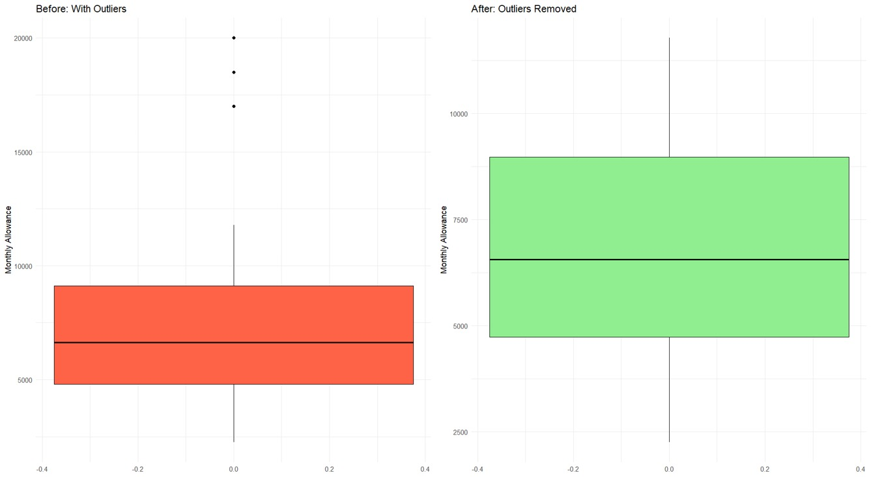

Preprocessed Data :

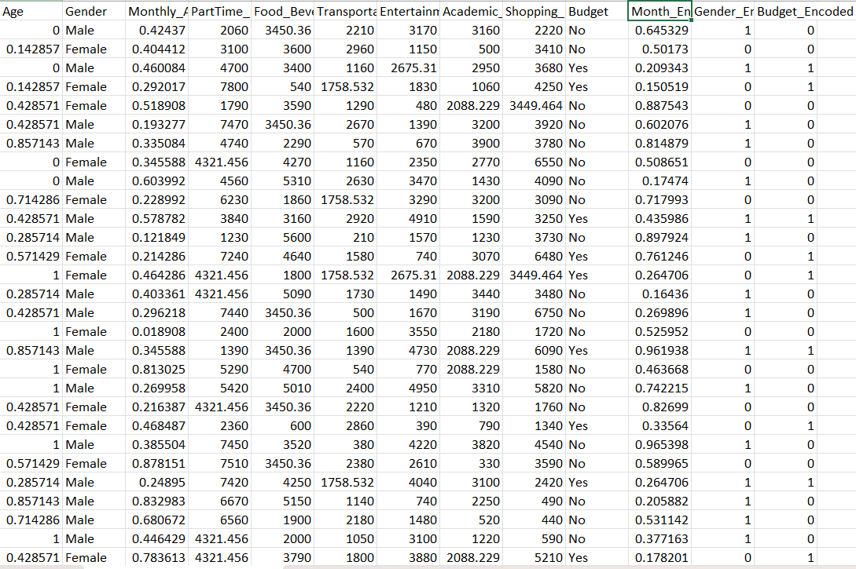

6. Visualization and Analysis
Visualization helps in understanding complex relationships between different factors affecting student finances. Four different plots were created using the ggplot2 and corrplot libraries.

Plot 1: Distribution of Student Savings
- Type: Histogram
- Description: Shows the frequency distribution of the Month_End_Leftover amount, illustrating the typical saving behavior of the student group.
- Observation:
  - The majority of students manage to save between 2,000 and 4,000 currency units by the end of the month.
  - This indicates a common savings baseline, with very few students at the extreme ends (either saving nothing or saving a very large amount).
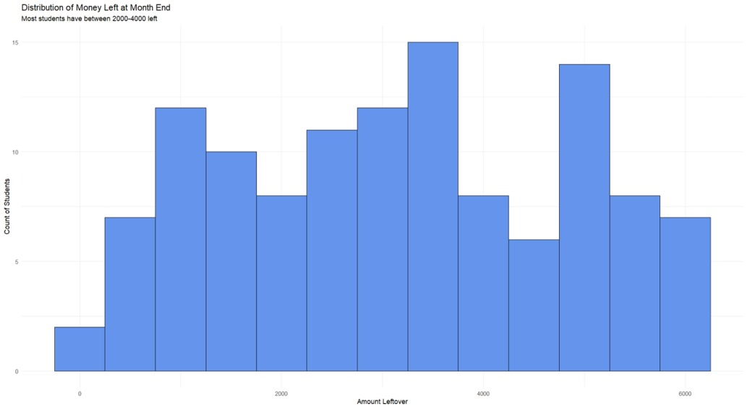

Plot 2: Impact of Budgeting on Savings
- Type: Scatter Plot (with regression lines)
- Description: Plots Monthly_Allowance (x-axis) against Month_End_Leftover (y-axis) and colors the points based on whether a student Budgets (Yes/No).
- Observation:
  - Students who actively budget (Budget = "Yes") show a stronger positive trend line.
  - This suggests that the act of budgeting itself is a more significant factor in saving money than the total allowance received.

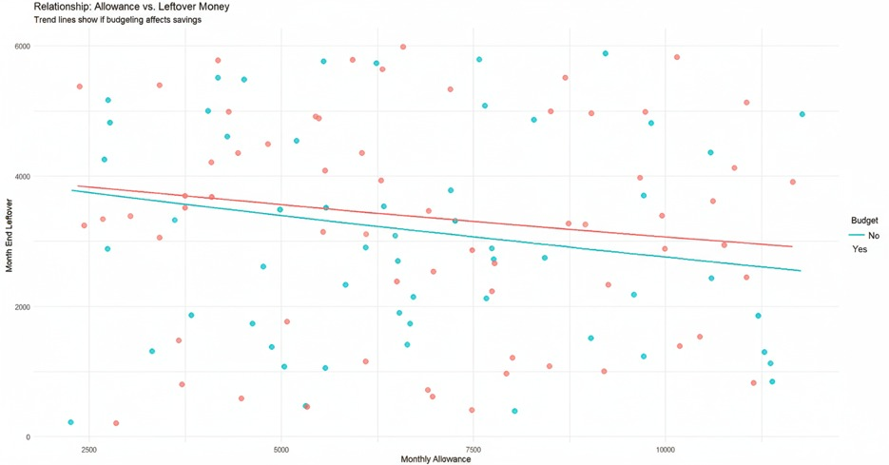

Plot 3: Spending Breakdown by Category and Gender
- Type: Boxplot
- Description: Compares the median and spread of spending across the five main expense categories (Food, Shopping, Entertainment, etc.), with data grouped by Gender.
- Observation:
  - Shopping_Expenses and Food_Beverages_Expenses are consistently the two highest categories of expenditure for students.
  - This finding pinpoints discretionary spending as a key area influencing financial outcomes.

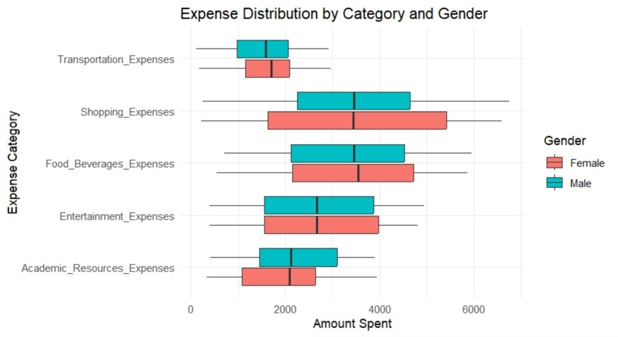

Plot 4: Correlation Analysis of Financial Variables
- Type: Correlation Heatmap
- Description: Displays a matrix of correlation coefficients (from -1 to 1) for all numeric variables, showing the strength and direction of their relationships.
- Observation:
  - Contrary to expectations, there is a very weak (near-zero) correlation between Monthly_Allowance and Month_End_Leftover (-0.08).
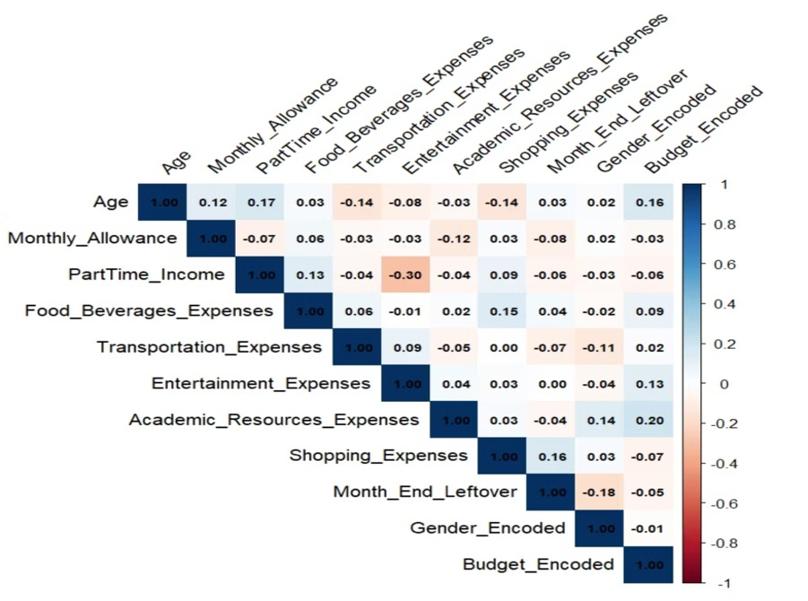

Complete R Script for the Visualization :

# A. Distribution of Month End Leftover
# (Using df_no_outliers so we see real currency amounts)
ggplot(df_no_outliers, aes(x = Month_End_Leftover)) +
geom_histogram(binwidth = 500, fill = "cornflowerblue", color = "black") +
labs(title = "Distribution of Money Left at Month End",
subtitle = "Most students have between 2000-4000 left",
x = "Amount Leftover",
y = "Count of Students") +
theme_minimal()

# B. Income vs. Leftover (colored by Budget)
# Pattern: Do students who budget save more?
ggplot(df_no_outliers, aes(x = Monthly_Allowance, y = Month_End_Leftover, color = Budget)) +
geom_point(size = 3, alpha = 0.7) +
geom_smooth(method = "lm", se = FALSE) + # Adds trend lines
labs(title = "Relationship: Allowance vs. Leftover Money",
subtitle = "Trend lines show if budgeting affects savings",
x = "Monthly Allowance",
y = "Month End Leftover") +
theme_minimal()

# C. Spending Habits by Gender (Box Plots)
# Pattern: Compare spending categories between genders
df_long <- df_no_outliers %>%
select(Gender, ends_with("Expenses")) %>%
pivot_longer(cols = -Gender, names_to = "Expense_Category", values_to = "Amount")

ggplot(df_long, aes(x = Expense_Category, y = Amount, fill = Gender)) +
geom_boxplot() +
coord_flip() + # Makes labels readable
labs(title = "Expense Distribution by Category and Gender",
x = "Expense Category",
y = "Amount Spent") +
theme_minimal()

# D. Correlation Matrix (Heatmap)
# Pattern: See which variables are linked (using df_final to include encoded cols)
num_cols <- df_final %>% select_if(is.numeric)
cor_matrix <- cor(num_cols)

corrplot(cor_matrix, method = "color", type = "upper",
tl.col = "black", tl.srt = 45, addCoef.col = "black",
number.cex = 0.7, # Make text smaller to fit
title = "Correlation Heatmap", mar=c(0,0,1,0))

# --- 8. Export Data to CSV ---

# Option A: Export the fully processed data (Normalized 0-1 values, Encoded)
# Use this if you are feeding the data into a Machine Learning model.
write_csv(df_final, "D:\\DMA LAB\\lab project\\student_finance_final_dataset.csv")

print("Files exported successfully!")

7. Results and Interpretation
After data cleaning and visualization:
- Budgeting behavior is the strongest predictor of savings. Students who actively budget show a clear and positive trend of saving more money, regardless of their income level.
- Income level (Allowance) does not guarantee savings. The analysis revealed a near-zero correlation between Monthly_Allowance and Month_End_Leftover, proving that high-income students do not necessarily save more.
- Discretionary spending is the primary drain on finances. Shopping_Expenses and Food_Beverages_Expenses were consistently identified as the two largest expense categories.
- Most students operate within a common savings range. The majority of students end the month with 2,000 to 4,000 currency units, establishing a clear baseline for typical financial health.
The analysis confirms that financial habits, particularly active budgeting and control over discretionary spending, are significantly more important for month-end savings than the amount of allowance a student receives.
.

9. Conclusion
This project successfully demonstrates how R can be used to:
- Clean raw financial data into structured, numeric datasets by handling missing values and outliers.
- Visualize complex relationships between student income, spending habits, and savings.
- Identify the strongest predictors of student financial health, such as budgeting.

