Raspberry Pi Pico Interpolator Block Diagram

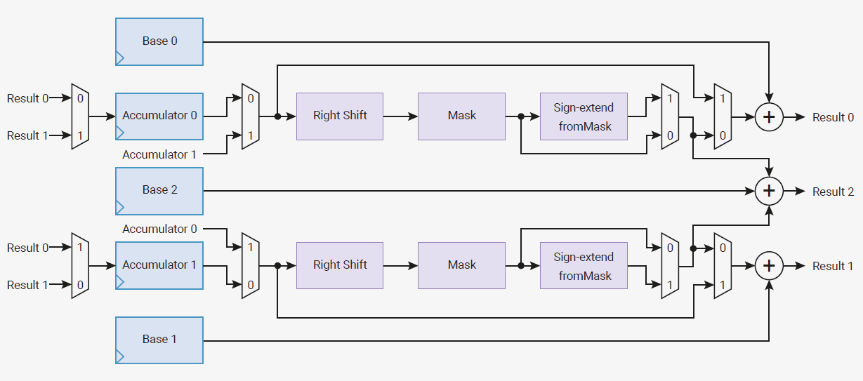

set_cross_input(bool cross_input)

set_cross_result(bool cross_result)

set_add_raw(bool add_raw)

set_signed(bool _signed)

set_shift(uint shift)

set_mask(uint mask_lsb, uint mask_msb)

base[0]

accum[0]

add_raw[1] (read)

add_raw[0] (read)

base[2]

accum[1]

base[1]

peek[0] or pop[0]

peek[1] or pop[1]

peek[2] or pop[2]

add_raw[1] (write)

add_raw[0] (write)