lEXICAL ANALYZER

**Prepared By**

Youssef Elsayed  
200036307

**Under Supervision**

Dr / Nehal A. Mohamed

Eng /Menna Sherif

**1.1 Phases of Compiler**

1. **Lexical Analyzer**: Breaks source code into tokens.
2. **Syntax Analyzer**: Checks grammar using tokens and builds a parse tree.
3. 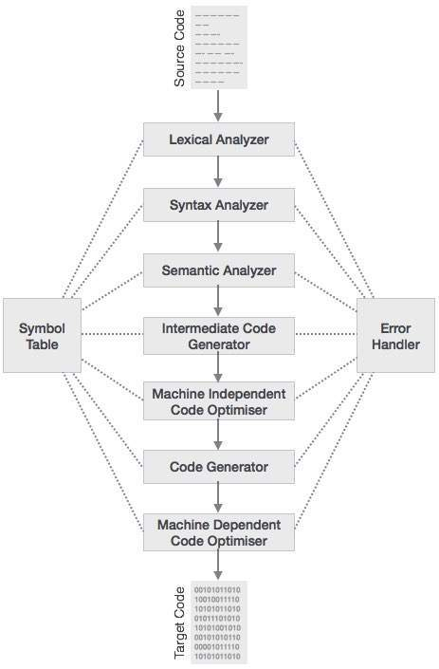**Semantic Analyzer**: Validates meaning (e.g., types, scope).
4. **Intermediate Code Generator**: Produces platform-independent code.
5. **Machine-Independent Code Optimizer**: Improves efficiency without hardware specifics.
6. **Code Generator**: Converts intermediate code to machine-dependent code.
7. **Machine-Dependent Code Optimizer**: Further optimizes for the target hardware.
8. **Target Code**: Final executable output.

**Supporting Components**:

* **Symbol Table**: Tracks identifiers and their attributes.
* **Error Handler**: Detects and reports errors at each phase.

**Key Divisions**:

* **Machine-Independent**: Phases 1–5 (work universally).
* **Machine-Dependent**: Phases 6–7 (hardware-specific).

The process transforms source code into optimized machine code systematically.

**2. Lexical Analyzer**

1. A diagram of a computer program

   AI-generated content may be incorrect.**Start: Reads first character (Letter → id, Digit → Int_Lit).**
2. **Build Token:**
   * **For id: Keeps adding letters/digits, checks symbol table (lookup).**
   * **For Int_Lit: Keeps adding digits.**
3. **Handle Unknowns: Skips invalid chars, resumes after.**
4. **Return Token: Outputs id, Int_Lit, or error.**

**Key Actions: addChar (append), getChar (next char), lookup (validate).**

**3. Software Tools**

Various software tools are used in compiler construction.

**3.1. Computer Program**

Visual Studio Code

**3.2. Programming Language**

Python

Lexical Analyzer

# Python Code

import string  
  
char_class = None  
lexeme = []  
next_char = ''  
lex_len = 0  
token = None  
next_token = None  
input_string = "(sum + 457) / total"  
input_index = 0  
  
LETTER = 0  
DIGIT = 1  
UNKNOWN = 99  
  
INT_LIT = 10  
IDENT = 11  
ASSIGN_OP = 20  
ADD_OP = 21  
SUB_OP = 22  
MULT_OP = 23  
DIV_OP = 24  
LEFT_PAREN = 25  
RIGHT_PAREN = 26  
EOF = -1  
  
def add_char():  
 global lex_len  
 if lex_len <= 98:  
 lexeme.append(next_char)  
 lex_len += 1  
 else:  
 print("Error - lexeme is too long")  
  
def get_char():  
 global next_char, char_class, input_index  
 if input_index < len(input_string):  
 next_char = input_string[input_index]  
 input_index += 1  
 else:  
 next_char = ''  
 if next_char == '':  
 char_class = EOF  
 elif next_char.isalpha():  
 char_class = LETTER  
 elif next_char.isdigit():  
 char_class = DIGIT  
 else:  
 char_class = UNKNOWN  
  
def get_non_blank():  
 while next_char.isspace():  
 get_char()  
  
def lookup(ch):  
 global next_token  
 if ch == '(':  
 add_char()  
 next_token = LEFT_PAREN  
 elif ch == ')':  
 add_char()  
 next_token = RIGHT_PAREN  
 elif ch == '+':  
 add_char()  
 next_token = ADD_OP  
 elif ch == '-':  
 add_char()  
 next_token = SUB_OP  
 elif ch == '*':  
 add_char()  
 next_token = MULT_OP  
 elif ch == '/':  
 add_char()  
 next_token = DIV_OP  
 else:  
 add_char()  
 next_token = EOF  
 return next_token  
  
def lex():  
 global lex_len, next_token  
 lex_len = 0  
 get_non_blank()  
 if char_class == LETTER:  
 add_char()  
 get_char()  
 while char_class == LETTER or char_class == DIGIT:  
 add_char()  
 get_char()  
 next_token = IDENT  
 elif char_class == DIGIT:  
 add_char()  
 get_char()  
 while char_class == DIGIT:  
 add_char()  
 get_char()  
 next_token = INT_LIT  
 elif char_class == UNKNOWN:  
 lookup(next_char)  
 get_char()  
 elif char_class == EOF:  
 next_token = EOF  
 lexeme.extend(['E', 'O', 'F'])  
 print(f"Next token is: {next_token}, Next lexeme is {''.join(lexeme)}")  
 return next_token  
  
def main():  
 get_char()  
 while next_token != EOF:  
 lex()  
  
if __name__ == "__main__":  
 main()

# Explanation of Code

Lexical Analyzer Code Explanation

# Token Classes

LETTER = 0 # Represents alphabetic characters (A-Z, a-z)

DIGIT = 1 # Represents numeric characters (0–9)

UNKNOWN = 99 # Represents unknown characters (e.g., +, -, /, etc.)

EOF = -1 # End of input

# Token Types

INT_LITERAL = 10 # Integer literal (like 457)

IDENTIFIER = 11 # Identifiers (like variable names: result, total)

ASSIGN_OP = 20 # Assignment operator (=), not used here but can be added

ADD_OP = 21 # Addition operator (+)

SUB_OP = 22 # Subtraction operator (-)

MULT_OP = 23 # Multiplication operator (*)

DIV_OP = 24 # Division operator (/)

LEFT_PAREN = 25 # Left parenthesis '('

RIGHT_PAREN = 26 # Right parenthesis ')'

# Global State

char_class = None # The type of the current character (letter, digit, etc.)

current_lexeme = [] # Stores the current sequence of characters (like a word or number)

current_char = '' # The current character being analyzed

current_token = None # The token type identified from the input

input_string = "(result + 457) / total" # The string to be tokenized

input_index = 0 # Index to keep track of position in the input string

def add_char():

# Adds the current character to the lexeme list

current_lexeme.append(current_char)

def get_char():

# Gets the next character from input and determines its class

if input_index < len(input_string):

current_char = input_string[input_index]

input_index += 1

if current_char.isalpha():

char_class = LETTER

elif current_char.isdigit():

char_class = DIGIT

else:

char_class = UNKNOWN

else:

current_char = ''

char_class = EOF

def skip_whitespace():

# Skips any space characters between tokens

while current_char.isspace():

get_char()

def lookup_operator(char):

# Determines the token type for operators or parentheses

if char == '(':

add_char()

current_token = LEFT_PAREN

elif char == ')':

add_char()

current_token = RIGHT_PAREN

elif char == '+':

add_char()

current_token = ADD_OP

elif char == '-':

add_char()

current_token = SUB_OP

elif char == '*':

add_char()

current_token = MULT_OP

elif char == '/':

add_char()

current_token = DIV_OP

else:

add_char()

current_token = EOF

return current_token

def lexer():

# Main lexical analyzer function

current_lexeme = []

skip_whitespace()

if char_class == LETTER:

add_char()

get_char()

while char_class in (LETTER, DIGIT):

add_char()

get_char()

current_token = IDENTIFIER

elif char_class == DIGIT:

add_char()

get_char()

while char_class == DIGIT:

add_char()

get_char()

current_token = INT_LITERAL

elif char_class == UNKNOWN:

lookup_operator(current_char)

get_char()

elif char_class == EOF:

current_token = EOF

current_lexeme = ['E', 'O', 'F']

print(f"Next token is: {current_token}, Next lexeme is {''.join(current_lexeme)}")

return current_token

def main():

get_char()

while True:

current_token = lexer()

if current_token == EOF:

break

if __name__ == "__main__":

main()

# References

1. Parr, T. (2022). Language Implementation Patterns: Create Your Own Domain-Specific and General Programming Languages with Python.
2. Parsons, D. (2021). Introduction to Compiler Design.