FINAL PROJECT REPORT
SmartFlow: Adaptive Traffic Signal Control with Reinforcement Learning
Preserving the single-intersection presentation experiment and extending it with a coordinated corridor experiment
Course Project | Group 19 | Final Deliverable
Main Body | 3 pages | References + Appendix after page 3

1. Motivation and Original MDP Formulation
Urban congestion is a sequential decision-making problem under stochastic arrivals. Traditional fixed-cycle traffic signals cannot respond to changing queues, while reinforcement learning (RL) can learn policies that trade immediate queue clearance against future congestion. This report preserves the original Group 19 single-intersection experiment and adds a coordinated two-intersection extension to test when RL becomes more valuable than simple heuristics.
The original presentation models one signalized intersection as a Markov Decision Process with state S = (Q_NS, Q_EW, Phase). Queue lengths are discretized into Low (0-3), Medium (4-8), and High (9+) buckets. The action set is {Stay, Switch}. The reward is R = -(Q_NS + Q_EW) - C, where C is a small switching penalty that discourages unsafe high-frequency oscillation.
Algorithms compared: Q-Learning, SARSA, Monte Carlo, static fixed-cycle control, greedy longest-queue control, and a Value Iteration optimal reference.

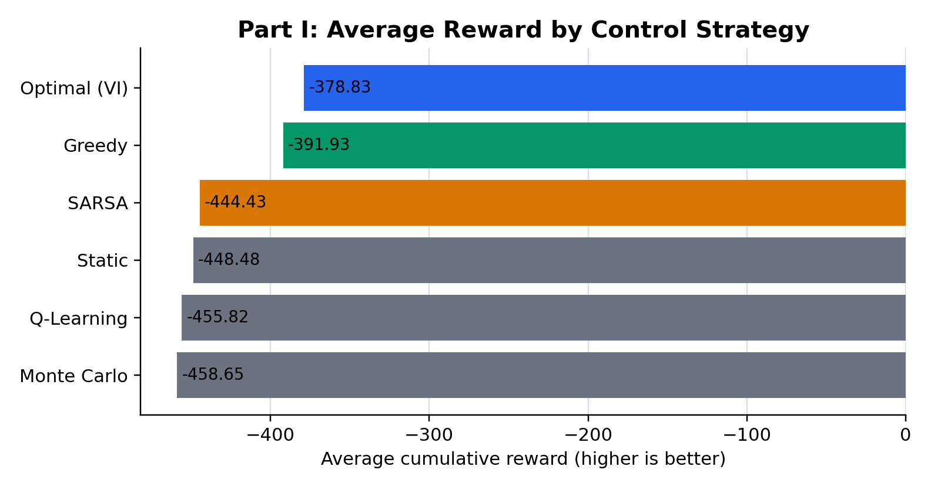
Figure 1. Slide-exact average reward comparison for the single-intersection experiment.

2. Preserved Part I Results
The Part I values below are preserved exactly from the presentation's Experiment Results slide. Higher reward is better because the reward function penalizes waiting queues.
Approach | Avg. Reward | Execution Time
Optimal (VI) | -378.83 | 0.24s
Greedy | -391.93 | 0.22s
SARSA | -444.43 | 0.85s
Static | -448.48 | 0.20s
Q-Learning | -455.82 | 1.16s
Monte Carlo | -458.65 | 5.81s

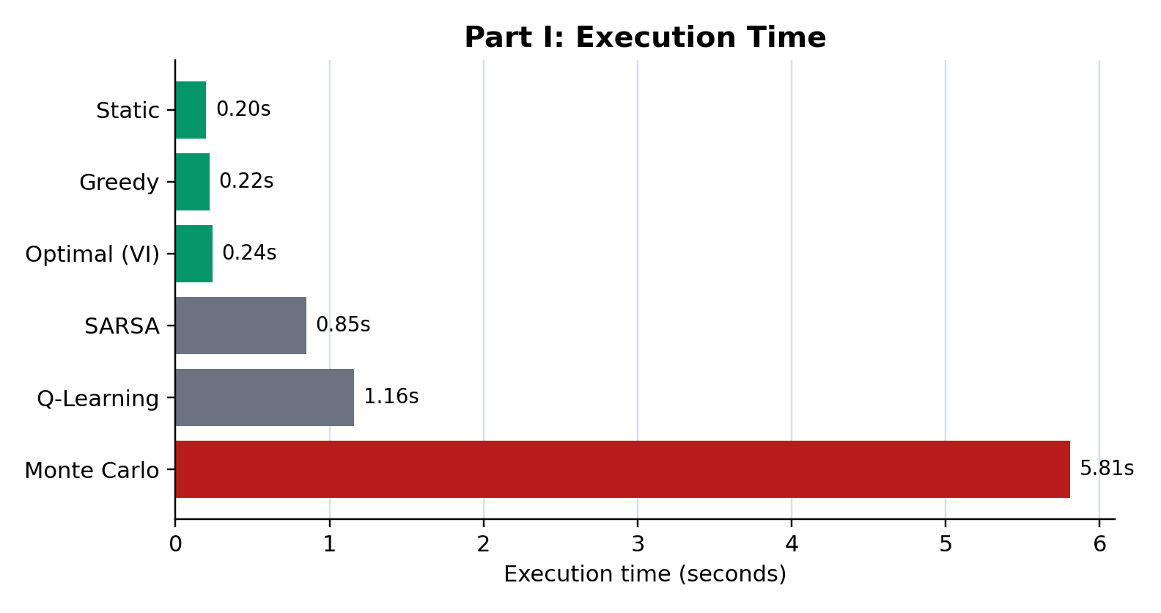
Figure 2. Execution-time comparison from the preserved presentation results.
In the simple single-intersection setting, SARSA slightly outperforms static timing, validating that reinforcement learning can learn useful adaptive policies. However, the greedy heuristic still performs strongly because the environment is simple and the heuristic has direct access to exact current queue information.
This result should be interpreted as a benchmark limitation rather than a failure of RL. The test is local, two-phase, and fully observable to the heuristic. A richer networked experiment is needed to examine delayed interactions and coordination effects.

3. Extension: Coordinated Two-Intersection Corridor
The extension adds a corridor with Intersection A upstream of Intersection B. Vehicles released from A arrive at B after a four-step delay, traffic demand changes by regime, and both signals must coordinate phases. The DQN observes queue buckets at both intersections, both phases, in-transit vehicles, and the demand regime. Static timing alternates on a fixed cycle, while greedy control serves only the largest current local queue.
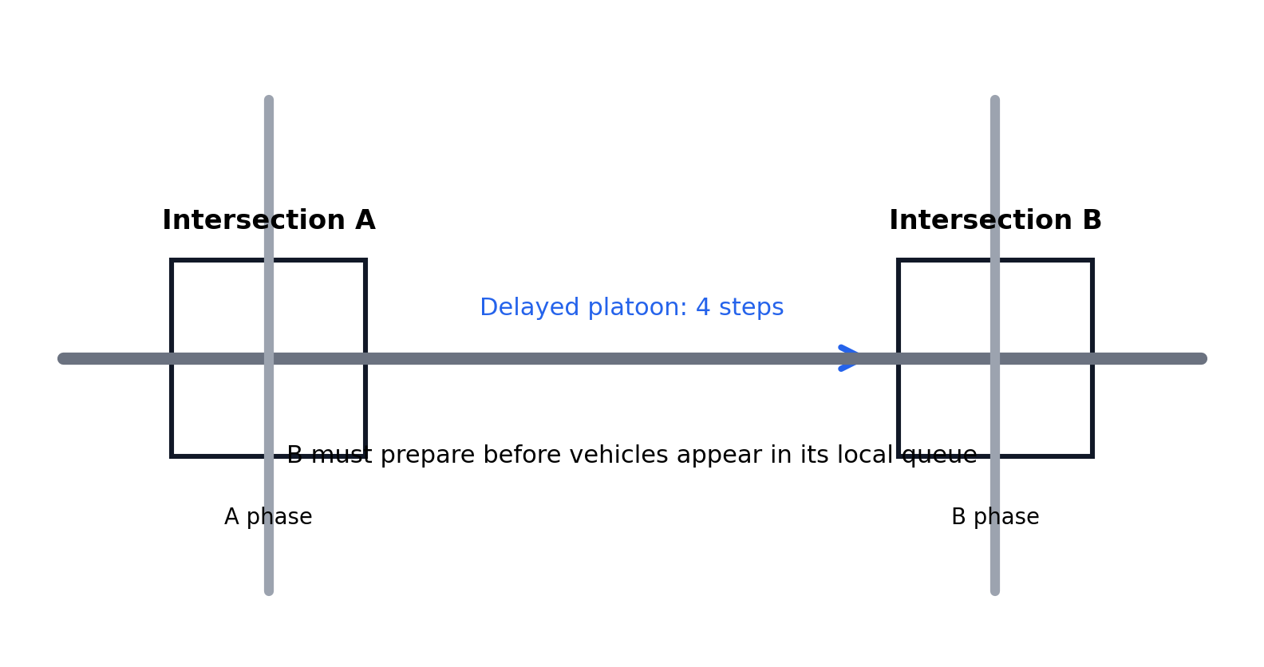
Figure 3. Coordinated corridor with delayed upstream-to-downstream platoons.
Approach | Reward | Avg. Queue | Avg. Delay | Switches
DQN RL | -6352.98 | 41.75 | 41.75 | 66.55
Static | -13452.73 | 78.96 | 81.50 | 28.00
Greedy | -17328.68 | 99.41 | 102.29 | 181.18
Threshold | -17546.14 | 101.53 | 104.56 | 70.49

DQN achieves the highest reward and lowest average delay. Greedy clears visible queues aggressively, but its reactive switching creates downstream congestion and high delay. The extension therefore supports the refined conclusion: RL does not universally beat every traffic rule, but its advantage becomes clearer when traffic systems contain delayed interactions and coordination requirements.
Future work should expand this approach toward continuous-state deep RL, larger multi-agent road networks, richer sensing, and safety constraints suitable for real traffic infrastructure.

References
Sutton, R. S., and Barto, A. G. (2018). Reinforcement Learning: An Introduction. MIT Press.
Watkins, C. J. C. H., and Dayan, P. (1992). Q-learning. Machine Learning, 8, 279-292.
Rummery, G. A., and Niranjan, M. (1994). On-line Q-learning using connectionist systems. Cambridge University Engineering Department.
Mnih, V. et al. (2015). Human-level control through deep reinforcement learning. Nature, 518, 529-533.
Wei, H. et al. (2019). PressLight: Learning max pressure control to coordinate traffic signals in arterial network. KDD, 1290-1298.

Appendix: Reproducibility Notes
Part I figures are generated from the slide-exact CSV file at experiments/simple_intersection/presentation_results.csv. The original stochastic single-intersection simulator remains in efficiency_experiment.py for reproducibility, but the final report preserves the presentation values exactly.
Part II uses a DQN with experience replay, a target network, epsilon-greedy exploration, and fixed evaluation seeds. Evaluation compares DQN RL against static fixed timing, local greedy control, and threshold switching.
Parameter | Value
Training episodes | 180
Horizon | 180 steps
Discount factor | 0.96
Learning rate | 0.001
Replay buffer | 20,000 transitions
Evaluation episodes | 80

