**Specification**

1. Overview

The car which is driven by Ardunio can pass through a 3X3 simple maze, scan and take pictures of the "treasure" at the end of the maze with the camera, transfer the video and photos to the device connected to the WiFi (PC, cell phone, etc.) via WiFi, and then exit the maze.

1. Appearance

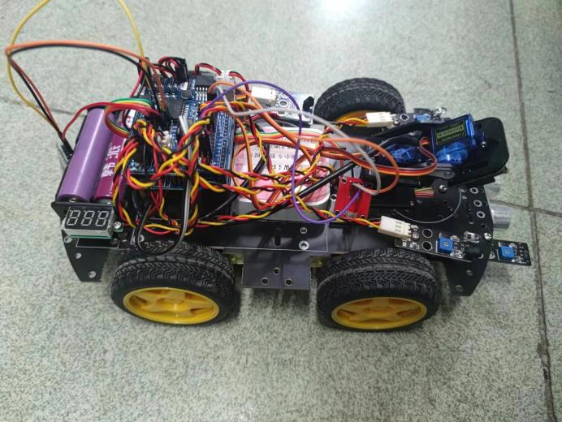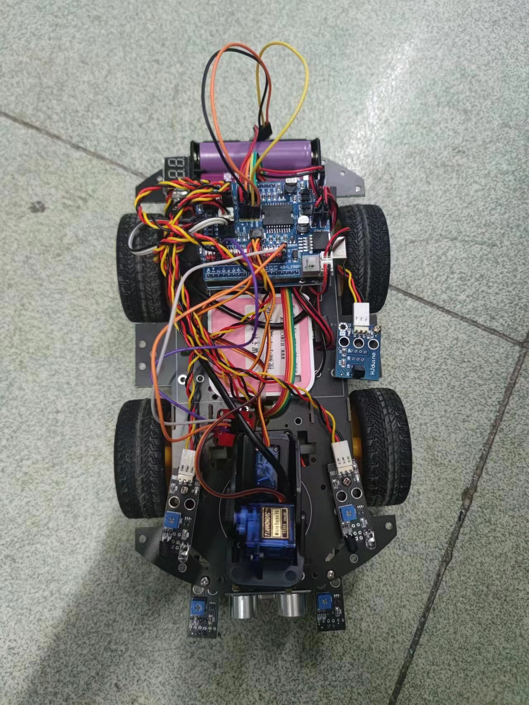

The front of this car is equipped with an ultrasonic sensor and two infrared sensors to detect obstacles. A camera with a steering gear is installed on the front side of the motherboard, and the pink box in the middle is our WiFi module. There is also a connected infrared receiver next to it, which can control the car through an infrared remote control. The rear end is the Ardunio board and power battery.

1. Hardware Components

①Mainboard: Arduino Uno R3

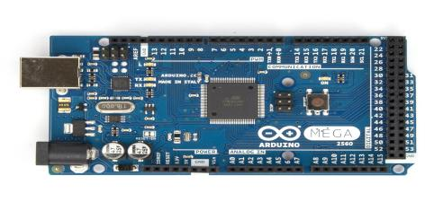

②Motor driver chip (L298N, TB6612FNG, etc) to control motors

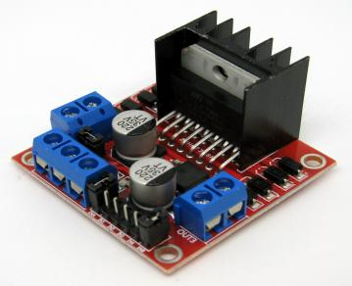

③2 DC motors with wheels and tires/tracks for locomotion

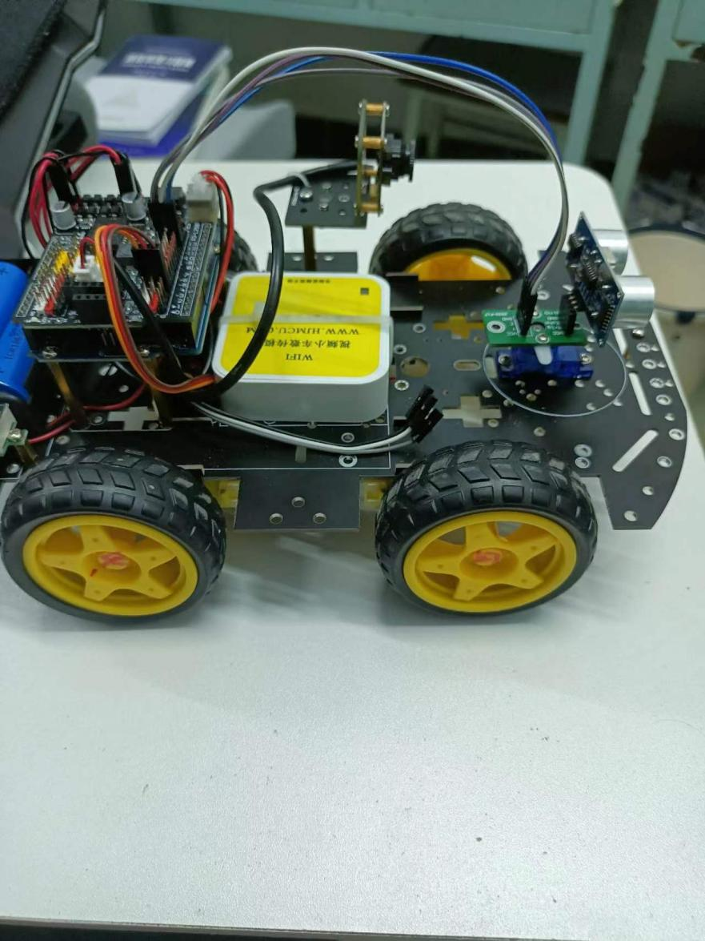

④1 Ultrasonic to detect line

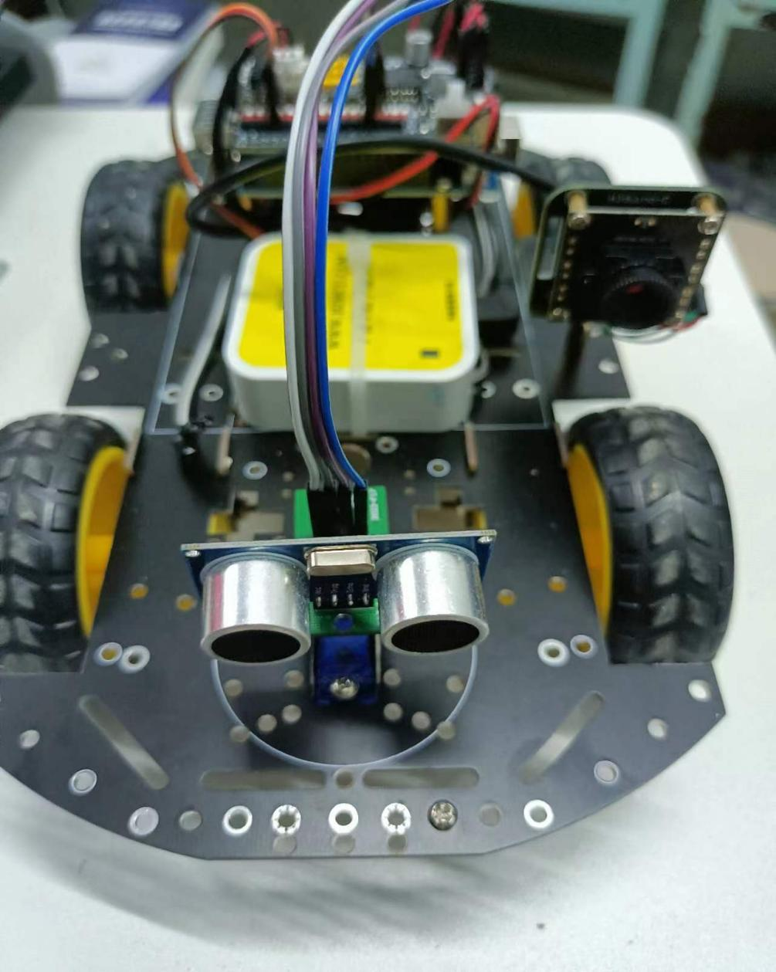

⑤Power source 2*3.7 volt-ampere battery pack

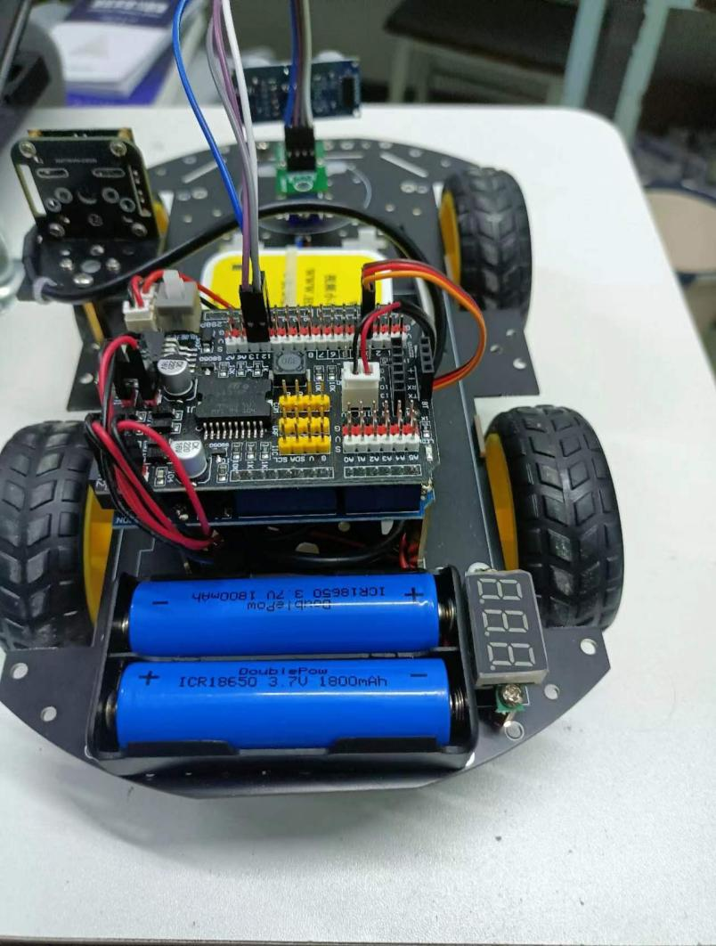

⑥front camera model GC0308 HBVCAN-W2312 V11

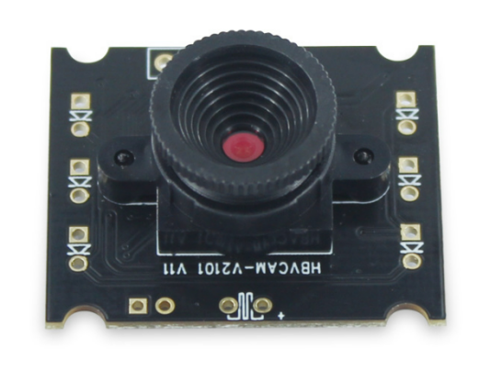

⑦WiFi module for uploading information

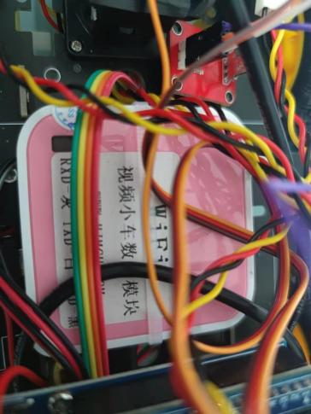

⑧Infrared receiving module

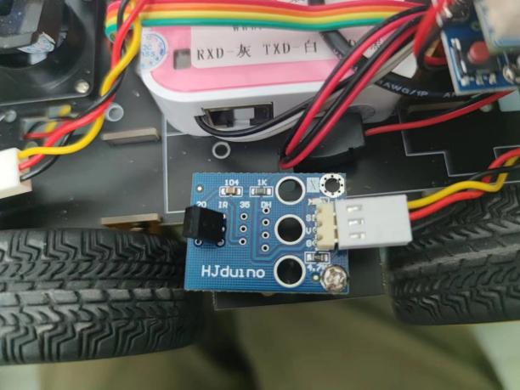

⑨Bluetooth module

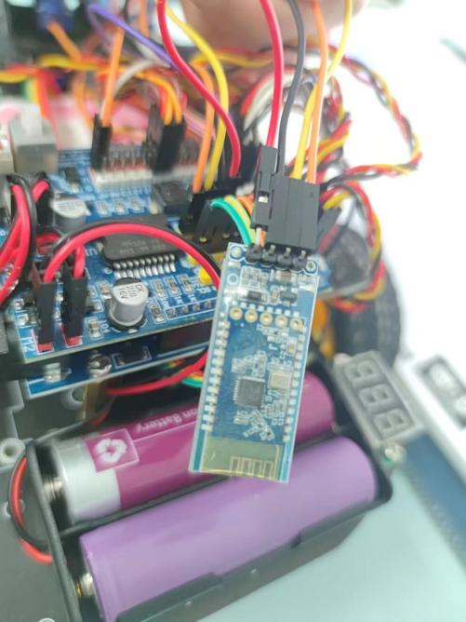

1. Operation method
2. walk the maze:

Press the white button next to the arduino board to start the car. Wait for the WiFi module to start and connect to the computer. At this point, the camera can start and the car can also transmit real-time images. The car can automatically avoid obstacles and find a suitable path through ultrasonic and infrared detection components, and walk in the maze.After traveling to the end of the labyrinth, the car backs up for a long distance, and then the servo turns continuously at a small angle to scan ahead and capture the "treasure". After shooting, the car turns around and exit the maze.

1. WiFi Module:

Power the module with rechargeable battery to make it start, after starting, it sends out WiFi signals, connecting to the WiFi can open its corresponding program, which has a video link. After the computer or cell phone is connected to the WiFi, use the browser to open the link to see the real-time picture of the car camera.

1. Bluetooth module:

connected to the microcontroller, it sends the real-time status information of the cart to the device connected to Bluetooth through Bluetooth signal, so that other users and devices can grasp the status of the cart in real time.

1. Infrared remote control module:

Since the infrared remote control module can receive infrared remote control signals, we can program different infrared signals into different remote control commands to operate the car using the remote control