**实验报告一**

姓名：叶倩琳

班级：软工1706班

学号：201706061330

提交日期：2019年12月6日

**【实验结果】**

**Lab 1**

1.

(i) uname （OutPut:Linux)

(ii) logname

(iii) hostname （OutPut:DESKTOP-TRMDDFQ）

2.

who

whoami （OutPut:yql)

3.

(i) cal jan 2000

(ii)cal feb 1999

(iii)cal sep 7

(iv)cal

(v) date ‘+%d/%m/%y’(Output:01/12/19)

4.

date ‘+24Hour:%H:%M:%S 12Hour:%l:%M:%S’

(24Hour:21:21:44 12Hour: 9:21:44

%R：显示小时分钟（格式：小时:分钟）

%H%k：小时（24小时制）

%I：小时（12小时制）)

5.

date '+currentdate:%D %ncurrenttime:%T'

(OutPut:currentdate:12/01/19

currenttime:21:28:19)

banner –w “good morning”

(OutPut:GOOD MORNING)

7. pwd (OutPut:/home/yql)

8. mkdir SAMPLE

9.

cd SAMPLE

mkdir TRIAL

10. cd SAMPLE

11. cd

12.

cd SAMPLE/TRIAL (relative path)

cd /home/yql/SAMPLE/TRIAL (absolute path)

13.

cd

cd SAMPLE

rmdir TRIAL

14. mkdir /home/yql/SAMPLE/TEST (absolute path)

15. cd/SAMPLE/TEST

16. rmdir /home/yql/SAMPLE/TEST (absolute path)

17.

cat>myfile

This is myfile

^d

cat >yourfile

This is yourfile

^d

18.

cat myfile (Output:This is myfile)

cat yourfile (Output:This is yourfile)

19.

cat >> myfile

Add

^d

(Output:This is myfileAdd)

cat>>yourfile

Append

^d

(Output:This is yourfileAppend)

20.

cat>.hide

hidden

^d

21. cp myfile emp

22. ln yourfile aliasname

23. mv yourfile dept

24. cp emp dept ../TRIAL

25. diff yourfile yourfile

(if there is no difference no output)

26. cmp myfile emp

27.

cd SAMPLE/TRIAL

cat>>emp

28. cmp employee emp

29. diff employee emp

30. rm *

31.

cd ../

rm –r TRIAL

32. undelete (SCO)

33.

mv TRIAL DATA

或rename TRIAL DATA

34. cp DATA TRIAL

35.

cd SAMPLE/TRIAL

cat>dummy

ln dummy star

36. ln –s /home/yql/SAMPLE/TRIAL/dummy /home/yql/SAMPLE/DATA/power

**Lab 2**

1. echo “Hello Welcome to shell Programming”

2. read

3. export

4. expr

expr 10 + 10 (Output:20)

5.

x=’date’

echo$x

**Lab 3**

1.

vi lab3.sh

i(插入)

# vi menu

echo “Choose option between 1-4 to execute commands:”

read choice

case $choice in

1)ls -l;;

2)ps;;

3)date;;

4)exit;;

*)echo “Wrong input,please choose option between 1-4:”

break;;

esac

#sh menu

bash lab3.sh

Choose option between 1-4 to execute commands:

1

total 0

drwxrwxrwx 1 yql yql 512 Dec 3 22:21 SAMPLE

-rw-rw-rw- 1 yql yql 5 Dec 5 23:31 a.txt

-rw-rw-rw- 1 yql yql 220 Dec 6 08:50 lab3.sh

-rw-rw-rw- 1 yql yql 54 Dec 2 15:12 myfile

-rw-rw-rw- 1 yql yql 10 Dec 5 23:38 sfile.txt

-rw-rw-rw- 1 yql yql 22 Dec 2 15:19 yourfile

bash lab3.sh

Choose option between 1-4 to execute commands:

2

PID TTY TIME CMD

4 tty1 00:00:00 bash

108 tty1 00:00:00 bash

109 tty1 00:00:00 ps

bash lab3.sh

Choose option between 1-4 to execute commands:

3

Fri Dec 6 08:54:03 DST 2019

bash lab3.sh

Choose option between 1-4 to execute commands:

4

2.

vi testFile.sh

i

# vi exist

echo “Please enter the filename:”

read fname

if [-f $fname -a -r $fname -a -w $fname -a -e $fname]

then

echo “$fname is exist,readable,writable and executable.”

else

echo “Sorry,$fname is not exist.”

fi

# sh exist

bash testFile.sh

Please enter the filename:

a.txt

a.txt is exist,readable,writable and executable.

bash testFile.sh

Please enter the filename:

aaa.txt

Sorry,aaa.txt is not exist.

3.

vi testCopy.sh

i

#vi copy

sfile=$1

tfile=$2

if [ $# -eq 2 ]

then

cp $sfile $tfile

else

echo “Usage: copy source-file target-file”

fi

# sh copy

bash testCopy.sh

Usage: copy source-file target-file

# sh copy a.txt a_copy.txt

ls

SAMPLE a.txt lab3.sh myfile sfile.txt testCopy.sh testFile.sh yourfile

bash testCopy.sh a.txt a_copy.txt

ls

SAMPLE a.txt a_copy.txt lab3.sh myfile sfile.txt testCopy.sh testFile.sh yourfile

4.

# vi lowerToUpper

echo "Enter the file name to convert all lowercase letters to uppercase letter:"

read fname

if [ -f $fname ]

then

echo $fanme"file exist."

echo

cat $fname | tr "[a-z]" "[A-Z]" >b.txt

(或tr "[a-z]" "[A-Z]" <$fname >b.txt)

else

echo $fanme"file not exist."

fi

# sh lowerToUpper

cat a.txt

aaa

vi lowerToUpper.sh

bash lowerToUpper.sh

Enter the file name to convert all lowercase letters to uppercase letter:

a.txt

file exist.

cat b.txt

AAA

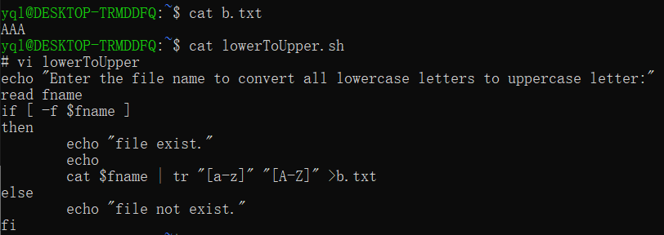

5.

# cat>database

Murali:chennai:tamilnadu:India

Sivam:wasington:Washington:usa

Natty:gobi:tamilnadu:India

# vi testSort

vi testSort.sh

echo "Enter the filename to sort:"

read fname

if [ -f $fname ]

then

echo "Enter the primary field key to sort:[field number]"

read key1

echo "Enter the secondary field key to sort: [field number]"

read key2

echo "$fname exists."

cut -d":" -f$key1,$key2 $fname|sort

else

echo "$fname is not exist."

fi

# sh testSort success

bash testSort.sh

Enter the filename to sort:

database

Enter the primary field key to sort:[field number]

2

Enter the secondary field key to sort: [field number]

4

database exists.

chennai:India

gobi:India

wasington:usa

# sh testSort false

bash testSort.sh

Enter the filename to sort:

none.txt

none.txt is not exist.

