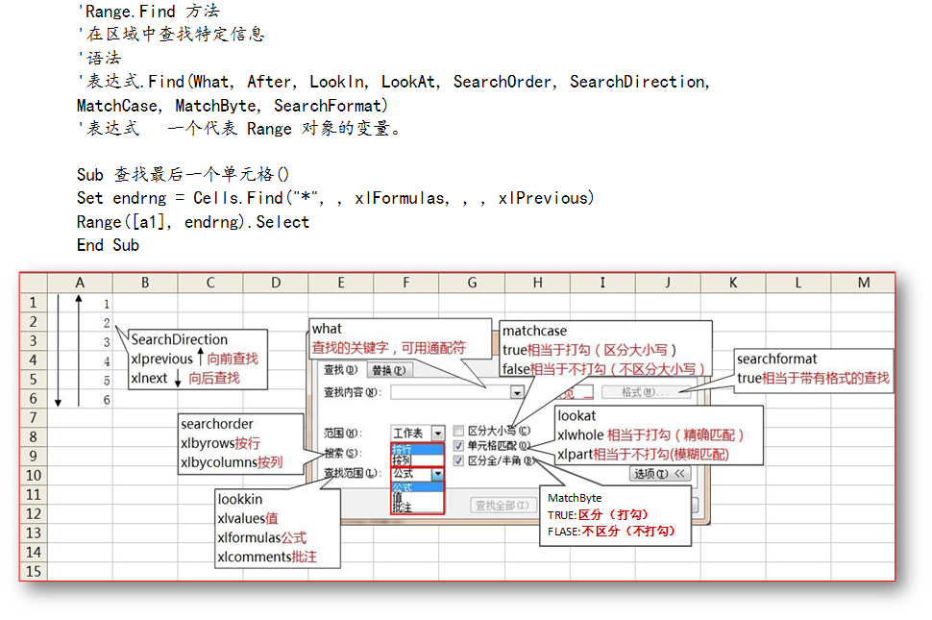

Sub 查询系统()

ends = Columns(1).Find("*", , , , , searchdirection:=xlPrevious).Row '动态找到A列的最后一个单元格

Range("g3:l999").Clear '清除之前所有的筛选结果

For Each rng In Range("a2:a" & ends)

m = m + 1

If rng Like Range("h1") Then '如果条件成立，那么

k = k + 1

Range("a" & m + 1 & ":e" & m + 1).Copy Range("g" & k + 2) '将记录复制到另一个区域

End If

Next

End Sub

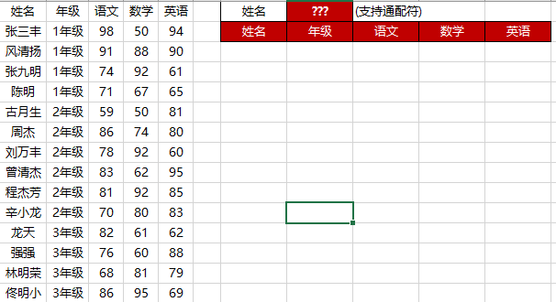

**备注：find好像不是函数，并且columns后find没有成员提示。**

**但是range，cells后find有成员提示。**

Sub 开单()

Set es = Cells.Find("*", , xlFormulas, , , xlPrevious)

a = es.Address

[b2] = "SM" & Format(Now(), "ymdhms")

Range([a5], es.Offset(4)) = ""

[e2] = ""

End Sub

Sub 保存()

On Error GoTo 100

Dim es As Range, a%

If Sheet2.[f:f].Find([b2]) = [b2] Then

MsgBox "已经保存过了!"

Else

100:

Set es = Cells.Find("*", , xlFormulas, , , xlPrevious)

a = Application.CountA(Sheet2.[a:a])

If es.Row = 4 Then MsgBox "没有填写内容": End

Range([a5], es).Copy Sheet2.Cells(a + 1, 1)

Sheet2.Cells(a + 1, "f").Resize(es.Row - 4) = [b2] '保存入库单

Sheet2.Cells(a + 1, "g").Resize(es.Row - 4) = [e2] '保存供应商

Sheet2.Cells(a + 1, "h").Resize(es.Row - 4) = Now() '保存日期时间

MsgBox "保存成功!"

End If

End Sub

Sub 计算()

Set es = Columns(3).Find("*", , xlFormulas, , , xlPrevious)

For Each Rng In Range([c5], es)

Rng.Offset(0, 2) = Rng.Offset(0, 1) * Rng

Next

End Sub