'like:用来比较两个字符串，返回值是逻辑值true或false

'语法结构：result = string Like pattern

'

' pattern 中的字符 符合 string 中的

' ？ 任何单一字符

' * 零个或多个字符。

' # 任何一个数字 (0–9)。

' [charlist] charlist.中的任何单一字符

' [!charlist] 不在 charlist 中的任何单一字符。

Sub test()

Dim re

're = "w4" Like "w[!0-5]"

're = 23 Like "*2*"

re = "wB" Like "w[0-589a-zA-Z]" '0-5之间的数字，89为单个数字：8和9，小写a-z，大写A-Z

End Sub

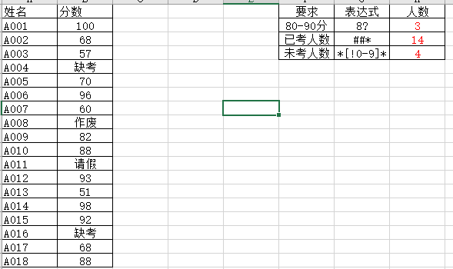

Sub test()

Dim tiaojian As Range, rng As Range, n%

For Each tiaojian In [g2:g4]

For Each rng In [b2:b19]

If rng.Value Like tiaojian.Value Then n = n + 1

Next rng

tiaojian(1, 2) = n

n = 0

Next tiaojian

End Sub

为什么不能用if elseif判断的话，会出现有些满足第一个条件的情况下，就直接跳过第二个判断了，所以得出来的结果会比实际多少。

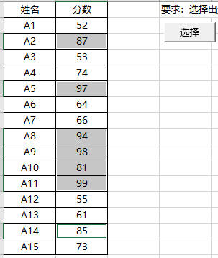

Sub test2()

Dim rng As range, rngs As range

For Each rng In [b2:b16]

If rng.Value >= 80 Then

If rngs Is Nothing Then

Set rngs = rng

Else

Set rngs = Union(rngs, rng)

End If

End If

Next

rngs.Select

End Sub

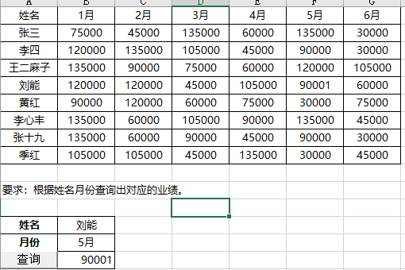

Sub test()方法一

Dim rng1 As Range, rng2 As Range

Dim rws As Range, cols As Range

For Each rng1 In [a2:a9]

If rng1.Value = [b13].Value Then

Set rws = rng1.EntireRow

Exit For

End If

Next

For Each rng2 In [b1:g1]

If rng2.Value = [b14].Value Then

Set cols = rng2.EntireColumn

Exit For

End If

Next

[b15] = Intersect(rws, cols).Value

End Sub

Sub shl()方法二

Dim rng1 As Range, rng2 As Range, rng As Range

Set rng1 = Range("a2:a9").Find([b13])

Set rng2 = Range("b1:g1").Find([b14])

Set rng1s = rng1.Resize(1, 7)

Set rng2s = rng2.Resize(9, 1)

Set rng = Intersect(rng1s, rng2s)

[b15] = rng

End Sub

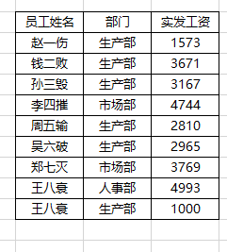

Sub test()

Dim rng As Range, n%, num%

For Each rng In Intersect(Range("b3").CurrentRegion, [c:c])

If rng.Value = "生产部" Then

n = n + 1

num = num + rng(1, 2).Value

End If

Next

MsgBox "生产部的平均工资是：" & num / n

End Sub

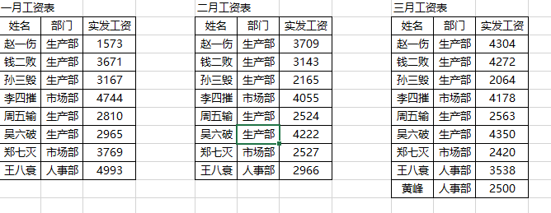

Sub demo()

Dim rngs As Range, rng As Range, num

Set rngs = ActiveSheet.UsedRange

For Each rng In Union(Intersect(rngs, [c:c]), Intersect(rngs, [g:g]), Intersect(rngs, [k:k]))

num = num + Val(rng.Value)

Next

MsgBox num

End Sub

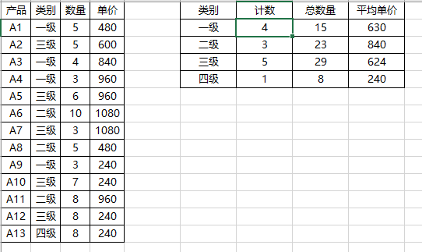

Sub shl()

Dim rng As Range

For Each rng In Range("f11:f14")

rng(1, 2) = Application.WorksheetFunction.CountIf(Range("b:b"), rng.Value)

rng(1, 3) = Application.WorksheetFunction.SumIf(Range("b:b"), rng.Value, Range("c:c"))

rng(1, 4) = Application.WorksheetFunction.AverageIf(Range("b:b"), rng.Value, Range("d:d"))

Next rng

End Sub

在循环单元格上移的过程中，需要注意同行中先上移同行其他单元格，最后上移本身，如先rng(1,2).delete(xlshiftup)

最后rng.delete(xlshiftup)

Private Sub Constant_demo_Click()  
 d = ("2018-08-15 20:25")  
 msgbox("Line 1 : " & FormatDateTime(d))  
 msgbox("Line 2 : " & FormatDateTime(d,1))  
 msgbox("Line 3 : " & FormatDateTime(d,2))  
 msgbox("Line 4 : " & FormatDateTime(d,3))  
 msgbox("Line 5 : " & FormatDateTime(d,4))  
End Sub

Line 1 : 15/08/2018 8:25:00 PM

Line 2 : Thursday, 15 August 2018

Line 3 : 15/08/2018

Line 4 : 8:25:00 PM

Line 5 : 20:25