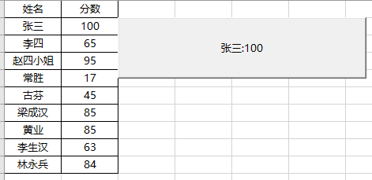

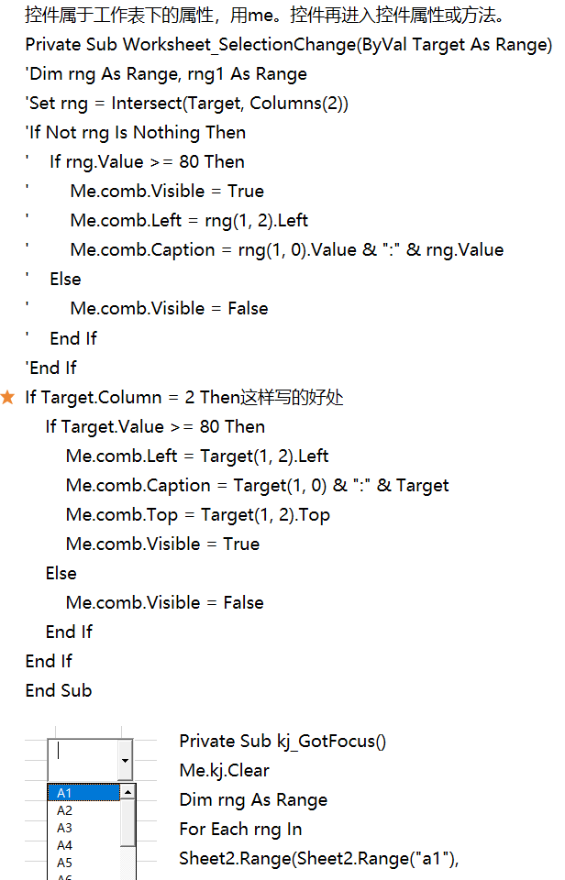  
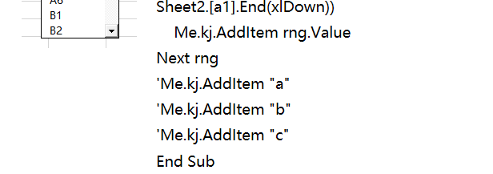

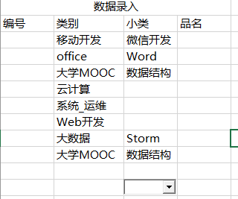

Private Sub Worksheet_SelectionChange(ByVal Target As Range)

Dim rng As Range, rng1 As Range

With Me.大类

If Target.Column = 2 Then

.Visible = True

.Top = Target.Top

.Left = Target.Left

.Width = Target.Width

.Height = Target.Height

For Each rng In Sheet2.Range("a1", Sheet2.Range("a1").End(xlToRight))

.AddItem rng.Value

Next

Else

.Visible = False

End If

End With

If Target.Column = 3 Then

Set rng1 = Sheet2.Range("1:1").Find(Target.Offset(0, -1).Value)

Me.小类.ListFillRange = "Sheet2!" & Range(rng1.Offset(1, 0).Address, rng1.End(xlDown).Address).Address

小类.Top = Target.Top

小类.Left = Target.Left

小类.Width = Target.Width

小类.Height = Target.Height

End If

End Sub

Private Sub 大类_Click()

ActiveCell = Me.大类.Value

End Sub

Private Sub 小类_Click()

ActiveCell = Me.小类.Value

End Sub

|  |  |  |  |
| --- | --- | --- | --- |
|  |  |  |  |
|  |  |  |  |
|  |  | Private Sub ListBox1_GotFocus() '列表框的添加  Me.list.Clear  Me.list.AddItem 1  Me.list.AddItem 3  Me.list.AddItem 2  End Sub |
|  |  |  |

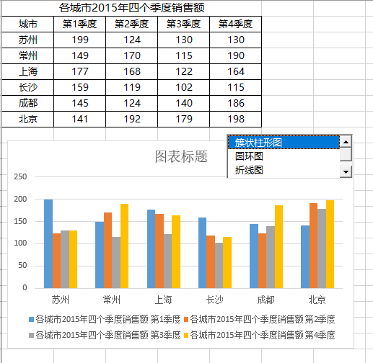

Private Sub ListBox1_GotFocus() '列表框的添加

Me.ListBox1.Clear

Me.ListBox1.AddItem "簇状柱形图"

Me.ListBox1.AddItem "圆环图"

Me.ListBox1.AddItem "折线图"

Me.ListBox1.AddItem "股价图"

End Sub

Private Sub ListBox1_Click()

Dim cht As Chart

Set cht = Sheet3.Shapes("图表 1").Chart

Select Case Me.ListBox1.Value

Case "簇状柱形图"

cht.ChartType = xlColumnClustered

Case "圆环图"

cht.ChartType = xlDoughnut

Case "折线图"

cht.ChartType = xlLine

Case "股价图"

cht.ChartType = xlStockOHLC

End Select

End Sub

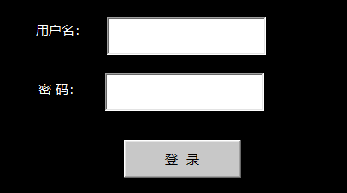

清除网格线：视图è网格线

掩码è属性èpasswordchart

Private Sub 登录_Click()

If Me.TextBox1.Value = "yqlshl" And Me.TextBox2.Value = "555666" Then

Me.TextBox1.Value = ""

Me.TextBox2.Value = ""

Sheet2.Visible = xlSheetVisible

Sheet3.Visible = xlSheetVisible

Sheet4.Visible = xlSheetVisible

Sheet5.Visible = xlSheetVisible

Sheet11.Visible = xlSheetVisible

Sheet11.Activate

Sheet1.Visible = xlSheetVeryHidden

Else

MsgBox "密码或用户名不正确！"

End If

End Sub

Private Sub Workbook_Open()

Sheet1.Visible = xlSheetVisible

Sheet2.Visible = xlSheetVeryHidden

Sheet3.Visible = xlSheetVeryHidden

Sheet4.Visible = xlSheetVeryHidden

Sheet5.Visible = xlSheetVeryHidden

Sheet11.Visible = xlSheetVeryHidden

End Sub

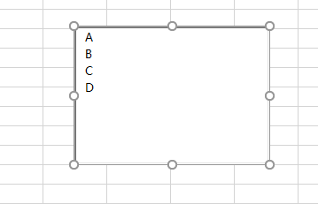

列表框的多项选择

列表框è属性èMultiselect 0为单选，1为多选，2位ctrl+单击为多选

list属性

selected属性

Private Sub ListBox21_Click()

'msgbox me.ListBox21.List(1)'显示的时B

Dim i%

For i = 0 To Me.ListBox21.ListCount - 1

MsgBox Me.ListBox21.List(i) '逐个获取

Next i

End Sub

Private Sub ListBox21_GotFocus()

Me.ListBox21.Clear

Me.ListBox21.AddItem "A"

Me.ListBox21.AddItem "B"

Me.ListBox21.AddItem "C"

Me.ListBox21.AddItem "D"

End Sub

Private Sub ListBox21_LostFocus()

Dim i%, sr$

For i = 0 To Me.ListBox21.ListCount - 1

If Me.ListBox21.Selected(i) Then

MsgBox Me.ListBox21.List(i)

sr = sr & "," & Me.ListBox21.List(i)

End If

Next

MsgBox Mid(sr, 2, 9)

End Sub

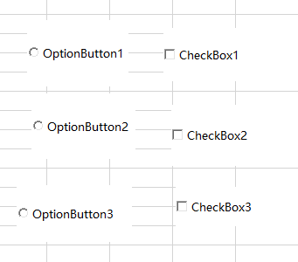

Private Sub CheckBox21_Click()

MsgBox Me.CheckBox21.Value '返回的是逻辑值。

End Sub

Private Sub CommandButton21_Click()

Dim ar, ole, sr

For Each ar In Array("A", "B", "C")

Set ole = Sheet1.OLEObjects(ar).Object

If ole.Value Then

sr = sr & "," & ole.Caption

End If

Next

End Sub

Private Sub OptionButton21_Click()

MsgBox Me.OptionButton22.Value

End Sub

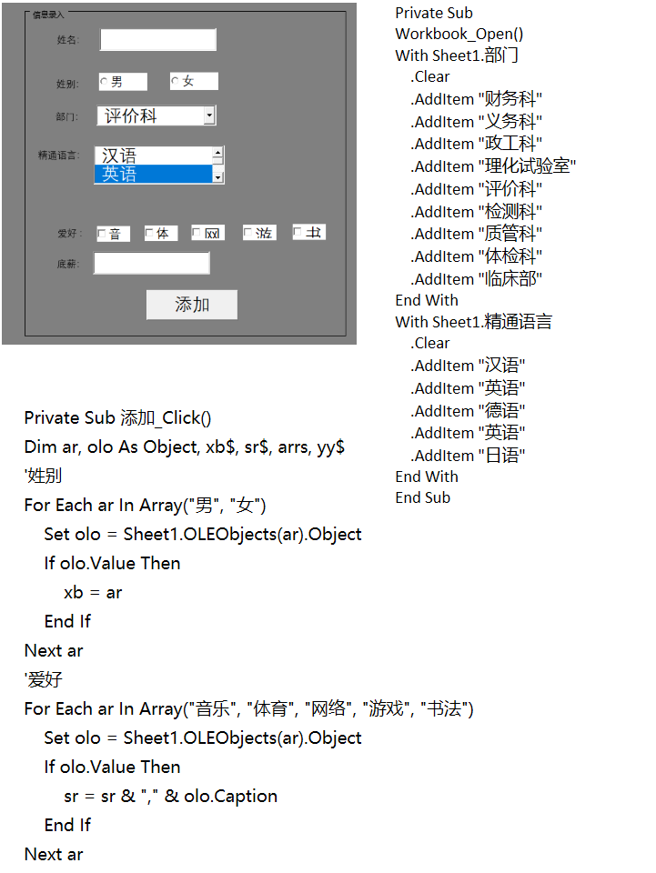  
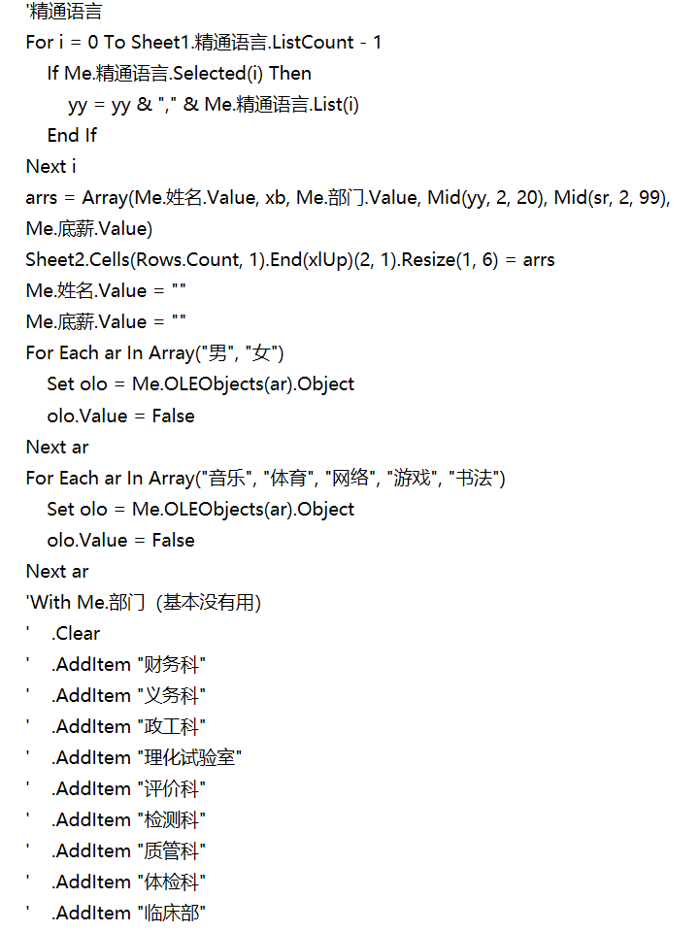  


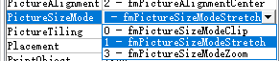

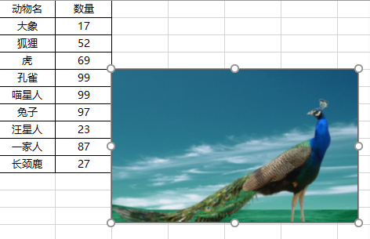

当picturesizemode的值为1时，表示图片显示为控件的全部尺寸。

当picturesizemode的值为3时，表示图片显示本身的缩放比例，不会占满整个控件。

当picturesizemode的值为0时，表示图片本身的大小，会出现显示不全的情况。

Private Sub Worksheet_SelectionChange(ByVal Target As Range)

If Target.Column = 1 Then

On Error Resume Next

Me.Image1.Visible = True

Me.Image1.Picture = LoadPicture("C:\Users\SHLLSFSYH\Desktop\Excel 2013 VBA教程素材\08第8章 activex控件应用\素材图片\" & Target.Value & ".jpg")

Me.Image1.Left = Target(1, 3).Left

Me.Image1.Top = Target(1, 3).Top

Else

Me.Image1.Visible = False

End If

End Sub

