Function COLORSUM(单元格区域 As Range, 汇总的颜色 As Range)

Set d = CreateObject("Scripting.Dictionary")

For Each Rng In 汇总的颜色

d(Rng.Interior.ColorIndex) = ""

Next

For Each ci In d.keys

For Each Rng In 单元格区域

If Rng.Interior.ColorIndex = ci Then

r = r + Rng.Value

End If

Next

Next

COLORSUM = r

End Function

Sub test()

Set d = CreateObject("Scripting.Dictionary")

Set 区域 = Application.InputBox("区域选择", , , , , , , 8)

Set 颜色 = Application.InputBox("颜色选择", , , , , , , 8)

For Each Rng In 颜色

d(Rng.Interior.ColorIndex) = ""

Next

For Each ci In d.keys

For Each Rng In 区域

If Rng.Interior.ColorIndex = ci Then

r = r + Rng.Value

End If

Next

Next

MsgBox r

End Sub

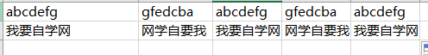

Function fz(rng As Range) '反转字符

For i = Len(rng.Value) To 1 Step -1

sr = sr & Mid(rng, i, 1)

Next i

fz = sr

End Function

Function DD(rng As Range) '反转字符

For i = Len(rng) To 1 Step -1

a = Mid(rng, i, 1)

b = b & a

Next

DD = b

End Function



Function 求和(rng As Range, Optional s As String = "")

Application.Volatile

Set regx = CreateObject("vbscript.regexp")

With regx

.Global = True

.Pattern = "\d" & s '针对s的判定，不太理解，正则表达式增加的s部分感觉可以放在后面的循环中使用更为合理。

Set mat = .Execute(rng)

End With

For Each m In mat

n = n + m \* 1

'num = num + Val(o.Value)

Next

求和 = n

End Function

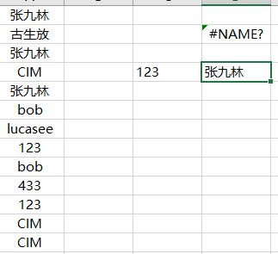

Function 不重复值(rng As Range)

Set d = CreateObject("scripting.dictionary")

For Each rn In rng

d(rn.Value) = "" '必须要注明value，不注明的话会提取重复的值。目前不清楚为什么。

Next

不重复值 = d.keys

End Function

Function 不重复2(rng As Range, Optional num As Integer = 0)

Set d = CreateObject("scripting.dictionary")

Set regx = CreateObject("vbscript.regexp")

With regx

.Global = True

If num = 0 Then

.Pattern = ".+" '所有值的不重复

ElseIf num = 1 Then

.Pattern = "[一-龢]+" '汉字不重复

ElseIf num = 2 Then

.Pattern = "[a-zA-Z]+" '字母不重复

ElseIf num = 3 Then

.Pattern = "\d+" '数字不重复

End If

For Each rn In rng

For Each m In .Execute(rn)

d(m.Value) = ""

Next

Next

不重复2 = d.keys

End With

End Function