|  |  |  |  |
| --- | --- | --- | --- |
|  |  |  |  |
|  |  |  |  |
|  |  |  |
|  |  |  |

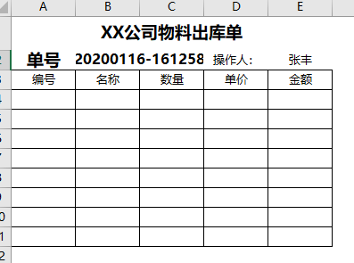

Sub test111()

Dim rng As Range, n%

If Sheet2.Range("h:h").Find([b2]) Is Nothing Then

For Each rng In Range("a4", Cells(Rows.Count, 1).End(xlUp))

n = n + 1

rng.Resize(1, 4).Copy Sheet2.Cells(Rows.Count, 1).End(xlUp)(2, 1)

Next rng

[e2].Copy Sheet2.Cells(Rows.Count, "f").End(xlUp)(2, 1).Resize(n, 1)

[b2].Copy Sheet2.Cells(Rows.Count, "h").End(xlUp)(2, 1).Resize(n, 1)

Sheet2.Cells(Rows.Count, "g").End(xlUp)(2, 1).Resize(n, 1) = Format(Now, "yyyy年mm月dd日-hh时mm分ss秒")

Else

MsgBox "已经保存过了"

End If

End Sub

Sub shl()

Dim rng1 As Range, rng2 As Range

If Sheet2.Range("h1", Sheet2.Cells(Rows.Count, "g").End(xlUp)).Find([b2]) Is Nothing Then

Set rng1 = Worksheets("单据").Range("a4", Cells(Rows.Count, "d").End(xlUp))

Set rng2 = Worksheets("流水账").Cells(Rows.Count, 1).End(xlUp)(2, 1)

rng1.Copy rng2

rng2(1, 7).Resize(rng1.Rows.Count, 1) = Format(Now, "yyyy年mm月dd日-hh时mm分ss秒")

rng2(1, 8).Resize(rng1.Rows.Count, 1) = [b2]

rng2(1, 6).Resize(rng1.Rows.Count, 1) = [e2]

Else

MsgBox "已经保存过了"

End If

End Sub

Sub shl1()

Sheet1.Range("a4:d11").ClearContents

[b2] = Format(Now, "yyyymmdd-hhmmss")

End Sub

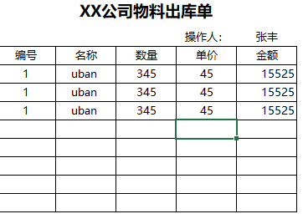

Sub shl()

Dim rng1 As Range, rng2 As Range, n%

Set rng1 = Sheet1.Range("a4", Cells(Rows.Count, "e").End(xlUp))

Set rng2 = Sheet2.Cells(Rows.Count, 1).End(xlUp)(2, 1)

rng1.Copy rng2

n = rng1.Row - 1

Sheet2.Cells(Rows.Count, "f").End(xlUp)(2, 1).Resize(n, 1) = [e2]

Sheet2.Cells(Rows.Count, "g").End(xlUp)(2, 1).Resize(n, 1) = Format(Now, "yyyy年mm月dd日")

Sheet1.Range("a4:e11").ClearContents

End Sub

excel密码保护解决办法

<https://blog.csdn.net/alivio/article/details/6756394?locationNum=14>

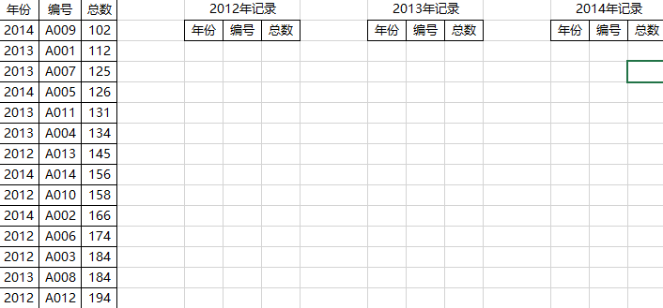

Sub 分类()

Dim rng As Range

For Each rng In Range("a2:a" & Cells(Rows.Count, 1).End(xlUp))

If rng.Value = CStr(Left([e1].Value, 4)) Then

rng.Resize(1, 3).Cut [e1].End(xlDown)(2, 1)

ElseIf rng.Value = CStr(Left([i1].Value, 4)) Then

rng.Resize(1, 3).Cut [i1].End(xlDown)(2, 1)

ElseIf rng.Value = CStr(Left([m1].Value, 4)) Then

rng.Resize(1, 3).Cut [m1].End(xlDown)(2, 1)

Else

Exit For

End If

Next rng

End Sub

Sub shl()

Dim rng As Range

For Each rng In Sheet3.Range("a2", Cells(Rows.Count, 1).End(xlUp))

If rng.Value = 2012 Then

rng.Resize(1, 3).Cut Cells(Rows.Count, 5).End(xlUp)(2, 1)

ElseIf rng.Value = 2013 Then

rng.Resize(1, 3).Cut Cells(Rows.Count, 9).End(xlUp)(2, 1)

ElseIf rng.Value = 2014 Then

rng.Resize(1, 3).Cut Cells(Rows.Count, 13).End(xlUp)(2, 1)

End If

Next rng

End Sub

Sub shl1()

Dim rng As Range, col%

For Each rng In Sheet3.Range("a2", Cells(Rows.Count, 1).End(xlUp))

col = (rng.Value - 2011) * 4 + 1

rng.Resize(1, 3).Cut Cells(Rows.Count, col).End(xlUp)(2, 1)

Next rng

End Sub

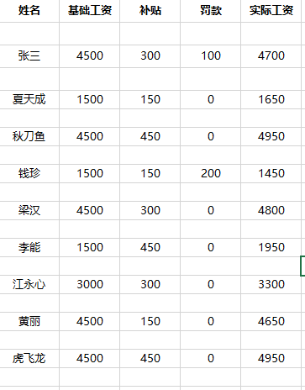

Sub shl() '删除空白行

Dim rng As Range, rngs As Range

Set rngs = Sheet2.Range("a1", Cells(Rows.Count, 1).End(xlUp))

For Each rng In rngs

If rng.Value = "" Then

rng.EntireRow.Delete

End If

Next rng

End Sub

Sub shl1() '隔行插入

Dim rw%, sr$, srr$

num = Application.WorksheetFunction.CountA([a:a]) '调用工作表函数写法

num1 = Sheet2.Range("a2", Cells(Rows.Count, 1).End(xlUp)).Rows.Count '动态获取的第一种写法

num3 = Sheet2.[a1].End(xlDown).Row '动态获取的第二种写法

For rw = 2 To num

sr = sr & rw & ":" & rw & ","

Next rw

srr = Left(sr, Len(sr) - 1)

Sheet2.Range(srr).Insert

End Sub