项目环境搭建步骤：
- 安装vue和element-ui
# 安装vue （如果已安装过可忽略这一步骤）
$ npm install vue@2.1.6
# 全局安装 vue-cli ，此步骤会在操作系统安装一个全局的vue-cli（vue脚手架）
$ npm install --global vue-cli （如果已安装过可忽略这一步骤）
# 创建一个基于 webpack 模板的新项目my-project （此处打开要新建项目的目录即可）
$ vue init webpack vvproject
# 进入项目目录
$ cd vvproject
# 安装依赖
$ npm install
# 运行项目
$ npm run dev
# 项目运行成功后，安装element-ui
$ npm i element-ui@2.2.2
之后按照缺少什么就安装依赖即可
vue-router、axios、jquery、vuex、font-awesome、sass-loader
$ npm install vue-router --save
$ npm install axios --save
$ npm install jquery
$ npm install --save vuex
$ npm install font-awesome
$ npm install --save-dev sass-loader
$ npm install --save-dev node-sass (如果安装不成功，尝试关闭防火墙)
在src下添加文件夹并添加一些页面，目录如下：
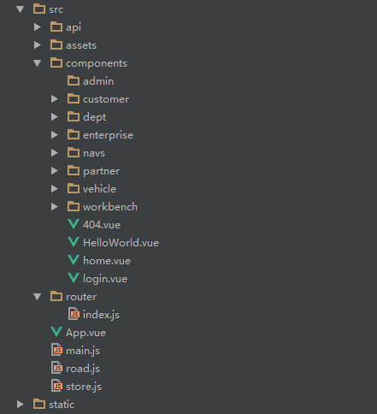
- 配置文件
main.js
import Vue from 'vue'
import App from './App'
import router from './router'
import ElementUI from 'element-ui'
import store from './store.js'
import 'element-ui/lib/theme-chalk/index.css'
import '@/assets/font-awesome-4.7.0/css/font-awesome.min.css'
import '@/assets/css/style.css'
Vue.config.productionTip = false
Vue.use(ElementUI)
new Vue({
router,
store,
el: '#app',
render: h => h(App)
})

router/index.js
import Vue from 'vue'
import Router from 'vue-router'
import HomeNav from '@/components/navs/homeNav.vue'
import Home from '@/components/home.vue'
import Dashboard from '@/components/workbench/dashboard.vue'
import Mission from '@/components/workbench/mission.vue'
import Plan from '@/components/workbench/plan.vue'
import Maillist from '@/components/workbench/maillist.vue'
import EnterpriseNav from '@/components/navs/enterpriseNav.vue'
import EnterpriseList from '@/components/enterprise/index.vue'
import EnterpriseAdd from '@/components/enterprise/add.vue'
import EnterpriseDetail from '@/components/enterprise/detail.vue'
import EnterpriseValidate from '@/components/enterprise/validate.vue'
import VehicleManage from '@/components/vehicle/index.vue'
import DeptManager from '@/components/dept/index.vue'
import CustomerManager from '@/components/customer/index.vue'
import PartnerManager from '@/components/partner/index.vue'
// 懒加载方式，当路由被访问的时候才加载对应组件
const Login = resolve => require(['@/components/login'], resolve)
Vue.use(Router)
let router = new Router({
routes: [
{
path: '/login',
type: 'login',
component: Login
},
{
path: '/',
type: 'home',
name: 'home',
redirect: '/dashboard',
component: Home,
menuShow: true,
children: [
{
path: '/dashboard',
component: HomeNav,
name: 'dashboard',
leaf: true, // 只有一个节点
iconCls: 'fa fa-home', // 图标样式class
menuShow: true,
children: [
{ path: '/dashboard', component: Dashboard, name: '首页', menuShow: true }
]
},
{
path: '/mySet',
component: HomeNav,
name: '我的设置',
iconCls: 'el-icon-menu',
menuShow: true,
children: [
{ path: '/mySet/plan', component: Plan, name: '行程计划', menuShow: true },
{ path: '/mySet/mission', component: Mission, name: '我的任务', menuShow: true },
{ path: '/mySet/maillist', component: Maillist, name: '通讯录', menuShow: true }
]
}
]
},
{
path: '/enterpriseManager',
type: 'enterprise',
name: 'enterprise',
component: Home,
redirect: '/enterprise/list',
menuShow: true,
children: [
{
path: '/enterpriseList',
component: EnterpriseNav,
name: 'enterpriseList',
leaf: true, // 只有一个节点
iconCls: 'fa fa-home', // 图标样式class
menuShow: true,
children: [
{ path: '/enterprise/list', component: EnterpriseList, name: '企业列表', menuShow: true },
{ path: '/enterprise/detail', component: EnterpriseDetail, name: '企业详情', menuShow: false }
]
},
{
path: '/enterpriseAdd',
component: EnterpriseNav,
name: 'enterpriseAdd',
leaf: true, // 只有一个节点
iconCls: 'el-icon-menu',
menuShow: true,
children: [
{ path: '/enterprise/add', component: EnterpriseAdd, name: '企业添加', menuShow: true }
]
},
{
path: '/enterpriseValidate',
component: EnterpriseNav,
name: 'enterpriseValidate',
leaf: true, // 只有一个节点
iconCls: 'el-icon-menu',
menuShow: true,
children: [
{ path: '/enterprise/validate', component: EnterpriseValidate, name: '企业认证', menuShow: true }
]
}
]
}
]
});
router.beforeEach((to, from, next) => {
// console.log('to:' + to.path)
if (to.path.startsWith('/login')) {
window.localStorage.removeItem('access-user')
next()
} else {
let user = JSON.parse(window.localStorage.getItem('access-user'))
if (!user) {
next({path: '/login'})
} else {
next()
}
}
});
export default router
store.js
import Vue from 'vue'
import Vuex from 'vuex'
Vue.use(Vuex)
/*测试数据*/
const date = 'Mon Mar 24 2018 00:00:00 GMT+0800 (中国标准时间)'
const data = [
{
id: '1111',
name: 'Allen',
type: '员工',
status: '已离职'
},{
id: '2222',
name: 'Thomas',
type: '司机',
status: '在职'
}
]
const state = {
activeList: data
}
/*从本地存储读取数据*/
for(var item in state) {
localStorage.getItem(item)? state[item] = JSON.parse(localStorage.getItem(item)): false;
}
export default new Vuex.Store({
state
})

App.vue
<template>
<div id="app">
<router-view></router-view>
</div>
</template>
<script>
export default {
name: 'app'
}
</script>

Home.vue
<template>
<el-row class="container">
<!--头部-->
<el-col :span="24" class="topbar-wrap">
<div class="topbar-logo topbar-btn">
<a href="/"><img src="../assets/logo.png" style="padding-left:8px;"></a>
</div>
<div class="topbar-logos" v-show="!collapsed">
<a href="/" style="color: #fff;">VV租行</a>
</div>
<div class="topbar-title">
<el-row v-show="homeShow">
<el-col :span="24">
<el-menu :default-active="defaultActiveIndex" class="el-menu-demo" mode="horizontal" @select="handleSelect" :router="true">
<el-menu-item index="/">工作台</el-menu-item>
<el-menu-item index="/enterpriseManager">企业管理</el-menu-item>
<el-menu-item index="/orderManager">订单管理</el-menu-item>
<el-menu-item index="/systemManager">系统管理</el-menu-item>
</el-menu>
</el-col>
</el-row>
<el-row v-show="enterpriseShow">
<el-col :span="24">
<el-menu :default-active="defaultActiveIndex" class="el-menu-demo" mode="horizontal" @select="handleSelect" :router="true">
<el-menu-item index="/enterpriseManager">企业信息</el-menu-item>
<el-menu-item index="/vehicleManager">车辆信息</el-menu-item>
<el-menu-item index="/deptManager">组织架构</el-menu-item>
<el-menu-item index="/customerManager">客户管理</el-menu-item>
<el-menu-item index="/partnerManager">伙伴管理</el-menu-item>
</el-menu>
</el-col>
</el-row>
</div>
<div class="topbar-account topbar-btn">
<el-dropdown trigger="click">
<span class="el-dropdown-link userinfo-inner">
<i class="fa fa-user"></i> {{nickname}} <i class="fa fa-caret-down"></i></span>
<el-dropdown-menu slot="dropdown">
<el-dropdown-item>
<div @click="jumpTo('/user/profile')"><span style="color: #555;font-size: 14px;">个人信息</span></div>
</el-dropdown-item>
<el-dropdown-item>
<div @click="jumpTo('/user/changepwd')"><span style="color: #555;font-size: 14px;">修改密码</span></div>
</el-dropdown-item>
<el-dropdown-item divided @click.native="logout">退出登录</el-dropdown-item>
</el-dropdown-menu>
</el-dropdown>
</div>
</el-col>
<!--中间-->
<transition name="fade" mode="out-in">
<router-view></router-view>
</transition>
</el-row>
</template>
<script>
import $ from 'jquery'
import {road} from '../road.js'
import API from '../api/api_user';
export default {
name: 'home',
data () {
return {
defaultActiveIndex: "/",
nickname: '',
collapsed: false,
homeShow: true,
enterpriseShow: false
}
},
created() {
road.$on('setNickName', (text) => {
this.nickname = text;
});
road.$on('goto', (url) => {
if(url === "/login") {
localStorage.removeItem('access-user');
this.$router.push(url);
}
});
// 组件创建完后获取数据，
// 此时 data 已经被 observed 了
this.fetchData()
},
methods: {
handleSelect(index){
this.defaultActiveIndex = index;
if (index == "/") {
this.homeShow = true;
this.enterpriseShow = false;
} else if (index == "/enterpriseManager") {
this.homeShow = false;
this.enterpriseShow = true;
} else {
this.homeShow = true;
this.enterpriseShow = false;
}
},
//折叠导航栏
collapse () {
this.collapsed = !this.collapsed;
},
fetchData () {
var cur_path = this.$route.path; //获取当前路由
var routers = this.$router.options.routes; // 获取路由对象
var nav_type = "";
for (var i = 0; i < routers.length; i++) {
var children = routers[i].children;
if(routers[i].children){
for (var j = 0; j < children.length; j++) {
var grand_children = children[j].children;
for (var k = 0; k < grand_children.length; k++) {
if (grand_children[k].path == cur_path) {
nav_type = routers[i].type;
break;
}
}
}
}
}
if (nav_type == "home") {
this.defaultActiveIndex = "/";
this.homeShow = true;
this.enterpriseShow = false;
} else if (nav_type == "enterprise") {
this.defaultActiveIndex = "/enterpriseManager";
this.homeShow = false;
this.enterpriseShow = true;
}
},
jumpTo(url){
this.defaultActiveIndex = url;
this.$router.push(url); //用go刷新
},
logout(){
//logout
}
},
mounted() {
let user = localStorage.getItem('access-user');
if (user) {
user = JSON.parse(user);
this.nickname = user.nickname || '';
}
},
watch: {
'$route': 'fetchData'
}
}
</script>
homeNav.vue
<template>
<el-col :span="24" class="main">
<!--左侧导航-->
<aside :class="{showSidebar:!collapsed}">
<!--展开折叠开关-->
<div class="menu-toggle" @click.prevent="collapse">
<i class="fa fa-outdent" v-show="!collapsed" title="收起"></i>
<i class="fa fa-outdent" v-show="collapsed" title="展开"></i>
</div>
<!--导航菜单-->
<el-menu :default-active="defaultActiveIndex" router :collapse="collapsed" @select="handleSelect">
<template v-for="(issue,index) in $router.options.routes">
<template v-if="issue.type === 'home'">
<template v-for="(item,index) in issue.children">
<el-submenu v-if="!item.leaf" :index="index+''" v-show="item.menuShow">
<template slot="title"><i :class="item.iconCls"></i><span slot="title">{{item.name}}</span></template>
<el-menu-item v-for="term in item.children" :key="term.path" :index="term.path" v-if="term.menuShow"
:class="$route.path==term.path?'is-active':''">
<i :class="term.iconCls"></i><span slot="title">{{term.name}}</span>
</el-menu-item>
</el-submenu>
<el-menu-item v-else-if="item.leaf&&item.children&&item.children.length" :index="item.children[0].path"
:class="$route.path==item.children[0].path?'is-active':''" v-show="item.menuShow">
<i :class="item.iconCls"></i><span slot="title">{{item.children[0].name}}</span>
</el-menu-item>
</template>
</template>
</template>
</el-menu>
</aside>
<!--右侧内容区-->
<section class="content-container">
<div class="grid-content bg-purple-light">
<el-col :span="24" class="content-wrapper">
<transition name="fade" mode="out-in">
<router-view></router-view>
</transition>
</el-col>
</div>
</section>
</el-col>
</template>
<script>
export default {
name: 'homeNav',
data () {
return {
defaultActiveIndex: "0",
collapsed: false
}
},
methods: {
handleSelect(index){
this.defaultActiveIndex = index;
},
//折叠导航栏
collapse: function () {
this.collapsed = !this.collapsed;
},
jumpTo(url){
this.defaultActiveIndex = url;
this.$router.push(url); //用go刷新
}
},
watch: {
'$route': function(to, from){ // 路由改变时执行
console.info("homeNav to.path:" + to.path);
}
}
}
</script>
workbench/dashboard.vue
<template>
<div>
<el-button type="primary" icon="el-icon-edit">首页</el-button>
</div>
</template>
axios配置：
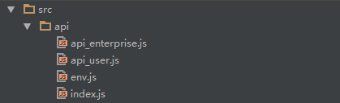
- env.js
/**
* 设置api请求的baseURL
* 实际项目中建议该文件不纳入版本管理
*/
export default {
baseURL: 'http://localhost:8090',
isDev: true
}
- index.js
import Env from './env';
import axios from 'axios'
import {road} from '../road.js'
axios.defaults.withCredentials = true;
// axios.defaults.headers.common['Authorization'] = AUTH_TOKEN;
// axios.defaults.headers.post['Content-Type'] = 'application/x-www-form-urlencoded;charset=UTF-8';//配置请求头
//添加一个请求拦截器
// axios.interceptors.request.use(function (config) {
// console.dir(config);
// return config;
// }, function (error) {
// // Do something with request error
// return Promise.reject(error);
// });
// 添加一个响应拦截器
axios.interceptors.response.use(function (response) {
if (response.data && response.data.errcode) {
if (parseInt(response.data.errcode) === 40001) {
//未登录
road.$emit('goto', '/login')
}
}
return response;
}, function (error) {
// Do something with response error
return Promise.reject(error);
});
//基地址
let base = Env.baseURL;
//测试使用
export const ISDEV = Env.isDev;
//通用方法
export const POST = (url, params) => {
return axios.post(`${base}${url}`, params).then(res => res.data)
}
export const GET = (url, params) => {
return axios.get(`${base}${url}`, {params: params}).then(res => res.data)
}
export const PUT = (url, params) => {
return axios.put(`${base}${url}`, params).then(res => res.data)
}
export const DELETE = (url, params) => {
return axios.delete(`${base}${url}`, {params: params}).then(res => res.data)
}
export const PATCH = (url, params) => {
return axios.patch(`${base}${url}`, params).then(res => res.data)
}

- src/road.js
import Vue from 'vue'
export let road = new Vue()

- api_enterprise.js
import * as API from './'
export default {
//查询列表
findList: params => {
return API.GET('/json', params)
},
findById: id => {
return API.GET(`/api/enterprise/list/${id}`)
}
}

- 开始开发
components/enterprise/index.vue
<template>
<div>
<el-table ref="multipleTable" :data="tableData" border style="width: 100%" @selection-change="handleSelectionChange">
<el-table-column type="selection" width="60"></el-table-column>
<el-table-column prop="eNumber" label="企业编号" width="180" sortable></el-table-column>
<el-table-column prop="eName" label="企业名称" show-overflow-tooltip></el-table-column>
<el-table-column prop="eIndustry" label="所属行业" width="180"></el-table-column>
<el-table-column prop="eRange" label="经营范围" width="180"></el-table-column>
<el-table-column prop="eModel" label="经营模式" width="180"></el-table-column>
<el-table-column prop="createTime" label="创建日期" width="180"></el-table-column>
<el-table-column prop="updateTime" label="更新日期" width="180"></el-table-column>
<el-table-column prop="recordStatus" label="企业状态" width="180"></el-table-column>
</el-table>
<el-col :span="24" class="toolbar">
<el-pagination background
@size-change="handleSizeChange"
@current-change="handleCurrentChange"
:current-page="currentPage"
:page-sizes="[10, 50, 100, 200]"
:page-size="10"
layout="total, sizes, prev, pager, next, jumper"
:total="total">
</el-pagination>
</el-col>
</div>
</template>
<script>
import API from '../../api/api_enterprise'
export default {
data() {
return {
keyword: "集团",
total: 5,
currentPage: 1,
pageSize: 10,
tableData: [{
eNumber: 'A10001',
eName: 'YE集团',
eIndustry: '金融业',
eRange: '商业',
eModel: '国有企业',
createTime: '2017-03-27',
updateTime: '2016-03-27',
recordStatus: '1'
}],
multipleSelection: []
}
},
created: function(){
// 组件创建完后获取数据，
// 此时 data 已经被 observed 了
this.fetchData(1, 10);
},
methods: {
toggleSelection(rows) {
if (rows) {
rows.forEach(function(row) {
this.$refs.multipleTable.toggleRowSelection(row);
});
} else {
this.$refs.multipleTable.clearSelection();
}
},
fetchData(curr, pageSize){ //获取数据
let self = this;
let params = {
curr: curr,
pageSize: pageSize,
keywords: ''
};
API.findList(params).then(function(result){
self.total = result.count;
self.currentPage = result.curr;
self.tableData = result.data;
}).catch(function (error) {
console.log(error);
});
},
handleSizeChange(val){
this.pageSize = val;
this.currentPage = 1;
this.fetchData(1, val);
// console.log(`每页 ${val} 条`);
},
handleCurrentChange(val){
this.currentPage = val;
this.fetchData(val, this.pageSize);
// console.log(`当前页: ${val}`);
},
handleSelectionChange(val) {
this.multipleSelection = val;
}
}
}
</script>
<style>
.el-table th {
text-align: center;
}
.el-table tbody tr td:first-child {
text-align: center;
}
</style>

- 项目打包：
$ npm run build
会在当前目录下生成dist目录，打开index.html文件就能访问到。
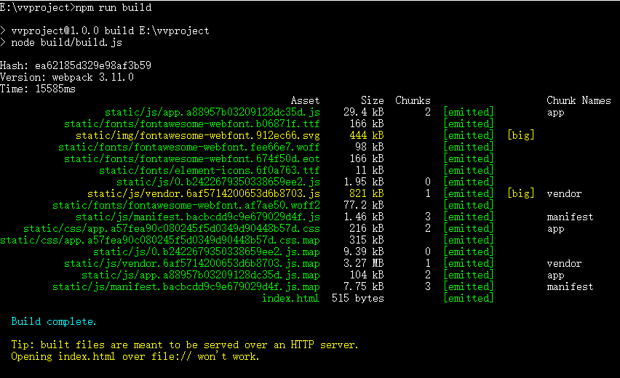
- 整合到springboot项目中：
将打包好的dist下的static文件夹和index.html文件放到springboot项目下的src/main/resources/static中，启动项目，如果发现font-awesome路径错误，将fonts文件夹拷贝到static/css/static中即可。
- 使用Vuex，因为使用了ES6中用来传递异步信息的Promise，而IE低版本浏览器不支持。解决方法：
第一步，安装babel-polyfill，babel-polyfill可以模拟ES6使用的环境，可以使用ES6的所有新方法。$ npm install --save babel-polyfill
第二步，在build/webpack.base.conf.js中，使用
module.exports = {
entry: {
app: ["babel-polyfill", "./src/main.js"]
}
};
替换：
module.exports = {
entry: {
app: './src/main.js'
}
}

