# Exercise 1 - Preparing AWS Resources Using CloudFormation

In this exercise, you will launch a template that creates the AWS resources needed to complete the Replicate, Analyze and Visualize datasets using AWS Database Migration Service and Serverless Big Data technologies workshop. You’ll launch the template using AWS CloudFormation.

AWS CloudFormation gives developers and system administrators an easy way to create and manage a collection of related AWS resources, provisioning and updating AWS resources by defining infrastructure as code.

This template will be run in the **EU-West-1 (Ireland) Region.**

**Create a Key Pair**

Before launching CloudFormation, you will need to create an EC2 Key Pair which will be used to allow administrative access into the EC2 Instances created by CloudFormation.

Sign in to the AWS management console. Open the EC2 page by clicking the searching for EC2 or going to <https://console.aws.amazon.com/ec2/home>.

* Once on the EC2 page, look in the upper right corner for the AWS Region and change this to **EU (Ireland)**

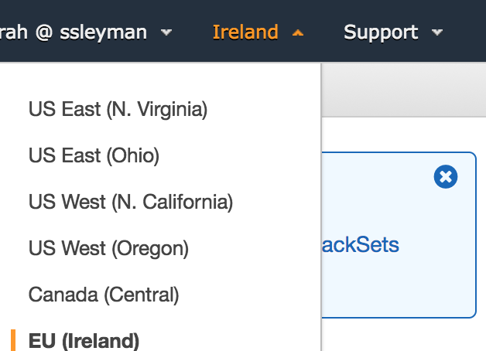

* Under **Network & Security**, select **Key Pairs** on the left and select **Create Key Pair**. Recommended name “**DMSServerless**”. Please append your initials if multiple people are running in the same account, such as “**DMSServerless_ws**”.

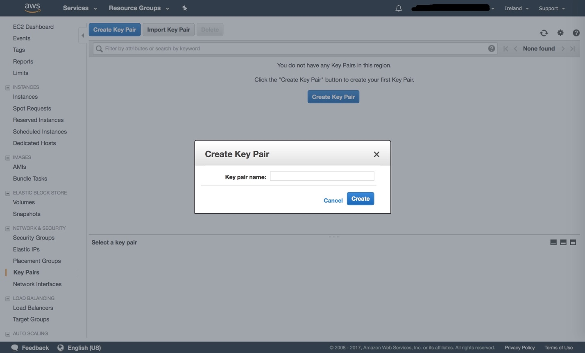

* + Mac users: You will receive a download of a pem.txt file. Rename the file and remove the .txt to make it a .pem file. For example: **DMSServerless_ws.pem**. Note where this file was downloaded.
  + Windows users: You will be prompted to download a .pem file. Save this, and note where this was downloaded.

You have completed creating a new EC2 Key Pair.

**Launch Resources using AWS CloudFormation**

* Return to the AWS management console home by clicking the AWS icon in the upper left of the EC2 page or by going to <https://console.aws.amazon.com/cloudformation/home>.
* Once on the CloudFormation home page, look in the upper right corner for the AWS Region and ensure this is **EU (Ireland).**



* In CloudFormation, click on CreateStack.

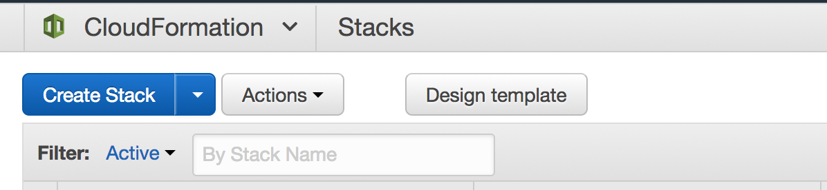

* On the create stack page, choose Upload a template to Amazon S3 and use the Choose file option to choose the **DMS_ServelessBigDataWorkshop.json** template in the zip package

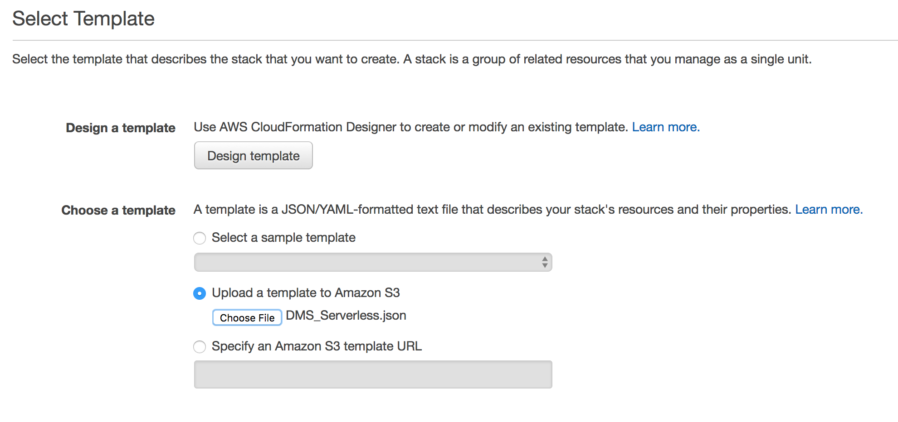

* Enter the following**:**
  + **Stack name**: Enter any name you would like to give the stack. A suggested name is “**DMSServerless**”. Please append your initials if multiple people are running in the same account such as “**DMSServerlessws**”.
  + **IPddress:** Your IP address from where you will RDP into the EC2 instance. You can get it from **https://WhatisMyIP.com** or a tool of your choice, followed with /32. For example, **192.168.1.10/32**.
  + **KeyName**: Enter the name of the key pair you created previously. Enter the name without the .pem extension, such as “**DMSServerless_ws**”.

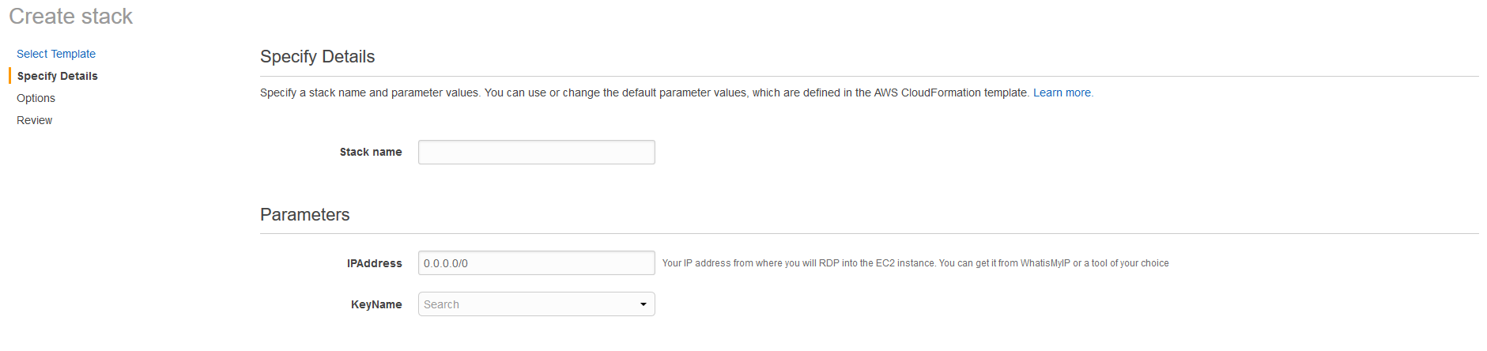

* On the **Options** page, put the following values for Tags and click **Next**.

Key = ‘**Environment’**  
Value = ‘**DMSServerless’**

* Under **Permissions**, you do not need to specify a role.
* You do not need to specify any **Advanced** settings.
* Click **Next**.

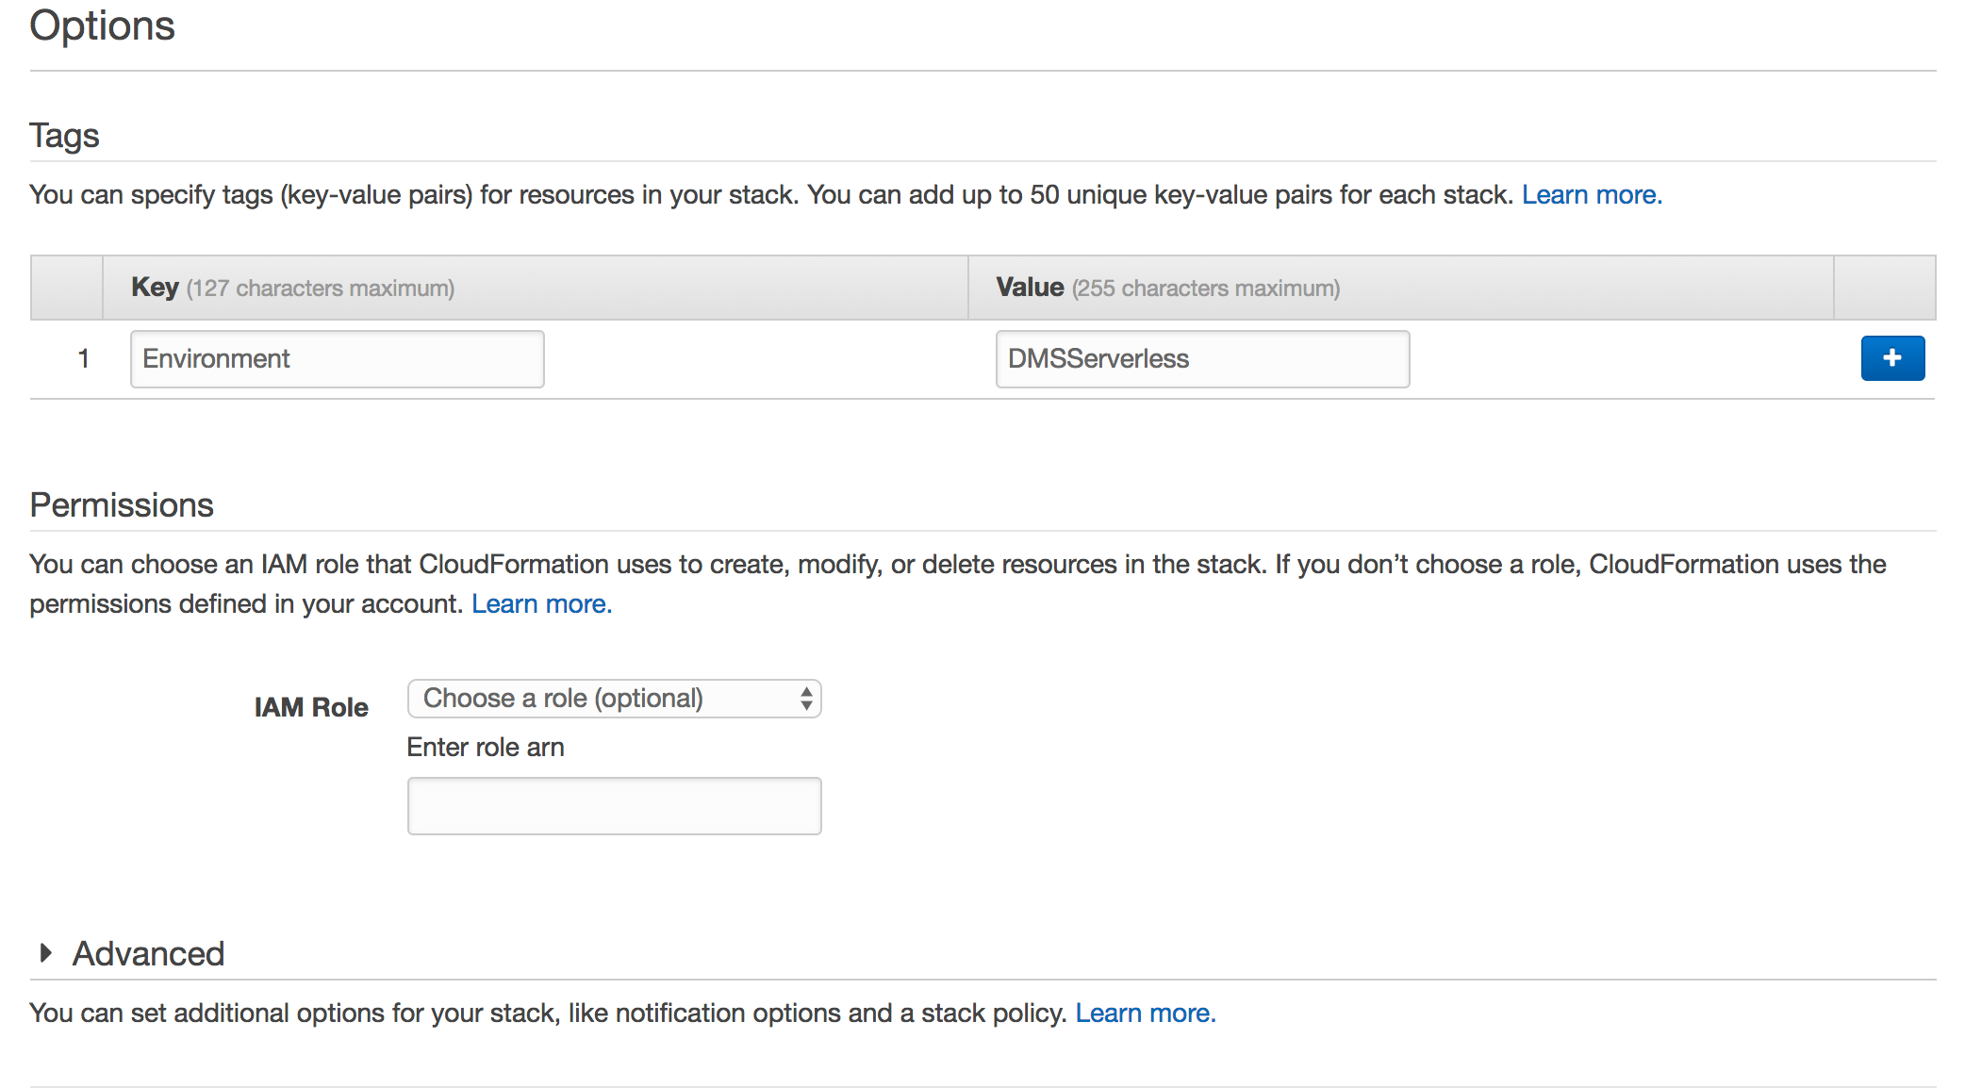

* Make sure you click the Checkbox that states that AWS CloudFormation might create IAM resources with customer names.
* Check through the final **Review** page and click **Create.**
* At this point, you will be directed back to the CloudFormation console and will see a status of **CREATE_IN_PROGRESS**. The stack will take approximately 10 minutes to launch. You can check the progress in the **Events** tab on the CloudFormation home page**.** Do not continue until the status changes to **CREATE_COMPLETE**
* Once CloudFormation has completed building the stack, the status will change to complete. Make sure to note the values for the following keys in the **OUTPUT** tab. These will be needed as input for the Database Migration Service setup.

|  |  |
| --- | --- |
| **VpcId** | VPC ID of the newly created VPC |
| **SourceEC2EndpointDNS** | Public name of the EC2 instance that holds the Source database |
| **TargetAuroraEndpointDns** | Endpoint for the Target Aurora database |
| **S3BucketName** | Target S3 Bucket Name |

* Once the Stack is complete, view the newly created resources in the AWS Management Console.
* From the Management Console home page, search for EC2 and go to the EC2 home page to view the EC2 instance that holds the source database. Look for the instance with “**DMSServerless**” in the name:

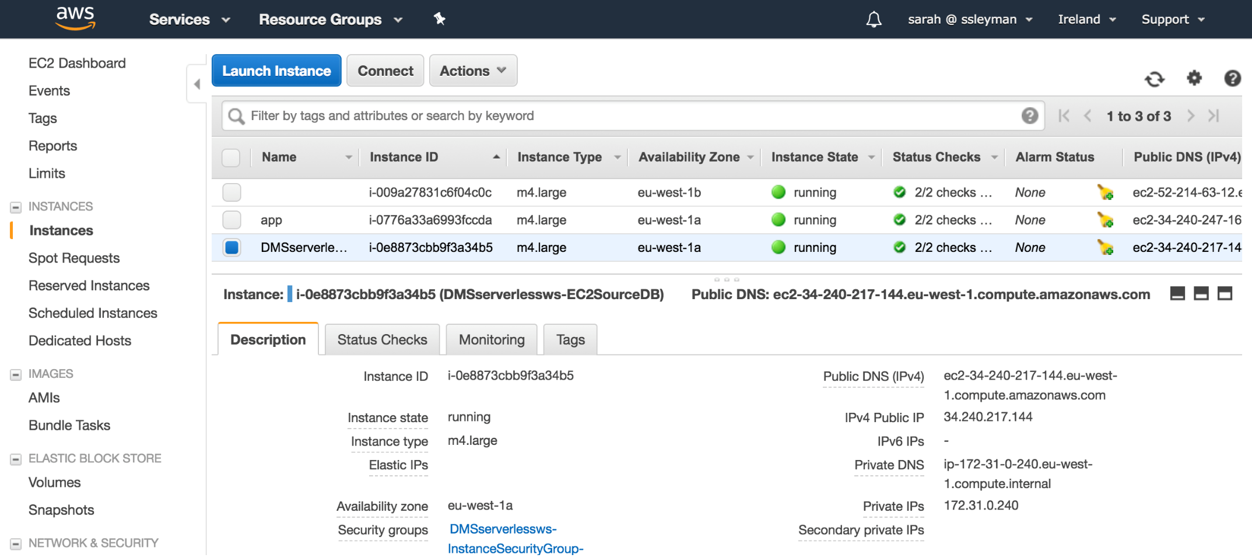

* From the Management Console home page, search for RDS and go to the RDS home page. Click on **Databases** in the table of the left to find and view the target Serverless Aurora database:

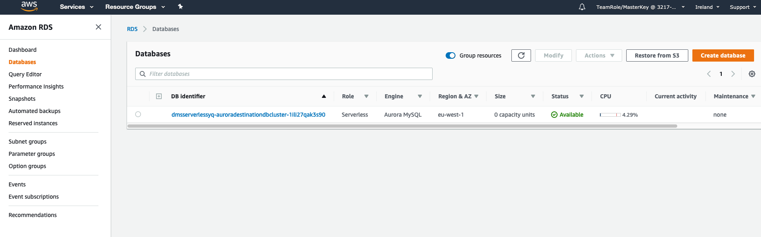

* From the Management Console home page, search for S3 and go to the S3 home page. Find and view the target S3 bucket that will be a target for the Database Migration Service.

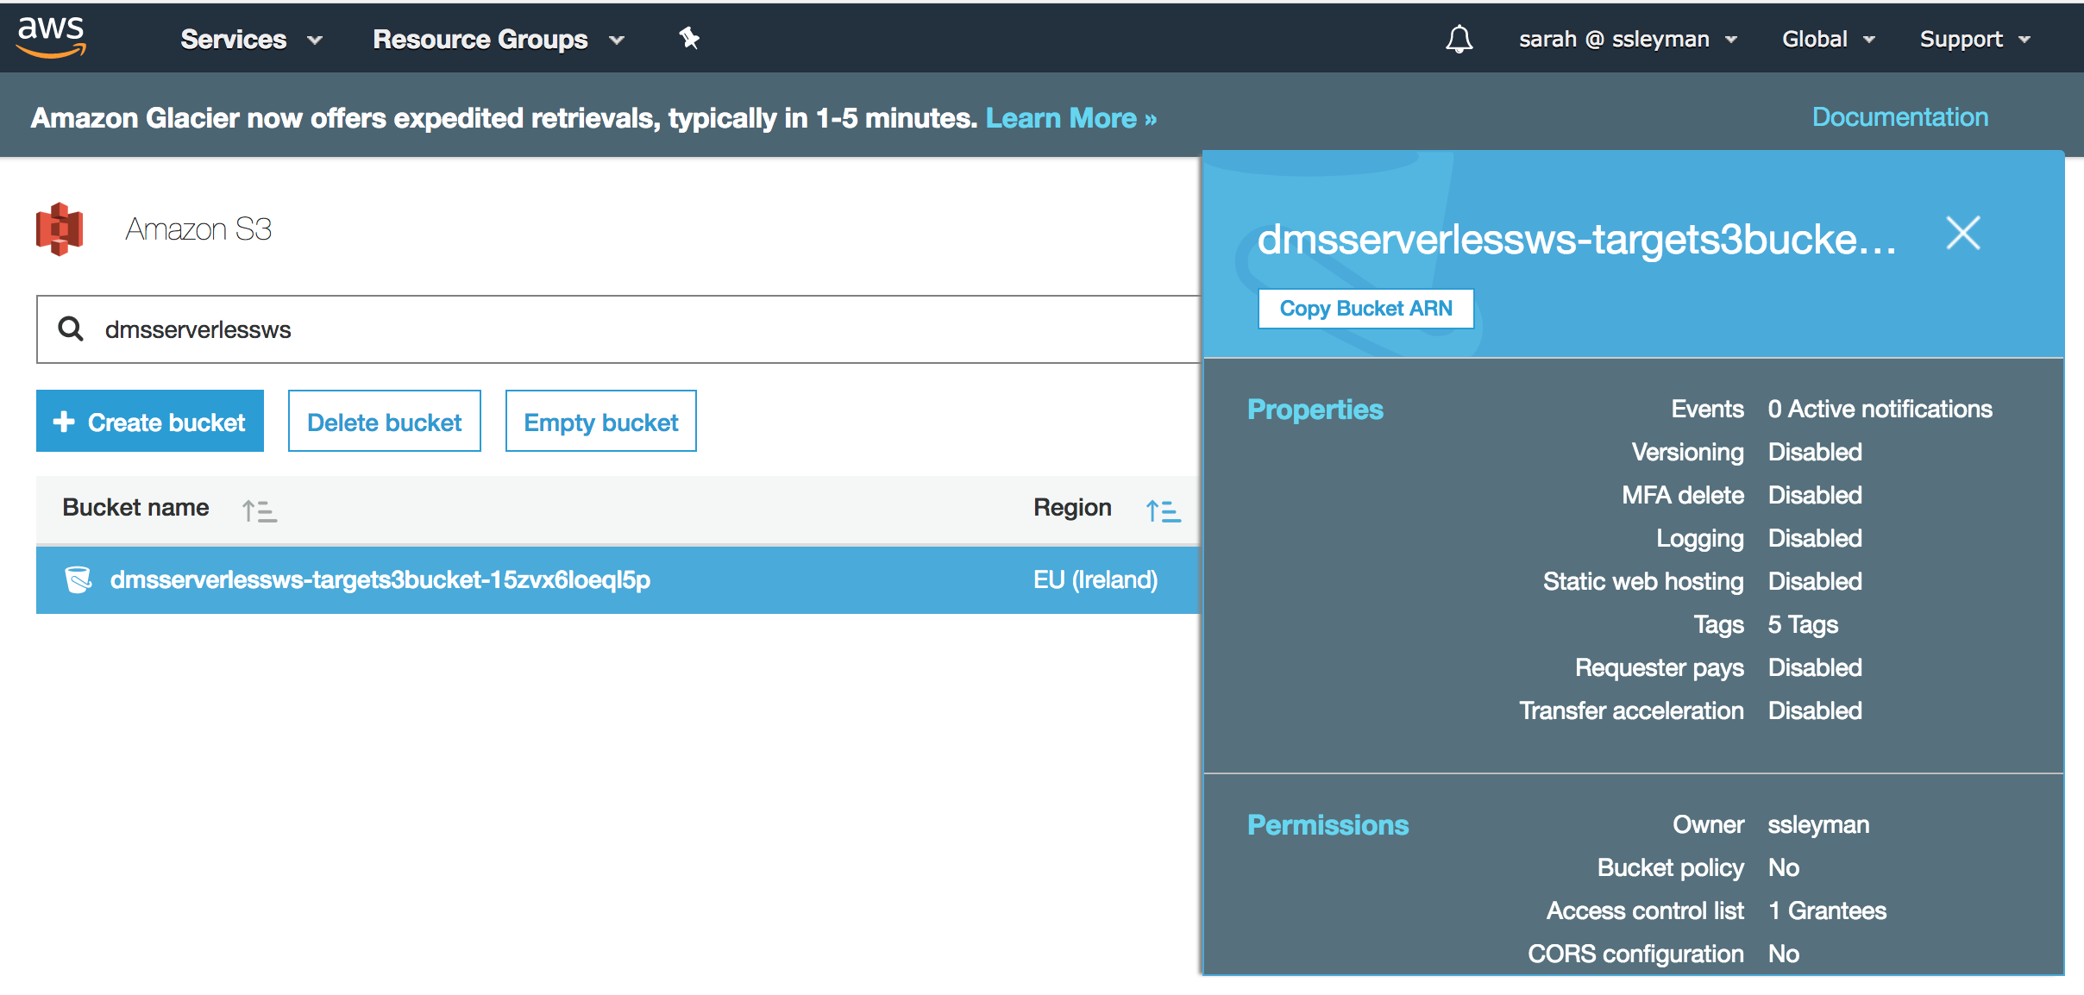

**Connecting to your EC2 Instance**

Once CloudFormation has completed building the environment, the next step is to connect to the EC2 instance.

* Search for EC2 or go to <https://console.aws.amazon.com/ec2/v2/home> and click **Instances** in the left column.
* Select the instance with *DMSServerless* in its name, which you viewed previously, and then click the **Connect** button at the top of the page:

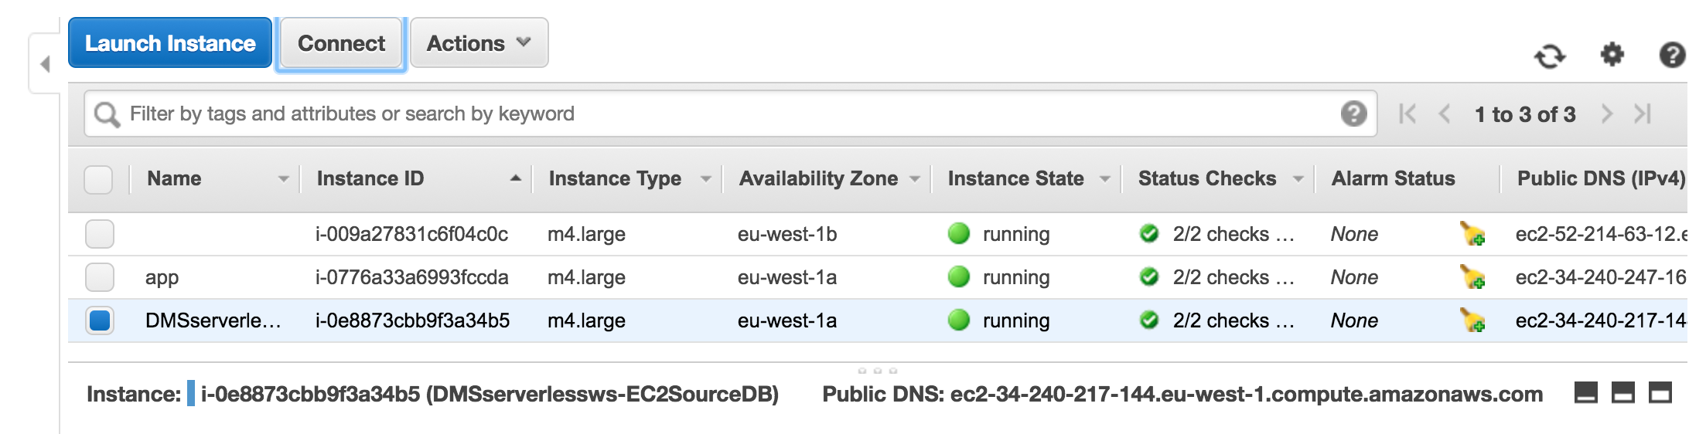

* In this step, you will perform 3 tasks:
  1. Click **Get Password** and navigate to the key file (with a .pem extension) that you specified when launching the CloudFormation template. Click on Decrypt and Copy the automatically generated administrator password.
  2. Click **Download Remote Desktop File** to download the RDP file for this instance.
  3. Connect to the instance using your RDP client.
     1. For Username, enter: “Administrator”
     2. For Password - paste the password that you had copied in step ‘a’.

For more information on connecting to a Windows instance from a Windows or Mac PC see this document:

<http://docs.aws.amazon.com/AWSEC2/latest/WindowsGuide/connecting_to_windows_instance.html>

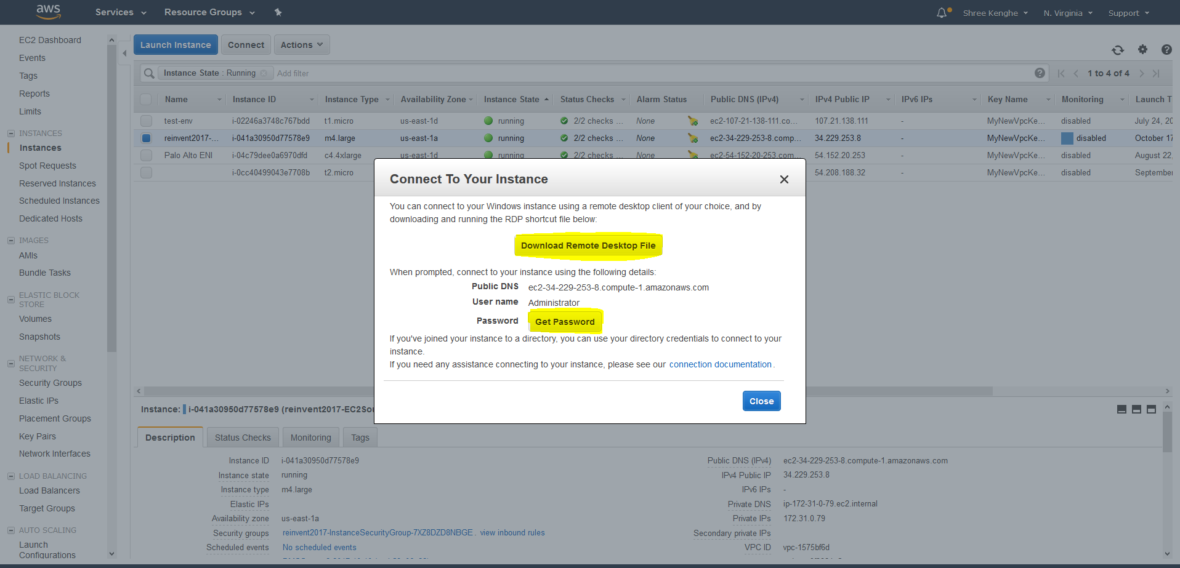

* You may see a certificate warning as you begin the RDP session. This is expected when connecting using the Public DNS name. Click Continue.
* You are now connected to the EC2 Instance.

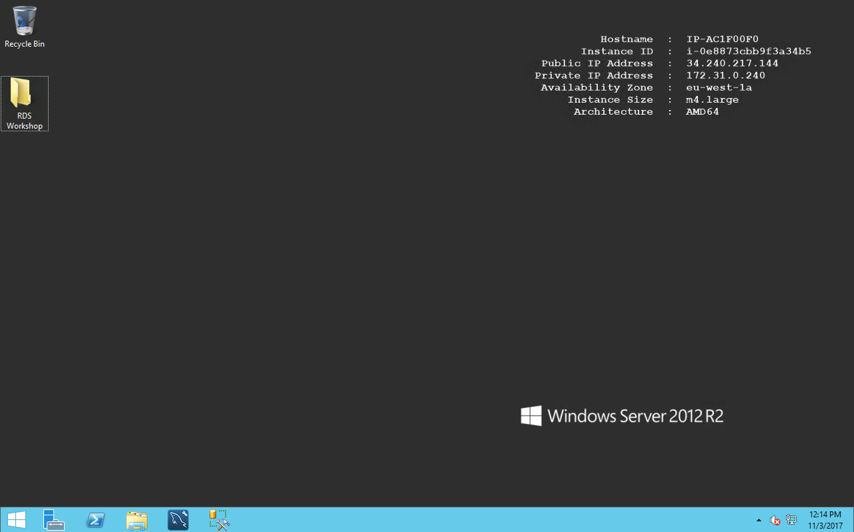

In this exercise, you have used an AWS CloudFormation template to launch the resources needed to complete the AWS Database Migration Service and Serverless Big Data technologies workshop. These included a VPC, Windows EC2 instance, Serverless Aurora and S3 bucket. You also used Remote Desktop to connect to the EC2 instance over RDP.