Exercise 6 - Creating Visualizations using Amazon QuickSight
In this exercise, you will create interactive visualizations utilizing Amazon QuickSight with Amazon Athena (interactive query service).
Amazon QuickSight is a fast business analytics service you can use to build visualizations, perform ad hoc analysis, and quickly get business insights from your data. Amazon QuickSight discovers AWS data sources, enables organizations to scale to hundreds of thousands of users, and delivers responsive performance by using a robust in-memory engine (SPICE).

Step 1 - Create a new Account
- On the AWS Management Console under AWS Services type in “QuickSight” and click the search icon.
- If this is the first time you have used QuickSight, you will be asked to sign up for QuickSight

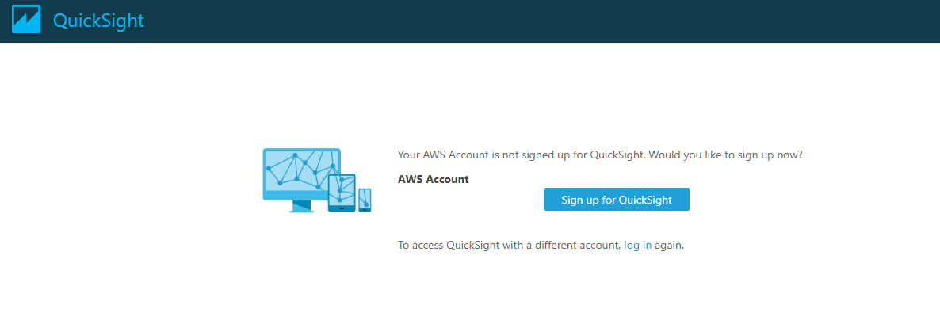

Choose the Standard Edition and hit “Continue”

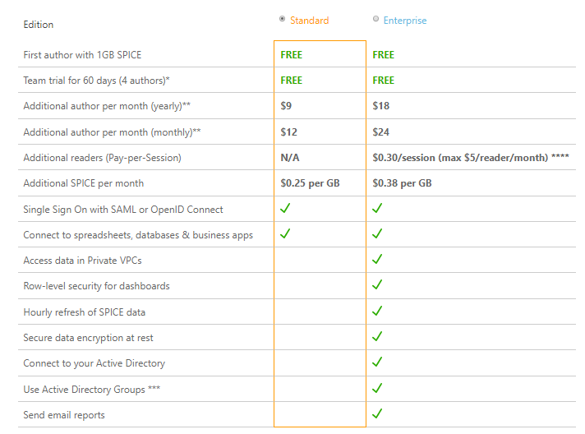

- Put your e-mail for notifications
- Use EU (Ireland) for the region
- Check the Amazon S3 checkbox
- Click on the “Choose S3 buckets” hyperlink on the far right
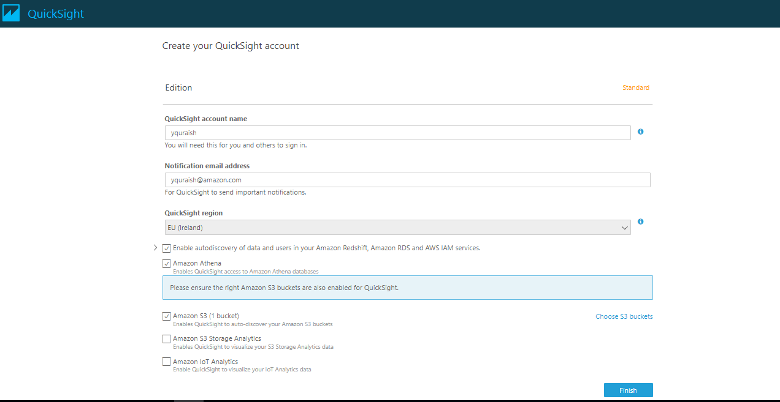

Step 2 - Add S3 as a Data source

Select the S3 bucket that was setup during the CloudFormation Instructions. If you’re not sure, see the S3 Bucket name mentioned in the CloudFormation output. Once selected, click on the “Select buckets” button.
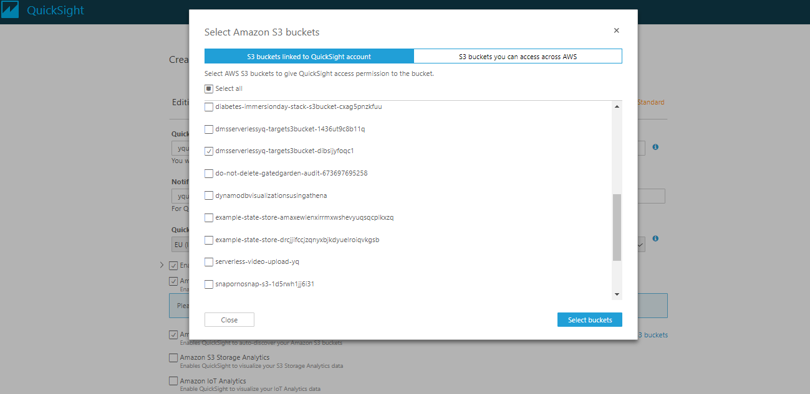

Click Finish
You should now see the following:
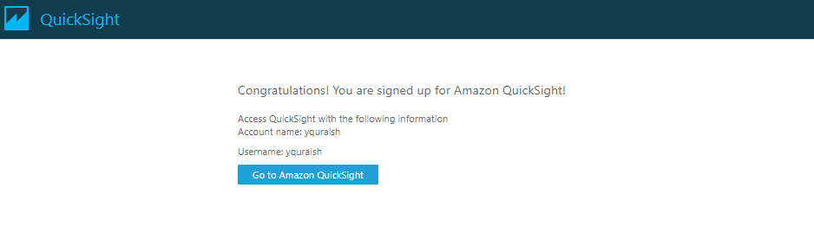
Click on “Go to Amazon QuickSight”
Once Quicksight comes up you should be in the QuickSight UI.

Step 3 - Create a New Analysis

Click on New Analysis button on the top left hand corner

Click on New data set
Select “Athena”
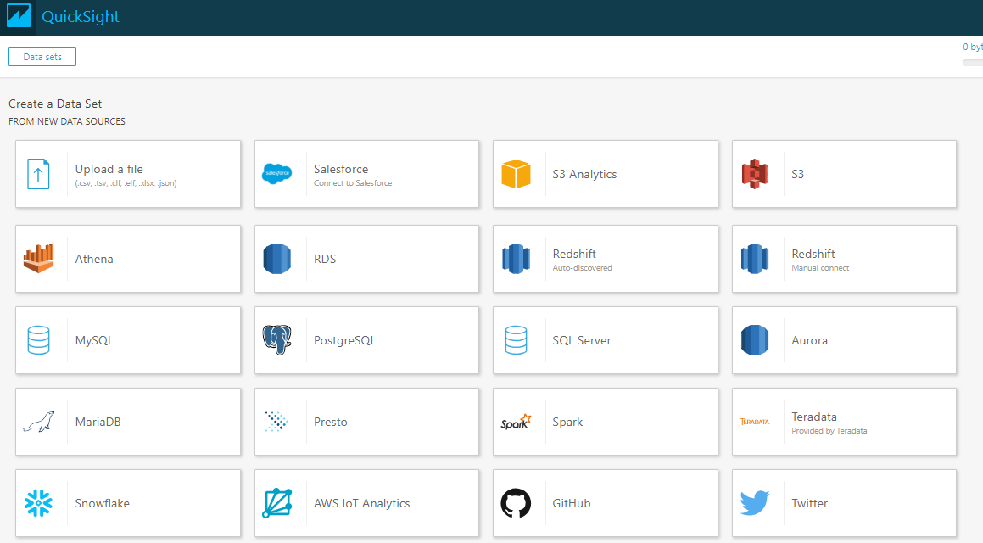

Enter “baseball” for Data source name in the dialog box and click on “Validate”
You will see a green check appear
Click on “Create data source” button
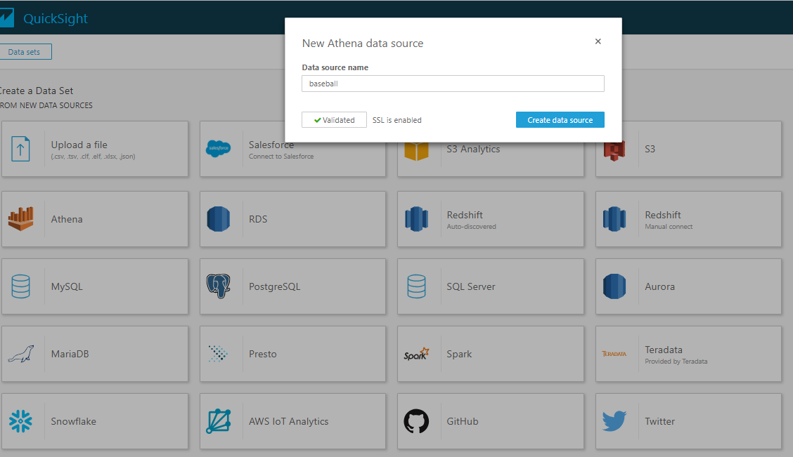

You will then see a Choose your table dialog box appear
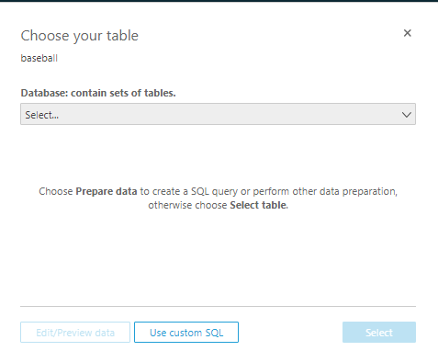

Click on the Select drop down and select the “baseball” database
Select the sporting_event table and hit Select
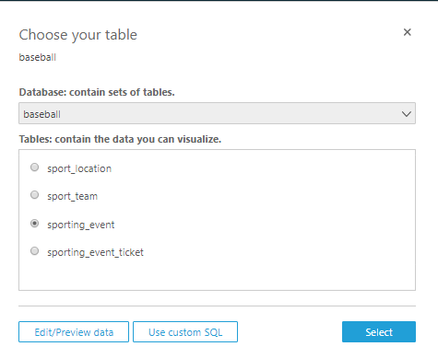
In the Finish data set creation dialog box, select the option for “Import to SPICE for quicker analytics”
Click the “Edit/Preview data” button
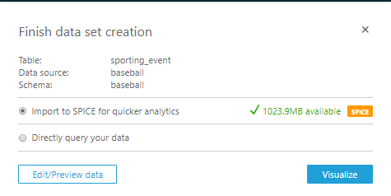

SPICE is Amazon QuickSight's Super-fast, Parallel, In-memory Calculation Engine. SPICE is engineered from the ground up to rapidly perform advanced calculations and serve data. Importing your data into SPICE speeds your analytical queries by allowing you to take advantage of its storage and processing capacity. It also allows you to avoid taking time to retrieve data from a data source whenever you make a change to an analysis or update a visual. Each Amazon QuickSight account receives 10 GB of SPICE capacity per paid user, which is allocated when the user signs into Amazon QuickSight for the first time. Each Amazon QuickSight account also receives one free user with 1 GB of SPICE capacity.

You should see the following view with data populated in the table.
Notice only the “sporting_event” table is displayed
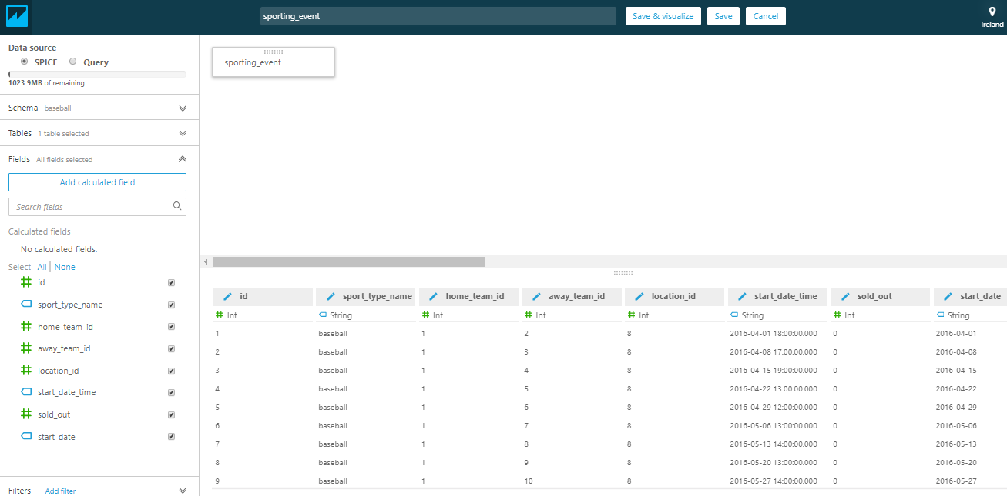

Note: If you do not see any data in the table, no need to worry - it is probably because QuickSight does not have the correct permissions necessary to access data from Athena and S3. Remember, in AWS, everything adheres to the principle of least privilege. Follow the troubleshooting steps in Step 4

If you see the following:

Click on Show Details, which will display a dialog box similar to:
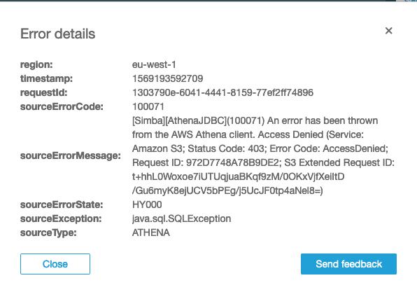

Step 4 - In case you run into issues
The following steps are outlined in this document: https://docs.aws.amazon.com/quicksight/latest/user/troubleshoot-athena-insufficient-permissions.html

- To do this, choose your profile name (top right). Choose Manage QuickSight, and then choose Security & permissions.
- Choose Add or remove.
- Locate Athena in the list. Clear the checkbox next to it, and then enable it. Then choose Connect both.
- Select the buckets you want to access from Amazon QuickSight.
The settings for S3 buckets that you access here is the same one that you access by choosing Amazon S3 from the list of AWS Services. Be careful you don't inadvertently disable a bucket that someone else uses.
- Choose Select to save your S3 buckets.
- Choose Update to save your new settings for Amazon QuickSight access to AWS services. Or, choose Cancel to exit without making any changes.

Now click on the QuickSight icon at the top left of your screen. You will be brought back to the Analysis Dashboard
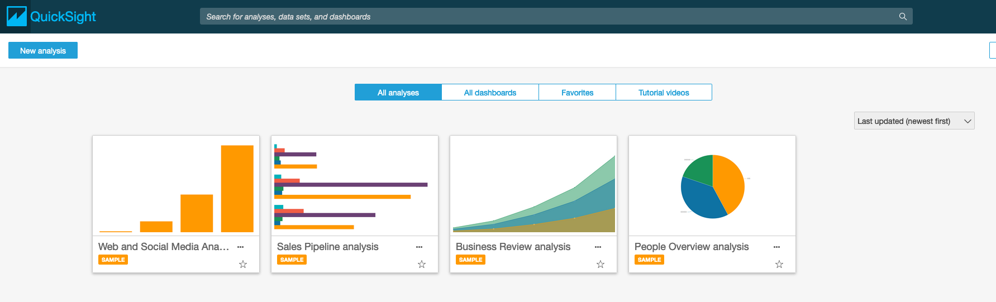

Click on New Analysis sporting_event
Hit Refresh Now Refresh

Once the data has been refreshed, you should see:
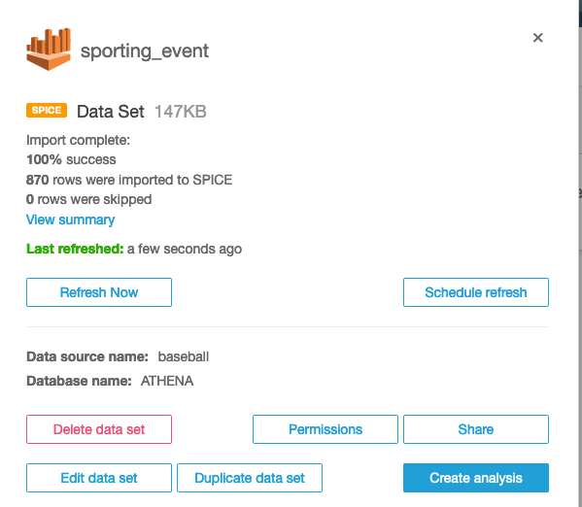

Click on Edit data set

You should see the sporting_event data:
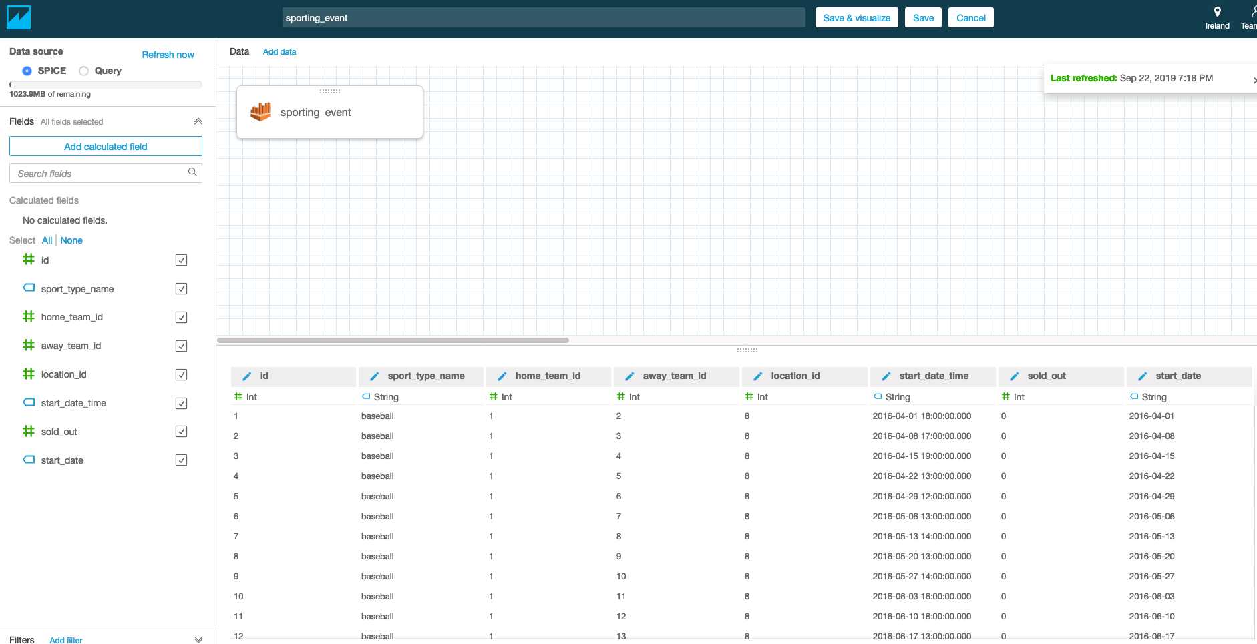

Step 5 - Query table data from baseball database in Athena

Let’s add the “sport_team” table to this view. To do this, click on “Add data” at the top of the screen. Select “sport_team”

You should now see both “sporting_event” and “sport_team” with 2 red circles in the middle
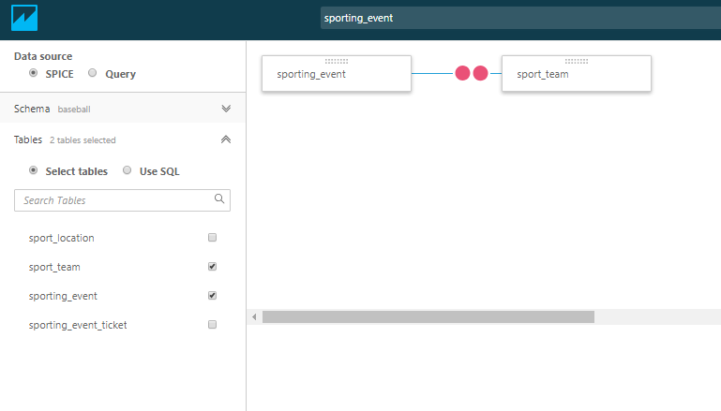
We will now join a few tables to prepare our dataset. Click on the red circles on the line joining sporting_event and sport_team table and configure the join. Select home_team_id column under sporting_event table and id column under sport_team table to join on. Hit Apply. We are only doing analysis for events for home team.

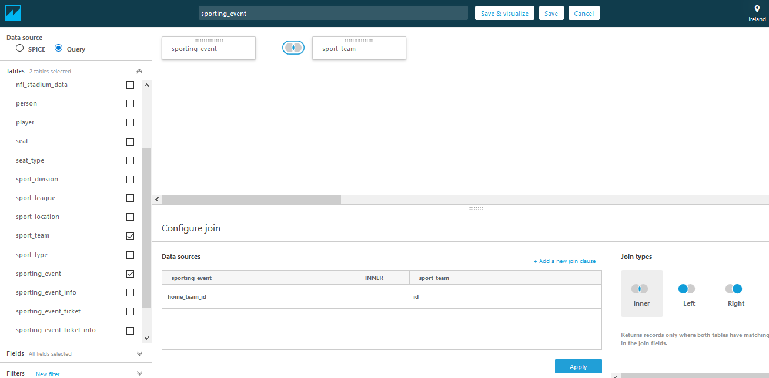

Your screen should display the following:
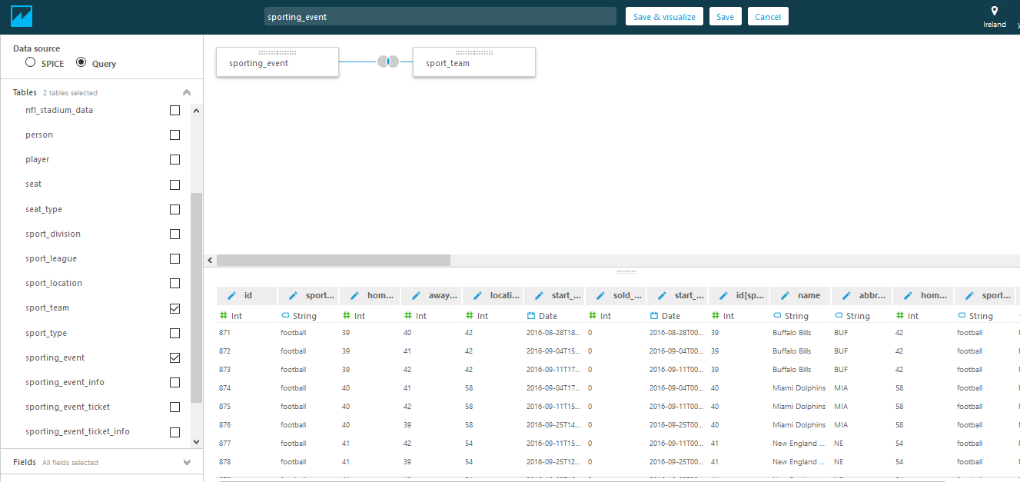

Now join two more tables

Click on Add data and choose sporting_event_ticket under the Table category.
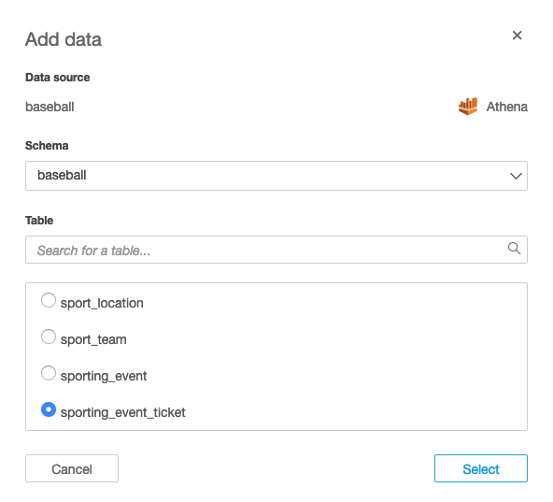

Click on the red circles on the line joining sporting_event and sporting_event_ticket tables
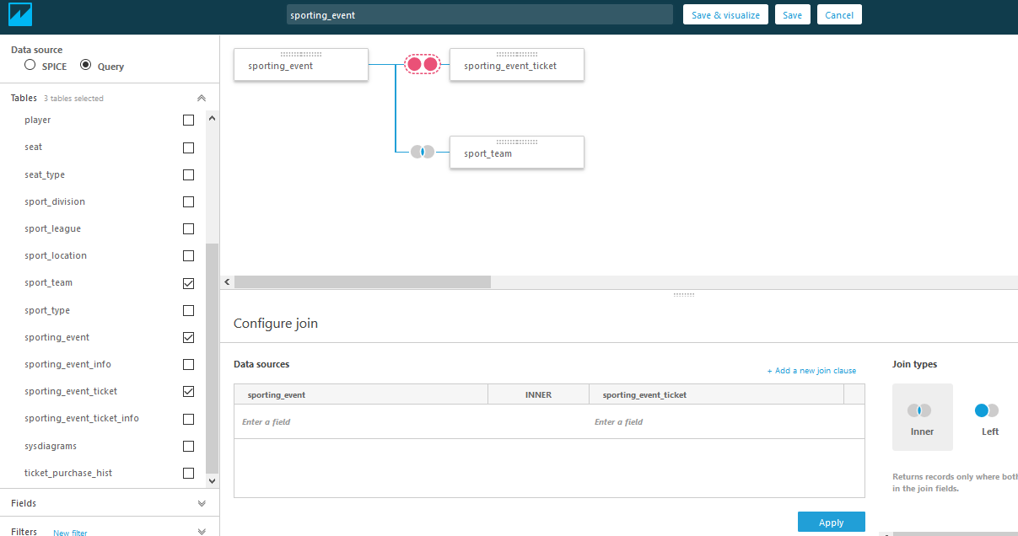

In the Join Configuration section at the bottom of the screen, from the drop down menu in sporting_event, select location_id. From the drop down menu in sporting_event_ticket, select sport_location_id.
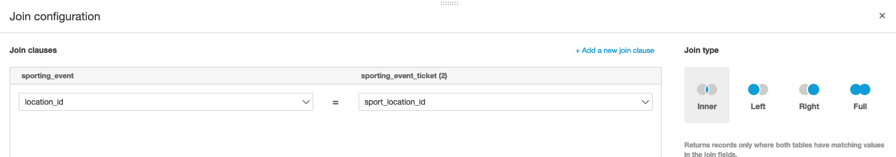

Click on Apply

You should get the following data:
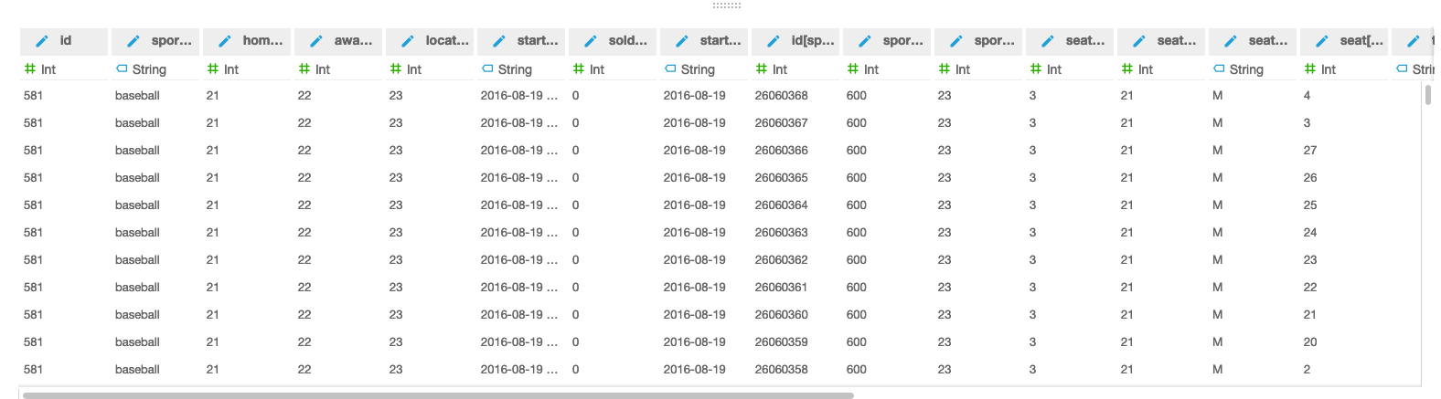

sporting_event and sporting_event_ticket on
Sporting_event.id = sporting_event_ticket.sporting_event_id
And
Sporting_event and sporting_location on
Sporting_event.location_id = sport_location.id

Add sport_location to the data set.

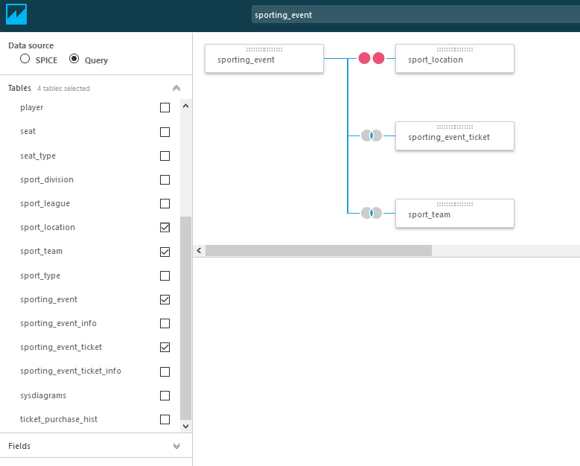

Click on the red circles between sporting_event and sport_location. The Configure join section is displayed at the bottom half of the screen.
Under sporting_event, select location_id
Under sport_location, select id
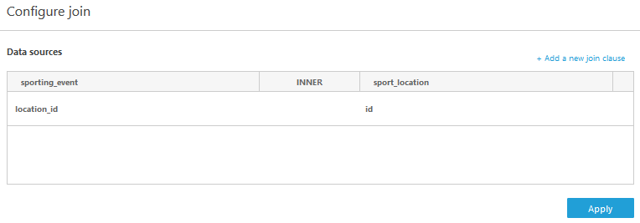
Click on Apply
Your screen should look similar to this:
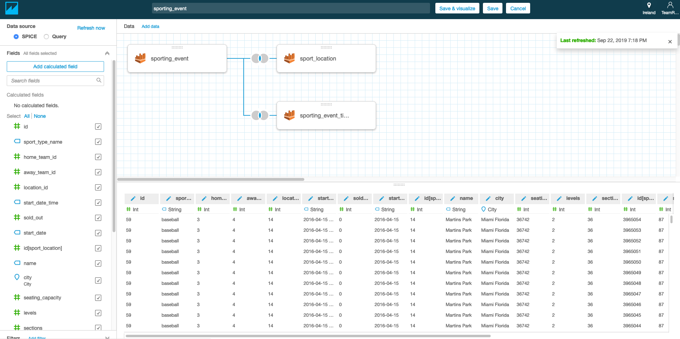

Now give the data set a name e.g. ‘Event ticket name and location’ in the text field at the top and click Save and Visualize to save the data set and start visualization

We will now create our first visual. In the fields list click on name [sport_team] dimension and ticket_price which is a measure that appears the list of measures in green below the dimensions. We are creating an analysis to find out how much revenue was collected in terms of tickets price from each teams home game. With QuickSight’s auto graphing feature it selects the right visualization based on the fields selected. In this case it is a bar graph.

Sample visualization: Average of Ticket price by City
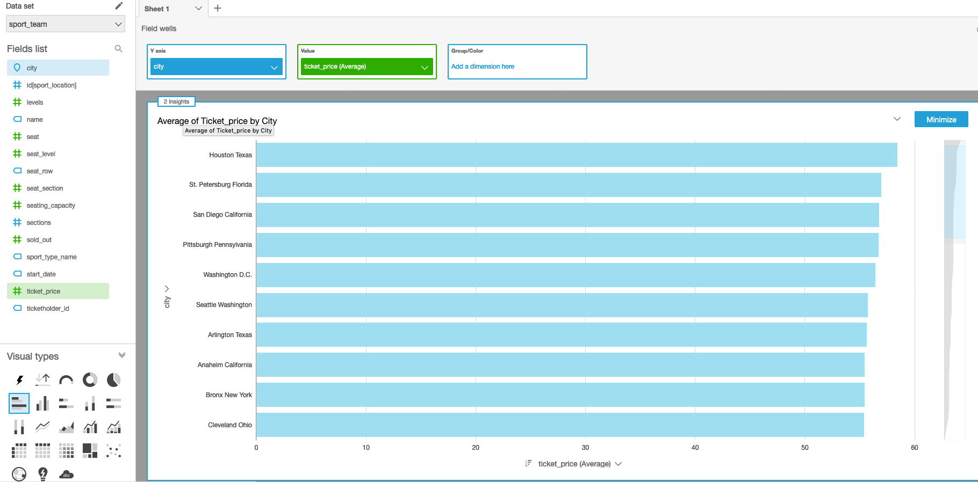

Click on “2 Insights” at the top of the graph. You will see the following Insights that were automatically generated:

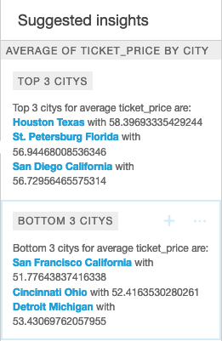

Click on the pie chart in the Visual types area in the left pane below Fields list and convert the bar graph to a pie chart.

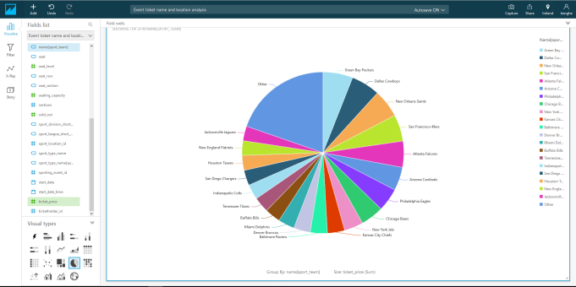

Now click on the + Add on the top Menu bar to add a new visual. Then select Pivot table in the Visual types.

Click on name[city], [seating_capacity] in the Fields list to add them to your report

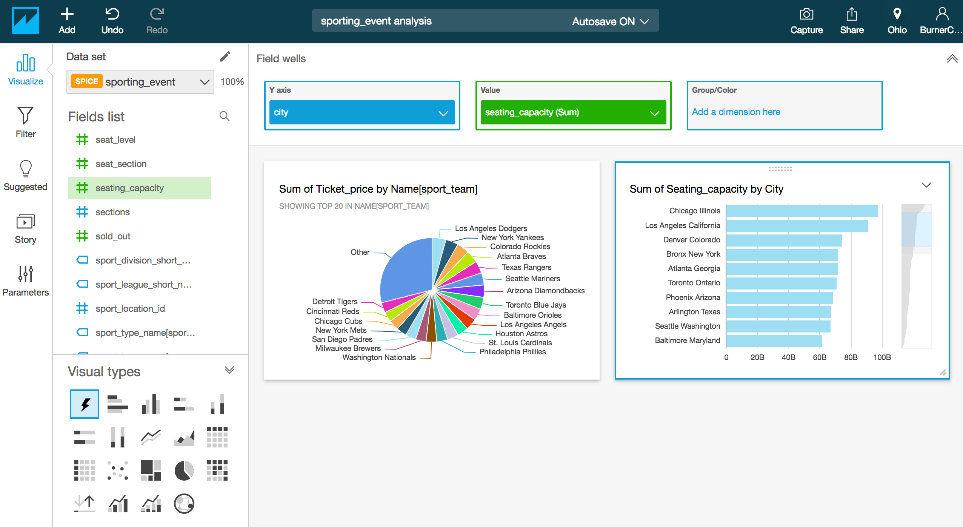

Now, we know how many sporting seats each city has to offer.

Quicksight can be used to create Dashboards and Stories in addition to Analyses.
A dashboard is a read-only snapshot of an analysis that you can share with other Amazon QuickSight users for reporting purposes. A dashboard preserves the configuration of the analysis at the time you create it, including such things as filtering and sort order. The data used for the analysis is not captured as part of the dashboard. When you view the dashboard, it will reflect the current data in the data sets used by the analysis.
When you share a dashboard, you specify which users have access to it. These users can view and filter the dashboard data. Any filters applied to the dashboard visuals exist only while the user is viewing the dashboard, and aren't saved once it is closed.

Click on the menu item Share in the top right corner of the QuickSight UI and Select Publish Dashboard
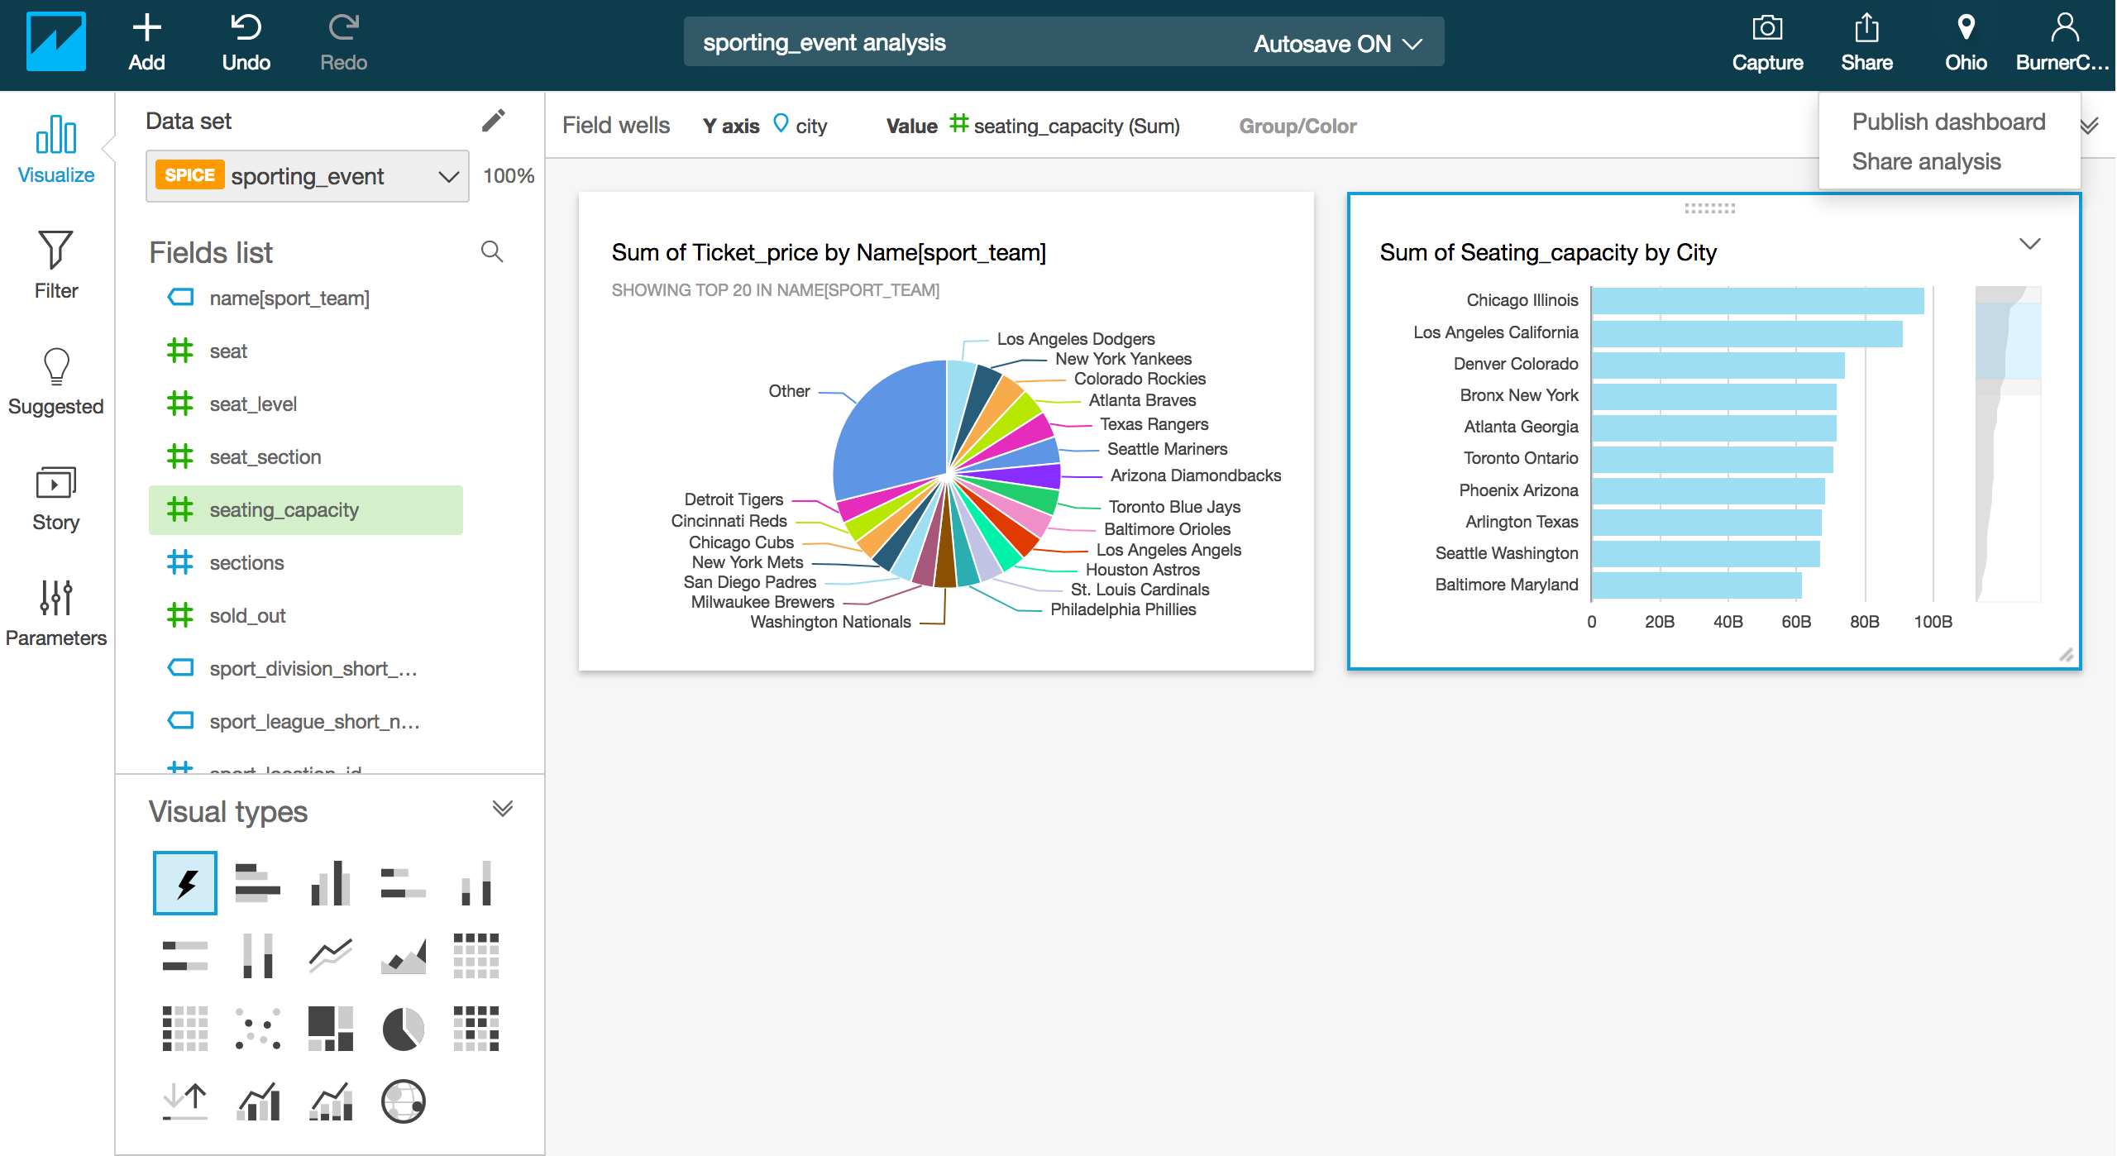

Give the Dashboard a name e.g. Ticket Price Analysis Dashboard and click Publish Dashboard.
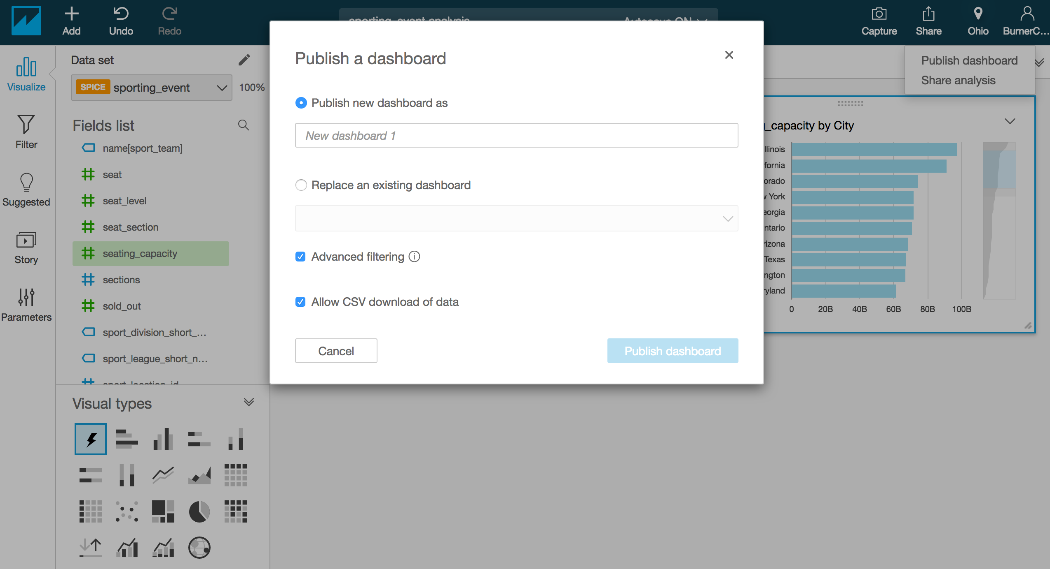

- For this lab just check “Share with all users in the account”. Then click Confirm, then click the X (upper right) to close the window displaying the active users with access to your dashboard

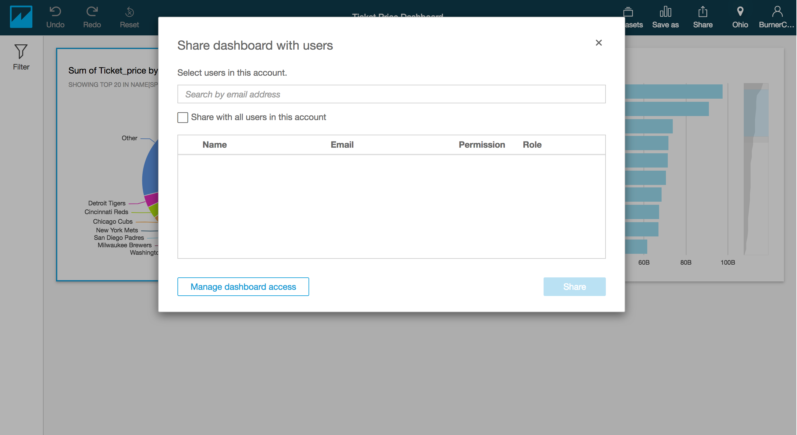

QuickSight has the ability to create and grant access to specific users to your Dashboard. This process can be found under “Manage QuickSight” under the user profile button.

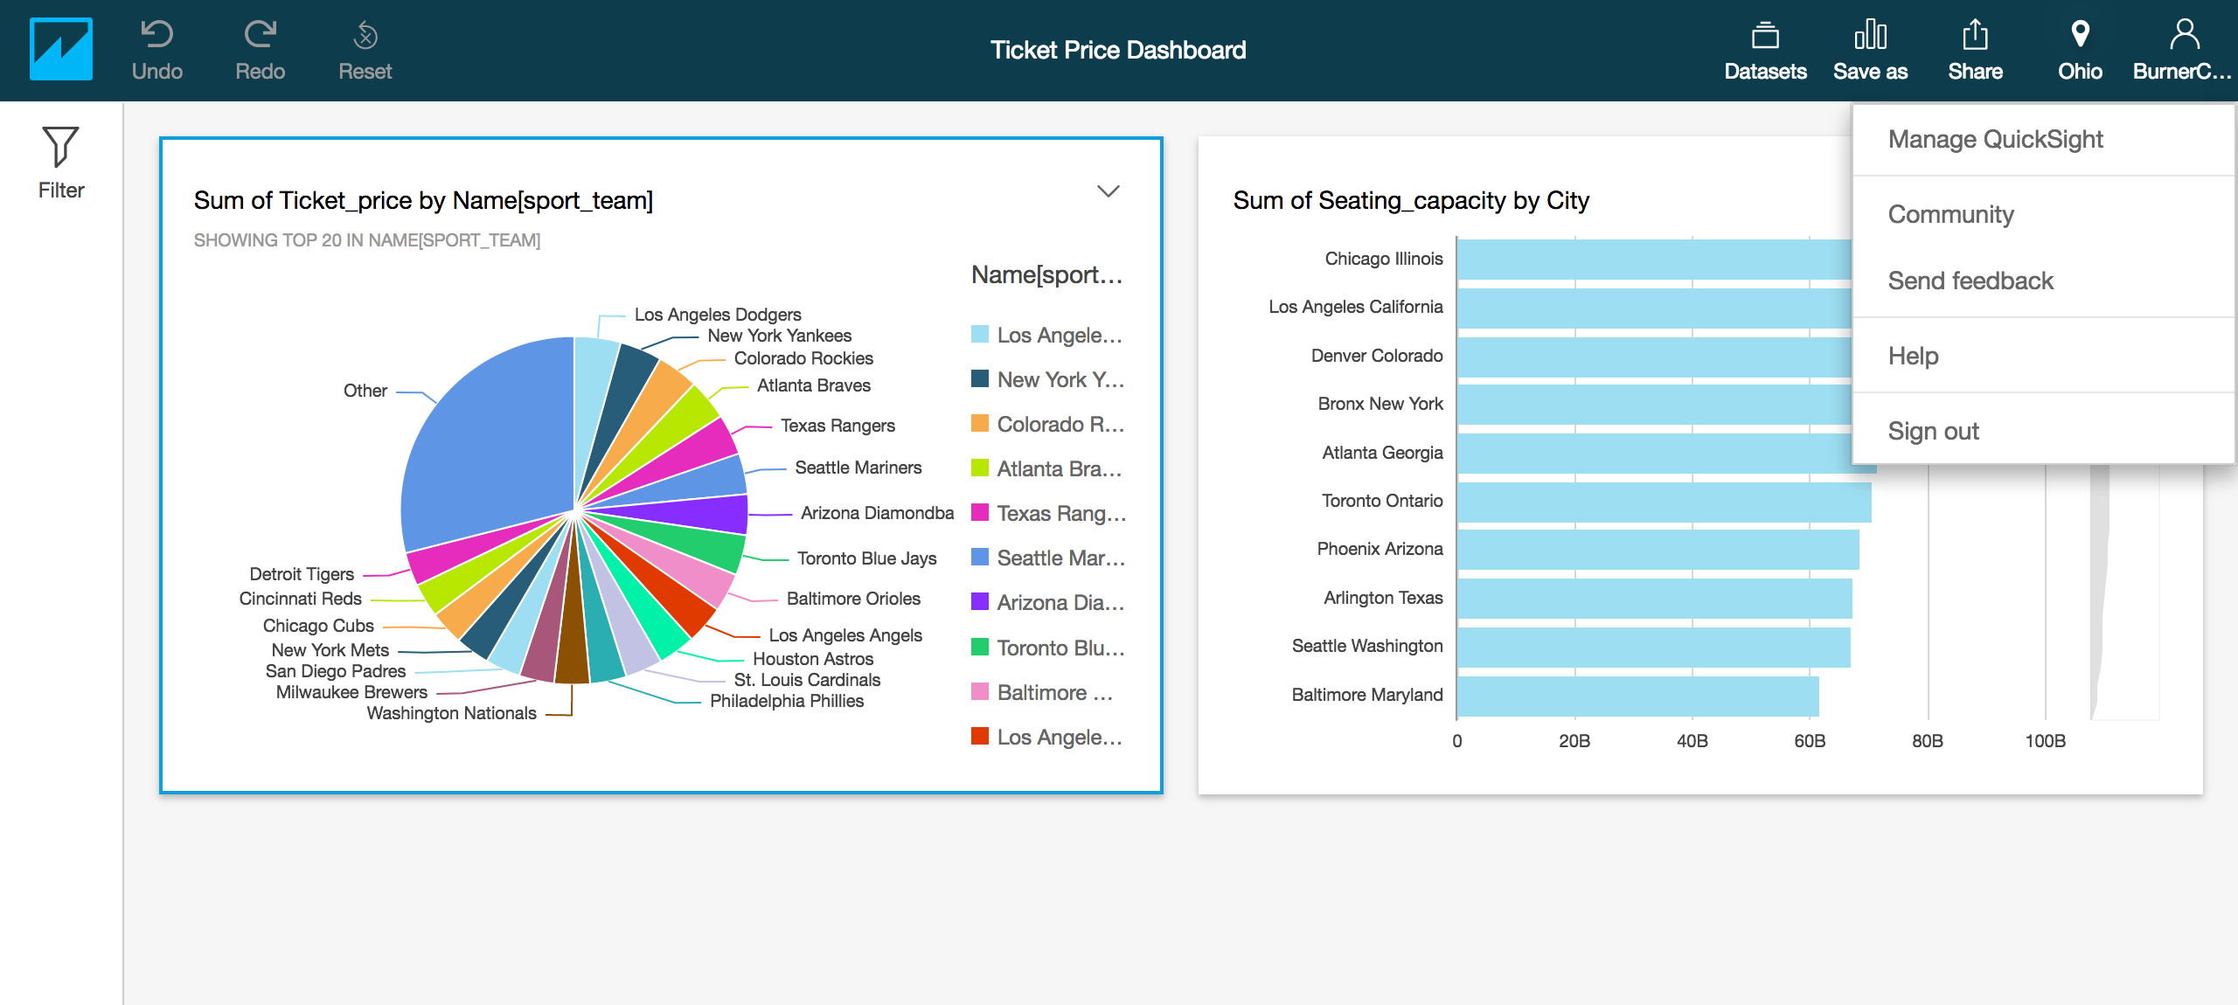

You can use a story to preserve multiple iterations of an analysis and then play them sequentially to provide a narrative about the analysis data. For example, you might want to see several versions of the analysis, all with the
same charts but with different filters applied.

Exercise Recap:
In this exercise, we created data visualizations in QuickSight from data that was stored in Athena. Once the data source was configured, we created datasets from the Athena data source. Using these datasets we created visualizations to better understand the data.

Important – Delete all resources
Make sure you delete DMS Task and the DMS Replication instance. Once the replication instance is deleted you should be able to delete the QuickSight Account, then delete the CloudFormation stack, which will in turn delete all other resources.
Note: If you do not delete resources they will keep incurring charges.

Delete all resources:
You will want to delete all resources to avoid incurring additional cost.

1. Navigating to the DMS page from the AWS Management Console. Stop running tasks.
2. Delete tasks from DMS console.
3. Delete all end points from DMS console.
4. Delete both baseball and football migrating replication instances.
5. Once the replication instances are deleted, you may delete other resources using CloudFormation. Navigate to the CloudFormation page from the AWS Management Console.
6. Delete the stack created for the workshop.
7. Ensure CloudFormation completes the delete process. This can take several minutes.
8. Delete S3 Buckets used during this workshop
9. Delete Athena databases
10. Delete Quicksight

Dropping Tables from Athena:
- From the Athena console, click on Catalog Manager
- Type the database you want to drop and press Drop:

Deleting Quicksight:
- From the QuickSight console, click on the user admin in the upper right hand corner and select, Manage Quicksight

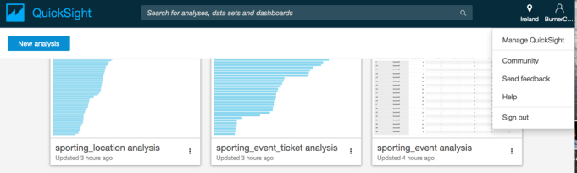

- From the left hand side, select Account Settings and scroll to the bottom and select Unsubscribe

Select Unsubscribe at the confirmation window

At this point, you will no longer incur billing charges for QuickSight, however, you may have some policies in place for QuickSight. If you no longer need these policies, you can detach in the IAM console.

