User Manual for InSAR-Based Pipeline Strain Analysis in Landslide Areas

Prepared By

University of California, Berkeley

Youqi Zhang, youqi.zhang@berkeley.edu

Matthew De Jong, dejong@berkeley.edu

Tianyu Han, tyhan@berkeley.edu

Release date: October, 2026

Table of Contents
Table of Contents 2
1. Application Overview 4
1.1 Purpose of the Software 4
1.2 Intended Users 4
1.3 Main Capabilities 4
1.4 Workflow (Step 1 to Step 3) 5
1.5 Analysis Scope and Limitations 5
2. Quick Start Guide 6
3. Installation and Environment 7
4. User Interface Layout 7
4.1 Main Window Structure 7
4.2 Input Files and Run Controls 7
4.3 Parameter Panels 8
4.4 Visualization Panel 9
5. Input Data 10
5.1 Required Input Files 10
5.2 InSAR Data Requirements 11
6. Core Analysis Workflow 11
6.1 Workflow Overview 11
6.2 Step 1: DEM Processing 11
6.3 Step 2: Ground Deformation Analysis 12
6.4 Step 3: Pipeline Displacement and Strain 13
6.5 Run All Steps 17
7. Visualization and Strain Display Options 17
7.1 Result Tabs 17
7.2 Strain Display Logic 17
8. Export, State, and Reproducibility 18
9. Logs and Performance 19
10. Glossary 19

1. Application Overview

1.1 Purpose of the Software
This software provides a desktop environment for assessing pipeline displacement and strain induced by landslide-related ground deformation. It processes ascending and descending InSAR observations to estimate three-dimensional ground displacement, which is subsequently mapped onto pipeline networks for axial and bending strain calculations.
The workflow consists of three processing stages: DEM preprocessing, InSAR displacement inversion, and pipeline response estimation. Intermediate results can be inspected through the visualization panel, allowing users to check terrain aspect, displacement fields, and pipeline mesh quality before proceeding to subsequent calculations.

1.2 Intended Users
The manual is written for geotechnical engineers, GIS practitioners, and infrastructure risk analysts. The user should be familiar with InSAR LOS data, coordinate systems, and basic pipeline inventory fields.
The tool can also support project managers and reviewers who need to inspect processing assumptions and compare runs across parameter settings.

1.3 Main Capabilities
The current release supports a complete three-stage pipeline from raw geospatial inputs to pipeline strain maps.
- DEM preprocessing: Merges DEM tiles, computes slope aspect, and optionally smooths the terrain field.
- InSAR pair processing: Matches ascending and descending observations by date and spatial proximity.
- N/E/Z inversion: Solves three displacement components using LOS geometry and an aspect-based constraint.
- Quality filtering: Removes unstable inversion points based on condition number.
- Contour-based selection: Allows users to pick and save a landslide contour and selected pipeline lines.
- Pipeline meshing: Builds a node-element representation from selected lines with configurable spacing.
- Response mapping: Interpolates displacement to mesh nodes and computes axial and bending strain.
- Visualization controls: Provides controls for date, direction, map limits, strain type, strain period, and diameter-field usage.
- Reproducibility tools: Supports save/load workflow state, parameter presets, and timestamped exports.

1.4 Workflow (Step 1 to Step 3)
A standard analysis run follows Step 1, Step 2, and Step 3 in order.
Step 1 prepares terrain context from DEM inputs. Step 2 solves ground displacement components from paired InSAR observations. Step 3 focuses the analysis on a selected landslide area and evaluates pipeline response in that area. The user can also run grouped shortcuts to reduce repetitive clicks.
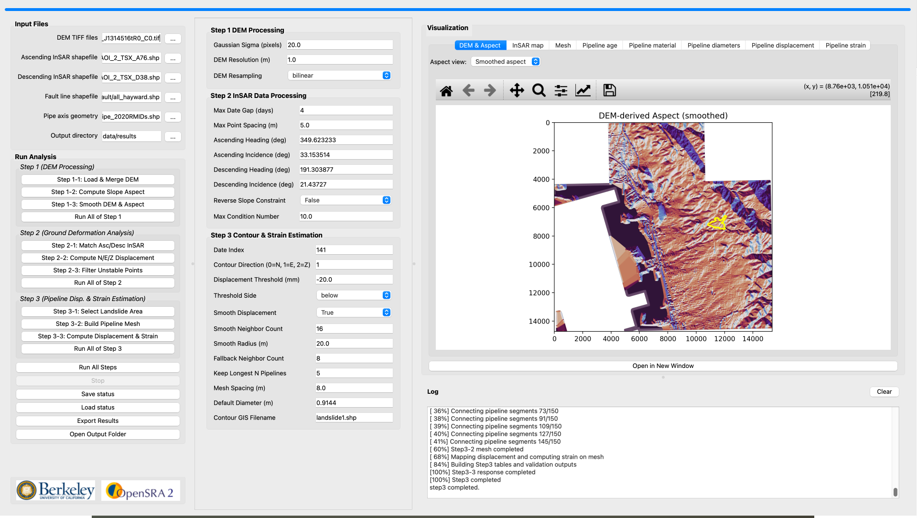

1.5 Analysis Scope and Limitations
This application supports engineering interpretation, screening, and comparison. It is not a substitute for detailed structural design calculations.
Result quality depends on data coverage, LOS geometry, DEM quality, and contour selection. Parameter settings also influence interpolation behavior and mesh density.
In the Pipeline strain tab, strain-period and diameter-field options are display controls. They modify visualization results but do not overwrite stored Step 3-3 arrays.

2. Quick Start Guide
Prepare these inputs before the first run: one or two DEM GeoTIFF files, ascending and descending InSAR shapefiles, a fault-line shapefile, and a pipeline-axis shapefile.
Open the application and check all input paths in the left panel. Keep default parameters for the first test run unless project requirements say otherwise.
Run Step 1 first. After completion, inspect the DEM & Aspect tab. Check that aspect patterns look consistent with local terrain behavior.
Run Step 2 next. Inspect the InSAR map using different dates and N/E/Z directions. Keep vmin and vmax symmetric around zero for balanced interpretation. The default values are -80 and 80.
Run Step 3 after Step 2 is validated. In the contour picker, save a contour that captures the landslide zone. Continue to mesh and strain mapping.
After Step 3-3, review Pipeline displacement and Pipeline strain tabs. Save workflow status and export the run folder when results are ready for sharing.

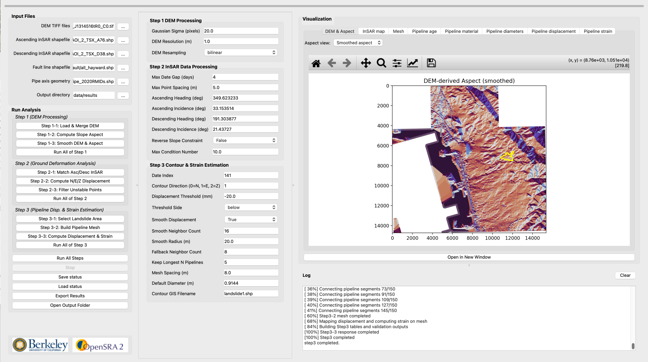

3. Installation and Environment
The software can run from a packaged executable on both MacOS and Windows platforms. A 64-bit operating system is recommended. Adequate memory is required for DEM merge and geospatial plotting. Write permission is required for output and state files.

4. User Interface Layout

4.1 Main Window Structure
The interface is divided into three vertical regions. The left region manages file input and run actions. The center region contains processing parameters. The right region contains visualization tabs and the log panel. A progress bar is shown at the top. During active processing, run controls are disabled to prevent conflicting actions.

4.2 Input Files and Run Controls
Use the Input Files panel to set required paths before running the workflow.
Each row has a browse button. The DEM input expects two raster paths in one field.
The Run Analysis panel contains the following buttons:
- Step 1-1: Load & Merge DEM
Loads the DEM tiles and merges them into one analysis raster.
- Step 1-2: Compute Slope Aspect
Computes slope aspect from the merged DEM.
- Step 1-3: Smooth DEM & Aspect
Applies DEM smoothing and updates the aspect field.
- Run All of Step 1
Runs Step 1-1, Step 1-2, and Step 1-3 in sequence.
- Step 2-1: Match Asc/Desc InSAR
Matches ascending and descending InSAR observations by date and location.
- Step 2-2: Compute N/E/Z Displacement
Solves North, East, and Vertical displacement components.
- Step 2-3: Filter Unstable Points
Filters points using condition-number criteria and prepares Step 2 outputs.
- Run All of Step 2
Runs Step 2-1 through Step 2-3 in sequence.
- Step 3-1: Select Landslide Area
Opens the contour picker and saves selected contour outputs.
- Step 3-2: Build Pipeline Mesh
Builds the pipeline mesh from selected lines.
- Step 3-3: Compute Displacement & Strain
Maps displacement to mesh nodes and computes axial and bending strain.
- Run All of Step 3
Runs Step 3-1 through Step 3-3 in sequence.
- Run All Steps
Runs Step 1 and Step 2 from a clean state, then prompts contour selection and continues Step 3 if confirmed.
- Stop
Sends a stop request to the active background task.
- Save status
Saves the current workflow state and configuration for later reuse.
- Load status
Restores a previously saved workflow state.
- Export Results
Exports arrays, tables, figures, and configuration to a timestamped run folder.
- Open Output Folder
Opens the configured output directory in the system file browser.

The Stop button sends a cancellation signal to the running worker. Cancellation is cooperative, so termination may occur after the current internal operation finishes.

4.3 Parameter Panels
Parameter controls are grouped by stage to match the workflow.
The list below explains every control in the center panel.
Step 1 DEM Processing
- Gaussian Sigma (pixels): Width of the Gaussian filter applied to the merged DEM in Step 1-3. A larger value produces a smoother slope aspect. The default is 20.
- DEM Resolution (m): Target ground resolution used when the two DEM tiles are merged. The default is 1 m.
- DEM Resampling: Method used to resample DEM cells during the merge. Choices are nearest, bilinear, and cubic. The default is bilinear.
Step 2 InSAR Data Processing
- Max Date Gap (days): Largest allowed day difference when pairing one ascending date with one descending date. Pairs outside this gap are rejected. The default is 4 days.
- Max Point Spacing (m): Largest allowed distance when pairing an ascending point to a descending point. The default is 5 m.
- Ascending Heading (deg): Satellite heading of the ascending track. It is used in the LOS-to-N/E/Z conversion.
- Ascending Incidence (deg): Radar incidence angle of the ascending track. It is used in the LOS-to-N/E/Z conversion.
- Descending Heading (deg): Satellite heading of the descending track. It is used in the LOS-to-N/E/Z conversion.
- Descending Incidence (deg): Radar incidence angle of the descending track. It is used in the LOS-to-N/E/Z conversion.
- Reverse Slope Constraint: If True, the sign of the slope-aspect constraint is flipped. Use this when the downslope direction convention is reversed. The default is False.
- Max Condition Number: Points with a condition number at or above this value are removed in Step 2-3. The remaining points are used for maps and Step 3 interpolation. The default is 10.
Step 3 Contour and Strain Estimation
- Date Index: Zero-based index of the matched date pair used for contour picking and displacement mapping. It stays in sync with the Visualization Date list. The default is 141.
- Contour Direction (0=N, 1=E, 2=Z): Displacement component used to build the contour field. 0 is North, 1 is East, and 2 is Vertical. It stays in sync with the Visualization NEZ control. The default is 1 (East).
- Displacement Threshold (mm): Contour level used to define the landslide field. The default is -20 mm.
- Threshold Side: Which side of the threshold is treated as the landslide field. below keeps values at or below the threshold. above keeps values at or above the threshold. The default is below.
- Smooth Displacement: If True, the contour-picker field is smoothed before polygons are built. The default is True.
- Smooth Neighbor Count: Number of nearby points used in the Gaussian smooth for the contour field. The default is 16.
- Smooth Radius (m): Gaussian bandwidth for field smoothing and for mapping displacement onto the mesh. The default is 20 m.
- Fallback Neighbor Count: Neighbor count used if the first interpolation neighborhood is too small. The default is 8.
- Keep Longest N Pipelines: Number of longest connected pipeline components kept when the mesh is built. The default is 5.
- Mesh Spacing (m): Target distance between mesh nodes along selected pipeline lines. The minimum is 1 m. The default is 8 m.
- Default Diameter (m): Uniform pipe diameter used for bending strain when the diameter field is off or missing. The default is 0.9144 m.
- Contour GIS Filename: Filename written for the selected-line shapefile after Step 3-1. The default is landslide1.shp.

4.4 Visualization Panel
The Visualization panel contains eight tabs for inspecting intermediate and final results. Each tab becomes available once the corresponding processing step has been completed.
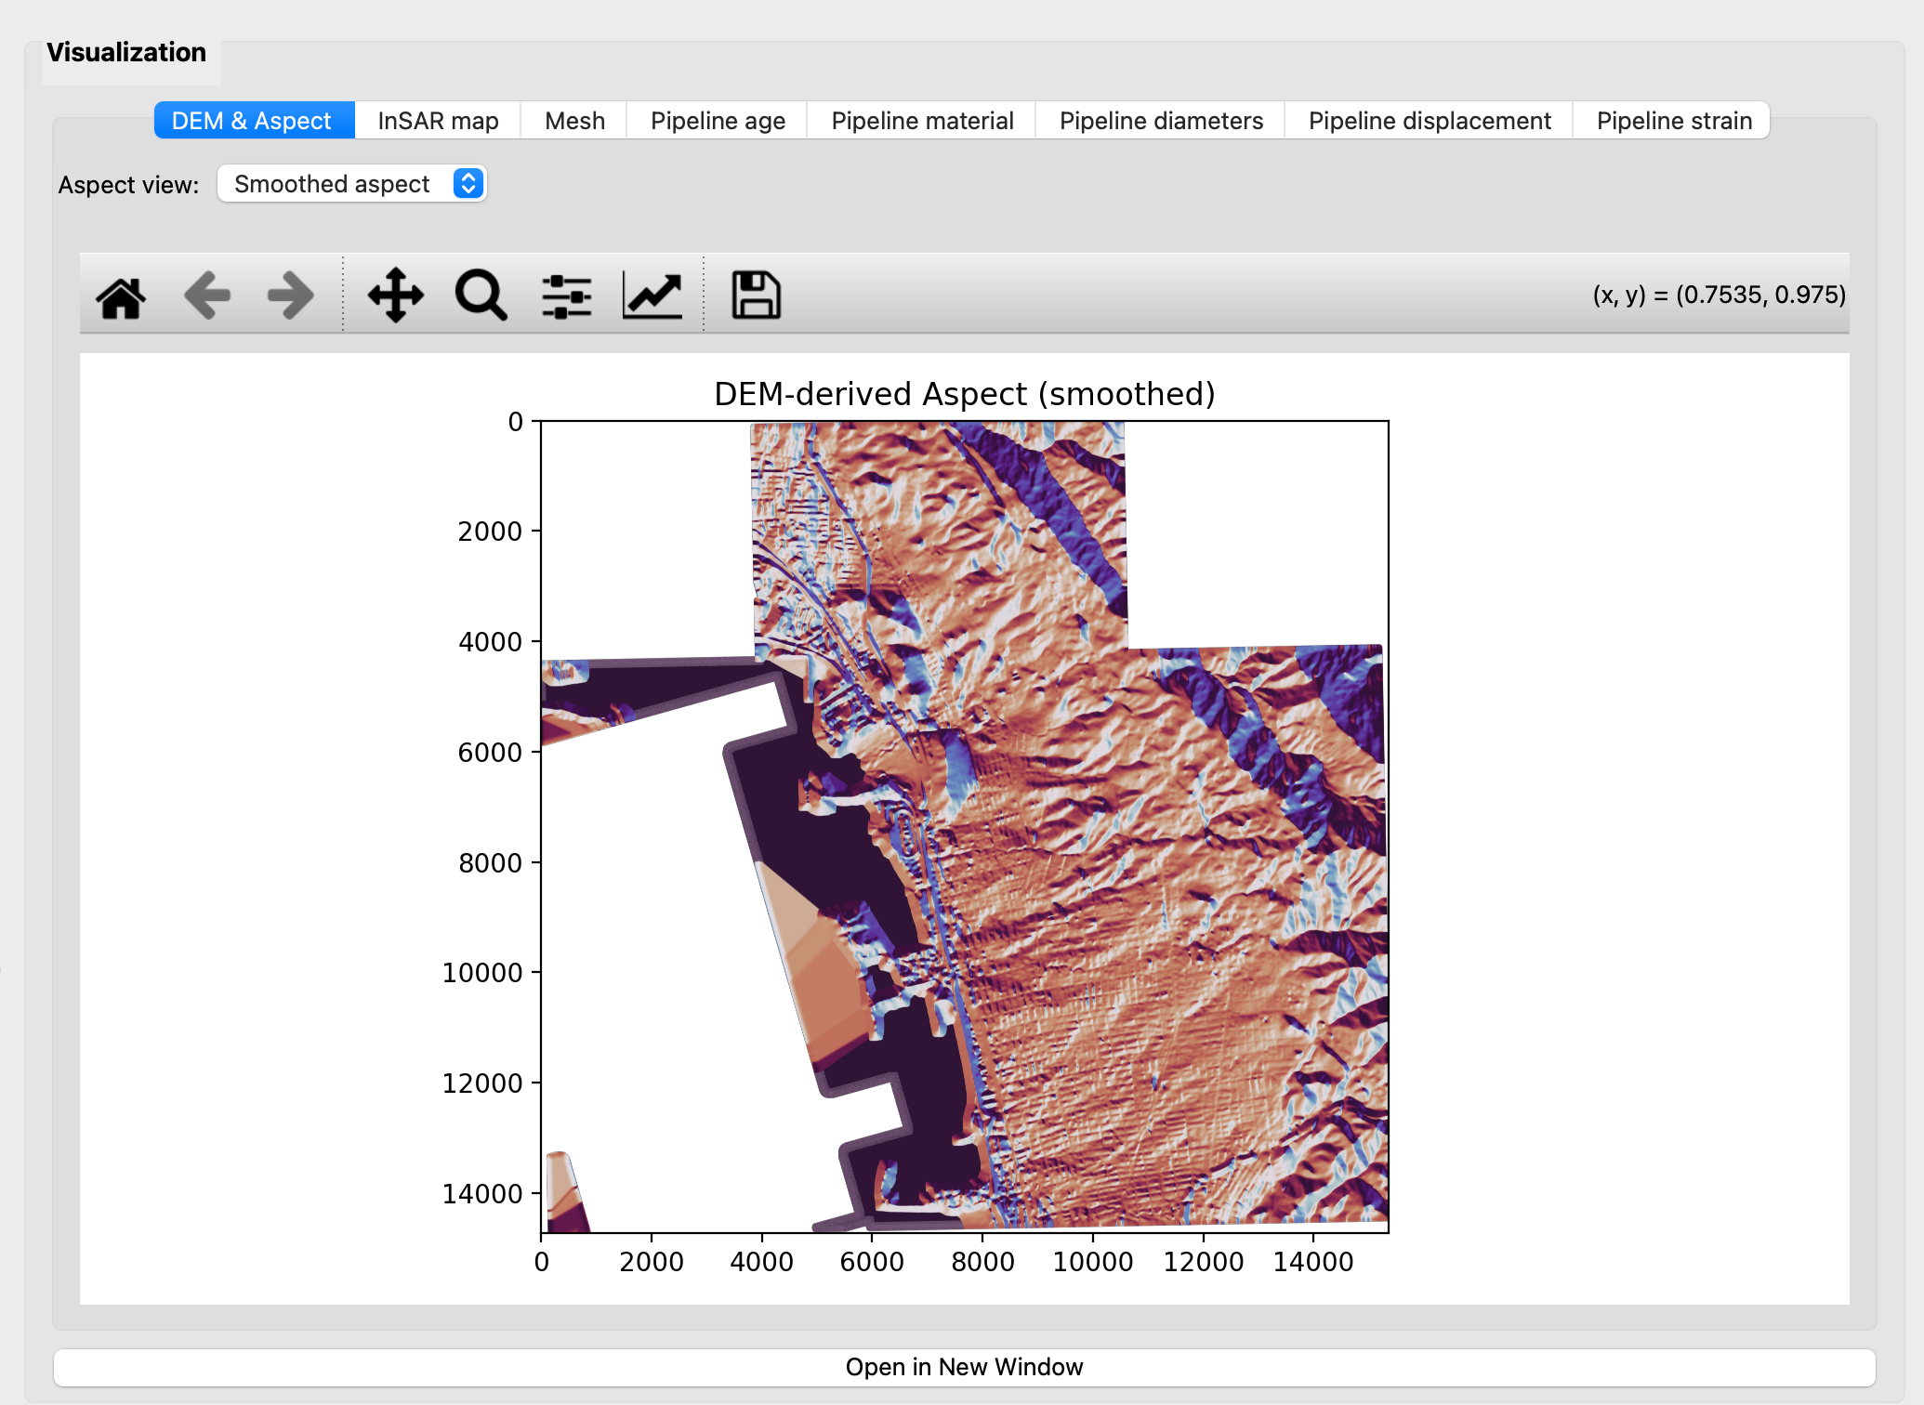
- DEM & Aspect: Displays the terrain aspect calculated in Step 1. Users can switch between raw aspect (Step 1-2) and smoothed aspect (Step 1-3) using the Aspect view control. A landslide outline is also displayed if a contour has been selected. The aspect map can be used to examine local slope directions before proceeding to the InSAR displacement analysis.
- InSAR map: Visualizes the North, East, and Vertical displacement components obtained from Step 2, together with pipeline and fault-line overlays. Users can select the acquisition date and displacement component (NEZ), switch between Complete field and Filtered field, and adjust the color scale (vmin/vmax) and map extent (xlim/ylim). Comparing the complete and filtered fields helps identify points removed by the condition-number filter.
- Mesh: Shows the pipeline nodes and elements generated in Step 3-2. The map extent can be adjusted using xlim and ylim. Users should inspect the mesh connectivity and node spacing before calculating pipeline displacement and strain.
- Pipeline age: Presents the age distribution of pipeline segments selected in Step 3-1. The map provides the pipeline age information used for estimating strain over the service life of the pipelines. The displayed area can be adjusted using xlim and ylim.
- Pipeline material: Maps the material types of the pipeline segments selected in Step 3-1, based on their inventory attributes. Users can adjust the map extent using xlim and ylim.
- Pipeline diameters: Displays the nominal diameters of the selected pipeline segments based on the available inventory data. These values can be used in bending strain calculations when the Consider pipeline diameter field option is enabled. The map extent is controlled by xlim and ylim.
- Pipeline displacement: Shows the displacement interpolated from InSAR observations onto the pipeline mesh nodes in Step 3-3. The NEZ control allows users to switch between North, East, and Vertical components. The displayed displacement values are not affected by the strain-period scaling options.
- Pipeline strain: Displays the axial and bending strain calculated in Step 3-3. Users can select the strain type (Axial or Bending), adjust the strain period, and enable or disable the Consider pipeline diameter field option. The map extent can also be modified using xlim and ylim. These settings affect only the displayed strain values and do not modify the stored Step 3-3 results.

5. Input Data

5.1 Required Input Files
The software expects geospatial inputs that can be projected to a common processing CRS.
Input | Expected Format | Use in Workflow
DEM | Two GeoTIFF files | Used in Step 1 for aspect derivation.
Ascending InSAR | Point shapefile with date columns | Used in Step 2 matching and inversion.
Descending InSAR | Point shapefile with date columns | Used in Step 2 matching and inversion.
Fault line | Line shapefile | Displayed as map context in red.
Pipeline axis | Line shapefile | Source geometry for contour clipping and meshing.

After Step 3-1, selected-line attributes support attribute maps and life-scaling logic. Age and diameter fields can come from the same shape file.

5.2 InSAR Data Requirements
Ascending and descending datasets should have sufficient overlap in both space and acquisition period. Date fields should be consistent and parseable.
Incorrect heading or incidence values will directly affect solved N/E/Z directionality. When unexpected patterns appear, verify LOS geometry settings before continuing to Step 3.

6. Core Analysis Workflow

6.1 Workflow Overview
Every run action starts a background worker. Progress updates and status text are written to the log. Completed runs refresh all relevant tabs.
Dependency checks are enforced in the interface. For example, Step 3-2 requires Step 3-1 output, and Step 3-3 requires Step 3-2 mesh output.

6.2 Step 1: DEM Processing
Step 1-1 reads and merges DEM tiles. Step 1-2 computes raw slope aspect. Step 1-3 smooths the DEM and recomputes aspect.
If Step 1 is rerun after Step 2 or Step 3 exists in memory, the interface asks for confirmation. This prevents accidental invalidation of downstream results.

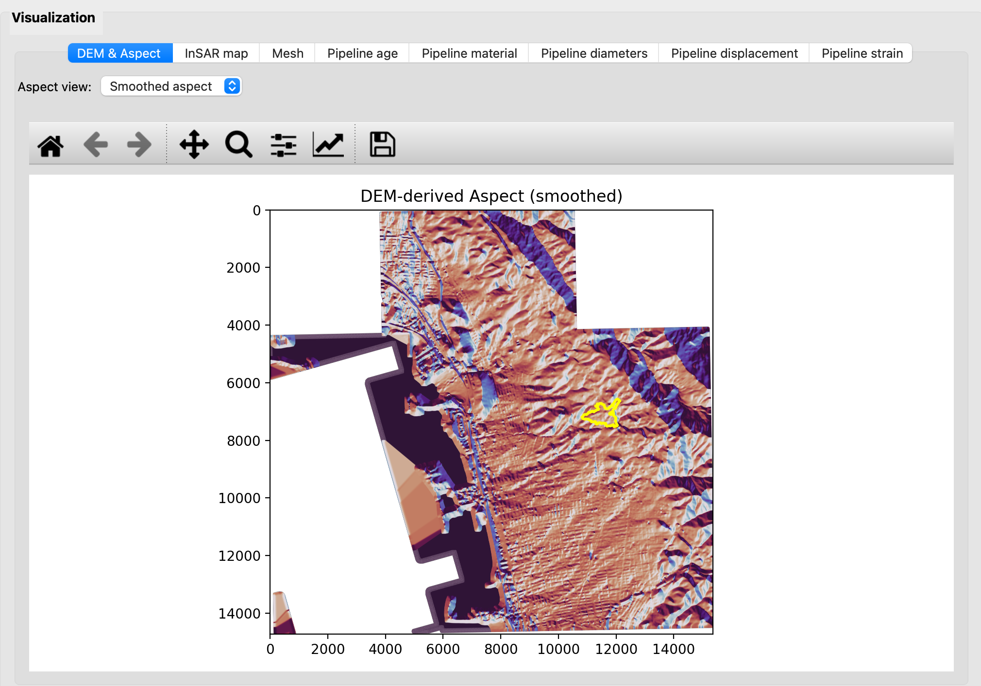

6.3 Step 2: Ground Deformation Analysis
Step 2-1 performs temporal and spatial matching between ascending and descending observations. It also samples terrain aspect at matched coordinates.
Step 2-2 solves North, East, and Vertical displacement using LOS equations and a slope-aspect constraint equation.
Step 2-3 computes condition numbers, filters unstable points, and writes summary outputs. Remaining points become the source for map display and Step 3 interpolation.

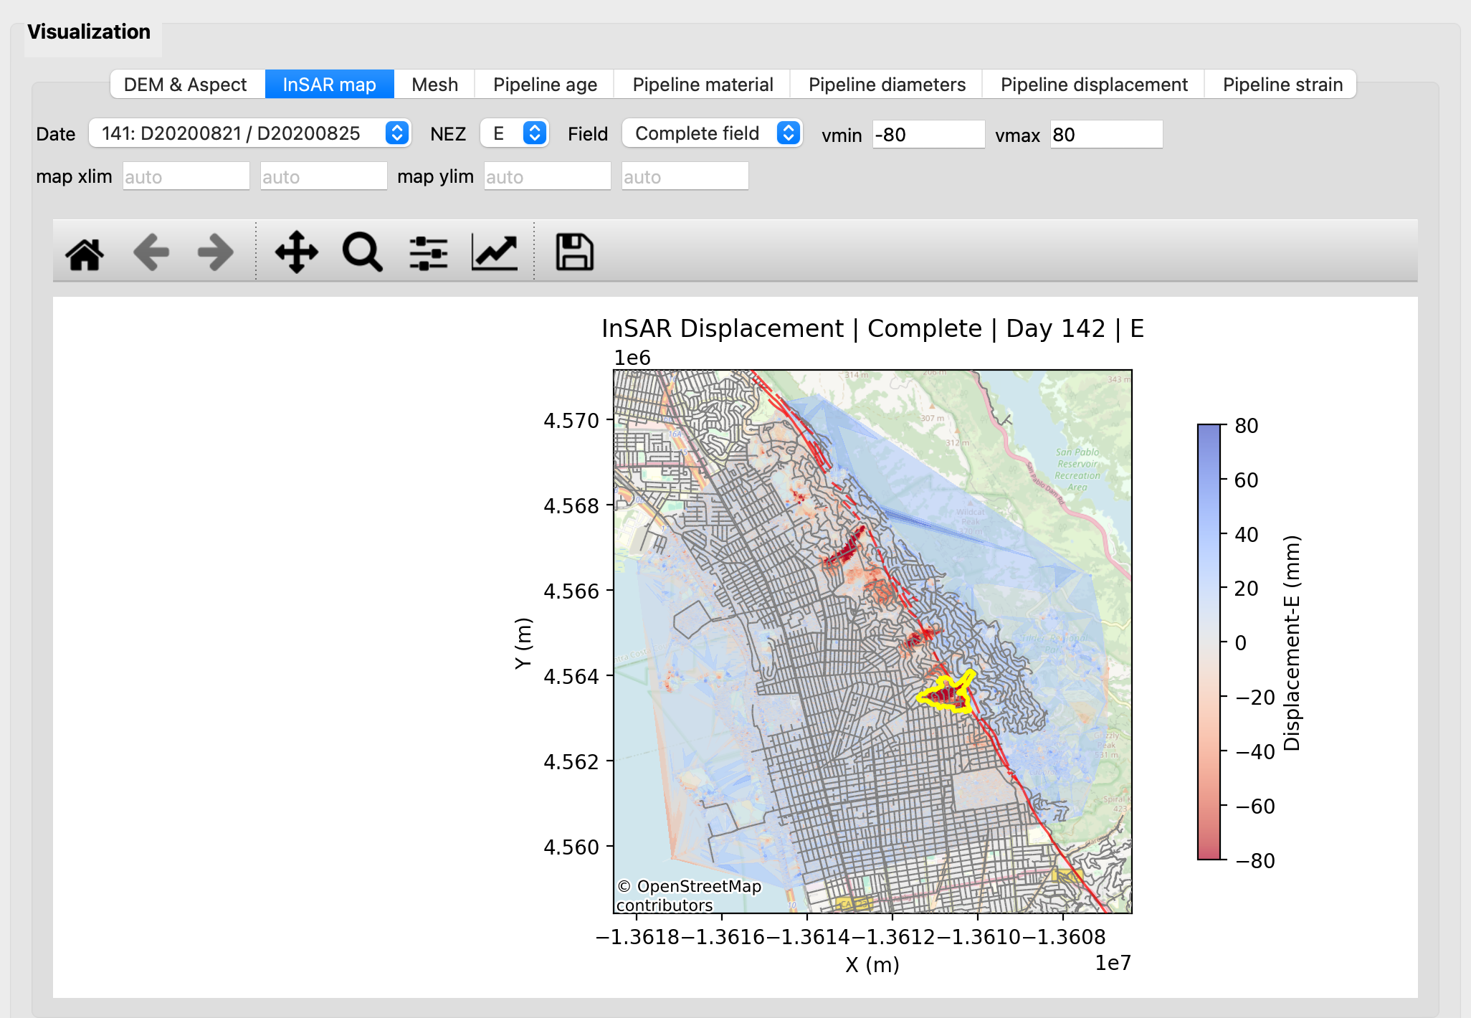

6.4 Step 3: Pipeline Displacement and Strain
Step 3-1 opens an interactive contour picker. The user selects and saves one contour polygon. The software then writes selected pipeline lines to GIS output.
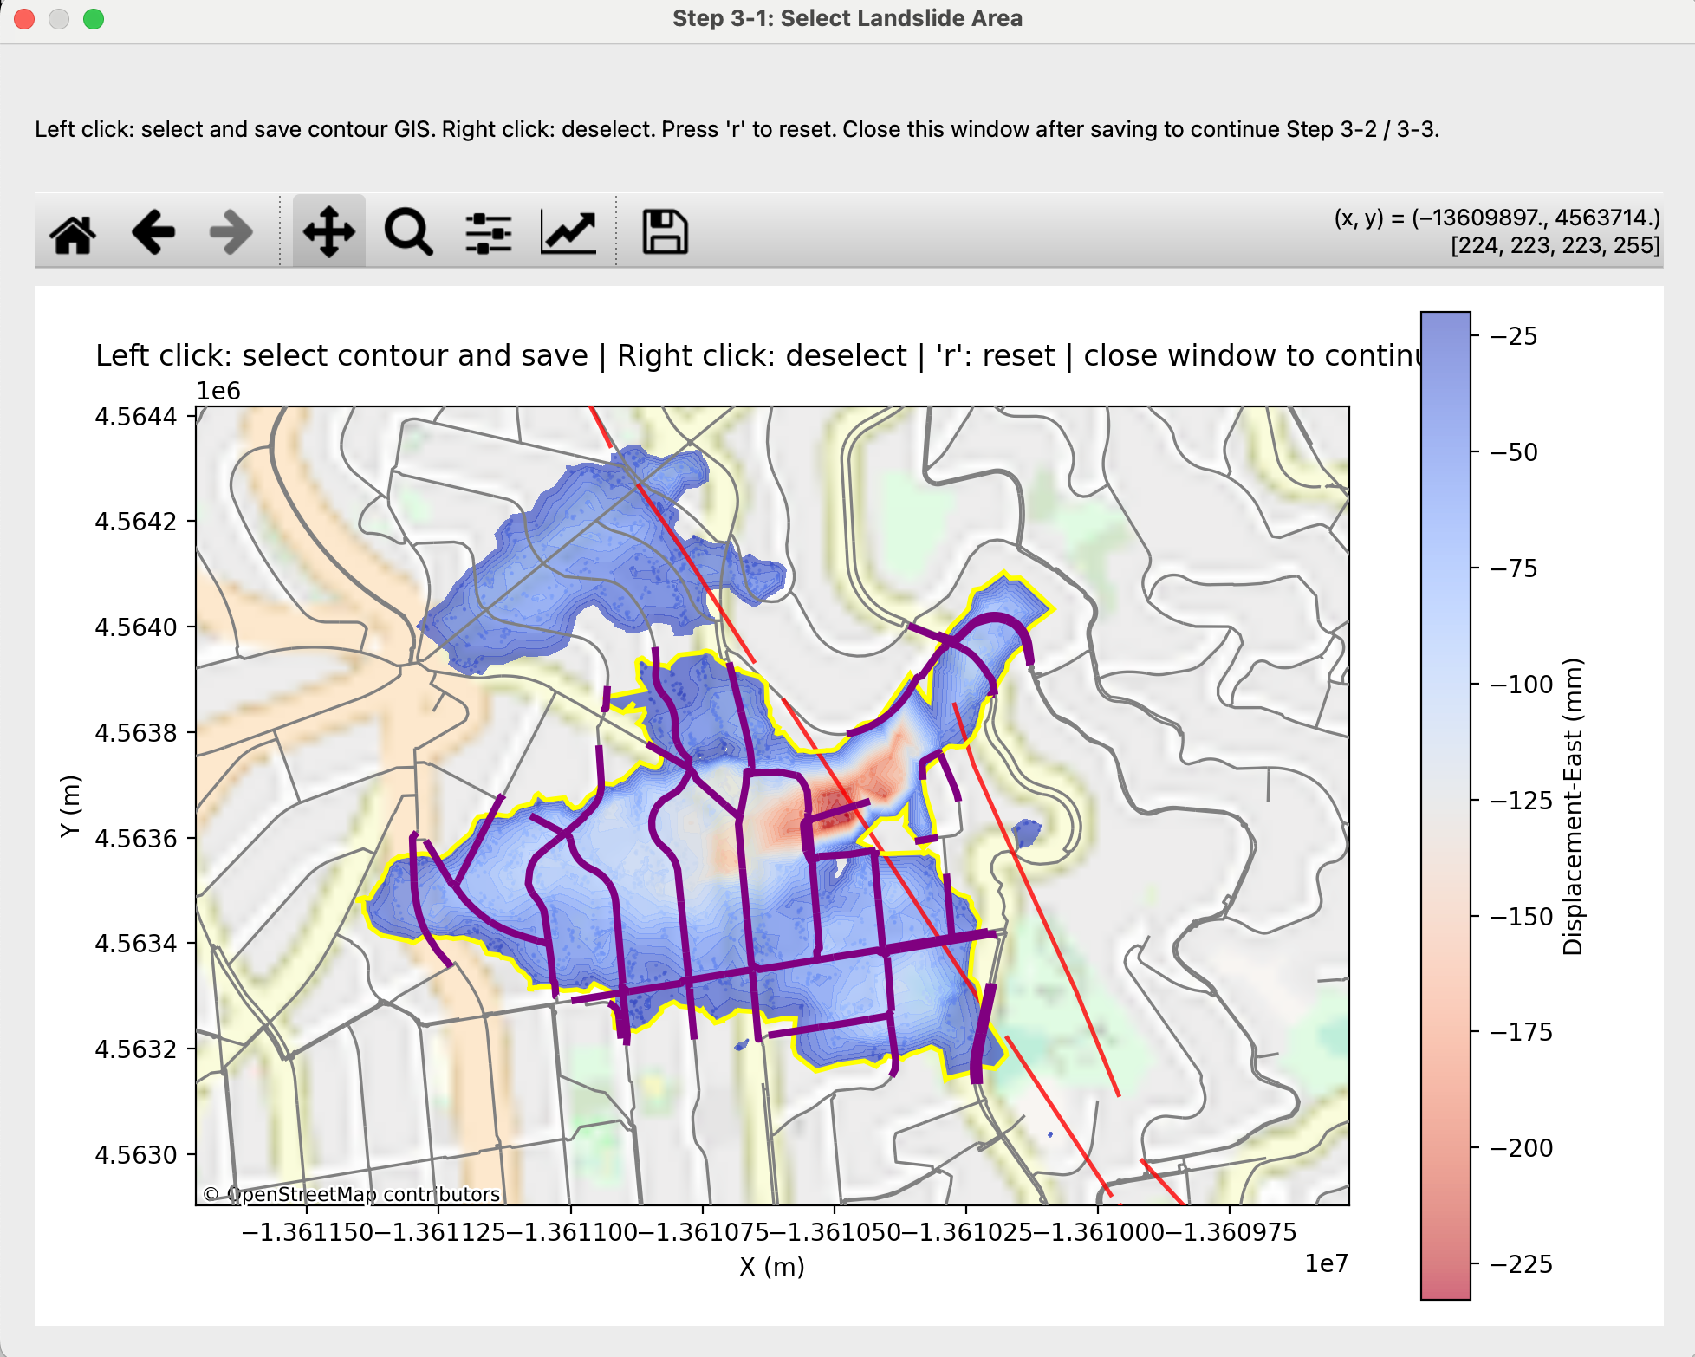
Step 3-2 builds a mesh from selected lines. Mesh spacing and retained component count are controlled by user parameters.
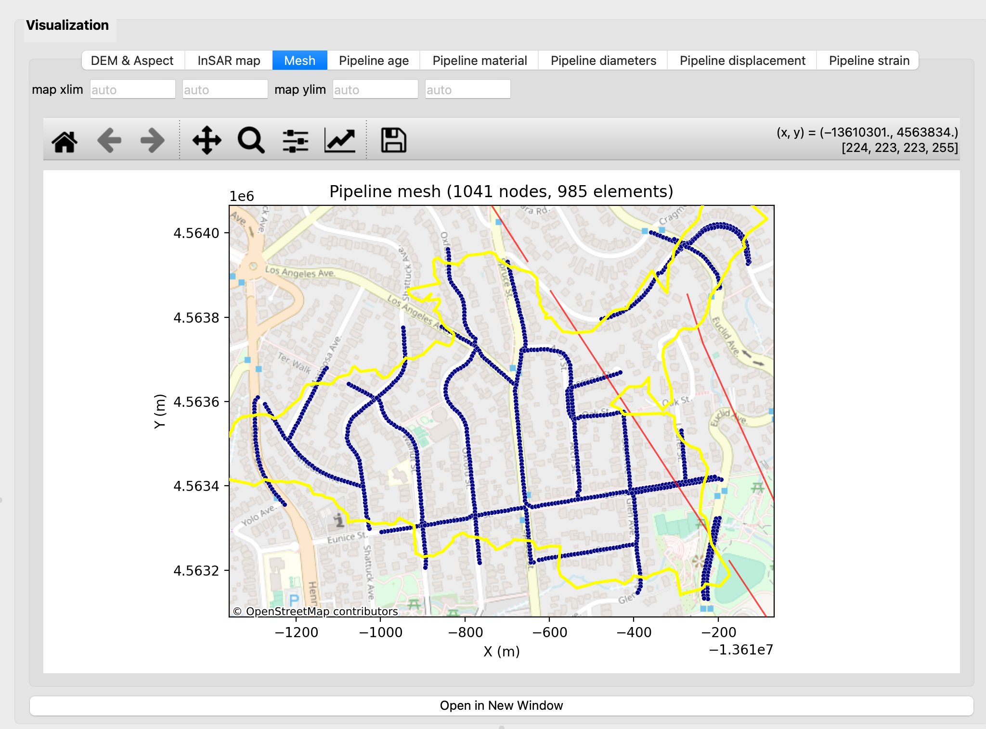
Step 3-3 interpolates displacement from retained InSAR points to mesh nodes. It computes axial strain on elements and bending strain at nodes.

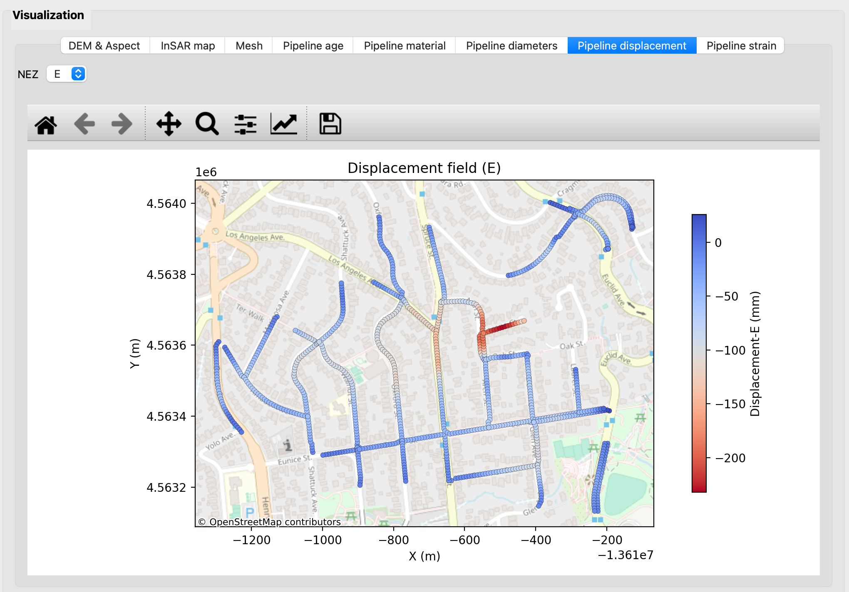

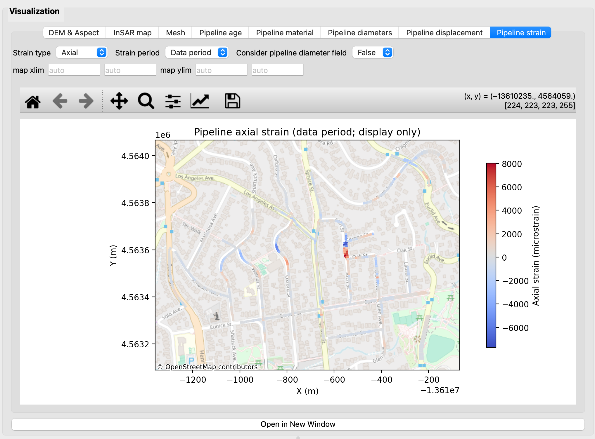

Attribute tabs for age, material, and diameter become available after Step 3-1. Mesh and response tabs require later Step 3 stages. The age field is used for a quick, rough estimate of pipeline strain over its entire service life via linear interpolation. This provides a conservative estimate because soil-structure interaction (SSI) is ignored. Accounting for SSI generally smooths the strain distribution and mitigates stress concentrations, resulting in lower peak strain than when SSI is neglected.
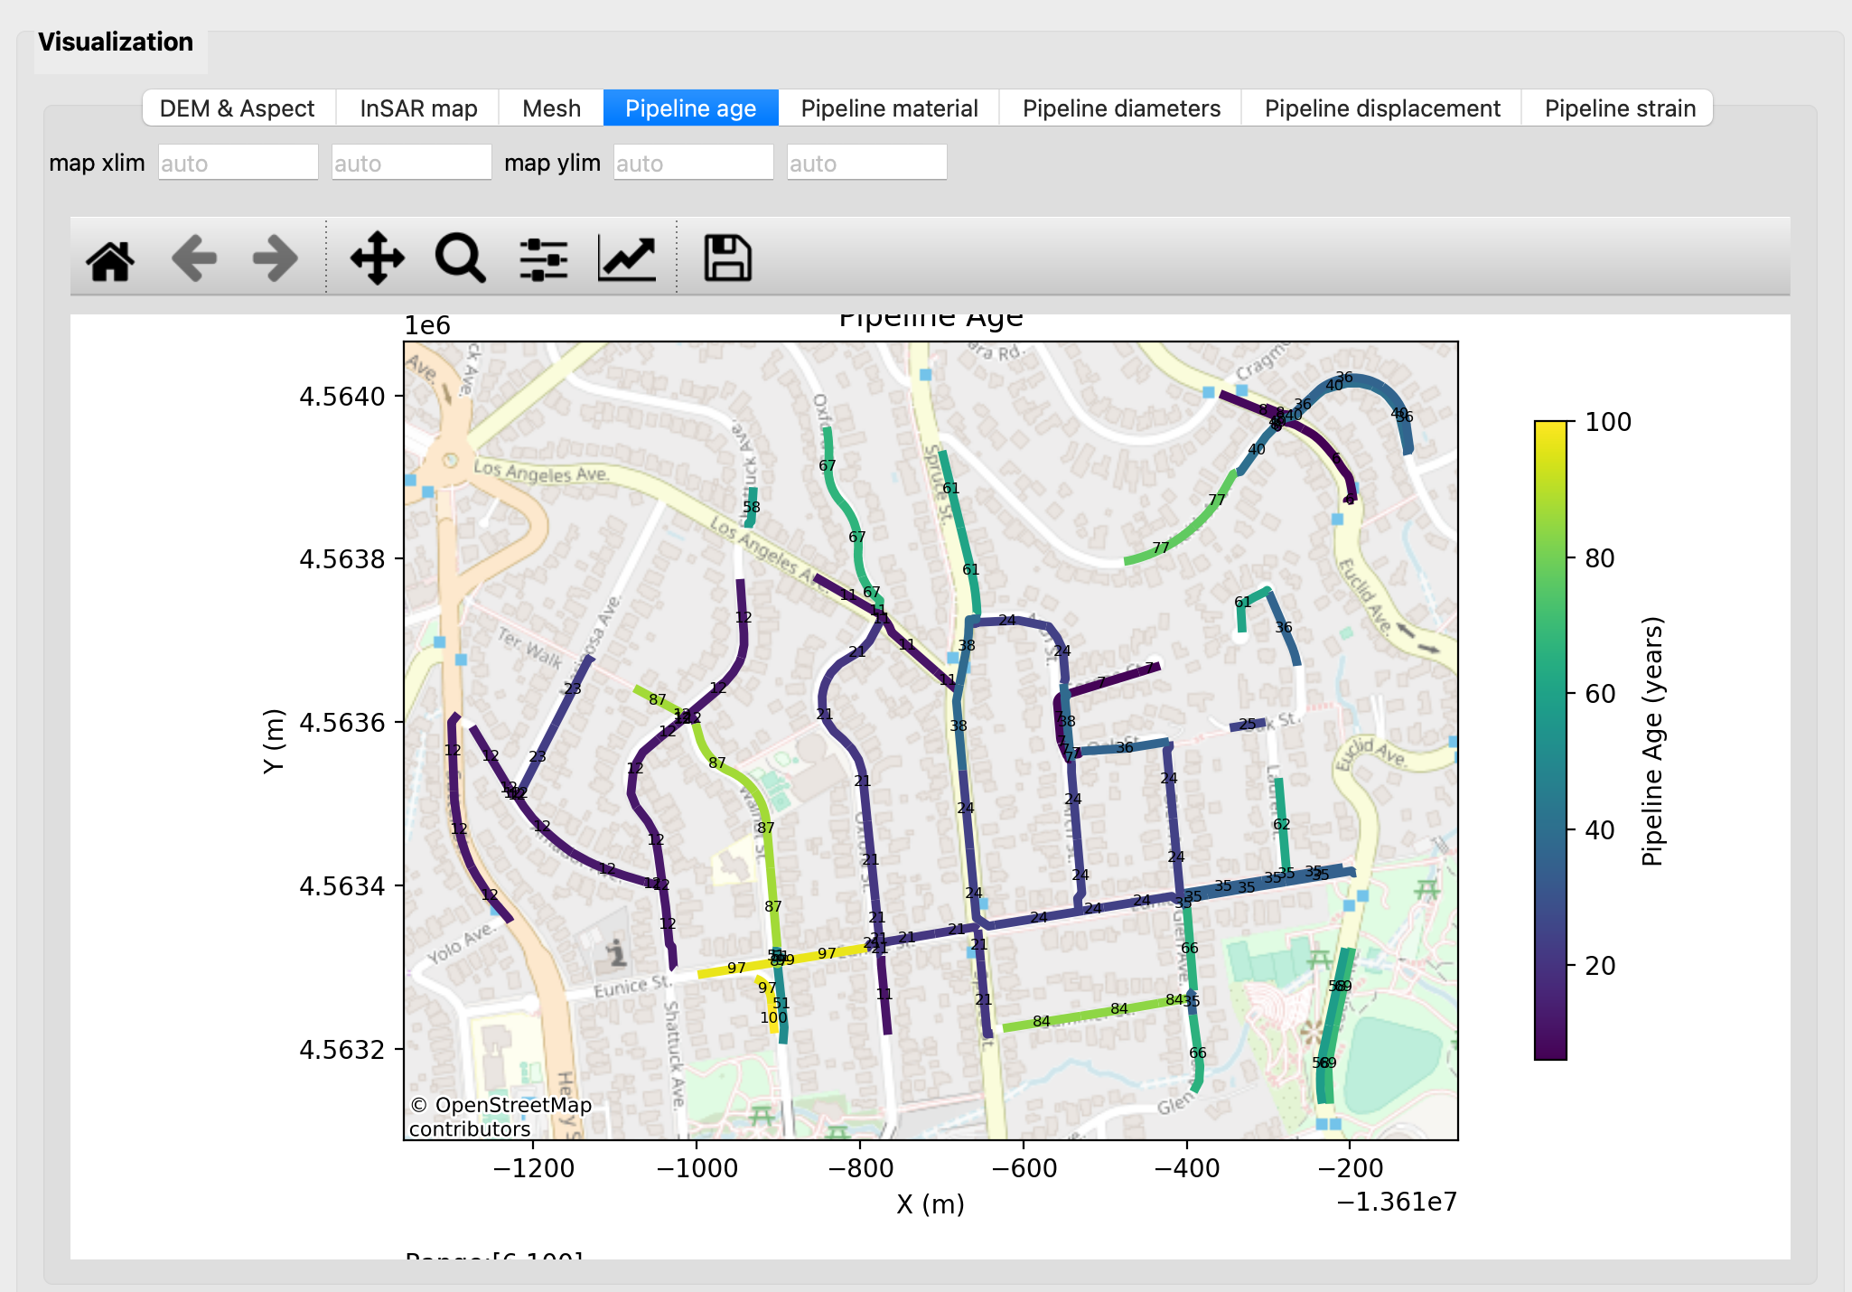
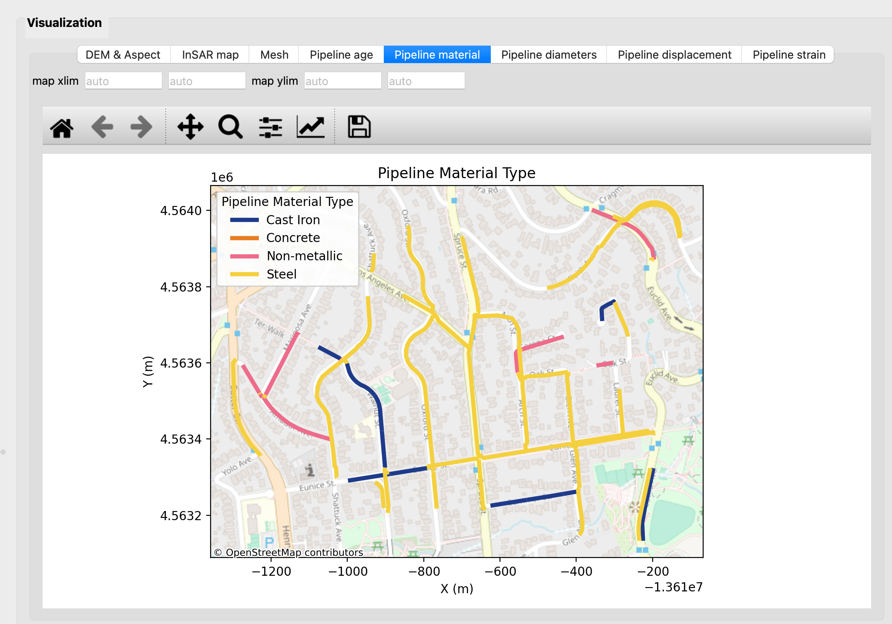
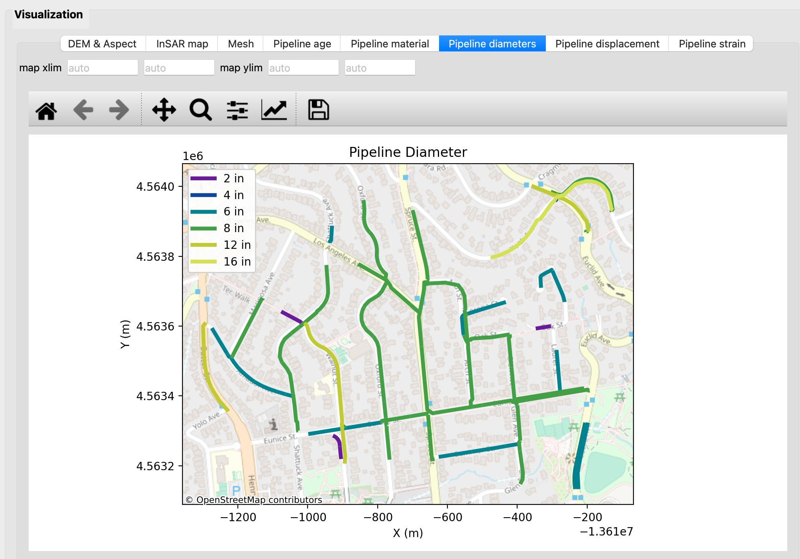

6.5 Run All Steps
Run All Steps is a convenience command. It resets analysis memory, executes Step 1 and Step 2, and then requests contour selection.
If contour selection is saved, Step 3 continues automatically. If contour selection is canceled, the sequence stops after Step 2 and logs the stop reason.

7. Visualization and Strain Display Options

7.1 Result Tabs
The result area includes DEM & Aspect, InSAR map, Mesh, Pipeline age, Pipeline material, Pipeline diameters, Pipeline displacement, and Pipeline strain tabs. Result tabs become available as the corresponding processing steps are completed.

7.2 Strain Display Logic
Stored Step 3-3 results represent data-period strain. Display controls can rescale these values without rerunning the solver.
- Strain type = Axial: Displays element-based axial strain.
- Strain type = Bending: Displays element color based on node-level bending recomputation.
- Strain period = Data period: Shows stored strain values directly.
- Strain period = Yearly: Divides stored strain by coverage years.
- Strain period = Entire life: Applies yearly strain scaled by age where age data is available.
- Diameter field option = True: Uses node diameters derived from NOMINALDIA for bending display when available.

Axial strain does not depend on diameter. Bending display can change with diameter choice. Exported figures capture the current display state.

8. Export, State, and Reproducibility
Save status stores configuration, workflow state objects, and selected contour context in one file. Load status restores the same state and redraws interface views.

Parameter presets are separate from workflow state. A preset updates configuration values only.
Export Results writes a timestamped run folder with config.json, array files, table files, and figure files.

9. Logs and Performance
The log panel records task progress, user actions, file save paths, and error traces. It is the first place to inspect when a run behaves unexpectedly.
Performance is driven by DEM merge size, point-matching complexity, and mesh density. Very fine mesh spacing increases interpolation and strain runtime.
If basemap loading fails due to network limits, map layers still render and analysis results remain valid.

10. Glossary
Term | Definition
LOS | Line-of-sight displacement from one InSAR track.
Matched date pair | One ascending date paired with one descending date within configured date gap.
NEZ | North, East, and Vertical displacement components.
Condition number | Numerical stability metric for local inversion equations.
Data period strain | Strain stored by Step 3-3 for the original temporal coverage.
Yearly strain | Display-only strain normalized by coverage years.
Entire-life strain | Display-only yearly strain scaled by age.
Microstrain | Strain multiplied by 10e6 for map display.

