Term Project Report

In this assignment, pandas, numpy and matplotlib were utilized to carry out signal processing. The assignment can be divided into 4 parts: plotting of the energy histogram, spatial positioning, crystal segmentation and the display of results.

**1. Energy histogram**

The first csv file named ‘Cs137.csv’ was read and its data was converted into a pandas data frame. An extra column ‘E’ was added by calculating it with the formula as below:

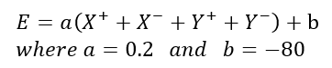

The values of ‘E’ were divided by 32 and filtered to be between 0 to 1500 only. The energy histogram was then plotted using matplotlib.

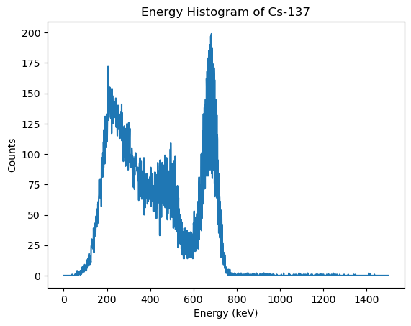

**2. Spatial Positioning**

Point estimation data of the gamma rays was tabulated using data from the X+, X-, Y+ and Y- columns of filtered data above. The spatial positioning formula is as follows:

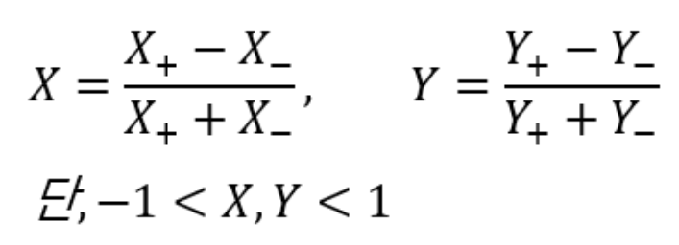

The values of X and Y were filtered to be between -1 and 1 only.

**3. Crystal Segmentation**

The second csv file named ‘Cs137_Segmap.csv’ was read and its data was converted into a numpy array.