**预习作业2**

1. 设计产生式描述while语句

stmt→while ( expr ) stmt

1. 设计产生式描述for语句

stmt→for( expr;expr;expr ) stmt

1. 设计产生式描述变量声明语句

type→int|float|double|char

id→id1|id2

2.

推导过程：

expr→expr - term

→term-term

→factor-term

→7-term

→7-term*factor

→7-factor*factor

→7-3*expr

→7-3*(expr+term)

→7-3*(term+term)

→7-3*(factor+term)

→7-3*(4+term)

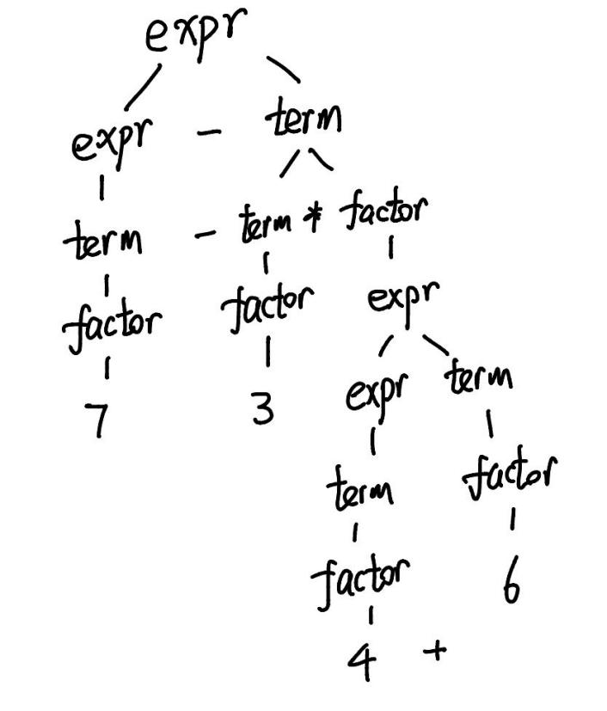→7-3*(4+factor)

→7-3*(4+6)

语法分析树：

3.

