**SI100B Python Programming Quiz 2**

**English-only Rule: In this quiz, you may only answer the questions in English.** Answers in other languages (e.g. Chinese) will result in **0 point for the corresponding question**. Before you start, **please fill your FULL CHINESE name, student ID and your ShanghaiTech email address** in the related blanks in Question 0 **AND** the blanks on the top of every page. Failing to do so may result in 0 point of this quiz.

Please **fill your answers in the table at the end of each section**. Answers written in

other places will not be graded. Q1-Q13: 5 points per question; Q14: 20 points; Q15: 15 points.

**Question 0: Please Identify Yourself**

Please **fill your FULL CHINESE name, student ID and your ShanghaiTech email address** in the related blanks below **AND** the blanks on the top of every page. Failing to do so may result

in 0 point of this quiz.

Your FULL CHINESE name: ____________曹有容_____________

Your student ID: ________________2022533062_________________

Your ShanghaiTech email address: [_______caoyr2022__________@shanghaitech.edu.cn](mailto:_______caoyr2022__________@shanghaitech.edu.cn)

|  |  |  |  |  |  |  |  |  |
| --- | --- | --- | --- | --- | --- | --- | --- | --- |
| 1 | 2 | 3 | 4 | 5 | 6 | 7 | 8 | 9 |
| B | D | C | C | C | B | A | B | B |
| 10 | 11 | 12 | 13 |  | 0 | 2 | 2 | 3 |
| D | B | C | C |  | a 1 | b 0 | c(1,2,3) | D{‘x’:1,’y’:2,’z’:3} |

Emmm,’b’ could not be zero

1. **If there is a finally: branch inside the try: block, we can say that:**
   1. it won’t be executed if no exception is raised
   2. it will always be executed
   3. branches is executed
   4. it will be executed when there is no else: branch
2. **What will be the output of the following snippet?**

   try:

      raise Exception

   except BaseException:

      print(“a”,end=”)

   else:

       print(“b”,end=”)

   finally:

       print(“c”)

* 1. a
  2. ab
  3. bc
  4. ac

1. **What will be the output of the following snippet?**

   class A:

      def __init__(self,name):

         self.name = name

   a = A(“class”)

   print(a)

* 1. a number
  2. a string ending with a long hexadecimal number
  3. class
  4. name

1. **What will be the output of the following snippet?**

   try:

      raise Exception

   except:

      print(“c”)

   except BaseException:

      print(“a”)

   except Exception:

      print(“b”)

* 1. it will an cause error
  2. b
  3. c
  4. a

1. **What will be the output of the following snippet?**

   class X:

      pass

   class Y(X):

      pass

   class Z(Y):

      pass

   x = X()

   z = Z()

   print(isinstance(x,Z),isinstance(z,X))

1. False False
2. True True
3. True False
4. False True
5. **The following code prints:**

   x = “\”

   print(len(x))

* 1. 1
  2. the code will cause an error
  3. 2
  4. 3

1. **If the class constructor is declared as below, which one of the assignments is valid?**

   class Class:

      def __init__(self):

         pass

* 1. object = Class(None)
  2. object = Class(1)
  3. object = Class(1,2)
  4. object = Class()

1. **What will be the output of the following code?**

   class A:

      A = 1

      def __init__(self,v = 2):

         self.v = v + A.A

         A.A += 1

      def set(self,v):

         self.v += v

         A.A += 1

         return

   a = A()

   a.set(2)

   print(a.v)

* 1. 7
  2. 5
  3. 1
  4. 3

1. **What will be the effect of running the following code?**

   class A:

      def __init__(self,v):

      self._a = v + 1

   a = A(0)

   print(a._a)

* 1. it will print 0
  2. it will print 1
  3. it will print 2
  4. it will raise an AttributeError exception

1. **What will be the result of executing the following code?**

   class A:

      def __init__(self):

         pass

      def f(self):

         return 1

      def g():

         return self.f()

   a = A()

   print(a.g())

* 1. it will print 0
  2. it will print True
  3. it will print 1
  4. it will raise an exception

1. **What will be the result of executing the following code?**

   class A:

      def a(self):

        print(‘a’)

   class B:

      def a(self):

         print(‘b’)

   class C(A,B):

      def c(self):

         self.a()

   o = C()

   o.c()

* 1. it will print b
  2. it will print a
  3. it will raise an exception
  4. it will print c

1. **What will be the result of executing the following code?**

   def a(x):

      def b():

         return x + x

      return b

   x = a(‘x’)

   y = a(”)

   print(x() + y())

* 1. it will print xxxxxx
  2. it will print x
  3. it will print xx
  4. it will print xxxx

1. **If s is a stream opened in read mode, the following line**

   q = s.readlines()

**will assign q as a:**

* 1. string
  2. dictionary
  3. list
  4. tuple

1. **Blank Filling**

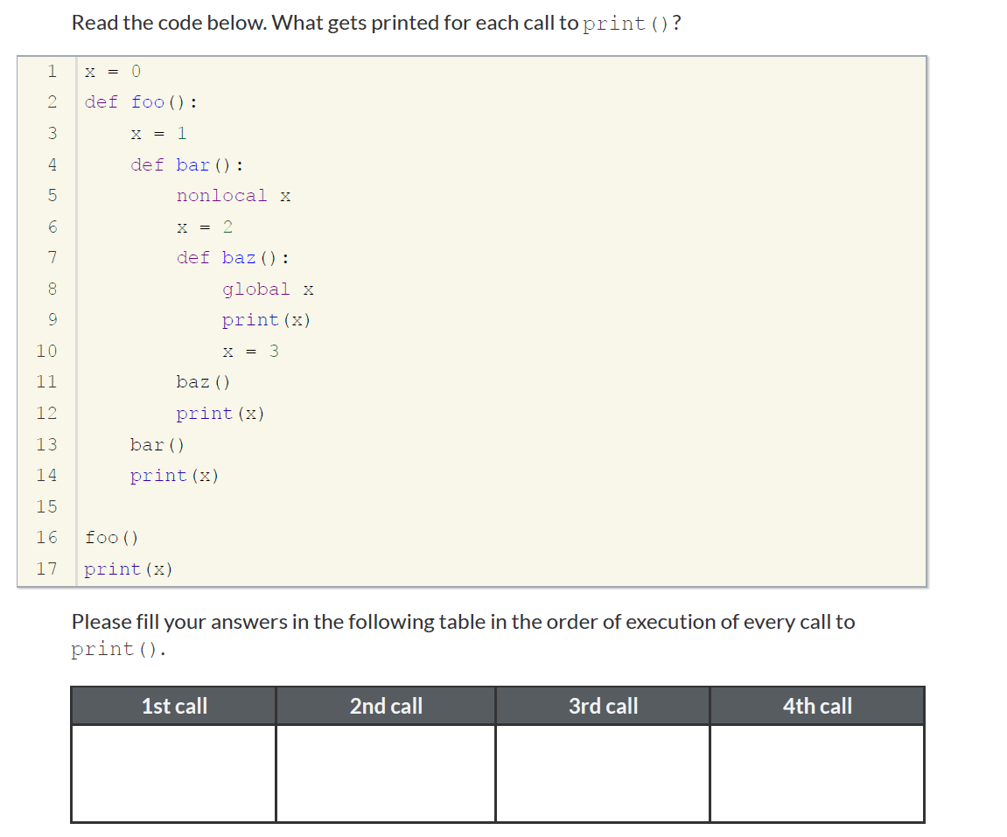

1. **Read the following code snippet in the file bar.py, determine what will be printed on your console.**

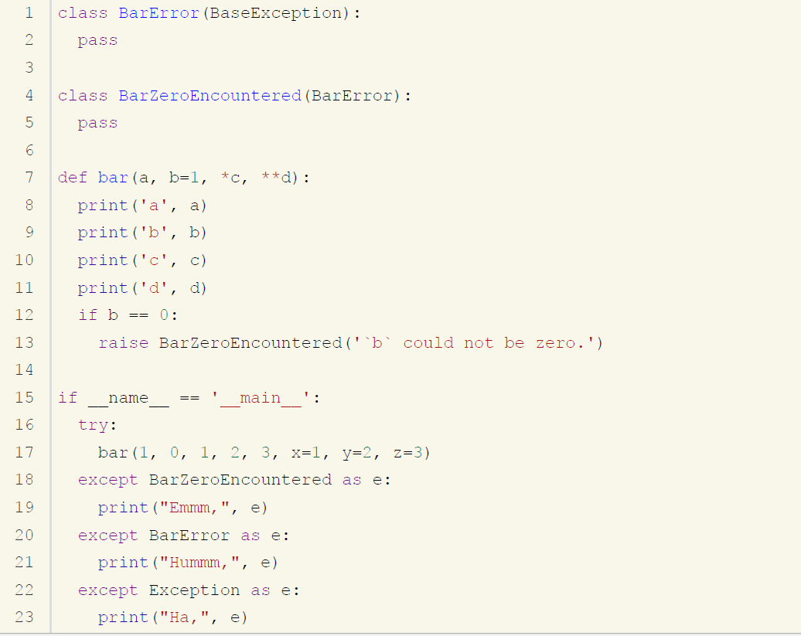

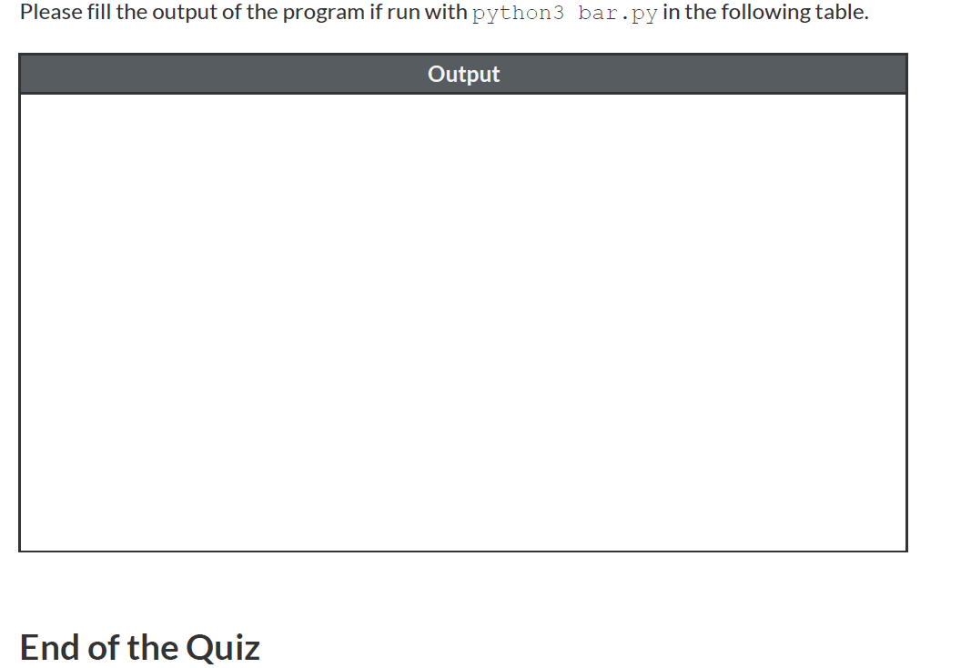

* [CCNA2 v7](https://www.premiumexam.net/pcap-programming-essentials-in-python/pcap-programming-essentials-in-python-quizzes-final-test-answers/#tabs_desc_7472_2)
* [CCNA3 v7](https://www.premiumexam.net/pcap-programming-essentials-in-python/pcap-programming-essentials-in-python-quizzes-final-test-answers/#tabs_desc_7472_3)