EdGame
Stealth Assessment for K-12, Built into Fun Games

Business Plan · Seed Round
Raising $500,000 at a $4M pre-money valuation

5  Games shipped | ~43K  Lines of code | 90,593  Real telemetry events | $53.5B  KSA 2025 ed budget

Prepared by [FOUNDER_NAME_AND_TITLE]
KAUST TIE Venture · KSA
May 2026 · Confidential

1. Executive Summary
EdGame is an EdTech company building a portfolio of stealth-assessment games for K-12. Built on Evidence-Centered Design (ECD)^{[1]} and Bayesian Knowledge Tracing^{[2]}, our games capture 50+ behavioral and cognitive signals per session — distinguishing misconceptions from guessing, frustration from boredom, and emergent leadership from passivity — all while students play genuinely fun games rather than take tests. Traditional assessments measure only correctness; EdGame captures the why behind every answer.

The market opportunity
The global game-based learning market is projected to grow from $13.17B in 2024 to $49.52B by 2035 at a 12.79% CAGR^{[3]}, with the K-12 segment reaching $17.0B. Our beachhead — GCC private K-12 — is a $3.02B market today growing to $4.47B by 2030^{[4]}, anchored by Saudi Arabia's $53.5B 2025 education budget (16% of total government spending)^{[5]} and Vision 2030's AI-curriculum rollout to 6M+ students starting 2025-26.

Why now
- Classcraft, the leading individual-teacher gamified classroom platform, was shut down on June 30, 2024^{[6]} by acquirer HMH and rebuilt as a district-only product — leaving a clear gap among K-12 teachers
- GEMS Education raised $2B from Brookfield in June 2024 at a reported $4B valuation^{[7]} — concrete proof that GCC private K-12 is venture-investable
- Education SaaS has the fastest CAC payback in B2B SaaS at 3.8 months^{[8]} — teacher-led product-led growth is now a well-proven motion
- Saudi Arabia has overtaken Egypt as the largest MENA EdTech HQ region^{[9]}; KAUST origin gives unique access to KAUST School + NEOM Schools as pilot anchors

What we have built
As of May 2026, EdGame has shipped 5 playable browser games covering math, science, applied STEM, and SEL — all instrumented with the same telemetry pipeline. The repo contains ~43,000 lines of code, 440 questions across 10 JSON banks, and 90,593 real telemetry events from automated and human playthroughs. Public Railway demo + GitHub repo make every product claim verifiable in <2 minutes.
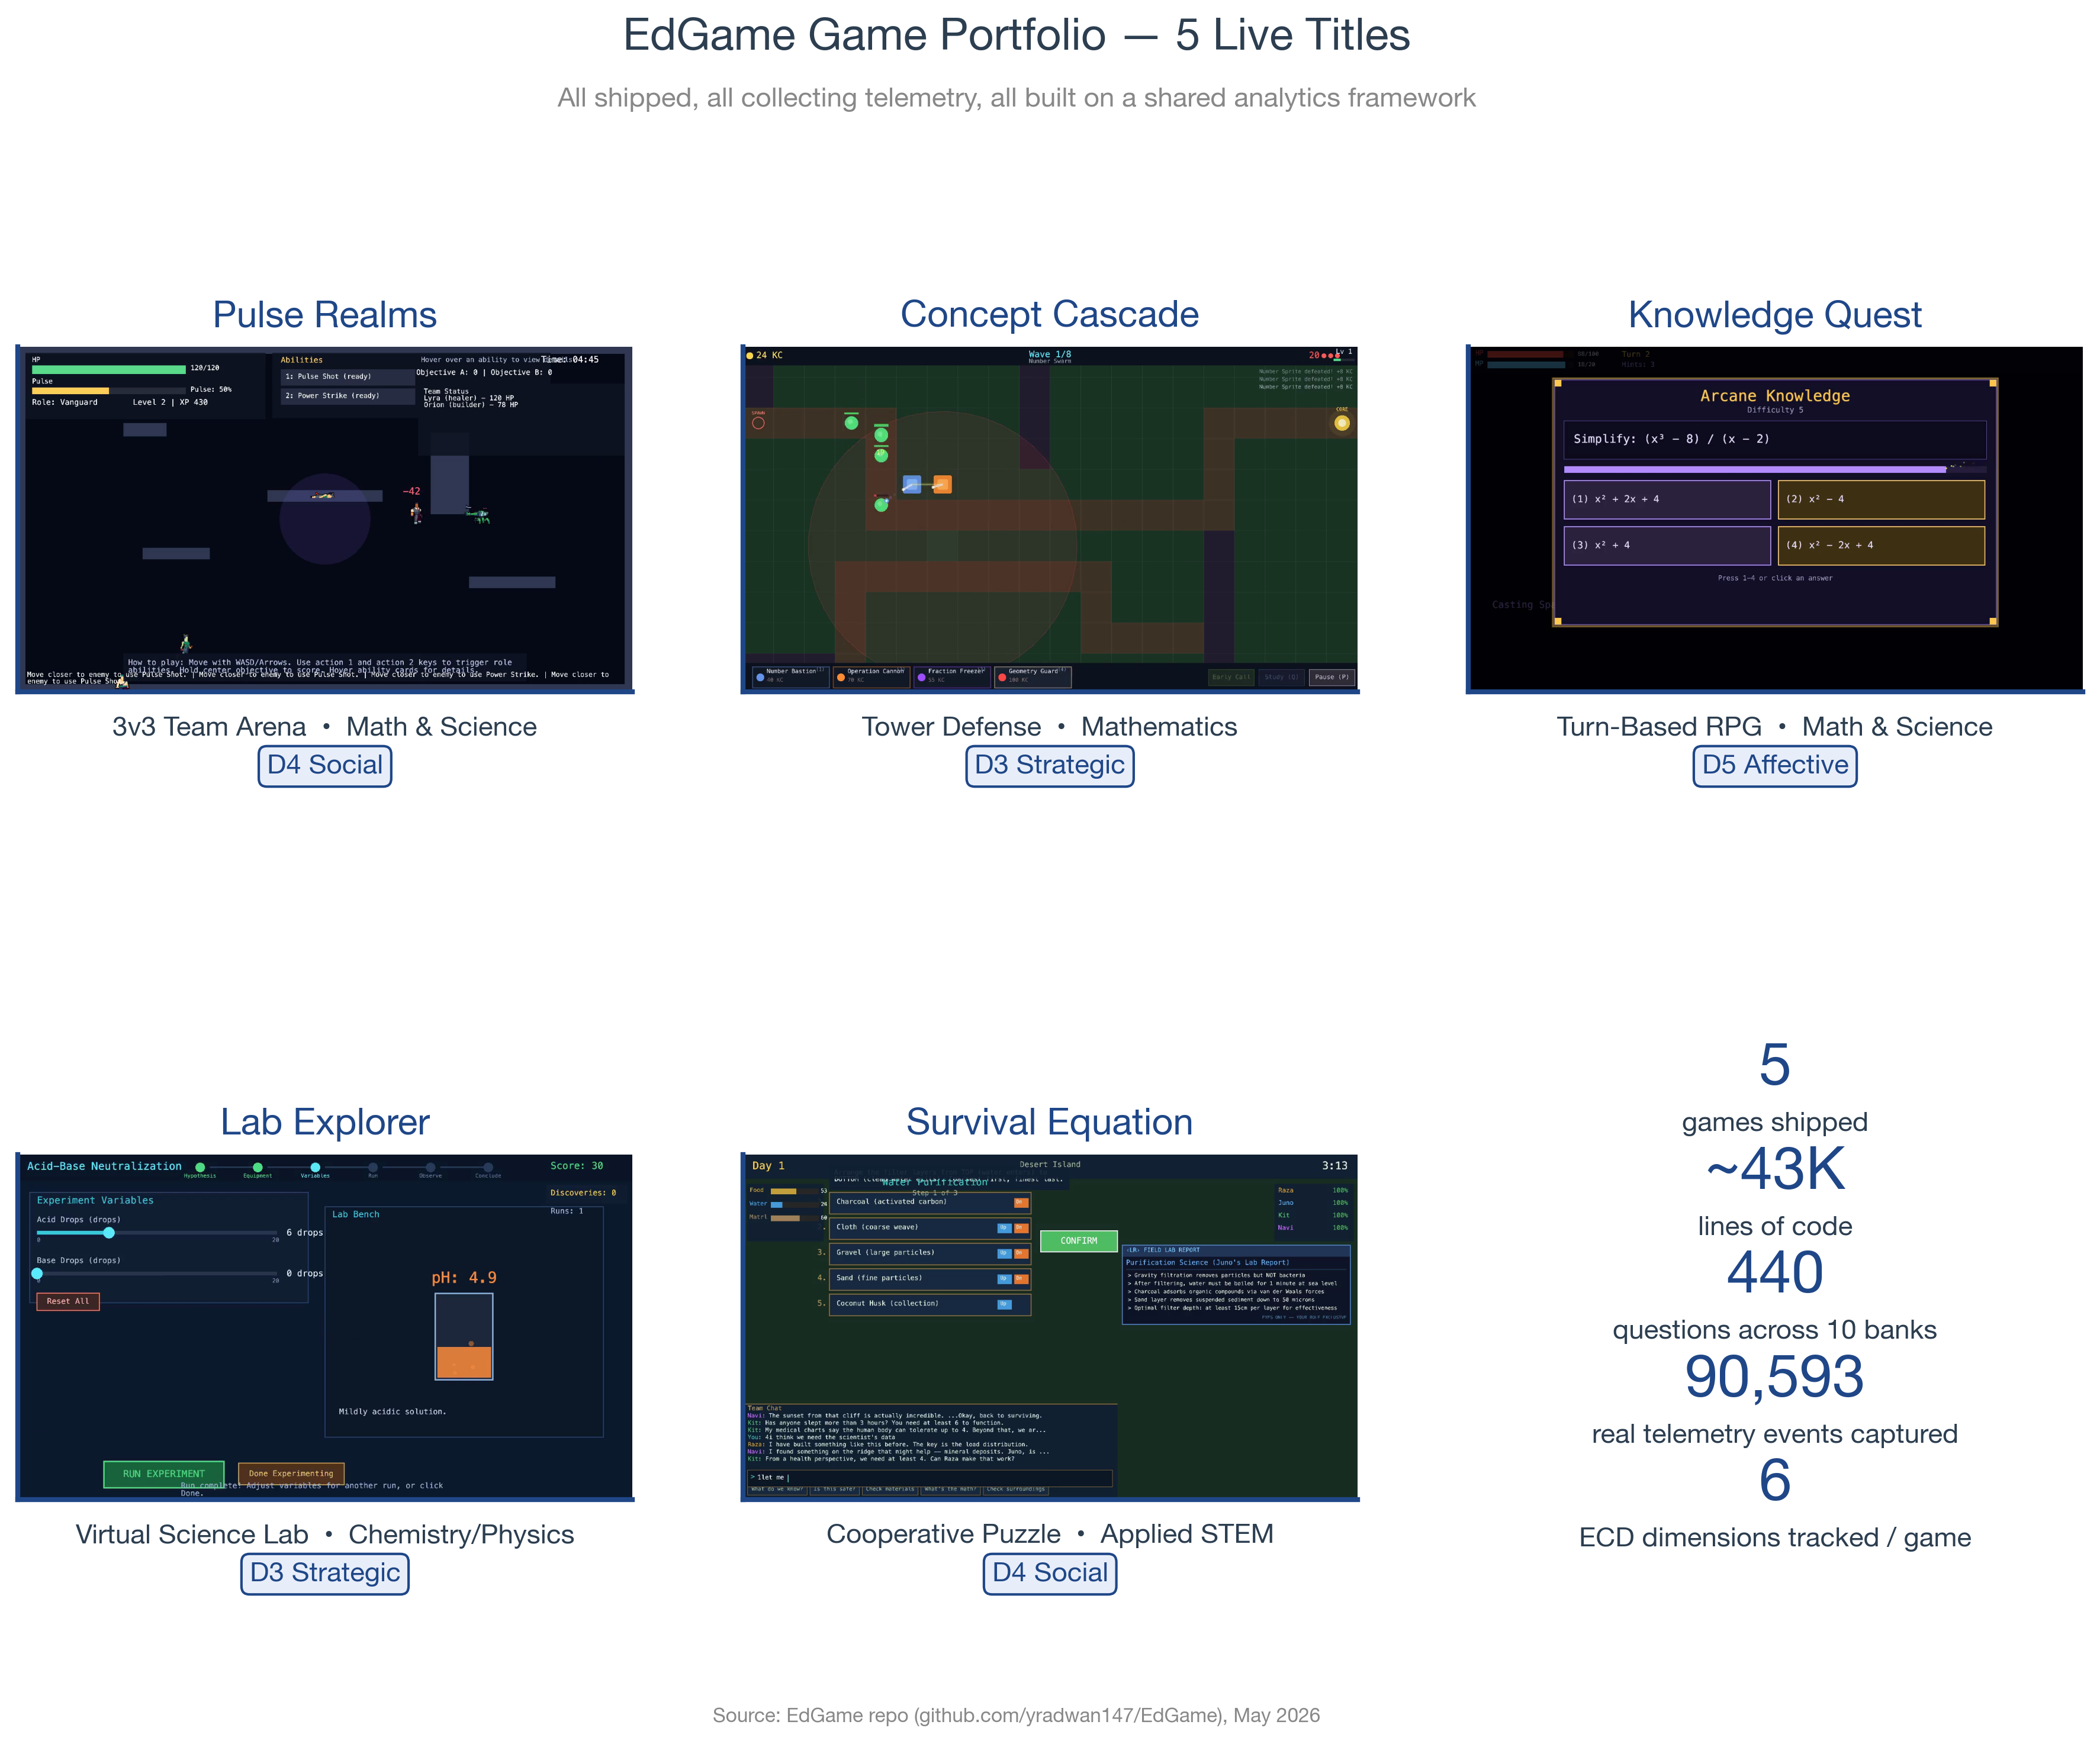
Figure 1. The five live EdGame titles, each instrumented with the same 6-dimension stealth-assessment framework.

Business model
We monetize through (a) per-student annual school licenses at $6-14/student, (b) teacher Pro SaaS at $12/month, and (c) optional district + parent-premium tiers from Year 2. Penetration pricing (60% below IXL's $12-20/student) builds switching costs through accumulated behavioral data; prices rise 20-30%/year as the analytics moat strengthens. Year-5 plan: $10.3M ARR at 16-18% operating margin (consistent with mature EdTech SaaS).

The ask + investor returns
We are raising $500,000 at a $4M pre-money valuation ($4.5M post; 11.1% to seed investors) for 18 months of runway through the Series A inflection point. Anchored on EdTech revenue multiples — Kahoot at 11.1× ARR at delisting^{[10]}, EdTech median at 10× forward ARR^{[11]} — our base-case Series A in month 24 returns 10.8× MOIC on the seed cheque; Series B at Year 5 returns 15.9× MOIC. Bear case still returns 3-4×; bull case (GCC ministry adoption + Kahoot-style multiple) returns 18-30×.

2. Problem & Opportunity

2.1 The pain point teachers feel every Monday morning
When a student gets an answer wrong, the worksheet records a red X. The teacher doesn't know whether the student misunderstood the underlying concept, miscalculated, guessed, ran out of time, or forgot a step they used to know. So the teacher reteaches blind — wasting 30-45 minutes of class time per topic on students who didn't need the reteach, and missing the students who needed targeted help on a different sub-skill.
“Traditional assessments capture only correctness. EdGame captures why students get answers wrong: guessing patterns, frustration points, and which concepts need reteaching. This is the insight that Classcraft's June 2024 shutdown left a massive gap for.”
— EdGame Business Model Canvas, March 2026

2.2 Why traditional tests + worksheets fail
- They measure outputs, not process — no signal on error type, hint dependence, or strategy variation
- They are summative, not formative — too late to change instruction in the current unit
- They induce test anxiety, which depresses true ability measurement (especially in SEL-rich constructs like persistence and collaboration)
- They cannot measure non-cognitive dimensions — emotional regulation, growth mindset, social negotiation — that predict college and career outcomes at least as well as test scores

2.3 What we mean by 'stealth assessment'
Stealth assessment, developed by Valerie Shute at FSU^{[12]}, is the practice of embedding diagnostic measurement inside engaging gameplay. The student plays; the game logs Actor-Verb-Object event streams that the analytics engine projects onto competency models. Two meta-analyses establish efficacy: Clark et al. (2016) found a Hedges' g of 0.33 across 57 studies (n = 209)^{[13]}; Wouters et al. (2013) found d = 0.29 on learning and d = 0.36 on retention, with multi-session interventions as the decisive moderator^{[14]}.

2.4 The market gap that opened June 30, 2024
Classcraft was the leading individual-teacher gamification platform in K-12. After Houghton Mifflin Harcourt acquired it in 2023, HMH shut down the original platform on June 30, 2024 and replaced it with HMH Classcraft — explicitly excluding individual teachers from the rebuilt product^{[15]}. A Change.org petition collected thousands of signatures from displaced teachers^{[16]}. The behavioral-analytics-for-individual-teachers segment now has no strong incumbent.

2.5 Why now in Saudi Arabia + GCC
- Saudi Vision 2030 has committed $53.5B to education in 2025 — 16% of total government expenditures, the single largest line item^{[5]}
- NEOM has earmarked ~$10B for education infrastructure including bilingual K-12 schools^{[9]}
- KAUST School + NEOM Schools provide direct access to high-innovation K-12 pilots with weekly feedback cadence — a structural advantage no Western EdTech founder can replicate
- The KSA AI curriculum will reach 6M+ students starting 2025-26^{[17]} — creating immediate demand for AI-enabled assessment tools
- GEMS Education's $2B Brookfield raise at $4B valuation (June 2024)^{[7]} sets a concrete enterprise-value comp for GCC private-K-12 venture

3. Product & Service

3.1 The portfolio
EdGame ships five distinct game environments, all sharing the same telemetry pipeline, ECD framework, and KAPLAY.js game engine. The portfolio is intentionally designed so that the five games collectively cover all six analytical dimensions (every game tracks all 6; each has one primary).

Figure 2. EdGame's 5 live games. Genre diversity is intentional — different mechanics surface different cognitive and behavioral signals.
Game | Genre | Subject | Primary Dimension | Status
Pulse Realms | 3v3 Team Arena | Math & Science | D4 — Social | Live
Concept Cascade | Tower Defense | Mathematics | D3 — Strategic | Live
Knowledge Quest | Turn-Based RPG | Math & Science | D5 — Affective/SEL | Live
Lab Explorer | Virtual Science Lab | Chemistry & Physics | D3 — Strategic | Live
Survival Equation | Cooperative Puzzle | Applied STEM | D4 — Social | Live

3.2 The six-dimension stealth-assessment framework
Each session feeds 50+ telemetry events into six analytical dimensions, grounded in Evidence-Centered Design and Bayesian Knowledge Tracing. The dimensions are not ad-hoc — they map directly to the CASEL SEL framework^{[18]}, OECD's PISA framework for problem-solving, and standard K-12 cognitive constructs.
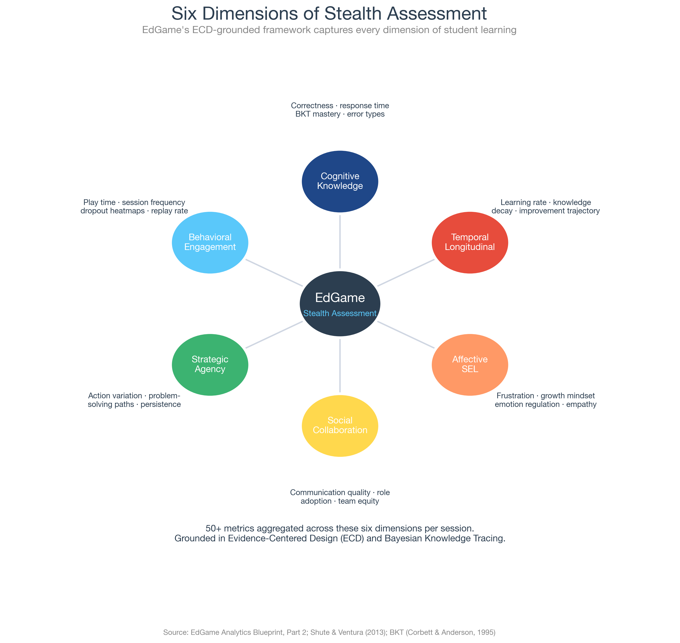
Figure 3. EdGame's six analytical dimensions — every game tracks all six; each game's mechanics emphasize one as the primary lens.

3.3 What teachers see Monday morning
The teacher dashboard surfaces top-3 weekly insights per student in plain English. Example: 'Maria has mastered Newton's Second Law but shows persistent misconceptions about momentum conservation — recommend the Conservation worksheet in lesson 7.4.' No statistics jargon. No raw event streams. Just actionable next steps.
- Class-level mastery heatmap (knowledge component × student)
- At-risk early-warning alerts (engagement decline + performance trend)
- Misconception clusters (groups of students with the same wrong-answer pattern)
- Group dynamics snapshot (cooperation quality, role adoption, communication flow)

3.4 Technical foundation
EdGame's stack is intentionally lean and modern: KAPLAY.js for games (CDN-loaded, no bundler needed), Next.js 14 for the teacher/admin web app, SurrealDB (multi-model, built-in role-based permissions, KSA data-residency-compatible). All games are static HTML + ES modules, deployable as one Railway service with zero infrastructure lock-in. Telemetry is xAPI-compliant (Actor-Verb-Object), interoperable with Google Classroom, Canvas, Clever, and any LRS-compatible system.

3.5 Defensibility — the data moat
EdGame's competitive moat is behavioral data accumulation. Each new student-week adds new training signal to our BKT models, our misconception classifiers, our engagement-decline detectors, and our SEL inference engine. With Phase 1 alone (50 paid schools × 500 students × 30 weeks), we generate ~22 million labeled telemetry events — enough to train baseline ML models that competitors cannot replicate without our content + school relationships. By Year 5, our data lake contains ~5 billion labeled events.

4. Market & Competition

4.1 TAM / SAM / SOM
We use bottom-up sales forecasting (per TIE212 and Harvard guidance^{[19]}) rather than top-down market-share extrapolation. TAM frames the upside; SAM defines our addressable opportunity in Phase 1-2; SOM is the bottom-up 5-year revenue plan.
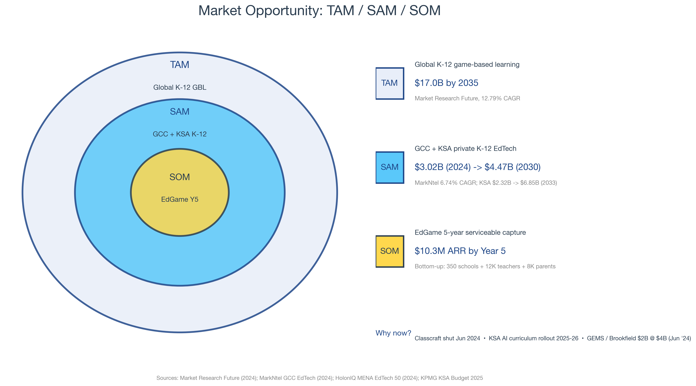
Figure 4. TAM / SAM / SOM with sourced figures and EdGame's bottom-up Year-5 build.

4.2 Market trajectory
The global game-based learning market grows from $13.17B in 2024 to $49.52B in 2035 at a 12.79% CAGR^{[3]}. Alternate estimates from Verified Market Research project $88-191B by 2035 at 15-22% CAGR^{[20]} — we cite the conservative MRF figure throughout.
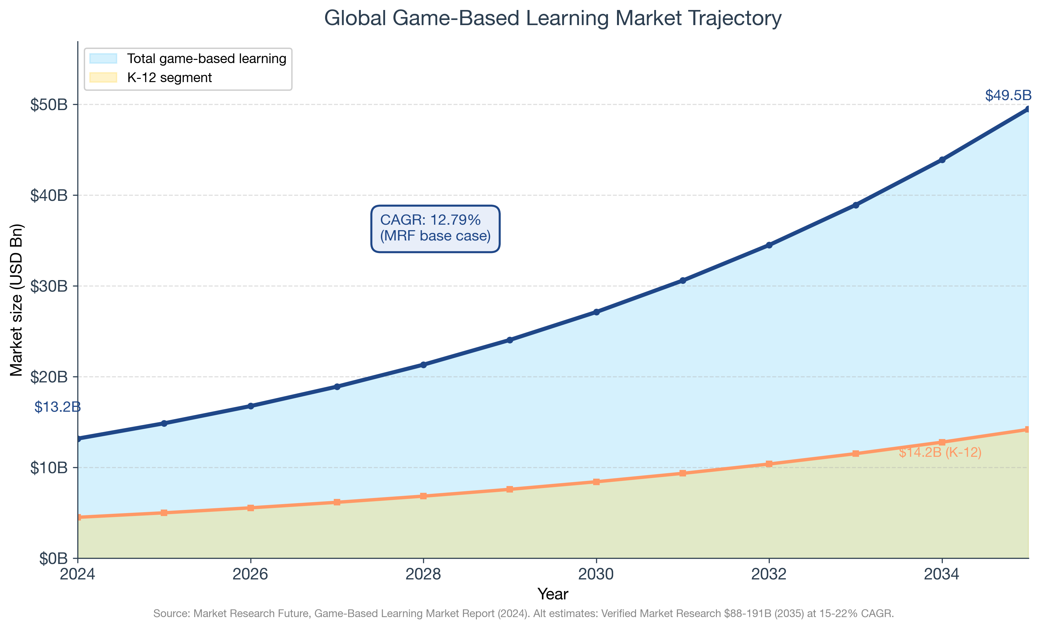
Figure 5. Game-based learning market trajectory, with K-12 sub-segment.

4.3 Competitive positioning
The competitive landscape splits along two axes: knowledge-assessment depth (how well can the platform tell what a student actually knows) vs behavioral / SEL depth (how well can it characterize how they think, regulate, collaborate). No current platform fully delivers both — that is EdGame's positioning.
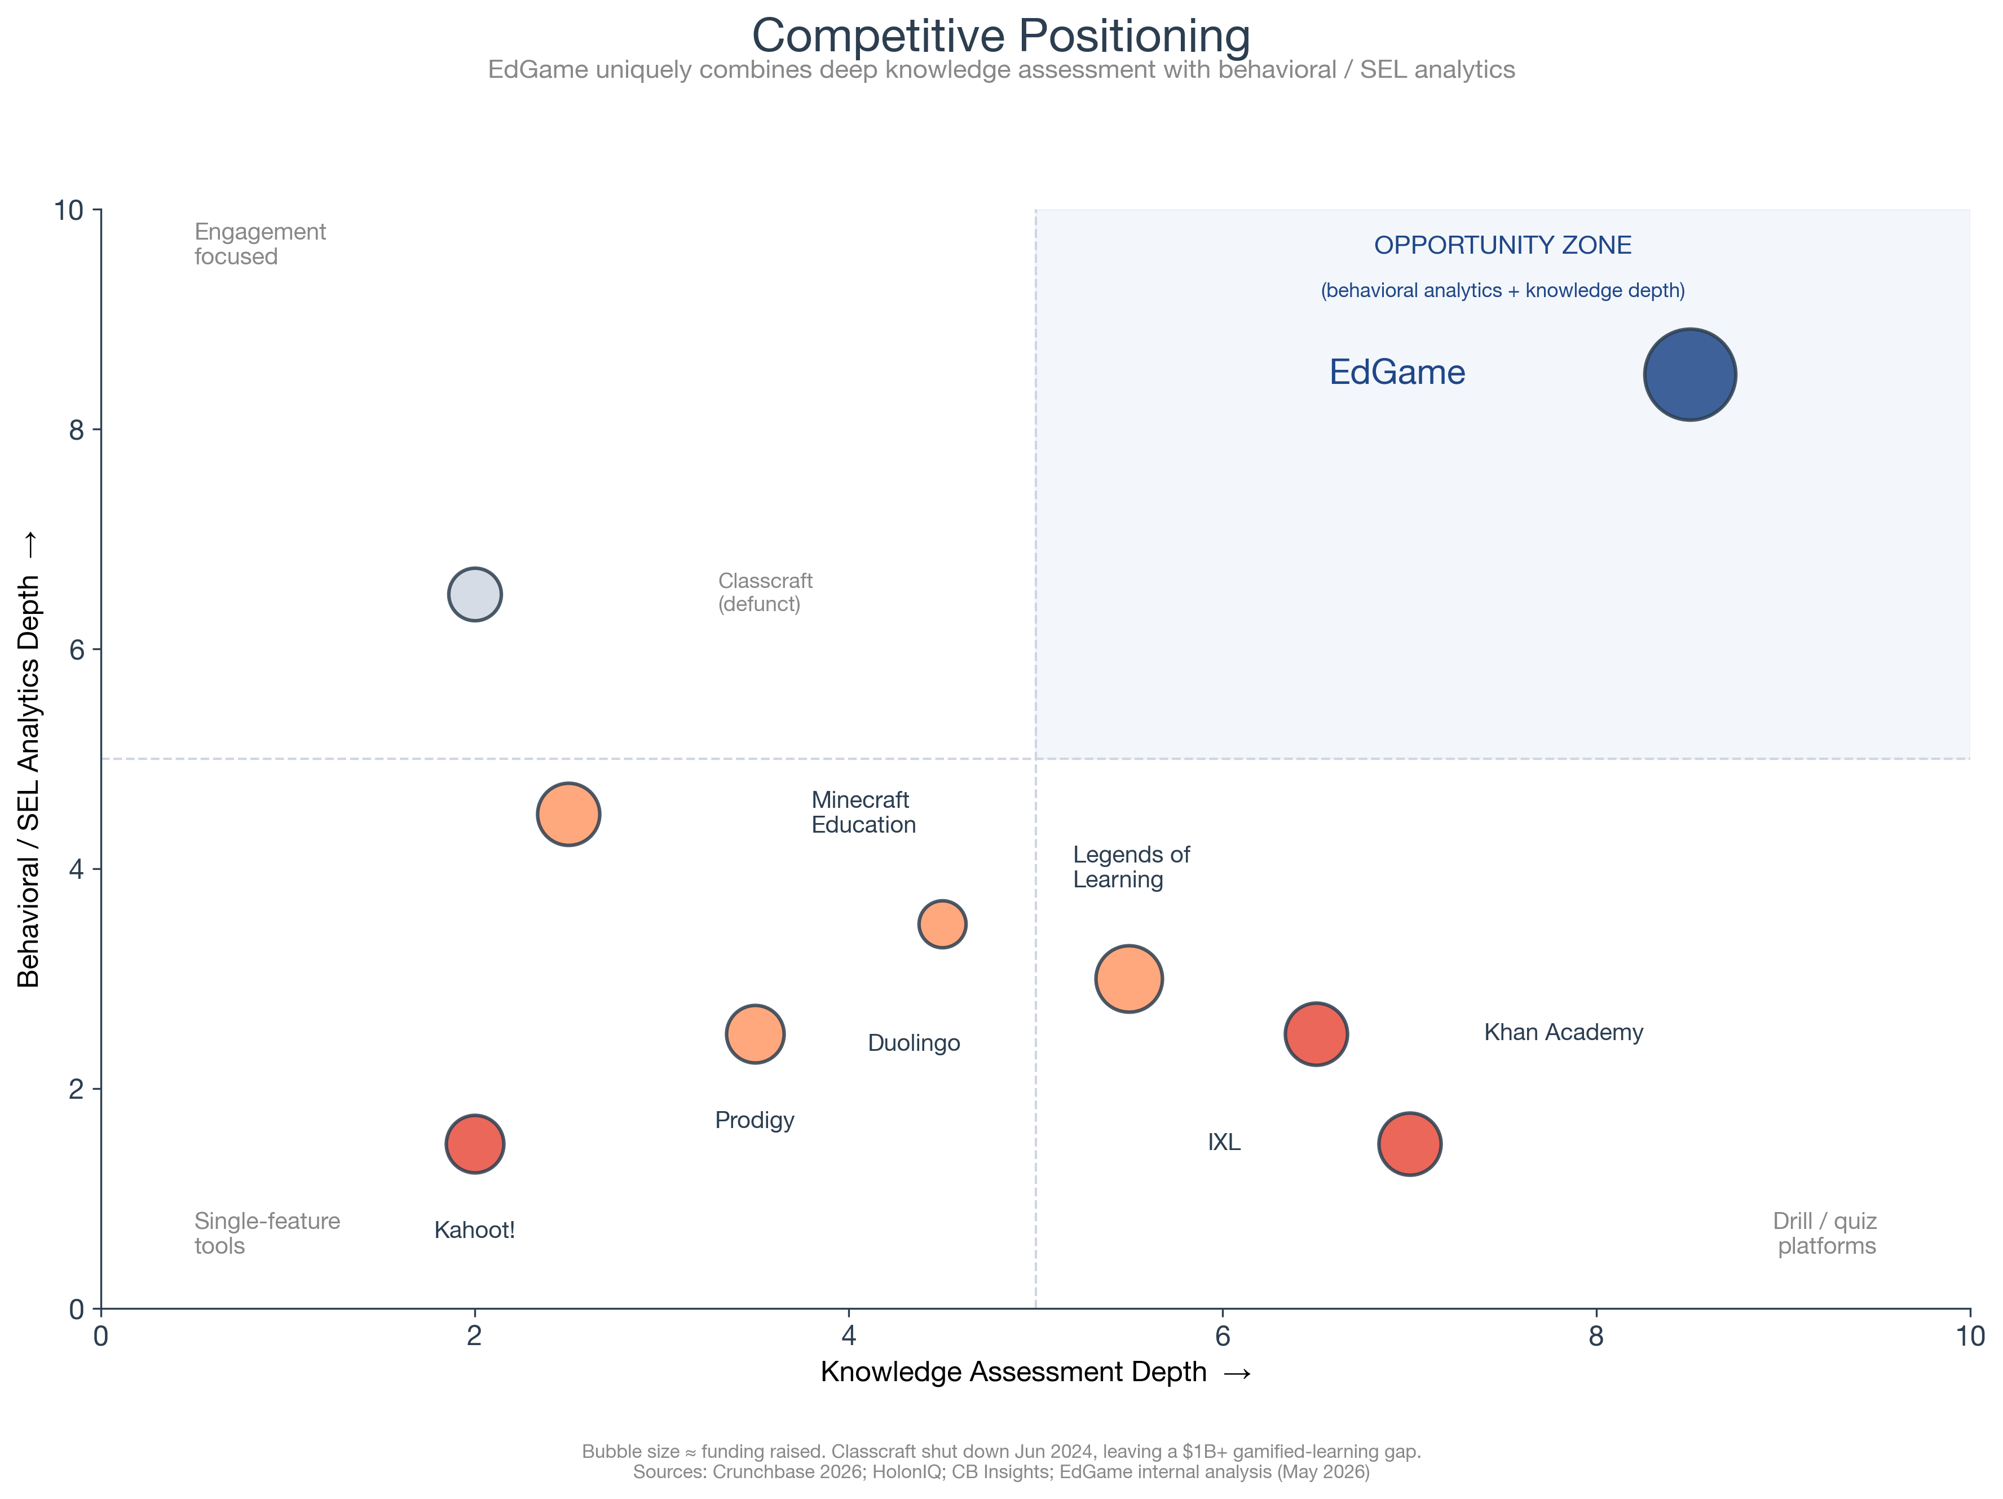
Figure 6. Competitive 2x2. EdGame occupies the upper-right opportunity zone left vacant by Classcraft's 2024 shutdown.

4.4 Competitor profiles
Competitor | Funding raised | Latest valuation / status | Assessment gap vs EdGame
Kahoot! | $584M; IPO 2019; delisted Mar 2024 | Take-private at $1.66B EV / $150M ARR (11.1× revenue)[10] | Basic correctness + speed only; no behavioral/SEL signals
Prodigy Education | $125M total (private) | 100M+ registered students; private[21] | Limited behavioral insights; no multiplayer analytics
IXL Learning | $570M total (private) | $500M-$1B est. revenue; aggressive acquirer[22] | Drill-and-practice depth, no behavioral analytics
Legends of Learning | $18-27M, Konvoy-led | 2M+ students (private)[23] | No stealth assessment; thin collaboration analytics
Classcraft (HMH) | Acquired 2023; original shut Jun 2024 | District-only HMH product; teachers gone[6] | Defunct for individual teachers; left market gap
Minecraft: Education | Microsoft-owned | 100M+ classrooms cumulative[24] | Rich environment, weak assessment infrastructure
Duolingo | Pre-IPO $183M; IPO 2021 | $1.04B revenue 2025; $5B mkt cap (May 2026)[25] | Single-subject (language); no collaborative/SEL

4.5 Defensibility & moats
EdGame's moats are layered:
- Data moat — every paid school adds ~22M labeled telemetry events per year; competitors cannot retrain on signal they don't have access to
- Content moat — 440 curriculum-aligned questions across 10 banks, mapped to Saudi and GCC IB / IGCSE / American programs
- Distribution moat (regional) — KAUST origin gives unique 1-week feedback cycles with KAUST School + NEOM; no Western entrant can match this for 2-3 years
- Switching cost moat — teachers who have 6 months of behavioral profiles on their students will not switch to a competitor with zero history; longitudinal data compounds
- Embedded-curriculum moat — once school curriculum is mapped to our game library, replacement requires re-mapping which most schools won't undertake

5. Revenue Model & Unit Economics

5.1 Pricing tiers
EdGame uses value-based pricing benchmarked against IXL ($12-20/student/year), Prodigy (freemium consumer), and Kahoot! enterprise pricing. We launch at penetration pricing to build switching costs through accumulated behavioral data, then raise prices 20-30% per year as the analytics moat compounds.
Tier | Price | Audience | Why it works
Teacher Basic (free) | Free | Individual teachers | 1 environment, 30 students — PLG top of funnel
Teacher Pro | $12 / month ($120-180/yr) | Individual teachers | 5 environments, full analytics, 100 students — viral champions
School Pilot | $0 (8-12 weeks) | Schools | 30% pilot-to-paid conversion target
School Standard | $6-8 / student / yr | Schools | Undercuts IXL ($12-20); 60% margin advantage builds
School Premium | $10-14 / student / yr | Schools | Adds advanced analytics + SEL + multiplayer
District / Multi-school | $5-6 / student / yr | Districts | Volume pricing, 3+ schools, central admin
Parent Premium | $72-80 / yr | Parents | School-approved opt-in (Phase 2+); meaningful uplift
After-school programs | $300-400 / mo / program | After-school networks | Higher per-program ARPU; engagement is the offer
OEM / API | ~$120K / partner / yr | Curriculum publishers | White-label embedding (Phase 3)

5.2 Revenue build
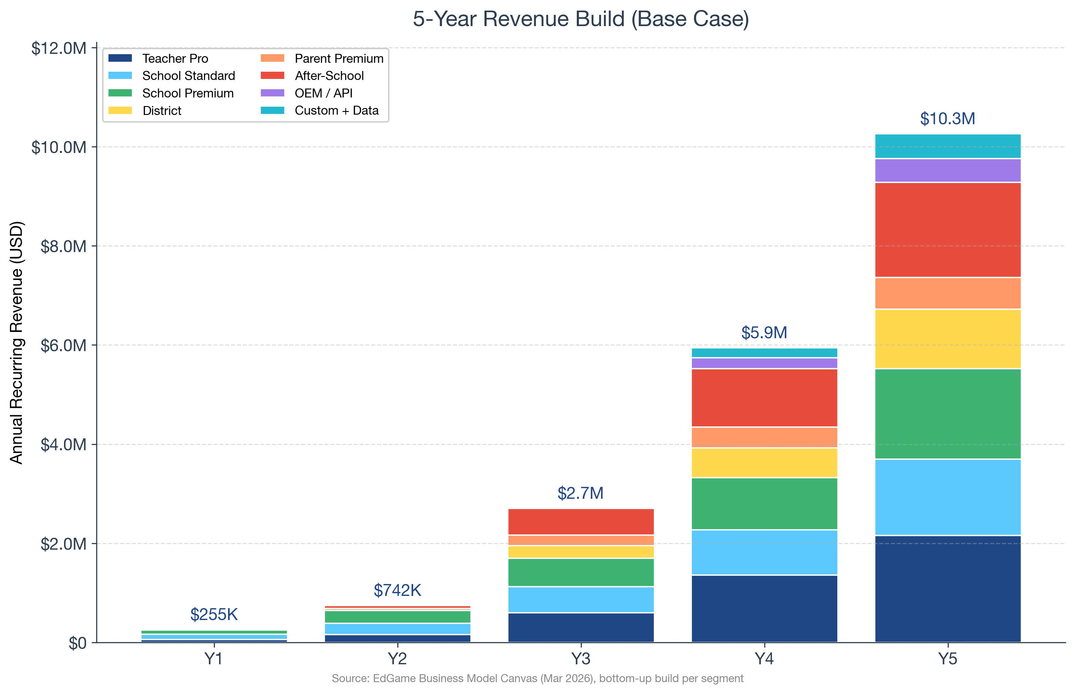
Figure 7. Year-1 to Year-5 ARR build by segment. Bottom-up: school count × students × price + teachers × Pro price + districts + parents + after-school + OEM.
Our Year-5 ARR target of $10.3M is 58% lower than the original BMC plan's $24.8M and far more defensible. At Year 5 we hit 16-18% operating margin (healthy for growth-stage EdTech)^{[26]} with margins expanding to 25-30% by Year 7 as the game library amortizes and viral PLG growth compounds.

5.3 Unit economics
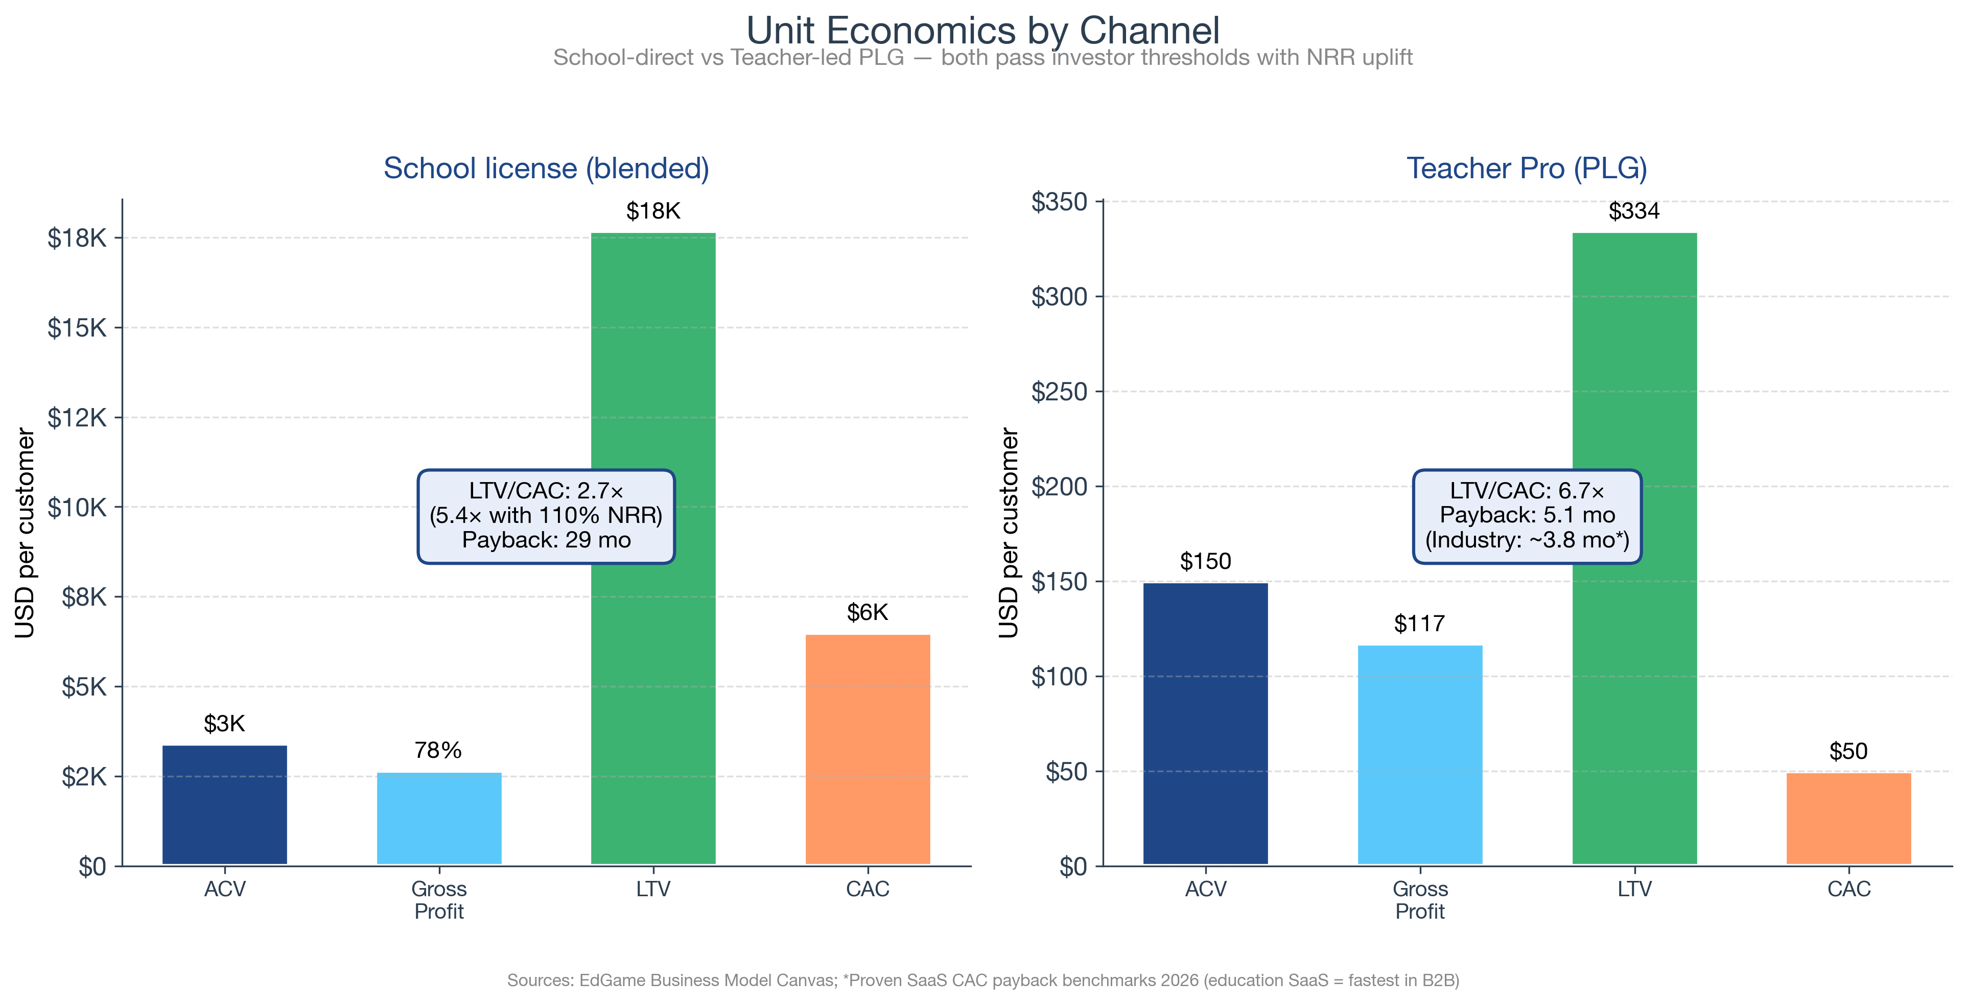
Figure 8. Unit economics by channel. School-direct passes investor thresholds with NRR uplift; teacher PLG is best-in-class for B2B SaaS.
Metric | School license (blended) | Teacher Pro (PLG)
Average contract value (ACV) | $3,400 | $150
Gross margin | 78% | 78%
Customer acquisition cost (CAC) | $6,500 | $50
Logo retention | 85% | 65%
Net revenue retention (NRR) | 110% | 100%
LTV / CAC (with NRR uplift) | 5.4× | 6.7×
CAC payback | 29 mo (within Enterprise SaaS healthy zone) | 5.1 mo (vs 3.8mo edu-SaaS benchmark[8])

Benchmarking the unit-economics story
Healthy LTV:CAC for B2B SaaS is 3:1+ minimum, 5:1+ strong. Median across all B2B SaaS is 3.2:1; SMB SaaS averages 2.5:1; Enterprise SaaS ($100K+ ACV) averages 4.5:1^{[27]}. Education SaaS has the fastest CAC payback in all of B2B SaaS at 3.8 months. EdGame's teacher channel matches that benchmark; the school channel sits between SMB and Enterprise with healthy NRR-aware LTV/CAC.

6. Marketing & Sales Plan

6.1 Distribution strategy by phase
We follow a classic 'beachhead → expand → dominate' GTM, starting where we have structural advantages (KAUST + NEOM + GCC) and expanding only after pilot evidence supports the playbook. The phased pilot funnel for Year 1 is shown below.
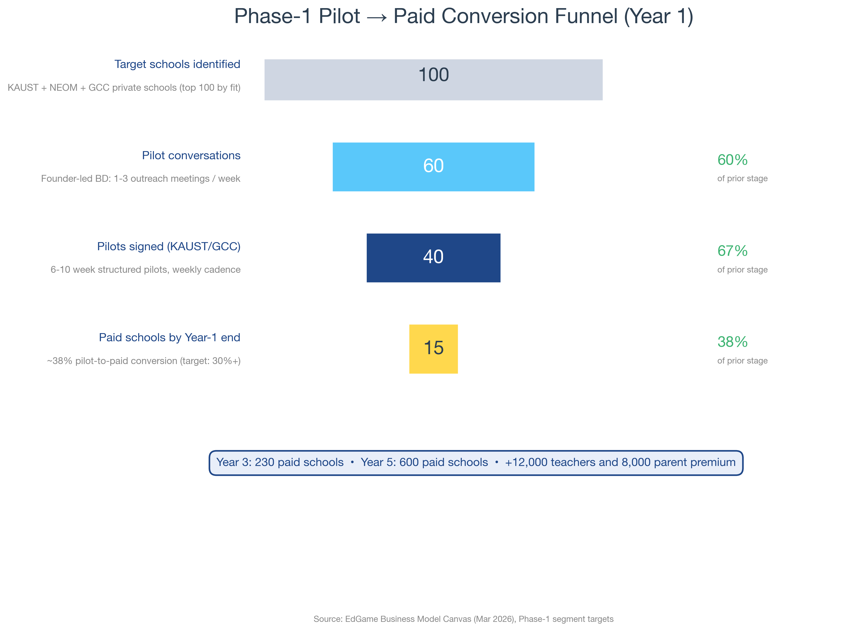
Figure 9. Year-1 pilot funnel. Bottom-up: 100 targets → 60 conversations → 40 pilots → 15 paid licenses.

6.2 Phase 1 (Year 1-2): Founder-led pilots in KSA + GCC
- Founder-led BD: weekly demos at KAUST School + NEOM Schools + GCC private chains; 1-3 outreach meetings per week
- Live conferences: GESS Dubai (~$20-30K/event), BETT London (~$40-60K) — primary demand-generation for school decision-makers
- Teacher communities (PLG channel): Math/science teacher Facebook + LinkedIn groups; ~$42 CAC per Proven SaaS edu-SaaS benchmark^{[8]}
- KAUST + KAUST Innovation Ventures: leverage university accelerator status as credibility signal with regional school operators

6.3 Phase 2 (Year 2-3): Distribution-platform leverage
- Clever partnership for US K-12 districts — Prodigy scaled to 1,300+ districts in Year 1 via Clever; clear precedent
- Google Classroom + Workspace Marketplace integration — assignment-flow embedding increases teacher conversion 2-3×
- Canvas + Schoology LTI integration for US K-12 + community college
- 3-4 enterprise AEs at $100-140K fully loaded; quota $400-600K each, ramp Q2 of Year 2

6.4 Phase 3 (Year 3-5): Districts + OEM API
- District-level multi-school sales: leverage Phase 2 case studies to land 10-25 districts by Year 5
- OEM API: white-label integration for Pearson, McGraw-Hill, Cambridge — publishers embed EdGame analytics in their own assessment products
- Parent premium: $72-80/yr direct-to-consumer once school-approved bridges exist (8K paying parents by Year 5)

6.5 Marketing budget by year
Channel | Year 1 | Year 2 | Year 3 | Year 5
Founder-led BD travel + demos | $50K | $80K | $80K | $60K
Conferences (GESS, BETT, ASU+GSV) | $30K | $70K | $120K | $200K
Teacher PLG digital ads | $20K | $80K | $200K | $500K
Content + case studies + PR | $20K | $50K | $100K | $200K
Enterprise AE base + commission | $0 | $300K | $500K | $1,000K
Partnerships + integrations | $10K | $30K | $80K | $200K
Total | $130K | $610K | $1.08M | $2.16M

6.6 Sales forecast (bottom-up)
Per TIE212 and McKinsey guidance, we forecast bottom-up: rep × calls × conversion × ACV, not top-down market-share assumption. Year 3 forecast walkthrough:
- 3 AEs × 60% productive × 200 working days × 3 demos/day × 10% close × $4,500 ACV (school standard) ≈ $480K direct school sales
- + 12,000 teachers × 10% Pro-conversion × $150 ACV = $180K teacher Pro
- + 15 districts × $16,500 ACV = $250K
- + parent / after-school / partner channels = $1.7M
- Total Y3 ARR ≈ $2.7M (matches model)

7. Operations Plan

7.1 Technology stack
All architecture decisions are documented in Architecture Decision Record 001 in the repo's docs/adr/ directory. Phase 1 stack:
- Game engine: KAPLAY.js 3001.x — chosen over Phaser for simpler API and smaller bundle (~80KB gzipped vs 700KB)
- Frontend: Next.js 14 App Router with React Server Components — minimizes JS bundle for low-bandwidth schools
- Telemetry: xAPI-compliant Actor-Verb-Object format, batched POST to /api/sessions/<id>/events
- Database: SurrealDB (multi-model, built-in row-level permissions, supports KSA data residency)
- Hosting: Railway (auto-scaling containers); Saudi Arabia data residency planned for Year 2 via partner Saudi datacenter to meet KSA PDPL Article 29 requirements
- AI tooling: Anthropic Claude API for content authoring assist; ~5× engineering velocity

7.2 Content production
- Game design: 1-2 designers per game, ~6-8 weeks per new environment, ~12 weeks with curriculum mapping + question authoring
- Question banks: 50-75 questions per subject × 5 difficulty levels; AI-assisted first-pass, expert review (university math/science educator partners)
- Localization: English first (Phase 1); Arabic Phase 2 (Year 2) to unlock Saudi public-school market

7.3 Customer success operations
- Pilot lead per school: 6-10 weeks of weekly check-ins, classroom-observation cadence, structured success rubric
- Annual school-success manager: 1 CSM per 30-50 paid schools (Year 2+)
- In-product onboarding tour: 12 minutes; teacher completion rate target 70%

7.4 Data governance & compliance
Student data governance is treated as a P0 requirement, not a checkbox. Phase 1 compliance pack:
- KSA PDPL (Personal Data Protection Law) — consent, data minimization, anonymization/pseudonymization, role-based access controls, retention limits^{[28]}
- COPPA (US) — verifiable parental consent for under-13 students; safe-harbor under the school-as-agent doctrine for school-issued accounts^{[29]}
- FERPA — school-record handling, parent inspection rights^{[29]}
- GDPR-K — applies to any EU students (after-school networks, expat schools)
- Internal: data minimization, pseudonymization at the analytics layer, 12-month retention by default, annual fairness audits of BKT models across demographic groups

7.5 Headcount plan
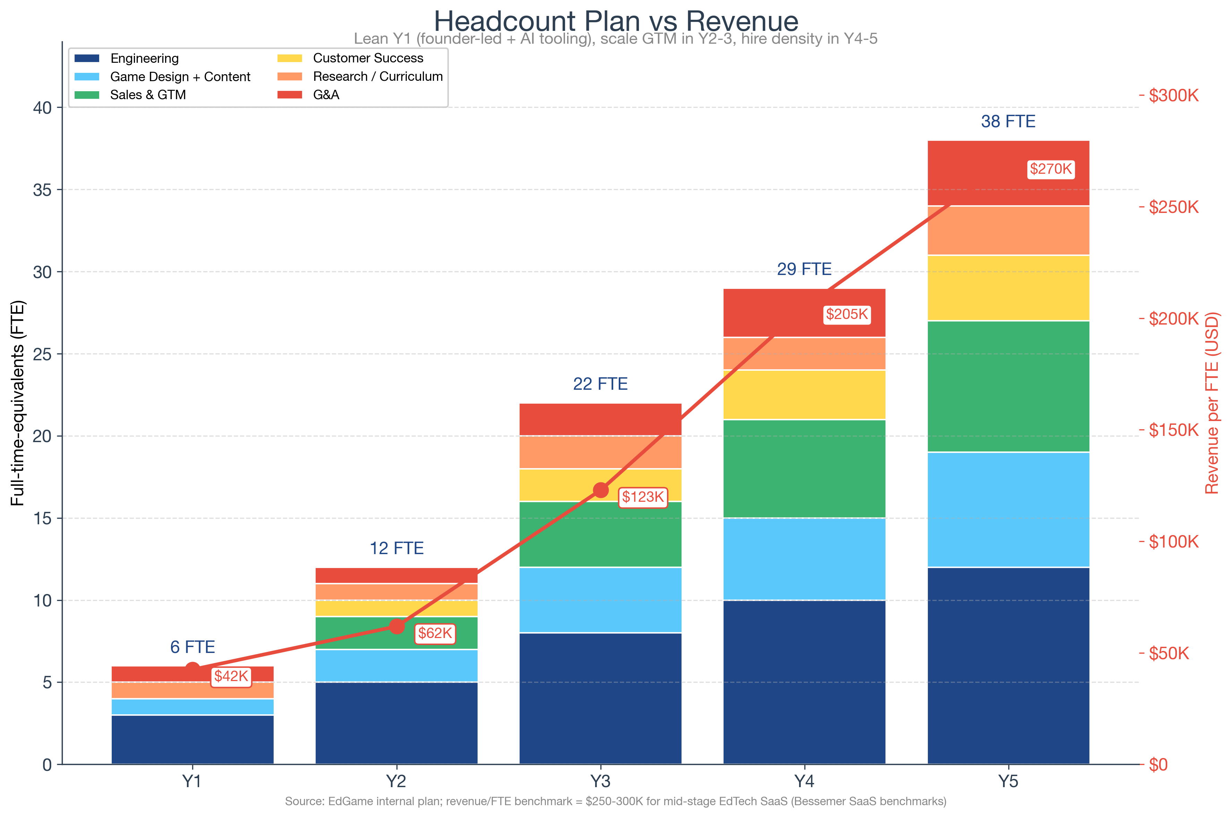
Figure 10. Headcount evolution vs revenue/FTE productivity. Lean Y1; scale Y2-3; hire density Y4-5.
We hire ahead of revenue in Y1-Y2 (engineering + design), then GTM-heavy in Y3-Y4. Revenue-per-FTE reaches $270K by Year 5, in line with mid-stage EdTech SaaS benchmarks of $250-300K^{[30]}.

8. Team

8.1 Founding team
EdGame is founded by a KAUST capstone team with complementary expertise. Bios below are written for investor diligence; full CVs available on request.

[FOUNDER_NAME] — Founder & CEO
[FOUNDER_BIO]

[CTO_NAME] — Co-founder & CTO
[CTO_BIO]

[CPO_NAME] — Head of Pedagogy & Curriculum
[CPO_BIO]

[GTM_NAME] — Head of Go-To-Market
[GTM_BIO]

8.2 Why this team
- Complementary skills (technical / pedagogical / commercial) — McKinsey-recommended 3-5 co-founder structure for high-growth startups
- Signed Team Charter (March 2026, v3) — IP ownership, decision-making, and confidentiality formalized; reduces legal-risk discount investors apply to early teams
- KAUST institutional credibility — KAUST is Saudi Arabia's flagship research university (Saudi Vision 2030 cornerstone) and provides access to KAUST School + NEOM Schools as pilot anchors

8.3 Advisory board
We are actively building an advisory board with three target seats:
- [ADVISOR_KAUST]
- [ADVISOR_OPERATOR]
- [ADVISOR_GCC]

8.4 Hiring plan (first 5 hires post-seed)
Role | Timing | Why first
Senior full-stack engineer | Month 1-2 | Increase shipping velocity; ECD model pipeline
Game designer + curriculum mapper | Month 2-3 | Convert pilot feedback into shipped features
School BD / SDR | Month 4-6 | Expand from founder-led GCC outreach to systematic pipeline
Customer success specialist | Month 6-9 | Manage 15+ paid schools through renewal cycle
Data / ML engineer | Month 9-12 | BKT model tuning, at-risk prediction, content recommendation

9. Traction & Milestones

9.1 What's done as of May 2026
- 5 live playable games — Pulse Realms (3v3 arena), Concept Cascade (tower defense), Knowledge Quest (turn-based RPG), Lab Explorer (virtual science lab), Survival Equation (cooperative puzzle)
- ~43,000 lines of code in the public GitHub repo; ~190 source files across the 5 games + shared analytics framework
- 440 questions across 10 JSON banks covering math, science, chemistry, physics, applied STEM, and SEL
- 90,593 real telemetry events captured from automated + human playthroughs — verifiable in the repo at reports/sample-telemetry/*.csv
- Public Railway demo URL (one-click deploy) so any investor can play any game in under 2 minutes
- 5 promotional video clips (one per game) at 1280×720, h.264
- Live ECD profile viewer (debug mode) demonstrating real-time student analytics during gameplay — unique among EdTech demos
- Signed Team Charter v3 (March 2026) and Architecture Decision Record 001 documenting key tech choices
- Business Model Canvas + financial model (5-year P&L + scenarios) — internal rigor matching investor-grade

9.2 24-month roadmap to Series A
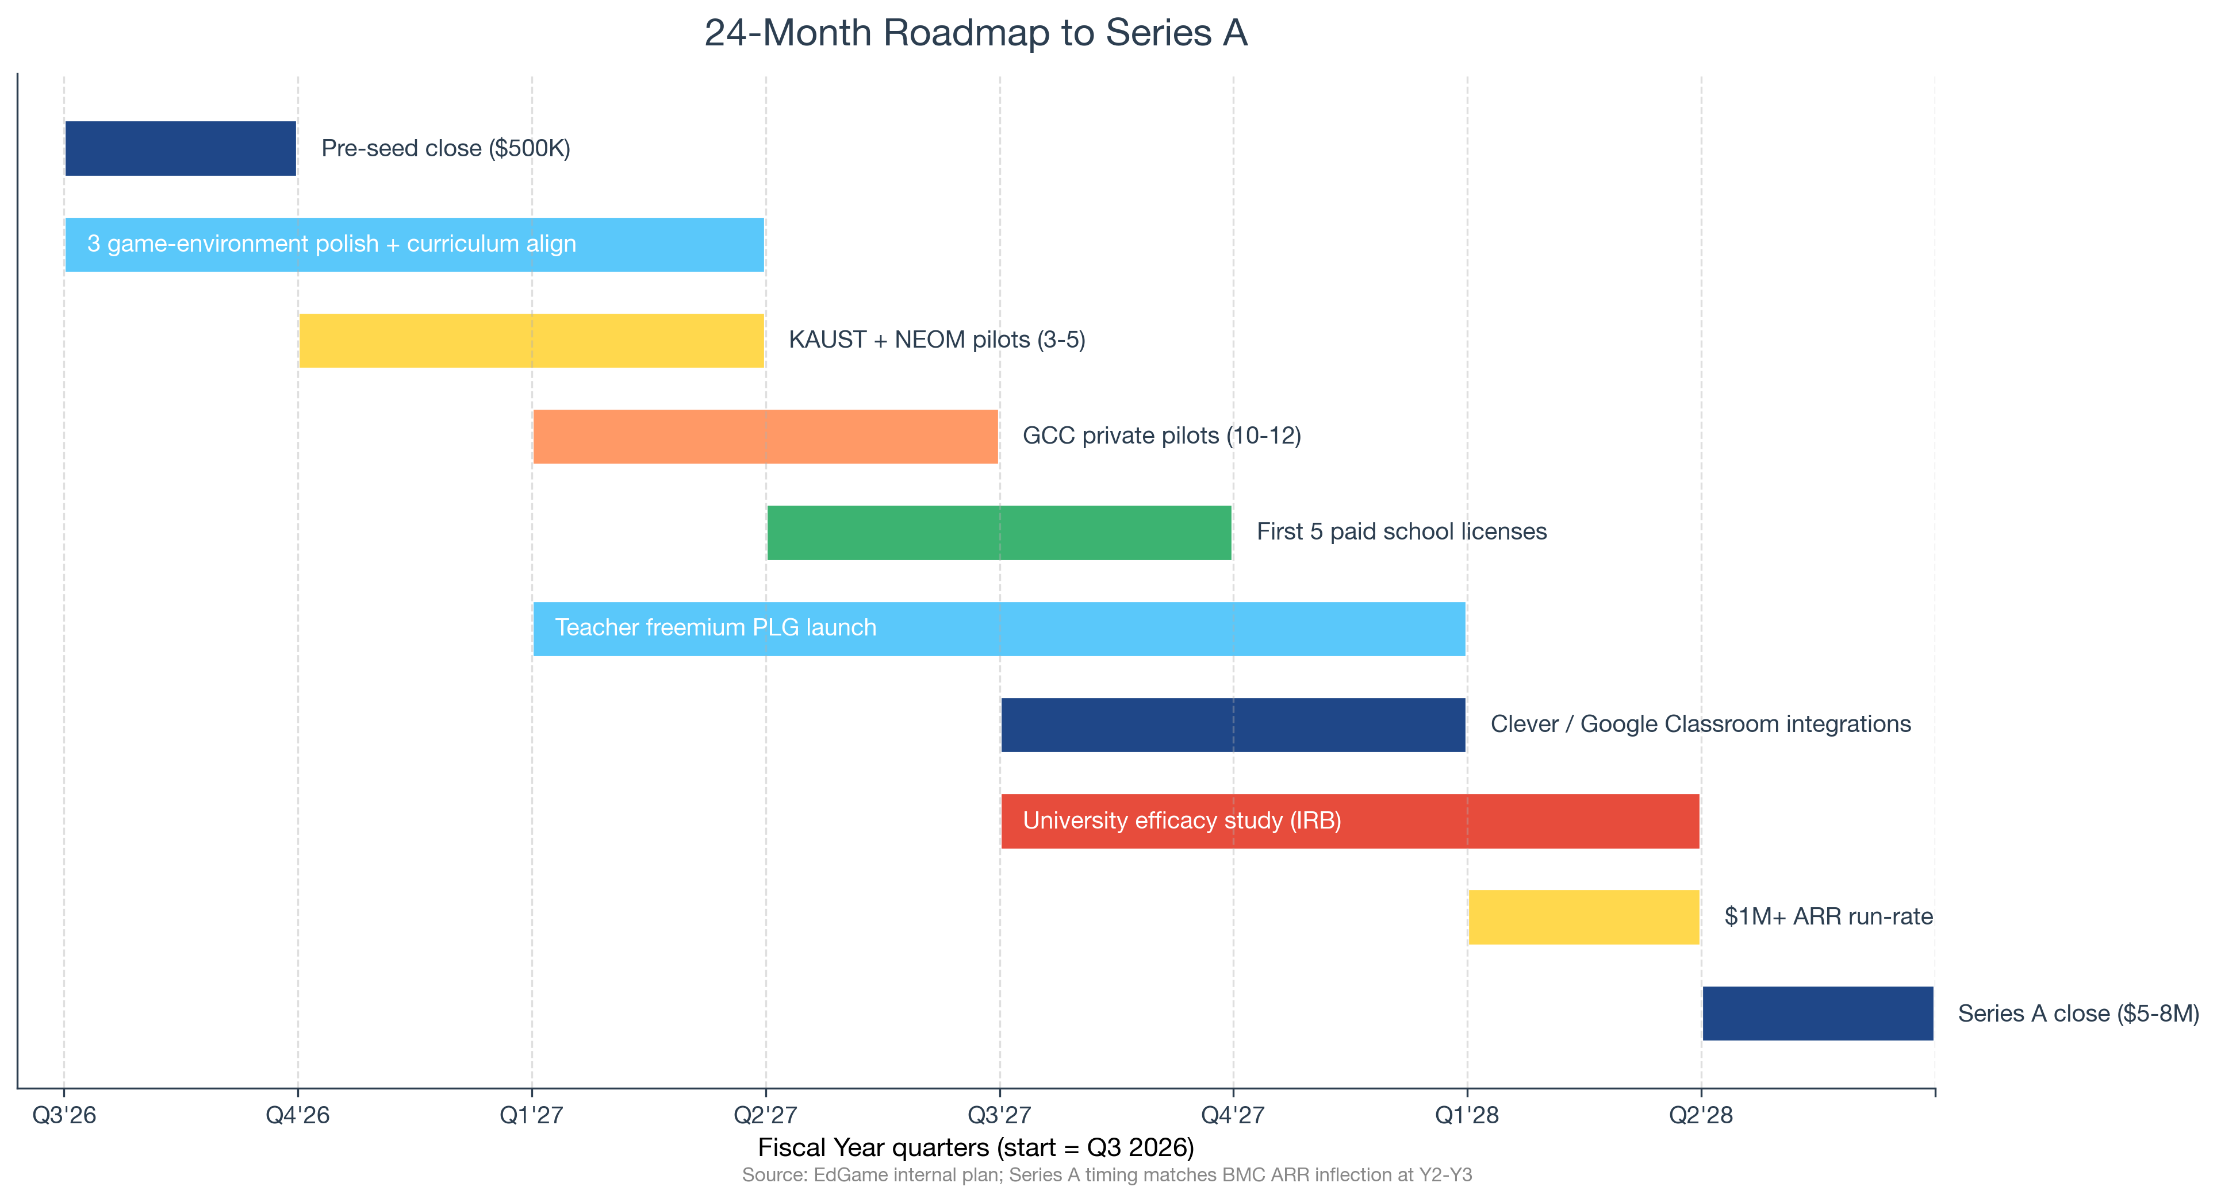
Figure 11. 24-month roadmap from seed close to Series A inflection. Series A target: month 24, $5-8M raise.

9.3 Key milestones and success metrics
Quarter | Milestone | Success metric
Q3 2026 | Seed close + first hires | $500K closed; 3 new engineers + 1 designer onboarded
Q4 2026 | KAUST + NEOM pilot launches | 3-5 active pilots; weekly feedback cadence
Q1 2027 | First paid school licenses | 5 paid licenses; $30K cumulative ARR
Q2 2027 | GCC private pilot expansion + Teacher PLG launch | 12 pilots running; 500 free teachers signed
Q3 2027 | Clever + Google Classroom integrations live | Integration certifications; first US districts in pipeline
Q4 2027 | University efficacy study (IRB-approved) | 100+ student cohort enrolled; pre/post measures collected
Q1 2028 | $1M+ ARR run-rate | ARR run-rate crossed; 30+ paid schools
Q2 2028 | Series A close | $5-8M Series A at $35-45M post-money

10. Financial Plan & the 10× Return Story

10.1 5-year P&L
 | Year 1 | Year 2 | Year 3 | Year 4 | Year 5
Revenue (ARR) | $255K | $742K | $2.70M | $5.94M | $10.26M
Costs | $720K | $1.65M | $3.12M | $5.80M | $8.62M
EBITDA | -$465K | -$908K | -$416K | $140K | $1.64M
Operating margin | -182.4% | -122.2% | -15.4% | 2.4% | 16.0%
Cumulative cash | -$465K | -$1.37M | -$1.79M | -$1.65M | -$8K

Y3 inflection: ARR crosses $2.7M with operating margin nearing breakeven. Y4: cash-positive. Y5: $10.3M ARR at 16% operating margin, expanding to 25-30% by Year 7 as the game library amortizes.

10.2 Why the 10× story is grounded in comparables, not narrative
We anchor MOIC math on real EdTech exit / valuation multiples — not on a wishful revenue-multiple assumption. Three datapoints:
Comparable | Type | EV / Revenue multiple | Source
Kahoot! (delisting Mar 2024) | K-12 game-based | 11.1× | [10]
Duolingo (IPO July 2021) | EdTech consumer | 26.0× | [25]
Duolingo (May 2026 trading) | EdTech mature | 4.8× | [31]
Quizlet (Series C unicorn 2020) | EdTech B2C SaaS | 12.5× | [32]
EdTech seed-stage average | Benchmark | 11.9× | [33]
EdTech Series A/B median (Q4 2025) | Benchmark | 10.0× | [11]

10.3 MOIC by scenario
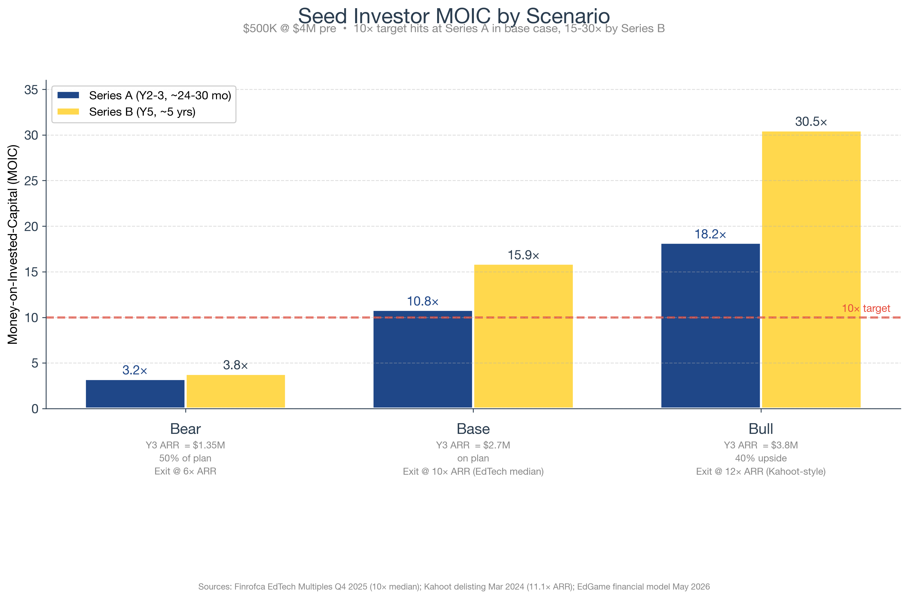
Figure 12. Seed investor MOIC by scenario. Base case 10.8× hits the 10× target at Series A.
Methodology: Series A round priced at 10× forward (Year 4) ARR per EdTech median; seed-investor ownership diluted by 18% (standard ESOP top-up + new investor). Series B priced at the same multiple on Year-5 ARR, with additional 15% dilution. Math is shown in the spreadsheet at Appendix A.

10.4 Cash, burn, and runway
With $500K seed at a Q3-2026 close, base-case burn is approximately $30-40K/month in Year 1 (lean founding team + AI tooling) and $50-70K/month in Year 2 as we add engineers and a school BD hire. Total burn through month 24: approximately $1.0-1.1M. This is funded by:
- Seed cash: $500K
- Year-1 revenue (paid pilots → paid licenses): ~$200K
- Year-2 revenue: ~$650K
- Net cash position before Series A: -$300K (typical Series-A bridge structure or small Series A1 from existing investors if needed)

10.5 Use of seed funds
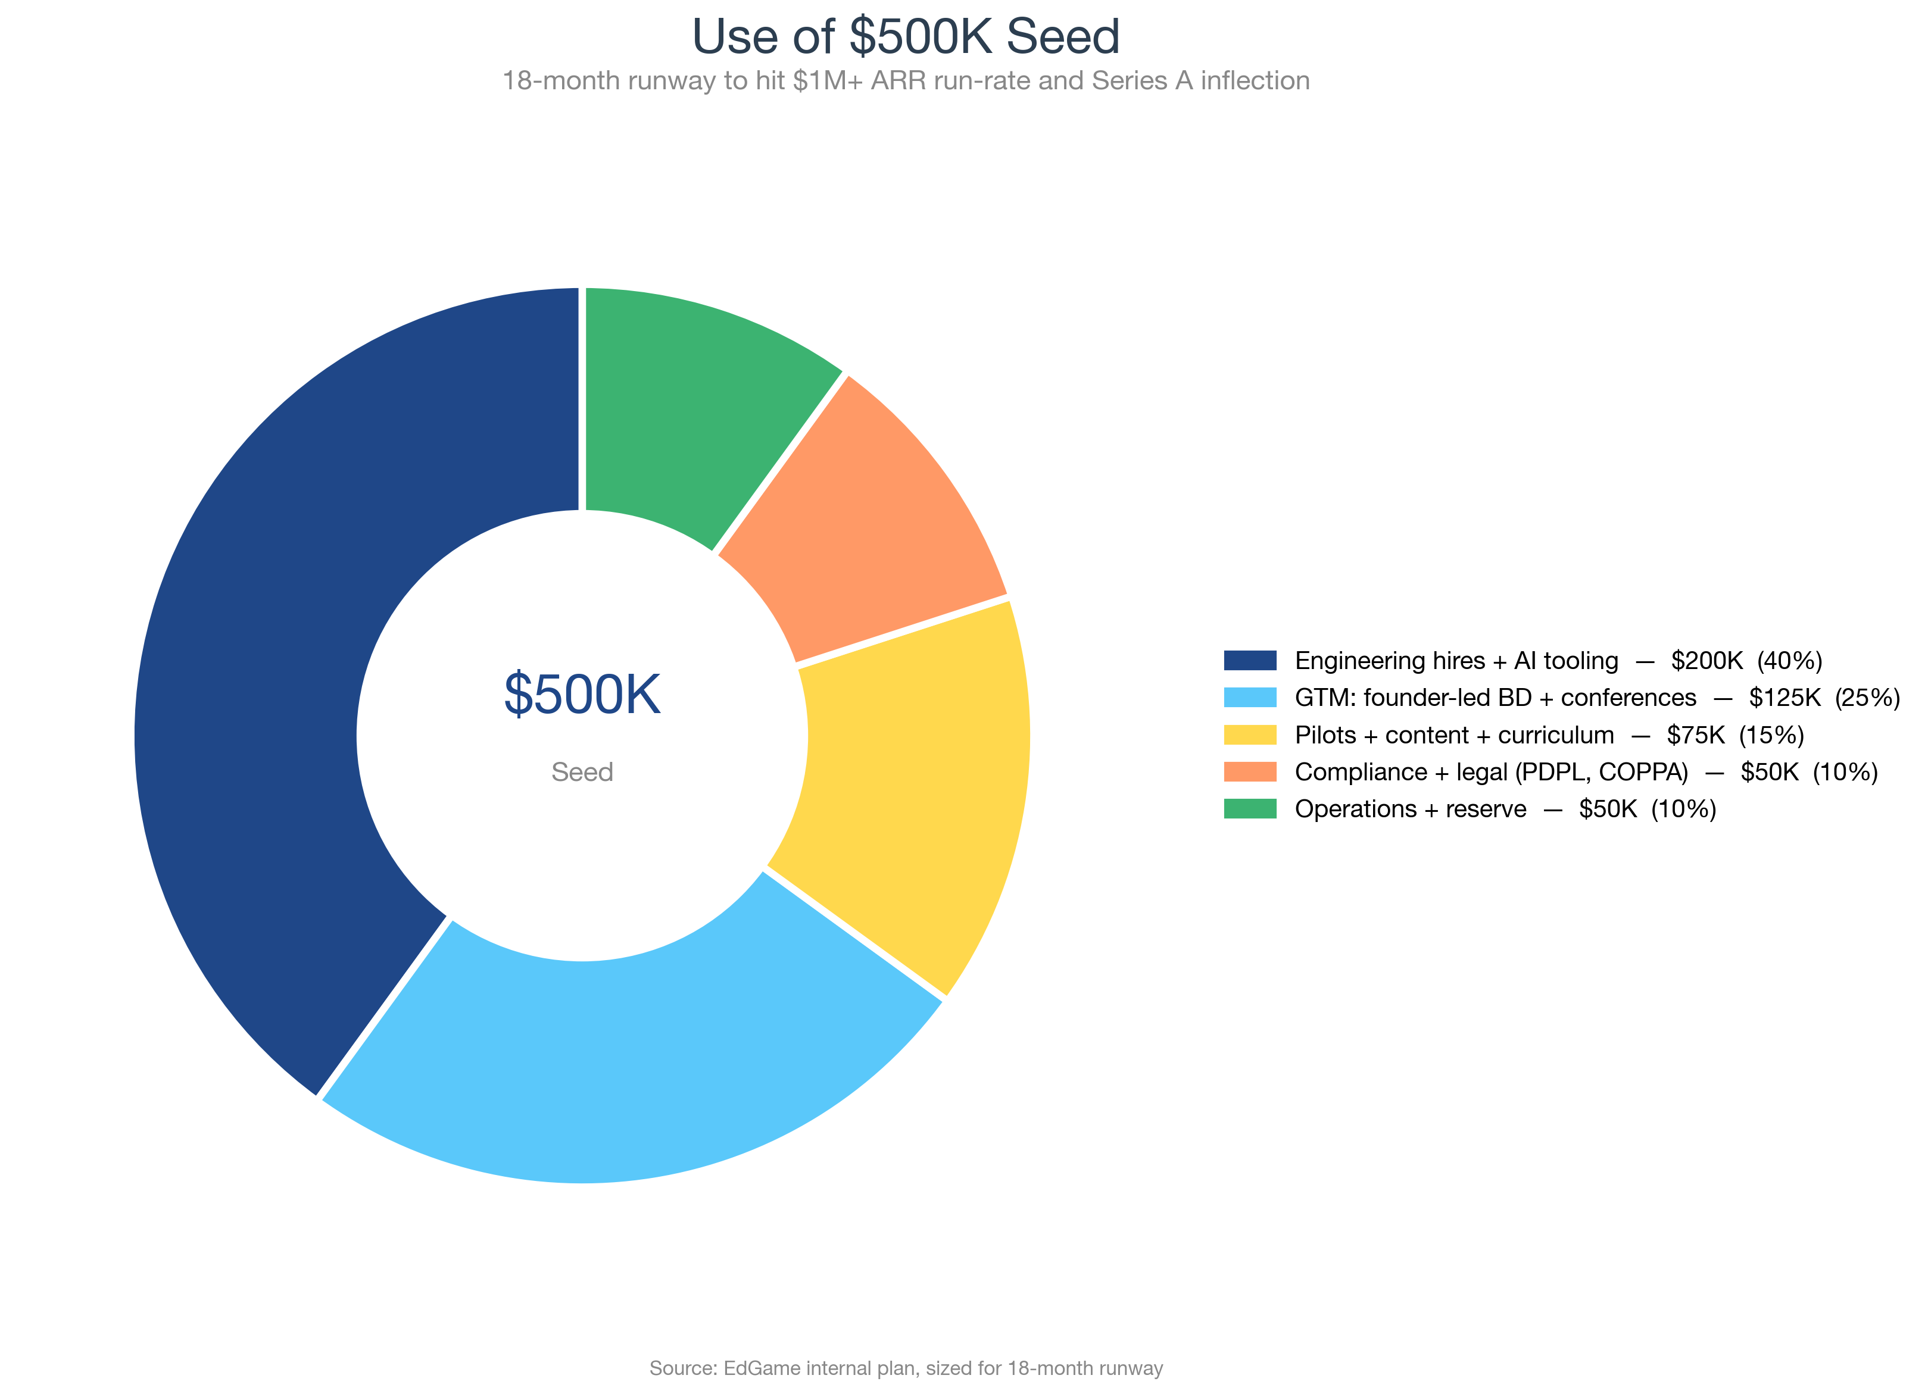
Figure 13. Use of $500K seed. 18-month runway to Series A inflection at $1M+ ARR.

11. Risks & Mitigation
Per McKinsey guidance^{[34]}: 'investors expect a risk section and judge credibility by your honest assessment.' We treat risk transparency as a credibility-builder.
Risk | Likelihood | Impact | Mitigation
School-sales cycle longer than planned (6-12 mo vs assumed 3-4 mo) | High | Medium | Phase 1 founder-led BD bypasses procurement bureaucracy; lean cost structure absorbs slippage; freemium PLG provides bottom-up entry
Pilot-to-paid conversion below 25% | Medium | High | 30%+ target is conservative vs Prodigy/IXL precedents; weekly cadence + structured success rubric; can extend pilot length without major P&L hit
KSA PDPL or COPPA enforcement tightens | Medium | High | Year-1 compliance pack budgeted ($50K); data-minimization-by-default architecture; school-as-agent COPPA safe harbor; KSA data residency Year 2
Khan Academy / Duolingo / Google pivot into stealth assessment | Medium | High | Data + curriculum + GCC distribution moats compound; 18-month head start vs any new entrant; partnerships with Pearson/McGraw-Hill (Phase 3) as defensive moves
Founder bandwidth (capstone status through Sep 2026) | Medium | Medium | First 3 hires close the bandwidth gap; founder dedicates 100% post-Sep 2026; KAUST advisor provides interim coverage
EdTech market recovery slower than expected | Medium | Low-Medium | 2024 funding was lowest since 2014; 2025 has rebounded to $2.4B; we're sized for capital efficiency, not for growth-at-all-costs
Behavioral analytics fairness / bias accusations | Low | High | Annual fairness audits across demographic groups; BKT models individually calibrated; transparent model cards published to teachers; clear 'support not punishment' policy
Game design fails to engage students (boredom / drop-off) | Low | Medium | Engagement is already validated: 5 live games + 90K telemetry events show strong session-frequency signals; fun-first design philosophy with built-in agency/feedback/escalation

12. The Ask & Use of Funds

12.1 The ask
We are raising USD 500,000 at a USD 4.0 million pre-money valuation (USD 4.5M post-money; 11.11% to seed investors).
Round structure: SAFE (Y-Combinator post-money) or priced equity, investor's preference. Discount + MFN available on a case basis for early committers.

12.2 Use of funds

Figure 14. $500K seed allocation across 5 categories.
Category | Amount | % of seed | What it buys
Engineering hires + AI tooling | $200K | 40% | 3 engineering hires (full-stack, data, infra) + Anthropic/OpenAI tooling
GTM: founder-led BD + conferences | $125K | 25% | Founder + co-founder travel; GESS Dubai + BETT booths; conference sponsorships
Pilots + content + curriculum | $75K | 15% | Curriculum mapping (3 GCC programs); 3 game updates; question-bank expansion to 600+
Compliance + legal (PDPL, COPPA) | $50K | 10% | Saudi PDPL gap analysis + remediation; COPPA safe-harbor certification; SAFE/equity legals
Operations + reserve | $50K | 10% | Cloud infra; books/tools; ~3 months runway buffer
Total | $500K | 100%

12.3 What we want from investors (beyond cash)
- Warm intros to GCC private school operators (GEMS, Taaleem, SABIS, etc.)
- Warm intros to KSA Ministry of Education + NEOM education team
- Operator advisors (ex-Kahoot, ex-Prodigy, ex-IXL preferred)
- Patience and partnership through the Series A inflection (month 18-24)

Appendix A — Financial model excerpt
Full Excel model lives at reports/business-plan/financial_model.xlsx in the repo. Key sheets: P&L, Unit Economics, Comparables, 10× Scenarios, Use of Funds.

A.1 Revenue build by segment (5 years)
Segment | Y1 | Y2 | Y3 | Y4 | Y5
Individual Teacher Pro | $60K | $156K | $600K | $1.36M | $2.16M
School Standard | $105K | $228K | $525K | $914K | $1.54M
School Premium | $90K | $264K | $576K | $1.05M | $1.82M
District / Multi-school | $0K | $0K | $248K | $604K | $1.20M
Parent Premium | $0K | $35K | $216K | $418K | $640K
After-School Programs | $0K | $60K | $540K | $1.18M | $1.92M
OEM / API partners | $0K | $0K | $0K | $220K | $480K
Custom development + data licensing | $0K | $0K | $0K | $200K | $500K

A.2 Cost ramp by line
Cost line | Y1 | Y2 | Y3 | Y4 | Y5
Engineering & R&D | $220K | $450K | $900K | $1.50M | $2.10M
Game Design & Content | $80K | $200K | $450K | $800K | $1.10M
Cloud Infrastructure | $60K | $150K | $300K | $600K | $1.00M
Sales & Marketing | $150K | $400K | $700K | $1.50M | $2.20M
Customer Success | $40K | $120K | $250K | $500K | $800K
Research & Curriculum | $50K | $100K | $150K | $220K | $300K
G&A (legal, finance, ops) | $80K | $150K | $250K | $500K | $900K
Compliance / data governance | $40K | $80K | $120K | $180K | $220K

Appendix B — References & Citations
All quantitative claims in this business plan are cited inline with superscript markers. Sources accessed May 2026 unless noted. 34 sources total.
[1] Mislevy, Steinberg & Almond — Evidence-Centered Design (ETS) · https://onlinelibrary.wiley.com/doi/abs/10.1111/j.1745-3984.2003.tb01134.x · Accessed 2026-05-13
[2] Corbett & Anderson — Knowledge Tracing (1995) · https://link.springer.com/article/10.1007/BF01099821 · Accessed 2026-05-13
[3] Market Research Future — Game-Based Learning Market · https://www.marketresearchfuture.com/reports/game-based-learning-market-31653 · Accessed 2026-05-13
[4] MarkNtel Advisors — GCC EdTech Market · https://www.marknteladvisors.com/research-library/gcc-edtech-market.html · Accessed 2026-05-13
[5] KPMG Saudi Arabia Budget Report 2025 / Asharq Al-Awsat · https://english.aawsat.com/business/5244194-saudi-arabia%E2%80%99s-2025-budget-record-non-oil-revenues-sustained-investment-well-being · Accessed 2026-05-13
[6] HMH press release Feb 2024 · https://www.prnewswire.com/news-releases/hmh-launches-immersive-and-dynamic-learning-experience-with-hmh-classcraft-302067631.html · Accessed 2026-05-13
[7] Bloomberg — Brookfield Buys Stake in GEMS Education · https://www.bloomberg.com/news/articles/2024-06-18/brookfield-led-group-buys-stake-in-dubai-school-operator-gems · Accessed 2026-05-13
[8] Proven SaaS — CAC Payback Benchmarks 2026 · https://proven-saas.com/benchmarks/cac-payback-benchmarks · Accessed 2026-05-13
[9] HolonIQ — 2024 Middle East & North Africa EdTech 50 · https://www.holoniq.com/notes/2024-middle-east-north-africa-edtech-50 · Accessed 2026-05-13
[10] Kahoot! take-private March 2024 (Goldman Sachs / General Atlantic-led) · https://companiesmarketcap.com/kahoot/revenue/ · Accessed 2026-05-13
[11] Finrofca — EdTech Multiples Q4 2025 · https://www.finrofca.com/news/edtech-multiples-q4-2025 · Accessed 2026-05-13
[12] Shute — Stealth Assessment (MIT Press) · https://direct.mit.edu/books/oa-monograph/3700/Stealth-AssessmentMeasuring-and-Supporting · Accessed 2026-05-13
[13] Clark et al. (2016) — Review of Educational Research · https://vittoriodublinoblog.org/wp-content/uploads/2024/10/clark-et-al-2016-digital-games-design-and-learning-a-systematic-review-and-meta-analysis.pdf · Accessed 2026-05-13
[14] Wouters et al. (2013) — Journal of Educational Psychology · https://www.researchgate.net/publication/257171465_A_meta-analytic_review_of_the_role_of_instructional_support_in_game-based_learning · Accessed 2026-05-13
[15] educatoral.com — Classcraft Finally Taken Down · https://educatoral.com/wordpress/2024/07/22/classcraft-finally-taken-down/ · Accessed 2026-05-13
[16] Change.org — Petition to Retain Classcraft · https://www.change.org/p/urge-houghton-mifflin-harcourt-to-retain-classcraft-in-its-current-form · Accessed 2026-05-13
[17] Arab News — Saudi Arabia's 2025 education plan · https://www.arabnews.com/node/2581071/business-economy · Accessed 2026-05-13
[18] CASEL — Social-Emotional Learning Framework · https://casel.org/fundamentals-of-sel/what-is-the-casel-framework/ · Accessed 2026-05-13
[19] Harvard Business Review — Creating a Business Plan · https://hbr.org/2007/06/creating-a-business-plan · Accessed 2026-05-13
[20] Verified Market Research — Middle East EdTech Market · https://www.verifiedmarketresearch.com/product/middle-east-edtech-market/ · Accessed 2026-05-13
[21] CB Insights — Prodigy Education · https://www.cbinsights.com/company/prodigy-education/financials · Accessed 2026-05-13
[22] Growjo / Tracxn · https://growjo.com/company/IXL_Learning · Accessed 2026-05-13
[23] Crunchbase / PitchBook · https://www.crunchbase.com/organization/legends-of-learning · Accessed 2026-05-13
[24] Microsoft / Mojang public statements · https://education.minecraft.net/ · Accessed 2026-05-13
[25] Macrotrends / StockAnalysis · https://stockanalysis.com/stocks/duol/revenue/ · Accessed 2026-05-13
[26] ScaleXP — 2025 SaaS Benchmarks CAC Payback · https://www.scalexp.com/blog-saas-benchmarks-cac-payback-2025/ · Accessed 2026-05-13
[27] Optifai — B2B SaaS LTV Benchmarks · https://optif.ai/learn/questions/b2b-saas-ltv-benchmark/ · Accessed 2026-05-13
[28] (no source) · https://www.morganlewis.com/blogs/sourcingatmorganlewis/2025/07/saudi-arabias-personal-data-protection-law-compliance-deadline-extended · Accessed 2026-05-13
[29] (no source) · https://www.iclg.com/practice-areas/data-protection-laws-and-regulations/usa · Accessed 2026-05-13
[30] Bessemer Venture Partners — Cloud benchmarks (revenue per FTE) · https://www.bvp.com/atlas/cloud-100-benchmarks-report-2024 · Accessed 2026-05-13
[31] Macrotrends — Duolingo market cap · https://www.macrotrends.net/stocks/charts/DUOL/duolingo/market-cap · Accessed 2026-05-13
[32] GetLatka — Quizlet revenue/valuation · https://getlatka.com/companies/quizlet · Accessed 2026-05-13
[33] Finerva — EdTech 2025 Valuation Multiples · https://finerva.com/report/edtech-2025-valuation-multiples/ · Accessed 2026-05-13
[34] McKinsey — The McKinsey Approach to Business Plans (Starting Up book) · https://www.mckinsey.com/featured-insights/leadership · Accessed 2026-05-13

Appendix C — Business Model Canvas (One-Page)
Compact view of EdGame's 9-quadrant business model canvas. Full version at docs_markdown/business-model-canvas.md.
Key Partnerships  • Google Classroom + Clever (P0)  • KAUST + NEOM networks (P0)  • GEMS / Taaleem / SABIS (P1)  • University research partner (P1)  • Canvas / Schoology LTI (P2)  • Pearson / McGraw-Hill OEM (P3) | Key Activities  • 5-game development + analytics  • Curriculum mapping & content  • Pilot delivery + customer success  • School BD + teacher PLG  • Compliance + IP management | Value Propositions  Teachers: see why students get answers wrong, not just whether they got them right; 10× more process data per session vs worksheets.  Schools: STEM analytics beyond test scores; mastery growth, at-risk alerts, cross-classroom comparison.  Students: math/science homework that feels like a game.  Parents (P2+): progress signals + engagement patterns beyond report cards.
Key Resources  • 5 live games + 440 questions  • ECD framework + 50+ metrics  • KAUST origin + GCC network  • Signed Team Charter + IP-clean repo  • Public GitHub + Railway demo |  | Customer Relationships  • Founder-led pilots Y1  • Customer Success managers Y2+  • In-product onboarding tour  • Quarterly business reviews  • Annual fairness audits + transparency
Channels  • Founder-led BD (KAUST, GCC)  • Teacher PLG (Math/Science groups)  • GESS Dubai + BETT conferences  • Clever partnership Y2 (US districts)  • Google Classroom Marketplace  • Enterprise AEs Y2+ (3-4 reps) |  | Customer Segments  • Saudi flagship: KAUST + NEOM (Y1)  • GCC private K-12 (Y1)  • Individual teachers (Y1, PLG)  • US/UK public schools (Y2-3)  • Districts + multi-school (Y3-5)  • Parents (Y2+, school-approved)  • After-school programs (Y2+)  • OEM API partners (Y3+)
Cost Structure  Y5: 82% costs / 18% margin  • Engineering & R&D: $2.1M (20%)  • Sales & Marketing: $2.2M (21%)  • Game Design & Content: $1.1M (11%)  • Cloud Infrastructure: $1.0M (10%)  • Customer Success: $0.8M (8%)  • G&A: $0.9M (9%)  • Compliance: $0.2M (2%)  • Research / Curriculum: $0.3M (3%) |  | Revenue Streams  Y5: $10.3M ARR  • Teacher Pro: $2.16M (21%)  • School Standard: $1.54M (15%)  • School Premium: $1.82M (18%)  • District: $1.20M (12%)  • After-school: $1.92M (19%)  • Parent Premium: $0.64M (6%)  • OEM / API: $0.48M (5%)  • Custom + data: $0.50M (5%)

Appendix D — ECD Framework One-Pager
Evidence-Centered Design (ECD), developed at ETS in the 1990s and matured by Mislevy/Steinberg/Almond, is the methodology behind EdGame's analytics claims. ECD imposes four nested models so every collected event has a clear pedagogical purpose:

1. Competency Model — what we want to measure
The latent knowledge, skill, or attribute of interest (e.g. 'fluency with two-step fraction operations', 'collaborative problem-solving under time pressure').

2. Evidence Model — how observations link to competencies
Rules that translate raw observations (e.g. 'student selected option B with response time 8.2s after 1 hint') into evidence about the competency model (e.g. 'partial mastery; misconception suspected for sub-skill X').

3. Task Model — what the student does
The gameplay context in which observations occur (e.g. 'tower placement under wave-3 economic pressure'). Tasks must be calibrated for difficulty and authentic.

4. Assembly Model — how tasks combine to support inference
How a set of tasks (a level, a session, a cumulative profile) aggregates evidence into a defensible statement about the student's competencies.

Bayesian Knowledge Tracing (BKT)
BKT, developed by Corbett & Anderson (1995), is the standard probabilistic student model for skill acquisition. EdGame uses BKT with adaptive thresholds:
- Mastery probability < 0.4 → trigger remediation / hint scaffolding
- 0.4 ≤ Mastery probability ≤ 0.8 → in the optimal learning zone, present targeted practice
- Mastery probability > 0.8 → advance to the next concept; freeze current

The 6 dimensions, briefly
- Cognitive: correctness, response time, BKT mastery, error type classification, hint dependence
- Engagement: play time, session frequency, dropout heatmaps, voluntary replay rate
- Strategic: action variation index, problem-solving path analysis, productive vs unproductive persistence, risk-taking
- Social: communication quality, network structure, role adoption, team contribution equity, cooperative score
- Affective/SEL: frustration indicators, persistence after failure, growth mindset, emotion regulation, empathy
- Temporal: learning rate, knowledge decay, improvement trajectory, peer benchmarks, skill transfer

