EdGame Analytics Platform
Technical Architecture & Design Document

Living Document — Version 1.0

Author: Yousef Radwan
Course: TIE 251 — Capstone Computing Studies
Institution: KAUST
Date: March 2026

1. Executive Summary
EdGame is a game-based learning analytics platform designed for K-12 classrooms. It integrates five educational games with a real-time analytics dashboard, enabling teachers to gain actionable insights into student knowledge, engagement, strategic thinking, collaboration, and social-emotional development.
The platform is built on Evidence-Centered Design (ECD), using stealth assessment and Bayesian Knowledge Tracing (BKT) to measure student competencies without interrupting gameplay. Every game mechanic is intentionally designed to produce observable evidence mapped to specific knowledge components and analytics dimensions.
Key capabilities:
- 5 educational games spanning math and science, each targeting different analytics dimensions
- 50+ learning metrics across 6 analytical dimensions (Cognitive, Behavioral, Strategic, Social, Affective, Temporal)
- Real-time teacher dashboards with class-level and student-level views
- Adaptive difficulty that adjusts question difficulty based on estimated mastery
- Privacy-first architecture compliant with FERPA and COPPA regulations
Technology stack: Next.js 14, SurrealDB, KAPLAY.js, pnpm + Turborepo monorepo, deployed on Railway.
This document serves as the canonical technical reference for the EdGame project, consolidating architecture decisions, data models, API specifications, assessment frameworks, and game design documentation into a single living document.

2. System Overview & Vision

Product Description
EdGame transforms classroom assessment by embedding rigorous measurement within engaging game experiences. Rather than testing students with traditional quizzes, EdGame captures rich behavioral telemetry during gameplay and uses evidence-centered design to infer mastery of specific knowledge components.

Strategic Principle
"Every game mechanic is an assessment opportunity." No mechanic exists purely for entertainment — each interaction generates observable evidence that feeds into the analytics pipeline.

Design Principles
- Stealth Assessment: Students are assessed through natural gameplay, not separate test modes
- Evidence-Centered Design: Every observable maps to specific knowledge components through explicit task and evidence models
- Teacher Empowerment: Analytics dashboards provide actionable insights, not just raw data
- Adaptive Learning: Difficulty adjusts in real-time based on Bayesian mastery estimates
- Privacy by Design: Minimal data collection, FERPA/COPPA compliance, no PII in telemetry

5-Game Portfolio
Game | Genre | Subject | Primary Dimension | Status
Pulse Realms | 3v3 Team Arena | Math & Science | D4: Social & Collaborative | Active Development
Concept Cascade | Tower Defense | Mathematics | D3: Strategic Behavior | Planned
Lab Explorer | Virtual Science Lab | Science | D3: Strategic Behavior | Planned
Knowledge Quest | Turn-Based RPG | Math & Science | D5: Affective & SEL | Planned
Survival Equation | Cooperative Puzzle | Math & Science | D4: Social & Collaborative | Planned

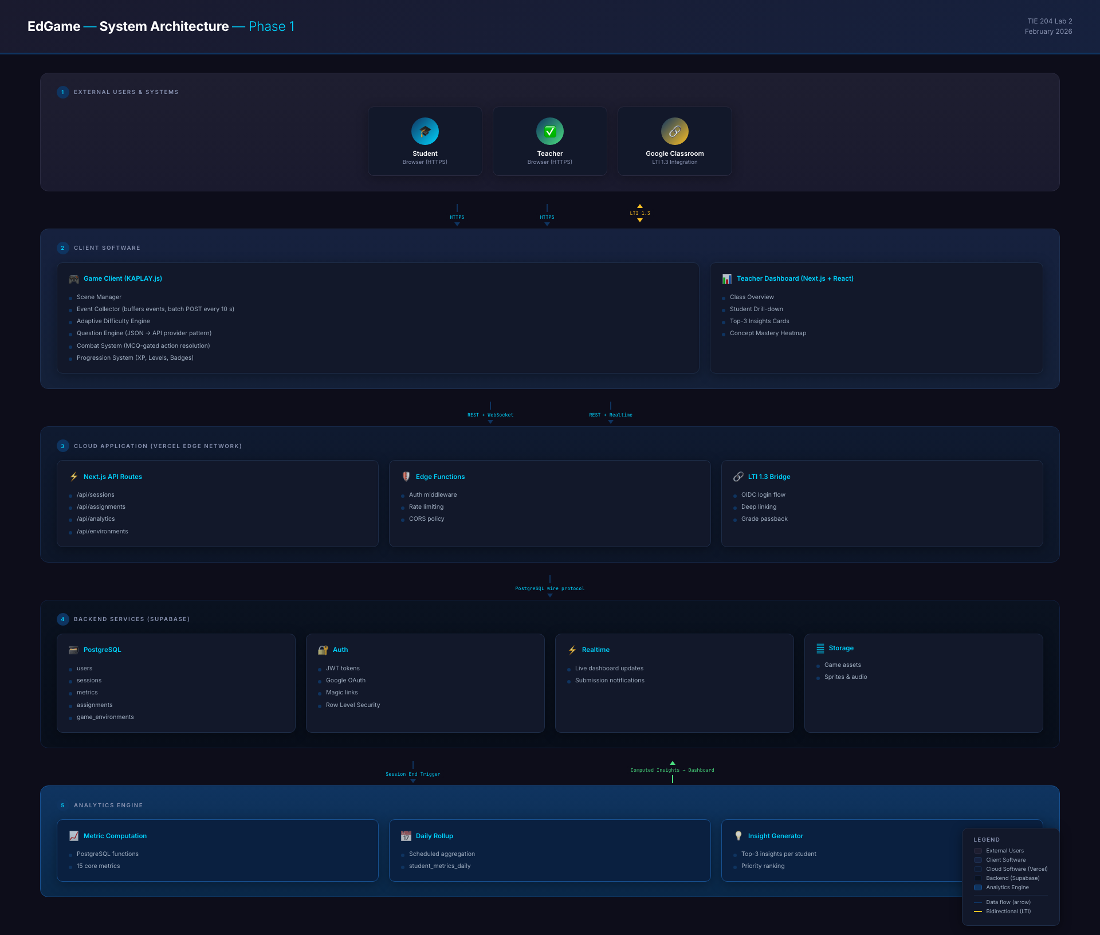
Figure: System Architecture — High-level overview of EdGame platform components

3. Architecture Decisions (ADR)
This section contains the full Architecture Decision Record (ADR) for Phase 1, documenting all binding technology decisions with their rationale, consequences, and considered alternatives.

- Status: Accepted
- Date: 2026-03-06
- Authors: TIEVenture Team

Context
EdGame is a game-based learning analytics platform for K-12 classrooms. Phase 1 targets launch with a single game (Pulse Realms), teacher dashboards, and a core analytics pipeline. This ADR records the binding technology decisions for Phase 1.

Decisions

1. Next.js 14 App Router (not Pages Router)
Choice: Next.js 14+ with the App Router.
Rationale:
- Server Components reduce client bundle size — critical for schools with low-bandwidth networks.
- Built-in API routes (Route Handlers) eliminate the need for a separate backend service.
- Vercel-native deployment with edge functions, automatic scaling, and CI/CD.
- React Server Components enable streaming SSR for dashboard pages with heavy data.
- App Router is the stable, recommended architecture going forward; Pages Router is legacy.
Consequences:
- Team must learn React Server Component patterns (server vs. client boundaries).
- Some older React libraries may not yet support RSC.

2. KAPLAY.js as Game Engine (not Phaser)
Choice: KAPLAY.js (v3001.x) for all game environments.
Rationale:
- The original spec (spec-v1.0.md §2.2) listed Phaser 3 as the game engine. During prototyping, the team built Pulse Realms with KAPLAY.js instead.
- KAPLAY provides a simpler, more declarative API better suited to our question-gated combat mechanics.
- The existing Pulse Realms codebase (PulseRealms/main.js) imports from kaplay@3001.0.19 and all game systems (telemetry, combat, question engine, progression) are built on KAPLAY primitives.
- Switching back to Phaser would require a full rewrite of the working prototype with no clear benefit.
Decision: Adopt KAPLAY.js as the standard game engine. Update the spec to reflect this. Future games (Concept Cascade, Lab Explorer, Knowledge Quest, Survival Equation) will also use KAPLAY.
Consequences:
- Smaller community than Phaser — fewer third-party plugins available.
- Team owns more low-level game infrastructure (asset loading, scene management).

3. SurrealDB as Database
Choice: SurrealDB as the primary database.
Rationale:
- Multi-model database (document, graph, relational) — fits our mixed data needs (structured schemas for users/classes, semi-structured JSONB-like payloads for game events, graph relations for class membership).
- Built-in permissions system (DEFINE TABLE ... PERMISSIONS) provides data isolation between schools/teachers without application-level authorization code.
- SurrealQL is expressive and supports record links, subqueries, and computed fields natively.
- Easy to deploy as a single service on Railway — no managed service vendor lock-in.
- Built-in functions and live queries for real-time dashboard updates.
- Authentication handled via NextAuth.js at the application layer, with SurrealDB storing user records.
Consequences:
- Newer database with a smaller ecosystem than PostgreSQL — fewer ORMs, tools, and community resources.
- Auth is handled at the Next.js layer (NextAuth.js) rather than database-level.
- Team must learn SurrealQL syntax (similar to SQL but with differences).

4. Railway for Hosting
Choice: Railway for all web infrastructure and database hosting.
Rationale:
- Simple deployment from GitHub with automatic builds.
- Supports Next.js natively (Nixpacks builder auto-detects).
- Can host both the Next.js app and SurrealDB as separate services in one Railway project.
- Persistent volumes for SurrealDB data.
- No serverless cold-start latency — runs as a persistent process.
- Simpler configuration than Vercel for monorepo + database co-hosting.
Consequences:
- No edge functions — API routes run from a single region (acceptable for Phase 1).
- Must configure Railway services manually (Next.js service + SurrealDB service).
- Long-running jobs (daily rollups) can run as cron jobs within the Next.js service or as SurrealDB functions.

5. pnpm Monorepo with Turborepo
Choice: pnpm workspaces managed by Turborepo.
Rationale:
- Multiple packages need to share code: apps/web (Next.js dashboard), apps/games (KAPLAY game environments), packages/shared (types, utilities, constants), packages/ui (shadcn/ui component library).
- pnpm provides strict dependency isolation (no phantom dependencies) and efficient disk usage via content-addressable storage.
- Turborepo provides incremental builds, remote caching, and parallel task execution.
- Both are Vercel-maintained, ensuring long-term compatibility.
Consequences:
- Slightly higher setup complexity vs. a single-package repo.
- CI must be configured for Turborepo caching.

6. Phased Scaling Strategy
Choice: Three-phase infrastructure scaling tied to user milestones.
Phase | Users | Infrastructure | Key Changes
Phase 1 (Launch) | 0–5,000 | Railway (Next.js + SurrealDB) | Single SurrealDB instance, client-side telemetry batching, daily metric rollups via cron
Phase 2 (5K–50K) | 5,000–50,000 | Railway Pro + dedicated SurrealDB | Separate analytics namespace, event queue, Redis caching for dashboards
Phase 3 (50K+) | 50,000+ | Multi-service Railway or dedicated infrastructure | SurrealDB cluster, CDN edge caching for game assets, data warehouse for longitudinal analytics

Rationale:
- Avoids premature optimization — Phase 1 keeps infrastructure simple and cheap.
- Clear trigger points for scaling decisions (not time-based, load-based).
- Each phase has a concrete migration plan, not just "we'll figure it out."
Consequences:
- Phase 1 architecture must be designed so that Phase 2 migrations are non-breaking (e.g., event schema must support future queue-based ingestion).

References
- docs_markdown/spec-v1.0.md — Original specification
- PulseRealms/main.js — KAPLAY import and game bootstrap
- PulseRealms/src/systems/telemetry.js — Event format used in prototype
- docs/architecture/data-model.surql — Phase 1 database schema (SurrealQL)
- docs/architecture/api-routes.md — Phase 1 API route inventory
- docs/architecture/monorepo-structure.md — Directory layout

4. System Architecture & Algorithms
This section details the functional architecture, algorithm designs, and interface specifications for the EdGame platform. Each subsection includes a diagram placeholder for the corresponding visual from the TIE 204 assignments.

Functional Block Diagram
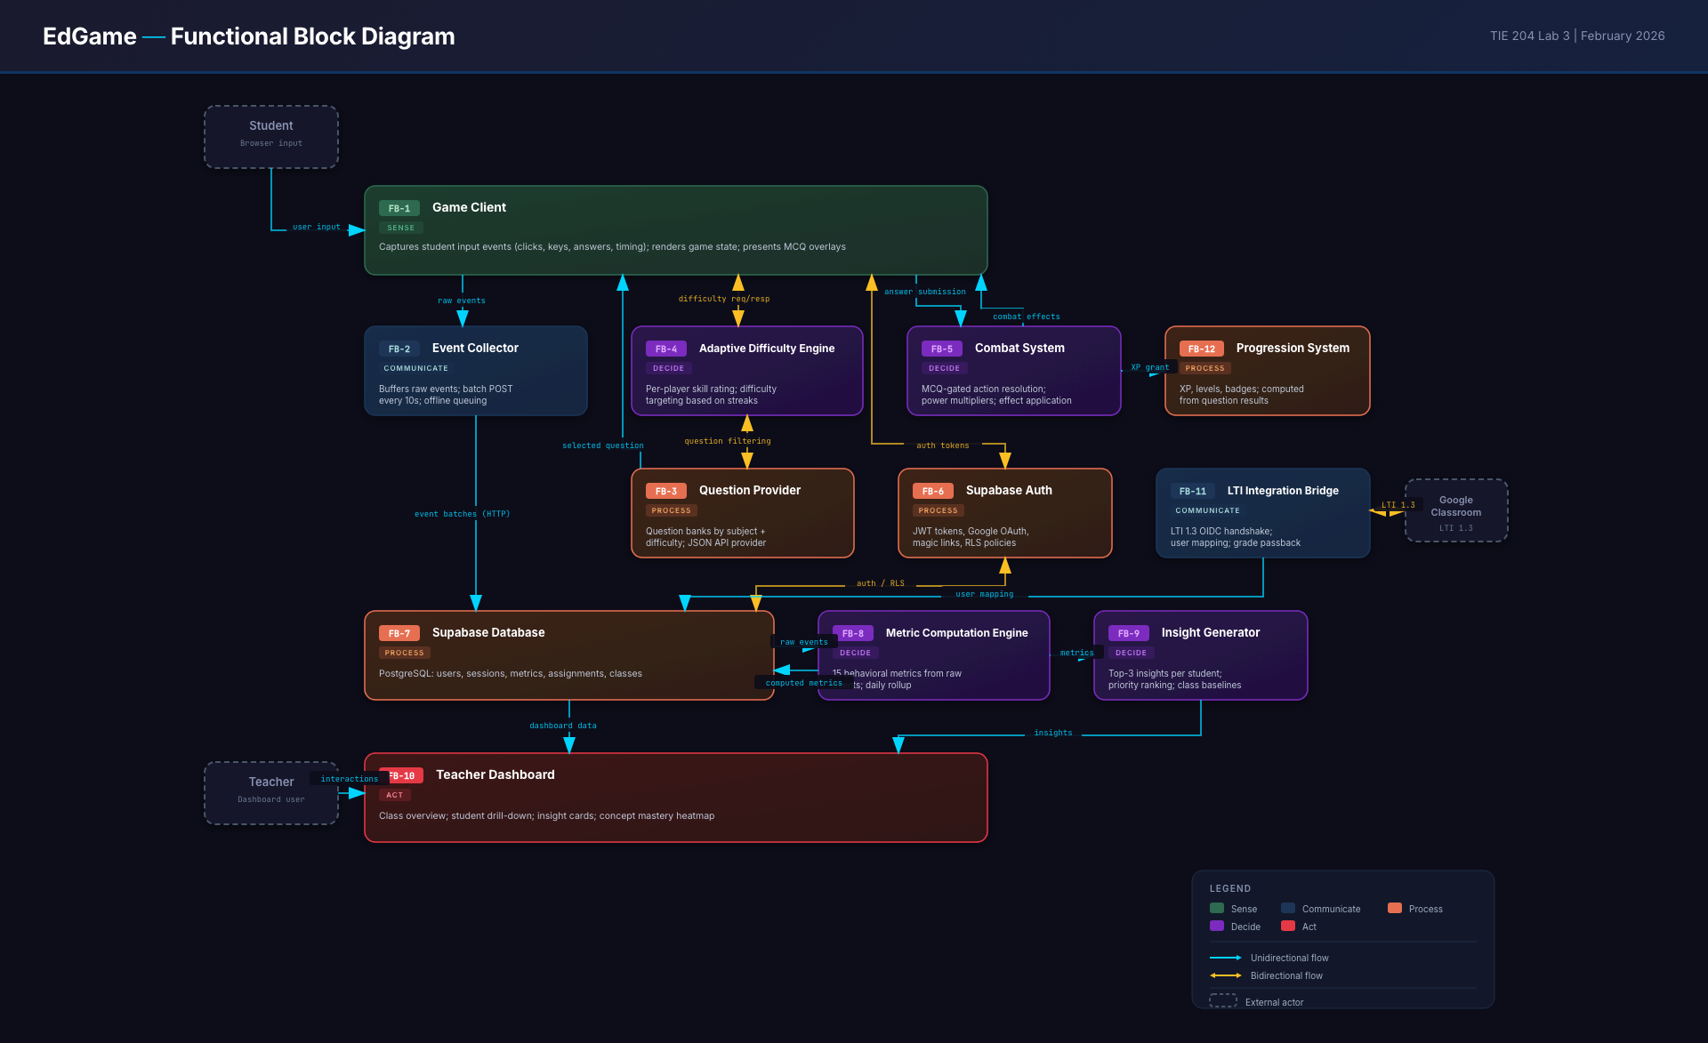
Figure: Functional Block Diagram — Major system components and data flow

Algorithm Mapping
Maps game mechanics to assessment algorithms and shows how player actions translate into analytics metrics through the ECD pipeline.
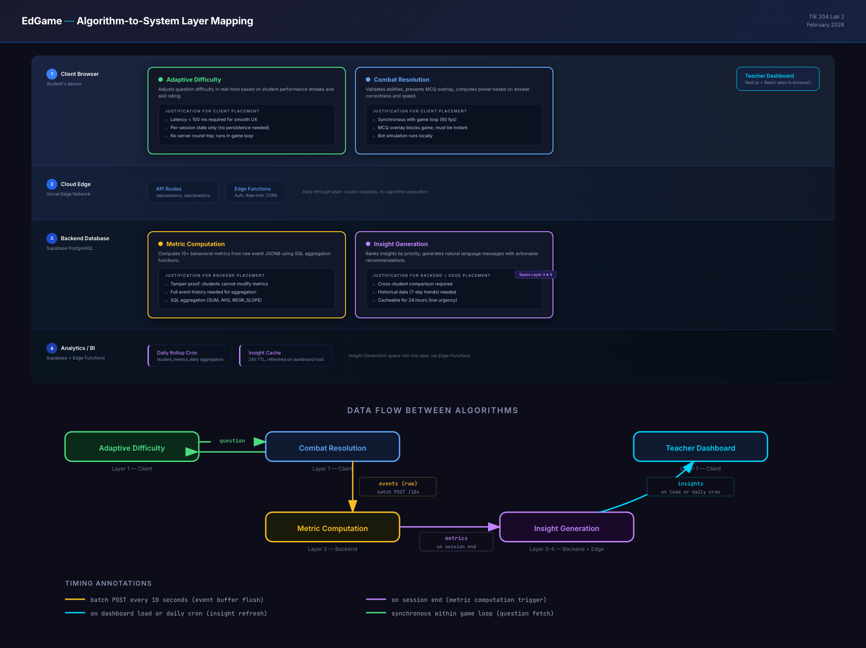
Figure: Algorithm Mapping — Game mechanics to assessment algorithms

Combat Resolution FSM
The Combat Resolution Finite State Machine governs how player actions (attack, heal, shield) are resolved in Pulse Realms. Each state transition emits telemetry events that feed into the analytics pipeline.
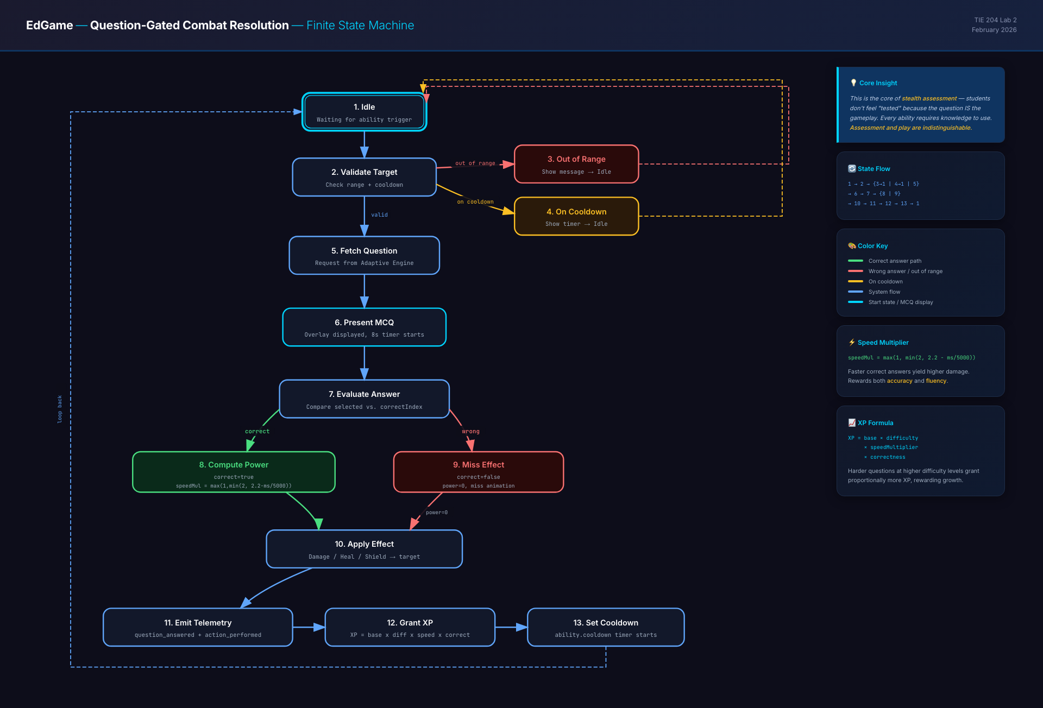
Figure: Combat Resolution FSM — State transitions during Pulse Realms combat

Adaptive Difficulty FSM
The Adaptive Difficulty system uses Bayesian Knowledge Tracing to estimate student mastery of specific knowledge components. The FSM manages transitions between difficulty levels based on mastery estimates:
- Easy Zone (mastery < 0.3): Foundation-level questions to build confidence
- Growth Zone (0.3 ≤ mastery < 0.7): Grade-level questions for active learning
- Challenge Zone (mastery ≥ 0.7): Above-grade questions to push growth
- Transitions require sustained performance (not single answers) to prevent oscillation
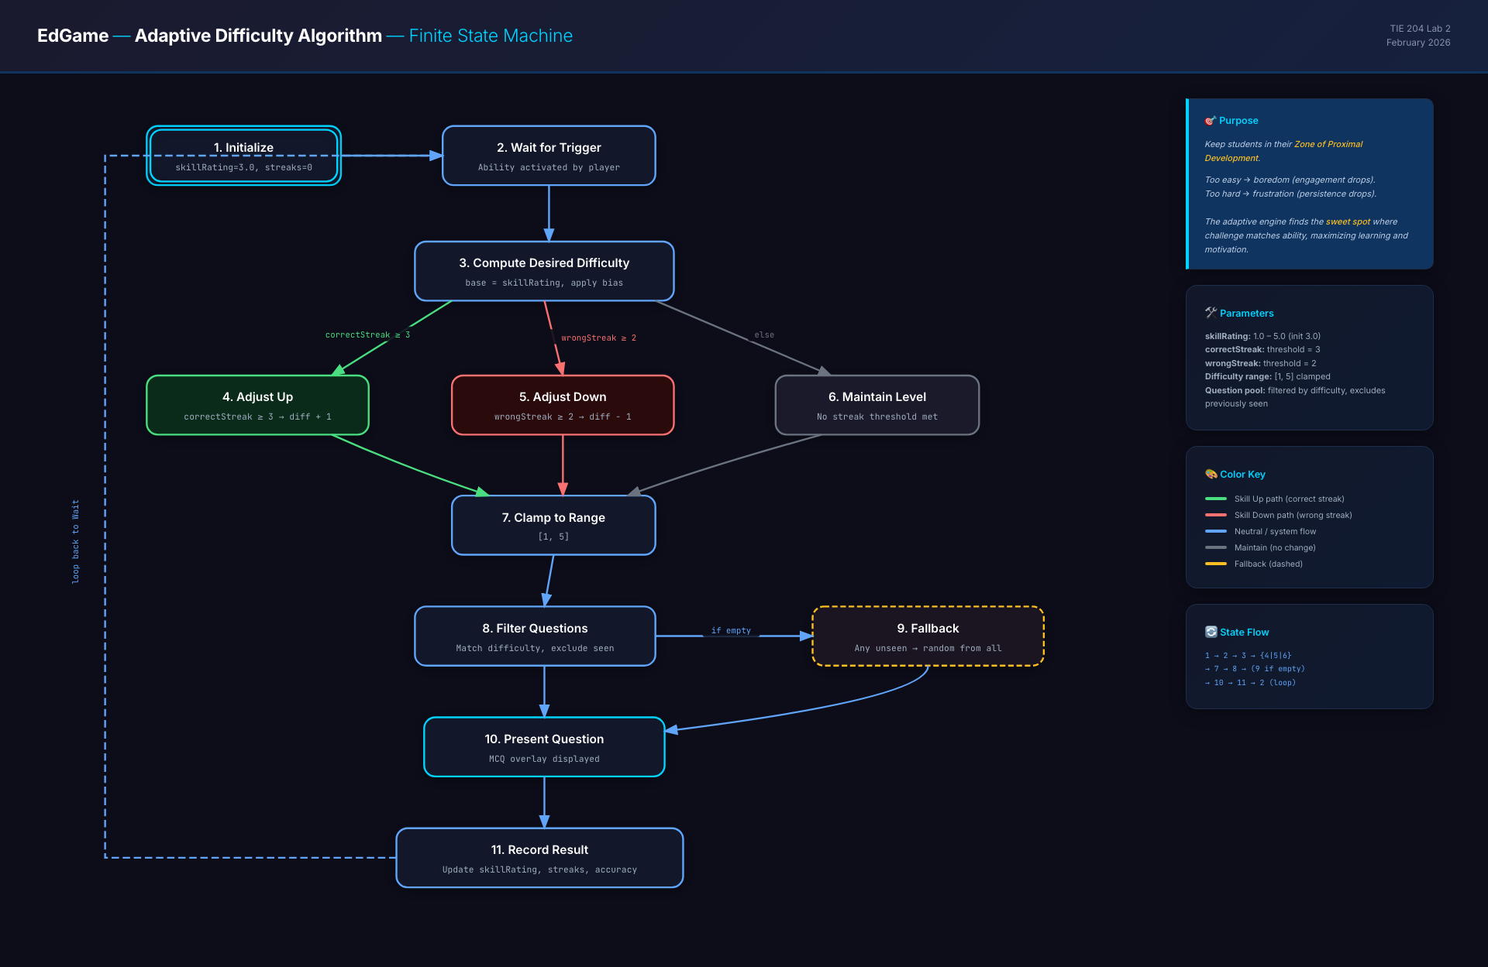
Figure: Adaptive Difficulty FSM — BKT-driven difficulty transitions

Metric Computation Dataflow
Shows the dataflow from raw telemetry events through aggregation and computation to final metric values displayed on teacher dashboards. Covers all 6 analytics dimensions.
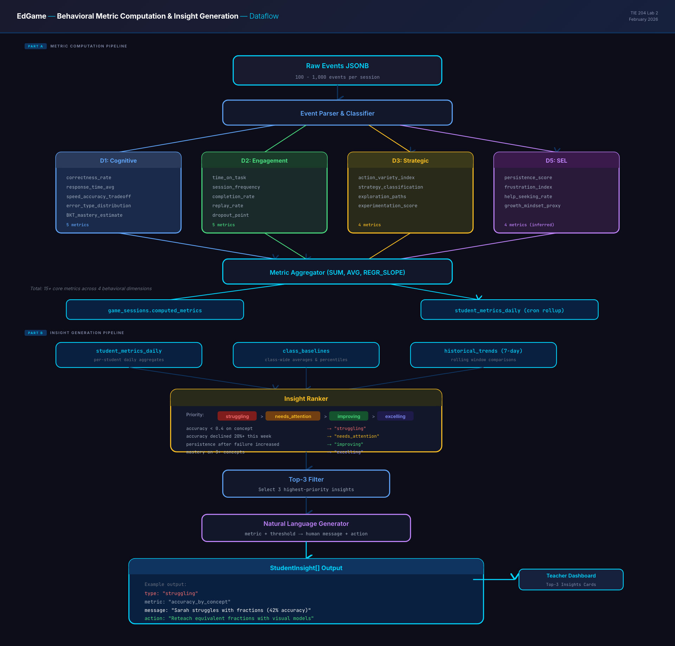
Figure: Metric Computation Dataflow — From raw events to dashboard metrics

Interface Dependency Graph
Documents the TypeScript interfaces and their dependencies across the shared packages, game clients, and API layer. Ensures type safety across the monorepo.
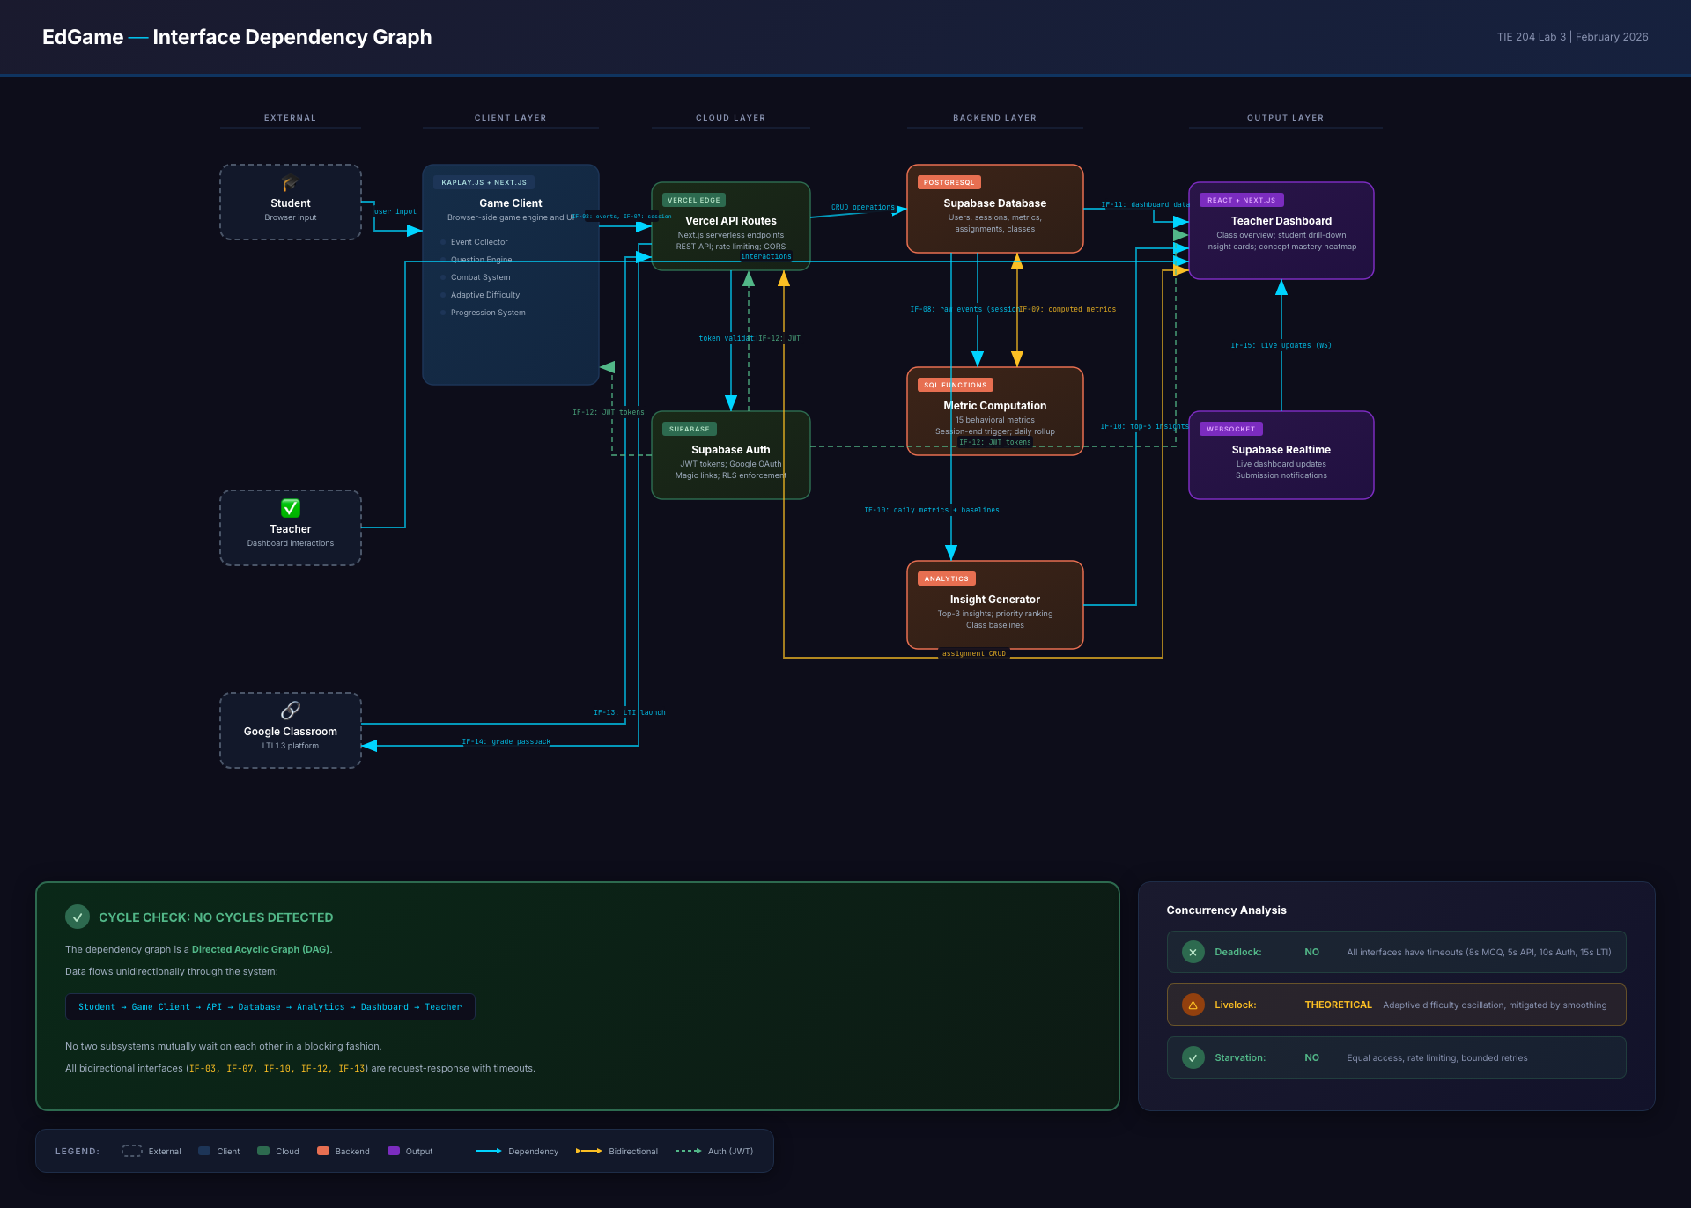
Figure: Interface Dependency Graph — TypeScript interfaces across packages

5. SpacetimeDB for Multiplayer

What is SpacetimeDB?
SpacetimeDB is a server-side database engine that combines a relational database with a real-time multiplayer server. Instead of writing separate game server code and database queries, developers write server-side modules (in Rust or C#) that define tables, reducers (server functions), and subscriptions. Clients connect via WebSocket and subscribe to table rows — when data changes, all subscribed clients receive automatic delta updates with no manual networking code required.
Key architectural properties:
- Single source of truth: Game state lives in the database; there is no separate "game server" process
- Automatic replication: Clients declare which rows they care about; SpacetimeDB pushes changes
- Conflict resolution built-in: Reducers execute transactionally on the server, eliminating race conditions
- Sub-50ms latency: Optimized for real-time multiplayer games
- Zero server code for networking: No WebSocket handlers, no serialization, no message routing

Why SpacetimeDB Fits EdGame
EdGame's multiplayer games (Pulse Realms 3v3, Survival Equation 2-4 player co-op) require real-time synchronization of game state, server-authoritative logic (to prevent cheating and ensure valid telemetry), and persistent state (match history, player stats). SpacetimeDB unifies all three requirements in a single system.
For an educational platform, the key advantage is telemetry integrity: because all game state mutations happen server-side in reducers, every action is automatically logged with a server timestamp. This eliminates the risk of client-side telemetry tampering and ensures assessment data is trustworthy.

Comparison with Alternatives
Feature | SpacetimeDB | Photon (PUN/Fusion) | Colyseus | Custom WebSocket | Firebase Realtime
Architecture | DB + Server in one | Cloud relay/host | Node.js rooms | Manual server | Cloud NoSQL
Real-time sync | Automatic (subscriptions) | Built-in (RPCs/state) | Built-in (schema sync) | Manual | Automatic (listeners)
Server authority | Yes (reducers) | Optional (host mode) | Yes (room handlers) | Yes (custom) | No (client writes)
Persistence | Built-in (is a database) | External DB needed | External DB needed | External DB needed | Built-in
Language | Rust/C# modules | C#/Unity | TypeScript/Node.js | Any | JavaScript SDK
Latency | <50ms | <100ms (relay) | <100ms | Depends | 100-500ms
Cost model | Self-host or cloud | Per-CCU pricing | Self-host | Self-host | Pay per read/write
Telemetry integrity | Inherent (server-only mutations) | Manual implementation | Manual implementation | Manual implementation | Weak (client can write)
Learning curve | Moderate (new paradigm) | Low (Unity-native) | Low (Node.js) | High | Low
Offline support | Limited | Photon has reconnect | Manual | Manual | Strong

Pros and Cons for EdGame

Pros
- Unified data layer: No impedance mismatch between game state and persistent storage — SpacetimeDB is both
- Telemetry integrity by design: All mutations are server-side reducers, guaranteeing authentic assessment data
- Automatic real-time sync: Drastically reduces multiplayer networking code complexity
- Transactional game logic: Reducers execute atomically, preventing race conditions in combat resolution and scoring
- Natural fit for ECD pipeline: Server-side events can be directly fed to the analytics pipeline without a separate collection layer
- Self-hostable: Important for school deployments with data sovereignty requirements

Cons
- Newer technology: Smaller community, fewer production references compared to Photon/Colyseus
- Rust module development: Requires Rust proficiency for server modules (mitigated by C# alternative)
- Not a full analytics DB: Still need SurrealDB for long-term analytics aggregation, dashboard queries, and complex graph traversals
- Limited ecosystem: No built-in matchmaking, lobby system, or voice chat — must be implemented manually
- Vendor dependency risk: Newer project with less established long-term support guarantees
- Browser client maturity: TypeScript/WASM client SDK is newer than native SDKs

Integration Architecture: SpacetimeDB + SurrealDB
EdGame uses a dual-database architecture:
- SpacetimeDB handles real-time game state during active matches (player positions, health, combat state, active questions, team composition). This is the "hot" layer — fast, transactional, and ephemeral per match.
- SurrealDB handles persistent analytics data, user accounts, curriculum mapping, dashboard queries, and long-term metric aggregation. This is the "warm/cold" layer — optimized for complex queries and graph relationships.
Data flow:
- Match starts → SpacetimeDB creates match tables, players subscribe
- During gameplay → All actions execute as SpacetimeDB reducers, state syncs to all clients
- Reducers emit telemetry events → A bridge service streams events to SurrealDB in near-real-time
- Match ends → Final match summary written to SurrealDB; SpacetimeDB match data archived or purged
- Dashboard queries → Read exclusively from SurrealDB

Games Requiring SpacetimeDB
Game | Players | SpacetimeDB Role | Priority
Pulse Realms | 3v3 (6 players) | Full real-time combat sync, team coordination | Phase 1
Survival Equation | 2-4 co-op | Shared puzzle state, role-specific information hiding | Phase 2
Knowledge Quest | 1 (single-player) | Not needed — client-side with REST API | N/A
Concept Cascade | 1 (single-player) | Not needed — client-side with REST API | N/A
Lab Explorer | 1 (potential co-op later) | Future consideration for collaborative experiments | Phase 3

Phased Rollout Plan
Phase 1 (Current): Pulse Realms uses a simplified client-authoritative model with REST API telemetry submission. This works for classroom LAN environments where cheating risk is low.
Phase 2: Integrate SpacetimeDB for Pulse Realms multiplayer. Migrate combat resolution, team state, and question delivery to server-side reducers. Implement the SpacetimeDB → SurrealDB bridge service.
Phase 3: Build Survival Equation on SpacetimeDB from the start, using the architecture established in Phase 2. Implement information hiding (role-specific data only visible to each player's subscription).
Phase 4: Evaluate SpacetimeDB for collaborative Lab Explorer experiments if co-op features are added.

6. AI-Powered Question Generation Pipeline

Overview
A critical requirement for EdGame is generating high-quality, curriculum-aligned questions at scale. Teachers should not need to manually author hundreds of MCQs — instead, they upload their curriculum materials (textbook chapters, lesson plans, worksheets) and the platform generates questions automatically, mapped to the appropriate knowledge components.
This section describes the end-to-end pipeline from teacher upload to question delivery within games.

Pipeline Architecture
The question generation pipeline consists of six stages:

Stage 1: Upload & Ingest
Teachers upload curriculum materials through the dashboard. Supported formats include PDF, DOCX, PPTX, and plain text. The system extracts text content using format-specific parsers, preserving structural information (headings, sections, figures with captions).
Key considerations:
- OCR fallback for scanned PDFs
- Chunking strategy: split by section headings, with overlap to preserve context
- Metadata extraction: grade level, subject, chapter/unit identification
- Storage: raw files in object storage, extracted text + metadata in SurrealDB

Stage 2: Content Analysis & Knowledge Component Extraction
Before generating questions, the system analyzes the uploaded content to identify discrete knowledge components (KCs) that can be assessed. This step uses an LLM with a structured output schema.
Prompt strategy:
- System prompt defines the KC extraction task with examples
- Input: chunked text content + grade level + subject area
- Output: structured JSON with KC ID, description, Bloom's taxonomy level, prerequisite KCs
- Post-processing: deduplicate KCs, merge near-duplicates, link to existing KC taxonomy

Stage 3: Question Generation
For each identified KC, the system generates multiple-choice questions using an LLM with carefully designed prompts.
Algorithm details:
- Prompt template includes: the source text chunk, the target KC, the desired difficulty level (1-5), the desired Bloom's taxonomy level, and 2-3 example questions as few-shot demonstrations
- Difficulty calibration: Difficulty is parameterized along multiple axes:
- Conceptual complexity: recall vs. application vs. analysis
- Distractor similarity: how close wrong answers are to the correct answer
- Context dependency: whether the question requires integrating multiple concepts
- Linguistic complexity: vocabulary level and sentence structure
- Output format: Structured JSON with question stem, 4 options (1 correct, 3 distractors), correct answer index, KC mapping, difficulty rating, Bloom's level, and source reference
Distractor generation strategy:
- Common misconception distractors: Based on known student misconceptions for the topic (sourced from educational research databases)
- Computational error distractors: For math questions, include answers that result from common procedural errors (e.g., sign errors, order-of-operations mistakes)
- Partial knowledge distractors: Answers that would be correct if the student only partially understood the concept
- Plausible but unrelated distractors: Factually correct statements that don't answer the specific question

Stage 4: Quality Filtering
Generated questions pass through automated quality checks before entering the question bank:
- Answer validation: Verify the marked correct answer is actually correct (cross-check with a second LLM call)
- Distractor quality: Ensure distractors are plausible but unambiguously wrong
- Readability check: Flesch-Kincaid grade level appropriate for target audience
- Bias detection: Flag questions with cultural, gender, or socioeconomic bias indicators
- Duplicate detection: Semantic similarity check against existing question bank
- Bloom's alignment: Verify the question actually assesses the claimed Bloom's level
Questions that fail any check are flagged for human review or regenerated with adjusted prompts.

Stage 5: KC Mapping & Difficulty Tagging
Validated questions are mapped to the EdGame knowledge component taxonomy and tagged with metadata for the adaptive difficulty system:
- KC mapping: Link to existing KCs in the taxonomy, or create new KCs if the curriculum introduces novel concepts
- Difficulty parameters: Initial difficulty estimate (refined through BKT as students answer)
- Prerequisite chain: Which KCs must be mastered before this question is appropriate
- Game integration tags: Which games can use this question (based on format, timing, and subject)

Stage 6: Storage & Delivery
Questions are stored in SurrealDB with full metadata and served to games through the question engine API:
- Question bank structure: Organized by subject → grade → unit → KC → difficulty
- Versioning: Questions are versioned; retired questions are soft-deleted to preserve historical analytics
- Delivery API: Games request questions by KC + difficulty range; the engine selects based on BKT mastery estimates and spacing algorithms

Nuances & Improvements

Bloom's Taxonomy Integration
Questions are tagged with Bloom's taxonomy levels (Remember, Understand, Apply, Analyze, Evaluate, Create). The adaptive difficulty system can target specific Bloom's levels based on student mastery:
- Low mastery (< 0.3): Primarily Remember and Understand questions
- Medium mastery (0.3-0.7): Apply and Analyze questions
- High mastery (> 0.7): Evaluate and Create questions (where applicable for MCQ format)

Domain-Specific Generation
Different subjects require different generation strategies:
- Mathematics: Questions must include precise notation, step-by-step solution paths, and computation-based distractors. The LLM is prompted with LaTeX formatting guidelines.
- Science: Questions should reference experimental contexts, include diagram descriptions, and test conceptual understanding rather than memorization.
- Mixed (game-contextualized): Questions embedded in game narratives must feel natural within the game world while maintaining educational rigor.

Teacher Review Workflow
While the pipeline is automated, teachers maintain control:
- Preview generated questions before they enter the active question bank
- Edit questions directly (corrections auto-propagate to metadata)
- Rate question quality (feedback improves future generation)
- Add custom questions that bypass the generation pipeline
- Set curriculum scope to control which topics generate questions

Versioning & Analytics Feedback Loop
- Questions that consistently show high discrimination (good at separating high/low mastery students) are rated higher and served more frequently
- Questions with poor discrimination are flagged for review or retirement
- BKT parameters for each question are continuously refined as more students answer them
- Generation prompts are iteratively improved based on quality metrics of generated questions

Adaptive Tagging
As students interact with questions in games, the system refines its understanding of each question's properties:
- Empirical difficulty: Actual p-value (% correct) compared to LLM-estimated difficulty
- Discrimination index: How well the question differentiates between high and low mastery students
- Time characteristics: Average response time, time-pressure sensitivity
- Distractor analysis: Which distractors are selected most often, indicating specific misconceptions

Integration with Game Systems
The question generation pipeline connects to two game systems:
Question Engine: Receives requests from games for questions matching specific criteria (KC, difficulty, Bloom's level) and returns appropriately selected questions using spacing and mastery-aware algorithms.
Adaptive Difficulty System: Uses BKT mastery estimates to determine the appropriate difficulty level for the next question. As mastery increases, the system requests harder questions with higher Bloom's levels. If mastery drops, it reverts to reinforcement-level questions.

7. Tablet vs PC Experimentation

Rationale
Saudi Arabian K-12 classrooms vary significantly in available technology. Some schools have dedicated computer labs with desktop PCs, while others rely on tablet carts (primarily iPads and Android tablets). EdGame must understand how form factor affects learning outcomes and engagement to make informed deployment recommendations and ensure equitable assessment across devices.
This section outlines the experimental design for comparing tablet and PC gameplay experiences using a single EdGame title.

Game Selection for Cross-Platform Testing
Pulse Realms is the primary candidate for tablet adaptation because:
- It is the most developed game (active development, Phase 1 priority)
- Its touch-based combat mechanics (tap to select ability, tap target) translate naturally to touchscreens
- The 3v3 format creates consistent, controlled match conditions for comparison
- It generates the richest telemetry data across multiple analytics dimensions
Adaptation scope: The game already runs in a web browser (KAPLAY.js); the tablet version requires responsive UI scaling and touch input optimization, not a full rewrite.

Key Differences: Tablet vs PC
Dimension | PC (Desktop/Laptop) | Tablet (iPad/Android)
Input method | Mouse + keyboard (precise, fast) | Touch (direct, less precise)
Screen size | 13-24 inches | 9-11 inches
UI density | Can display more information | Requires larger touch targets
Typing | Physical keyboard (fast text input) | On-screen keyboard (slower, covers screen)
Posture | Seated at desk, fixed screen | Handheld or propped, variable angle
Distraction | Browser tabs, other apps | Notifications, app switching
Accessibility | Mouse accommodation, screen readers | VoiceOver/TalkBack, Switch Access
Network | Typically wired/stable Wi-Fi | Wi-Fi only, potentially less stable

Adaptation Requirements

UI/UX Modifications for Tablet
- Touch targets: Minimum 44x44 pt for all interactive elements (Apple HIG standard)
- Responsive layout: Game UI scales to tablet viewport; HUD elements repositioned to avoid thumb zones
- Gesture support: Swipe to switch abilities, pinch to zoom game map (optional)
- Input fallback: MCQ answers are tap-only (no keyboard input required)
- Orientation lock: Landscape mode enforced during gameplay
- Performance: Target 30fps minimum on iPad 7th gen / Samsung Galaxy Tab A8

Telemetry Additions
Additional telemetry events for the tablet version:
- input_method: "touch" vs "mouse" tag on all action events
- touch_precision: distance between touch point and target center (px)
- response_area_size: actual rendered size of answer buttons (px)
- orientation_changes: count of orientation switches during match
- device_model: specific device identification for performance correlation

Study Design

Participants
- Target: 60-120 students, grades 6-8, from 2-4 Saudi Arabian schools
- Assignment: Within-subject crossover design — each student plays on both PC and tablet (counterbalanced order to control for learning effects)
- Duration: 2 matches per device, spaced 1 week apart

Experimental Conditions
Condition | Device | Input | Setting
PC | School desktop or laptop | Mouse + keyboard | Computer lab
Tablet | iPad or Android tablet | Touchscreen | Classroom (tablet cart)

Outcome Measures
Engagement metrics (from telemetry):
- Actions per minute (interaction rate)
- Session duration and voluntary continuation
- Off-task behavior indicators (inactivity periods)
- Emotional engagement proxies (ability selection speed, celebration actions)
Performance metrics (from analytics pipeline):
- Question accuracy (overall and by KC)
- Response time distribution
- BKT mastery progression rate
- Strategic depth (ability usage patterns, team coordination)
Usability metrics (from survey + telemetry):
- System Usability Scale (SUS) adapted for age group
- Touch precision data (tablet only)
- Self-reported preferences and comfort
- Error rates (misclicks, unintended actions)

Analysis Plan
- Primary analysis: Paired t-tests / Wilcoxon signed-rank tests comparing engagement and performance metrics across conditions
- Secondary analysis: Interaction effects with student characteristics (prior gaming experience, device familiarity, gender)
- Equivalence testing: TOST procedure to determine if tablet assessment is equivalent to PC assessment (important for fairness)
- Qualitative: Thematic analysis of open-ended survey responses

Cross-Platform Assessment Fairness
A critical question is whether assessment scores are comparable across devices. If tablet users systematically score lower due to input difficulty rather than knowledge gaps, the platform must account for this.
Fairness safeguards:
- Device-adjusted timing: Response time thresholds adjusted for input method (touch is inherently slower than mouse click)
- Difficulty calibration per device: If significant performance differences exist, BKT parameters can be calibrated separately for each input method
- DIF analysis: Differential Item Functioning analysis to identify questions that are unfairly harder on one device
- Minimum hardware requirements: Establish and communicate minimum device specifications to prevent performance-related score depression
- Teacher visibility: Dashboard shows device type per session so teachers can contextualize results

Expected Outcomes
This experiment will produce:
- Deployment recommendations: Data-driven guidance on which devices are suitable for EdGame
- Device-specific UX guidelines: Optimizations for tablet gameplay based on empirical data
- Assessment equivalence evidence: Statistical evidence of whether tablet and PC assessments are comparable
- Fairness adjustments: Calibration parameters if device-specific scoring adjustments are needed
- Publication-ready findings: Contribution to the educational technology literature on form factor effects in game-based assessment

8. Data Model
The complete SurrealDB data model for EdGame Phase 1. Defines all tables, fields, permissions, and server-side functions.

-- EdGame Phase 1 Data Model (SurrealDB)
-- Reconciles spec-v1.0.md §2.3 with issue #9 requirements
-- Uses SurrealQL schema definitions with permissions
-- ============================================================
-- NAMESPACE & DATABASE
-- ============================================================
DEFINE NAMESPACE edgame;
USE NS edgame;
DEFINE DATABASE production;
USE DB production;
-- ============================================================
-- CORE TABLES
-- ============================================================
-- School / organization model
DEFINE TABLE schools SCHEMAFULL
PERMISSIONS
FOR select WHERE $auth.role = 'admin' OR school = $auth.school
FOR create, update, delete WHERE $auth.role = 'admin';
DEFINE FIELD name ON schools TYPE string ASSERT $value != NONE;
DEFINE FIELD type ON schools TYPE option<string> ASSERT $value INSIDE ['private', 'public', 'charter', 'international'];
DEFINE FIELD country ON schools TYPE option<string>;
DEFINE FIELD region ON schools TYPE option<string>;
DEFINE FIELD license_type ON schools TYPE option<string> ASSERT $value INSIDE ['trial', 'standard', 'premium'];
DEFINE FIELD license_expires_at ON schools TYPE option<datetime>;
DEFINE FIELD created_at ON schools TYPE datetime DEFAULT time::now();
-- Users with role-based access
DEFINE TABLE users SCHEMAFULL
PERMISSIONS
FOR select WHERE id = $auth.id OR $auth.role = 'admin'
FOR update WHERE id = $auth.id
FOR create, delete WHERE $auth.role = 'admin';
DEFINE FIELD email ON users TYPE string ASSERT string::is::email($value);
DEFINE FIELD role ON users TYPE string ASSERT $value INSIDE ['teacher', 'student', 'admin'];
DEFINE FIELD first_name ON users TYPE option<string>;
DEFINE FIELD last_name ON users TYPE option<string>;
DEFINE FIELD school ON users TYPE option<record<schools>>;
DEFINE FIELD avatar_url ON users TYPE option<string>;
DEFINE FIELD password_hash ON users TYPE option<string>;
DEFINE FIELD created_at ON users TYPE datetime DEFAULT time::now();
DEFINE FIELD updated_at ON users TYPE datetime DEFAULT time::now();
DEFINE INDEX idx_users_email ON users FIELDS email UNIQUE;
-- Teacher class groups with join codes
DEFINE TABLE classes SCHEMAFULL
PERMISSIONS
FOR select WHERE teacher = $auth.id
OR (SELECT * FROM class_members WHERE class = $parent.id AND student = $auth.id)
FOR create, update, delete WHERE $auth.role = 'teacher' AND teacher = $auth.id;
DEFINE FIELD teacher ON classes TYPE record<users>;
DEFINE FIELD name ON classes TYPE string ASSERT $value != NONE;
DEFINE FIELD subject ON classes TYPE option<string>;
DEFINE FIELD grade_level ON classes TYPE option<int>;
DEFINE FIELD join_code ON classes TYPE string ASSERT $value != NONE;
DEFINE FIELD is_active ON classes TYPE bool DEFAULT true;
DEFINE FIELD created_at ON classes TYPE datetime DEFAULT time::now();
DEFINE INDEX idx_classes_join_code ON classes FIELDS join_code UNIQUE;
-- Student ↔ Class many-to-many
DEFINE TABLE class_members SCHEMAFULL
PERMISSIONS
FOR select WHERE student = $auth.id
OR (SELECT * FROM classes WHERE id = $parent.class AND teacher = $auth.id)
FOR create WHERE $auth.role = 'teacher'
FOR delete WHERE $auth.role = 'teacher';
DEFINE FIELD class ON class_members TYPE record<classes>;
DEFINE FIELD student ON class_members TYPE record<users>;
DEFINE FIELD joined_at ON class_members TYPE datetime DEFAULT time::now();
DEFINE INDEX idx_class_members_unique ON class_members FIELDS class, student UNIQUE;
-- Game environments catalog
DEFINE TABLE game_environments SCHEMAFULL
PERMISSIONS
FOR select WHERE true -- readable by all authenticated users
FOR create, update, delete WHERE $auth.role = 'admin';
DEFINE FIELD slug ON game_environments TYPE string ASSERT $value != NONE;
DEFINE FIELD name ON game_environments TYPE string ASSERT $value != NONE;
DEFINE FIELD subject ON game_environments TYPE string ASSERT $value INSIDE ['math', 'science', 'language_arts', 'mixed'];
DEFINE FIELD grade_min ON game_environments TYPE option<int>;
DEFINE FIELD grade_max ON game_environments TYPE option<int>;
DEFINE FIELD description ON game_environments TYPE option<string>;
DEFINE FIELD thumbnail_url ON game_environments TYPE option<string>;
DEFINE FIELD config ON game_environments FLEXIBLE TYPE option<object> DEFAULT {};
DEFINE FIELD is_active ON game_environments TYPE bool DEFAULT true;
DEFINE FIELD created_at ON game_environments TYPE datetime DEFAULT time::now();
DEFINE INDEX idx_environments_slug ON game_environments FIELDS slug UNIQUE;
-- Teacher-created assignments
DEFINE TABLE assignments SCHEMAFULL
PERMISSIONS
FOR select WHERE teacher = $auth.id
OR (SELECT * FROM class_members WHERE class = $parent.class AND student = $auth.id)
FOR create, update, delete WHERE $auth.role = 'teacher' AND teacher = $auth.id;
DEFINE FIELD teacher ON assignments TYPE record<users>;
DEFINE FIELD environment ON assignments TYPE record<game_environments>;
DEFINE FIELD class ON assignments TYPE option<record<classes>>;
DEFINE FIELD title ON assignments TYPE string ASSERT $value != NONE;
DEFINE FIELD instructions ON assignments TYPE option<string>;
DEFINE FIELD due_at ON assignments TYPE option<datetime>;
DEFINE FIELD config ON assignments FLEXIBLE TYPE option<object> DEFAULT {};
DEFINE FIELD created_at ON assignments TYPE datetime DEFAULT time::now();
-- ============================================================
-- GAME DATA TABLES
-- ============================================================
-- Individual play sessions
DEFINE TABLE game_sessions SCHEMAFULL
PERMISSIONS
FOR select WHERE student = $auth.id
OR $auth.role = 'teacher'
FOR create WHERE $auth.role = 'student' AND student = $auth.id
FOR update WHERE student = $auth.id;
DEFINE FIELD student ON game_sessions TYPE record<users>;
DEFINE FIELD assignment ON game_sessions TYPE option<record<assignments>>;
DEFINE FIELD environment ON game_sessions TYPE record<game_environments>;
DEFINE FIELD started_at ON game_sessions TYPE datetime DEFAULT time::now();
DEFINE FIELD ended_at ON game_sessions TYPE option<datetime>;
DEFINE FIELD duration_seconds ON game_sessions TYPE option<int>;
DEFINE FIELD completed ON game_sessions TYPE bool DEFAULT false;
DEFINE FIELD score ON game_sessions TYPE option<float>;
DEFINE INDEX idx_sessions_student ON game_sessions FIELDS student;
-- Raw telemetry events
DEFINE TABLE game_events SCHEMAFULL
PERMISSIONS
FOR create WHERE $auth.role = 'student'
FOR select WHERE $auth.role = 'teacher' OR $auth.role = 'admin';
DEFINE FIELD session ON game_events TYPE record<game_sessions>;
DEFINE FIELD event_type ON game_events TYPE string ASSERT $value != NONE;
DEFINE FIELD payload ON game_events FLEXIBLE TYPE object DEFAULT {};
DEFINE FIELD ts ON game_events TYPE datetime DEFAULT time::now();
DEFINE INDEX idx_events_session ON game_events FIELDS session;
DEFINE INDEX idx_events_type ON game_events FIELDS event_type;
-- Aggregated metrics per session across 6 dimensions
DEFINE TABLE computed_metrics SCHEMAFULL
PERMISSIONS
FOR select WHERE student = $auth.id OR $auth.role = 'teacher'
FOR create, update WHERE $auth.role = 'admin' OR $auth.role = 'teacher';
DEFINE FIELD session ON computed_metrics TYPE record<game_sessions>;
DEFINE FIELD student ON computed_metrics TYPE record<users>;
DEFINE FIELD environment ON computed_metrics TYPE record<game_environments>;
-- D1: Cognitive Knowledge
DEFINE FIELD correctness_rate ON computed_metrics TYPE option<float>;
DEFINE FIELD avg_response_time_ms ON computed_metrics TYPE option<int>;
DEFINE FIELD speed_accuracy_profile ON computed_metrics TYPE option<string>;
DEFINE FIELD questions_attempted ON computed_metrics TYPE int DEFAULT 0;
DEFINE FIELD questions_correct ON computed_metrics TYPE int DEFAULT 0;
-- D2: Behavioral Engagement
DEFINE FIELD total_time_seconds ON computed_metrics TYPE option<int>;
DEFINE FIELD action_count ON computed_metrics TYPE int DEFAULT 0;
DEFINE FIELD completion_rate ON computed_metrics TYPE option<float>;
-- D3: Strategic Behavior
DEFINE FIELD strategy_classification ON computed_metrics TYPE option<string>;
DEFINE FIELD action_variation_index ON computed_metrics TYPE option<float>;
DEFINE FIELD role_chosen ON computed_metrics TYPE option<string>;
-- D4: Social & Collaborative
DEFINE FIELD teammate_interactions ON computed_metrics TYPE int DEFAULT 0;
DEFINE FIELD heal_actions ON computed_metrics TYPE int DEFAULT 0;
DEFINE FIELD shield_actions ON computed_metrics TYPE int DEFAULT 0;
-- D5: Affective & SEL
DEFINE FIELD persistence_after_failure ON computed_metrics TYPE option<float>;
DEFINE FIELD frustration_score ON computed_metrics TYPE option<float>;
-- D6: Temporal & Longitudinal
DEFINE FIELD response_consistency ON computed_metrics TYPE option<float>;
DEFINE FIELD learning_velocity ON computed_metrics TYPE option<float>;
DEFINE FIELD computed_at ON computed_metrics TYPE datetime DEFAULT time::now();
DEFINE INDEX idx_metrics_session ON computed_metrics FIELDS session UNIQUE;
-- Daily aggregation of metrics per student
DEFINE TABLE student_metrics_daily SCHEMAFULL
PERMISSIONS
FOR select WHERE student = $auth.id OR $auth.role = 'teacher'
FOR create, update WHERE $auth.role = 'admin';
DEFINE FIELD student ON student_metrics_daily TYPE record<users>;
DEFINE FIELD date ON student_metrics_daily TYPE datetime;
DEFINE FIELD environment ON student_metrics_daily TYPE option<record<game_environments>>;
-- Engagement
DEFINE FIELD total_time_minutes ON student_metrics_daily TYPE option<float>;
DEFINE FIELD session_count ON student_metrics_daily TYPE option<int>;
DEFINE FIELD completion_rate ON student_metrics_daily TYPE option<float>;
-- Performance
DEFINE FIELD accuracy ON student_metrics_daily TYPE option<float>;
DEFINE FIELD avg_response_time_ms ON student_metrics_daily TYPE option<int>;
DEFINE FIELD concepts_practiced ON student_metrics_daily TYPE option<array<string>>;
DEFINE FIELD concepts_mastered ON student_metrics_daily TYPE option<array<string>>;
-- Behavioral
DEFINE FIELD help_requests ON student_metrics_daily TYPE option<int>;
DEFINE FIELD retry_count ON student_metrics_daily TYPE option<int>;
DEFINE FIELD strategy_changes ON student_metrics_daily TYPE option<int>;
DEFINE INDEX idx_daily_unique ON student_metrics_daily FIELDS student, date, environment UNIQUE;
-- Top-3 generated insights per student (issue #9)
DEFINE TABLE student_insights SCHEMAFULL
PERMISSIONS
FOR select WHERE student = $auth.id OR $auth.role = 'teacher'
FOR create, update, delete WHERE $auth.role = 'admin' OR $auth.role = 'teacher';
DEFINE FIELD student ON student_insights TYPE record<users>;
DEFINE FIELD class ON student_insights TYPE option<record<classes>>;
DEFINE FIELD period_start ON student_insights TYPE datetime;
DEFINE FIELD period_end ON student_insights TYPE datetime;
DEFINE FIELD insights ON student_insights FLEXIBLE TYPE array DEFAULT [];
-- Each insight: { dimension: string, title: string, description: string, action: string, severity: string }
DEFINE FIELD generated_at ON student_insights TYPE datetime DEFAULT time::now();
-- Question bank
DEFINE TABLE questions SCHEMAFULL
PERMISSIONS
FOR select WHERE true -- readable by all authenticated users
FOR create, update, delete WHERE $auth.role = 'admin' OR $auth.role = 'teacher';
DEFINE FIELD subject ON questions TYPE string ASSERT $value INSIDE ['math', 'science', 'general'];
DEFINE FIELD topic ON questions TYPE option<string>;
DEFINE FIELD difficulty ON questions TYPE int ASSERT $value >= 1 AND $value <= 5;
DEFINE FIELD question_text ON questions TYPE string ASSERT $value != NONE;
DEFINE FIELD options ON questions FLEXIBLE TYPE array ASSERT $value != NONE;
DEFINE FIELD correct_answer ON questions TYPE string ASSERT $value != NONE;
DEFINE FIELD explanation ON questions TYPE option<string>;
DEFINE FIELD grade_level ON questions TYPE option<int>;
DEFINE FIELD tags ON questions TYPE option<array<string>>;
DEFINE FIELD created_at ON questions TYPE datetime DEFAULT time::now();
-- ============================================================
-- DATABASE FUNCTIONS
-- ============================================================
-- Compute session metrics from raw events
DEFINE FUNCTION fn::compute_session_metrics($session_id: record<game_sessions>) {
LET $session = (SELECT student, environment FROM game_sessions WHERE id = $session_id)[0];
LET $question_events = SELECT * FROM game_events
WHERE session = $session_id AND event_type = 'question_answered';
LET $total = count($question_events);
LET $correct = count(SELECT * FROM $question_events WHERE payload.correct = true);
LET $avg_rt = math::mean(SELECT VALUE payload.responseTimeMs FROM $question_events);
UPSERT computed_metrics SET
session = $session_id,
student = $session.student,
environment = $session.environment,
correctness_rate = IF $total > 0 THEN $correct / $total ELSE 0 END,
avg_response_time_ms = $avg_rt,
questions_attempted = $total,
questions_correct = $correct,
computed_at = time::now()
WHERE session = $session_id;
};
-- Daily rollup job
DEFINE FUNCTION fn::daily_rollup() {
LET $today = time::now();
LET $sessions_today = SELECT student, environment,
math::sum(duration_seconds) AS total_seconds,
count() AS session_count
FROM game_sessions
WHERE started_at >= time::floor($today, 1d)
GROUP BY student, environment;
FOR $row IN $sessions_today {
LET $metrics = SELECT
math::mean(correctness_rate) AS accuracy,
math::mean(avg_response_time_ms) AS avg_rt
FROM computed_metrics
WHERE student = $row.student AND environment = $row.environment;
UPSERT student_metrics_daily SET
student = $row.student,
date = time::floor($today, 1d),
environment = $row.environment,
total_time_minutes = $row.total_seconds / 60,
session_count = $row.session_count,
accuracy = $metrics[0].accuracy,
avg_response_time_ms = $metrics[0].avg_rt
WHERE student = $row.student
AND date = time::floor($today, 1d)
AND environment = $row.environment;
};
};

9. REST API Specification
Complete Phase 1 API routes for the EdGame platform. All endpoints are Next.js Route Handlers deployed on Railway.

All endpoints are Next.js Route Handlers deployed on Railway.
Authentication via NextAuth.js session tokens (passed as cookie or Authorization: Bearer <token>).

Auth

`POST /api/auth/[...nextauth]`
NextAuth.js auth handler (Google OAuth, credentials).
- Auth: Public
- Response: Redirect to dashboard or game
────────────────────────────────────────────────────────────

Environments

`GET /api/environments`
List available game environments.
- Auth: Teacher+
- Response:
{
"environments": [
{
"id": "uuid",
"slug": "pulse-realms",
"name": "Pulse Realms",
"subject": "math",
"gradeRange": [3, 8],
"description": "3v3 team arena...",
"thumbnailUrl": "/assets/pulse-realms-thumb.png",
"config": {},
"isActive": true
}
]
}
────────────────────────────────────────────────────────────

Assignments

`GET /api/assignments`
List assignments for the authenticated teacher, or assigned-to for students.
- Auth: Teacher (own assignments) | Student (assigned to them)
- Query: ?classId=uuid&status=active
- Response:
{
"assignments": [
{
"id": "uuid",
"title": "Fractions Practice",
"environmentId": "uuid",
"environmentName": "Pulse Realms",
"classId": "uuid",
"className": "Period 3 Math",
"instructions": "Complete 3 matches",
"dueAt": "2026-03-14T23:59:00Z",
"config": { "subject": "math", "difficulty": 3 },
"createdAt": "2026-03-06T10:00:00Z"
}
]
}

`POST /api/assignments`
Create a new assignment.
- Auth: Teacher
- Request:
{
"title": "Fractions Practice",
"environmentId": "uuid",
"classId": "uuid",
"instructions": "Complete 3 matches focusing on fractions",
"dueAt": "2026-03-14T23:59:00Z",
"config": { "subject": "math", "difficulty": 3, "matchCount": 3 }
}
- Response: 201 with created assignment object

`GET /api/assignments/:id`
Get single assignment details.
- Auth: Teacher (owner) | Student (assigned)
- Response: Single assignment object (same shape as list item)

`PUT /api/assignments/:id`
Update an assignment.
- Auth: Teacher (owner)
- Request: Partial assignment fields
- Response: Updated assignment object

`DELETE /api/assignments/:id`
Delete an assignment.
- Auth: Teacher (owner)
- Response: 204 No Content
────────────────────────────────────────────────────────────

Sessions

`POST /api/sessions`
Start a new game session.
- Auth: Student
- Request:
{
"assignmentId": "uuid",
"environmentId": "uuid"
}
- Response:
{
"sessionId": "uuid",
"startedAt": "2026-03-06T14:30:00Z"
}

`PATCH /api/sessions/:id`
Update session with completion status. Called when game ends.
- Auth: Student (session owner)
- Request:
{
"completed": true,
"score": 850,
"durationSeconds": 312
}
- Response: Updated session object

`GET /api/sessions/:id/metrics`
Get computed metrics for a session.
- Auth: Teacher (class owner)
- Response:
{
"sessionId": "uuid",
"studentId": "uuid",
"environmentId": "uuid",
"metrics": {
"d1_cognitive": {
"correctnessRate": 0.75,
"avgResponseTimeMs": 3200,
"speedAccuracyProfile": "deliberate",
"questionsAttempted": 12,
"questionsCorrect": 9
},
"d2_engagement": {
"totalTimeSeconds": 312,
"actionCount": 28,
"completionRate": 1.0
},
"d3_strategic": {
"strategyClassification": "healer",
"actionVariationIndex": 0.6,
"roleChosen": "healer"
},
"d4_social": {
"teammateInteractions": 8,
"healActions": 5,
"shieldActions": 3
},
"d5_sel": {
"persistenceAfterFailure": 0.9,
"frustrationScore": 0.2
},
"d6_temporal": {
"responseConsistency": 450,
"learningVelocity": 0.12
}
},
"computedAt": "2026-03-06T14:36:00Z"
}
────────────────────────────────────────────────────────────

Game Event Pipeline

`POST /api/sessions/:id/events`
Batch-submit telemetry events from the game client. Called periodically during gameplay (every 10 seconds) and on session end.
- Auth: Student (session owner)
- Request:
{
"events": [
{
"type": "question_answered",
"ts": 1741276200000,
"payload": {
"questionId": "q_frac_12",
"subject": "math",
"difficulty": 3,
"correct": true,
"responseTimeMs": 2800,
"actionType": "attack",
"powerMultiplier": 1.64
}
},
{
"type": "action_performed",
"ts": 1741276201000,
"payload": {
"actionType": "attack",
"role": "attacker",
"targetId": "bot_enemy_1",
"success": true,
"value": 45,
"effectType": "damage"
}
},
{
"type": "damage_taken",
"ts": 1741276205000,
"payload": {
"amount": 30,
"sourceId": "bot_enemy_2",
"sourceRole": "attacker",
"targetId": "player_1"
}
}
]
}
- Response: 202 Accepted with count of events stored
────────────────────────────────────────────────────────────

Analytics

`GET /api/analytics/class/:id`
Class-level analytics dashboard data.
- Auth: Teacher (class owner)
- Query: ?from=2026-03-01&to=2026-03-07&environmentId=uuid
- Response:
{
"classId": "uuid",
"period": { "from": "2026-03-01", "to": "2026-03-07" },
"summary": {
"totalSessions": 142,
"avgAccuracy": 0.72,
"avgResponseTimeMs": 3400,
"activeStudents": 28,
"totalStudents": 30
},
"students": [
{
"studentId": "uuid",
"name": "Maria S.",
"sessionsCompleted": 5,
"accuracy": 0.85,
"avgResponseTimeMs": 2900,
"trend": "improving"
}
],
"conceptBreakdown": [
{ "concept": "fractions", "classAccuracy": 0.68, "studentCount": 30 }
]
}

`GET /api/analytics/student/:id`
Individual student analytics.
- Auth: Teacher (class owner)
- Query: ?from=2026-03-01&to=2026-03-07&classId=uuid
- Response:
{
"studentId": "uuid",
"name": "Maria S.",
"period": { "from": "2026-03-01", "to": "2026-03-07" },
"dimensions": {
"d1_cognitive": {
"overallAccuracy": 0.85,
"avgResponseTimeMs": 2900,
"profile": "deliberate",
"conceptMastery": [
{ "concept": "fractions", "mastery": 0.9 },
{ "concept": "decimals", "mastery": 0.6 }
]
},
"d2_engagement": {
"totalTimeMins": 45,
"sessionCount": 5,
"avgSessionMins": 9,
"completionRate": 1.0,
"trend": "stable"
},
"d3_strategic": {
"preferredRole": "healer",
"actionVariation": 0.6,
"strategyShifts": 2
},
"d4_social": {
"teammateInteractions": 42,
"helpGiven": 12,
"helpReceived": 3
},
"d5_sel": {
"persistenceScore": 0.9,
"frustrationLevel": "low",
"growthMindsetIndicator": "strong"
},
"d6_temporal": {
"learningVelocity": 0.12,
"responseConsistency": "improving",
"dailyAccuracy": [
{ "date": "2026-03-01", "accuracy": 0.7 },
{ "date": "2026-03-03", "accuracy": 0.8 },
{ "date": "2026-03-06", "accuracy": 0.85 }
]
}
}
}

10. Monorepo Structure
pnpm workspaces + Turborepo monorepo structure. See ADR-001 (Section 3) for rationale.

pnpm workspaces + Turborepo. See ADR-001 for rationale.
edgame/
├── apps/
│ ├── web/ # Next.js 14 App Router — teacher/student dashboard
│ │ ├── app/
│ │ │ ├── (auth)/ # Auth routes (login, signup, callback)
│ │ │ ├── (dashboard)/ # Teacher dashboard (requires auth)
│ │ │ │ ├── classes/ # Class management pages
│ │ │ │ ├── assignments/ # Assignment CRUD pages
│ │ │ │ ├── analytics/ # Analytics views (class-level, student-level)
│ │ │ │ └── layout.tsx # Dashboard shell (sidebar, nav)
│ │ │ ├── (student)/ # Student-facing pages
│ │ │ │ ├── play/ # Game launcher / assignment list
│ │ │ │ └── progress/ # Student self-view of progress
│ │ │ ├── api/ # Route Handlers (see api-routes.md)
│ │ │ │ ├── auth/
│ │ │ │ ├── assignments/
│ │ │ │ ├── sessions/
│ │ │ │ ├── environments/
│ │ │ │ └── analytics/
│ │ │ ├── layout.tsx # Root layout
│ │ │ └── page.tsx # Landing page
│ │ ├── components/ # App-specific components
│ │ ├── lib/ # App-specific utilities (SurrealDB client, auth, etc.)
│ │ ├── next.config.js
│ │ ├── tailwind.config.ts
│ │ ├── tsconfig.json
│ │ └── package.json
│ │
│ └── games/ # KAPLAY game environments
│ ├── pulse-realms/ # Game 1: Team Arena (existing code → migrated)
│ │ ├── src/
│ │ │ ├── scenes/ # menu, roleSelect, arenaBriefing, arena, postGame
│ │ │ ├── systems/ # telemetry, combatSystem, questionEngine, progression, gameState
│ │ │ ├── config/ # constants, roles
│ │ │ ├── components/ # UI overlays, HUD
│ │ │ └── data/ # Question JSON files
│ │ ├── main.js # KAPLAY entry point
│ │ ├── index.html
│ │ └── package.json
│ ├── concept-cascade/ # Game 2: Tower Defense (future)
│ ├── lab-explorer/ # Game 3: Virtual Science Lab (future)
│ ├── knowledge-quest/ # Game 4: Turn-Based RPG (future)
│ └── survival-equation/ # Game 5: Collaborative Puzzle (future)
│
├── packages/
│ ├── shared/ # Shared types, constants, utilities
│ │ ├── src/
│ │ │ ├── types/ # TypeScript types (User, Session, Event, Metric schemas)
│ │ │ ├── constants/ # Shared constants (dimensions, roles, subjects)
│ │ │ ├── validators/ # Zod schemas for API request/response validation
│ │ │ ├── db/ # SurrealDB client factory
│ │ │ └── utils/ # Pure utility functions
│ │ ├── tsconfig.json
│ │ └── package.json
│ │
│ └── ui/ # Shared UI component library (shadcn/ui based)
│ ├── src/
│ │ ├── components/ # Button, Card, Dialog, Chart, DataTable, etc.
│ │ ├── styles/ # Tailwind theme, CSS variables
│ │ └── index.ts # Barrel exports
│ ├── tailwind.config.ts
│ ├── tsconfig.json
│ └── package.json
│
├── docs/ # Architecture docs, ADRs, assessment specs
│ ├── adr/
│ ├── architecture/
│ └── assessment/
│
├── turbo.json # Turborepo pipeline config
├── pnpm-workspace.yaml # Workspace definition
├── package.json # Root scripts
├── .eslintrc.js
├── .prettierrc
└── tsconfig.base.json # Shared TS config

Workspace Config
`pnpm-workspace.yaml`:
packages:
- "apps/*"
- "apps/games/*"
- "packages/*"
`turbo.json`:
{
"$schema": "https://turbo.build/schema.json",
"pipeline": {
"build": {
"dependsOn": ["^build"],
"outputs": [".next/**", "dist/**"]
},
"dev": {
"cache": false,
"persistent": true
},
"lint": {},
"typecheck": {
"dependsOn": ["^build"]
}
}
}

Package Dependencies
apps/web
├── @edgame/shared (types, validators, constants)
├── @edgame/ui (UI components)
├── next, react
├── surrealdb
└── tailwindcss, shadcn/ui primitives
apps/games/pulse-realms
├── @edgame/shared (types, constants)
└── kaplay
packages/shared
├── zod (schema validation)
└── typescript
packages/ui
├── @edgame/shared (types)
├── react
├── tailwindcss
└── @radix-ui/* (shadcn/ui primitives)

11. Assessment Framework — Evidence-Centered Design

ECD Overview
Evidence-Centered Design (ECD) is the foundational assessment architecture for EdGame. It provides a principled framework for designing assessments that are embedded within gameplay, ensuring that every game mechanic produces interpretable evidence about student competencies.
ECD consists of four interconnected models:
- Student Model: What knowledge, skills, and attributes are we measuring? Defined as Knowledge Components (KCs) with mastery probabilities estimated via Bayesian Knowledge Tracing (BKT).
- Task Model: What game situations elicit evidence? Defined as specific game mechanics, scenarios, and interactions that create observable opportunities.
- Evidence Model: How do we interpret observations? Defined as rules that connect observable behaviors (e.g., answer correctness, response time, strategy choices) to updates in the student model.
- Assembly Model: How do we select and sequence tasks? Managed by the adaptive difficulty system and question engine.

Stealth Assessment
EdGame uses stealth assessment — students are assessed through natural gameplay without awareness of being tested. This eliminates test anxiety and captures authentic behavior. The assessment is "invisible" because:
- Questions are gated behind game mechanics (answer to attack, answer to build)
- Strategic choices reveal problem-solving approaches
- Social interactions reveal collaboration skills
- Response patterns reveal engagement and affect

Bayesian Knowledge Tracing (BKT)
BKT estimates the probability that a student has mastered a specific knowledge component, updated after each observation:
- P(L₀): Prior probability of mastery (initial estimate)
- P(T): Probability of learning (transitioning from unmastered to mastered)
- P(G): Probability of guessing correctly despite not having mastered the KC
- P(S): Probability of slipping (answering incorrectly despite mastery)
After each student response, the posterior mastery probability is updated using Bayes' theorem.

Six Analytics Dimensions
EdGame organizes its 50+ metrics across six complementary dimensions:

D1: Cognitive Knowledge
Measures what students know and can do — factual recall, conceptual understanding, and procedural fluency. Primary metrics: accuracy rate, mastery probability (BKT), knowledge component coverage, misconception identification.

D2: Behavioral Engagement
Measures how students interact with the learning environment — participation intensity, persistence, and attention patterns. Primary metrics: actions per minute, session duration, voluntary continuation rate, inactivity periods, response time consistency.

D3: Strategic Behavior & Agency
Measures how students approach problems — planning, resource allocation, experimentation, and self-correction. Primary metrics: strategy diversity index, resource efficiency, exploration rate, error recovery patterns, hint usage patterns.

D4: Social & Collaborative
Measures how students work together — communication, role fulfillment, knowledge sharing, and team contribution balance. Primary metrics: communication frequency, role adoption consistency, team contribution equity (Gini coefficient), peer teaching instances.

D5: Affective & Social-Emotional Learning
Measures emotional and motivational states — frustration tolerance, growth mindset indicators, empathy, and emotional regulation. Primary metrics: frustration index (rapid incorrect answers), persistence after failure, emotional response patterns, empathy choices in RPG scenarios.

D6: Temporal & Longitudinal
Measures learning trajectories over time — mastery growth rates, retention, spacing effects, and long-term trends. Primary metrics: mastery velocity, retention rate, learning curve shape, spacing effect responsiveness.

Coverage Matrix
5-games × 6-dimensions analytics coverage matrix showing which dimensions each game primarily (P), secondarily (S), or minimally (·) covers.

Game | D1: Cognitive Knowledge | D2: Behavioral Engagement | D3: Strategic Behavior & Agency | D4: Social & Collaborative | D5: Affective & SEL | D6: Temporal & Longitudinal
Pulse Realms | · | · | · | · | · | ·
Concept Cascade | · | · | · | · | · | ·
Lab Explorer | · | · | · | · | · | ·
Knowledge Quest | · | · | · | · | · | ·
Survival Equation | · | · | · | · | · | ·

Metric Mapping — Pulse Realms
Maps core metrics to Pulse Realms telemetry events and computed fields. Source: metric-mapping.json

12. ECD Model: Pulse Realms — Team Arena

Game Overview
- Mechanic: 3v3 team combat where every attack/heal/shield is gated behind an MCQ
- Engine: KAPLAY.js
- Subject: Math & Science (configurable via SUBJECT_IDS)
- Duration: 5 min per match (matchDurationSec: 300)
- Roles: Attacker, Healer, Builder (each with unique abilities)
────────────────────────────────────────────────────────────

1. Competency Model
What skills and knowledge does this game assess?

Content Knowledge (D1)
Competency | Description | Curriculum Alignment
Mathematical Fluency | Speed and accuracy solving math problems under time pressure | CCSS.Math operations, number sense
Scientific Reasoning | Applying science concepts to answer questions correctly | NGSS disciplinary core ideas
Adaptive Knowledge | Maintaining accuracy as difficulty increases (adaptive engine raises difficulty after 3 correct in a row) | Cross-curricular metacognition

21st-Century Skills (D3–D5)
Competency | Description
Strategic Thinking | Selecting appropriate roles and actions based on game state
Teamwork & Prosocial Behavior | Choosing to heal/shield allies vs. focusing on damage
Emotional Regulation | Maintaining performance under combat pressure (low HP, time pressure)
Persistence | Continuing to engage after incorrect answers
Risk Assessment | Choosing between safe actions (shield) and high-risk/high-reward actions (power strike)

────────────────────────────────────────────────────────────

2. Evidence Model
What observable in-game behaviors indicate competency?

Content Knowledge Evidence
Observable Behavior | Telemetry Event | Payload Fields | Evidence Rule
Answers question correctly | question_answered | correct: true | Direct evidence of content mastery for the question's subject and difficulty
Answers quickly and correctly | question_answered | correct: true, responseTimeMs < 3000 | Evidence of fluent, confident knowledge (not guessing)
Answers quickly but incorrectly | question_answered | correct: false, responseTimeMs < 2000 | Evidence of guessing behavior — no mastery
Answers slowly but correctly | question_answered | correct: true, responseTimeMs > 5000 | Evidence of effortful recall — knowledge present but not fluent
Maintains accuracy at higher difficulty | question_answered | difficulty: 4-5, correct: true | Evidence of deep understanding beyond surface recall
Accuracy improves within session | sequence of question_answered | correct trend over ts | Evidence of learning during gameplay

Strategic Behavior Evidence
Observable Behavior | Telemetry Event | Payload Fields | Evidence Rule
Chooses healer role | session meta | role: 'healer' | Preference for support/prosocial play style
Uses diverse action types | action_performed | varying actionType | Higher Shannon entropy = strategic flexibility
Targets low-HP enemies | action_performed | targetId cross-ref with game state | Evidence of tactical awareness
Switches from attack to heal when ally is low | action_performed sequence | actionType change pattern | Evidence of situational awareness and teamwork

SEL / Affective Evidence
Observable Behavior | Telemetry Event | Payload Fields | Evidence Rule
Continues playing after 2+ wrong answers | question_answered sequence | correct: false followed by further actions | Persistence after failure — growth mindset indicator
Accuracy drops when HP is low | question_answered + damage_taken | correct rate when cumulative damage_taken.amount > 72 (60% of 120 HP) | Low emotional regulation under stress
Response time increases after failure | question_answered sequence | responseTimeMs after correct: false | Possible frustration or increased deliberation (context-dependent)
Heals teammates before self-interest actions | action_performed | actionType: 'heal' targeting allies when attacker role could deal damage | Empathy / prosocial prioritization

────────────────────────────────────────────────────────────

3. Task Model
What game tasks elicit the evidence above?

Core Task Loop
1. Player selects target → chooses action (attack/heal/shield/build)
2. Question engine selects MCQ at adaptive difficulty
- Difficulty = base (3 + action's difficultyBias) adjusted by player streak
- After 3 correct → difficulty +1; after 2 wrong → difficulty -1
- Questions drawn from subject-specific JSON pools, avoiding recently seen
3. Player answers within 8-second time limit (questionTimeLimitSec)
4. If correct: action fires with speed-based power multiplier
- multiplier = max(1, min(2, 2.2 - responseTimeMs/5000))
- Fast + correct = up to 2× power; slow + correct = 1× power
5. If incorrect: action misses (effectType: 'miss')
6. Combat effects applied (damage/heal/shield)
7. Match runs for 300 seconds or until objective captured

Task Design Constraints
Design Feature | Purpose | Config Reference
8-second time limit | Prevents unlimited deliberation; creates authentic pressure | constants.js:4 — questionTimeLimitSec: 8
Adaptive difficulty (1-5 scale) | Keeps questions in Zone of Proximal Development | questionEngine.js:51-56 — computeDesiredDifficulty()
Speed-based power multiplier | Incentivizes confident, fluent knowledge (fast + correct = more damage) | combatSystem.js:4-6 — speedMultiplier()
Role selection (3 roles) | Forces strategic choice; reveals preferred play style | constants.js:33-37 — ROLE_IDS
6 action types per role | Ensures diverse evidence collection across action categories | constants.js:39-46 — ACTION_IDS
No respawn (respawnEnabled: false) | Raises stakes — mistakes have consequences, elicits emotional regulation | constants.js:22
3v3 team format | Creates social context for prosocial behavior measurement | AI teammates in Phase 1

────────────────────────────────────────────────────────────

4. Assembly Model
How does evidence combine into competency scores?

Per-Session Aggregation
For each game session:
1. Collect all question_answered events
2. Compute:
- correctness_rate = correct / total
- avg_response_time = mean(responseTimeMs)
- speed_accuracy_profile = classify(dominant response pattern)
- action_variation_index = shannon_entropy(actionType distribution)
- persistence = actions_after_failure / total_failures
- frustration_score = accuracy_when_low_hp vs accuracy_when_healthy
- learning_velocity = accuracy_second_half - accuracy_first_half
3. Store in computed_metrics table

Cross-Session Aggregation (Daily Rollup)
For each student per day:
1. Average computed_metrics across all sessions
2. Track trends:
- accuracy_trend = linear regression slope over last 7 days
- engagement_trend = session_count change week-over-week
- mastery_by_subject = per-subject correctness_rate
3. Store in student_metrics_daily table

Mastery Thresholds
Level | Correctness Rate | Response Profile | Interpretation
Not Yet | < 0.40 | Any | Significant knowledge gaps; needs targeted support
Developing | 0.40–0.65 | Mostly deliberate or struggling | Knowledge present but not fluent; benefits from practice
Proficient | 0.65–0.85 | Mix of fluent and deliberate | Solid understanding; can handle grade-level content
Advanced | > 0.85 | Mostly fluent | Confident mastery; ready for acceleration

Adaptive Difficulty Response
The question engine (in questionEngine.js:51-56) uses a built-in assembly model:
- skillRating starts at 3 (mid-range)
- After each answer: skillRating += correct ? 0.15 : -0.2 plus accuracy adjustment
- correctStreak >= 3 → requested difficulty +1
- wrongStreak >= 2 → requested difficulty -1
- This creates a real-time competency estimate that adapts task difficulty accordingly
────────────────────────────────────────────────────────────

References
File | Relevant Content
PulseRealms/src/systems/combatSystem.js | Telemetry events emitted (lines 71-113)
PulseRealms/src/systems/questionEngine.js | Adaptive difficulty algorithm (lines 51-56, 92-111)
PulseRealms/src/systems/telemetry.js | Event storage format (lines 35-42)
PulseRealms/src/config/constants.js | Game configuration values
EdGame Analytics Blueprint.md | 6-dimension taxonomy and ECD framework

13. ECD Model: Concept Cascade — Tower Defense
**Status:** DRAFT — To be completed when game development begins.

Game Overview
- Mechanic: Tower defense where towers are built/upgraded by answering questions. Enemy types represent specific knowledge components.
- Subject: Mathematics (number sense, operations, fractions, geometry)
- Duration: 10-15 min per session
- Primary Analytics Dimension: D3 (Strategic Behavior — resource allocation, problem-solving paths)
────────────────────────────────────────────────────────────

1. Competency Model
Competency | Description
Concept-Specific Mastery | Each enemy type maps to a knowledge component (e.g., "Fraction Phantom"). Which enemies get through reveals specific concept gaps.
Resource Allocation | Strategic investment in tower types reveals planning and prioritization skills.
Productive Persistence | Whether students change strategy after wave failures vs. repeat identical approaches.

2. Evidence Model
TODO: Define telemetry events and evidence rules once game mechanics are finalized.
Key observables to design for:
- Tower build/upgrade decisions (resource allocation)
- Enemy breakthrough patterns (concept gap identification)
- Strategy shifts between waves (productive persistence)
- Dropout points per wave (frustration bottleneck detection)

3. Task Model
TODO: Design wave/level structure with calibrated difficulty progression.

4. Assembly Model
TODO: Define aggregation rules for concept mastery and strategic behavior scoring.

14. ECD Model: Lab Explorer — Virtual Science Lab
**Status:** DRAFT — To be completed when game development begins.

Game Overview
- Mechanic: Open-ended science experiment simulation with guided challenges. Students choose equipment, set variables, run experiments, record observations, draw conclusions.
- Subject: Science (Chemistry, Physics)
- Duration: 15-20 min per session
- Primary Analytics Dimension: D3 (Strategic Behavior — experimentation rate, process mining, self-correction)
────────────────────────────────────────────────────────────

1. Competency Model
Competency | Description
Scientific Process Skills | Ability to design, execute, and interpret experiments
Calculation Accuracy | Precision of numerical measurements and computations
Hypothesis Formation | Quality and specificity of hypotheses before experimentation
Skill Transfer | Applying learned principles to novel experimental contexts

2. Evidence Model
TODO: Define telemetry events for experimental actions, measurement precision, and process mining.
Key observables to design for:
- Variable selection and manipulation sequences
- Measurement precision (partial credit for process)
- Exploration breadth beyond minimum requirements
- Self-correction after observing unexpected results

3. Task Model
TODO: Design experiment scenarios with multiple valid solution paths.

4. Assembly Model
TODO: Define scoring rubrics for process quality and conceptual understanding.

15. ECD Model: Knowledge Quest — Turn-Based RPG
**Status:** DRAFT — To be completed when game development begins.

Game Overview
- Mechanic: Story-driven RPG with branching dialogue, question-gated spells, NPC social dilemmas, and mentor hint system.
- Subject: Math & Science (mixed, story-contextualized)
- Duration: 15-25 min per chapter
- Primary Analytics Dimension: D5 (Affective & SEL — empathy choices, emotional regulation, growth mindset)
────────────────────────────────────────────────────────────

1. Competency Model
Competency | Description
Content Mastery Across Chapters | BKT tracking as story chapters map to curriculum progression
Help-Seeking Behavior | Strategic vs. over-dependent vs. never-asks hint usage patterns
Empathy & Prosocial Decisions | Branching choices between helping NPCs vs. keeping resources for self
Growth Mindset | Choosing to retry failed quests; selecting harder quests for better rewards
Emotional Regulation | Maintaining performance under narrative pressure

2. Evidence Model
TODO: Define telemetry events for dialogue choices, hint usage, and quest outcomes.
Key observables to design for:
- NPC dialogue branch selections (help vs. self-interest)
- Mentor hint request frequency and timing
- Quest retry patterns after failure
- Difficulty selection when given choice

3. Task Model
TODO: Design story chapters with embedded social dilemmas (modeled after Hall of Heroes research).

4. Assembly Model
TODO: Define SEL competency scoring from behavioral choice patterns.

16. ECD Model: Survival Equation — Collaborative Puzzle Survival
**Status:** DRAFT — To be completed when game development begins.

Game Overview
- Mechanic: 2-4 students stranded in an environment (desert island, space station, underwater base). Each has a unique specialist role with exclusive tools/information. Problems require combining information across roles.
- Subject: Math & Science (applied survival problems)
- Duration: 15-20 min per scenario
- Primary Analytics Dimension: D4 (Social & Collaborative — communication, team contribution, role adoption)
────────────────────────────────────────────────────────────

1. Competency Model
Competency | Description
Applied Problem Solving | Math/science applied to authentic survival contexts (water purification ratios, structural load)
Communication Quality | On-task vs. off-task messaging; information sharing completeness
Team Contribution Equity | Even distribution of problem-solving effort across team members
Leadership & Social Initiation | Who initiates conversations, proposes solutions, coordinates team
Conflict Resolution | How teams handle disagreements about resource allocation
Empathy | Sharing scarce resources when not personally beneficial

2. Evidence Model
TODO: Define telemetry events for communication, resource sharing, and role-specific actions.
Key observables to design for:
- Message frequency, content quality, and network structure (who talks to whom)
- Resource allocation decisions (sharing vs. hoarding)
- Information request patterns (proactive vs. reactive)
- Task completion attribution per team member
- Conflict and resolution patterns

3. Task Model
TODO: Design survival scenarios with mandatory interdependence (modeled after Blueprint §3 recommendations).
Phase 1: 1 human + AI partners (tracking communication patterns with AI reveals help-seeking and leadership tendencies).
Phase 2: Fully multiplayer.

4. Assembly Model
TODO: Define social competency scoring from communication patterns and contribution analysis.

17. EdGame Analytics Blueprint (Research Study)
This section contains the complete EdGame Analytics Blueprint — a comprehensive research study covering the foundational assessment framework, metrics taxonomy, game design principles, dashboard specifications, competitive landscape analysis, implementation roadmap, and ethical considerations.

Executive Summary
Game-based assessment environments offer an unprecedented opportunity to capture behavioral data that traditional testing misses—how students think, collaborate, solve problems under pressure, and regulate their emotions. This report synthesizes research from game learning analytics (GLA), stealth assessment, knowledge tracing, multimodal learning analytics, and social-emotional learning (SEL) to define a comprehensive data-tracking framework for EdGame's classroom assessment platform. It provides a taxonomy of 50+ metrics organized across six analytical dimensions, explains the pedagogical rationale for each, details how game environments should be designed to elicit maximum diagnostic value, and outlines how teachers, parents, and administrators should interpret and act on the resulting insights.[^1][^2]
The framework draws on Evidence-Centered Design (ECD) as the foundational assessment architecture, the Four Principles of Game Learning Analytics (Agency, Engagement, Growth, Social Connection), Bayesian Knowledge Tracing for mastery estimation, and multimodal analytics research combining gameplay traces with affective and behavioral data.[^3][^4][^5][^6][^7][^8][^9]
────────────────────────────────────────────────────────────

Part 1: Foundational Assessment Framework

Evidence-Centered Design (ECD)
Every game environment EdGame builds should be grounded in Evidence-Centered Design, the gold-standard framework for linking observable gameplay behaviors to claims about student competencies. ECD consists of four interconnected models:[^6][^7][^10]
ECD Model | Purpose | EdGame Application
Competency Model | Defines what to assess (knowledge, skills, attributes) | Map each game scenario to specific curriculum standards and 21st-century skills
Evidence Model | Specifies observable behaviors that reveal competencies | Define scoring rubrics for in-game actions (e.g., correct equipment selection in a virtual lab)
Task Model | Describes game tasks that elicit target evidence | Design game levels/challenges calibrated to specific difficulty and skill targets
Assembly Model | Sequences tasks for sufficient evidence collection | Arrange game levels adaptively based on accumulating competency estimates

The competency model should be developed in collaboration with subject-matter experts and curriculum designers to ensure alignment with standards like Common Core, NGSS, or TEKS. The evidence model then maps every trackable in-game action to one or more competency variables through explicit evidence rules. This ensures that every data point collected has a clear pedagogical purpose—avoiding the trap of collecting data without a plan for interpreting it.[^11][^12][^13][^10]

Stealth Assessment: Assessment Without Disruption
Stealth assessment, pioneered by Valerie Shute at Florida State University, embeds formative assessments seamlessly into gameplay so that assessment and learning become indistinguishable. Students produce rich sequences of actions while performing complex tasks, drawing on the very competencies being assessed—collaboration, critical thinking, problem solving, persistence—without the anxiety or behavioral distortion of traditional testing.[^2][^14][^13][^10]
For EdGame, stealth assessment means the game continuously and silently collects evidence about student knowledge and skills, updates a probabilistic student model in real time, and uses those estimates to adapt difficulty, provide targeted scaffolding, and generate teacher-facing analytics. Evidence accumulation typically uses Bayesian Networks, where each student action updates the probability of mastery across competency variables. The proficiency estimates can range from 0 to 1, with thresholds (e.g., below 0.4 triggers support, 0.4–0.8 is acceptable, above 0.8 indicates mastery) guiding adaptive decisions.[^15][^1]
────────────────────────────────────────────────────────────

Part 2: Comprehensive Metrics Taxonomy
The following taxonomy organizes every metric EdGame should track into six analytical dimensions. Each dimension captures a different facet of student capability.

Dimension 1: Cognitive Knowledge Metrics
These metrics directly assess subject-matter understanding—what traditional assessments try to measure, but with far richer granularity.
Metric | Description | Why It Matters | How Teachers Use It
Correctness rate | Percentage of in-game challenges answered/completed correctly | Core indicator of content mastery | Identify which concepts students have and haven't mastered
Response time | Time between question presentation and answer submission | Indicates confidence and fluency; faster correct responses suggest stronger mastery[^16] | Distinguish between students who know material fluently vs. those who struggle to recall
Speed-accuracy profile | Joint analysis of response time and correctness | Reveals guessing (fast + wrong), deliberate problem-solving (slow + correct), or confident mastery (fast + correct)[^16][^17] | Flag students who guess randomly vs. those genuinely attempting
Error type classification | Categorization of wrong answers by misconception type | Reveals why students get answers wrong—not just that they did[^18] | Reteach specific misconceptions rather than repeating entire units
Hint/help usage | Frequency and timing of accessing in-game help resources | Overuse may indicate gaming the system; strategic use indicates self-regulated learning[^19] | Identify students who are struggling silently (never use help) vs. those gaming hints
Mastery probability (BKT) | Bayesian Knowledge Tracing estimate of skill mastery over time | Dynamically tracks knowledge state as students interact with problems[^8][^9] | See real-time mastery trajectories for each student across knowledge components
Calculation accuracy | For math scenarios: precision of numerical answers, partial credit for process | Captures process quality beyond binary correct/incorrect | Diagnose whether errors are conceptual vs. computational
Speech/language correctness | For language courses: grammar, vocabulary, pronunciation accuracy | Measures expressive language skills in authentic contexts | Target specific language areas (e.g., verb conjugation, pronunciation)

Design implication: Game challenges must be mapped to specific knowledge components (KCs) so that BKT can track mastery per concept. Each KC should have 10–15 associated challenges to ensure reliable estimation.[^20][^21]

Dimension 2: Behavioral Engagement Metrics
Engagement metrics capture whether and how deeply students interact with the learning environment. The four principles of GLA identify engagement—encompassing cognitive, behavioral, and affective components—as essential to learning.[^3]
Metric | Description | Why It Matters | How Teachers Use It
Total play time | Cumulative time spent across all sessions | Basic measure of exposure and behavioral engagement | Spot students who disengage early vs. those who invest time
Session frequency | Number of separate play sessions | Indicates habit formation and sustained interest | Track whether homework/practice is being completed regularly
Session duration | Average length of each play session | Short sessions may indicate frustration or distraction | Correlate with performance to find optimal session length
Voluntary replay rate | How often students replay completed levels voluntarily | Signals intrinsic motivation and desire to improve[^3] | Identify highly motivated students who self-drill
Level progression rate | Speed of advancement through game content | Captures both skill and engagement; too fast may indicate rushing | Monitor pacing—flag students significantly behind or suspiciously ahead
Completion rate | Percentage of assigned game content completed | Direct homework compliance metric | Simple accountability measure for assigned practice
Idle time / AFK detection | Periods of no input during active sessions | Reveals disengagement, distraction, or off-task behavior | Flag students who may need more engaging content or teacher check-in
Dropout points (heatmaps) | Where in the game students quit or disengage | Identifies frustrating or boring content[^3] | Provides game-design feedback and flags conceptual bottlenecks
Login patterns | Time of day, day of week when students play | Reveals study habits and scheduling preferences | Help parents and teachers understand when students are most productive

Design implication: Engagement metrics are most useful when correlated with learning outcomes. High engagement without learning gains may indicate "dark design patterns" where fun activities don't advance pedagogical goals. Track engagement at the granularity of individual game elements to identify which mechanics drive learning vs. mere time-on-task.[^3]

Dimension 3: Strategic Behavior & Agency Metrics
Agency reflects how students make decisions, adopt strategies, and express their learning identity through gameplay. GLA research shows that analyzing play styles reveals prior knowledge, learning preferences, and self-regulation skills.[^22][^3]
Metric | Description | Why It Matters | How Teachers Use It
Action variation index | Diversity of strategies attempted across challenges | Higher variation suggests exploratory/creative thinking; low variation suggests rigid or rote approaches | Identify students who need encouragement to try new strategies
Strategy classification | Categorization of play style (e.g., aggressive/healer/support in team games) | Reveals personality traits, risk tolerance, and preferred roles[^23] | Inform group composition for collaborative activities
Problem-solving path analysis | Sequence of steps taken to solve challenges (process mining) | Reveals thinking process, not just final answer[^24] | Understand how students approach problems, not just whether they succeed
Productive vs. unproductive persistence | Whether repeated attempts show strategy shifts or identical repetition | Productive persistence (trying new approaches) correlates with learning; unproductive repetition does not[^3] | Distinguish constructive struggle from frustration-driven repetition
Experimentation rate | Frequency of trying novel approaches or tools | Indicators of curiosity, creativity, and growth mindset | Identify students with strong scientific/exploratory thinking
Resource allocation decisions | How students allocate limited in-game resources (time, items, points) | Reveals planning, prioritization, and strategic thinking | Assess executive function and decision-making skills
Self-correction rate | How often students change answers or approaches after initial errors | Indicates metacognitive awareness and self-monitoring | Identify students with strong self-regulation vs. those who need metacognitive scaffolding
Risk-taking behavior | Willingness to attempt harder challenges when easier ones are available | Indicates growth mindset and confidence level | Encourage appropriate challenge-seeking in students who always play it safe

Design implication: Games should offer meaningful choices with multiple valid strategies. A virtual chemistry lab, for example, might allow students to reach the correct result through different experimental procedures—tracking which path they choose reveals conceptual understanding depth.[^24][^25]

Dimension 4: Social & Collaborative Metrics
Multiplayer game environments uniquely capture interpersonal dynamics that are invisible in traditional assessments. Research on communication patterns in multiplayer games demonstrates that team communication structure—not just volume—predicts team performance.[^26][^27]
Metric | Description | Why It Matters | How Teachers Use It
Communication frequency | Volume of in-game chat/voice messages | Basic indicator of social participation[^28] | Identify isolated students who may need support engaging
Communication quality | Analysis of message content (on-task vs. off-task, supportive vs. critical) | Quality matters more than quantity for team performance[^26] | Flag negative communication patterns (bullying, exclusion)
Communication network structure | Who talks to whom within a team (centralized vs. distributed) | Teams with distributed communication (all members participating) outperform those with one dominant communicator[^26] | Restructure groups to improve dynamics
Role adoption | Which in-game roles students gravitate toward (leader, supporter, executor) | Reveals natural tendencies—leadership, followership, specialization | Understand student strengths for real-world group project assignment
Solo vs. group affinity | Preference for joining solo activities vs. group activities | Indicates social comfort, independence, or possible social anxiety | Flag students who consistently avoid group activities for SEL support
Team contribution equity | Distribution of task completion across team members | Identifies free-riders and students who dominate group work | Address equity issues in collaborative learning
Cooperative game score | Group-level performance on collaborative challenges | Measures collective problem-solving effectiveness | Assess class-wide collaboration readiness; identify high-performing teams
Competitive K/D ratio | Kill/death or win/loss ratio in competitive game modes | In competitive STEM games, correlates with content mastery under pressure | Identify students who thrive under competition (potential for academic competitions)
Help-giving and help-seeking | How often students offer or request help from peers | Reveals prosocial behavior and willingness to learn from others | Encourage peer tutoring; pair help-seekers with competent help-givers
Conflict resolution patterns | How teams handle disagreements or resource conflicts | Reveals social-emotional maturity and negotiation skills | Inform social skills instruction and group counseling

Design implication: Multiplayer modes should be structured to require collaboration—not just allow it. Research shows that common goals, explicit role assignments, collaborative interfaces, and structured guidance for collective action are design features that support collaborative play and learning. For example, a desert survival scenario might assign each student a unique resource (water, map, radio) that must be shared to succeed.[^3]

Dimension 5: Affective & Social-Emotional Learning (SEL) Metrics
Game-based environments can assess social-emotional competencies through stealth assessment, capturing how students actually behave in social and emotional situations rather than relying on self-reports. The CASEL framework identifies five SEL domains: self-awareness, self-management, social awareness, relationship skills, and responsible decision-making.[^29][^30][^31]
Metric | Description | Why It Matters | How Teachers Use It
Frustration indicators | Behavioral patterns correlated with frustration (rapid clicking, idle periods after failure, quit attempts) | Frustration can drive engagement in productive struggle or cause disengagement[^32][^33] | Identify students needing affective support or difficulty adjustment
Persistence after failure | Continued engagement after incorrect answers or failed challenges | One of the strongest predictors of long-term learning success[^2][^34] | Identify students who give up quickly for targeted growth-mindset interventions
Impulse control | Ability to follow instructions, avoid distractions, demonstrate time management in-game | Assessed in Hall of Heroes through behavioral choices—punctuality, staying on-task[^29] | Support students with attention difficulties; inform IEP discussions
Empathy indicators | In-game choices prioritizing helping peers over self-interest | Assessed through scenario design where students choose between helping and self-advancement[^29] | Identify students with strong prosocial tendencies or those needing empathy development
Emotion regulation | Ability to maintain focus and appropriate behavior under in-game pressure | Assessed through temptation scenarios (gossip, revenge opportunities)[^29] | Support emotional development; identify students at risk for behavioral issues
Cooperation quality | Teamwork behaviors considering teammates' thoughts and feelings | Scavenger hunts and collaborative tasks assess ability to share decision-making[^29] | Build stronger group dynamics in the classroom
Social initiation | Willingness to start interactions with new or unfamiliar peers | In multiplayer lobbies, track who initiates contact vs. who waits passively[^29] | Identify socially anxious students who may need support
Boredom indicators | Patterns suggesting disengagement—repetitive actions, minimal effort, rapid skipping | Boredom correlates with negative learning outcomes when not addressed | Increase challenge level or change activity type for bored students
Growth mindset indicators | Response patterns after failure—seeking help, trying harder problems, or giving up | Students with growth mindset show qualitatively different post-failure behavior[^3] | Design interventions that praise effort and strategy over innate ability

Design implication: SEL assessment requires carefully crafted scenarios with embedded social dilemmas—not just knowledge questions. The Hall of Heroes research demonstrates that game-based SEL assessment can detect meaningful differences in impulse control, cooperation, communication, empathy, emotion regulation, and social initiation through story-based challenges relevant to real-world school situations.[^29]

Dimension 6: Temporal & Longitudinal Metrics
These metrics track change over time, providing the dynamic picture of student development that snapshot assessments cannot.
Metric | Description | Why It Matters | How Teachers Use It
Learning rate | Speed of mastery acquisition across knowledge components | Captures learning efficiency, not just current level | Identify fast and slow learners for differentiated instruction
Knowledge decay rate | Performance decline on previously mastered content over time | Reveals retention strength—critical for long-term learning | Schedule strategic review of topics showing decay
Improvement trajectory | Trend line of performance across sessions | More informative than any single data point | Set realistic goals and communicate progress to parents
Engagement trend | Changes in engagement metrics over weeks/months | Early decline signals risk of dropout or disengagement[^35][^36] | Early warning system for at-risk students
Skill transfer indicators | Performance on novel problems requiring application of learned concepts | The ultimate test of deep understanding vs. memorization[^3] | Assess whether students can apply knowledge in unfamiliar contexts
Peer comparison benchmarks | Student performance relative to class, grade, or school norms | Contextualizes individual performance | Identify outliers—both struggling students and gifted students for competitions
Seasonal patterns | Performance variations across academic calendar | Reveals effects of holidays, exam periods, external stressors | Plan instructional intensity and review periods

────────────────────────────────────────────────────────────

Part 3: Game Design Principles for Maximum Analytics Value

Designing for Diagnostic Richness
The quality of analytics depends entirely on how well game mechanics elicit the behaviors being measured. Several design principles maximize diagnostic value:
Multiple valid solution paths. Every challenge should be solvable through at least 2–3 different approaches. A frisbee-throwing math competition testing projectile mechanics, for example, should accept solutions using different equation forms, estimation strategies, or trial-and-error approaches—each revealing different levels of understanding.[^18][^24]
Calibrated difficulty progression. Game levels should follow Item Response Theory principles, with known difficulty parameters that adapt to student ability. The stealth assessment framework recommends maintaining challenges at the "outer edges of do-ability"—aligned with both flow theory and Vygotsky's Zone of Proximal Development—to maximize both engagement and diagnostic precision.[^13][^18]
Embedded social dilemmas. Multiplayer scenarios should include authentic social challenges requiring cooperation, negotiation, or leadership—not just parallel play. A collaborative virtual lab experiment might require one student to read instructions, another to select reagents, and a third to control equipment timing, forcing genuine interdependence.[^27][^29]
Scenario authenticity. Game environments inspired by real contexts (virtual labs, desert survival, sports competitions) provide situated learning contexts where knowledge is applied authentically. This produces more valid assessment evidence than decontextualized questions.[^25][^37]
Freedom with boundaries. Sandbox-like exploration within structured objectives gives students agency while ensuring evidence collection for targeted competencies. Students should feel they are playing freely while the game systematically captures evidence across all required competency variables.[^3]

Adaptive Difficulty and Scaffolding
The game should dynamically adapt using stealth assessment estimates:[^38][^39]
- Below mastery threshold (< 0.4): Present easier challenges with embedded learning supports (short animations demonstrating concepts, hints from virtual tutors)
- In learning zone (0.4–0.8): Present appropriately challenging content without unsolicited help
- Above mastery (> 0.8): Advance to next concept or increase challenge complexity
- Frustration detected: Offer affective supports—motivational messages, brief relaxation activities, or option to switch to a different topic temporarily
Research on the Adaptive Game-Based Learning (AGBL) framework demonstrates that incorporating the MDA (Mechanics-Dynamics-Aesthetics) framework with the ARCS (Attention, Relevance, Confidence, Satisfaction) motivational model leads to significantly increased engagement and learning outcomes.[^38]

xAPI for Data Interoperability
All game interactions should be logged using the xAPI (Experience API) standard, which records learning events in "Actor–Verb–Object" format (e.g., "Student_42 completed Projectile_Level_3"). xAPI statements are stored in a Learning Record Store (LRS) that enables:[^40][^41]
- Cross-platform data integration with existing LMS platforms (Google Classroom, Canvas, Clever)[^42]
- Flexible tracking of diverse interactions—gameplay, chat messages, help-seeking, level creation[^43]
- Standardized data format for analytics, adaptive algorithms, and third-party integrations[^44]
────────────────────────────────────────────────────────────

Part 4: Analytics Dashboards and Stakeholder Applications

Teacher Dashboard: "What Do I Do Monday Morning?"
The primary design principle for the teacher dashboard is actionable insight—not a wall of data. Research on learning analytics dashboards emphasizes that dashboards must provide concrete, timely recommendations for instructional action.[^45][^46]
Top 3 weekly insights per student: The dashboard should surface the three most important observations per student each week—for example: "Maria has mastered Newton's Second Law but shows persistent misconceptions about momentum conservation," or "Ahmed's engagement dropped 40% this week and his frustration indicators spiked during algebra challenges."
Key teacher-facing features should include:
- Concept mastery heatmap: Visual grid showing each student's mastery level across all knowledge components—green (mastered), yellow (in progress), red (struggling). Teachers can immediately see which concepts need reteaching for which students.
- At-risk alerts: Predictive models using engagement trends, performance decline, and behavioral indicators to flag students at risk of falling behind. Research shows that early-semester LMS activity data can predict at-risk students with F1 scores above 0.77 using models like CatBoost.[^35]
- Misconception reports: Detailed breakdown of why students answered incorrectly, organized by misconception type. This is EdGame's core differentiator—traditional assessments capture only correctness; EdGame captures the reasoning behind errors.[^18]
- Group dynamics overview: For multiplayer activities, show team communication patterns, contribution equity, and role distributions. Flag groups with dysfunctional dynamics (one dominant member, isolated students, or unproductive conflict).[^26]
- Recommended actions: AI-generated suggestions for next steps—reteach a concept to a specific group, pair struggling students with peer tutors, or assign targeted practice levels.

Parent Dashboard: Understanding Your Child's Learning Journey
Parents receive insights they would never get from report cards:[^29]
- Behavioral profile: How their child handles frustration, collaborates with peers, and engages with challenging material—presented in clear, non-technical language
- Engagement patterns: When and how long their child practices, enabling parents to support good study habits
- Social dynamics: Whether their child is a leader, collaborator, or needs support engaging with peers in group activities
- Progress trajectory: Visual timeline showing improvement across subjects, with celebrations of milestones

Administrator Dashboard: School-Wide Intelligence
School administrators receive aggregate analytics for strategic decision-making:[^11]
- Cross-classroom benchmarking: Compare concept mastery rates across classrooms teaching the same subject to identify instructional best practices
- Talent identification: Automatically flag students showing exceptional STEM aptitude based on creativity scores, problem-solving strategies, and mastery speed—useful for competition selection
- School-wide risk monitoring: Aggregate at-risk student counts with demographic breakdowns to identify systemic issues
- Teacher effectiveness indicators: Correlate classroom-level learning gains with different instructional approaches (while preserving teacher privacy and avoiding punitive use)
────────────────────────────────────────────────────────────

Part 5: Competitive Landscape and Research Precedents

Existing Companies and Platforms
The game-based learning market is projected to reach approximately $37.9 billion by 2035, growing at a CAGR of 26.2%. Key players provide context for EdGame's positioning:[^47]
Company | Focus | Analytics Capability | Gap EdGame Fills
Kahoot! | Real-time quiz games, engagement tools | Basic correctness/speed analytics[^48][^16] | No behavioral or SEL analytics
Prodigy | Fantasy-based math (grades 1–8) | Adaptive difficulty, curriculum alignment[^49] | Limited behavioral insights, no multiplayer analytics
Legends of Learning | Standards-aligned science/math games | Pre/post test scores, usage tracking[^11][^12] | No stealth assessment, no collaboration analytics
Classcraft | Gamified classroom management (shut down June 2024) | Team behavior, XP tracking[^50] | Closed; left gap in behavioral analytics
Minecraft: Education | Open-ended creation/collaboration | Limited built-in analytics[^51] | Rich environment but weak assessment infrastructure
Duolingo | Language learning with gamification | Sophisticated adaptive learning, streak tracking[^48] | Single-subject, no collaborative or SEL assessment

EdGame's differentiation lies in combining behavioral analytics (how students think, collaborate, and behave) with knowledge assessment (what students know)—a combination no current platform fully delivers at scale.

Key Research Programs
Several academic research programs provide validated approaches EdGame should build upon:
- Physics Playground (Shute Lab, FSU/UF): Stealth assessment of physics understanding, creativity, and persistence using Bayesian Networks. Validated proficiency thresholds and adaptive support delivery.[^2][^13]
- Crystal Island (IntelliMedia, NC State): Multimodal learning analytics combining gameplay traces, eye tracking, and facial expressions to predict post-test performance and interest. Demonstrated that multimodal data outperforms unimodal for both performance and interest prediction.[^4]
- Hall of Heroes / Zoo U (3C Institute): Game-based SEL assessment across six competencies—impulse control, cooperation, communication, social initiation, empathy, emotion regulation. Cross-culturally validated across Malaysia, South Africa, and the United States.[^29]
- Geniventure (Concord Consortium): Stealth assessment for introductory genetics using ECD framework with zero-shot learning for unseen game levels. Demonstrated generalizability of competency models.[^1]
- Communication Patterns in Multiplayer Games (USC): Research on World of Tanks showing that team communication structure (distributed participation, cross-rank communication) predicts team performance better than communication volume.[^26]
────────────────────────────────────────────────────────────

Part 6: Implementation Roadmap

Phase 1: Core Metrics (Launch)
Focus on 15–20 core metrics that answer immediate teacher questions:
- Correctness rate, response time, speed-accuracy profile
- Mastery probability (BKT) per knowledge component
- Error type classification for misconception identification
- Total play time, session frequency, completion rate
- Persistence after failure, frustration indicators
- Basic engagement trends and dropout detection

Phase 2: Social & Multiplayer Metrics (Year 2)
Add multiplayer analytics as group game modes launch:
- Communication frequency and quality analysis
- Role adoption and team contribution equity
- Solo vs. group activity affinity
- Cooperative game scores and competitive performance metrics
- Social initiation and help-giving/seeking patterns

Phase 3: Advanced Analytics & Prediction (Year 3+)
Deploy machine learning models for predictive and prescriptive analytics:
- At-risk student prediction using longitudinal engagement and performance data
- Talent identification algorithms for competition selection
- Learning path optimization using reinforcement learning
- Cross-school benchmarking with privacy-preserving analytics
- SEL competency assessment through embedded social scenarios
────────────────────────────────────────────────────────────

Part 7: Ethical Considerations and Data Privacy

Student Data Protection
Game-based assessment generates sensitive behavioral data that demands rigorous protection:
- Informed consent: Parents and students must understand what data is collected, how it is used, and who can access it
- Age-appropriate design: Comply with COPPA (US), GDPR (EU), and PDPA (Saudi Arabia) regulations for minors' data
- Data minimization: Collect only metrics with clear pedagogical purpose—avoid surveillance creep
- Transparency: Students should eventually be able to see their own analytics (at age-appropriate levels) to support metacognition and self-regulated learning[^45]

Responsible Use Guidelines
- No punitive use: Analytics should inform support, not punishment. Frustration indicators should trigger help, not penalties
- Fairness auditing: Regularly test whether analytics models produce equitable outcomes across demographic groups. BKT models have been shown to exhibit bias if not individually calibrated[^9]
- Gaming detection: Implement detectors for strategic gaming behavior (random guessing, hint abuse, systematic trialing) that contaminates knowledge tracing models. Research shows gaming behaviors can significantly degrade KT model accuracy[^19]
- Teacher training: Provide professional development on interpreting analytics correctly—correlation is not causation, and analytics are probabilistic estimates, not certainties
────────────────────────────────────────────────────────────

Conclusion
The metrics framework presented here transforms game-based environments from simple engagement tools into comprehensive diagnostic instruments. By combining cognitive knowledge metrics with behavioral engagement data, strategic behavior analysis, social-collaborative dynamics, affective and SEL indicators, and longitudinal trends, EdGame can provide educators with a multidimensional portrait of every student that no traditional assessment could match.
The critical success factors are: (1) grounding all measurement in Evidence-Centered Design to ensure every collected data point has a clear interpretive purpose, (2) designing game mechanics that authentically elicit the behaviors being measured rather than adding assessment as an afterthought, (3) starting with 15–20 actionable metrics that answer immediate teacher questions before expanding to advanced analytics, and (4) prioritizing the "What do I do Monday morning?" principle—ensuring that every dashboard element translates directly into instructional action.[^6][^13]
────────────────────────────────────────────────────────────

References
- [Enhancing Stealth Assessment in Game-Based Learning ...](https://educationaldatamining.org/edm2022/proceedings/2022.EDM-long-papers.15/index.html) - Stealth assessment in game-based learning environments has demonstrated significant promise for pred...
- [Stealth Assessment: Measuring and Supporting Learning in Video ...](https://direct.mit.edu/books/oa-monograph/3700/Stealth-AssessmentMeasuring-and-Supporting) - Embedding assessments within games provides a way to monitor players' progress toward targeted compe...
- [[PDF] Chapter 15: Game Learning Analytics](https://solaresearch.org/wp-content/uploads/hla22/HLA22_Chapter_15_Reardon.pdf) - This chapter is intended to be useful not only to game learning analytics practitioners but also to ...
- [[PDF] Multimodal learning analytics for game-based learning](https://ecloude.github.io/files/mutlimodal-learning-analytics-for-game-based-learning.pdf) - This paper introduces a multimodal learning analytics approach that incorporates student gameplay, e...
- [Multimodal Learning Analytics for Predicting Student Collaboration ...](https://www.educationaldatamining.org/edm2024/proceedings/2024.EDM-long-papers.19/) - In this paper, we propose a framework for inferring student collaboration satisfaction with multimod...
- [[PDF] Newton's Playground: How to use evidence centered design (ECD ...](https://press.etc.cmu.edu/file/download/1594/8fa419b2-2531-4364-96b3-0bb8254ad719) - The following section describes three primary models of ECD (i.e., competency, evidence, and task mo...
- [The Expanded Evidence-Centered Design (e-ECD) for Learning ...](https://www.frontiersin.org/journals/psychology/articles/10.3389/fpsyg.2019.00853/full) - In this paper, we describe an expansion to the ECD framework (termed e-ECD) such that it includes th...
- [A Survey of Knowledge Tracing: Models, Variants, and Applications](https://arxiv.org/html/2105.15106v4) - Knowledge Tracing (KT) is one of the fundamental tasks for student behavioral data analysis, aiming ...
- [Bayesian Knowledge Tracing - Emergent Mind](https://www.emergentmind.com/topics/bayesian-knowledge-tracing) - Bayesian Knowledge Tracing is a probabilistic framework that models student mastery as a hidden Mark...
- [[PDF] Stealth assessment - ERIC](https://files.eric.ed.gov/fulltext/ED612156.pdf) - Stealth assessment aims to blur the boundaries between game play, learning, and assessment (Shute 20...
- [Game-based learning shows promise in academic studies](https://districtadministration.com/game-based-learning-proven-to-improve-test-scores/) - Legends of Learning's game-based learning platform is research-backed and award-winning, delivering ...
- [Raise School Test Scores with Game-Based Learning](https://www.legendsoflearning.com/blog/raise-school-test-scores-legends-of-learning/) - Legends of Learning is more than just games – it's a powerful product suite that can transform your ...
- [[PDF] Stealth assessment in computer-based games to support learning](https://myweb.fsu.edu/vshute/pdf/shute%20pres_h.pdf) - This chapter is about stealth assessment: what it is, why it's needed, and how to accomplish it effe...
- [Stealth Assessment - Real Discussion](https://realdiscussion.org/stealth-assessment/) - Shute and Ventura, in this 2013 study, sought to assess whether or not, and if so, how games can sup...
- [How Task Features Impact Evidence From Assessments Embedded ...](https://pmc.ncbi.nlm.nih.gov/articles/PMC6176773/) - ECD is the framework used to link the observed behaviors in the game to the claims about proficiency...
- [More haste, less speed? Relationship between response time and ...](https://www.frontiersin.org/journals/education/articles/10.3389/feduc.2024.1412954/full) - This study delves into the relationship between students' response time and response accuracy in Kah...
- [Speed-Accuracy Response Models: Scoring Rules based on ...](https://resolve.cambridge.org/core/journals/psychometrika/article/speedaccuracy-response-models-scoring-rules-based-on-response-time-and-accuracy/50D600FD53437CF8AEB9505998CF263D) - The model for response accuracy is found to be the two-parameter logistic model. It is found that th...
- [Learning Science Through Computer Games and Simulations (2011)](https://www.nationalacademies.org/read/13078/chapter/7) - Simulations are being designed to measure deep conceptual understanding and science process skills t...
- [Measuring the Impact of Student Gaming Behaviors on Learner ...](https://arxiv.org/html/2512.18659v3) - DPA can simulate extreme behavioral scenarios (such as large-scale random guessing or deliberate inc...
- [[PDF] Bayesian Knowledge Tracing Implemented in a ...](https://journal.seriousgamessociety.org/index.php/IJSG/article/download/738/541/4806) - This feature also forms part of the student model in the game. To do this, we implemented the BKT mo...
- [[PDF] Knowledge Tracing Over Time: A Longitudinal Analysis - ERIC](https://files.eric.ed.gov/fulltext/ED630851.pdf) - The use of Bayesian Knowledge Tracing (BKT) models in predicting student learning and mastery, espec...
- [[PDF] Profiling in Games: Understanding Behavior from Telemetry](https://andersdrachen.com/wp-content/uploads/2016/09/profiling_report_v1.pdf) - The analysis of player behavior has rapidly emerged to become an integrated component of game develo...
- [Introducing Clustering I: Behavioral Profiling for Game Analytics](https://www.gameanalytics.com/blog/introducing-clustering-behavioral-profiling-gameanalytics) - You collect metrics on kill/death ratios, time spent in particular modes (on foot, driving, being a ...
- [[PDF] Educational Game Analysis Using Intention and Process Mining](https://ceur-ws.org/Vol-2795/short6.pdf) - Usage of classical process mining for modeling discovered strategies forms hierarchical model of gam...
- [Designing and Integrating Interactive Science Simulations for Large ...](https://www.wested.org/blog/interactive-science-simulations-for-large-scale-assessment/) - Simulations allow students to explore data; to observe results from scientific inquiry; and to reaso...
- [[PDF] Communication Patterns Predict Team Skill in Multiplayer Online ...](http://dmitriwilliams.com/wp-content/uploads/2025/10/Bisberg-CSCW-2025-Communication-Patterns.pdf) - Research has shown that online games reflect core aspects of team collaboration that drive outcomes ...
- [Conversation dynamics in a multiplayer video game with knowledge ...](https://pmc.ncbi.nlm.nih.gov/articles/PMC9669907/) - This study investigated the verbal and behavioral coordination of four-player teams playing a cooper...
- [[PDF] A Smart Collaborative Educational Game with Learning Analytics to ...](https://www.ijimai.org/index.php/ijimai/article/download/693/802/1191) - Jungle animals is an adventure 2D – multiplayer game that aims to teach English vocabulary, specific...
- [[PDF] Game-Based Socio-Emotional Skills Assessment - Aditi Pathak |](https://aditipathak.in/wp-content/uploads/2024/10/Game-based-assessment.pdf) - Social and emotional learning (SEL) can be described as the process of integrat- ing thought, feelin...
- [Game-Based Social-Emotional Learning for Youth - PMC - NIH](https://pmc.ncbi.nlm.nih.gov/articles/PMC12289224/) - The primary aim of this research is to describe the experiences of students participating in the stu...
- [Developing social-emotional concepts for learning with video games](https://www.sciencedirect.com/science/article/abs/pii/S0360131522002792) - Based on the findings, we suggest how teachers and game designers can create learning opportunities ...
- [[PDF] Improving Frustration Detection in Game-Based Learning with ...](https://intellimedia.ncsu.edu/wp-content/uploads/sites/42/henderson-aied-2019.pdf) - In this paper, we introduce a data-driven framework that leverages spatial and temporal posture data...
- [[PDF] Is Student Frustration in Learning Games More Associated with ...](https://learninganalytics.upenn.edu/ryanbaker/ICLS-Shamya.pdf) - Data from 137 students playing a learning game was analyzed to identify the factors correlating with...
- [Modeling persistence behavior in serious games: A human-centered ...](https://www.sciencedirect.com/science/article/pii/S1071581925001582) - Moreover, GBAs are commonly used to measure 21-st century skills such as creativity, critical thinki...
- [Early Prediction of At Risk Students Using Minimal Data](https://journal.idscipub.com/index.php/digitus/article/view/953) - This study investigates the effectiveness of using pre admission and early semester LMS data to pred...
- [[PDF] PREDICTING STUDENT MOTIVATION AND ENGAGEMENT ...](https://tpmap.org/submission/index.php/tpm/article/download/2131/1657) - One of the clearest applications of engagement/motivation prediction is in Early Warning Systems (EW...
- [Game on: immersive virtual laboratory simulation improves student ...](https://pmc.ncbi.nlm.nih.gov/articles/PMC9989934/) - We identify best practices for implementation and suggest how simulations could supplement tradition...
- [[PDF] Adaptive Game-Based Learning (AGBL) Model](https://www.ijiet.org/vol15/IJIET-V15N7-2335.pdf) - Abstract—This study addresses the need for innovative educational methods, focusing on Adaptive Game...
- [[PDF] LLM-Based Student Plan Generation for Adaptive Scaffolding in ...](https://par.nsf.gov/servlets/purl/10545295) - Game-based learning environments that are adaptive in game difficulty have demonstrated positive imp...
- [What Is xAPI? Tracking Learner Data—Wherever It Goes](https://www.articulate.com/blog/what-is-xapi/) - It tracks informal learning like reading a book or contributing to a discussion forum. Gamified elem...
- [[PDF] Learning Analytics in Serious Games with xAPI - RWTH Publications](https://publications.rwth-aachen.de/record/828212/files/828212.pdf) - MTLG with the usage of xAPI. To achieve this goal transaction MTLG is upgraded to enable the collect...
- [Learning Record Store (LRS) - xAPI.com](https://xapi.com/learning-record-store/) - The LRS (or Learning Record Store) receives, stores & returns xAPI statements from learning platform...
- [xAPI: How It Measures Learning Experiences & Activities](https://learnexperts.ai/blog/what-xapi-learning-experiences-learning-activities/) - xAPI, which stands for Experience API and is also known as Tin-Can, is a specification for tracking ...
- [What is a Learning Record Store (LRS) and why are they useful ...](https://bealink.com/what-is-a-learning-record-store-lrs-and-why-are-they-useful-lrs-frequently-asked-questions/) - The recording process involves sending an xAPI statement to a Learning Record Store (LRS). Each LRS ...
- [Personalized Learning Analytics Dashboard - Hyperspace](https://hyperspace.mv/learning-analytics-dashboard/) - Unlock the power of data with a personalized Learning Analytics Dashboard to enhance learning outcom...
- [Learning analytics dashboard: a tool for providing actionable ... - PMC](https://pmc.ncbi.nlm.nih.gov/articles/PMC8853217/) - We analyze recent dashboards for their ability to provide actionable insights which promote informed...
- [EdTech Gamification Market Size | CAGR of 26.2%](https://market.us/report/edtech-gamification-market/) - By 2035, the EdTech Gamification Market is expected to reach a valuation of USD 37.9 billion, expand...
- [Top 10 Game-Based Learning Companies Transforming ...](https://www.researchandmarkets.com/articles/key-companies-in-game-based-learning) - 1. Kahoot! AS · 2. Duolingo, Inc. · 3. Prodigy Education Inc. · 4. Age of Learning, Inc. · 5. Quizle...
- [Best Kids Educational Games: Top 10 Companies in 2026](https://www.kingsresearch.com/blog/ranking-top-10-kids-educational-games-providers-2024) - Prodigy is a math platform designed to engage students in grades 1-8 through adaptive learning and g...
- [Initial Efficacy Study of Classcraft, A Gamified Approach to ...](https://ies.ed.gov/use-work/awards/initial-efficacy-study-classcraft-gamified-approach-classroom-management) - Using an RCT research design, researchers will examine the impact of Classcraft on middle school stu...
- [Gamification Education Market Size, Share & Trends, 2033](https://www.marketdataforecast.com/market-reports/gamification-education-market) - Notable companies shaping the global gamification education landscape include Kahoot!, Classcraft, D...

18. Implementation Status

Sprint 1 Deliverables (Completed)
- Monorepo scaffold: pnpm + Turborepo with Next.js 14, shared TypeScript packages
- SurrealDB schema: 12 tables with fields, permissions, and seed data
- Teacher dashboard UI: class overview, student detail, session timeline views
- Phase 1 API routes: auth, classes, sessions, telemetry, analytics endpoints
- Evidence-Centered Design mappings for all 5 games
- Analytics coverage matrix and metric mapping for Pulse Realms
- Architecture Decision Record (ADR-001) with 6 binding decisions

Sprint 2 Deliverables (Completed)
- Pulse Realms game migration into monorepo with backend integration
- Telemetry event pipeline: client → API → SurrealDB
- Real-time dashboard data flow
- Comprehensive documentation consolidation (this document)
- System architecture and algorithm diagrams (7 HTML visualizations)

Sprint 3 Targets (In Progress)
- BKT mastery estimation engine implementation
- Adaptive difficulty system (FSM-based, connected to BKT)
- Question engine with KC-aware question selection
- Dashboard enhancements: real-time metric visualization, class comparison views
- AI question generation pipeline (Stage 1-2: upload + KC extraction)
- SpacetimeDB evaluation and prototype for Pulse Realms multiplayer
- Tablet adaptation feasibility study for Pulse Realms

19. Repository Structure Overview
The EdGame repository is organized as a monorepo using pnpm workspaces and Turborepo for build orchestration.
edgame/
├── apps/
│ ├── web/ # Next.js 14 teacher/student dashboard
│ └── pulse-realms/ # KAPLAY.js 3v3 team arena game
├── packages/
│ ├── shared-types/ # TypeScript interfaces (shared across apps)
│ ├── analytics-engine/ # Metric computation & BKT engine
│ └── ui/ # Shared React components
├── docs/
│ ├── adr/ # Architecture Decision Records
│ ├── architecture/ # Data model, API routes, monorepo structure
│ └── assessment/ # ECD mappings, coverage matrix, metrics
├── TIE204Assignments/
│ └── diagrams/ # System architecture & algorithm diagrams
├── turbo.json # Turborepo pipeline configuration
├── pnpm-workspace.yaml # Workspace package definitions
└── package.json # Root package with shared scripts
Key conventions:
- All TypeScript interfaces live in packages/shared-types and are imported by both apps and API routes
- Game telemetry events follow the schema defined in docs/assessment/metric-mapping.json
- Database migrations are version-controlled in docs/architecture/data-model.surql
- Each game has its own ECD mapping document in docs/assessment/ecd/

