**Component Name**: React Carousel Component

**Component Functionality**:

For this slider we have two different functionalities:

1. Where user need to manually click on Previous and Next Buttons for Image Sliding.
2. Where user need to click on Auto play check box, which trigger auto play functionality for images.

**Usage Areas**:

It can be useful in Image gallery components, Cover Photo Components and wherever there is scope for Sliding UI.

**Component Technical details**:

* React
* JSX
* React Bootstrap for styling

There are two components’ in the current app.

1. App.js => for setting state and to pass data for its child
2. Carousel.js=> this component is used to show the images

First, we need to send an array of Images from state of App.js to Carousel.js as Props, later we need to send some functionalities as props from App.js to Carousel.js.

We can change the slider functionality to manual or auto play by using the check box. If check box was checked then the auto play functionality triggers you can also set the speed of the images by using the props, when it is unchecked the manual functionality triggers, see the below table how to send the props.

|  |  |  |
| --- | --- | --- |
| **Prop** | **Type** | **Default** |
| autoplay | Boolean | false |
| playbackSpeed | Number | 2000 |

**How this component can be integrated with other Applications**:

This code is reusable & Responsive. We can use it with any frontend framework.

**Screenshots**:

* **Manual Mode:**

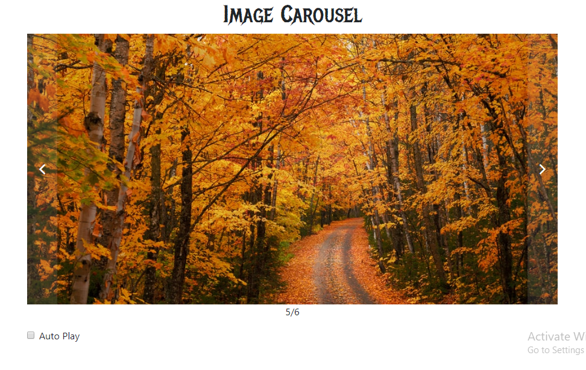

* **Auto Play Mode:**

