**Component Name**: Voice Search

**Component Functionality**:

This app presents a UI with a mic icon to the user. On initial load, it populates all the data.

When user clicks on mic icon and speaks something, speech to text transmission happens. The search string is displayed in read only text box. Then this search string is used to filter the data and presents it to the user.

Whenever user clicks on mic symbol, the old search string gets removed and the app starts listening for the new search option.

If the transcribed text does not match any record, a message is displayed.

The search is happening across all the data fields.

The app recognizes the spoken digits too.

**Usage Areas**:

Can be distributed as shared module for apps needing voice search

**Component Technical details**:

* Angular cli version: 9.0.7
* Typescript version: 3.7.5
* rxjs version: 6.5.4

There are two components in the current app.

One is speech-recognition. It uses Speech Recognition Interface of Web Speech API library. Supported by Chrome browser.

Other is the search-data which acts as the parent/container to show the filtered data.

The data is mocked inside search-data.

**How this component can be integrated with other Applications**:

Nothing needs to be changed. Currently data is mocked inside search-data, but filtration is happening dynamically. Only thing to be done is linking real time API for receiving data from server side.

**Screenshots**:

1. **Initial screen**:

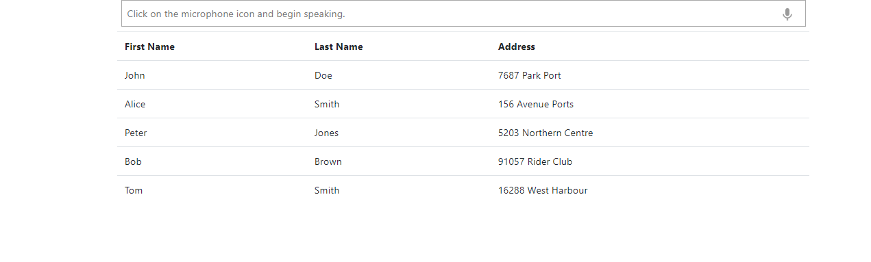

1. **User speaks, speech to text transcription happens and data gets filtered**

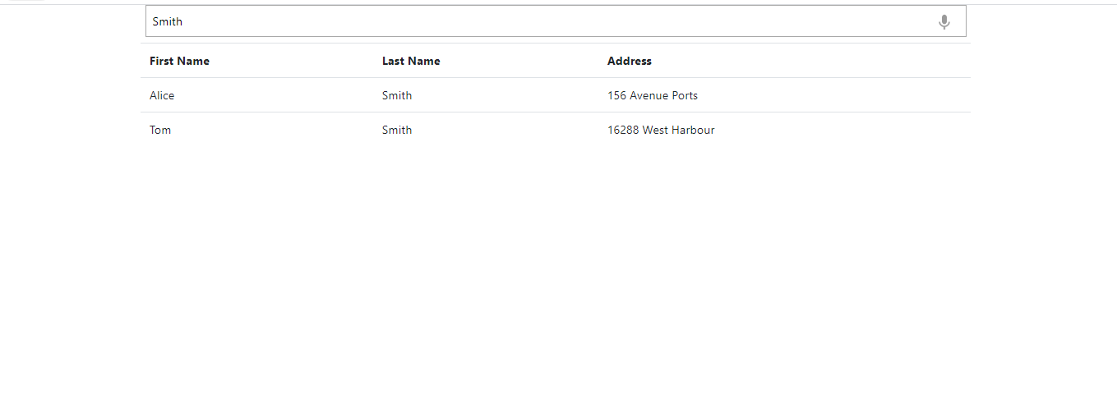

1. **Here, value is being matched with all the data fields:**

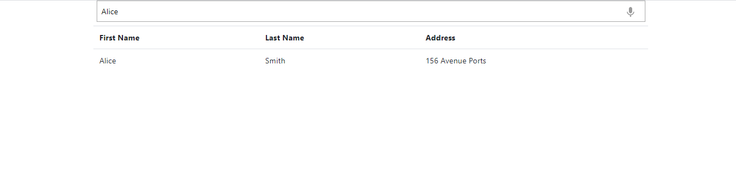

1. **When user clicks on mic icon, previous search string is removed, and all data is loaded:**

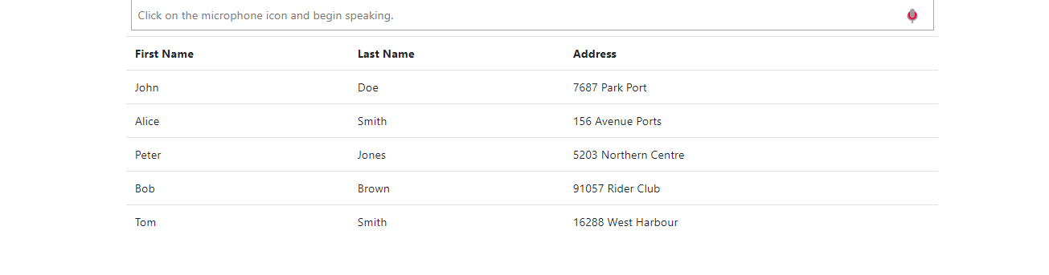

1. **Digits are also being transcribed:**

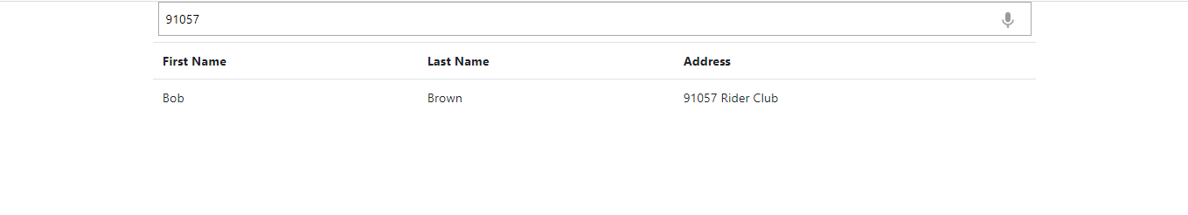

1. **If the transcribed text does not match any record, a message is displayed.**

