README

Kirana, Yohanes, 5310931.

Description

the game called connect 4 is built based on the principle of mvc (model controller view). This game is played by 2 people using network communication, where the first player plays as a host/server and the second player plays as a client.

Starting the game

1. Starting the game

Start the game by running MainServer.Java and MainClient.Java. Before entering the game State, the host enters the port where it will start the game. Apart from that, the Client also enters the port along with the Ip address on the game page. It is necessary to ensure that the ports entered by these two players are the same. After that the players can press the “Start Game” button.

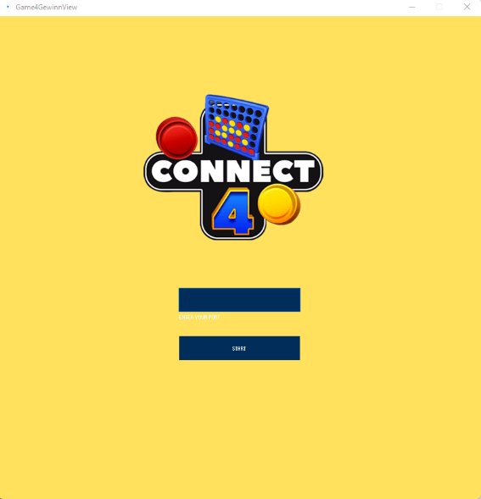 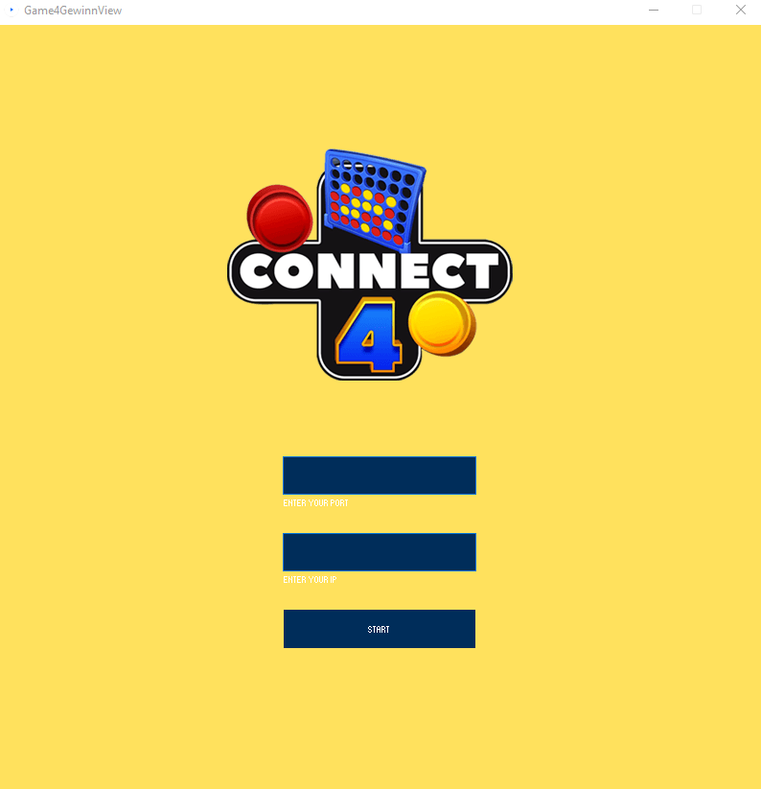

Starting Page for Client

Starting Page for Server

1. Rule of the game

The host starts the turn by selecting the column the ball will be entered by click on the column. Selecting any circle in the same column will result on inserting the same column. Keep in mind that the ball will occupy the bottom slot of each column. Then the Client gets a turn to select columns using the same method. The game continues alternately between the host and client.

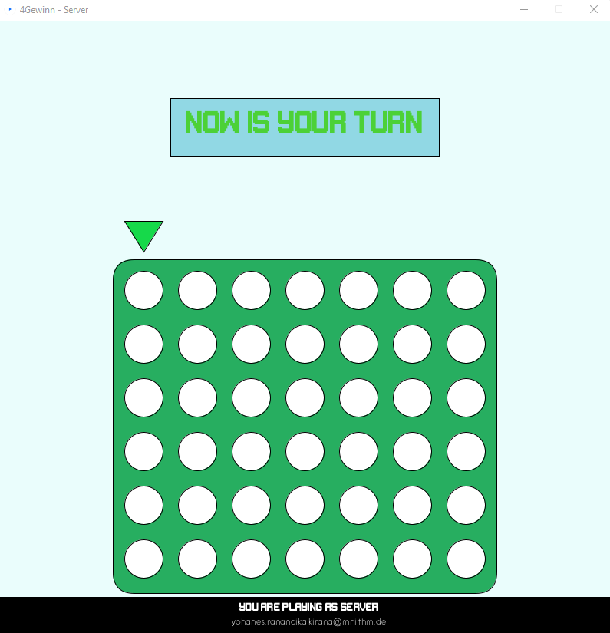

Game Page

1. End of the game

The game ends when the player has 4 balls in a row horizontally, vertically or diagonally.

Whoever manages to do this first becomes the winner

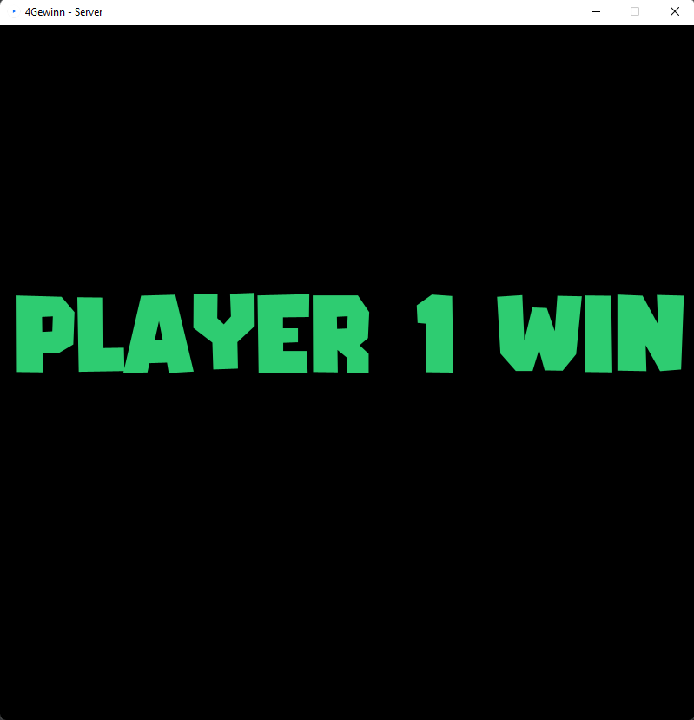

End Game Page if Player 1 Win

Used external Library

* [Processing](https://processing.org/)
* [ControlP5](https://www.sojamo.de/libraries/controlP5/)
* [Java.io](https://docs.oracle.com/javase/7/docs/api/java/io/package-summary.html)
* [Java.net](https://docs.oracle.com/javase/7/docs/api/java/net/package-summary.html)
* [Org.junit.jupiter.api](https://junit.org/junit5/docs/5.0.1/api/org/junit/jupiter/api/package-summary.html)

Used Package

* game.view
* game.controller
* game.model

Running Using *Jshell*

1. 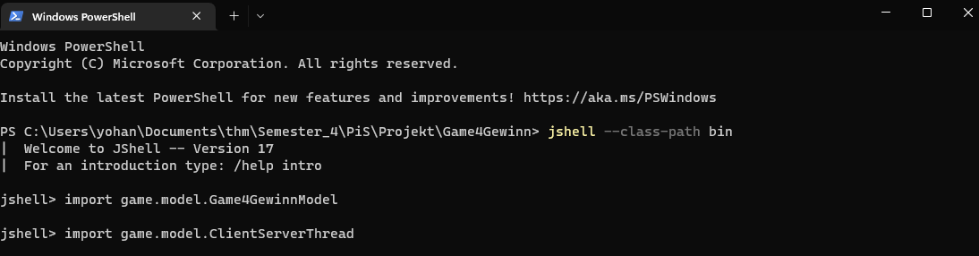To running the game model on *Jshell*, open a terminal and change the directory to where the project exists. Then set a class path using “jshell –class-path bin” to where the model package located. Import both java class using import <javaClass.class>.
2. 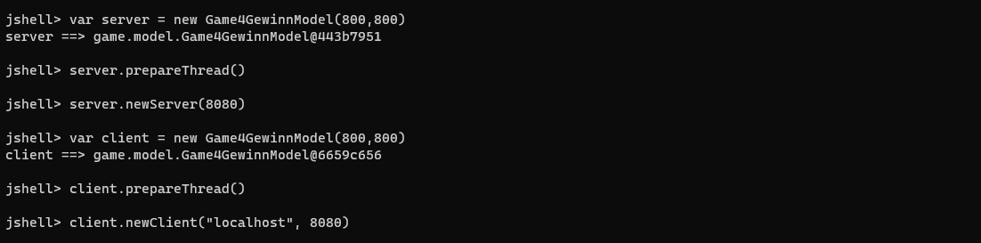Initialize two objects of Game4GewinnModel as server and as client. Prepare the thread for both object and create a new server and new client from them. You must keep in mind, that the port for server and client should be identical, so they can communicate each other.
3. Server and Client can start to play the game. They should use insertMove(n) and sendMove(n) when they want to play their turn. This n is the column number, which player insert to. The column numbers are represented by 0 until 6 (column 1 until 7). Player, who plays their turn first, play as player 1 and their move will be showed as number 1 in board. The Game will show the state of the game. -1 for the game has not end yet, 0 for the game end with no winner (tie), and 1 if player 1 win or 2 if player 2 win.

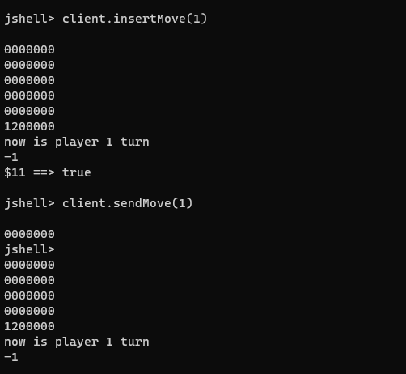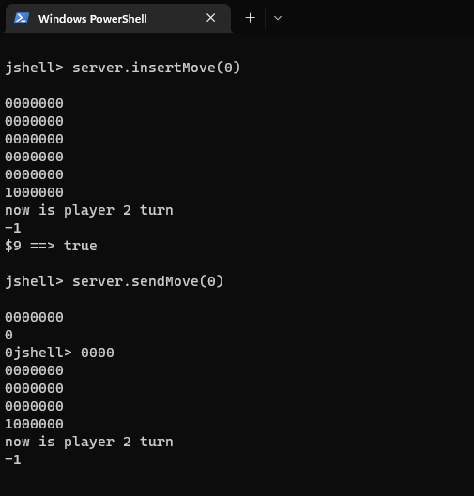

Credits

The creation of the connect 4 game using the mvc system and server communication was self-made from scratch, inspired by the mvc system and server communication from Prof.Dr. Martin Weigel.