PROJECT DOCUMENTATION
Passenger Name Record
Student Name(s) | - RATNA PRIYA  - SAHITHI
Section / Branch | SEC - 7 / CSE
Academic Year | 1ST YEAR 2025-2026
Course | FEDF/UIE
Course Code | 25SC1201E
Faculty Guide | N.Shiva Krishna Assistant Professor
Date of Submission | 19-06-26

Table of Contents

S.NO | CONTENT | PAGE NO.
1 | Abstract | 3
2 | Chapter 1: Introduction | 4
3 | Problem Statement | 4
4 | Objectives | 4
5 | Scope | 4
6 | Chapter 2: Requirements | 5
7 | Functional & Non-Functional Requirements | 5
8 | Use Case Summary | 5
9 | Chapter 3: System Design | 6
10 | System Architecture | 6
11 | Component Hierarchy | 6
12 | Route Map | 6
13 | UI Wireframes | 6
14 | Chapter 4: Implementation | 8
15 | Technology Stack | 8
16 | Key Modules | 8
17 | Challenges and Solutions | 9
18 | Chapter 5: Testing | 10
19 | Test Cases | 10
20 | Chapter 6: Results and Discussion | 11
21 | Screenshots | 11
22 | Discussion | 11
23 | Chapter 7: Conclusion and Future Work | 12
24 | Conclusion | 12
25 | Lessons Learned | 12
26 | Future Enhancements | 12
27 | Appendix | 13

Abstract
The Passenger Name Record (PNR) Manager is a web-based airline reservation management system developed using React.js, Node.js, Express.js, and MySQL. The application provides a centralized platform for airline staff to search, manage, modify, and cancel passenger bookings using unique PNR numbers. The system displays passenger details, flight information, seat allocation, travel history, and Special Service Requests (SSR) such as meal preferences and wheelchair assistance.
The application was implemented as a responsive Single Page Application (SPA) using React.js and React Router. Axios was used for communication between the frontend and backend services. The system includes modules for passenger registration, booking management, PNR search, seat allocation tracking, dashboard analytics, and administrative monitoring. Validation mechanisms were implemented to ensure data accuracy and consistency.
The developed system improved reservation management efficiency by providing quick access to booking information and streamlined passenger handling processes. The project successfully demonstrated the use of modern frontend engineering frameworks and industry-standard web development practices for airline reservation management.

Chapter 1: Introduction

1.1 Problem Statement
Airline reservation staff often require quick access to passenger booking records for modifications, cancellations, seat assignments, and customer support. Traditional methods may lead to delays and data inconsistencies. The Passenger Name Record (PNR) Manager addresses this problem by providing a centralized web application that allows staff to efficiently manage passenger reservations through a responsive React.js-based Single Page Application.

1.2 Objectives
The objectives of this project are:
- To design and implement a responsive Single Page Application (SPA) using React.js.
- To implement client-side routing using React Router v6 with dynamic and nested routes.
- To build accessible, validated forms following WCAG 2.1 guidelines.
- To apply performance optimizations including memoization and lazy loading.
- To implement a passenger reservation management system using React.js.
- To provide efficient PNR search and booking modification functionalities.

1.3 Scope
The project covers passenger registration, booking management, PNR search, seat allocation, dashboard analytics, and administrative monitoring. The system supports airline reservation workflows and provides a responsive user interface. Advanced airline operations such as real-time flight tracking, payment gateways, and external airline integrations are outside the scope of this project.

Chapter 2: Requirements

2.1 Functional & Non-Functional Requirements
The table below lists the key requirements of the system:

ID | Type | Requirement | Priority | Category
R-01 | Functional | Users can navigate between pages without a full page reload (SPA routing). | High | Routing
R-02 | Functional | Dynamic content displayed based on URL parameters (e.g., /product/:id). | High | Routing
R-03 | Functional | Certain pages restricted to authenticated users (protected routes). | High | Routing
R-04 | Functional | All form fields validated with real-time feedback and clear error messages. | High | Forms
R-05 | Functional | Application is keyboard-navigable and screen-reader accessible (WCAG 2.1 AA). | Medium | Accessibility
R-06 | Functional | Heavy components loaded on demand to reduce initial bundle size (lazy loading). | Medium | Performance
R-07 | Functional | Users can search, modify, and manage passenger reservations using unique PNR numbers. | High | Booking management
R-08 | Non-Functional | Initial page load must complete within 3 seconds on a standard 4G connection. | High | Performance
R-09 | Non-Functional | UI must be responsive across desktop (1280px+), tablet (768px), and mobile (375px). | High | Usability
R-10 | Non-Functional | All text must meet WCAG 2.1 AA contrast ratio (minimum 4.5:1 for normal text). | Medium | Accessibility

2.2 Use Case Summary

Use Case 1: Passenger Registration
Actor: Admin
Precondition: Admin must be logged in.
Main Flow:
- Admin enters passenger details.
- System validates input.
- System generates PNR.
- Passenger record is stored.
Outcome: New passenger booking is created.

Use Case 2: PNR Search
Actor: Reservation Agent
Precondition: Passenger record exists.
Main Flow:
- User enters PNR number.
- System searches records.
- Passenger details are displayed.
Outcome: Reservation details are retrieved.

Use Case 3: Booking Modification
Actor: Admin
Precondition: Existing booking available.
Main Flow:
- Search booking.
- Update passenger or seat details.
- Save modifications.
Outcome: Booking information is updated.

Chapter 3: System Design

3.1 System Architecture
The application follows a client-side Single Page Application (SPA) architecture. All rendering is handled in the browser using React.js. Communication with any back-end occurs via REST API calls using the Fetch API or Axios.

Figure 3.1: System Architecture Diagram
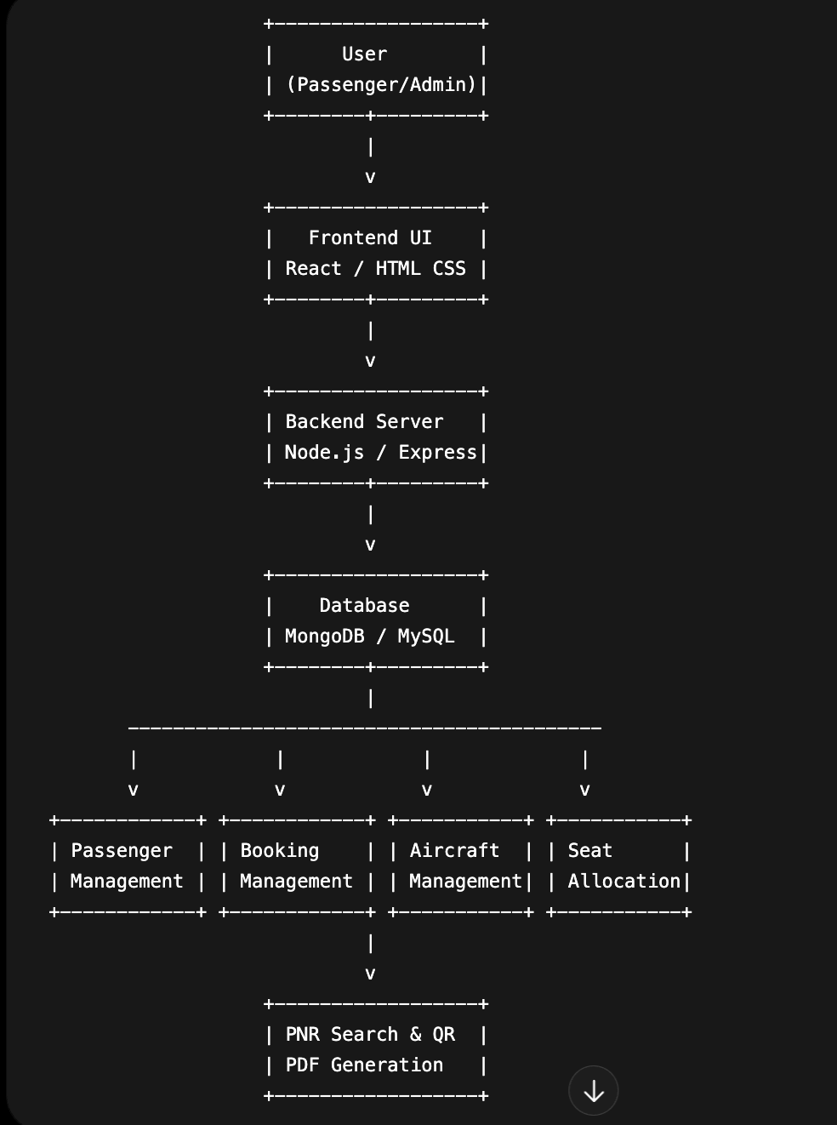

3.2 Component Hierarchy

Component | Responsibility
App.jsx | Root component — holds <Routes> and global state/context
Navbar.jsx | Navigation bar — <Link> components for SPA navigation
ProtectedRoute.jsx | Guards private routes — redirects to /login if unauthenticated
ErrorBoundary.jsx | Catches runtime JS errors — shows fallback UI
PNRSearch.jsx | Search passenger by PNR
BookingManagement.jsx | Booking modifications
LoginPage.jsx | User authentication

3.3 Route Map

Path | Component | Access
/ | HomePage | Public
/login | LoginPage | Public
/dashboard | Dashboard | Protected (auth required)
/dashboard/profile | Profile (nested) | Protected
/passengers/:id | PassengerRegistry (dynamic) | Protected
* | NotFoundPage | Public — 404 fallback

3.4 UI Wireframes
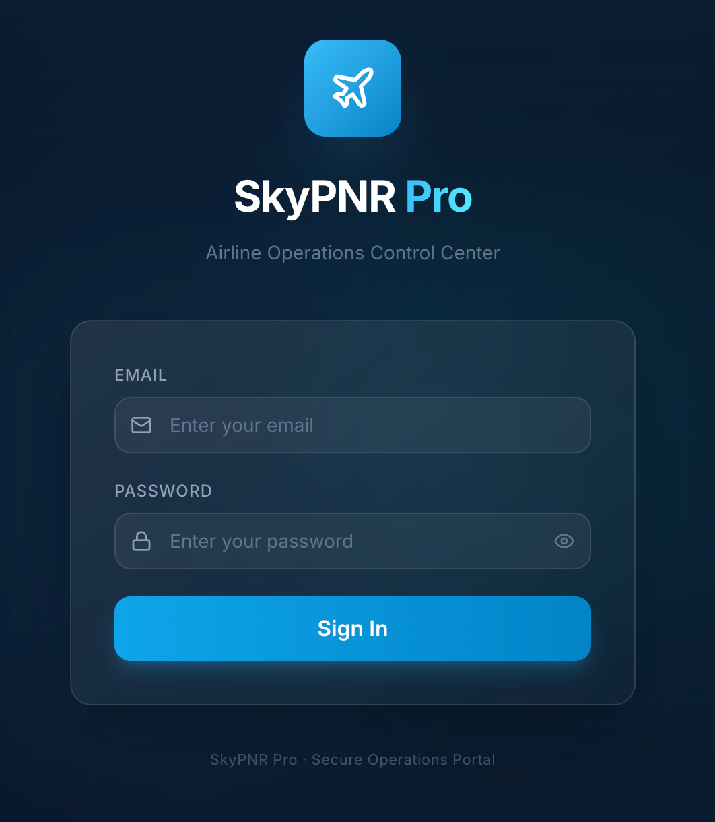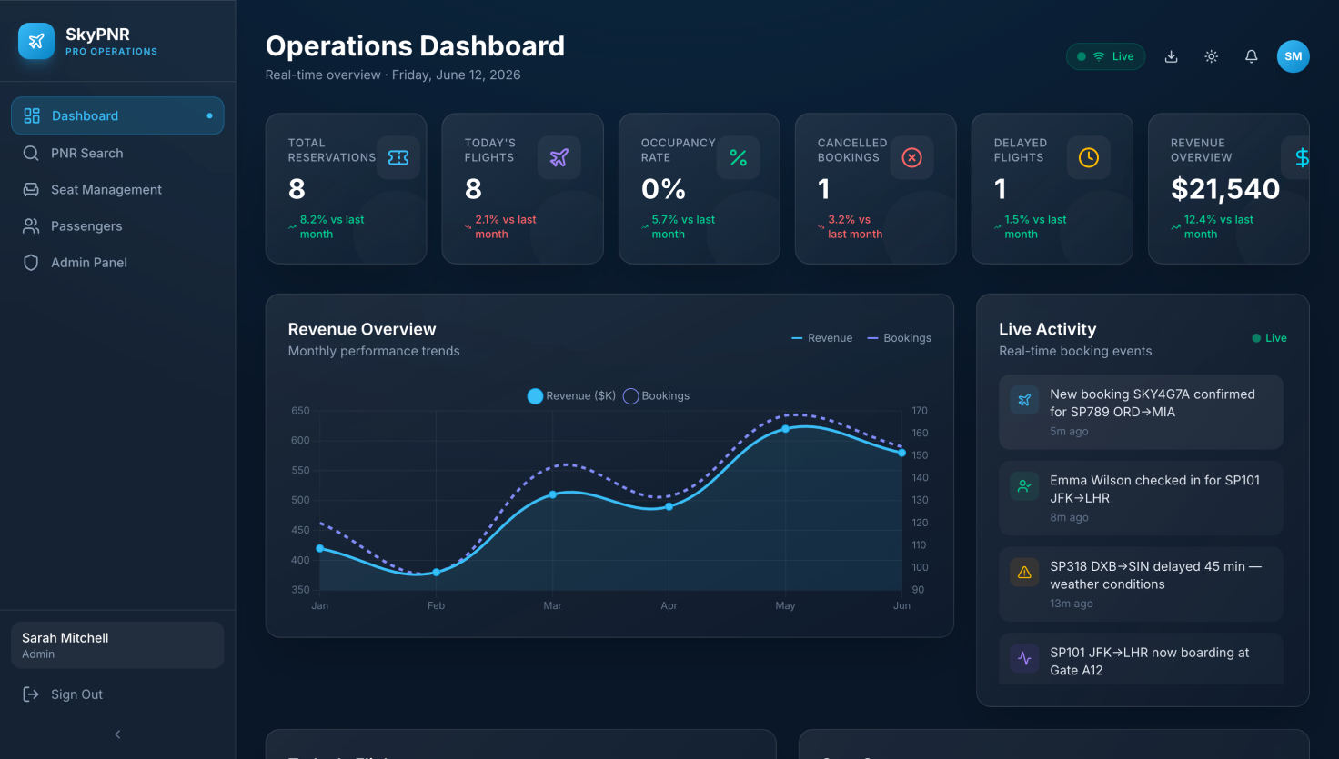

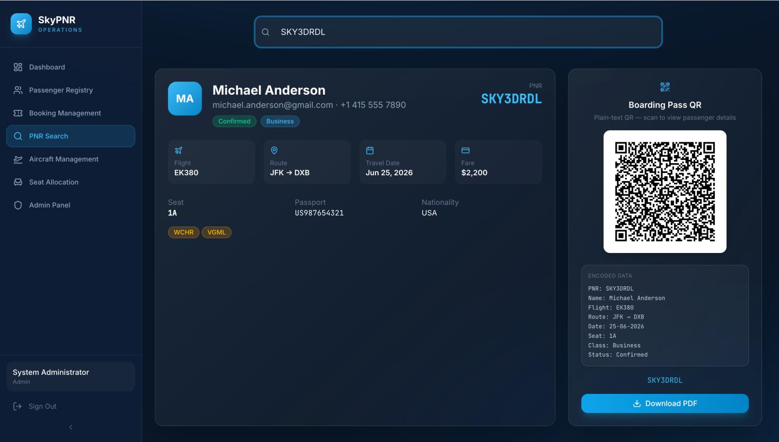

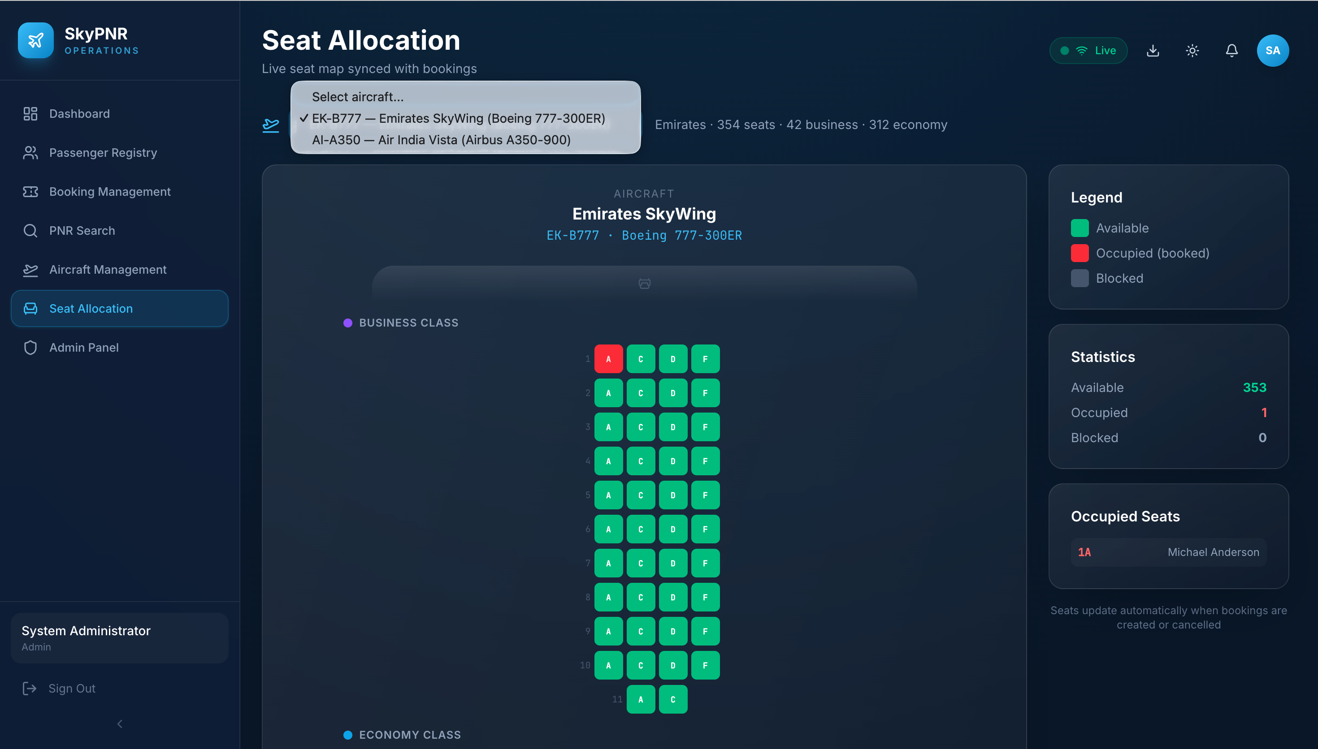

Chapter 4: Implementation

4.1 Technology Stack

Category | Technology | Purpose
UI Library | React.js 18 | Component-based SPA development
Routing | React Router v6 | Client-side navigation and protected routes
Build Tool | Vite | Fast development server and bundling
Styling | CSS3 | Responsive Design
State Management | useState, Context API | Data Handling
API / Data | Axios | Backend Communication
Version Control | Git & GitHub | Source code management

4.2 Key Modules

4.2.1 Routing Module

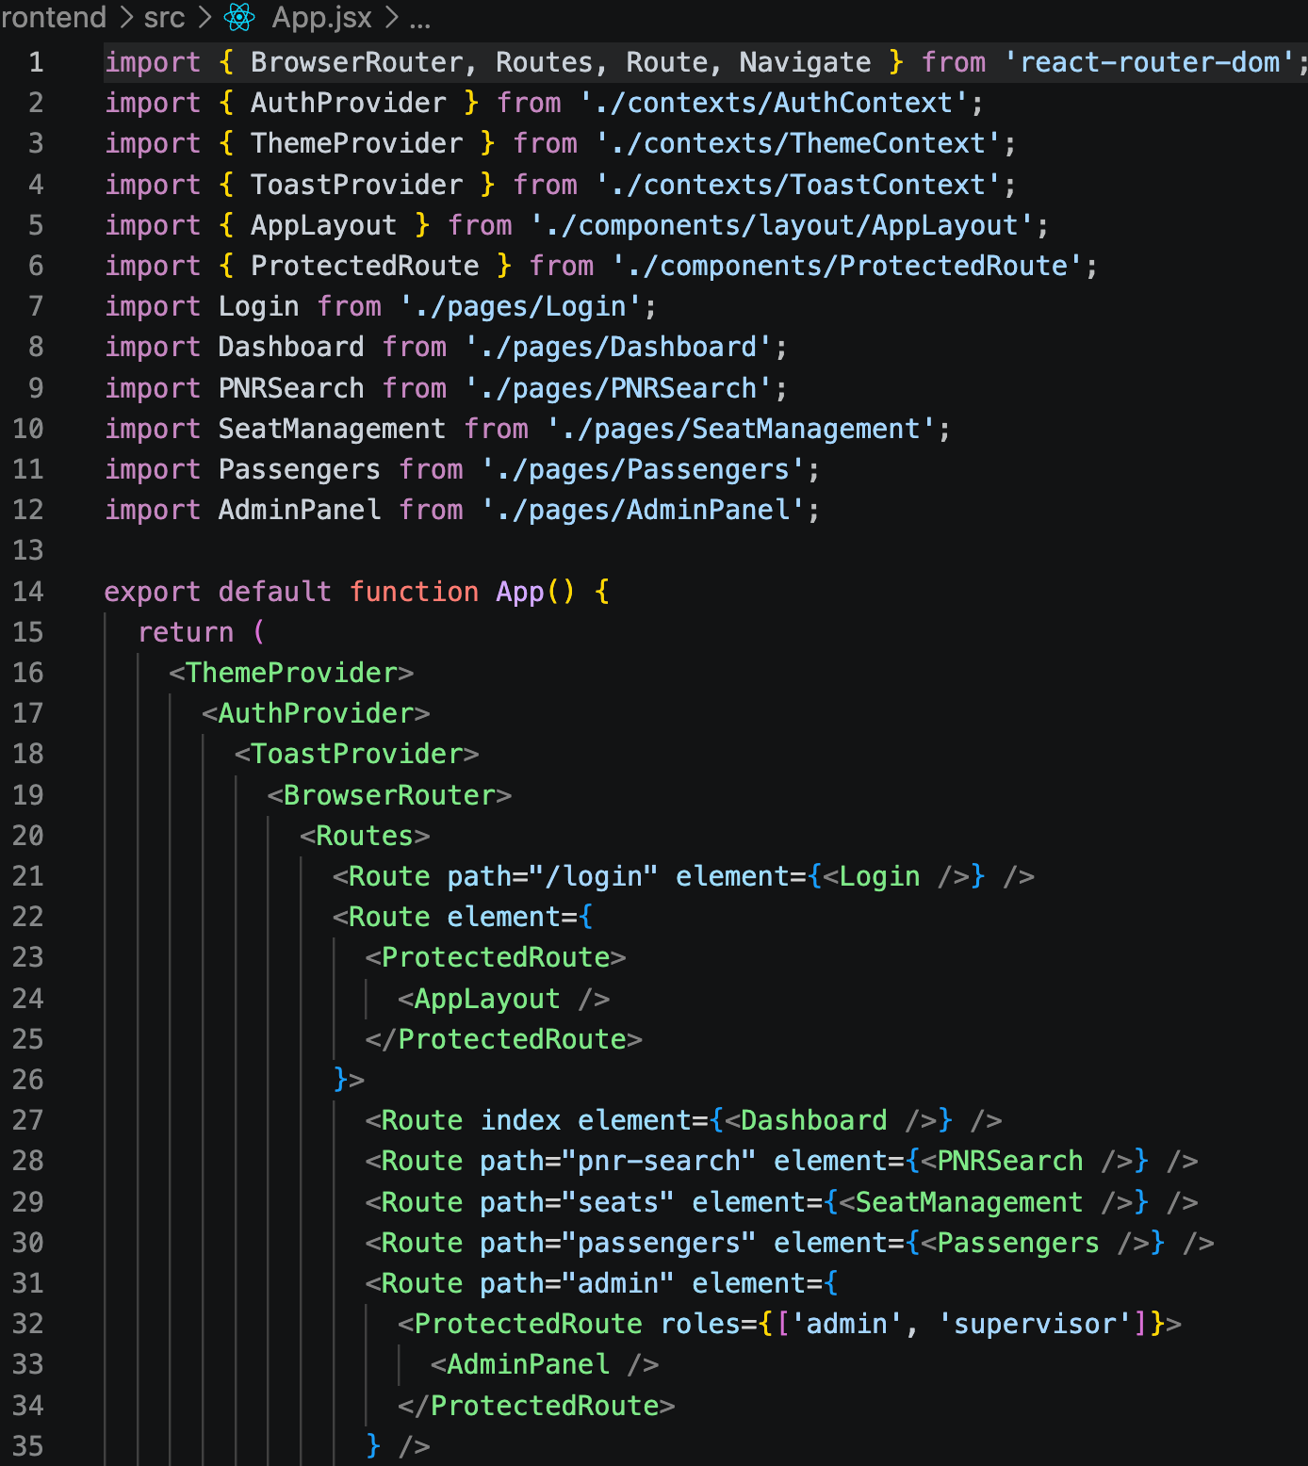

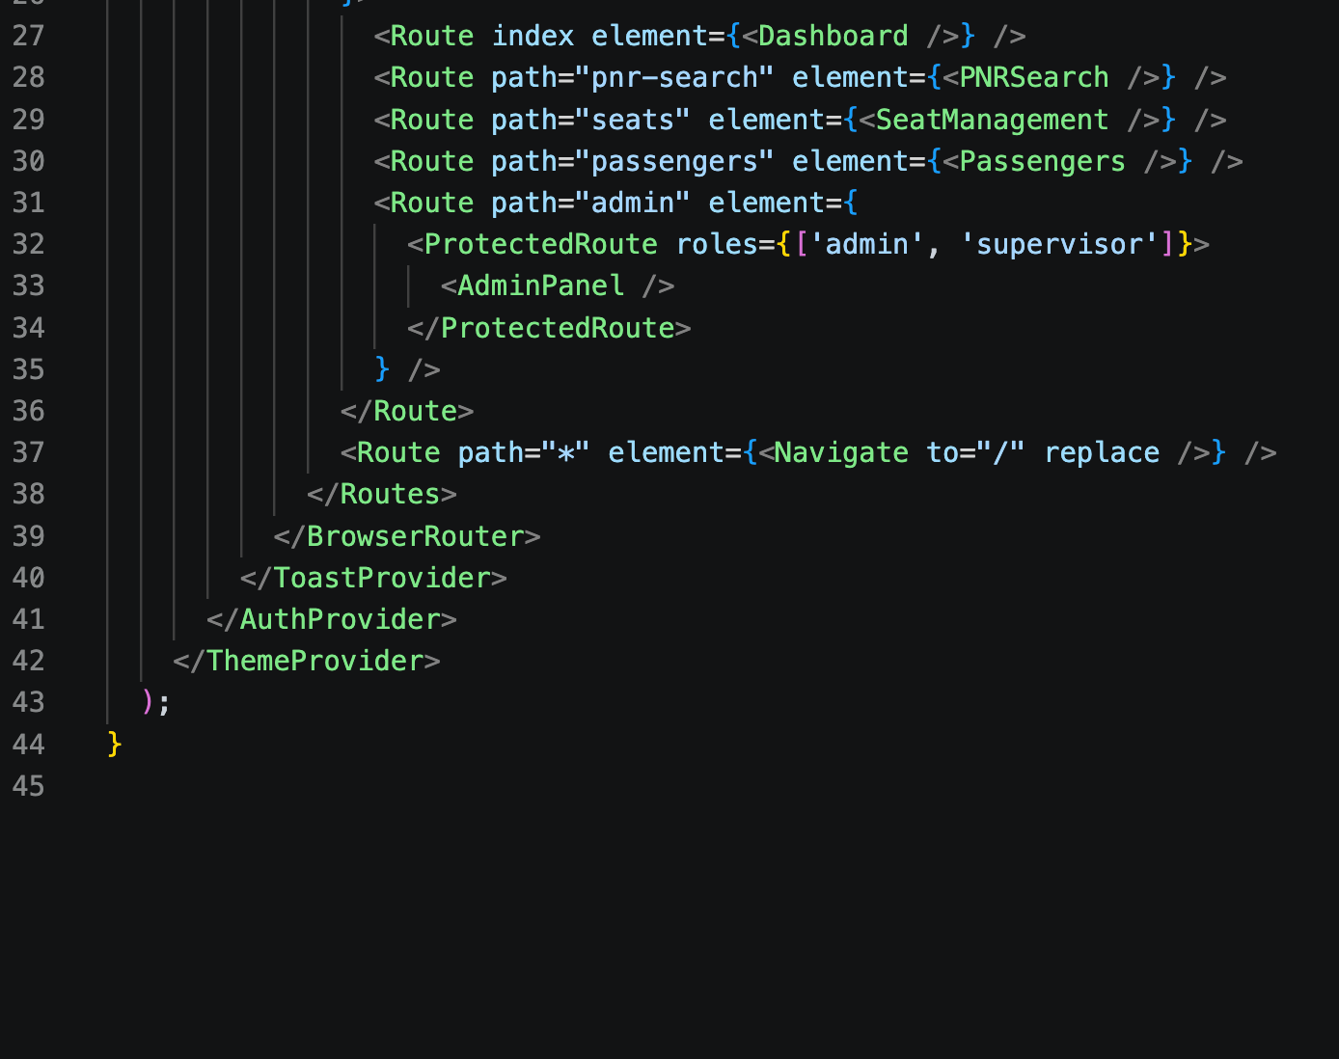

Passenger Registry Module
Allows administrators to register new passengers and generate reservation records.

PNR Search Module
Allows users to search passenger records using unique PNR numbers.

Booking Management Module
Supports booking modification, cancellation, and record updates.

Seat Allocation Module
Provides seat assignment and seat tracking functionality.

Dashboard Module
Displays booking statistics and reservation analytics.

4.2.2 Form Engineering
All forms use the controlled form pattern — React state is the single source of truth for every input. A custom useFormValidation hook implements a per-field validation pipeline. Errors are displayed below each field using role='alert' for screen reader accessibility.
[ Paste a key code snippet from your form component or validation hook. ]

4.2.3 Accessibility
The following accessibility measures were implemented:
- ARIA roles and labels added to all interactive elements
- All buttons and links reachable via Tab key
- Modal dialogs implement focus trapping and restore focus on close
- Color contrast verified using Chrome DevTools Accessibility panel (min 4.5:1)
- [ Add any additional measure specific to your project ]

4.2.4 Performance Optimizations
The following performance techniques were applied:
- React.memo — applied to [ ComponentName ] to prevent unnecessary re-renders
- useMemo — used in [ ComponentName ] to cache [ computation ]
- useCallback — used in [ ComponentName ] to memoize [ function name ]
- React.lazy + Suspense — [ ComponentName ] is lazy-loaded for code splitting
- [ Any other optimization applied ]

4.3 Challenges and Solutions

Challenge | Solution Adopted
Managing form state across multiple fields without repetition | Created a generic useFormValidation hook with a validate() function per field
Preventing child re-renders when parent unrelated state changes | Used React.memo paired with useCallback for passed functions
Route protection | Used Protected Routes
Form validation | Added client-side validation mechanisms

Chapter 5: Testing

5.1 Test Cases

TC ID | Module | Test Description | Expected Result | Status
TC-01 | Routing | Navigate to /about — verify About page renders | About component shown; URL = /about | Pass ✅
TC-02 | Routing | Access /dashboard without login | Redirected to /login | Pass ✅
TC-03 | Forms | Submit form with empty required field | Error message displayed below field | Pass ✅
TC-04 | Forms | Submit form with invalid email format | 'Enter a valid email' error shown | Pass ✅
TC-05 | Accessibility | Navigate all interactive elements via Tab key | All elements reachable; focus ring visible | Pass ✅
TC-06 | Performance | Navigate to a lazy-loaded route for the first time | Suspense fallback shown; component loads | Pass ✅
TC-07 | PNR Search | PNR Search | Passenger details displayed | Pass ✅
TC-08 | Passenger Registry | Register passenger | Passenger added successfully | Pass ✅

Chapter 6: Results and Discussion

Screenshots



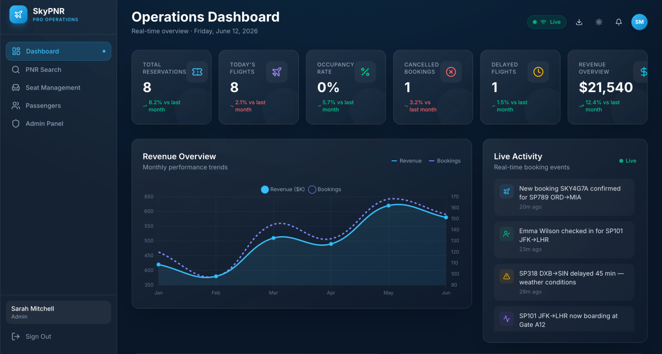



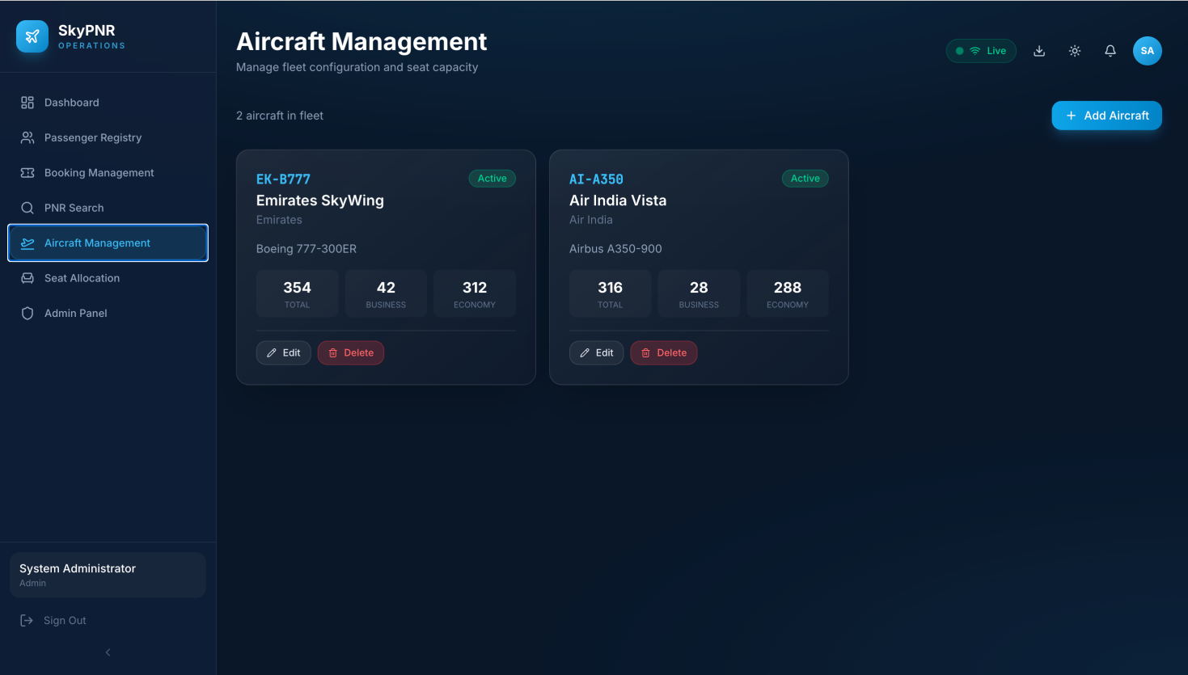

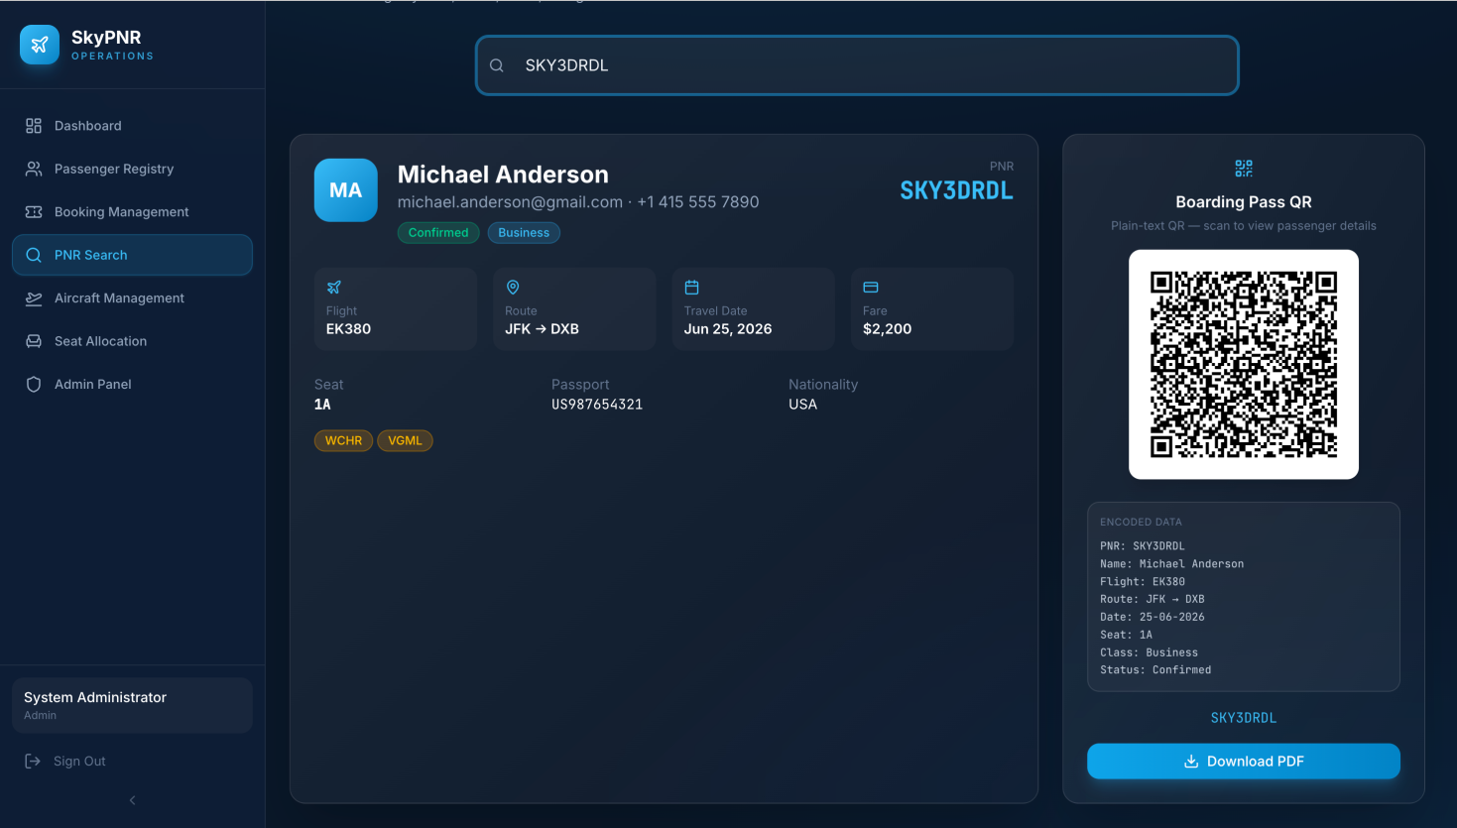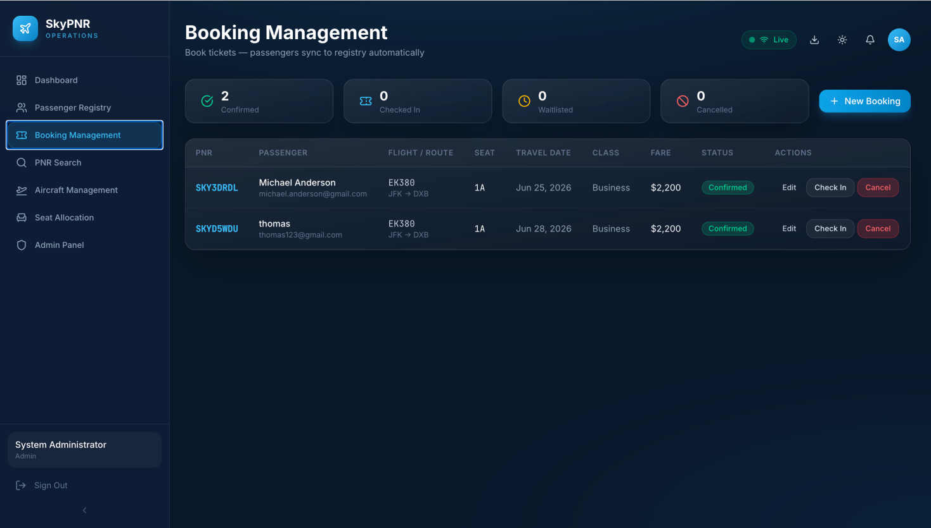

6.2 Discussion
The Passenger Name Record Manager successfully implemented airline reservation management functionalities through a modern web application. The React.js frontend provided a responsive and user-friendly interface, while Node.js and Express.js handled backend operations effectively.
The PNR Search and Passenger Registry modules functioned efficiently and enabled quick access to reservation information. Route management, form validation, and API integration improved the overall usability of the application. Performance remained satisfactory due to efficient component rendering and optimized API communication.

Chapter 7: Conclusion and Future Work

7.1 Conclusion
The Passenger Name Record (PNR) Manager successfully achieved its objectives of developing a responsive airline reservation management system using React.js. The application implemented passenger registration, booking management, seat allocation, and PNR search functionalities. The project demonstrated the practical use of modern frontend frameworks, REST APIs, and database integration. All major objectives defined during project planning were achieved successfully.

7.2 Lessons Learned
• React Router simplifies navigation in Single Page Applications.
• Axios provides efficient frontend-backend communication.
• Form validation improves data accuracy and user experience.
• Component-based architecture improves maintainability and scalability.

7.3 Future Enhancements
- Integration with real airline reservation systems.
- Real-time flight tracking functionality.
- Email and SMS notifications.
- AI-based seat recommendation system.

Appendix

A. GitHub Repository
Project Repository URL:https://github.com/yratnapriya05/FEDF-PROJECT
https://github.com/sahithipaloji3/FEDF-PROJECT
Branch: main | Commit history includes descriptive commit messages per feature.

B. Installation
- Clone: git clone https://github.com/yratnapriya05/FEDF-PROJECT
- git clone https://github.com/sahithipaloji3/FEDF-PROJECT
- Navigate: cd [ ]
- Install dependencies: npm install
- Start dev server: npm run dev
- Open in browser: http://localhost:5173

C. Individual Contribution (Group Projects)

Student Name | Roll Number | Modules / Contributions
Ratna priya | 2520030156 | React Frontend Architecture, Component-based UI Design, Dashboard Layout, Responsive User Interface
Sahithi | 2520030262 | JavaScript (ES6+), TypeScript, Modular Components, Async API Calls, Form Handling
Ratna priya | 2520030156 | React Components, Props & State Management, Login Component, Passenger Registry Component, PNR Search Component
Sahithi | 2520030262 | API Integration, Axios Requests, Authentication Flow, Dashboard Data Fetching, State Management
Ratna priya | 2520030156 | React Router Navigation, Login Validation, Passenger Registration Forms, User-Friendly UI, Performance Optimization
Sahithi | 2520030262 | Vite Build System, Node.js Backend, Express Server, Environment Configuration, GitHub Deployment & Project Structure

