,Data analytics:

* Descriptive analytics: what has happened over a given period of time.
* Dygnostic Analysis:why something happened
* Predictive:generate some insights
* Prescriptive analytics: after prediction give somerecoomendation.

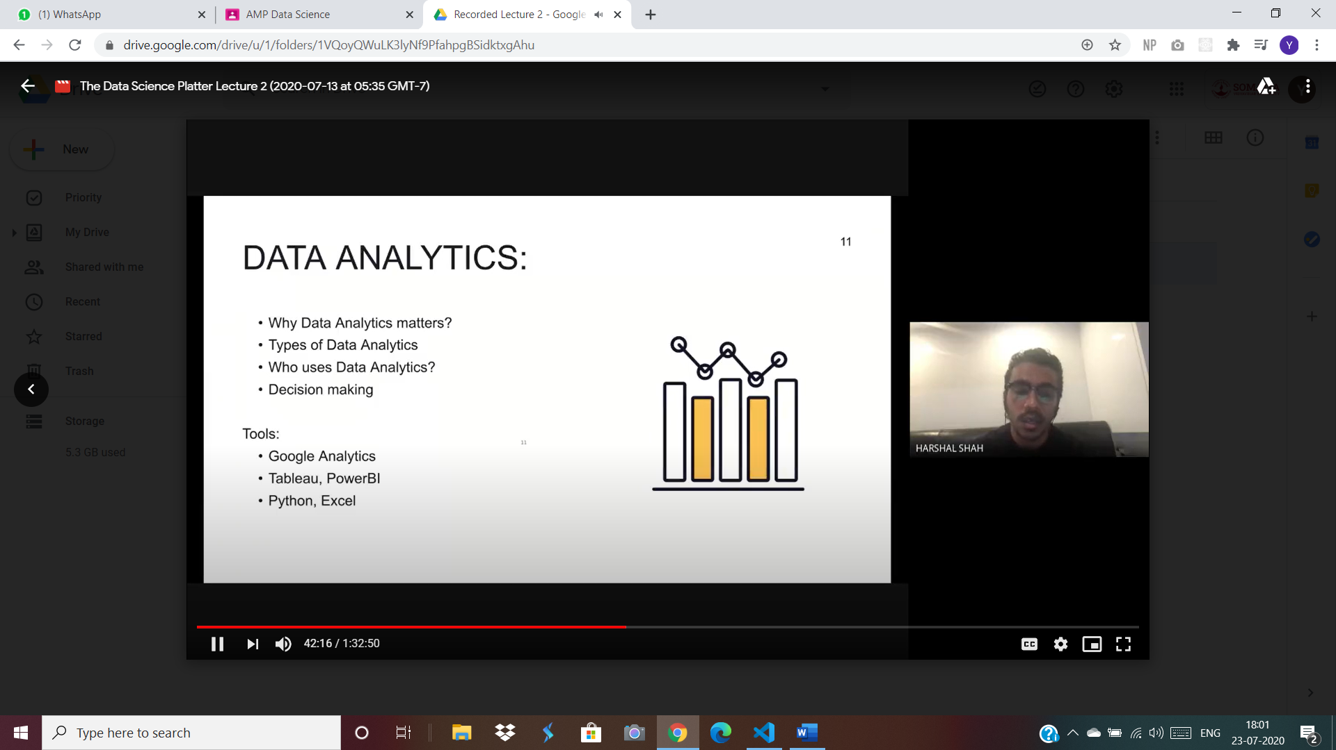

Tools for big data:

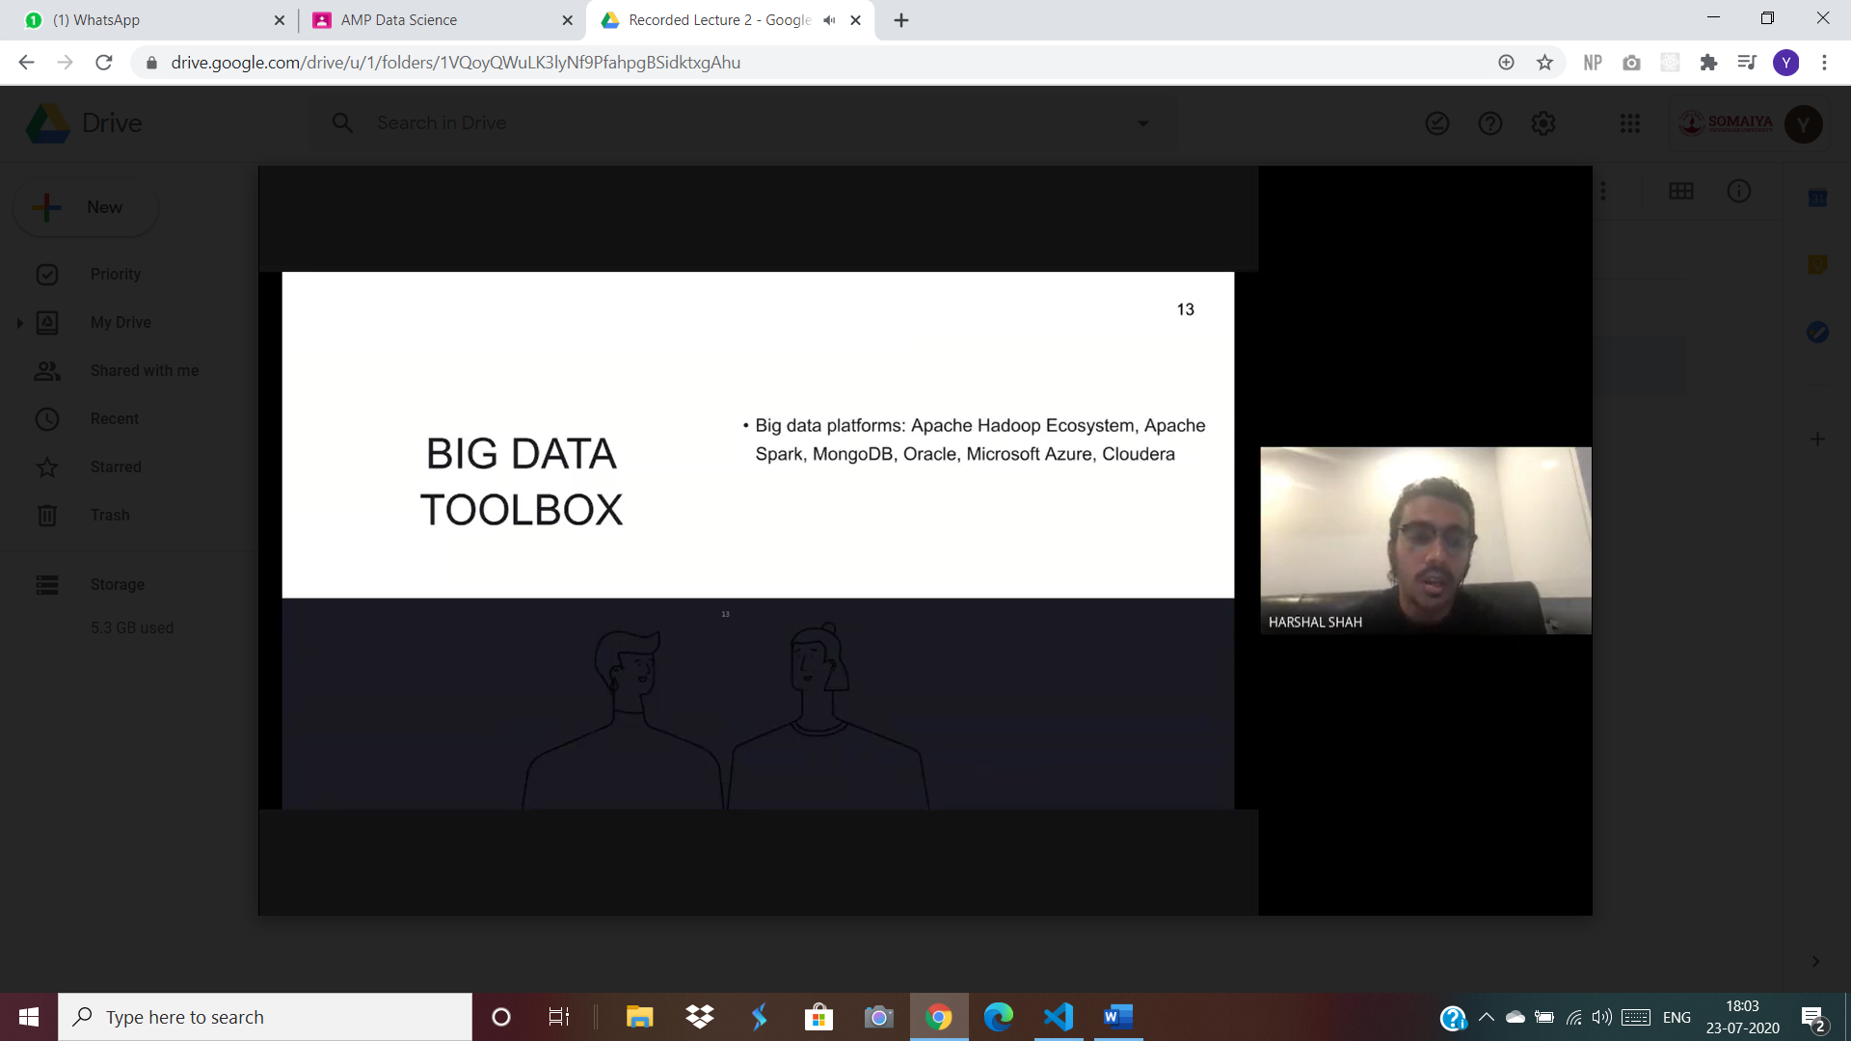

Bias:

Ratial, spatial, class

Jupyter:

Dropping colmns

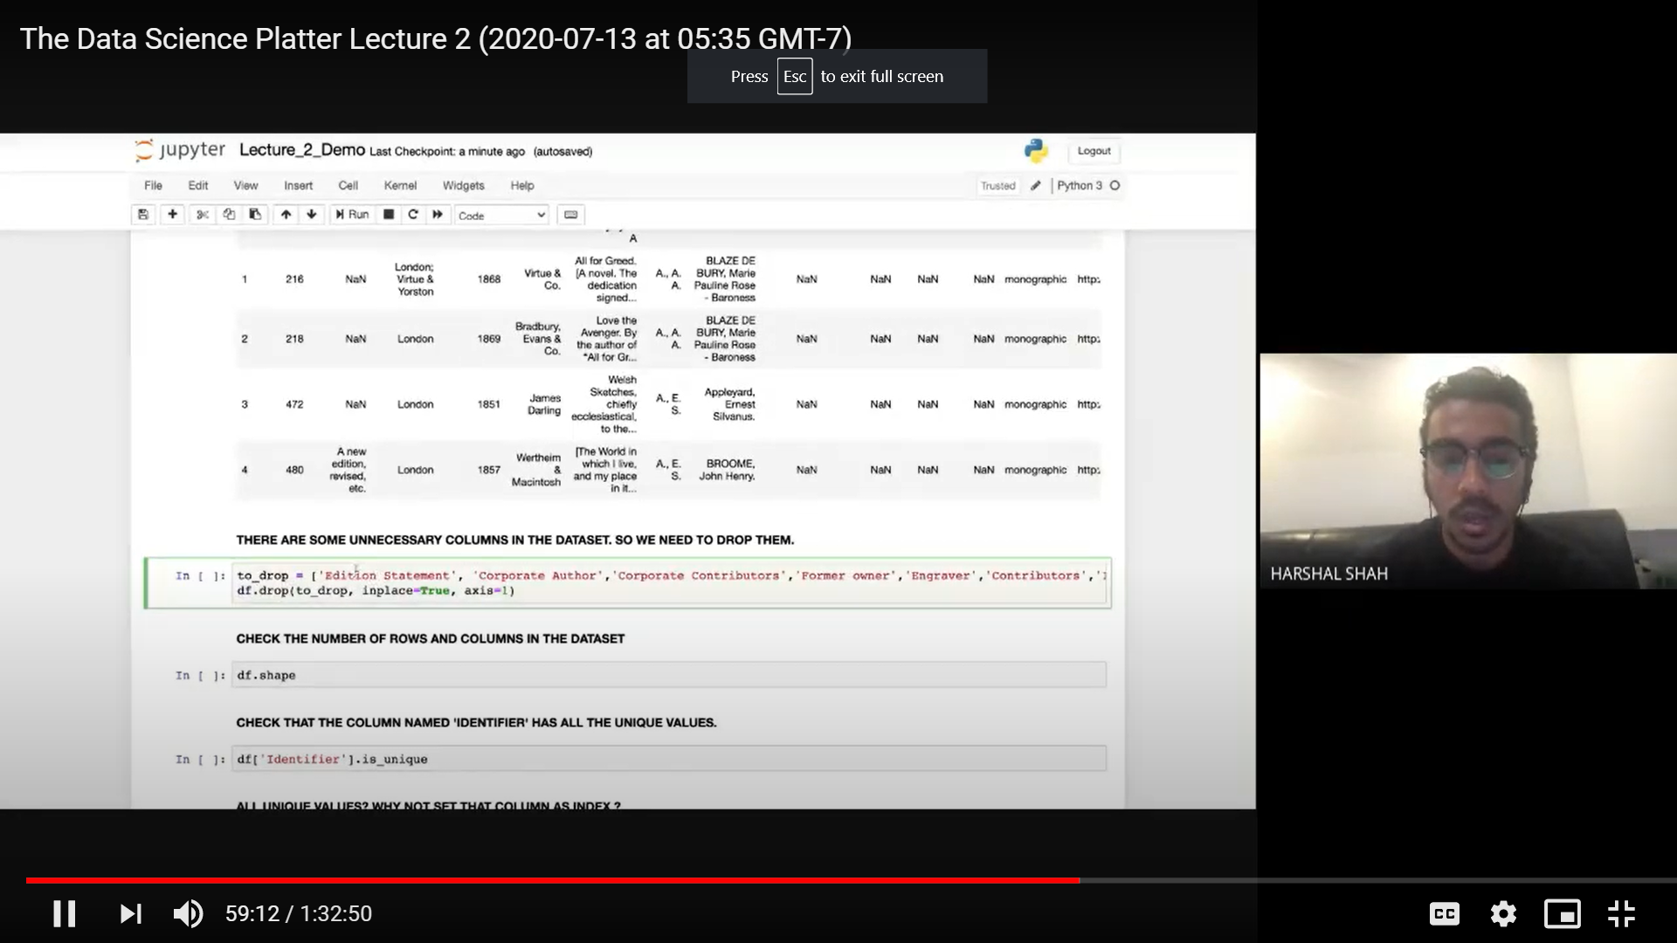

Checking unique and set_index:

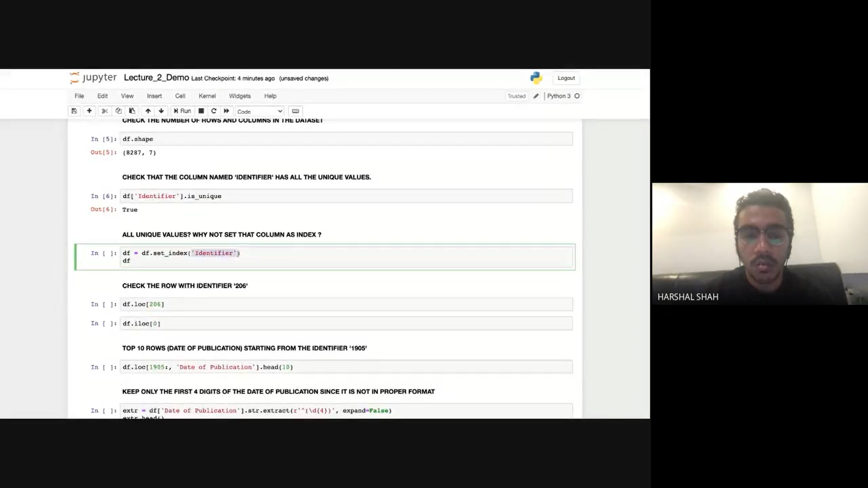

loc and iloc: in loc we pass values.

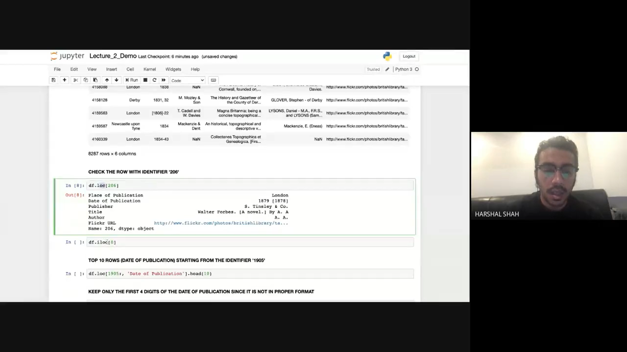

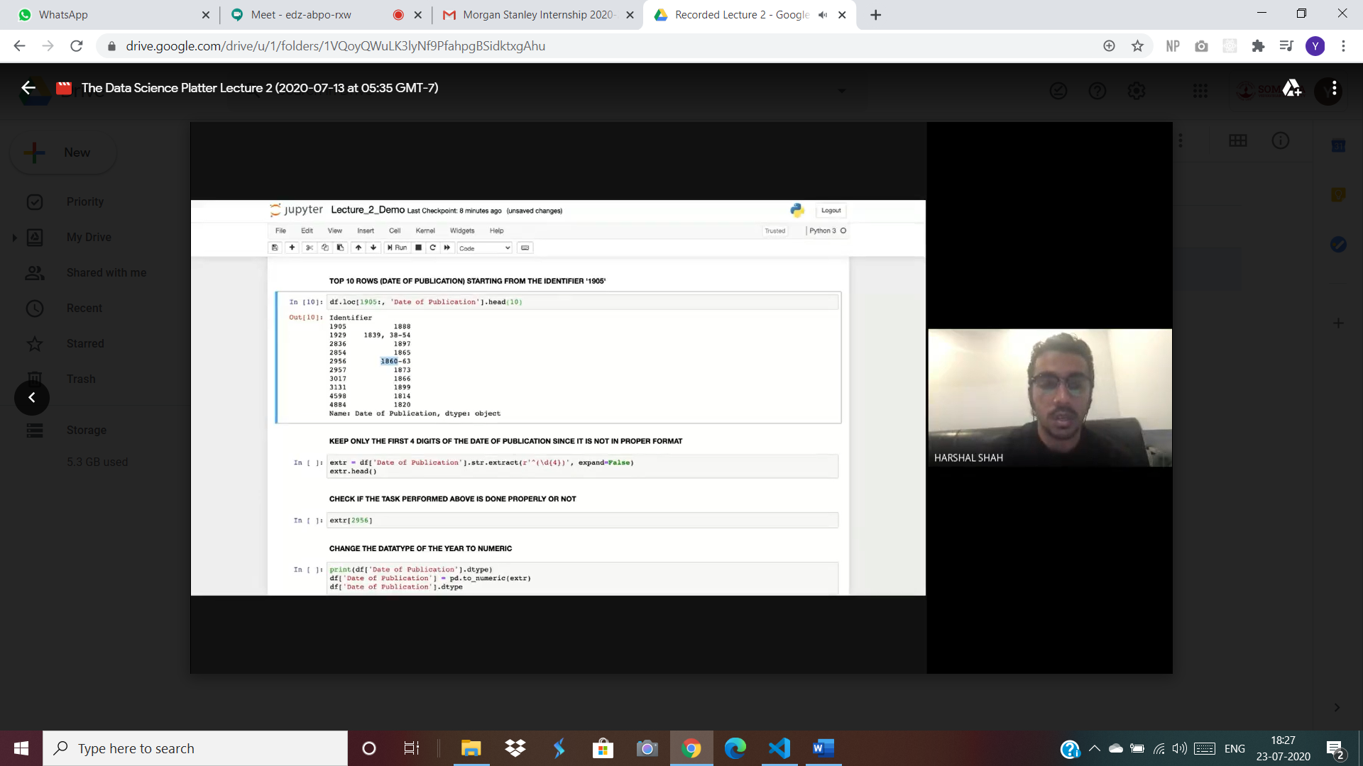

to_numeric, isnull and duplicated values:

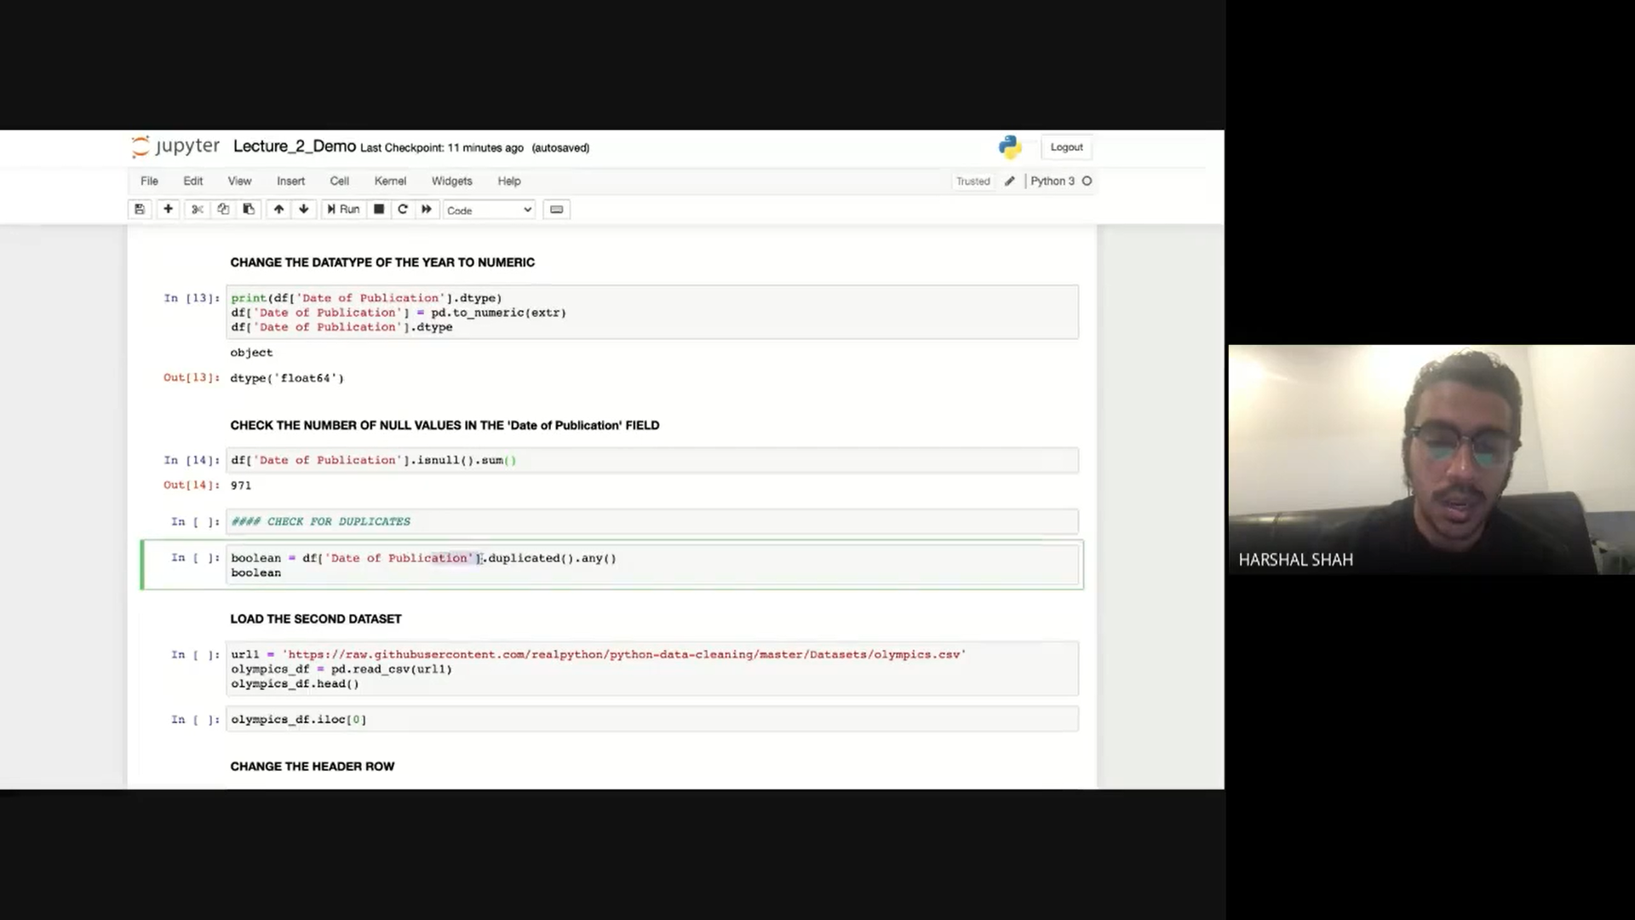

Imputing or filling nan values by average using scikit learn:

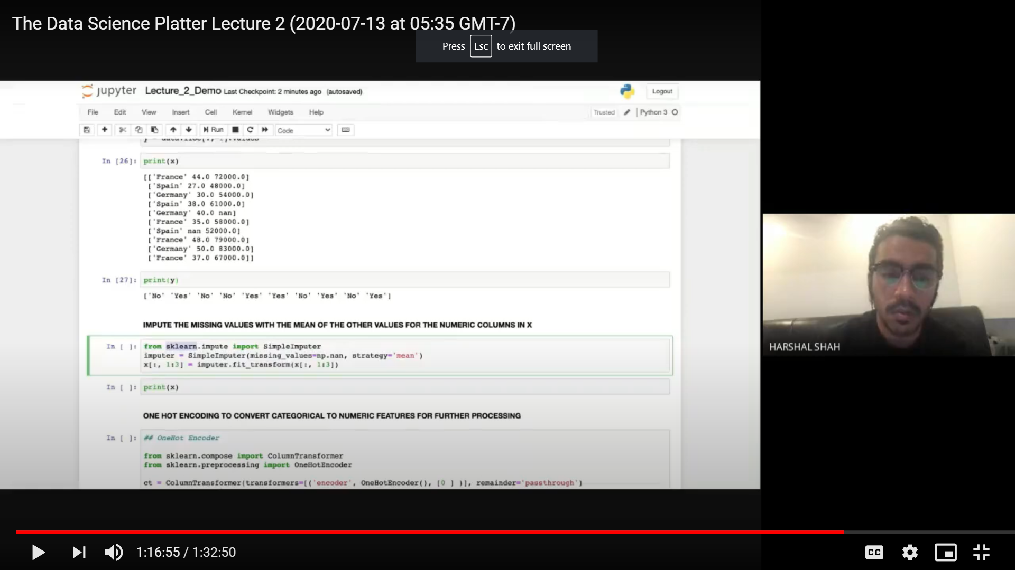

One hot encoding:

