Alexandria Times

‘We’ve impacted generations’: Community cookouts kick off summer in ALX
May 30, 2024

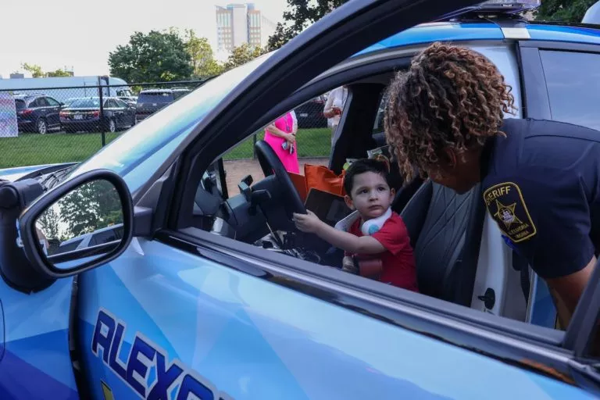
A boy sits in the new Ford Mustang police vehicle with Sgt. Cassandra Branch. (Photo/Audrey Keefe)

By Audrey Keefe | akeefe@alextimes.com
Hundreds of community members gathered at Southern Towers on May 21 for the City of Alexandria’s fifth community cookout of the season.
“It’s important when you let someone know you care about them,” Michael Johnson, the founder of the Community Cookouts said.
The cookouts began in 2006 with one table, one grill and only 20 people, and have blossomed over almost two decades into a resource-filled, free series open to residents, allowing them to connect over food throughout the spring and summer. Residents are invited to interact with more than 25 city agencies and nonprofits to help drive community involvement during each of the dozen cookouts planned for this year.
“The main goal of the cookout is to make sure that if people aren’t able to get resources, you bring the resources to them,” Sgt. Cassandra Branch, who was tabling for the Alexandria Sheriff’s Department, said.
More than 300 residents of Southern Towers attended the event, and more than 2,500 residents have already attended a cookout, according to Tracy Walker, communications manager at the Alexandria Police Department.
“They’re coming out and that is really important to us. … That shows they really want to build a relationship with us as well,” Leslie Palucho, a firefighter and community outreach coordinator at the Alexandria Fire Department, said.
Each of the cookouts takes place in a different community and neighborhood in the city to ensure people of all backgrounds and socioeconomic status can participate, according to Johnson.
“We can’t exclude anyone. These people probably don’t even mingle during the course of the day, but they are here together for today,” Johnson said.
Around 350 hot dogs and burgers were doled out by several city staffers and teenagers with Cornerstone Craftsman Inc., a nonprofit dedicated to mentoring at-risk teens to decrease juvenile crime rates through community service and construction trades.
Roberto Gomez, Cornerstone’s executive director, sees the community cookouts as a way for youths to create positive interactions with the police and community.
“These kids, who otherwise would be opposed to shaking out with police, are passing food out right next to them,” Gomez said.
According to Gomez, the interactions serve as a way to bridge the gap between the police and at-risk youths by helping them see that there are other ways to stay out of the streets and lead successful lives.
“It’s about community. It’s about providing services. It’s about making sure that marginalized communities know that they’re not alone and there’s ways out,” Gomez said.
The cookouts were initially started by another department almost two decades ago, but are now implemented by the Alexandria Police Department and Sheriff’s Office in partnership with the city.
Johnson said he created the cookouts with the main goal of bridging the gap between law enforcement and underserved youths through community policing. He said the cookouts start the dialogue between members of law enforcement and the community.
Johnson never envisioned the cookouts to grow into what it is today, but he is excited about the effect they are having on the community.
“It’s almost like having a utopian feeling because you see people out there mingling and talking and meeting new people,” Johnson said.
As the cookouts have grown, so have its partnerships with nonprofit organizations and city agencies. Residents have the opportunity to speak with representatives of different organizations ranging from the Alexandria Library to the Social Responsibility Group, which advocates for the disenfranchised.
“[Residents] get to interact with not only police, but agencies they didn’t have a clue about,” Sgt. John Paul Jones, who works in the technology services division of the APD, said.
The cookouts also have plenty of activities and gifts for kids, including firefighter hats, stickers and candy. A handful of agencies gave information on services and programs that are available for kids, especially for the summertime to promote positive activities aside from school. Branch even welcomed kids to take a seat in her new Ford Mustang Mach-E police vehicle.
“The most important thing for me is just getting to interact with the kids, but also getting the family members to know about resources that they couldn’t have known about before,” Branch said.
Malcolm Westbrook, who grew up in Alexandria and attended the cookout, was in awe of the resources available to residents. He hopes that this can spread to other communities in the future.
“This is absolutely beautiful,” he said. “It’s nice to see everybody mingling and connecting.”
Community leaders also attended the event, including Councilors John Taylor Chapman, Sarah Bagley and Alyia Gaskins. The councilors said they greatly supported the cookout and participated in conversations with residents about resources available to them.
Gaskins drew attention to the great community engagement tool that the cookouts have transformed into.
“What you see here is people dropping in and they’re finding different services, getting food, and we’re kind of just connected as a community,” Gaskins said.
Chapman described the low-stress environment that the cookouts bring to the community and how people need to connect, especially community leaders.
“It’s extremely important for us to get out of City Hall … and get out into the actual community, particularly for those communities more at risk,” Chapman said.
Bagley described the burden on many families to get information in neighborhoods that are extremely reliant on public transportation. It is vital to remove these barriers, she said.
“We can reduce that burden on them to get this information to simply bring it in, set the tables up, allow them to come out of the thousands of units that are here,” Bagley said.
For all individuals who have become involved, this opportunity has been an effective way to reduce the barriers to entry for a variety of nonprofits and city agencies. The cookouts also give communities a sense of belonging and togetherness that will stay with them for generations to come, Johnson said.
The city’s nonprofits, policymakers and law enforcement will come together to provide resources to the community on seven more occasions between May 29 and July 23.
The community cookouts have reached between 30,000 to 40,000 people during the past 18 years, according to Johnson.
“We’ve impacted generations,” Johnson said.

