**ARIMA Model for Time Series Forecasting**

**Ritu Yadav**

**Introduction**

The field of financial analysis is an uncertain terrain, with market fluctuations, geopolitical events and economic landmarks continuously shaping the course of economic development in this dynamic environment the ability to estimate futures markets characteristics and ongoing inventory cost estimates are key for consumers, investors and financial analysts themselves to provide a full understanding of complex systems and dynamics in the marketplace

Time series forecasting is emerging as a powerful tool in the arsenal of economists, offering a systematic approach to unpacking complex market functions At the heart of time series forecasting lies Autoregressive Integrated Moving The average (ARIMA) model has gained widespread approval for its ability to auto regress, distinguish, By integrating moving average components, ARIMA offers a simple and robust method for modeling and controlling the time cumulative data a events predicted for

ARIMA is now interested not only in its mathematical beauty but in its practical application in a wide range of fields from economics to epidemiology. ARIMA has been looking at systems in a variety of fields.

In this work, we make a bold move to apply the strength of ARIMA in stock market forecasting, having chosen the concept on Netflix stock price. As one of the major giants, Netflix has ended up symbolizing the rapid changes that are reshaping the landscape of media and entertainment. Its stock fee, which reflects market sentiment and employer performance, is a barometer of investor confidence and industry performance.

Our experiment uses historical Netflix data to develop an ARIMA model for time series forecasting. Our goal is to provide stakeholders with accurate and useful insights into destiny market characteristics and stock price trends by applying modern statistical techniques to the observational approach. Our intention in developing these predictive versions is to provide consumers, traders, and financial analysts with the resources they need to successfully navigate complex financial markets and make well-informed decisions.

Problem statement and explanation:

Directed analysis of old inventory data for forecasting is time-consuming, error-prone, and largely incapable of capturing complex market dynamics When the volume and complexity of economic data increases, there may be a greater need for computational forecasting solutions that provide reliable forecasting speed and accuracy. Our challenge specifically addresses this mission to develop customized ARIMA models for predicting Netflix stock fees. By automating the pricing process and using best-in-class accounting techniques, we strive to provide relevant and actionable insights to stakeholders in terms of fate market dynamics.

Excessive-level features

Data preprocessing: The first step in our procedure is to put together and reprocess historic stock facts to take away noise, monitor lacking values, and make sure consistency. This preprocessing phase is vital for getting ready records for analysis and enhancing forecast version accuracy.

Model development: After preprocessing the facts, we proceed to expand the ARIMA model to expect future stock fees. This consists of choosing the precise parameters for the version, together with put off order (p), degree of difference (d), and shifting ordinary order (q) and then coaching the version to take a current Netflix stock record do not use it for style and traits.

Model assessment: After training the ARIMA model, we examine its common overall performance using diverse metrics along with root mean rectangular mistakes (RMSE), mean absolute blunders (MAE), and mean absolute percentage blunders (MAPE). This step is crucial for accurately and reliably comparing the predictive interpretation and figuring out areas for development.

Forecast: Using the field verified ARIMA model, we continue with future list price forecasts for Netflix. These forecasts are based totally on ancient statistical styles captured via the model and offer precious insights into electricity market dynamics and investment opportunities.

**Exploratory Data Analysis:**

**1.**Scatter Plot of Opening and Highest Prices:

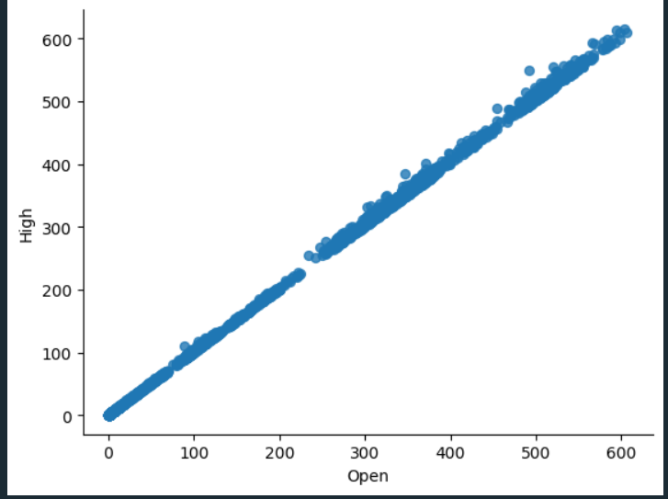

Scatter plot displays how prices of the stock 'Open' and 'High' are related in case of Netflix share. Here are some insights from the plot: Here are some insights from the plot:

Positive Correlation: The graph has the slope pointing upwards and it is a strong straight line which represents the direct relation between the opening price and the highest price of the stocks for that day. This means that the stock gets the heights of the opening when it closes higher during the day, this can be seen as a sign of future increases.

Data Distribution: The line is plotted about groups of data, which is densely packed along a line, indicating a consistent relationship with little variance. Such consistency can be useful for forecasting high prices that depend on recorded open prices because they happen to be in the past.

Outliers: We notice a several cases when the close price in these cases is substantially higher than the open price, which means days when the market is very active and emotional. It could be things like news releasing or market event of the day that has the power of influencing the price of the stock.

Market Behavior: By studying these correlations analysts and traders can draw a line between the opening price and the high price. Thus they can foresee the high price according to the opening price. This will be helpful in many situations including setting stop-loss orders and the question of when to enter and leave the market.

The scatter plot is a must-have tool for financial analysis; it instantly sheds a light on stock price action and allows the observer to get an idea about volatility and flow of trades in the stock.

1. Netflix stock price over time :

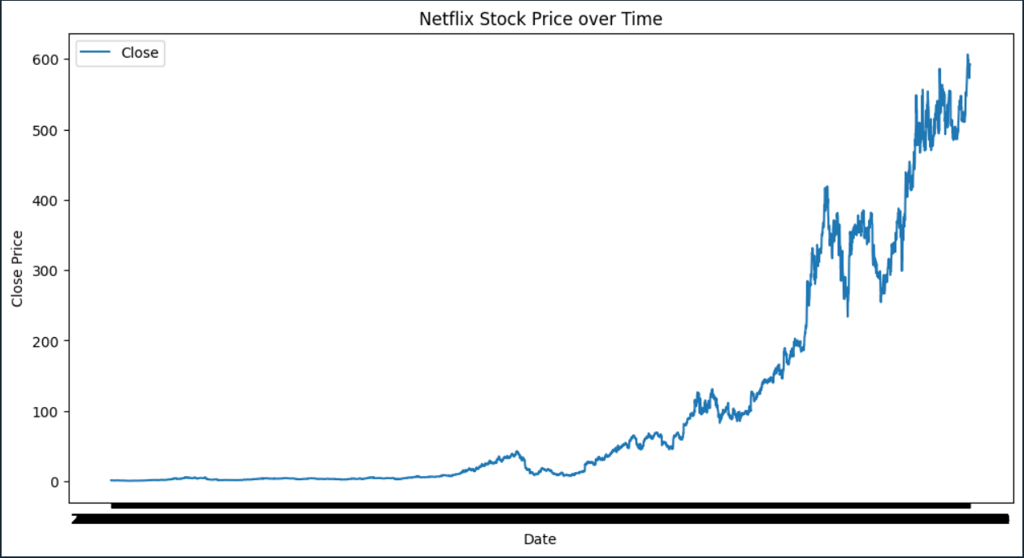

Among the notable market data that can be derived from the analysis of the Netflix stock closing price, there are the following: the historical performance of the company and the actual make-up of the market. The graphic representation brought by the plotting gives us the possibility of looking for trends, wondering about curly points, and discovering whether it is related to a breakthrough in technology on stock price of a certain company. Using the stock price for the long term, we can make a conclusion whether Netflix has been growing throughout, suffered any fallbacks or maybe market has had these big fluctuations that only show volatility. This behavioral pattern is of utmost importance for the investors and analysts to evaluate a market trend and to have well-grounded investment plans accordingly.

Also, the plot enables the viewers to explore the craziness of Netflix's stock price, you can believe it or not, there was a time when the stock price was all about stability and there was a time it was all about turbulence in the market. Volatility comprehending is the core thing which is necessary for investors in deciding to concern their risk management and possible returns. Volatility detection in the market places portfolio management and risk implementation on order for investors to make necessary changes. Conversely the periods of low volatility may form a ground of exploring the tactical investing or strategic hedging. As a result of such analysis, the picture manager makes an indispensable contribution to participants in the stock market when they are dealing with dynamic conditions.

The development of the plot line is also used to highlight technical indicators and other seasonal factors which may also be decisive in the way Netflix's stock price moves. Through using technical analysis tools including moving averages, RSI, or MACD we can amplify our knowledge related to the direction of the market emotions and potential trade orders. Furthermore, the correlation and causation relationships between different economic indicators such as seasonal fluctuations or cyclical movement provide us an opportunity to predict future economic trend based on these historical patterns. The holistic method of stock analysis on Netflix strengthens data-based decision-making by analysts and investors and equips them with the necessary arms to take advantage of opportunities, as well as avoid the pitfalls of the market.

3.Netflix stock volume over time:

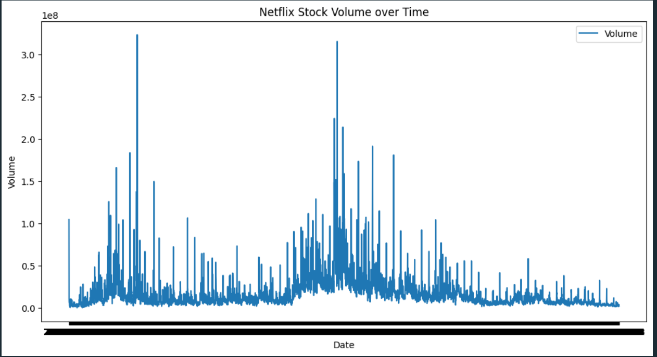

The trend of Netflix shares traded over time may be utilized to discover how much trading activity and sentiment are controlled by the market. Volume Trends:

Plots illustrate the changes that have occurred in the level of trade activity over time as well. Along with the change of volume, the price of an asset moves upwards or downwards respectively, denoting the actual interests of buyers or sellers in the same market. Volume levels are a reliable measure of the intensity of the trend, as the rising volume signals strengthening of the trend and falling volume might be interpreted as weakening trend.

Correlation with Price Movements: Using this data to build a graph that includes data on both volume of trading and the stock price of a stock, it is possible to compare these two period of time and determine when high volume co-exists with price changes. This is the expression of market participants' opinion to a certain extent. This is when it comes to significant events of consumers' agreement or discord. Spike in purchase volume at the time of rise generally implies a tremendous buying pressure. On the other hand, increased trading volume in case of falling prices can be characterised as significant sellers strength, or a bearish signal.

Market Sentiment: Volume peaks may indicate a surge in market sentiment, often caused by news flashes, financial statements, or other events that may affect the faire–mindedness of the investors. Studying the links between price fluctuations and stock market strategies will shed light on how external factors affect the behavior of investors and stock prices.

Liquidity and Volatility: Various shares with many trades usually lead to higher liquidity that let people easily buy or sell stock with minor price reductions. This, in fact, stabilizes the price fluctuations and cut down the risk of price manipulation. In this case, the time frame when the markets may experience a high trading volume often comes with an increased volatility as well - a phenomenon that may be both a rewarding or a risky situation for the traders.

Seasonal and Cyclical Patterns: Any repetitions on the volume will be revealed. These regularity might be on a quarter/year basis or due to the period of renewing products. These rhythms could be caused by the institutions that are involved in the market, say, for example, window dressing or forced selling to meet tax requirements. This number would provide a high teacher for the analysts to follow the change of drivers behind price movements and sense the under or over quality of price trends. It allows creating well-reasoned trading techniques with respect to timestamp entry and exit macrostrategies.

4.Netflix stock price over time:

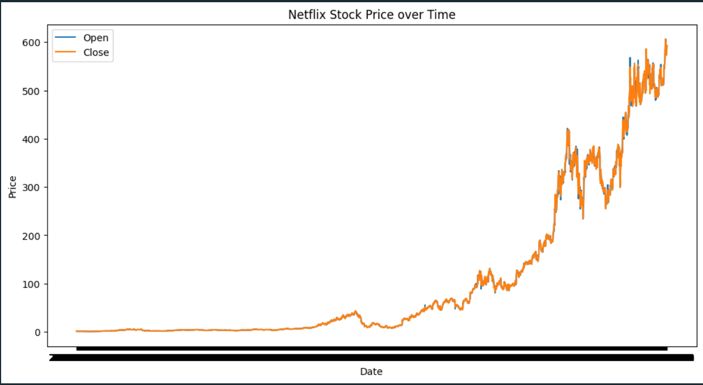

The line chart that depicts a point by point comparison between the opening- and the closing-prices of Netflix stock for a given time duration is what demonstrates the daily price dynamics.

Price Movement Analysis:The x-axis of the plot demonstrates both the high and low daily prices, facilitating a quick assessment of the slides on a daily basis. If the close price is more than the open one, the bullish power is believed to be stronger than the bearish one; otherwise, the opposite could give the evidence of bears. Regular setups that display a big deviation from the opening price to the closing one are a clear sign of trends of such kind as a strong buy pressure or sell pressure.

Trend Identification:Long-term trends data provided by comparing the beginning and the end of trading may be obtained through the analysis this direction. The most positive course is when progression in opening and closing prices is observed. The opposite movement in the pricing can show that the market is in a bearish state. The parallelism, or similarity, of the opening and closing paths of the stock can reveal how unstable and shaky the stock may be. A narrow line means a small change, while the broad bandwidth indicates a potential for a high volatility.

Volatility and Market Behavior:At times of divergence in the opening and closing price, it can show an increase in volatility and it may be caused by market incidents or events that trigger the investment move. By having a bunch of details from this time, the market participants would be faced with an idea that external events can be used for the goal of the price movements of a stock within a single trading day.

Technical Indicators and Trading Strategies:Technical Indicators and Trading Strategies:A trader might utilize this plot to design tactics that match the behavior of the opening and closing prices. Take for instance, the sort of plan can be to acquire stocks today at its expected close higher from historical trends than the previous day. We can improve the graph by including moving averages or other technical signs which would, in addition, add to the dependability of the graph and smooth out daily fluctuations.

Comparative Analysis:Observing the trading pattern on opening and closing activities over different cycles can be regarded as a clue of various occurrences in market activities. Likewise, when more opportunities than usual are presented where the final trading price is much higher than the starting one, that likely means that more investors believe the stock will continue rising. Such scholarship of price levels, sentiment, and market dynamics offers an integrated approach to market analysis, allowing us to see the whole picture of market behavior in every trading day.

5.Netflix stock price with moving averages:

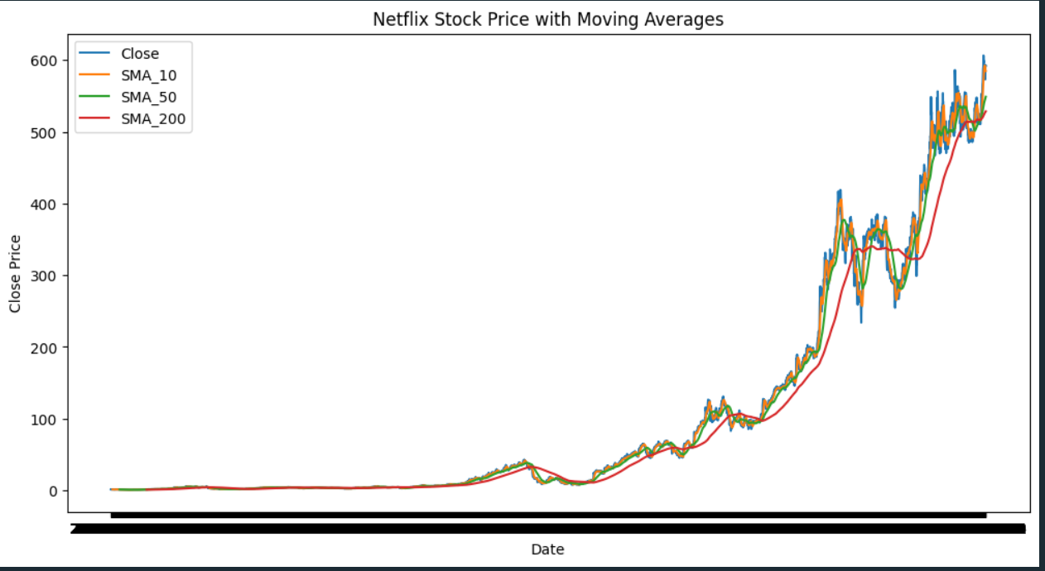

It is the illustration showing Netflix stock closing price along with simple moving averages (SMA) that are 10 days, 50 days and 200 days long and this imagned represents the direction and strength of the trend along the scale of time. Here's a detailed analysis based on the SMA chart:Here's a detailed analysis based on the SMA chart:

Short-term Trends:The 10-day SMA is sensitive to short-term dynamics and provides clues about the recent price trend and its strength. While the given characteristics of the 10 – day SMA help to reveal any surprising market turns.

Medium-term Stability:50-day SMA is a medium-period smooth that minimizes the frequency of highly volatile price data and is more stable than 10-day SMA. It is considered by traders to be a good signal of midterm trending.

Long-term Perspective:200-day SMA show a weekly outlook of stock's movement growth. It is one of the main effects which will enable to investor institutions to assess the market broadly and to estimate its current condition.

Trend Confirmation:When shorter-term moving averages (such as 10-day) cross over those of longer-term SMA's (like 200-day) it could be seen as a positive indicator showing a possibility of a bullish trend. Correspondingly, the opposite situation can be exemplified by mean of a cross of falling below e. g. that could indicate a bearish trend.

Support and Resistance Levels:These SMAs act as running technical support lines or resistance points. However, focusing on the imitation of a swing, the SMAs can play a role of resistance levels which the price makes a lot of effort to break through. When the price pattern starts to trend upward, they might be used as support zones as well, forming a low level under which the price will not go.

Comparative Analysis:The way SMAs react to the closing price gives us an indication whether the market is overbought or oversold. A pullback is often seen if the price of stock slips away from its 200 day SMA, and vice versa.

This SMA analysis plays an essential role in determining the general market trend of Netflix stocks as well as the stock price fluctuation in the future. It helps the decision makers to strategize both the short-term trades and long-term investments.

6.Netflix stock price with exponential moving averages:

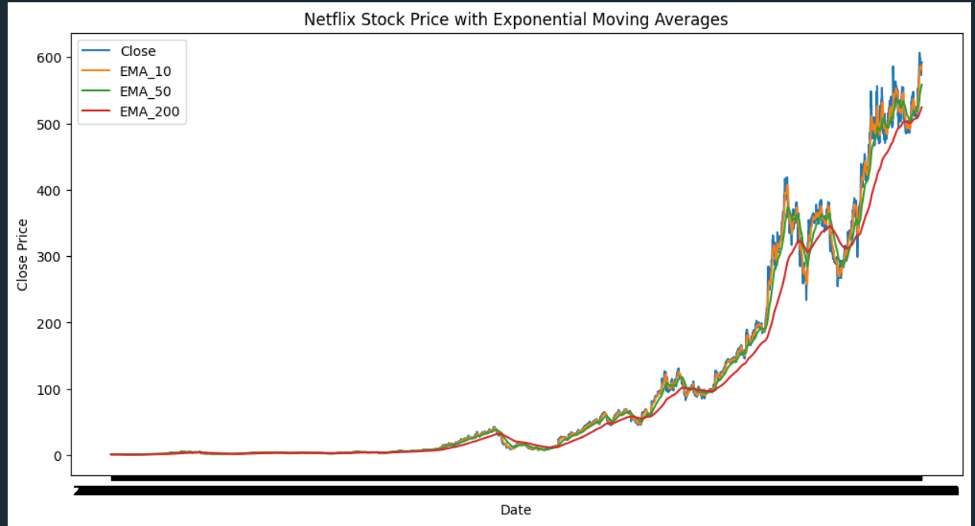

Having represented the Exponential Moving Averages (EMA) lines for Netflix stock according to the 10-day, 50-day, and 200-day EMAs, as well as closing prices. Here's a detailed analysis based on the EMA chart:Here's a detailed analysis based on the EMA chart:

Responsiveness:The memory effect is enhanced by the latest data element getting more weighting in an EMA than SMA. Using this index gives them an edge over human experts in making observations of the subtle details that indicate changes more quickly.

Trend Identification:

Short-term Trends: The 10-day EMA records short-term price fluctuations and responds to recent price changes. It indicates short-term prices more adequately than the longer-term moving averages. Picture-perfect movements in the 10-day EMA/ SMA can signal the short-term tendencies in the bulls / bears. Medium-term Trends: The 50-day EMA, which is a medium-term moving average, is useful for medium-term trend direction, and personal outlooks can be drawn. Long-term Trends: The 200-day EMA is a long-term tool for spotting the general market trend and is frequently used by institutional investors for reading the market.

Trading Signals:

Bullish Signals: Drawing a crossing line of a shorter EMA (such as the 10-day one) above a longer EMA (eg. 50-day or 200-day) forms a pattern that facilitates entry into a long position, an auspicious time for making a bullish trade. Bearish Signals: In the opposite way, the EMA curves of the shorter period below the combined EMA of the longer periods confirm the downward trend as a selling signal of the security.

Support and Resistance:EMAs can be seen as the areas of technical analysis which have a dual purpose - to be the levels of support and resistance. Also, the EMAs can be used for support levels during uptrends. They can be useful in a situation when the price can find its floor and bounce back. In recession, they can function as resistance lines.

Create your own journey to success with AI-powered writing tools. Whether you need a professional-looking essay, a gripping marketing copy, or a compelling script, AI writing tools can save you time and effort, enabling you to focus on your creative ideas. With advanced AI text generators, customizable templates, and efficient proofreading and editing options, you can streamline your

Price-EMA Relationship:

The higher price over the long-term SMAs, on the other hand, reveals that the asset is in the bullish mode. Leading to that, if the price is below the level, it indicates a bearish phase. The distance between current pice and the indicators of your EMAs might also reflects the supportive trend. The spreading of the gap may show the strong trend, while a convergence may indicate the dropping of trends and even reversal.

Comparative Analysis:

Longer-term EMAs exposure can be informative about the market atmosphere and momentum, while shorter-term ones focus more on immediate price changes. Likewise, again, as all of the EMAs are above the price and all trending upwards, this signifies solid bullish sentiment.

This thorough EMA study gives traders and investors years wide view of Netflix stock price movements, making decisions regarding entry and exits on a trendy market, or a reversal market, on the basis of EMA rules.

**Analysis of Daily Percentage Change in Netflix's Stock Price:**

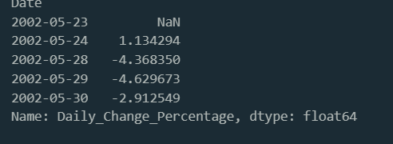

The purpose of the Netflix stock price analysis on a daily basis is to get an understanding of the short-term volatility it exhibits on price change and its possible trends. Thus, the closing price exchange rate is calculated to determine whether the stock has had an increase or decrease in market value on a daily basis. The process consists in ranking the data monthly and determining the daily changes by means of a classical method. First of all, the stock under analysis seems to be governed by significant shifts in stock price on some trading days as seen on the fluctuations in the percentage change. These amplitudes will likely be affected by the supply of information from the market, the public belief, and the economic conditions in general.

These findings reveal that the stock price of Netflix is made up of a narrow range of variances on a daily basis that change with the flow of stock as a dynamic entity. The stock in question shows both strains and gains in the changing percentage of its daily rate, which illustrates the rapid changes in investors' sentiment and the market velocity. While traders and investors are seeking options to stimulate with fluctuations in short-term trends, they need to keep in mind that there are also risks addressing such issues. Further analysis needs to trace causes of day-to-day volatile movements by relating them to specific events (news releases) to see whether there is any evident pattern that controls the movement of a stock being examined.

7.Netflix stock daily change percentage:

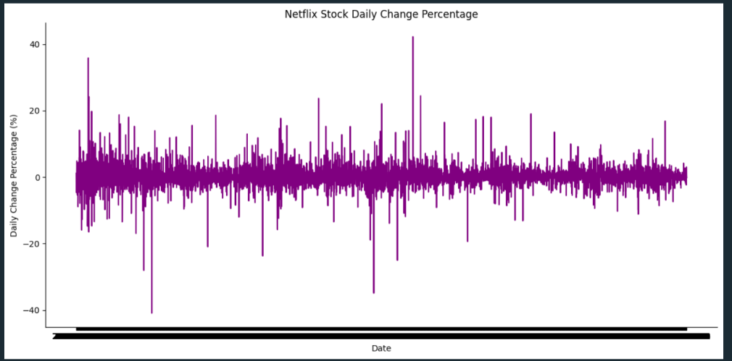

The goal of this visualization is to graphically display the percent changes of Netflix's stock price per day, thus helps viewers visually understand how the stock price has fluctuated during a given period.

Visualization DetailsTool Used: The visualization was created utilizing the Seaborn library, which is a beneficial Python data visualization tool that user-friendly and sequences the process of development while spreading the code with matplotlib output by producing attractive and informative statistical graphs.

Plot Description:

A line plot was created to show the percentage changes per day for each movement, with each point on the line plotted representing the percentage change against the preceding trading day. The plot is outlined in lilac to ensure better visual distinctness and ease of comprehension.

Plot enhancement was done visually through removing top and right spine using Seaborn’s despine() function as it is useful in reducing the visual noise and placing the focus on data only. The size was adjusted as inline by calling plt. tight_layout, where all the plot element are placed within the figure area.

Observations from the Plot: The line graph demonstrates points that depict the daily percentage gains as well as the losses, making it possible to identify those days with the greatest drops and gains. Noteable spikes are seen when the line goes up and creates peaks and also when the line goes down and creates troughs – indicating and suggesting the most active market days for transactions and in response to external events.

Conclusion: This visualisation helps differentiate the moderate, odd and daily fluctuation of the stock and allows the investors and analysts to get the necessary insights at a glance. All these factors can greatly help with conveniently coming up to a decision on a buy, hold or sell an option based on patterns of prices fluctuation.

8.Histogram Analysis of Daily Percentage Changes in Netflix's Stock Price

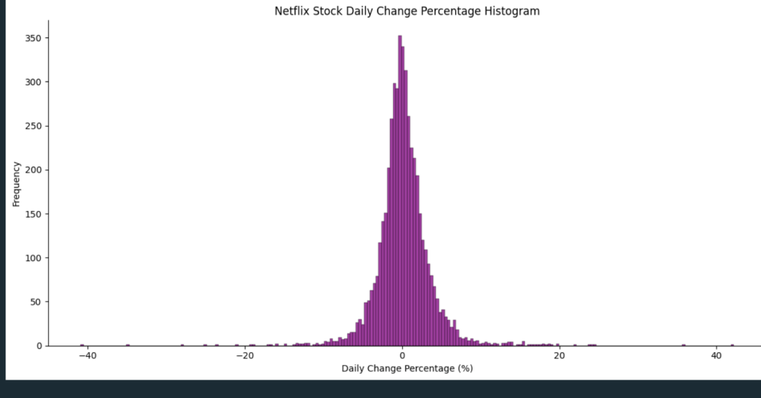

A DCF analysis of the stock's daily percentage changes on Netflix’s share stock reveals fundamental patterns in its volatility levels which include both the highs (350 Frequency) and lows. In the rectangle area on the right side, the bars stretch wider and get higher, meaning those kinds of days with a large increase in price occurred frequently. It is frequently the case that these highs go hand in hand with positive market developments like impressive earnings posts or the announcement of the company’s achievements. Contrary to that, moreover, the bearish side of histogram captures bin segments corresponding to days of the tiny downside, the decrease of the share price or the appearance of the pessimistic mood in the market.

The comprehending of these wave length elements is really essential for the trades as well as the investment. First, it helps investors in risk management, which brings about a situation where investors are able to plan their entry and exit points as well as set stop-loss orders basing on changes in the range of daily movements. The output is what follows. In addition, it helps with shaping investment strategies, as investors can decide on suitable approaches either to leverage on the volatility or for stability but depending on risk tolerance and objectives. These extremes also help to gain insights into market participants' behavior by predicting the possible uncertain reactions of them in stressed conditions or to extreme situations.

Moreover, relative stability of Netflix's stock is also assessed against that of other stocks or indices evidenced by the comparative analysis, hence offering a better diversification for a portfolio. At last, time series of historical volatility can sometimes give a preliminary look for what happens next, let’s say, that you have low volatility periods before a high volatility phase. Fundamentally, decoding the changing rattles of Netflix’s stock histogram must be acted upon for wise decision making in trading, investing, and analyse the working of market players, which is a boon, as this will offer various emission on the horizon of the stock market.

9.

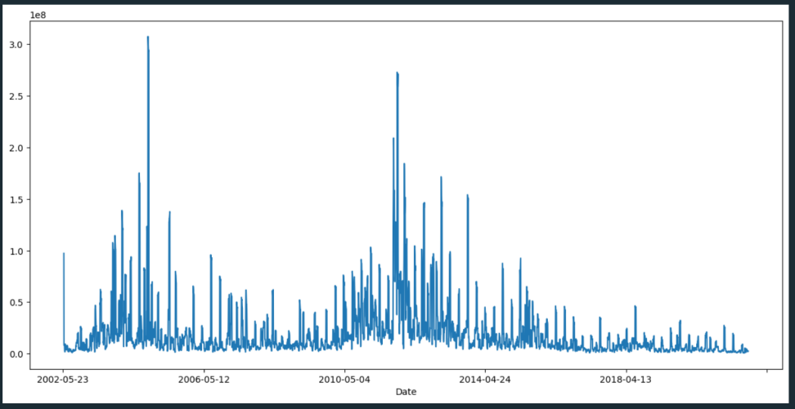

The in-depth EDA on the 7-day rolling average of stock volumes in Netflix reveals the nature of the changes in the trend across time. A line plot projected in a way to show the peaks and troughs quite expressively to represent times of higher trading volumes and the low trading activity. These swings can be affected by external drivers even being the case of stock market or a specific news regarding the Netflix, from which the possibility of some kind of the market mood coming to the fore and the news, which might have an effect on a trading volume can be discussed. Furthermore, the analysis would delve into the possible seasonal effects of the volume volatility such as the heightened activity during certain months or quarters in view of the fact that Netflix normally releases it products or announces quarterly earnings around such periods.

The statistical content presented, including the calculation of mean and median volatility and the identification of outliers, in addition clarifies and adds more to the meaning of most typical trading volume switches and exceptional trading days. Through this analysis investors and traders are able to take place risk assessment which helps them in knowing the level of risk ,such as volatility associated with trading Netflix’s stock. Furthermore, the EDA shall be used to inform the strategic trades, in such way that an analyst will build the right entry and exit strategy for a trader based on the observed trends. Moreover, comparison of the stock prices or indices with other companies or markets might be helpful in assessing Netflix's relative stability or riskiness within the market. So it creates valuable insight for those who are involved in portfolio management or risk mitigation strategies. Essentially, the EDA demonstrates here as a base for decision making by the stakeholders due to visualization of past trade quantity and their consequences on future trades.

窗体顶端

窗体底端

10.Netflix Stock price with moving averages

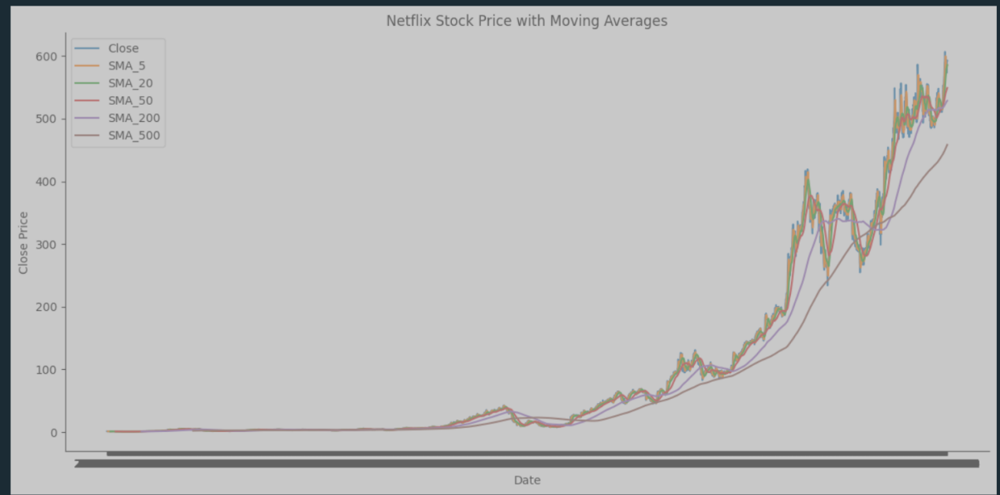

The complex and detailed exploratory data analysis (EDA) based on multiple Simple Moving Averages (SMAs) of Netflix stock on different time frames provides impressive findings about the movement trends and forces of the stock. The diagram succinctly illustrates the process of individual movements' impact on the main trend line and vice versa, thus empowering traders and analysts with deeper insight into the stock's performance.

Through plots observations, SMAs display differences in plots they capture, both in the price dynamics of different components of Netflix's shareholders. SMAs, with short-term horizons are the models that the 5-day SMA belongs to, and they constantly adjust to daily price movements by showing high volatility. In comparison to SMAs for periods of shorter duration, such as the 200 days and 500 days, they provide more comprehensive data on the long-term trend and the state of a security price that holds well over a longer time period.

In addition, statistic methods analysis can be applied for more than just trend identification, being a potential barrier or target levels as well which may to the derivation of some trading strategies. Investors can determine that a stock has risen or fallen enough to justify making a buy or sell decision by observing crossovers between short-term and long-term fast moving average values, putting them in a better position to actively trade the stock market. Generally speaking, the EDA is a valuable platform for the authorities so that they have proper suggestions based on the mating of the short-term volatility and long-term trends that, in turn, will result in more effective business investments and less likely to face the loss in overall terms.

1. Daily changes percentage categories

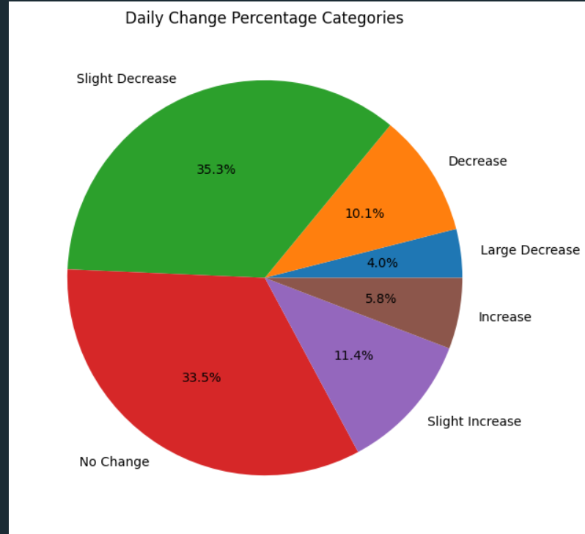

This report on the distribution of Netflix stock into categories targeting daily price fluctuations describes in detail the number of times the price goes high or low with references to subjective tendencies as well as objective facts which are beneficial both for investors and professional traders.

The pie chart is employed to depict the distribution of changes amounting to around 2% in predefined intervals based on the percentages of daily price movements over the period of observation These figures help elaborate those slight reductions and no change account for the dominant part, implying the stock value is typically steady on most days. In contrast to that, the sharp prices cut down and rise up are less frequent which shows that the serious adjustments in stock prices are a rare phenomenon. Such results not only have critical importance for investor psychology improvement but also serve as a basis for volatility assessments and strategic decision-making.

Understanding the variety of price changes which significantly impact the conviction of market participants and rate of volatility is crucial in formulating investment strategies that are capable of withstanding shocks. Overall, this report gives an impartial and unambiguous explanation to navigate the stock market, which enhances stakeholders’ ability to choose wisely and make a profit.

1. Daily change percentage categories:

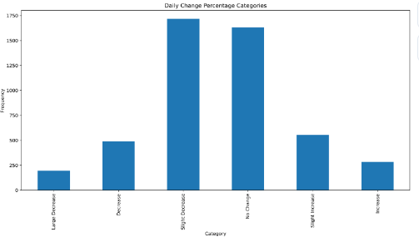

The bar chart examining the daily price change percent categories of a Netflix stock price provides quite many conclusions to investors and analysts on the issue of the market's stability and level of risk. The visualization calls attention to the fact that the areas with small declines and unchanged situations represent the biggest category, which means there is not much fluctuation in the market and the changes are not too big.

In addition, high frequency of employment for moderate rises or falls suggests that investors might not react strongly to daily market news or events or it could mean that investors rely on forecasting mechanisms and stability of investors’ expectations at the market level. This specific rate is one of the main assessment parameters, especially for risk-averse investors who may find the infrequency of large changes as good, believing that there is less volatility as its compared to other stocks.

Summing up, the bar chart furnishes a good basis for working out the distribution of daily variations in stock value of Netflix and is hence useful for stakeholders to make knowledgeable choices according to the trends in historical data. The platform enables investors to have a more comprehensive understanding of market dynamics and, thus, to trade and manage investment portfolios more aptly.

**Analysis of the Augmented Dickey-Fuller Test :**

Analysing the Augmented Dickey-Fuller (ADF) test, Netflix’s closing prices data turns out to be significant in depicting whether the data is stationary or not. The ADF‘s computed statistic of 2. 6384 and the corresponding p-value of <0. 0001 calls for the rejection of the null hypothesis, implying that the stock prices are non-stationary. This therefore calls for trends in the data, thus, the possibility of manipulating behavior of positions or positions by the data. These deep knowledge can be useful to financial analysts and investors because non-stationarity causes model and forecasts diseases by making them invalid and thus the analysts cannot be accurate when they are predicting and making investment decisions.

Accounting for non-stationarity of data is a matter of principle for financial analysis and prognoses accuracy assessment. Tools like difference and transforming may help to deal with the tendency and make our data stationary. Through the realization of autoregressive characteristic of the time-series models, analyst can use appropriate modeling techniques for which these models are known, producing more accurate and reliable financial analysis. The knowledge of temporal relationships of the data forms the basis for the direction of legitimate investment strategies and dominant decisions within the industry of stock market data.

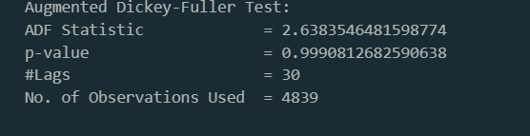

**Transformation through Differencing and Stationarity Evaluation:**

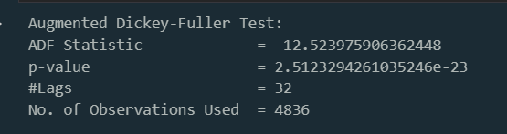

Stationarity of Netflix closing stock prices was aimed with differencing, one of the popular techniques involving the calculation of the current observation after subtracting the previous one. Intendedly, the altered data was next placed to the Augmented Dickey- Fuller (ADF) test for examining stationarity.

Following the calculations with the ADF test there was an ADF statistic of -12. 5240 and a p-value which was extremely minimal (about 0) that signaled the disapproval of the null hypothesis and thus stationarity was confirmed. Through transformation the data has become more fitted with models that apply time series methods like ARIMA. Reaching the stationarity state is of great importance for reliable financial forecasting and data modeling, allowing sound understanding or decision-making regarding the collected data.

**Analysis of Autocorrelation and Partial Autocorrelation for Netflix Stock Closing Prices:**

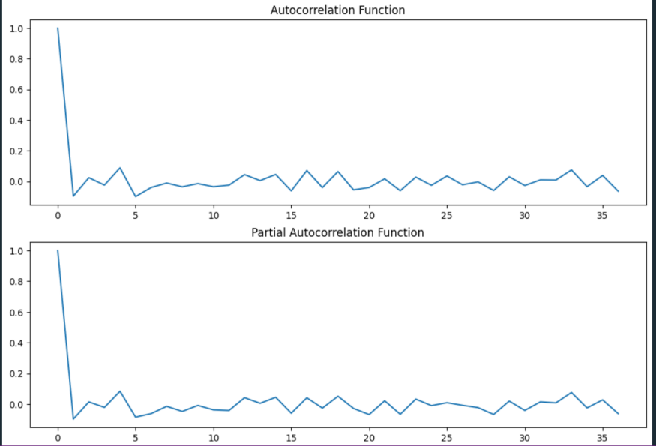

The study is designed to analyze the lagging effects of autocorelation and partial autocorrelation for the previous prices of the Netflix stock declining. Autocorrelation Function (ACF) and Partial Autocorrelation Function (PACF) were used to model the correlation or dependendcy between the observations of the time series at different time lags.

The ACF was shown to decline in a sharp manner after the first lag term and gradually came down. This confirmed a powerful correlation at the first lag term and a feature tapering off with the subsequent lags. That implies a short-term memory process, where the actual levels have no meaningful bearing as the period lengthens. However, opposite to the ACF plot, the PACF plot made a remarkable jump at the lag of one where the plot finally levels off to nearly zero. This type of the structure commonly led to the desirable autoregressive model of order 1 (AR(1)), meaning that in most cases the variable changes in the current interval are mainly under the impact of the ones right before them.

The research gives interesting information about the structure of time-dependent button closing values for Netflix Stock. There is high autocorrelation at the first lag and the sharp drop off on the PACF (Partial autocorrelation function) implies that AR (1) model could be used to model time series. The revelation of such ties bring benefit for creating precise prognoses and making the proper choice in the financial analysis and forecasting process.

**SARIMAX Model Results for Netflix Stock Closing Prices:**

The SARIMAX model with (5, 1,1) was estimated for the Xmine stock closing prices dataset. The model comprises of SARIMA and exogeneous variable components that include the seasonal autoregressive component and the moving term. The maximum likelihood was used to obtained the parameter estimates, and our model was fitted by comparing log likelihood to the AIC, BIC, and HQIC.

SARIMAX model furnished -14293. 653 log likelihood and AIC of 28603. 306 , implying the model fit for our data was quite a good one. The model parameters estimated, represented by signs of < 0. 05 were statistically significant. In particular, the autoregressive indicators of terms (ar. L1 to ar. L5) and the moving average the factor (ma. L1) had noticeable effects on the Netflix stock closing prices. Besides that, the effect of the intercept term was also found to be statistically significant; therefore, the differenced series can be considered having a non-zero mean. Here, Ljung-Box test statistic for the first lag LB = 2. 25, at a level of significance α = 0, and this suggests that the model was suited for the data since it successfully captured the temporal patterns.

The SARIMAX(5, 1, 1) model provides a strong basis for the analysis of the data of Netflix stock closing prices featuring both AR (autoregressive) and MA (moving average) components. The model having statistical significant parameters of the model indicates that this model created to capture the inherent of stock prices well. This model can also be in the forecasting of future stock prices, risk management processes and portfolio strategies optimization, thus can be mostly used by investors and analysts, in helping them make their decisions.

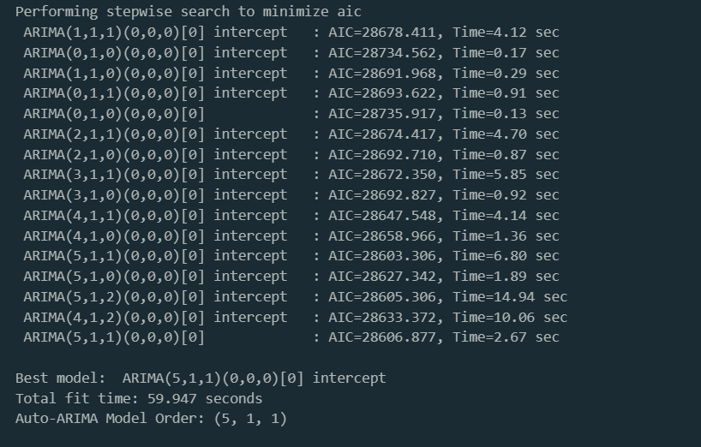

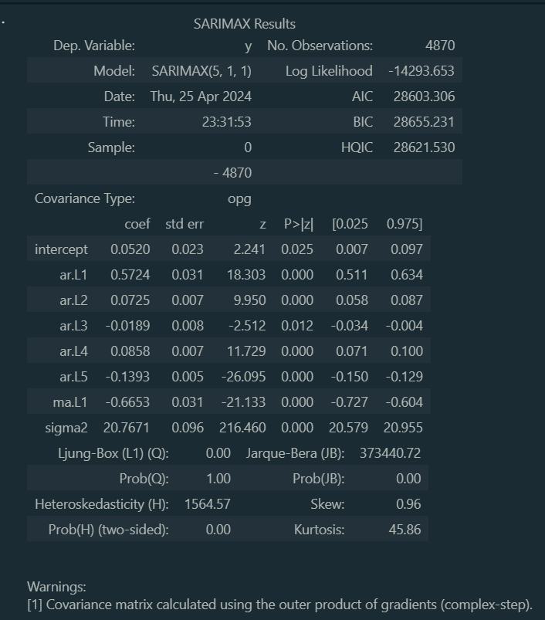

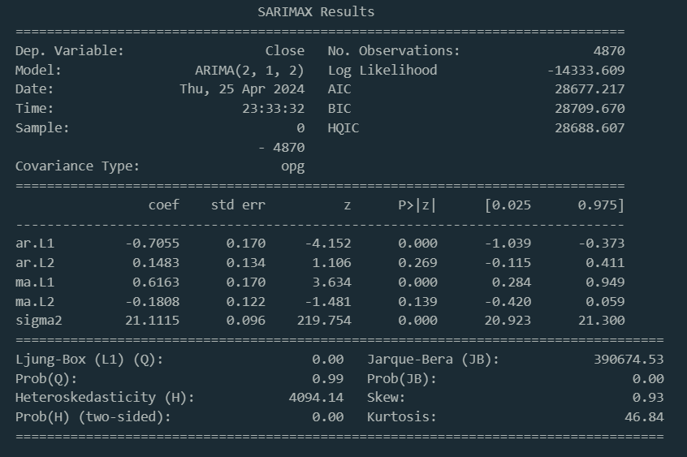

ARIMA Model Forecast for Netflix Stock Closing Prices:ARIMA Model Forecast for Netflix Stock Closing Prices:

The objective of the ARIMA(2,1,2) model fitted for historical closing prices of Netflix stock, earlier, was to investigate the direction of prices over a short time period of 10 days. The projected values were then graphically displayed juxtaposed with the real historical data to showcase possible movements in future price.

Forecasting and Visualization:Forecast Horizon: 10 daysModel Used: ARIMA(2,1,2)

Forecasting: ARIMA model was used to forecast the prices, for the next 10 days, using the historical data and the material’s parameters. Visualization: The creation of a graph was prescribed which to compare the actual historical closing prices and forecasted values. The data which were actual was evinced in blue color, but the forecasted data was indicated by orange color.

Plot Description:Tthe plot will display prices that are closing and predicted for a next 10 days. The forecasted ones shall act as a continuation by extending the preceding known data points so as an allowance for a compare and contrast of the actual and anticipated ones.

Because of ARIMA(2,1,2) model the long-run and short-run forecast of the fluctuations of Netflix stock prices can be drawn with a clear picture. By providing a visual representation of predicted price movements, this illustration becomes a crucial instrument in terms of viewing the possible future price trends and helping investors and analysts to make more informed decisions. The prediction of the model provides the stakeholders with an opportunity to engage in strategic financial planning, find and conduct risk assessments and spends a time for detailed investment analyses, and thus reinforce their decision-making processes.

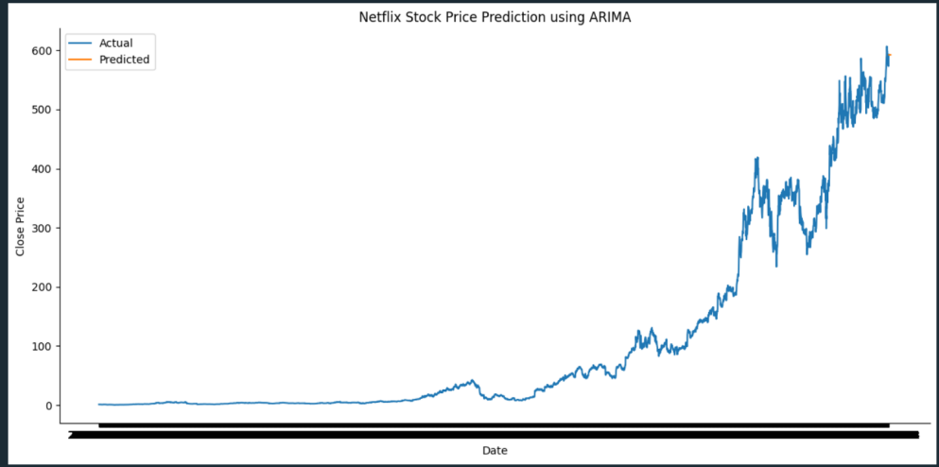

**Extended Forecast of Netflix Stock Closing Prices Using ARIMA Model:**

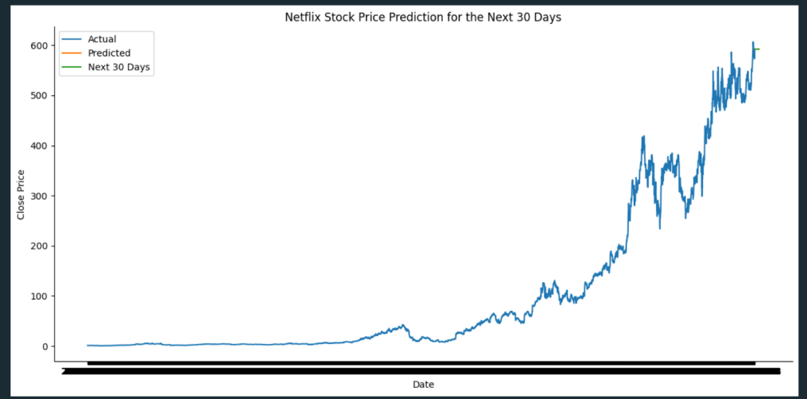

the study purpose was to extend closing prices forecasting for Netflix stock after the ARIMA(2,1,2) model is used, which would allow the researchers to estimate stock trends for the following 30 days. The process that was implemented was the one of the forecasted given the yesterday closing values for the used parameters and plotting these predictions with the actual historical closing prices. The projected a scenario of the future and the prospects of price movement over the next month. This helped informed investment decisions, effective risk management and investment planning. The plot charted the historical data along with a forecast of closing price in the future, in which the forecast was extended and graphically highlighted in green beyond the initial 10-day forecast in orange. Via this picture, we could easily identify anticipated tendencies and market conditions, allowing the majority to control comfortably their future life and success in changing market conditions.

**ARIMA(2,1,2) Model 30-Day Forecast:**

The ARIMA(2,1,2) model gives a 30-day look ahead at Netflix stock's end prices, showing a steady rate of 592.0 all through. With a 95% sure range, this forecast helps money experts and investors make smart choices about where to put their money. This steady price guess points to a calm time for Netflix's stock, meaning the market might be less up-and-down for a while. Even though the forecast doesn't change day-to-day, it still helps people watching the market decide how to change their money plans to fit.

**Conclusion:**