CMPS 240 – Sprint 2

**Team:** *Cachers*

**Members:** *Abdul Rahman Kobeissi*

*Stephane Najjar*

*Yara Khalifeh*

**LINK TO GITHUB REPOSITORY:**

<https://github.com/yrk04/CMPS240-xv6-project>

***OBJECTIVE****:*

Implement the following features in the xv6 operating system:

* A login screen, which prompts the user for their username and password before being able to use the terminal. The machine is shutdown after 3 failed login attempts.
* A touch command that creates an empty file if it does not exist.

***MODIFICATIONS****:*

| FILES | CHANGES FOR LOGIN SCREEN | CHANGES FOR TOUCH COMMAND |
| --- | --- | --- |
| Makefile | Added _shutdown to UPROGS | Added _touch to UPROGS |
| init.c | Added login method, which prompts users for username & password. After 3 failed attempts, the VM is shut down. Username and password are hardcoded in init.c |  |
| shutdown.c | Calls shutdown sys call |  |
| touch.c |  | Created a new user program. Iterates over file arguments and uses open() with O_CREATE() to create files if they don’t exist. Does nothing if the file already exists. |
| syscall.c | * Incremented the number of sys calls for compatibility with syscallcount and resetcallcount. * Added declaration for sys_shutdown * added sys_shutdown to syscalls array |  |
| syscall.h | Added #define SYS_shutdown 24 which assigns a syscall ID to shutdown |  |
| sysproc.c | Implemented shutdown sys call, which sends shutdown signal to qemu virtual I/O |  |
| user.h | Added ‘int shutdown(void)’ prototype |  |
| usys.S | Added SYSCALL(shutdown) |  |

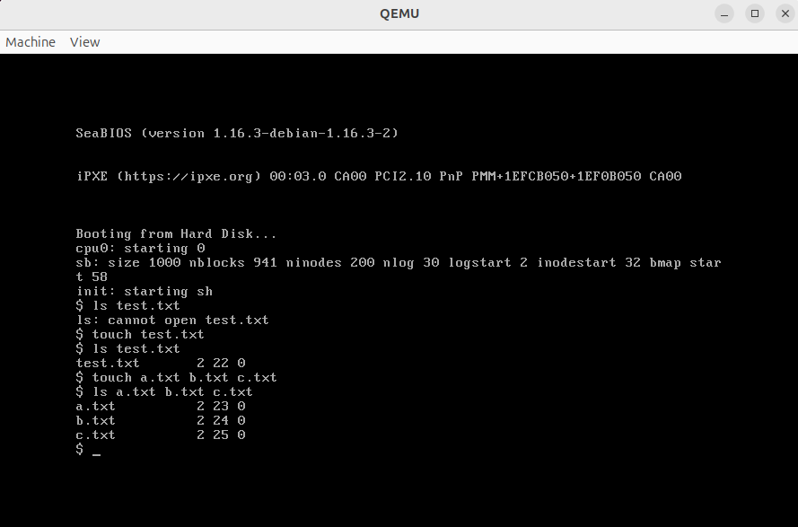

*This screenshot demonstrates the functionality of the newly added touch command. Initially, running “ls test.txt” results in an error because the file doesn’t exist. After executing “touch test.txt”, the file is successfully created. Running ls again confirms the file now exists. This behavior shows that touch works as expected by creating empty files when they do not already exist.*

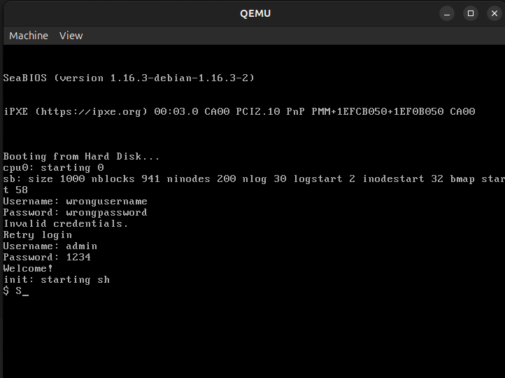

*Example of a login procedure. Upon failing to input the correct credentials, the user is prompted to try again at most twice, after which the VM will be shutdown via a new system call, shutdown. Once the correct credentials have been input, the user is met with a “Welcome!” message, and is granted access to the shell.*