----------------------------------------------------------------------
Report of Referee A -- LV18279/Rouzaire
----------------------------------------------------------------------

The authors found that a topological phase transition similar to the BKT transition occurs in the two-dimensional heterogeneous moving phase oscillators. It is interesting that the active motion generates quasi-long-range order. I think that the paper is worth publishing in Physical Review Letters. However, I have a few comments for revision.

1. Page 1, right column, line 7: Is "first order phase transition" correct? Isn't the phase transition second order?
The referee is absolutely right, the transition for a Kuramoto model with a Gaussian distribution of frequencies is second order, not first order. We apologize for this mistake and thank the referee for pointing it out.

2. Page 2, left column, the second line from bottom: What is \gamma?
We added “, where \gamma is the damping coefficient of Equation (1)” so the readers don’t have to come back to page 1.

3. The magnitude of the system size L is not written.
We indeed work in terms of the free parameters N (number of agents) and the density rho, which sets the linear size of the system L = sqrt(N/rho). We have added a note after “The Model” to clarify this point.

4. Page 4, right column, lines 2 and 3: What are "a +1" and "a -1" ? I could not understand the initial condition well. Could you explain it more in detail.
By +1 and -1 defects, we were referring to defects of topological charge +1 and -1. We have added this precision, as well as a reference to the Supplementary Material (SM), where we detail and illustrate this controlled initial condition composed of a pair of oppositely charged defects.
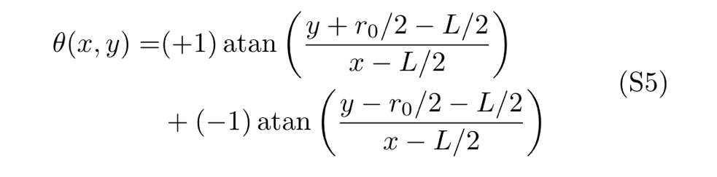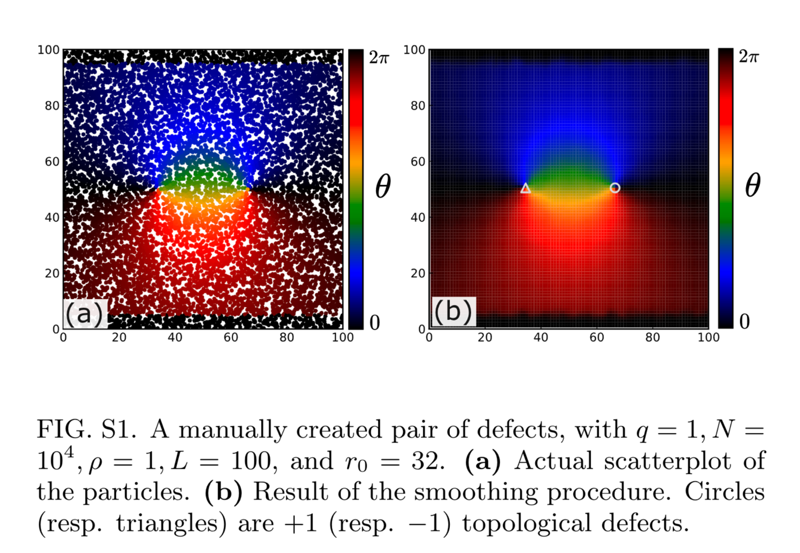

5. The numerical simulation is done at T=0.1. Is the same result obtained at T=0? The case of T=0 is closer to the original two-dimensional Kuramoto model. Isn't the effect of noise essential for the BKT transition?

That’s an interesting question, to which the short answer is that the results would be qualitatively similar for T=0.
We agree that case T=0 is indeed closer to the original two-dimensional Kuramoto model. Yet, throughout this work, we fix the temperature to a small but nonzero value T=0.1 . This choice was motivated by “historical” reasons. In our previous works on topological defects in a Kuramoto model (with immobile spins living on a square lattice), we concluded that the defects in the specific case T=0 behave rather differently. They very often end up trapped in some regions of space, or run endlessly on the contours of a domain. We initially wanted to avoid such singular behaviour in the present work.

However, in contrast with the immobile lattice case where the 4 neighbours of a given spin i remain the same over time, here, a spin’s neighbourhood is highly dynamic, even at T=0. This implies that the phases \theta_j with which i interacts change over time, effectively mimicking a sort of thermal noise for the rotational degrees of freedom.
Concretely, the results remain very similar for T=0.
Figure 3a of the main paper, augmented with the solid lines, for T=0.
NOTE : I have launched simulations to reproduce Figure 2 for T=0, just in case. Estimated time of arrival : Thursday 31/11.

6. How are the positions and number of topological defects calculated in this model. The topological defect can be counted by going around each unit square in the square lattice, but the positions of oscillators change in time in this model and seem to be random. Could you explain the calculation method in the paper?

The position of the oscillators in this model are indeed dynamic and live in a continuous space (but are not random), which makes the identification of defects a bit trickier than in the regular lattice case. We explain the smoothing procedure for visualisation and defect tracking in the SM and now refer to it in the main text when we first mention topological defects in our specific context.
In a nutshell, to identify defects, we coarse-grain the phase field so that each point in an auxiliary square grid is assigned a value. We then apply the standard procedure you explained to obtain the charge and position of the defects.

----------------------------------------------------------------------
Report of Referee B -- LV18279/Rouzaire
----------------------------------------------------------------------

The manuscript presents mainly a numerical analysis of interacting heterogeneous phase oscillators (planar spins) that freely and independently move persistently with constant speed in 2D (no particle-particle interactions of the kinematic degrees of freedom is considered), “flying planar spins”. The effects of this specific pattern of motion on the collective properties of the orientational degrees of freedom of the spins are studied.

Authors motivates its study mainly on elucidating a connection between the well-known XY model and Kuramoto model, and they mention, poorly in passing, a possible application in developmental biology (which needs a brief thorough explanation), however, conclusions focus only on the bridge between XY and Kuramoto model. This gave me the feeling of laziness on writing this part, in that no effort of finding a true motivation, other than the mere academic interest, for this analysis.

It is clear that the results are dependent, to some extent, on the Gaussian distribution of the individual frequencies \omega_i, one can imagine that for broader distributions QLRO is no longer stable. Please include a thorough comment on this point.

Additionally, in the limit of infinite persistence (ballistic motion), only the speed of the particle play a relevant role in the phase dynamics (and \sigma the other parameter), since even for low density systems, if the self-propulsion speed is high enough, would allow the spins to orientate among themselves leading to QLRO. In the case of high density systems such orientation among spins is anticipated to occur, even if persistence is finite (run-and-tumble particles, active Brownian particles, etc., which transit from ballistic to diffusive motion). This observation elucidate the interdependent role of the system density and the transport parameters of the pattern of motion. A thorough analysis of this point, I believe would be of interest for the community of active matter. Moreover, introducing steric interactions among particles would likely lead to MIPS, which would significantly alter the authors’ conclusions.
NOTE:
I don’t understand their point. They focus entirely on the velocity, saying that motility is expected to enhance order, which is true. We have written “For identical phase oscillators, such that ωi = ω0, spatial diffusion promotes the emergence of order in finite systems [16, 18, 19]”. But in my opinion, they have missed the true novelty of our work, which is that the sigma does not seem to perturb the phase field, leading to SRO…

I don’t understand this sentence : “This observation elucidate the interdependent role of the system density and the transport parameters of the pattern of motion.”
I agree on their comment on MIPS, but this has been studied already.

The authors should expand their list of references to include relevant works published since at least 2014.

Overall, while the writing is acceptable and the manuscript has its merits, may be worthy for publication, I consider that the analysis does not have the impact required for publication in Physical Review Letters. The model is interesting in itself and has the potential of giving rise to further research, however I consider that the current analysis lacks sufficient depth. Thus, in my opinion, the manuscript is not suitable for publication in its present form.

Some other points:
– Tick labels in Figs. 1(b)-1(e) are too small.
NOTE: do you mind if I simply remove the ticks and just add that L=100 in the caption ? We don’t show anything quantitative here, so the ticks don’t add any information.

– In the paragraph Ordering in finite systems the authors refer to Fig. 1B-e but the quantity theta in the vertical axis have not been defined.
We now state that \theta is the phase of the oscillators in the coarse-grained version of the field.
– There some typos for instance QRLO in page (4) should be QLRO.

