Jenkins and GITHUB
Java Source Code
public class StudentInfo
{
public static void main(String[] args)
{
System.out.println("Student Name: Dinesh Raj N");
System.out.println("Register Number: 23MIC0051");
System.out.println("Message: Jenkins GitHub Integration Successful");
}
}
Output
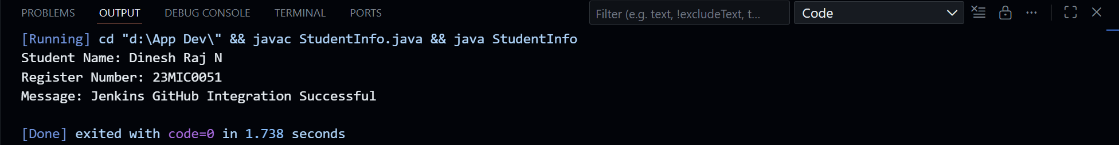
Github Repository Link
https://github.com/InfiKnight-TGP/DA-1-23MIC0051
Jenkins
Step 1 – Create Job
- Open Jenkins
- Click New Item
- Select Freestyle Project
- Name it: DA1_23MIC0051
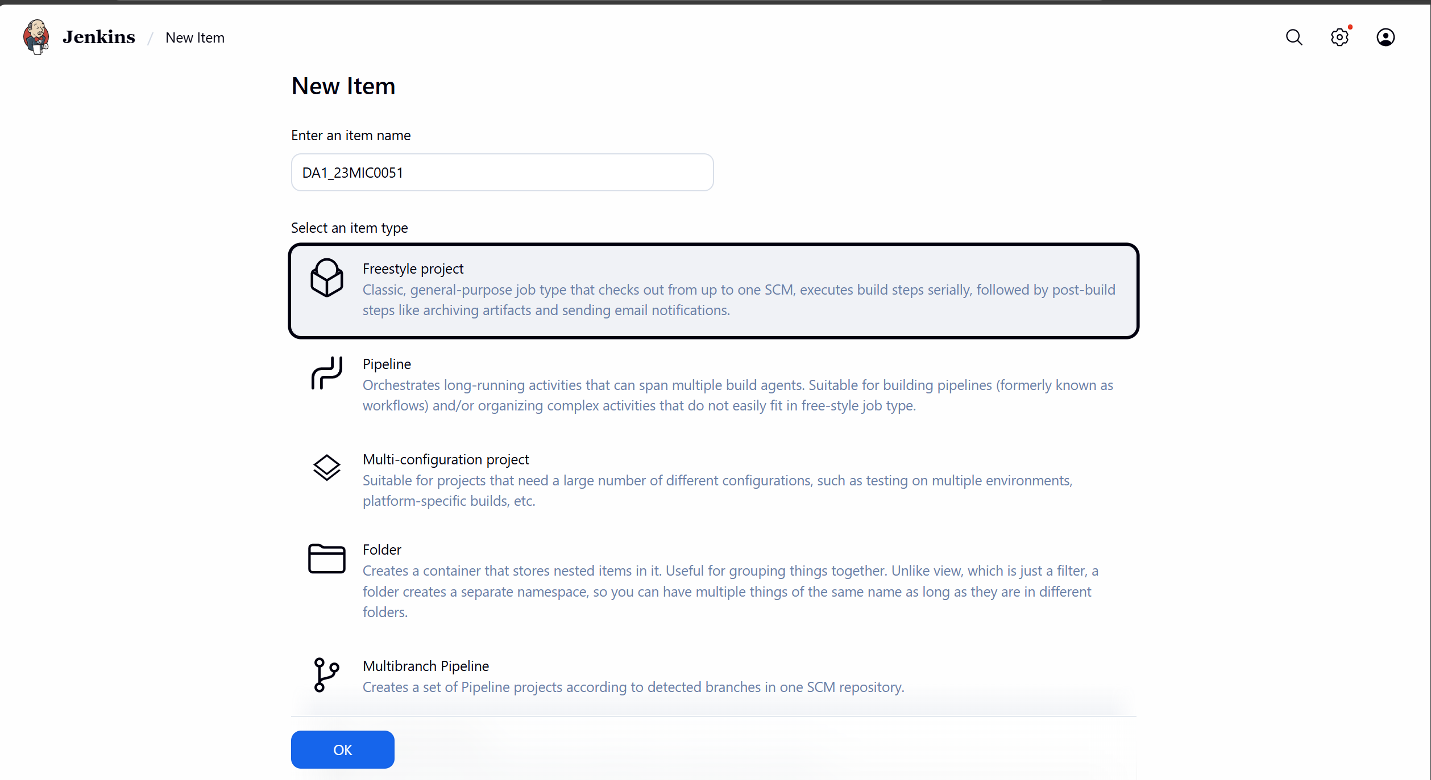
Step 2 – Connect GitHub
In Source Code Management:
- Select Git
- Paste GitHub repository URL

Step 3 – Add Build Steps
In Build → Execute Windows Batch Command:
javac StudentInfo.java
java StudentInfo
This compiles and runs the Java program automatically.
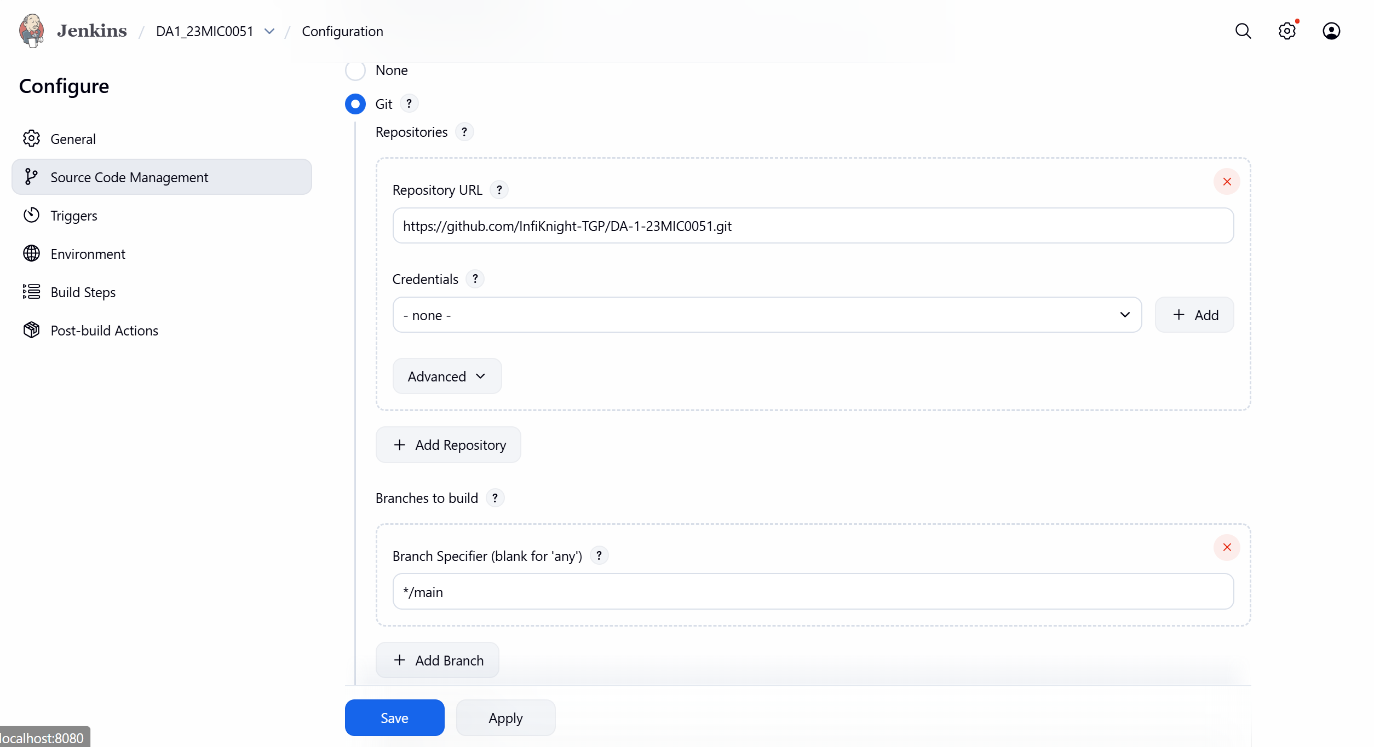
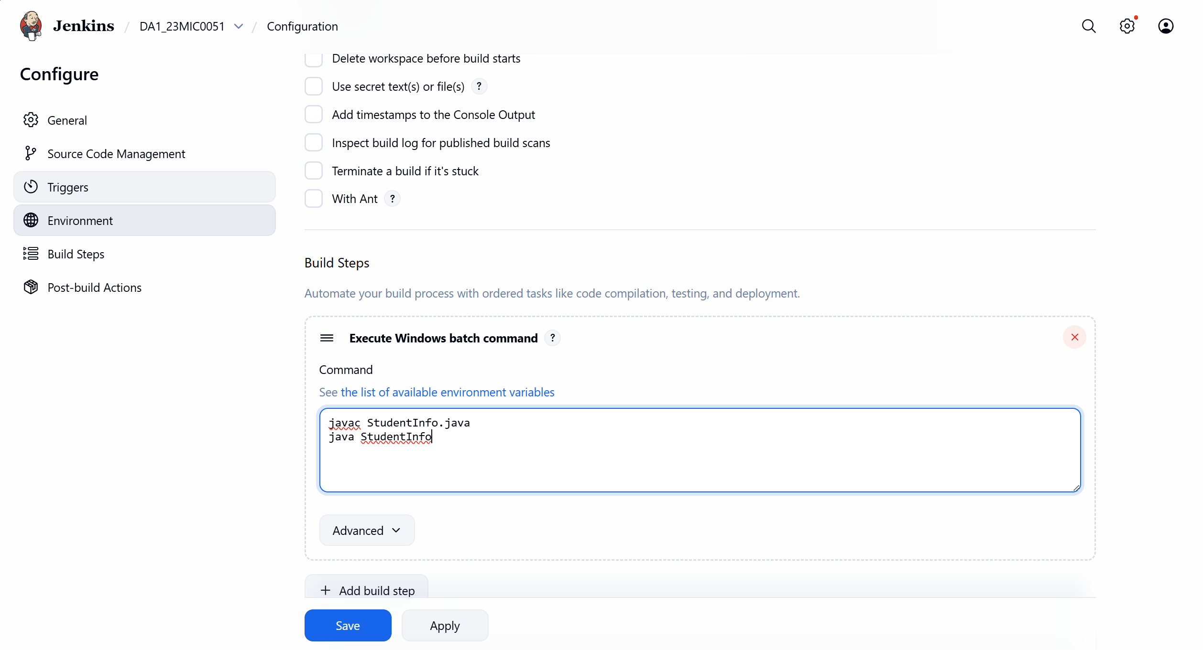6. Jenkins Execution (CI in Action)
When Jenkins runs the job:
- It pulls the code from GitHub
- Compiles the Java file
- Executes the program
- Displays output in Console
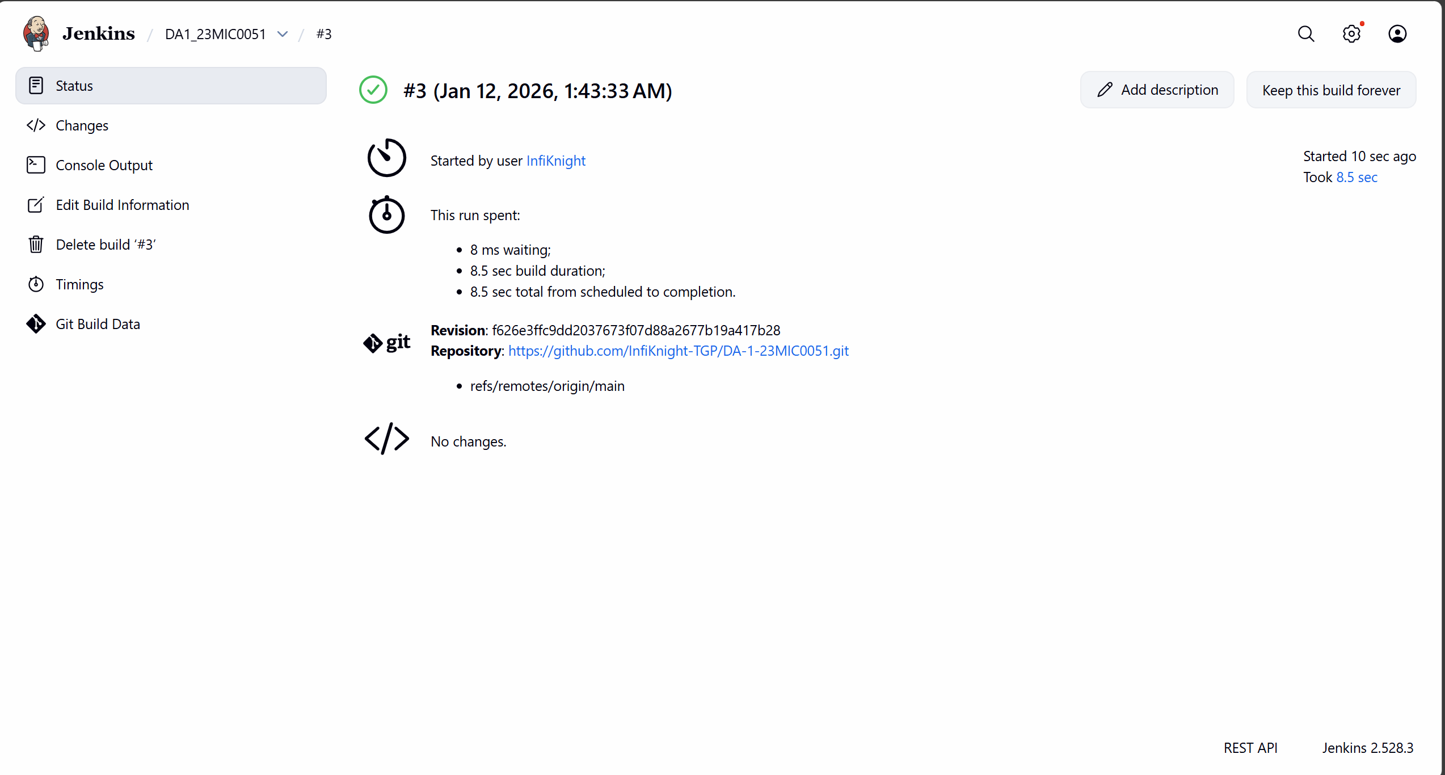
7. CI Workflow
Developer → GitHub → Jenkins → Build → Execute → Output
Every time code is pushed to GitHub, Jenkins automatically:
- Fetches the code
- Builds it
- Runs it
- Reports success or failure
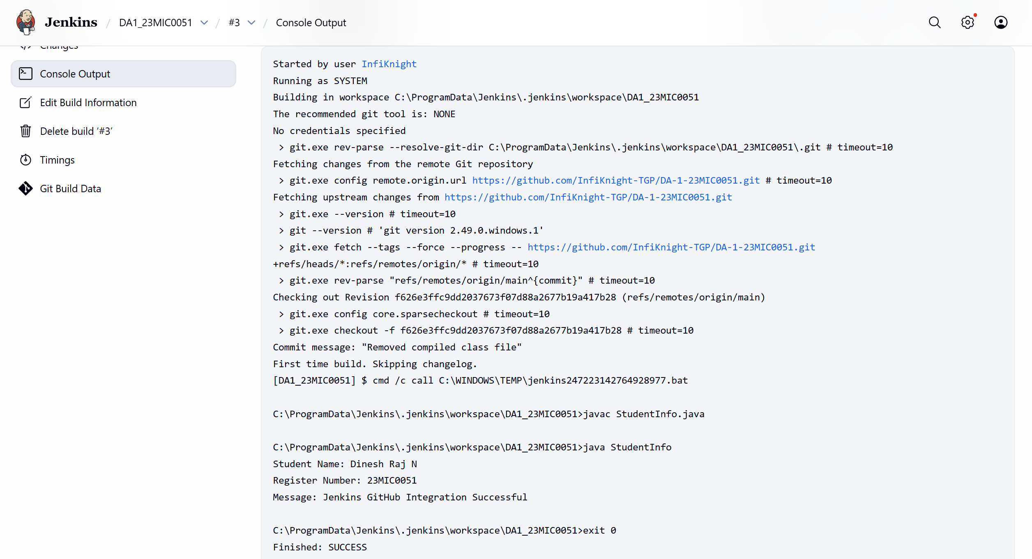

Springboot
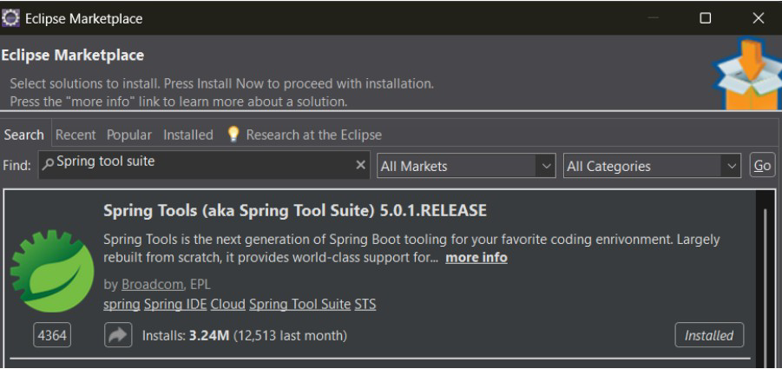
- Download eclipse spring tool suite(STS) from eclipse marketplace

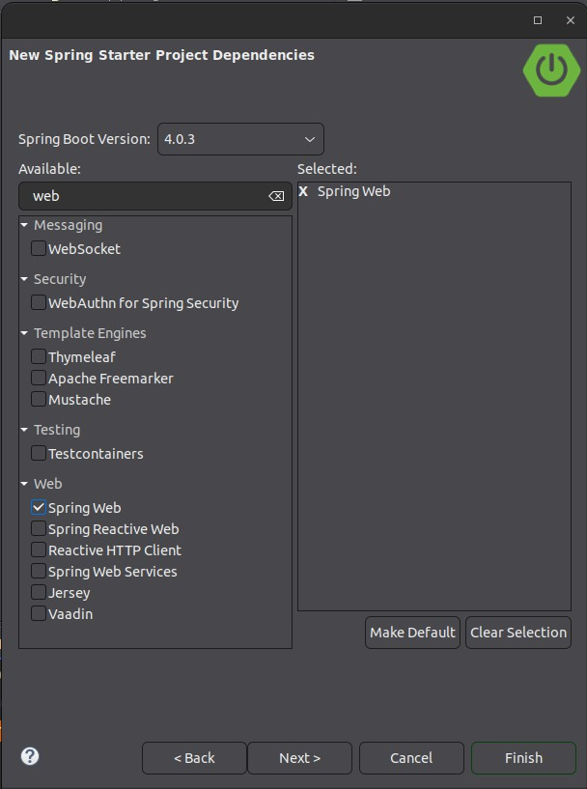
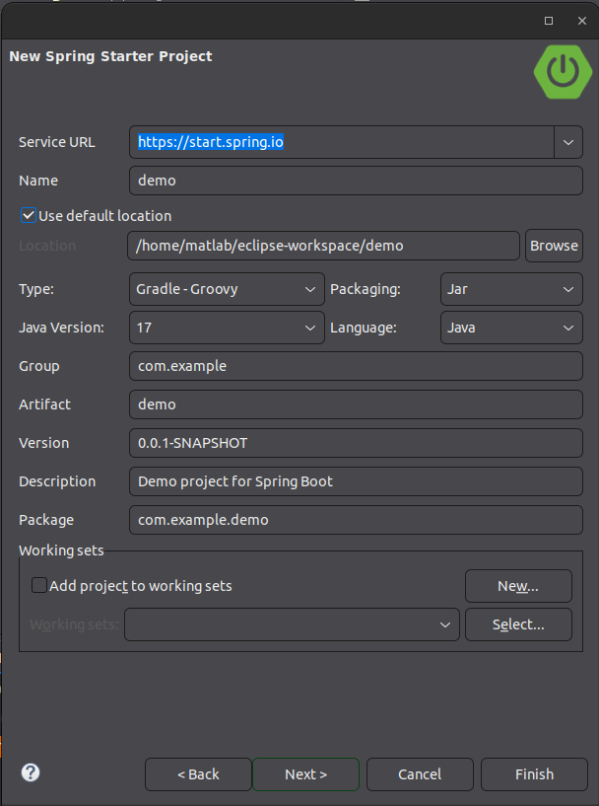
- Create Spring Boot Project.
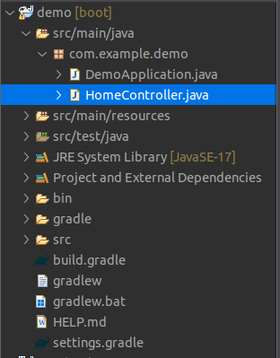
- Create Controller. PROJECT STRUCTURE:-

3) Write Code.
3
package com.example.demo;
import org.springframework.web.bind.annotation.GetMapping; import org.springframework.web.bind.annotation.RestController; @RestController
public class HomeController { @GetMapping("/") public String home() {
return "Application Running Successfully Dinesh Raj N
23MIC0051";
}
}
3) Run Application.
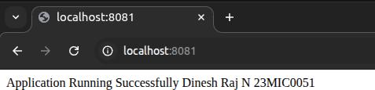
Output:
Application Running Successfully.
Application developed successfully using Eclipse STS.

Change Port:
- In STS, go to:
src → main → resources → application.properties
- Open application.properties
- Add this line:
server.port=8081
- Save (Ctrl + S)
- Run project again:
Right Click Project → Run As → Spring Boot App

Bugzilla
✅ STEP 1: Open Bugzilla
- Open Chrome
- Go to:
https://bugzilla.mozilla.org

✅ STEP 2: Login / Create Account
- Click Create Account (if new)
- OR Log In

✅ STEP 3: Create Bug
Click:
File a Bug

✅ STEP 4: None of the above; my bug is in:
Click:
Firefox

✅ STEP 5: Fill Bug Details(My issue is not listed)
🔹 Summary
Spring Boot application not loading homepage

🔹 Description
The Spring Boot application runs but the homepage is not loading.
Steps:
1. Run application in STS
2. Open browser
3. Enter http://localhost:8081
Expected Result:
Homepage should display output
Actual Result:
Page not loading

Kubernetes Lab – Commands (Step-wise)
# Verify Kubernetes cluster nodes
kubectl get nodes

# Create deployment using nginx image
kubectl create deployment webapp --image=nginx

# Verify pod status
kubectl get pods

# Scale deployment to 3 replicas
kubectl scale deployment webapp --replicas=3
kubectl get pods

# Expose using NodePort service
kubectl expose deployment webapp --type=NodePort --port=80
kubectl get svc

# Create YAML file (limited.yaml)
nano limited.yaml
apiVersion: v1
kind: Pod
metadata:
name: limited-pod
spec:
containers:
- name: nginx
image: nginx
resources:
limits:
cpu: "500m"
memory: "128Mi"
# Apply and verify configuration
kubectl apply -f limited.yaml
kubectl get pods
kubectl describe pod limited-pod
kubectl get all

Maven
🚀 1. Create Maven Project (Eclipse)
- Open Eclipse
- Go to File → New → Maven Project
- Select maven-archetype-quickstart → Next
- Enter:
  - Group Id: com.example
  - Artifact Id: calculator-app
- Click Finish

📦 2. Add JUnit 5 Dependency (pom.xml)
Replace <dependencies> with:
<dependencies>
<dependency>
<groupId>org.junit.jupiter</groupId>
<artifactId>junit-jupiter</artifactId>
<version>5.10.0</version>
<scope>test</scope>
</dependency>
</dependencies>
<build>
<plugins>
<plugin>
<groupId>org.apache.maven.plugins</groupId>
<artifactId>maven-surefire-plugin</artifactId>
<version>3.1.2</version>
</plugin>
</plugins>
</build>
👉 Right-click project → Maven → Update Project

💻 3. Create Class
📁 src/main/java/com/example/CalculatorService.java
package com.example;
public class CalculatorService {
public int multiply(int a, int b) {
return a * b;
}
}

🧪 4. Create Test Class
📁 src/test/java/com/example/CalculatorServiceTest.java
package com.example;
import org.junit.jupiter.api.Test;
import static org.junit.jupiter.api.Assertions.*;
class CalculatorServiceTest {
CalculatorService calc = new CalculatorService();
@Test
void testMultiplyPositive() {
assertEquals(6, calc.multiply(2, 3));
}
@Test
void testMultiplyNegative() {
assertEquals(-6, calc.multiply(-2, 3));
}
@Test
void testMultiplyZero() {
assertEquals(0, calc.multiply(5, 0));
}
}

▶️ 5. Execute Using Maven
Option 1 (Eclipse)
- Right-click project → Run As → Maven test
Option 2 (Terminal)
mvn test

📊 6. Output
[INFO] Running com.example.CalculatorServiceTest
[INFO] Tests run: 3, Failures: 0, Errors: 0
[INFO] BUILD SUCCESS

📁 Project Structure
calculator-app/
├── pom.xml
└── src/
├── main/java/com/example/CalculatorService.java
└── test/java/com/example/CalculatorServiceTest.java

