**ASSIGNMENT 1 FRONT SHEET**

|  |  |  |  |
| --- | --- | --- | --- |
| **Qualification** | **BTEC Level 5 HND Diploma in Computing** | | |
| **Unit number and title** | Unit 13:Computing Research Project | | |
| **Submission date** |  | **Date Received 1st submission** |  |
| **Re-submission Date** |  | **Date Received 2nd submission** |  |
| **Student Name** | Bui Nguyen Ngoc Han | **Student ID** | BH00150 |
| **Class** | IT0501 | **Assessor name** | Nguyen Thanh Trieu |
| **Student declaration**  I certify that the assignment submission is entirely my own work and I fully understand the consequences of plagiarism. I understand that making a false declaration is a form of malpractice. | | | |
|  |  | **Student’s signature** | Bui Nguyen Ngoc Han |

**Grading grid**

|  |  |  |  |  |  |  |  |  |  |
| --- | --- | --- | --- | --- | --- | --- | --- | --- | --- |
| P1 | P2 | P3 | P4 | P5 | M1 | M2 | M3 | D1 | D2 |
|  |  |  |  |  |  |  |  |  |  |

|  |  |  |
| --- | --- | --- |
| **❒ Summative Feedback: ❒ Resubmission Feedback:** | | |
| **Grade:** | **Assessor Signature:** | **Date:** |
| **Internal Verifier’s Comments:** | | |
| **Signature & Date:** | | |

Table of Contents

**I. INTRODUCTION 7**

**II. CONTENTS 8**

P1 Produce a research proposal that clearly defines a research question or hypothesis supported by a literature review 8

1. Research topic 8

2. Project type 8

3. Abstracts 9

4. Situation 10

5. Define the main aims and objectives of the report 11

5.1. Aims 11

5.2. Objectives 11

6. Project plan 12

6.1. Work Breakdown 12

6.2. Time estimation 12

6.3. Milestone 13

6.4. Activity sequencing 13

6.5. Scheduling 14

P2 Examine appropriate research methods and approaches to primary and secondary research 15

1. Research Methods 15

2. Primary research 16

2.1. Types of Primary research 16

2.2. Advantages of Primary research 17

2.3. Disadvantages of Primary research 18

3. Secondary research 19

3.1. Types of Secondary research 19

3.2. Advantages of Secondary research 20

3.3. Disadvantages of Secondary research 21

4. Compare Primary research with Secondary research 21

5. Qualitative research 23

5.1. Qualitative research methods 23

5.2. Qualitative data analysis 24

5.3. Advantages of Qualitative research 24

5.4. Disadvantages of Qualitative research 25

6. Quantitative research 26

6.1. Quantitative research methods 26

6.2. Quantitative data analysis 27

6.3. Advantages of Quantitative research 27

6.4. Disadvantages of Quantitative research 28

7. Compare Qualitative research with Quantitative research 29

8. Scientific method 31

8.1. The scientific method in technology and computers 31

8.2. Step of the scientific method 32

9. Research process 34

10. Population in research 35

10.1. Collecting data from a population 35

P3 Conduct primary and secondary research using appropriate methods for a computing research project that consider costs, access and ethical issues 37

1. Secondary research 37

1.1. Source 37

1.2. Interpretation and implications of the findings 38

2. Primary research 39

2.1. Interview 39

2.2. Survey 40

P4 Apply appropriate analytical tools, analyse research findings and data 41

1. Interview 41

1.1. Interview 1: Dr. Tran Hong Quan 42

1.2. Interview 2: Dr. Nguyen Thi Hong Van 43

1.3. Interview 3: Dr. Le Hai Ha 44

1.4. Interview 4: Dr. Nguyen Van Khanh 45

1.5. Interview 5: Dr. Dinh Quoc Thang 46

2. Interview summary 47

3. Survey 49

4. Survey summary 54

5. Analyze the results of the Primary research 59

P5 Communicate research outcomes in an appropriate manner for the intended audience 61

1. Conclution 61

2. Recommendation 62

**III. CONCLUSION 63**

**IV. REFERENCES 63**

List of Figures

Figure 1: Work breakdown 12

Figure 2: Milestone 13

Figure 3: Activity sequencing 13

Figure 4: Gantt 14

Figure 5: Primary research 16

Figure 6: Secondary research 19

Figure 7: Qualitative research 23

Figure 8: Quantitative research 26

Figure 9: Survey 1 49

Figure 10: Survey 2 50

Figure 11: Survey 3 51

Figure 12: Survey 4 52

Figure 13: Survey 5 53

Figure 14: Survey 1 55

Figure 15: Survey 2 55

Figure 16: Survey 3 56

Figure 17: Survey 4 56

Figure 18: Survey 5 57

Figure 19: Survey 6 57

Figure 20: Survey 7 58

Figure 21: Survey 8 58

List of Tables

Table 1: Time estimation 12

Table 2: Compare Primary research with Secondary research 22

Table 3: Compare Qualitative research with Quantitative research 30

Table 4: Interview 1: Dr. Tran Hong Quan 42

Table 5: Interview 2: Dr. Nguyen Thi Hong Van 43

Table 6: Interview 3: Dr. Le Hai Ha 44

Table 7: Interview 4: Dr. Nguyen Van Khanh 45

Table 8: Interview 5: Dr. Dinh Quoc Thang 46

1. **INTRODUCTION**

As the digital landscape continues to expand at an unprecedented rate, the environmental ramifications of this growth have become increasingly apparent. The exponential increase in data creation and storage, the amount of data created and stored globally is expected to reach 175 Zettabytes by 2025, a six-fold increase from 2018, is driving up the demand for additional hardware and energy consumption within the digital sector. This surge not only amplifies the environmental footprint of ICT equipment and services but also accentuates the urgency for sustainable solutions to mitigate its adverse effects on our planet.

Recognizing the imperative for action in addressing the challenges of climate change, it is incumbent upon professionals and industries to explore avenues through which the digital sector can contribute positively to environmental preservation. While digital technologies have made significant strides in enhancing efficiency, with approximately 100 times more computation power achieved from the same energy input over the past decade, the sustainability of current practices remains a concern.

In light of this pressing need for innovation, the focus of this research endeavors to delve into the environmental impacts of big data storage models, with a particular emphasis on the exploration of alternative materials. By scrutinizing the existing paradigms of data storage and consumption, this study seeks to identify and evaluate novel materials and methodologies that offer greener alternatives without compromising technological advancement. Through this research, I aim to catalyze the development of sustainable practices within the digital sector, fostering a transition towards a greener and more equitable future.

1. **CONTENTS**

## **P1 Produce a research proposal that clearly defines a research question or hypothesis supported by a literature review**

1. **Research topic**

Reasearch topic: “Environmental Impacts and the Search for Alternative Materials in Big Data Storage Models.”

1. **Project type**

**Research-based Investigation:** This aspect involves conducting a thorough investigation into the environmental impacts of current big data storage models and technologies. It includes:

* Improving understanding of the environmental implications of various storage methods.
* Identifying strengths and weaknesses within the field of big data storage in terms of environmental sustainability.
* Discussing how the field of big data storage has evolved concerning environmental concerns and advancements in sustainable practices.
* Acknowledging areas suitable for further development and investigation, such as the exploration of alternative materials and technologies for more sustainable storage solutions.
* Key activities include literature review, environmental impact assessment, data collection and analysis, and synthesis of findings to inform further research directions.

**Development:** In the context of the research project, development refers to the creation and refinement of alternative materials, technologies, and methodologies aimed at addressing environmental concerns in big data storage. It includes:

* Designing and implementing new materials or technologies that reduce the environmental footprint of data storage systems.
* Developing process models, algorithms, and design specifications for integrating sustainable practices into big data storage infrastructures.
* Creating interim documents such as requirement specifications and design proposals for the development of environmentally friendly storage solutions.
* Key activities may include materials research, prototyping, software development, and testing of alternative storage models.

**Evaluation:** The evaluation aspect of the project involves assessing and comparing various approaches to mitigating environmental impacts in big data storage. This includes:

* Comparing the environmental performance of different storage models and technologies.
* Analyzing the implementation process of sustainable storage solutions within industries.
* Assessing the user interfaces and user experiences of alternative storage systems from an environmental perspective.
* Considering alternative and new technological approaches to reducing the environmental footprint of data storage.
* Appraising development methodologies in terms of their effectiveness in addressing environmental concerns in big data storage.
* Key activities may include comparative analysis, case studies, user testing, environmental impact assessments, and evaluation of development methodologies.

1. **Abstracts**

Big Data is a term used to describe large and complex amounts of data that cannot be processed by traditional data processing tools. These are often large, powerful and diverse data sets, created from many different sources such as sensors, machines, social networks, websites, mobile applications,...

Although Big Data brings many information and knowledge benefits, it is also necessary to consider its negative impacts on the environment and find ways to minimize these impacts through sustainable measures. . Some effects of Big Data on the environment include:

Energy consumption: Storing, processing and transmitting large amounts of data requires the consumption of large amounts of energy from data centers and storage systems. The number of devices and servers required to process Big Data simultaneously increases energy demand significantly.

Resource Usage: Creating and maintaining infrastructure for storing and processing Big Data requires the use of a variety of resources such as water, metals, and other materials. Unsustainable use of these resources can cause environmental problems such as pollution and loss of biodiversity.

Data management: Maintaining and managing large amounts of data also requires the use of storage systems and data management software. This process also creates emissions and impacts the environment.

Analytics and applications: Data analytics activities and Big Data applications can also have an impact on the environment through the creation of products and services that may consume more resources or causes negative impacts on the environment during production and use.

1. **Situation**

In this section, I will provide some situations that can be used to conduct research on "Environmental Impacts and the Search for Alternative Materials in Big Data Storage Models". These situations can be used to define the scope and goals of the research and create specific methods and results to achieve these goals:

Comparing the environmental impact of big data storage materials: The use of environmentally friendly materials in the production of big data storage media can minimize the environmental impact compared to the use of Using traditional materials such as plastic, metal, etc. Research can compare the energy consumption, resource use and emissions of different materials during production, transportation and recycling.

Developing sustainable data storage models: Developing new data storage models can reduce environmental impact by improving performance and saving energy during data storage and access. Whether. Research may focus on analyzing storage methods based on new technologies such as resistive-based storage, light-based storage, or using renewable energy sources.

Estimating the environmental impact of existing Big Data systems: Assessing the environmental impact of existing Big Data systems can help identify weaknesses and opportunities to improve their efficiency and sustainability. they. Research may focus on analyzing the energy consumption, resource usage, and emissions of Big Data systems during daily operations.

Analyze the potential to minimize environmental impact: Analyzing measures to minimize the environmental impact of Big Data systems can provide important information to guide the development and implementation of sustainable measures . Research may focus on evaluating the effectiveness of measures such as optimizing production processes, recycling materials, and using renewable energy sources.

1. **Define the main aims and objectives of the report**
   1. **Aims**

The aim of the project is to complete research and better understand the impact of big data on the environment. Evaluate the environmental impact of existing big data storage models and look for alternatives that can minimize their environmental impact.

* 1. **Objectives**

Objectives of this project are:

* Assess the environmental impact related to current big data storage models and technologies.
* Identify key challenges and limitations of existing data archives on sustainability and environmental issues.
* Explore and evaluate alternative materials and technologies for environmentally friendly and sustainable big data storage.
* Analyze the potential benefits and drawbacks of applying alternative materials in big data storage models.
* Propose recommendations and guidelines for the application of sustainable materials and practices in the field of big data storage.

1. **Project plan**
   1. 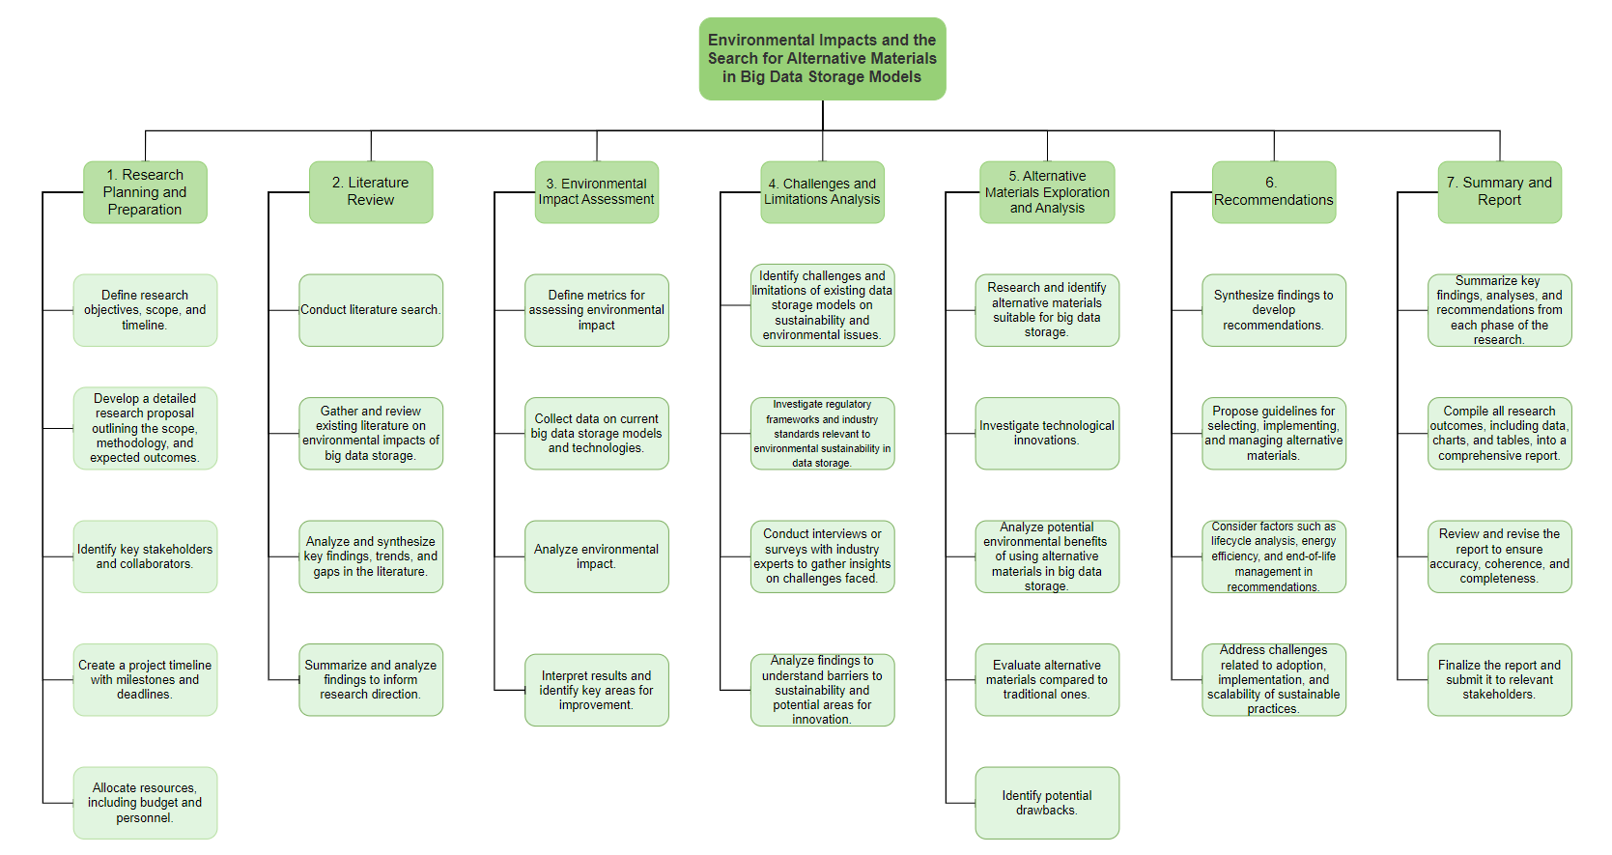**Work Breakdown**

Figure 1: Work breakdown

* 1. **Time estimation**

|  |  |
| --- | --- |
| Activity | Estimation Duration |
| Research Planning and Preparation | 10 days |
| Literature Review | 6 weeks |
| Environmental Impact Assessment | 6 weeks |
| Challenges and Limitations Analysis | 4 weeks |
| Alternative Materials Exploration and Analysis | 8 weeks |
| Recommendations and Guidelines Development | 3 weeks |
| Summary and Report Preparation | 4 weeks |

Table 1: Time estimation

* 1. 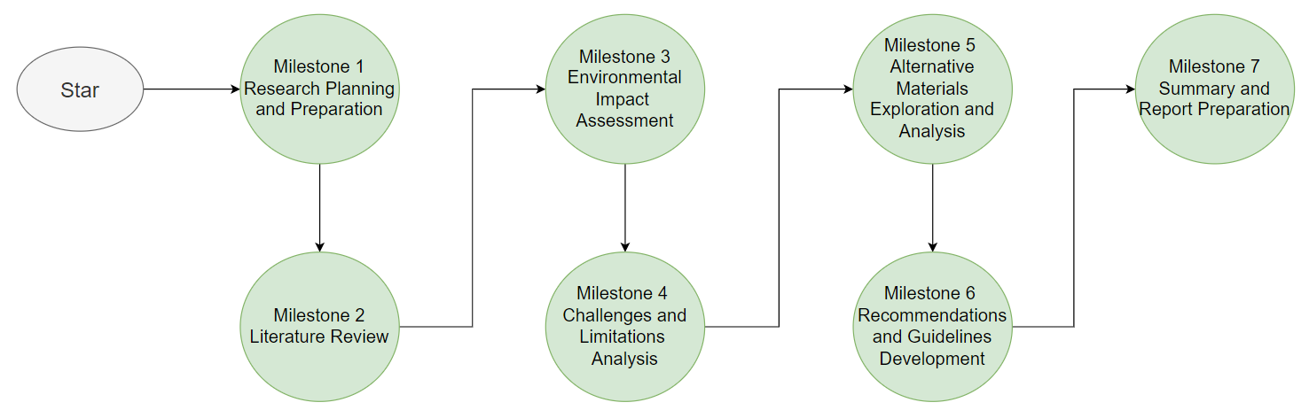**Milestone**

Figure 2: Milestone

* 1. 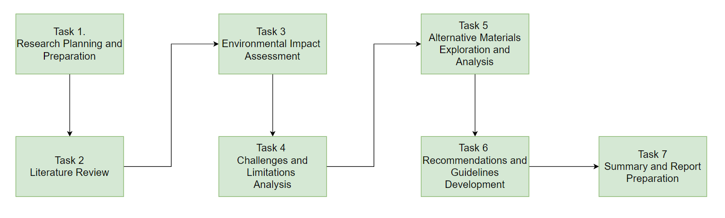**Activity sequencing**

Figure 3: Activity sequencing

* 1. **Scheduling**

Figure 4: Gantt

## **P2 Examine appropriate research methods and approaches to primary and secondary research**

1. **Research Methods**

Figure 1: Research Methods

Research methods refer to the systematic approaches used by researchers to gather, analyze, interpret, and draw conclusions from data. These methods are crucial for ensuring the validity, reliability, and credibility of research findings. There are various research methods employed across different disciplines, each suited to the specific objectives, questions, and contexts of the study. Some common research methods include: Quantitative research, Qualitative research, Mixed-Methods research, Experimental research, Survey research,...

1. **Primary research**
   1. 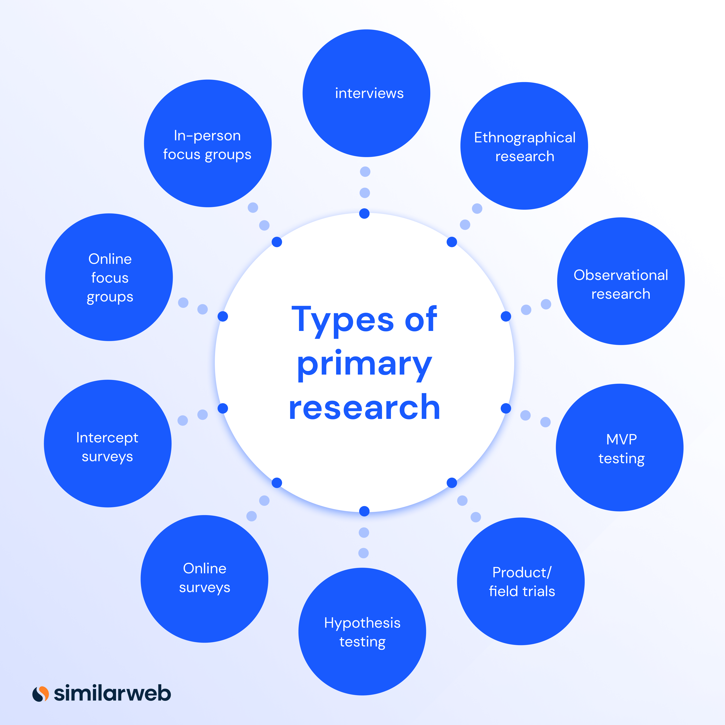**Types of Primary research**

Figure 5: Primary research

Primary research refers to the collection and analysis of original data directly from the source. It involves researchers gathering firsthand information to address specific research questions or objectives. Primary research methods are diverse and can include various techniques such as surveys, experiments, observations, interviews, focus groups, and case studies. Unlike secondary research, which involves analyzing existing data collected by others, primary research involves the direct collection of new data tailored to the researcher's needs.

Primary research encompasses various methods of data collection directly from the source. These methods can be broadly categorized into qualitative and quantitative research approaches. Here are some common types of primary research:

* Surveys: Surveys involve gathering information from a sample of individuals using standardized questionnaires or interviews. Surveys can be conducted through various mediums such as face-to-face interviews, telephone interviews, online surveys, or mailed questionnaires. They are useful for collecting data on attitudes, opinions, behaviors, and demographics.
* Interviews: Interviews involve direct interaction between the researcher and the participant(s) to gather detailed information on a specific topic. Interviews can be structured, semi-structured, or unstructured depending on the level of flexibility in questioning. They are particularly useful for exploring complex issues, understanding perspectives, and gathering rich qualitative data.
* Observational Studies: Observational studies involve systematically observing and recording behaviors, interactions, or phenomena in their natural settings. Researchers may use structured observation techniques with predefined criteria or unstructured observation to capture spontaneous behaviors. Observational studies are valuable for understanding behaviors, social dynamics, and environmental influences.
* Experiments: Experiments involve manipulating variables under controlled conditions to observe their effects on outcomes of interest. Experimental research allows researchers to establish cause-and-effect relationships and test hypotheses. Experiments can be conducted in laboratory settings or real-world environments, depending on the research question and context.
* Case studies involve in-depth analysis of a particular individual, group, organization, or event within its real-life context. Researchers collect data from multiple sources such as interviews, documents, observations, and archival records to provide detailed insights into the case under study. Case studies are valuable for exploring complex phenomena and generating rich qualitative data.
  1. **Advantages of Primary research**

Relevance and Timeliness: Primary research provides data that is directly relevant to the research question at hand. Since the data is collected firsthand, it is often more up-to-date and timely than secondary data.

Control over Research Design: Researchers have full control over the design of the study, including the choice of methodology, sampling techniques, and data collection instruments. This allows for customization to suit the specific needs of the research.

Depth of Insight: Primary research often allows for a deeper understanding of the research topic. Researchers can explore nuances, uncover new patterns, and gain insights that may not be apparent in existing literature or secondary data.

Flexibility: Researchers have the flexibility to adapt their approach during the research process based on emerging findings or changing circumstances. This adaptability can lead to richer and more robust results.

Contribution to Knowledge: Conducting primary research enables researchers to contribute new knowledge to their field. By generating original data and insights, primary research expands the body of scholarly literature and advances understanding within the discipline.

* 1. **Disadvantages of Primary research**

Resource Intensive: Primary research can be time-consuming and costly. It requires significant resources for planning, data collection, analysis, and interpretation. Depending on the research methodology chosen, primary research may also require specialized equipment, personnel, or access to participants.

Potential for Bias: Researchers must be vigilant about potential biases that could affect the validity and reliability of the findings. Biases may arise from factors such as researcher subjectivity, participant self-reporting, or sampling limitations. It's essential to employ rigorous methodology and data analysis techniques to mitigate bias.

Ethical Considerations: Conducting primary research involves ethical considerations related to participant consent, confidentiality, and potential harm. Researchers must adhere to ethical guidelines and obtain approval from institutional review boards (IRBs) or ethics committees to ensure the protection of participants' rights and well-being.

Sampling Challenges: Selecting an appropriate sample is critical for the generalizability of findings in primary research. However, sampling challenges such as non-response bias, sampling error, and difficulty reaching certain populations can impact the representativeness of the sample and limit the external validity of the results.

1. **Secondary research**
   1. **Types of Secondary research**

Figure 6: Secondary research

Secondary research, also known as desk research, involves the collection and analysis of existing data and information that has been previously collected by other researchers or organizations. It doesn't involve the direct collection of new data but rather relies on accessing and synthesizing data from various sources. Here are some common types of secondary research:

* Literature Reviews: Literature reviews involve synthesizing and analyzing existing academic or scholarly literature relevant to a particular research topic or question. Researchers examine journal articles, books, conference proceedings, and other scholarly publications to identify existing theories, findings, debates, and gaps in knowledge.
* Meta-Analysis: Meta-analysis is a statistical technique used to systematically combine and analyze the results of multiple independent studies on a specific topic. By pooling data from individual studies, researchers can quantify the overall effect size, test the robustness of findings across studies, and identify patterns or trends.
* Systematic Reviews: Systematic reviews follow a structured and rigorous process to identify, evaluate, and synthesize all relevant research studies on a particular topic. Researchers systematically search multiple databases, screen studies for eligibility, assess study quality, and extract data to provide a comprehensive overview of the evidence base.
* Data Mining: Data mining involves extracting patterns, trends, and insights from large datasets using statistical and computational techniques. Researchers analyze existing datasets such as government databases, industry reports, social media data, and electronic health records to uncover hidden relationships or patterns of interest.
* Archival Research: Archival research involves the examination of historical documents, records, and artifacts to study past events, trends, or phenomena. Researchers access archives, libraries, museums, and other repositories to collect primary source materials such as letters, diaries, newspapers, photographs, and official records.
* Content Analysis: Content analysis is a method used to systematically analyze and interpret the content of textual, visual, or audiovisual materials. Researchers code and categorize content to identify themes, patterns, or trends across documents, media texts, social media posts, advertisements, or websites.
* Surveys and Databases: Secondary research can also involve analyzing data collected by others through surveys, censuses, or administrative databases. Researchers access public-use datasets or proprietary databases to conduct secondary analysis and generate insights on various topics such as demographics, consumer behavior, or healthcare trends.

Secondary research offers several advantages, including cost-effectiveness, efficiency, and accessibility of existing data. However, it also has limitations, such as potential biases in the original data, reliance on available datasets, and inability to address specific research questions requiring primary data collection. Researchers must critically evaluate the quality, relevance, and reliability of secondary sources to ensure the validity of their findings.

* 1. **Advantages of Secondary research**

Cost-Effective: Secondary research is often more cost-effective compared to primary research since it utilizes existing data that is already available. Researchers do not need to incur expenses related to data collection, participant recruitment, or fieldwork.

Time-Saving: Secondary research can be completed more quickly than primary research since researchers do not need to spend time collecting new data. Existing data sources can be accessed relatively easily, allowing researchers to focus on data analysis and interpretation.

Large Sample Size: Secondary research often involves analyzing data from large-scale surveys, databases, or archival records, providing researchers with access to extensive datasets. This large sample size can enhance the statistical power of the analysis and improve the generalizability of findings.

Access to Specialized Data: Secondary research provides access to specialized datasets or sources of information that may not be feasible to collect through primary research. Researchers can leverage government databases, industry reports, or proprietary datasets to address specific research questions.

* 1. **Disadvantages of Secondary research**

Quality and Reliability: The quality and reliability of secondary data can vary depending on the source and methodology used in its collection. Researchers must critically evaluate the validity, accuracy, and completeness of the data to ensure its suitability for their research purposes.

Limited Control: Researchers have limited control over the design and methodology used in the collection of secondary data since it was collected by others for different purposes. This lack of control may introduce biases or limitations that could affect the interpretation of findings.

Potential for Bias: Secondary data sources may contain biases introduced by the original researchers or data collectors. Common biases include selection bias, measurement bias, and reporting bias, which can impact the validity and generalizability of findings.

Data Availability: Availability of relevant secondary data can be a limitation, especially for niche topics or research questions requiring specific types of data. Researchers may encounter challenges in accessing appropriate datasets or finding sources that meet their research needs.

Inability to Address Specific Questions: Secondary data may not always align perfectly with the research questions or objectives of the study. Researchers may encounter limitations in the scope or granularity of available data, preventing them from addressing certain aspects of their research.

1. **Compare Primary research with Secondary research**

|  |  |  |
| --- | --- | --- |
|  | Primary Research | Secondary Research |
| Data Collection | Involves the direct collection of new data by researchers through methods such as surveys, interviews, experiments, observations, or focus groups. | Involves the analysis of existing data and information that has been previously collected by other researchers or organizations. Researchers do not directly collect new data but rely on accessing and synthesizing existing data sources. |
| Control and Flexibility | Researchers have full control over the design, methodology, and data collection process. They can tailor the research approach to suit their specific research questions and objectives. | Researchers have limited control over the design and methodology used in data collection since the data was collected by others for different purposes. They must work with existing datasets and sources of information, limiting flexibility. |
| Cost and Time | Primary research can be time-consuming and expensive since it involves the direct collection of new data, including costs related to participant recruitment, data collection, and analysis. | Secondary research is often more cost-effective and time-saving compared to primary research since it utilizes existing data that is already available. Researchers do not need to incur expenses related to data collection and can focus on analysis. |
| Data Quality | Researchers can ensure the quality and reliability of data by employing rigorous methodologies, controlling for biases, and validating findings through peer review. | Data quality in secondary research depends on the reliability and validity of the original sources. Researchers must critically evaluate the quality, accuracy, and completeness of existing data to ensure its suitability for their research purposes. |
| Depth of Insight | Primary research often provides deeper insights into research questions since researchers have direct access to participants and can explore nuances, contexts, and individual perspectives. | Secondary research may provide broader overviews or general trends since it relies on existing datasets and sources of information. It may lack the depth of insight that can be achieved through primary research methods. |
| Scope and Generalizability | Findings from primary research may have limited generalizability, especially if the sample size is small or specific to a particular population or context. | Secondary research may offer broader generalizability, especially if it involves large-scale datasets or systematic reviews that aggregate findings from multiple studies. However, generalizability depends on the representativeness and diversity of the original data sources. |

Table 2: Compare Primary research with Secondary research

1. **Qualitative research**
   1. 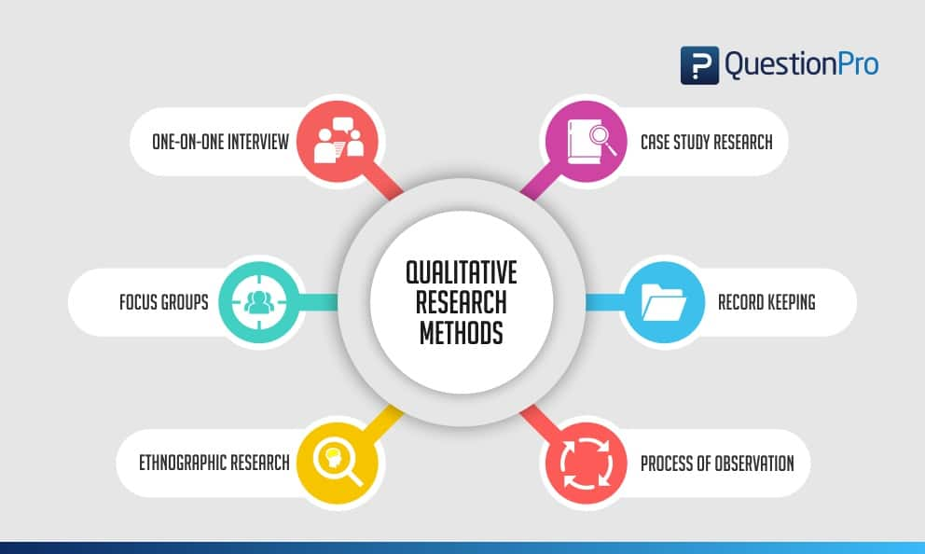**Qualitative research methods**

Figure 7: Qualitative research

Qualitative research methods focus on exploring and understanding social phenomena from the perspective of the individuals involved. These methods emphasize depth, context, and subjective interpretation, aiming to uncover meaning, patterns, and insights within the data. Qualitative research is particularly suited for studying complex social processes, attitudes, behaviors, and experiences. Here are some common qualitative research methods:

* Interviews: Interviews involve direct interaction between the researcher and participants to gather detailed information on a specific topic. Interviews can be structured, semi-structured, or unstructured, allowing for flexibility in questioning and exploration of participant perspectives. They are useful for exploring complex issues, understanding lived experiences, and eliciting rich, in-depth data.
* Focus Groups: Focus groups involve bringing together a small group of individuals (usually 6-10 participants) to discuss a specific topic under the guidance of a moderator. Focus groups encourage interaction and group dynamics, allowing researchers to explore diverse viewpoints, attitudes, and perceptions within a group setting. They are valuable for generating insights, uncovering social norms, and exploring group dynamics.
* Observation: Observational methods involve systematically observing and recording behaviors, interactions, or phenomena in their natural settings. Researchers may use structured observation techniques with predefined criteria or unstructured observation to capture spontaneous behaviors. Observation can provide valuable insights into social contexts, cultural practices, and everyday behaviors.
* Content Analysis: Content analysis is a method used to systematically analyze and interpret the content of textual, visual, or audiovisual materials. Researchers code and categorize content to identify themes, patterns, or trends across documents, media texts, social media posts, advertisements, or websites. Content analysis is useful for exploring representations, discourses, and cultural meanings within texts.

These qualitative research methods can be used individually or in combination to address research questions, explore phenomena, and generate rich, nuanced understandings within various disciplines such as sociology, anthropology, psychology, education, and health sciences.

* 1. **Qualitative data analysis**

Qualitative data analysis (QDA) is the process of systematically examining and interpreting qualitative data to uncover patterns, themes, and insights. Unlike quantitative data analysis, which focuses on numerical data and statistical techniques, qualitative data analysis involves working with non-numerical data such as text, images, or audiovisual materials.

Qualitative data analysis is iterative and recursive, meaning that researchers often move back and forth between different stages of the analysis process. It requires careful attention to detail, reflexivity, and analytical rigor to ensure the validity, reliability, and credibility of the findings. Throughout the analysis process, researchers should maintain transparency, document decision-making processes, and engage in reflexivity to acknowledge and address their own biases or assumptions.

* 1. **Advantages of Qualitative research**

In-Depth Understanding: Qualitative research methods allow researchers to explore complex phenomena in-depth, uncovering rich insights, meanings, and contexts that may not be captured by quantitative approaches. They provide a detailed understanding of the subjective experiences, perspectives, and behaviors of participants.

Flexibility: Qualitative research methods offer flexibility in data collection and analysis, allowing researchers to adapt their approach to the specific research context and objectives. Researchers can employ diverse methods such as interviews, focus groups, observations, or content analysis to suit the research question.

Exploratory Nature: Qualitative research is exploratory and hypothesis-generating, making it well-suited for generating new theories, hypotheses, or research questions. It allows researchers to explore emergent themes, patterns, or relationships within the data without imposing predefined categories or assumptions.

Participant Perspective: Qualitative research prioritizes the perspectives and voices of participants, allowing researchers to understand phenomena from the standpoint of those directly involved. It promotes participant engagement, empowerment, and collaboration throughout the research process.

Contextual Understanding: Qualitative research methods enable researchers to study phenomena within their natural contexts, considering social, cultural, and environmental influences. They provide insights into how context shapes behaviors, interactions, and meanings, enhancing the relevance and applicability of findings.

* 1. **Disadvantages of Qualitative research**

Subjectivity and Bias: Qualitative research is inherently subjective, as it involves interpretation, meaning-making, and researcher subjectivity. Researchers' biases, assumptions, and interpretations may influence the data collection and analysis process, potentially leading to biased findings.

Limited Generalizability: Qualitative research findings may lack generalizability, as they are often based on small, non-representative samples and context-specific data. The emphasis on depth and richness of data may compromise the ability to make broad generalizations to larger populations.

Time-Consuming: Qualitative research methods can be time-consuming, as they involve intensive data collection, transcription, coding, and analysis processes. Researchers may spend extended periods in the field, conducting interviews, observations, or participant observations, and analyzing qualitative data can be labor-intensive.

Data Analysis Challenges: Qualitative data analysis can be challenging and subjective, requiring researchers to manage large volumes of qualitative data and make subjective decisions during coding and interpretation. Ensuring inter-coder reliability, consistency, and rigor in qualitative analysis can be demanding.

1. **Quantitative research**
   1. 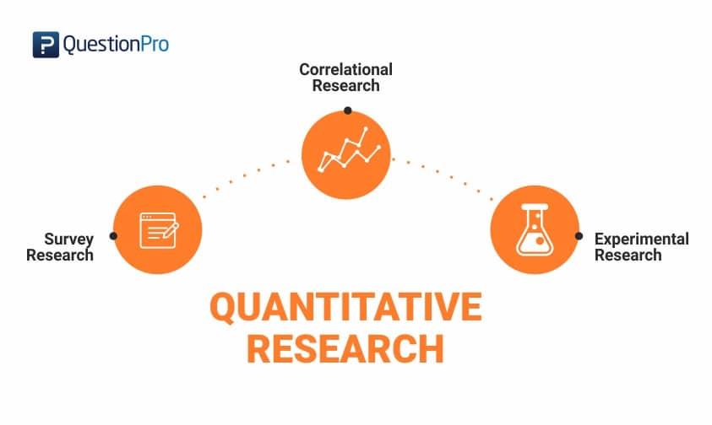**Quantitative research methods**

Figure 8: Quantitative research

Quantitative research methods involve the systematic collection and analysis of numerical data to quantify variables, test hypotheses, and identify patterns or relationships. These methods are characterized by their use of statistical and mathematical techniques to analyze data and draw conclusions. Quantitative research is widely used across various disciplines, including social sciences, natural sciences, health sciences, and business. Here are some common quantitative research methods:

* Surveys: Surveys involve the collection of data from a sample of individuals using standardized questionnaires or interviews. Surveys are used to gather information about attitudes, behaviors, preferences, and demographics. They can be conducted through various mediums such as face-to-face interviews, telephone surveys, online surveys, or mailed questionnaires.
* Experiments: Experiments involve manipulating one or more independent variables to observe their effects on dependent variables under controlled conditions. Researchers design experiments to test hypotheses and establish causal relationships between variables. Experiments can be conducted in laboratory settings or real-world environments, depending on the research question and context.
* Observational Studies: Observational studies involve systematically observing and recording behaviors, interactions, or phenomena in their natural settings without intervening or manipulating variables. Researchers may use structured observation techniques with predefined criteria or unstructured observation to capture spontaneous behaviors. Observational studies are useful for studying behaviors, social dynamics, and environmental influences.
* Secondary Data Analysis: Secondary data analysis involves analyzing existing datasets that have been collected by other researchers or organizations for purposes other than the current research study. Researchers use statistical techniques to analyze secondary data sources such as government surveys, administrative records, or commercial databases to address research questions or test hypotheses.

These quantitative research methods can be used individually or in combination to address research questions, test hypotheses, and generate empirical evidence within various disciplines. Quantitative research offers advantages such as objectivity, precision, and generalizability but may also have limitations related to its reliance on numerical data, controlled conditions, and assumptions about causality.

* 1. **Quantitative data analysis**

Quantitative data analysis involves the systematic examination and interpretation of numerical data to uncover patterns, relationships, and insights. It employs statistical and mathematical techniques to analyze data collected through quantitative research methods such as surveys, experiments, or observational studies.

Quantitative data analysis requires proficiency in statistical software such as SPSS, R, SAS, or Python,... as well as a solid understanding of statistical concepts and methods. Researchers must ensure the validity, reliability, and integrity of the data analysis process by adhering to appropriate statistical techniques, assumptions, and guidelines. Additionally, researchers should interpret quantitative findings cautiously, considering the limitations and assumptions of the statistical analyses and contextual factors that may influence the results.

* 1. **Advantages of Quantitative research**

Objectivity: Quantitative research methods aim to minimize researcher bias and subjectivity by focusing on numerical data and statistical analysis. They provide a structured and standardized approach to data collection and analysis, enhancing objectivity and reliability.

Generalizability: Quantitative research findings often have high external validity and generalizability, as they are based on large sample sizes and statistical techniques that allow researchers to make inferences about broader populations. This makes quantitative research useful for generating empirical evidence and informing decision-making in various contexts.

Precision and Reproducibility: Quantitative research methods enable researchers to measure variables precisely and replicate findings across different studies or populations. They use standardized measurement scales, statistical tests, and replicable procedures to ensure the reliability and reproducibility of results.

Statistical Analysis: Quantitative research methods employ sophisticated statistical techniques to analyze data, test hypotheses, and identify patterns or relationships between variables. Statistical analysis provides robust and quantifiable evidence, allowing researchers to draw precise conclusions and make predictions based on empirical data.

Quantitative Comparison: Quantitative research enables researchers to quantify differences or relationships between variables, allowing for direct comparison and analysis. Researchers can assess the magnitude of effects, calculate effect sizes, and identify statistical significance, facilitating comparisons across groups, conditions, or time points.

* 1. **Disadvantages of Quantitative research**

Lack of Depth: Quantitative research methods may lack the depth and richness of qualitative approaches, as they prioritize numerical data and statistical analysis over contextual understanding and subjective experiences. They may overlook subtle nuances, complexities, or social dynamics that qualitative methods can capture.

Limited Exploration: Quantitative research methods may limit researchers' ability to explore new or unexpected phenomena, as they rely on predefined variables, hypotheses, and measurement scales. Researchers may miss important insights or emerging patterns that qualitative methods allow for more flexible exploration.

Contextual Complexity: Quantitative research may oversimplify complex social phenomena by reducing them to numerical variables and statistical relationships. It may struggle to capture the contextual factors, cultural meanings, or subjective experiences that shape behaviors and interactions in real-world settings.

1. **Compare Qualitative research with Quantitative research**

|  |  |  |
| --- | --- | --- |
|  | Qualitative Research | Quantitative Research |
| Nature of Data | Involves non-numerical data such as words, texts, images, or observations. It focuses on exploring subjective experiences, meanings, and contexts, often using open-ended questions and qualitative data collection methods. | Involves numerical data collected through structured instruments such as surveys, experiments, or observations. It focuses on measuring variables, testing hypotheses, and identifying patterns or relationships using statistical analysis. |
| Research Design | Typically uses flexible and open-ended research designs that allow for exploration, emergence of themes, and in-depth understanding of phenomena. Qualitative studies may employ methods such as interviews, focus groups, or ethnography. | Typically uses structured and predefined research designs that involve hypothesis testing, measurement, and statistical analysis. Quantitative studies may employ methods such as surveys, experiments, or observational studies. |
| Data Collection Methods | Utilizes methods such as interviews, focus groups, observations, or document analysis to gather rich, descriptive data from participants. Qualitative data collection methods often involve open-ended questions and encourage participants to share their perspectives and experiences. | Utilizes methods such as surveys, experiments, or systematic observations to gather standardized, numerical data from participants. Quantitative data collection methods typically use closed-ended questions with predefined response options to measure variables objectively. |
| Data Analysis | Involves qualitative data analysis techniques such as coding, thematic analysis, or narrative analysis to identify patterns, themes, and meanings within the data. Qualitative analysis focuses on interpretation, context, and understanding rather than statistical inference. | Involves statistical data analysis techniques such as descriptive statistics, inferential statistics, or regression analysis to analyze numerical data and test hypotheses. Quantitative analysis focuses on numerical patterns, relationships, and statistical significance. |
| Purpose and Goals | Aims to explore, describe, and understand complex phenomena, behaviors, or social processes within their natural contexts. Qualitative research seeks to uncover meanings, perspectives, and experiences and generate rich, in-depth insights. | Aims to quantify, measure, and test relationships between variables, often focusing on hypothesis testing, prediction, or causal inference. Quantitative research seeks to identify patterns, associations, or trends using numerical data and statistical analysis. |
| Generalizability | Findings from qualitative research are typically context-bound and may lack generalizability to broader populations or settings. Qualitative research emphasizes depth and richness of understanding over generalizability. | Findings from quantitative research are often generalizable to broader populations or settings, especially when based on large, representative samples and rigorous statistical techniques. Quantitative research emphasizes external validity and generalizability. |

Table 3: Compare Qualitative research with Quantitative research

1. **Scientific method**
   1. **The scientific method in technology and computers**

The scientific method in the realm of technology and computers follows a similar framework to that in other scientific fields, with some adaptations to suit the unique characteristics of technology development and computer science. Here's how the scientific method is applied in technology and computers:

* Observation and Question: The process begins with observation of a phenomenon or problem in the realm of technology or computing. This observation leads to the formulation of a research question or problem statement. For example, an observation might be the slow performance of a computer system, leading to the question of how to improve its efficiency.
* Hypothesis: Based on the observation and question, researchers or engineers formulate a hypothesis, which is a proposed explanation or solution to the problem. In technology and computers, hypotheses may involve predictions about the performance of a new algorithm, the effectiveness of a software solution, or the impact of a hardware upgrade.
* Experimentation and Design: In technology and computing, experimentation involves designing and implementing systems, algorithms, or software solutions to test the hypothesis. This phase may involve writing code, building prototypes, or conducting simulations to evaluate the performance and functionality of the proposed solution.
* Data Collection: During experimentation, data is collected to assess the performance, effectiveness, or behavior of the system or solution being tested. Data may include metrics such as processing speed, memory usage, error rates, user satisfaction, or other relevant indicators.
* Analysis: Once data is collected, it is analyzed to evaluate the validity of the hypothesis and draw conclusions. In technology and computers, analysis may involve statistical techniques, performance evaluation, benchmarking, or qualitative assessment, depending on the nature of the research question and data collected.
* Conclusion: Based on the analysis of data, researchers or engineers draw conclusions about the effectiveness of the proposed solution or hypothesis. Conclusions may support the hypothesis, reject it, or suggest modifications or further research. For example, if an experiment demonstrates that a new algorithm significantly improves processing speed, the conclusion may be that the hypothesis is supported and the algorithm is effective.
* Communication and Reproducibility: The findings of the research are communicated to the scientific community through publications, presentations, or technical reports. Other researchers may attempt to reproduce the results or build upon them to further advance knowledge and technology in the field.
* Iteration and Improvement: The scientific method in technology and computers is often iterative, with researchers and engineers refining hypotheses, conducting further experiments, and continuously improving systems or solutions based on feedback and new insights. This iterative process drives innovation and advancement in technology and computing.

Overall, the scientific method in technology and computers involves systematic observation, experimentation, and analysis to develop and evaluate solutions to technological problems, advance knowledge, and drive innovation in the field.

* 1. **Step of the scientific method**

In the scientific method, there are typically several steps involved in the process of conducting scientific research and inquiry. Here's an overview of the steps:

* Observation: The process begins with observation, where scientists observe a phenomenon or aspect of the natural world. Observations can be made through direct observation, experimentation, or measurement.
* Question: Based on observations, scientists formulate a question or problem statement that addresses the observed phenomenon or seeks to understand a particular aspect of the natural world. The question should be clear, specific, and testable.
* Hypothesis: A hypothesis is a proposed explanation or tentative answer to the research question. It is a statement that can be tested through experimentation or observation. Hypotheses are often formulated based on prior knowledge, existing theories, or logical reasoning.
* Prediction: From the hypothesis, scientists make predictions about the outcomes of experiments or observations. Predictions are specific statements that can be tested to support or refute the hypothesis. They help guide the design of experiments and provide criteria for evaluating the hypothesis.
* Experimentation: Scientists design and conduct experiments to test the hypothesis and predictions. Experiments involve manipulating variables, collecting data, and analyzing results to determine whether they support or reject the hypothesis. Experiments should be carefully designed to control for confounding variables and ensure the validity and reliability of the results.
* Data Collection: During experimentation, scientists collect data through observation, measurement, or experimentation. Data may be quantitative (numerical) or qualitative (descriptive), depending on the nature of the research question and experimental design. Data collection methods should be systematic and rigorous to ensure the accuracy and validity of the data.
* Analysis: Once data is collected, scientists analyze it using statistical or qualitative techniques to identify patterns, trends, or relationships. Analysis involves organizing, summarizing, and interpreting the data to draw conclusions about the hypothesis and research question.
* Conclusion: Based on the analysis of data, scientists draw conclusions about whether the hypothesis is supported or rejected. Conclusions should be based on evidence and logical reasoning, and they may lead to revisions of the hypothesis or further research questions. It's essential to communicate conclusions clearly and transparently, including any limitations or uncertainties in the findings.
* Communication: Scientists communicate their findings to the scientific community and the public through publications, presentations, or reports. Communication of scientific results promotes transparency, peer review, and the advancement of knowledge in the field. It allows other researchers to evaluate, replicate, or build upon the findings and contributes to the collective understanding of the natural world.
* Reevaluation and Iteration: The scientific method is an iterative process, with scientists continually reevaluating hypotheses, conducting further research, and refining theories based on new evidence and insights. This iterative process drives scientific progress and leads to a deeper understanding of the natural world.

1. **Research process**

Researching the topic "Environmental Impacts and the Search for Alternative Materials in Big Data Storage Models" involves several steps to gather relevant information, analyze existing data, and contribute new insights. Here's a structured approach to the research process:

***Step 1 - Define the Research Question:*** Clearly articulate the specific aspect of environmental impacts and alternative materials in big data storage models that you want to investigate. This could involve examining the energy consumption, carbon footprint, resource depletion, or other environmental factors associated with traditional data storage methods and exploring potential alternatives.

***Step 2 - Literature Review:*** Conduct a comprehensive review of existing literature related to environmental impacts in big data storage. Look for academic papers, journal articles, books, and conference proceedings that discuss the environmental consequences of current data storage technologies and potential alternatives.

***Step 3 - Identify Relevant Data Sources:*** Gather relevant data and information from reputable sources such as academic journals, government reports, industry publications, and databases. This data may include statistics on energy consumption, greenhouse gas emissions, material usage, and environmental regulations related to data storage technologies.

***Step 4 - Research Methodology:*** Determine the appropriate research methodology for study. Depending on the nature of research question, you may choose qualitative methods (e.g., interviews, case studies) or quantitative methods (e.g., surveys, statistical analysis) to collect and analyze data.

***Step 5 - Data Collection:*** Collect data using the chosen research methodology. This may involve conducting interviews with industry experts, administering surveys to IT professionals, analyzing case studies of companies implementing alternative storage solutions, or performing experiments to compare the environmental performance of different storage materials.

***Step 6 - Data Analysis:*** Analyze the collected data using appropriate analytical techniques. This may involve statistical analysis, qualitative coding, thematic analysis, or other methods to identify patterns, trends, and correlations related to environmental impacts and alternative materials in big data storage models.

***Step 7 - Interpretation of Findings:*** Interpret the results of your data analysis in the context of your research question and objectives. Discuss how your findings contribute to existing knowledge in the field and address any research gaps or unanswered questions.

***Step 8 - Conclusion and Recommendations:*** Summarize your key findings and conclusions regarding the environmental impacts of current data storage models and the potential for alternative materials to mitigate these impacts. Provide recommendations for future research, policy implications, and practical strategies for industry stakeholders to adopt more sustainable data storage practices.

***Step 9 - The Report-writing:*** Write up the research findings in a scholarly paper or report format suitable.

1. **Population in research**
   1. **Collecting data from a population**

Collecting data from a population in research involves several steps to ensure that the data obtained are representative, reliable, and valid. Here's a systematic approach to collecting data from a population:

Define the Population: Clearly define the population you are interested in studying. The population is the entire group of individuals or elements that possess the characteristics you want to investigate. Ensure that your population definition is specific and well-defined to guide your sampling and data collection efforts.

Determine Sampling Frame: Identify a sampling frame, which is a list or representation of all the elements in the population from which you will draw your sample. The sampling frame should accurately represent the population and be accessible for sampling purposes. Depending on the population characteristics, the sampling frame could be a list of individuals, households, organizations, or geographic areas.

Choose a Sampling Method: Select an appropriate sampling method to obtain a representative sample from the population. Common sampling methods include:

Probability Sampling: In probability sampling, every element in the population has a known chance of being selected. Common types of probability sampling include simple random sampling, stratified sampling, cluster sampling, and systematic sampling.

Non-probability Sampling: Non-probability sampling does not involve random selection, and the chances of each element being selected are not known. Examples of non-probability sampling include convenience sampling, purposive sampling, snowball sampling, and quota sampling.

Select Sample Size: Determine the appropriate sample size for your study based on factors such as the desired level of precision, confidence level, population size, and research objectives. Use statistical techniques or sampling formulas to calculate the sample size needed to achieve sufficient statistical power and representativeness.

Develop Data Collection Instruments: Design data collection instruments such as surveys, questionnaires, interviews, or observation protocols to gather information from the selected sample. Ensure that the instruments are clear, concise, and relevant to the research objectives. Pilot test the instruments with a small group to identify and address any issues with clarity, comprehensibility, or validity.

Implement Data Collection: Conduct the data collection process according to the chosen methodology and sampling plan. Train data collectors (if applicable) on proper techniques for administering surveys, conducting interviews, or recording observations to minimize bias and ensure consistency. Adhere to ethical guidelines and obtain informed consent from participants when necessary.

Monitor Data Quality: Continuously monitor the quality of the collected data to identify and address any errors, inconsistencies, or missing information. Implement data validation checks, conduct regular reviews of data collection procedures, and maintain clear documentation to ensure the reliability and integrity of the data.

Analyze Data: Analyze the collected data using appropriate statistical or qualitative analysis techniques depending on the research objectives and data characteristics. Use software tools such as SPSS, R, NVivo, or Excel to perform data analysis and generate insights from the collected data.

Interpret Findings: Interpret the results of the data analysis in the context of your research question and objectives. Discuss the implications of the findings, identify patterns or trends in the data, and relate the results back to existing theory or literature in the field.

Report Results: Write up your research findings in a clear and concise manner, following the structure of a research report or academic paper. Present the results using tables, charts, and graphs to enhance readability and understanding. Discuss the limitations of the study and make recommendations for future research or practical applications based on the findings.

By following these steps, you can collect data from a population effectively and generate valuable insights for your research study.

## **P3 Conduct primary and secondary research using appropriate methods for a computing research project that consider costs, access and ethical issues**

1. **Secondary research**

Secondary research, also known as desk research, involves the collection and analysis of existing data and information that has been previously collected by other researchers or organizations. It doesn't involve the direct collection of new data but rather relies on accessing and synthesizing data from various sources. Secondary research is an important part of the project. Below I will also provide the sources of some scientific articles and documents that I have referenced. At the same time, I will also explain their significance for this project.

* 1. **Source**

Below are some specific scientific articles that may provide useful information for the project "Environmental Impacts and the Search for Alternative Materials in Big Data Storage Models":

*"Sustainable data centers: A survey and taxonomy"* - P. Patel, et al. (2015), Journal of Sustainable Computing: Informatics and Systems.

*"Green Storage: An Overview of the Energy Savings and Performance Trade-offs"* - F. Wang, et al. (2013), ACM Transactions on Storage.

*"Green big data: A review on energy-efficient big data computing research"* - Y. Zhang, et al. (2015), Future Generation Computer Systems.

*"Sustainable data storage: A survey of storage technologies"* - N. Kaveh, et al. (2017), Sustainable Computing: Informatics and Systems.

*"Energy-efficient data storage systems in the big data era: A review"* - S. Liu, et al. (2018), Journal of Parallel and Distributed Computing.

* 1. **Interpretation and implications of the findings**

The scientific articles listed all contain important findings related to the environmental impact of big data storage systems and the search for alternative materials. The findings from these scientific papers can help provide important information and perspectives on how to optimize the energy efficiency and reduce the environmental impact of big data storage systems, as well as search for environmentally friendly alternative materials. In this section, I will explain and mean the findings in these articles for my research topic:

*"Sustainable data centers: A survey and taxonomy":* This article provides an overview and taxonomy of strategies and techniques for creating sustainable data centers. Findings from this paper can help you understand how modern data centers can be designed and managed to minimize environmental impact.

*"Green Storage: An Overview of the Energy Savings and Performance Trade-offs":* This article focuses on energy saving and performance aspects of data storage. Findings from this paper can inform advanced techniques and technologies to optimize the energy efficiency of large data storage systems.

*"Green big data: A review on energy-efficient big data computing research":* This article delves into research on the energy efficiency of big data computing methods and technologies. Findings from this paper can help you better understand how big data computing technologies affect the environment and how they can be improved to reduce negative impacts.

*"Sustainable data storage: A survey of storage technologies":* This article provides an overview of sustainable data storage technologies. Findings from this paper can provide information about new materials and technologies that can be used to develop environmentally friendly data storage systems.

*"Energy-efficient data storage systems in the big data era: A review":* This article presents a detailed review of energy-efficient data storage systems in the big data era. Findings from this paper can provide a detailed perspective and insight into how to integrate sustainability elements into the design and implementation of the system.

1. **Primary research**

As mentioned before, Primary research refers to the collection and analysis of original data directly from the source. It involves researchers gathering firsthand information to address specific research questions or objectives. Primary research methods are diverse and can include various techniques such as surveys, experiments, observations, interviews, focus groups, and case studies.

For this topic, I will use two primary research methods to collect information. These two methods are: Interview and Survey. In this section, I will only briefly introduce what I will do in primary research through these two methods. Details of the interviews and surveys will be provided in the next section P4 on page 41.

* 1. **Interview**

For the interview part, I will conduct 5 interviews with 5 doctors including:

* Dr. Tran Hong Quan: Professor of Hanoi University of Science and Technology, has many studies on information technology and the environment.
* Dr. Nguyen Thi Hong Van: Lecturer at Ho Chi Minh City University of Natural Sciences, researching the environmental impact of information technology.
* Dr. Le Hai Ha: Information technology and environment expert at the Institute of Information Technology - Vietnam Academy of Science and Technology.
* Dr. Nguyen Van Khanh: Expert in renewable energy and green technology, has participated in many research projects on the interaction between technology and the environment.
* Dr. Dinh Quoc Thang: Lecturer at Ho Chi Minh City University of Technology, researching information technology and environmental impacts.

They are all experts with expertise in fields related to this research topic. During interviews, I will ask some questions such as:

* Why do you think researching the environmental impact of big data storage models and seeking alternative materials is important?
* From your perspective, what do you think are the main environmental impacts of current big data storage models?
* What alternative materials do you think could be considered to reduce the environmental impact of big data storage models?

After conducting the interview, I will draw conclusions and analyze the results obtained after the interview.

* 1. **Survey**

For the survey, I will create a Google Form that includes the following questions:

* How aware are you of the environmental impacts associated with current big data storage models?
* Do you believe that using alternative materials in big data storage models can help reduce environmental impacts?
* Are you familiar with any alternative materials that can be used in big data storage models to reduce environmental impacts? If yes, please specify.
* What do you think are the main barriers to implementing alternative materials in big data storage models? (Select all that apply)
* Do you think the use of renewable energy sources in data centers could help mitigate environmental impacts?
* Are you currently involved in or aware of any initiatives within your organization or industry aimed at reducing the environmental impact of big data storage models?
* Which alternative materials do you think would be most effective in reducing the environmental impact of big data storage models? (Select all that apply)
* Do you think government regulations are necessary to promote the adoption of alternative materials and sustainable practices in big data storage models?
* Do you think there should be more awareness campaigns or educational initiatives about the environmental impacts of big data storage models and the importance of adopting sustainable practices?
* What additional research do you think should be conducted in this area?

After conducting the survey, I will make conclusions and analysis based on the percentage of information obtained.

## **P4 Apply appropriate analytical tools, analyse research findings and data**

1. **Interview**

Conducting interviews is one of the methods I chose to conduct research on this topic. I interviewed and discussed with 5 doctors who have expertise in the field that the topic is aimed at. They are:

* Dr. Tran Hong Quan: Professor of Hanoi University of Science and Technology, has many studies on information technology and the environment.
* Dr. Nguyen Thi Hong Van: Lecturer at Ho Chi Minh City University of Natural Sciences, researching the environmental impact of information technology.
* Dr. Le Hai Ha: Information technology and environment expert at the Institute of Information Technology - Vietnam Academy of Science and Technology.
* Dr. Nguyen Van Khanh: Expert in renewable energy and green technology, has participated in many research projects on the interaction between technology and the environment.
* Dr. Dinh Quoc Thang: Lecturer at Ho Chi Minh City University of Technology, researching information technology and environmental impacts.

The content of the interviews will be provided shortly.

* 1. **Interview 1: Dr. Tran Hong Quan**

|  |
| --- |
| Interview with Dr. Tran Hong Quan on Environmental Impacts and the Search for Alternative Materials in Big Data Storage Models |
| *Interviewer:* Hello, Dr. Tran Hong Quan. Thank you for taking the time for this interview. To begin, could you introduce yourself and your research field?  *Dr. Tran Hong Quan:* Hello, I'm Dr. Tran Hong Quan. I'm currently a professor at Hanoi University of Science and Technology, and my research focuses on the environmental impact of information technology. I've conducted numerous studies on how big data storage affects the environment and the search for more environmentally friendly materials.  *Interviewer:* It's great to meet you, Dr. Quan. Why do you think researching the environmental impact of big data storage models and seeking alternative materials is important?  *Dr. Tran Hong Quan:* Thank you for asking. In today's digital age, the storage and processing of data are increasing rapidly, posing significant environmental challenges. Information technology, especially large data centers, consumes a lot of energy and generates significant carbon emissions. Researching ways to reduce the environmental impact of large data storage systems and finding alternative materials can help us move towards a more sustainable digital environment.  *Interviewer:* That's certainly true. From your perspective, what do you think are the main environmental impacts of current big data storage models?  *Dr. Tran Hong Quan:* There are various impacts, but one of the biggest issues is the energy consumption of data centers. Additionally, the production and disposal of hardware components contribute to electronic waste and environmental pollution. Moreover, the use of environmentally unfriendly materials in the manufacturing process also creates many problems.  *Interviewer:* Very interesting. What alternative materials do you think could be considered to reduce the environmental impact of big data storage models?  *Dr. Tran Hong Quan:* There are many types of materials that could be considered, from recycled materials to natural organic materials. Using renewable energy sources is also an effective way to reduce environmental impact.  *Interviewer:* Thank you so much for sharing your insights, Dr. Qua n.  *Dr. Tran Hong Quan:* My pleasure. Thank you for having me. |

Table 4: Interview 1: Dr. Tran Hong Quan

* 1. **Interview 2: Dr. Nguyen Thi Hong Van**

|  |
| --- |
| Interview with Dr. Nguyen Thi Hong Van on Environmental Impacts and the Search for Alternative Materials in Big Data Storage Models |
| *Interviewer:* Hello, Dr. Nguyen Thi Hong Van. Thank you for joining us today. Can you please introduce yourself and your expertise in this field?  *Dr. Nguyen Thi Hong Van:* Hello, it's my pleasure to be here. I am Dr. Nguyễn Thị Hồng Vân, a lecturer at the University of Science in Ho Chi Minh City. My research focuses on the environmental impact of technology, particularly in the context of data storage and processing.  *Interviewer:* Great, Dr. Van. Why do you believe researching the environmental impacts of big data storage models and exploring alternative materials is important?  *Dr. Nguyen Thi Hong Van:* Thank you for the question. As we witness the exponential growth of digital data, it's crucial to understand and mitigate the environmental consequences of our technological advancements. Exploring alternative materials and sustainable practices in data storage can significantly reduce our carbon footprint and contribute to a greener future.  *Interviewer:* That's insightful. From your perspective, what are some of the main environmental impacts associated with current big data storage models?  *Dr. Nguyen Thi Hong Van:* One of the significant impacts is the high energy consumption of data centers, leading to increased carbon emissions. Additionally, the extraction and processing of raw materials for hardware components contribute to environmental degradation. Moreover, the disposal of electronic waste poses serious challenges to waste management and pollution control.  *Interviewer:* Thank you for sharing. What alternative materials do you think show promise in reducing the environmental impact of big data storage?  *Dr. Nguyen Thi Hong Van:* There are several alternatives worth considering, such as biodegradable plastics, recycled metals, and sustainable wood-based materials. Additionally, renewable energy sources and energy-efficient technologies can significantly mitigate the environmental impact of data storage operations.  *Interviewer:* Thank you so much for sharing your insights |

Table 5: Interview 2: Dr. Nguyen Thi Hong Van

* 1. **Interview 3: Dr. Le Hai Ha**

|  |
| --- |
| Interview with Dr. Le Hai Ha on Environmental Impacts and the Search for Alternative Materials in Big Data Storage Models |
| *Interviewer:* Hello, Dr. Le Hai Ha. Thank you for joining us today. Can you please introduce yourself and your expertise in this field?  *Dr. Le Hai Ha:* Hello, it's my pleasure to be here. I am Dr. Le Hai Ha, a technology expert at the Institute of Information Technology - Vietnam Academy of Science and Technology. My research focuses on the intersection of information technology and environmental sustainability.  *Interviewer:* Great, Dr. Ha. Why do you believe researching the environmental impacts of big data storage models and exploring alternative materials is important?  *Dr. Le Hai Ha:* Thank you for the question. In today's digital age, the environmental impact of technology cannot be overstated. By researching and implementing sustainable practices in data storage, we can significantly reduce our ecological footprint and contribute to global efforts to combat climate change.  *Interviewer:* That's insightful. From your perspective, what are some of the main environmental impacts associated with current big data storage models?  *Dr. Le Hai Ha:* One of the significant impacts is the high energy consumption of data centers, which contribute to greenhouse gas emissions and climate change. Additionally, the manufacturing and disposal of hardware components generate electronic waste and contribute to environmental pollution. Furthermore, the use of non-renewable resources in data storage infrastructure exacerbates resource depletion and environmental degradation.  *Interviewer:* Thank you for sharing. What alternative materials do you think show promise in reducing the environmental impact of big data storage?  *Dr. Le Hai Ha:* There are several alternative materials and technologies worth exploring. These include biodegradable plastics, recycled metals, and sustainable materials such as bamboo and hemp. Additionally, renewable energy sources such as solar and wind power can significantly reduce the carbon footprint of data storage operations.  *Interviewer:* Thank you so much for sharing your insights |

Table 6: Interview 3: Dr. Le Hai Ha

* 1. **Interview 4: Dr. Nguyen Van Khanh**

|  |
| --- |
| Interview with Dr. Nguyen Van Khanh on Environmental Impacts and the Search for Alternative Materials in Big Data Storage Models |
| *Interviewer:* Hello, Dr. Nguyen Van Khanh. Thank you for joining us today. Can you please introduce yourself and your expertise in this field?  *Dr. Nguyen Van Khanh:* Hello, it's my pleasure to be here. I am Dr. Nguyễn Văn Khánh, a renewable energy and green technology expert. I have been involved in various research projects focusing on the interaction between technology and the environment.  *Interviewer:* Great, Dr. Khanh. Why do you believe researching the environmental impacts of big data storage models and exploring alternative materials is important?  *Dr. Nguyen Van Khanh:* Thank you for the question. As our reliance on technology continues to grow, it's imperative that we consider the environmental consequences of our actions. By researching and implementing sustainable practices in data storage, we can minimize our ecological footprint and ensure a healthier planet for future generations.  *Interviewer:* That's insightful. From your perspective, what are some of the main environmental impacts associated with current big data storage models?  *Dr. Nguyen Van Khanh:* One of the primary impacts is the significant energy consumption of data centers, which contributes to carbon emissions and global warming. Additionally, the extraction and processing of raw materials for hardware components result in resource depletion and environmental degradation. Moreover, the disposal of electronic waste poses serious challenges to waste management and pollution control.  *Interviewer:* Thank you for sharing. What alternative materials do you think show promise in reducing the environmental impact of big data storage?  *Dr. Nguyen Van Khanh:* There are several alternative materials and technologies that hold promise in this regard. These include biodegradable plastics, recycled metals, and sustainable materials such as bamboo and cork. Additionally, the use of renewable energy sources such as solar and wind power can significantly reduce the carbon footprint of data storage operations.  *Interviewer:* Thank you so much for sharing your insights |

Table 7: Interview 4: Dr. Nguyen Van Khanh

* 1. **Interview 5: Dr. Dinh Quoc Thang**

|  |
| --- |
| Interview with Dr. Dinh Quoc Thang on Environmental Impacts and the Search for Alternative Materials in Big Data Storage Models |
| *Interviewer:* Hello, Dr. Dinh Quoc Thang. Thank you for joining us today. Can you please introduce yourself and your expertise in this field?  *Dr. Dinh Quoc Thang:* Hello, it's my pleasure to be here. I am Dr. Dinh Quoc Thang, a lecturer at the University of Technology in Ho Chi Minh City. My research focuses on information technology and its environmental impact.  *Interviewer:* Great. Why do you believe researching the environmental impacts of big data storage models and exploring alternative materials is important?  *Dr. Dinh Quoc Thang:* Thank you for the question. In today's digital era, the environmental impact of technology cannot be overlooked. By studying and implementing sustainable practices in data storage, we can mitigate the negative effects on our planet and move towards a greener future.  *Interviewer:* That's insightful. From your perspective, what are some of the main environmental impacts associated with current big data storage models?  *Dr. Dinh Quoc Thang:* One significant impact is the high energy consumption of data centers, which leads to increased carbon emissions and contributes to climate change. Additionally, the production and disposal of hardware components result in electronic waste and environmental pollution. Furthermore, the use of non-renewable resources in data storage infrastructure exacerbates resource depletion and environmental degradation.  *Interviewer:* Thank you for sharing. What alternative materials do you think show promise in reducing the environmental impact of big data storage?  *Dr. Dinh Quoc Thang:* There are several alternative materials and technologies that hold promise in this regard. These include biodegradable plastics, recycled metals, and sustainable materials such as bamboo and hemp. Additionally, the use of renewable energy sources such as solar and wind power can significantly reduce the carbon footprint of data storage operations.  *Interviewer:* Thank you so much for sharing your insights |

Table 8: Interview 5: Dr. Dinh Quoc Thang

1. **Interview summary**

Here's a summary of the five interviews with experts on the topic of "Environmental Impacts and the Search for Alternative Materials in Big Data Storage Models":

Dr. Tran Hong Quan: Dr. Quan, a professor at Hanoi University of Science and Technology, stressed the importance of researching the environmental impacts of big data storage models and exploring alternative materials. He discussed the energy consumption of data centers, electronic waste generation, and the need for sustainable practices. Dr. Quan proposed alternative materials like recycled materials and renewable energy sources.

Dr. Nguyen Thi Hong Van: Dr. Van, a lecturer at the University of Science in Ho Chi Minh City, emphasized the importance of understanding and mitigating the environmental consequences of technology. She highlighted the significant energy consumption of data centers, the generation of electronic waste, and the need for exploring alternative materials such as biodegradable plastics and recycled metals.

Dr. Le Hai Ha: Dr. Ha, a technology expert at the Institute of Information Technology - Vietnam Academy of Science and Technology, underscored the need for sustainable practices in data storage to reduce our ecological footprint. He discussed the environmental impacts of data centers' energy consumption and electronic waste generation, proposing alternative materials like sustainable wood-based materials and renewable energy sources.

Dr. Nguyen Van Khanh: Dr. Khanh, a renewable energy and green technology expert, highlighted the importance of considering the environmental consequences of technological advancements. He discussed the significant energy consumption of data centers and the environmental impacts of raw material extraction and electronic waste disposal. Dr. Khanh proposed alternative materials such as biodegradable plastics and renewable energy sources like solar and wind power.

Dr. Dinh Quoc Thang: Dr. Thang, a lecturer at the University of Technology in Ho Chi Minh City, emphasized the need for sustainable practices in data storage to mitigate negative environmental effects. He discussed the high energy consumption of data centers and the environmental impacts of hardware production and disposal. Dr. Thang proposed alternative materials such as biodegradable plastics, recycled metals, and sustainable materials like bamboo and hemp.

Summary and Conclusion:

The interviews with experts on the topic of "Environmental Impacts and the Search for Alternative Materials in Big Data Storage Models" have highlighted a consensus regarding the importance of researching and implementing sustainable solutions to mitigate the environmental impacts of large data storage models. Here are the key points raised from the interviews and their conclusions:

* Environmental Impact of Information Technology: All experts agreed that information technology, especially large data centers, significantly impacts the environment. The substantial energy consumption and the production and disposal of hardware components contribute to electronic waste and environmental pollution.
* Search for Alternative Materials: The experts proposed a range of alternative materials and sustainable solutions to minimize the environmental impact of large data storage models. Materials such as biodegradable plastics, recycled metals, and natural resources were suggested to replace environmentally harmful materials.
* Use of Renewable Energy: A common solution mentioned by the experts is the use of renewable energy sources to operate data centers. Utilizing solar, wind, and other renewable energy sources not only reduces carbon emissions but also lowers operational costs.
* Collaboration and Knowledge Sharing: The interviews emphasized the importance of collaboration and knowledge sharing among researchers, businesses, and government agencies. Only through collective efforts can we find the most effective solutions to reduce the environmental impact of information technology.

In conclusion, the interviews have clarified that seeking sustainable solutions and alternative materials is crucial to minimize the environmental impact of large data storage models. Collaboration among stakeholders and enhanced research and technology development will play a vital role in advancing this process and creating a more sustainable environment for the future.

1. **Survey**

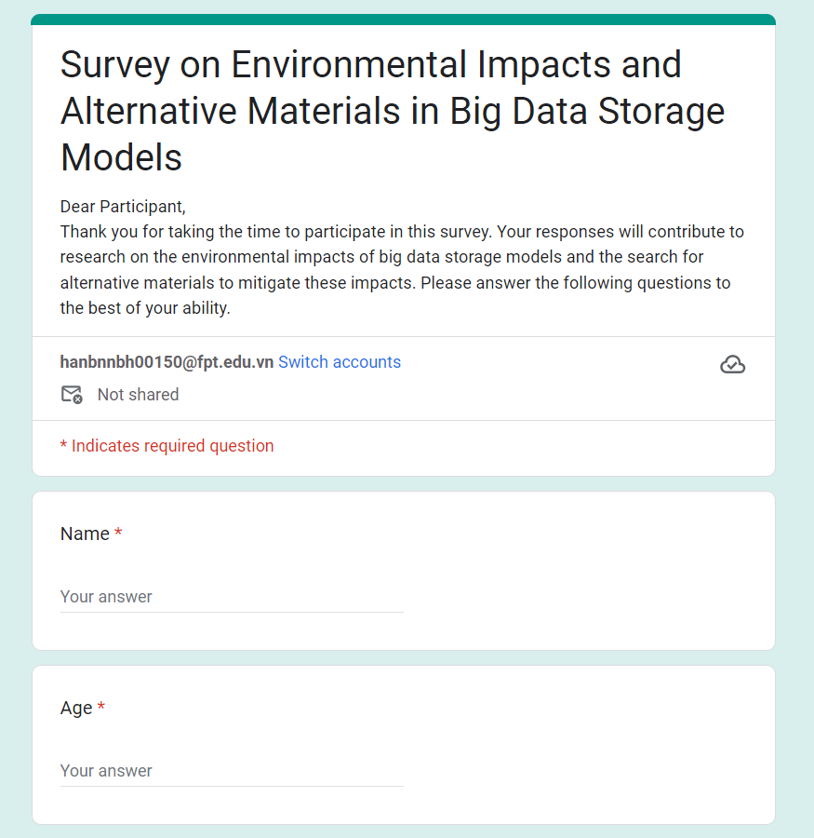I created a survey form via Google Form to conduct surveys and collect information. Survey questions and survey forms will be presented in this section

Figure 9: Survey 1

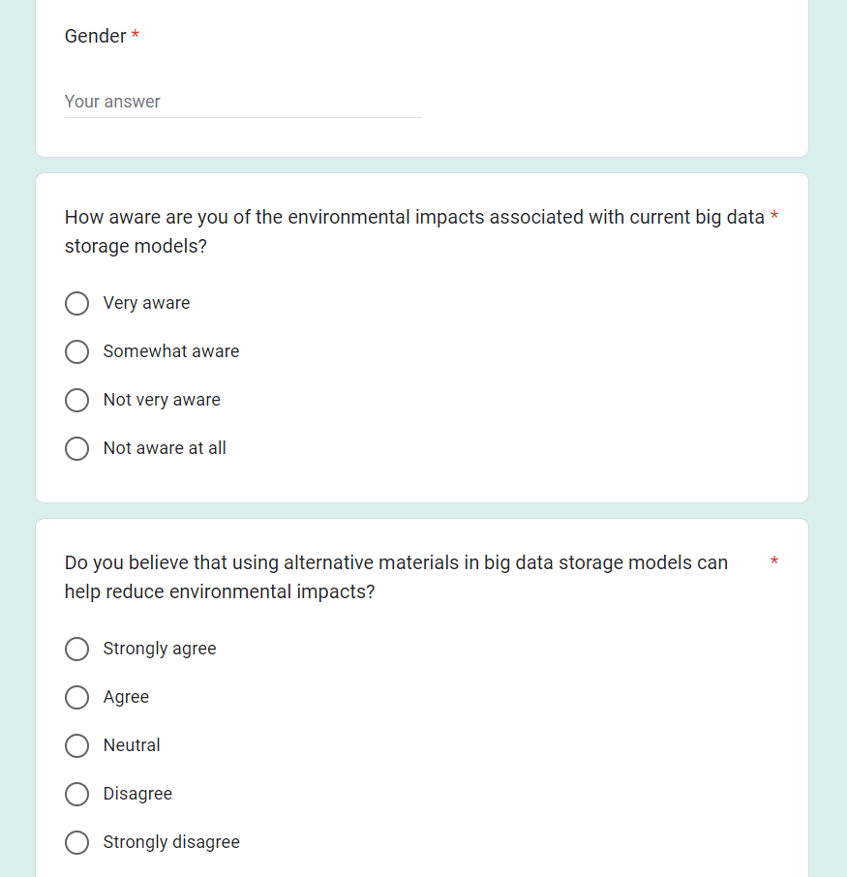

Figure 10: Survey 2

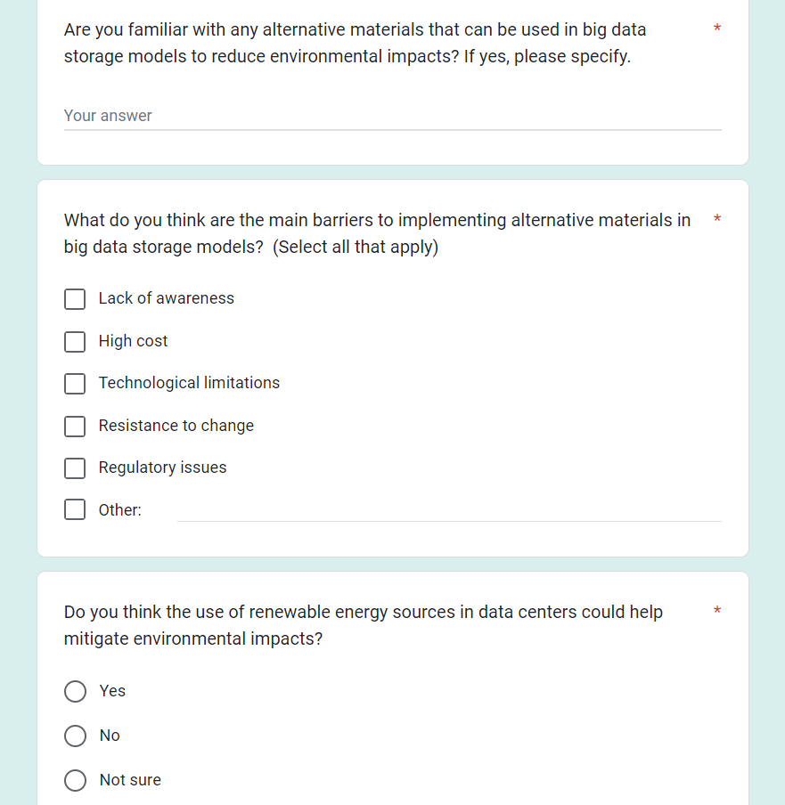

Figure 11: Survey 3

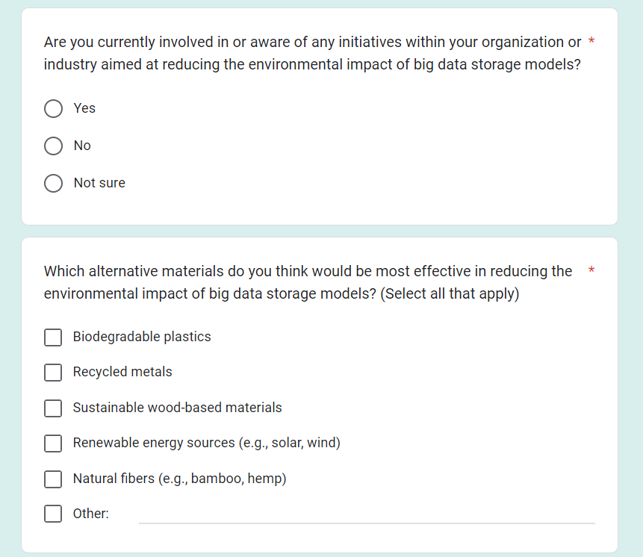

Figure 12: Survey 4

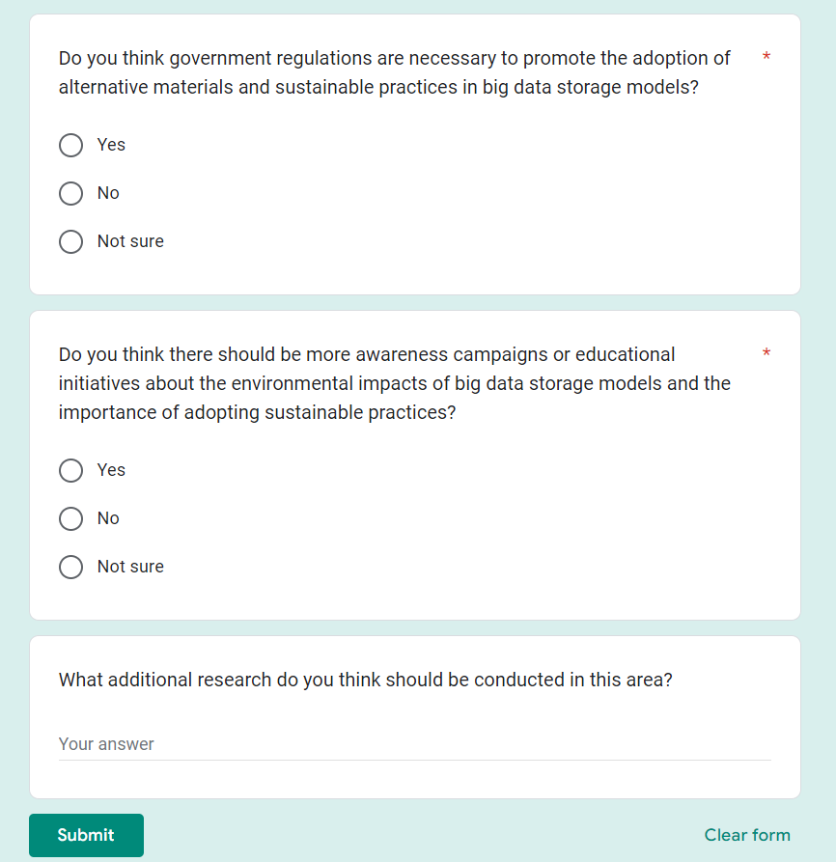

Figure 13: Survey 5

1. **Survey summary**

In this part I used Google Form to conduct the survey. The survey questions I asked were:

* How aware are you of the environmental impacts associated with current big data storage models?
* Do you believe that using alternative materials in big data storage models can help reduce environmental impacts?
* Are you familiar with any alternative materials that can be used in big data storage models to reduce environmental impacts? If yes, please specify.
* What do you think are the main barriers to implementing alternative materials in big data storage models?
* Do you think the use of renewable energy sources in data centers could help mitigate environmental impacts?
* Are you currently involved in or aware of any initiatives within your organization or industry aimed at reducing the environmental impact of big data storage models?
* Which alternative materials do you think would be most effective in reducing the environmental impact of big data storage models?
* Do you think government regulations are necessary to promote the adoption of alternative materials and sustainable practices in big data storage models?
* Do you think there should be more awareness campaigns or educational initiatives about the environmental impacts of big data storage models and the importance of adopting sustainable practices?
* What additional research do you think should be conducted in this area?

In the following section, I will provide the results obtained after conducting the survey:

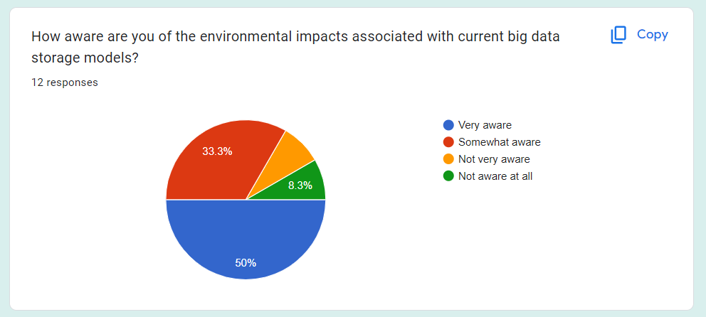To the question: "How aware are you of the environmental impacts associated with current big data storage models?", 50% of interviewees answered "Very aware". 33.3% answered "Somewhat aware". The remaining answers were "Not very aware" and "Not aware at all".

Figure 14: Survey 1

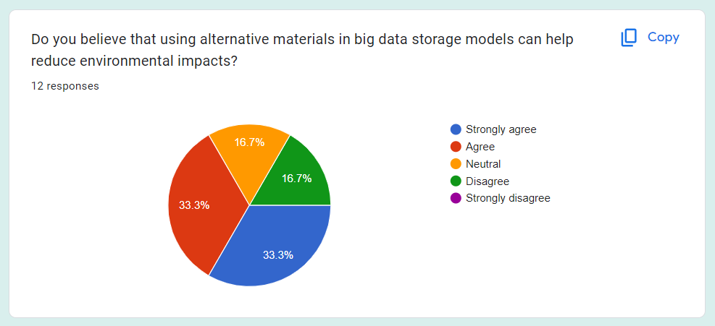To the question: "Do you believe that using alternative materials in big data storage models can help reduce environmental impacts?", the answers "Strongly agree" and "Agree" both reached 33.3%. The answers "Neutral" and "Disagree" also have the same percentage of 16.7%. No one is allowed to answer "Strongly disagree".

Figure 15: Survey 2

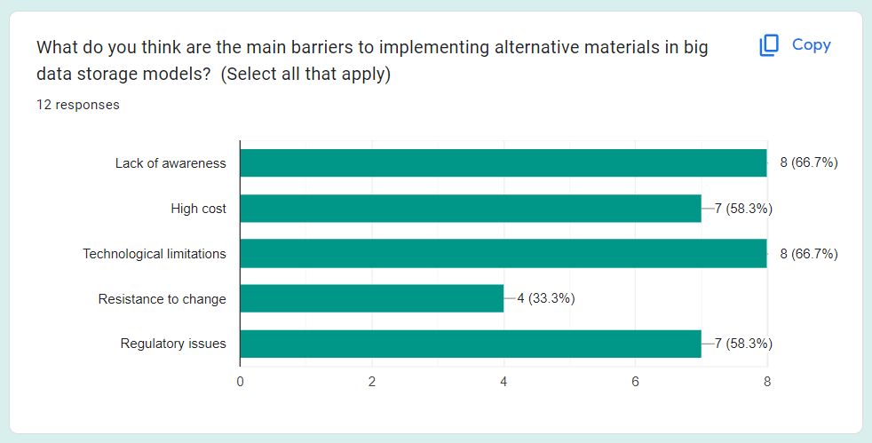To the question: "What do you think are the main barriers to implementing alternative materials in big data storage models?". The percentage of answers obtained were: "Lack of awareness" and "Technological limitations" respectively, accounting for 66.7%. "High cost" and "Regulatory issues" together account for 58.3%. "Resistance to change" accounts for 33.3%.

Figure 16: Survey 3

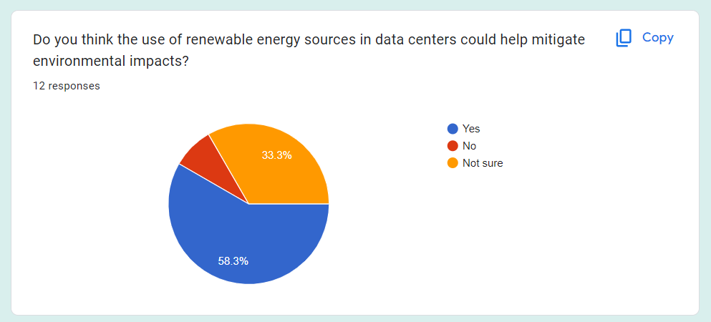To the question: "Do you think the use of renewable energy sources in data centers could help mitigate environmental impacts?". 58.3% of the interviewees answered "Yes", 33.3% gave the answer "Not sure" and the rest answered "No".

Figure 17: Survey 4

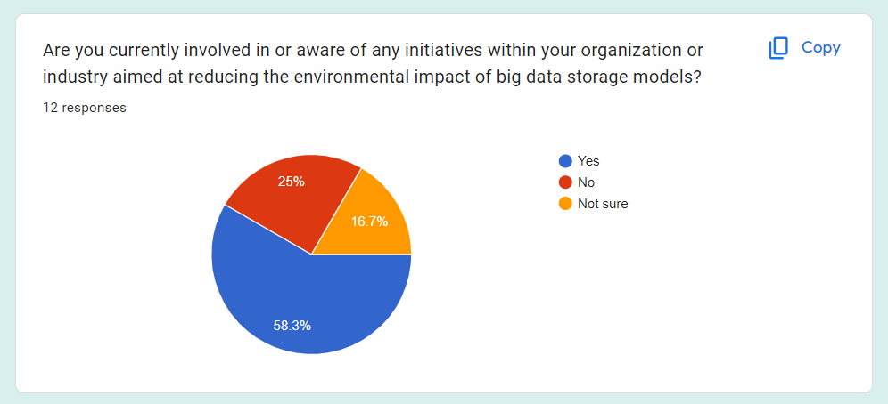To the question: "Are you currently involved in or aware of any initiatives within your organization or industry aimed at reducing the environmental impact of big data storage models?". 58.3% of the interviewees answered "Yes", 25% gave the answer "No" and the answer was "Not sure" accounting for 16.7%.

Figure 18: Survey 5

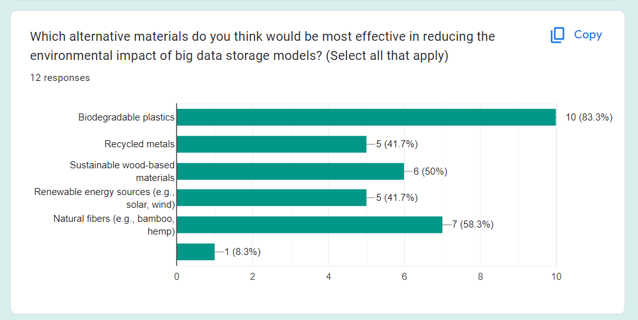To the question: "Which alternative materials do you think would be most effective in reducing the environmental impact of big data storage models?". 83.3% chose "Biodegradable plastics". 58.3% chose "Natural fibers". 50% choose "Sustainable wood-based materials". "Recycled metals" and "Renewable energy sources" have the same percentage of choices at 41.7%.

Figure 19: Survey 6

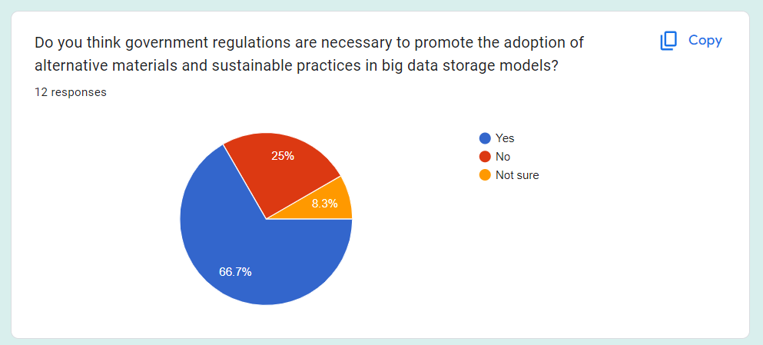To the question: "Do you think government regulations are necessary to promote the adoption of alternative materials and sustainable practices in big data storage models?". 66.7% gave the answer "Yes". 25% chose "No" and 8.3% chose "Not sure".

Figure 20: Survey 7

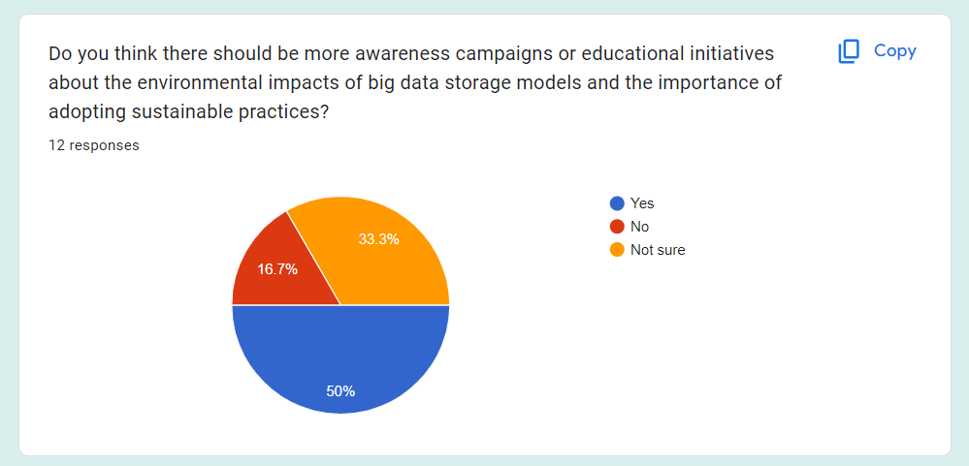To the question: "Do you think there should be more awareness campaigns or educational initiatives about the environmental impacts of big data storage models and the importance of adopting sustainable practices?". 50% gave the answer "Yes". 33.3% chose "Not sure" and 16.7% chose "No".

Figure 21: Survey 8

For the 2 questions, enter your answer as "Are you familiar with any alternative materials that can be used in big data storage models to reduce environmental impacts? If yes, please specify." and "What additional research do you think should be conducted in this area?" The most common response was that they were not familiar with any alternative materials that could be used in big data storage models to reduce environmental impact. A few had other answers about alternative materials: bamboo or biodegradable plastic. The majority of users interviewed also did not offer any suggestions for conducting additional research in this area.

1. **Analyze the results of the Primary research**

In Primary research, I conducted two methods of collecting information: interviews and surveys. After conducting 5 interviews, I will provide analysis based on the results obtained as follows:

Awareness of environmental impact: All five experts agreed that information technology, especially large data centers, has a significant impact on the environment. They gave specific examples of energy consumption, electronic waste production and environmental pollution.

Alternative materials perspective: There is a consensus that using alternative materials in big data storage models can help reduce environmental impact. However, there is diversity in determining the most preferred alternative material.

Challenges and opportunities: Experts highlighted challenges such as high costs, resistance to change, and regulatory issues. However, they also recognize that the use of renewable energy sources and legislative support can create opportunities for the adoption of sustainable solutions.

Current awareness and action: Some experts said they were involved in or aware of initiatives aimed at minimizing the environmental impact of big data storage models, while others were unsure about this.

Suggestions for the future: Experts suggest that more collaboration between stakeholders and awareness campaigns are needed to promote the use of alternative materials and big data storage methods lasting.

In summary, the results of the interviews showed a consistent perception of the importance of researching and applying sustainable solutions to minimize the environmental impact of data storage models. big. Challenges and opportunities have been identified, and suggestions for the future have been proposed to advance this progress.

Based on the results of the survey, I have the following analysis:

Awareness of Environmental Impacts: 50% of respondents indicated that they are "Very aware" of the environmental impacts associated with current big data storage models, while 33.3% reported being "Somewhat aware." This suggests that the majority of participants have a good level of awareness regarding this issue.

Perceptions of Alternative Materials: There is a divergence of opinion, but a relatively high percentage (66.7%) believe that using alternative materials in big data storage models can help reduce environmental impacts.

Barriers and Opportunities: Major challenges in implementing alternative materials include lack of awareness and technological limitations, as identified by 66.7% of respondents. High cost and regulatory issues together accounted for 58.3%. This reflects some degree of acceptance and readiness for change within the community.

Use of Renewable Energy Sources: A significant proportion (58.3%) believe that the use of renewable energy sources in data centers could help mitigate environmental impacts, although some remain unsure (33.3%).

Current Practices and Awareness: A notable percentage (58.3%) of respondents are currently involved in or aware of initiatives aimed at reducing the environmental impact of big data storage models.

Preferred Alternative Materials: Alternative materials such as biodegradable plastics and renewable energy sources have gained significant acceptance, with 83.3% and 41.7% of respondents choosing them respectively.

Role of Government Regulations: A majority (66.7%) believe that government regulations are necessary to promote the adoption of alternative materials and sustainable practices in big data storage models.

Awareness Campaigns: A significant portion (50%) of respondents believe that there should be more awareness campaigns or educational initiatives about the environmental impacts of big data storage models and the importance of adopting sustainable practices.

## **P5 Communicate research outcomes in an appropriate manner for the intended audience**

1. **Conclution**

Based on the interviews and survey conducted on the topic "Environmental Impacts and the Search for Alternative Materials in Big Data Storage Models," several conclusions can be drawn: Firstly, there is a significant level of awareness among participants regarding the environmental impacts associated with current big data storage models. This indicates a growing recognition within the industry about the importance of addressing these environmental concerns. Secondly, there is a notable interest among participants in exploring alternative materials for big data storage models to mitigate environmental impacts. This suggests a willingness to explore innovative solutions to address environmental challenges. Thirdly, participants highlighted various barriers to implementing alternative materials, including lack of awareness, technological limitations, high costs, and regulatory issues. Addressing these barriers will be crucial in facilitating the adoption of alternative materials in big data storage models. Moreover, there is significant support for the use of renewable energy sources in data centers to reduce environmental impacts. This indicates a recognition of the potential of renewable energy to contribute to sustainability efforts in the industry. Additionally, the majority of participants believe that government regulations are necessary to promote the adoption of alternative materials and sustainable practices in big data storage models. This underscores the importance of regulatory frameworks in driving sustainability initiatives. Furthermore, there is a consensus among participants regarding the need for more awareness campaigns or educational initiatives about the environmental impacts of big data storage models and the importance of adopting sustainable practices. This highlights the importance of raising awareness and educating stakeholders about sustainability issues in the industry.

In conclusion, the findings suggest a growing recognition of the environmental impacts associated with big data storage models and a willingness to explore alternative materials and sustainable practices. Addressing barriers and implementing supportive regulatory frameworks will be essential in promoting sustainability in the field of big data storage.

1. **Recommendation**

Based on the conclusions drawn from the study on "Environmental impact and search for alternative materials in big data storage models", below are some suggestions for improvement. By implementing these recommendations, I believe stakeholders can work together to minimize the environmental impact of big data storage models and promote a more sustainable digital future:

Increase Awareness and Education: Develop and implement comprehensive awareness campaigns and educational initiatives aimed at raising awareness about the environmental impacts of current big data storage models and the importance of adopting sustainable practices. This could include workshops, seminars, and online resources targeted at industry professionals, policymakers, and the general public.

Research and Development: Invest in research and development efforts to explore and develop innovative alternative materials for big data storage models that are environmentally friendly, cost-effective, and technologically feasible. Collaborate with academic institutions, research organizations, and industry partners to accelerate progress in this area.

Policy Support: Advocate for supportive government policies and regulations to incentivize the adoption of alternative materials and sustainable practices in big data storage models. This could include tax incentives, grants, and subsidies for companies investing in sustainable technologies and practices.

Technology Advancements: Continue to invest in advancements in technology that enable the implementation of alternative materials in big data storage models. This could include advancements in recycling technologies, renewable energy sources, and energy-efficient data center designs.

Industry Collaboration: Foster collaboration among industry stakeholders, including technology companies, data center operators, and environmental organizations, to share best practices, knowledge, and resources for promoting sustainability in big data storage.

Consumer Awareness: Educate consumers about the environmental impacts of their digital activities and empower them to make informed choices about the products and services they use. This could include labeling systems that provide information about the environmental footprint of digital products and services.

Continuous Improvement: Foster a culture of continuous improvement within the industry, encouraging companies to regularly review and update their sustainability practices in response to new technologies, regulations, and best practices.

1. **CONCLUSION**

In short, I have provided a report that includes knowledge and information about the research topic "Environmental Impacts and the Search for Alternative Materials in Big Data Storage Models". In this report, I have provided knowledge about Research Methods: Primary research, Secondary research, Qualitative research, Quantitative research, Research process,... I have also provided information such as Project type, Abstracts, Situation, Aim and Objectives, Project plan in this report. In addition, I also conducted interviews and surveys as well as made conclusions and analyzes based on the results obtained.

1. **REFERENCES**

Oracle.com. (2021). *What Is Big Data?* [online] Available at: <https://www.oracle.com/big-data/what-is-big-data/> [Accessed 7 Mar. 2024].

Scribbr. (2019). *Research Methods | Definitions, Types, Examples*. [online] Available at: <https://www.scribbr.com/category/methodology/> [Accessed 7 Mar. 2024].

‌Soton.ac.uk. (2024). *LibGuides@Southampton: Primary research: Home*. [online] Available at: [https://library.soton.ac.uk/sash/primary-research](https://library.soton.ac.uk/sash/primary-research%20) [Accessed 7 Mar. 2024].

‌George, T. (2023). *What is Secondary Research? | Definition, Types, & Examples*. [online] Scribbr. Available at: <https://www.scribbr.com/methodology/secondary-research/> [Accessed 7 Mar. 2024].

‌Bhandari, P. (2020). *What Is Qualitative Research? | Methods & Examples*. [online] Scribbr. Available at: <https://www.scribbr.com/methodology/qualitative-research/> [Accessed 7 Mar. 2024].

‌‌Bhandari, P. (2020). *What Is Quantitative Research? | Definition, Uses & Methods*. [online] Scribbr. Available at: <https://www.scribbr.com/methodology/quantitative-research/> [Accessed 7 Mar. 2024].