Ruozhong Yang (ry8)

IE598 MLF F18

Module 7 Homework (Random Forest)

Using the Wine dataset, described in Raschka chapter 4 and 10 fold cross validation;

**Part 1: Random forest estimators**

Fit a random forest model, try N_estimators form 1 to 100, report in-sample accuracies. We can get a list like this:

|  |  |  |  |  |  |  |  |
| --- | --- | --- | --- | --- | --- | --- | --- |
| N estimators | in-sample accuracies | N estimators | in-sample accuracies | N estimators | in-sample accuracies | N estimators | in-sample accuracies |
| 1 | 0.8541667 | 26 | 0.9748611 | 51 | 0.9748611 | 76 | 0.9748611 |
| 2 | 0.8575 | 27 | 0.9748611 | 52 | 0.9748611 | 77 | 0.9748611 |
| 3 | 0.94375 | 28 | 0.9681944 | 53 | 0.9748611 | 78 | 0.9748611 |
| 4 | 0.9304167 | 29 | 0.9748611 | 54 | 0.9748611 | 79 | 0.9748611 |
| 5 | 0.9308333 | 30 | 0.9748611 | 55 | 0.9748611 | 80 | 0.9748611 |
| 6 | 0.9308333 | 31 | 0.9748611 | 56 | 0.9748611 | 81 | 0.9748611 |
| 7 | 0.9375 | 32 | 0.9748611 | 57 | 0.9748611 | 82 | 0.9748611 |
| 8 | 0.9563889 | 33 | 0.9748611 | 58 | 0.9748611 | 83 | 0.9748611 |
| 9 | 0.9426389 | 34 | 0.9748611 | 59 | 0.9748611 | 84 | 0.9748611 |
| 10 | 0.9430556 | 35 | 0.9748611 | 60 | 0.9748611 | 85 | 0.9748611 |
| 11 | 0.9430556 | 36 | 0.9748611 | 61 | 0.9748611 | 86 | 0.9748611 |
| 12 | 0.9430556 | 37 | 0.9748611 | 62 | 0.9748611 | 87 | 0.9748611 |
| 13 | 0.9493056 | 38 | 0.9748611 | 63 | 0.9748611 | 88 | 0.9748611 |
| 14 | 0.9681944 | 39 | 0.9748611 | 64 | 0.9748611 | 89 | 0.9748611 |
| 15 | 0.9681944 | 40 | 0.9748611 | 65 | 0.9748611 | 90 | 0.9748611 |
| 16 | 0.9681944 | 41 | 0.9748611 | 66 | 0.9748611 | 91 | 0.9748611 |
| 17 | 0.9681944 | 42 | 0.9748611 | 67 | 0.9748611 | 92 | 0.9748611 |
| 18 | 0.9748611 | 43 | 0.9748611 | 68 | 0.9748611 | 93 | 0.9748611 |
| 19 | 0.9748611 | 44 | 0.9748611 | 69 | 0.9748611 | 94 | 0.9748611 |
| 20 | 0.9681944 | 45 | 0.9748611 | 70 | 0.9748611 | 95 | 0.9748611 |
| 21 | 0.9681944 | 46 | 0.9748611 | 71 | 0.9748611 | 96 | 0.9748611 |
| 22 | 0.9748611 | 47 | 0.9748611 | 72 | 0.9748611 | 97 | 0.9748611 |
| 23 | 0.9748611 | 48 | 0.9748611 | 73 | 0.9748611 | 98 | 0.9748611 |
| 24 | 0.9748611 | 49 | 0.9748611 | 74 | 0.9748611 | 99 | 0.9748611 |
| 25 | 0.9748611 | 50 | 0.9748611 | 75 | 0.9748611 | 100 | 0.9748611 |

With the rise of the n estimators the accuracies scores raised(more decision tree), however the time also increased. Since the result when n>=30 is almost the same, we make the N estimators equals to 30.

**Part 2: Random forest feature importance**

Display the individual feature importance of your best model in Part 1 above using the code presented in Chapter 4 on page 136. {importances=forest.feature_importances_ }

The result is as below.

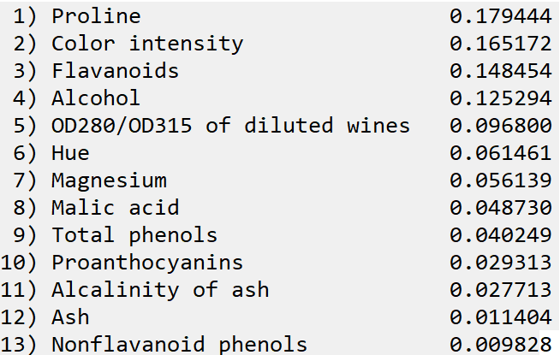

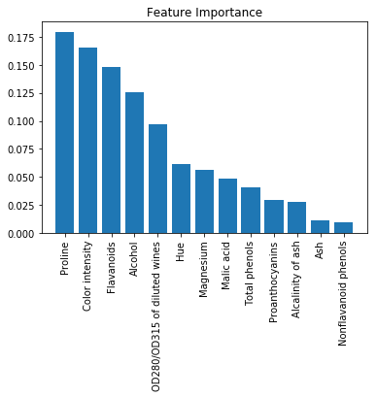

**Part 3: Conclusions**

When the n_estimator raise, the accuracy score raise until the n_estimators big enough(30). At the same time, the computation time also raise. The optimal number in this program is 30. The program calculates the variance and then calculates the mean of all trees’ variance.

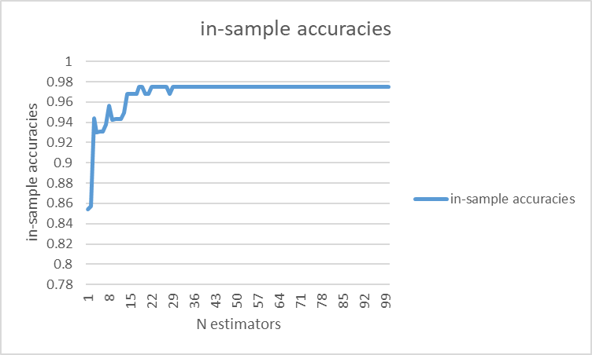

**Part 4: Appendix**

<https://github.com/yrz437396236/IE598_F18_HW1/tree/master/IE598_F18-HW7>