**First version**

This report is an informal report about what I found when I try to analyze the correlation and other statistic features of BP and RDSA.

1. The model I use is ,, from 2018 1min data.
2. Residuals is with 1.355027 std deviation and near zero mean(-2.827601e-15)
3. However, AR1 model shows they are highly correlation with the previous minute, but we should notice the fat tail of the noise of residuals (of course they will, since there is no price jump)

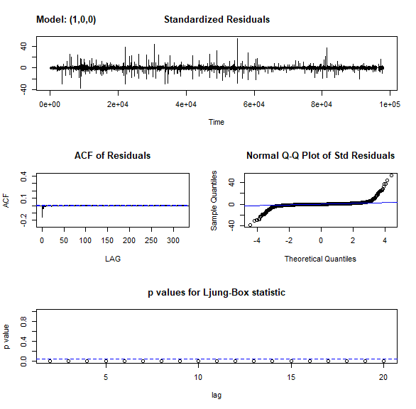

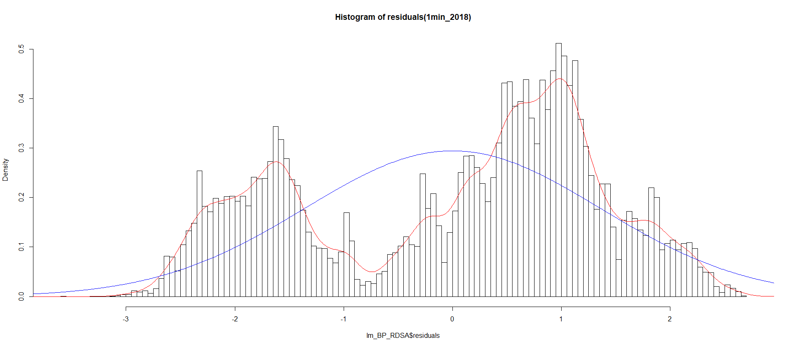

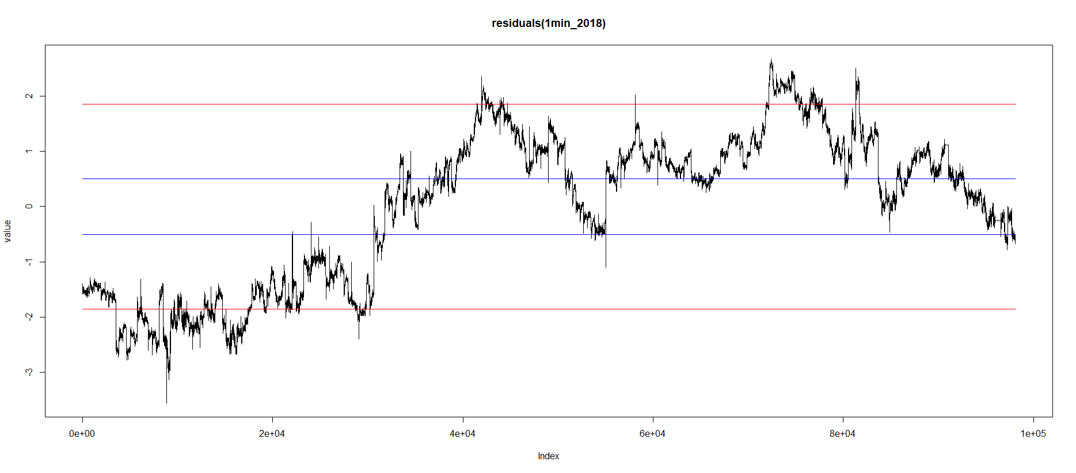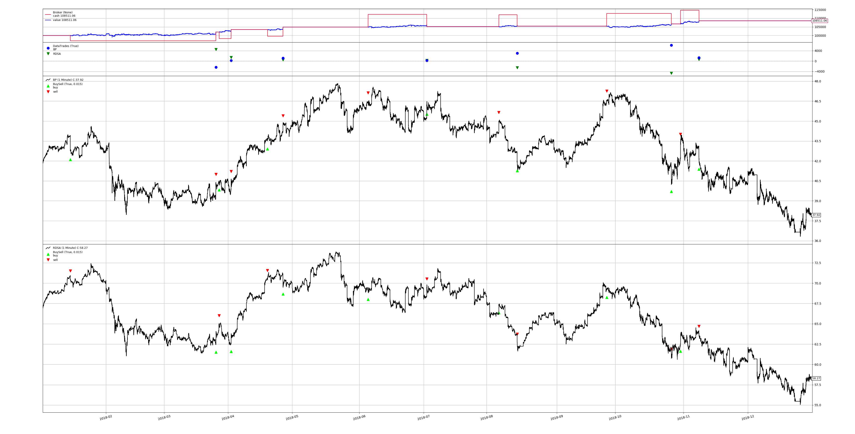

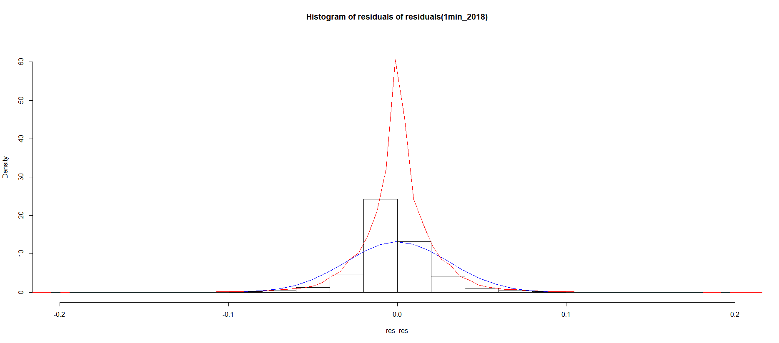

For the risk measure, the historical VaR is 13650, the Delta-Normal VaR is 19450.61

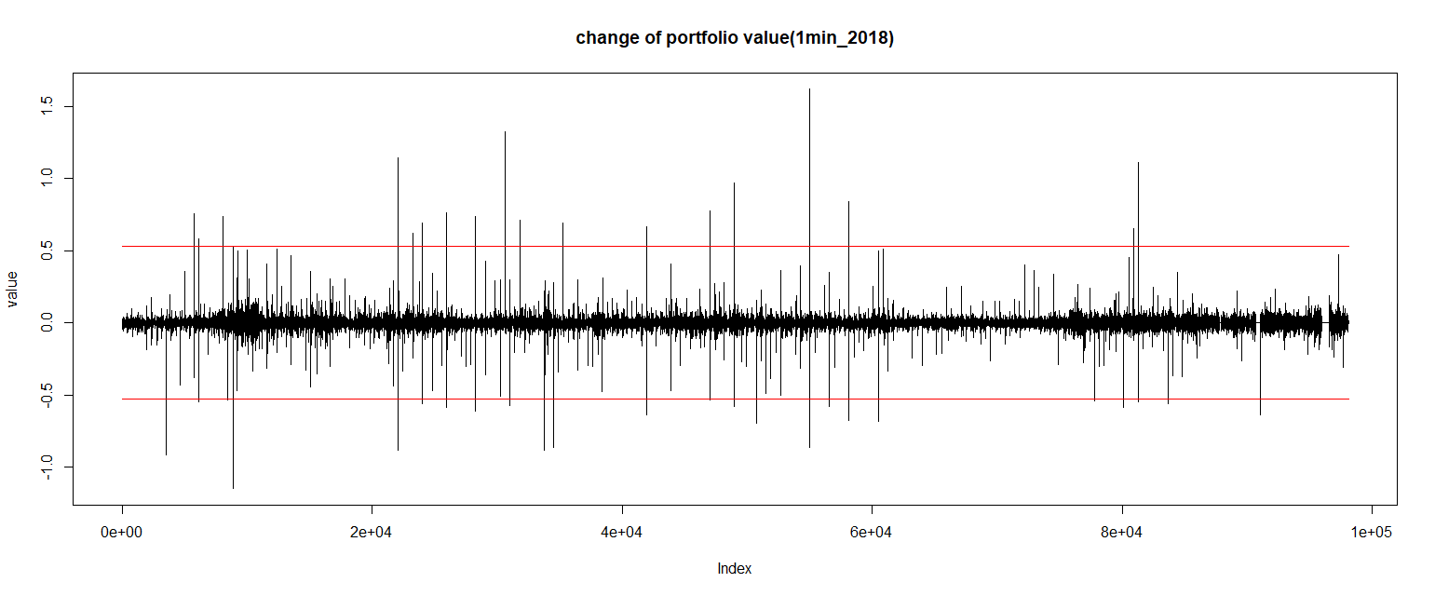

(this picture is wrong, new version available in the second part)

Road ahead

1. More accurate VaR measure (ES or EVT or t-distribution via MLE maybe)

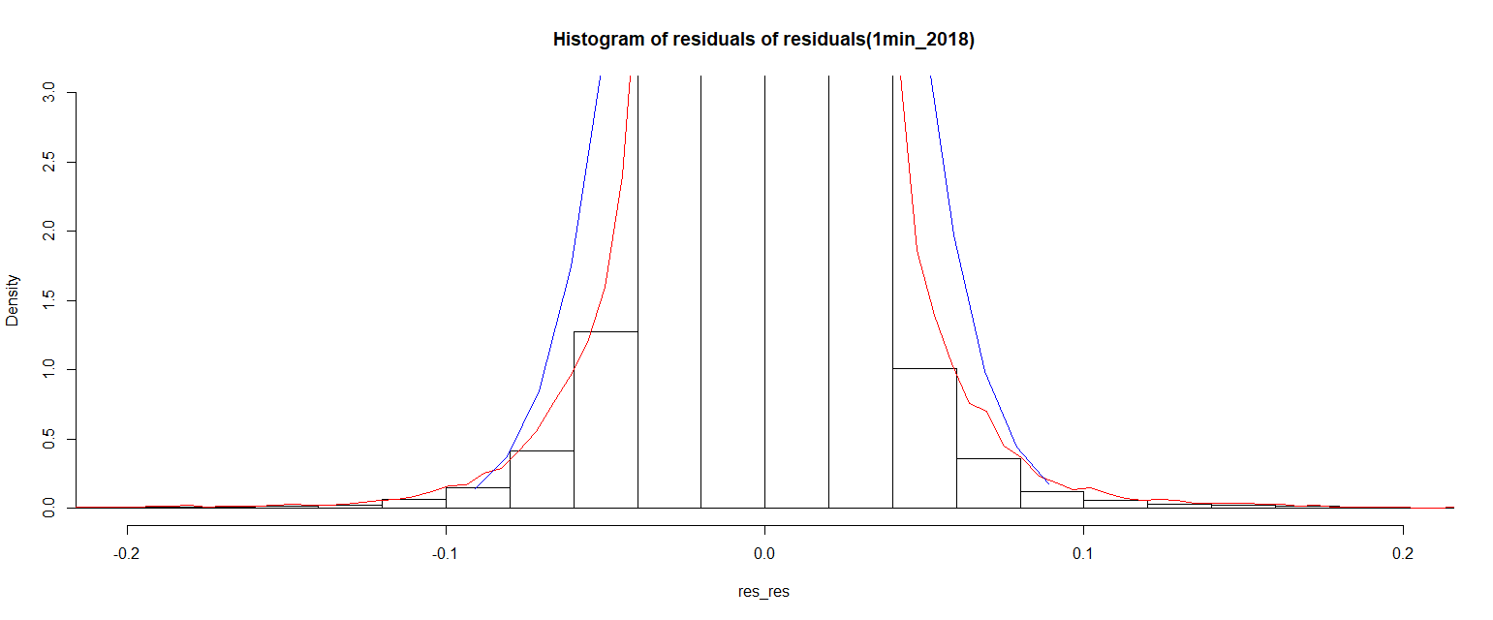

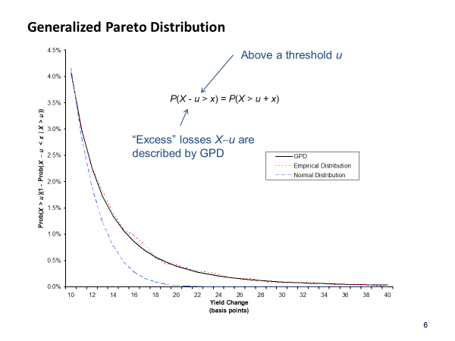

1. limit losses and take profit

what happened in the previous year is

1. use previous year for this year (2017 for 2018)

Then average this data for previous 10 year and take the average

**Second version**

Main changes

1. number of shares need to be an int

C:\Users\43739\AppData\Local\Temp\1558156995(1).png

|  |  |
| --- | --- |
|  |  |
| as an int | old plot |

1. limit losses and take profit

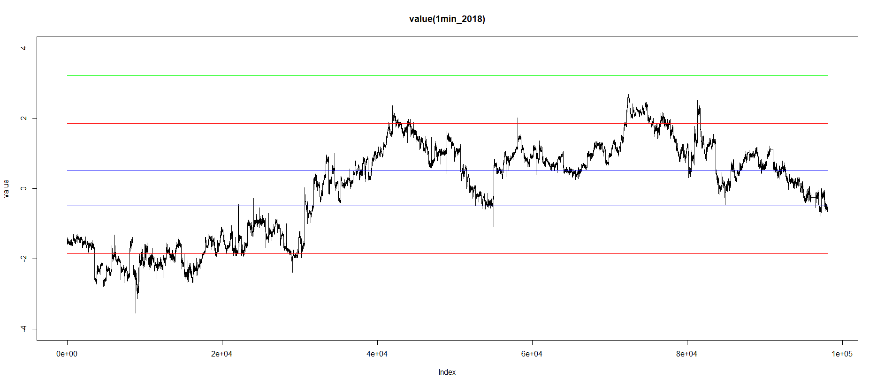

The new green line is our limit loss line (2*std+0.5)

1. daily change of portfolio value

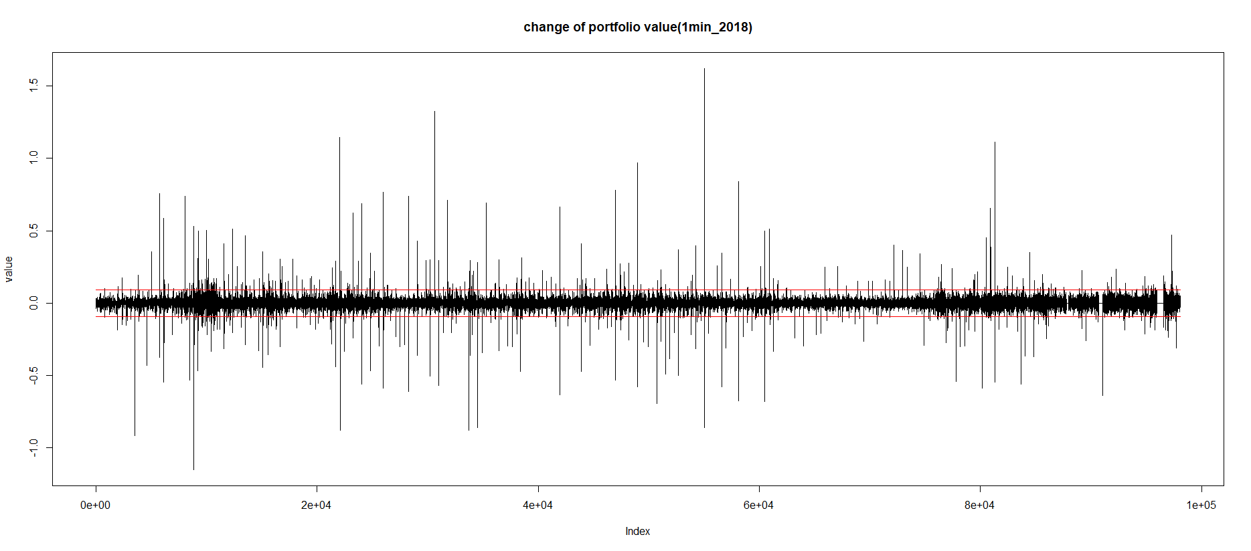

Red line is ±3*std (mean is almost zero), really fat tail

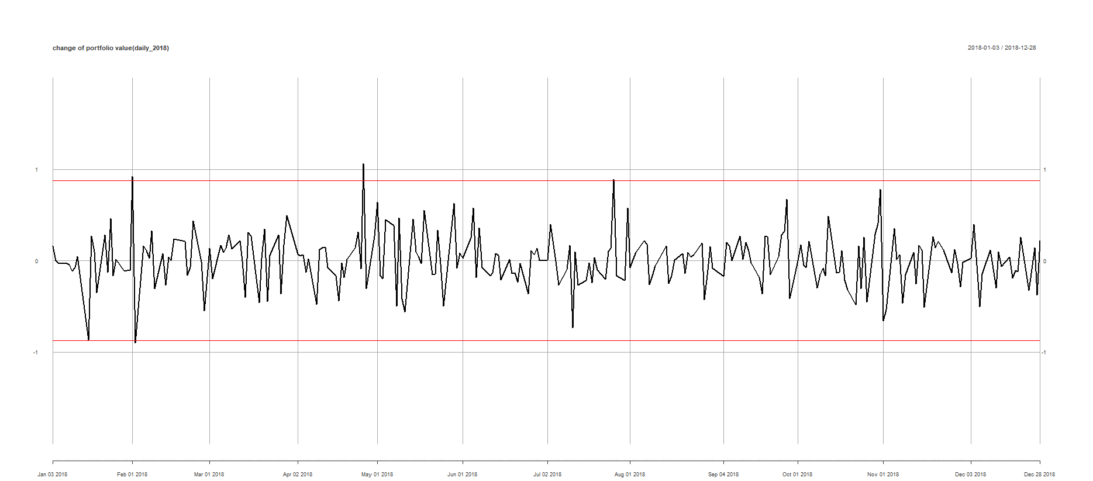

The std is 0.2894637, mean is 0.005978048

Red line is (±3*std+mean)

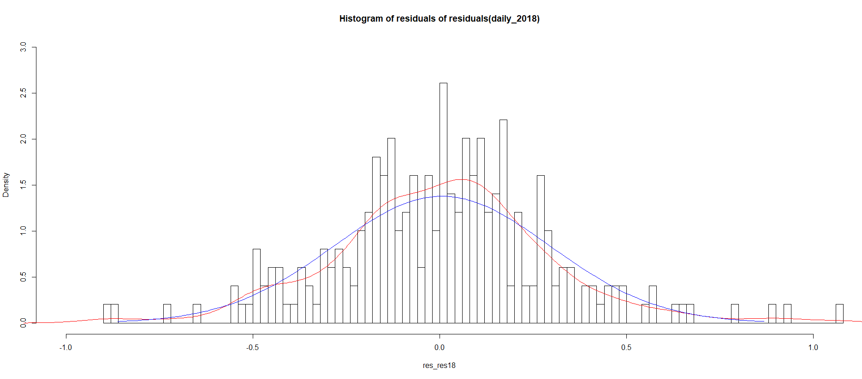

Red line is the density blue is the normal use its mean and std, the daily change of our product is also with fat tail and pointed head but look more “normal” than 1 min.

1. bid ask

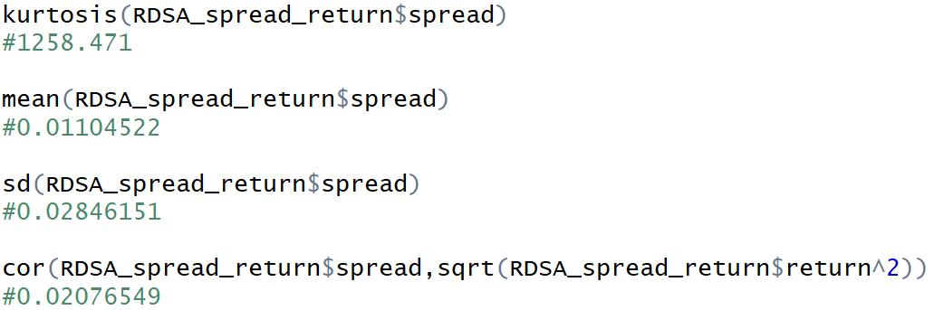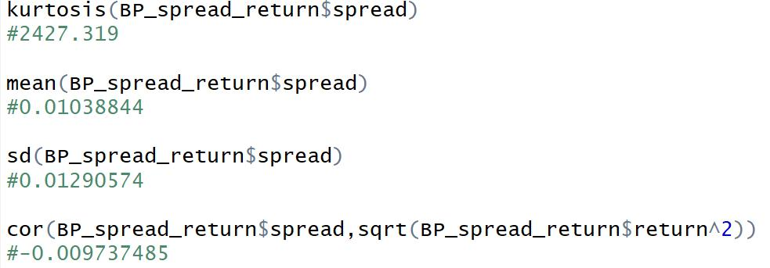

No cor and pass the ADF test

<https://en.wikipedia.org/wiki/Augmented_Dickey%E2%80%93Fuller_test>

<https://cran.r-project.org/web/packages/aTSA/aTSA.pdf>

use previous year for this year

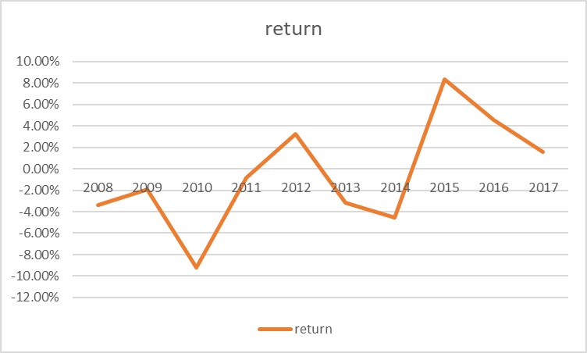

May not

1. extreme case

Can’t find way to clean our position so we can’t adjust the size of our order since we may not be able the clean our position later.

1. order book