NetID: ry8

In this project, I write 6 functions.

1. Random number generator

Produce random number between -5 to 5

1. Matrix initializer

Put random number into Matrix

1. Output

Output the data to txt

1. Matrix repeated squaring

Use algorithm to calculate

1. Brute force

Directly calculate

1. Brute force2

Same as the function 5 but without output for calculate time

The plot is as below:

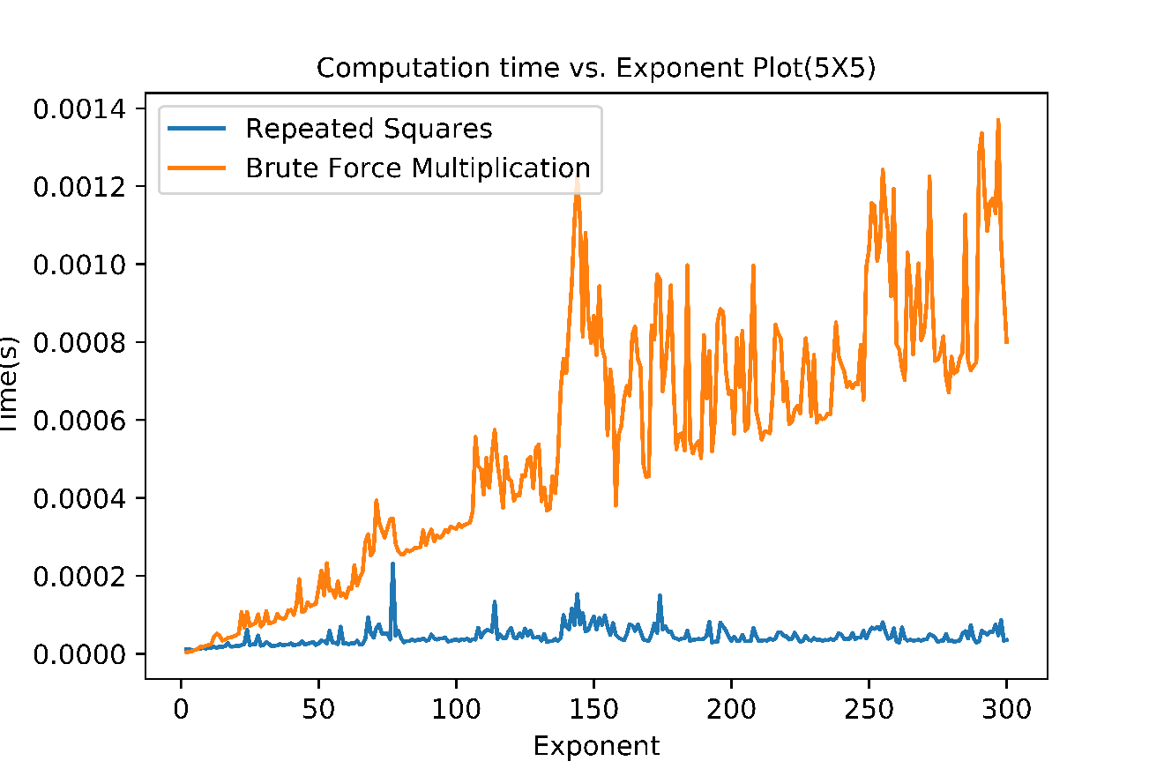

From data(5X5.xlsx) we can tell that when n = 1 or n = 2 or n = 3, brute force is even faster.

