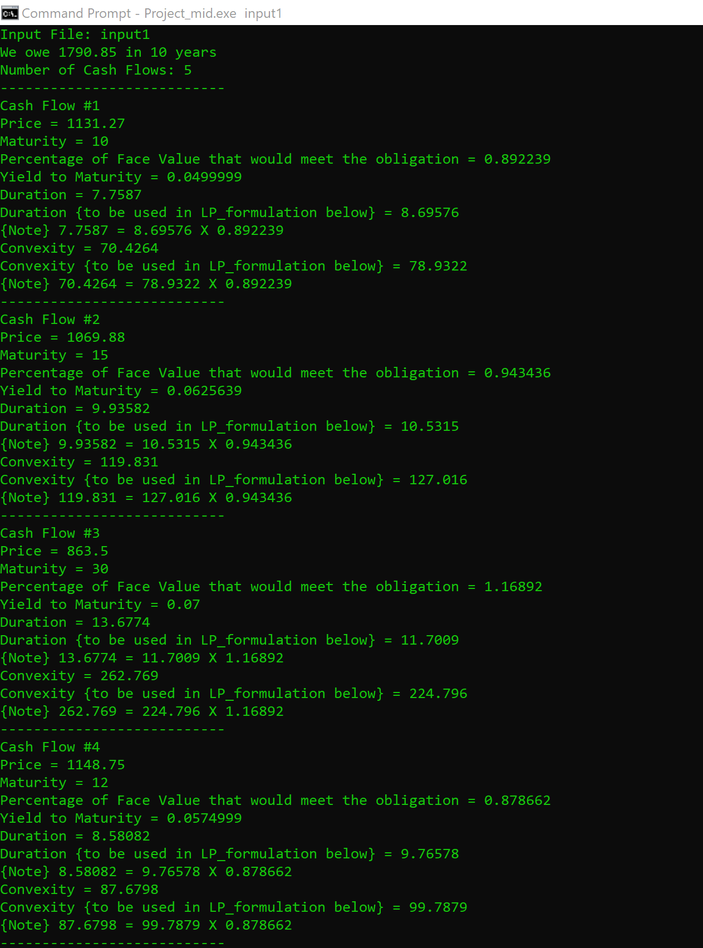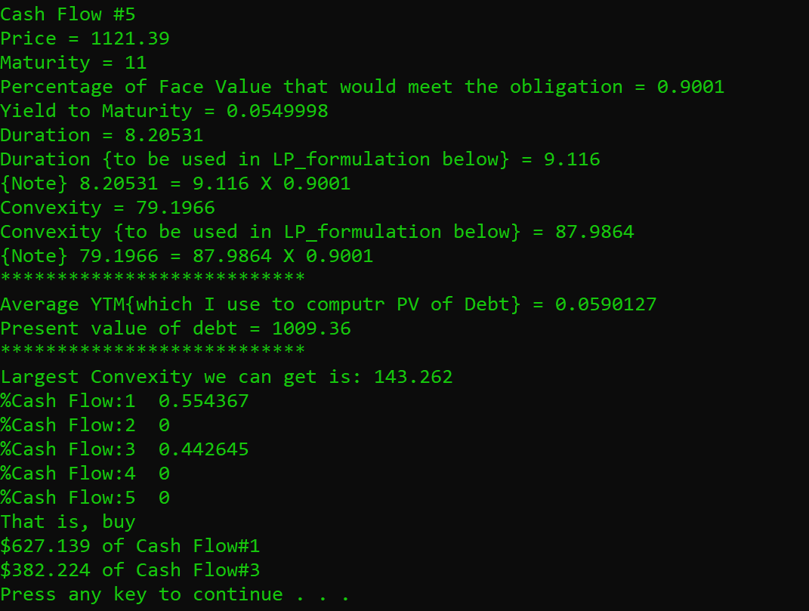

The result with input1

5

1131.27 10 67 67 67 67 67 67 67 67 67 1067

1069.88 15 69.88 69.88 69.88 69.88 69.88 69.88 69.88 69.88 69.88 69.88 69.88 69.88 69.88 69.88 1069.88

863.5 30 59 59 59 59 59 59 59 59 59 59 59 59 59 59 59 59 59 59 59 59 59 59 59 59 59 59 59 59 59 1059

1148.75 12 75 75 75 75 75 75 75 75 75 75 75 1075

1121.39 11 70 70 70 70 70 70 70 70 70 70 1070

1790.85 10

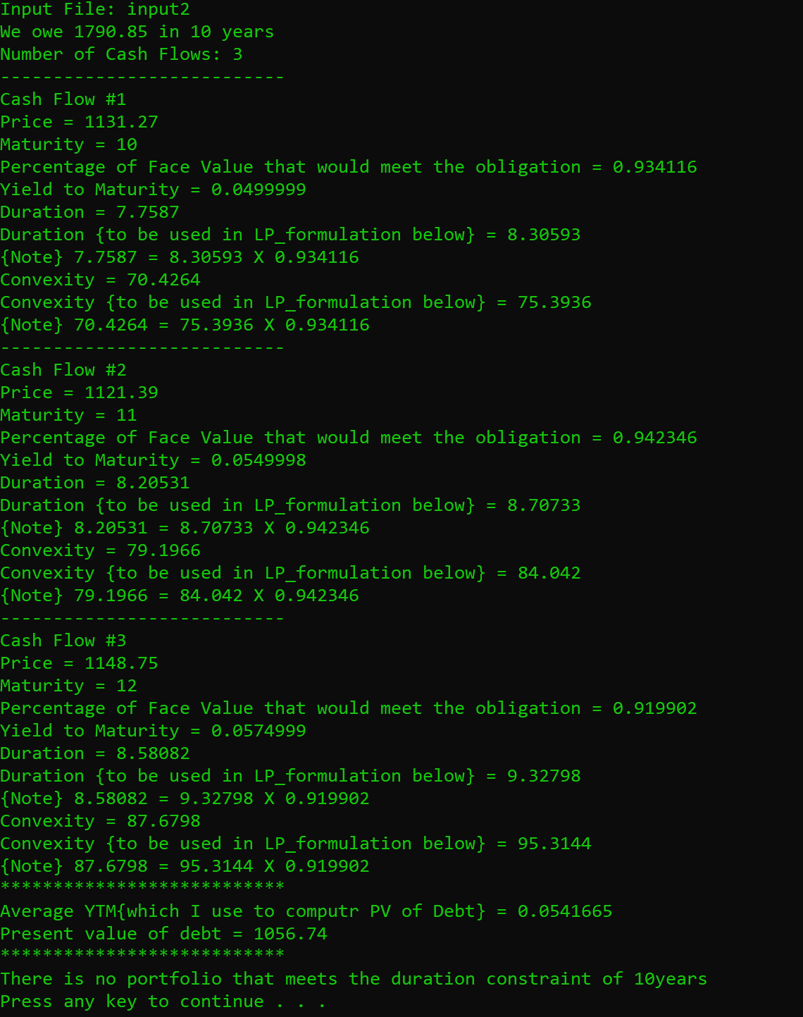

The result with input2

3

1131.27 10 67 67 67 67 67 67 67 67 67 1067

1121.39 11 70 70 70 70 70 70 70 70 70 70 1070

1148.75 12 75 75 75 75 75 75 75 75 75 75 75 1075

1790.85 10

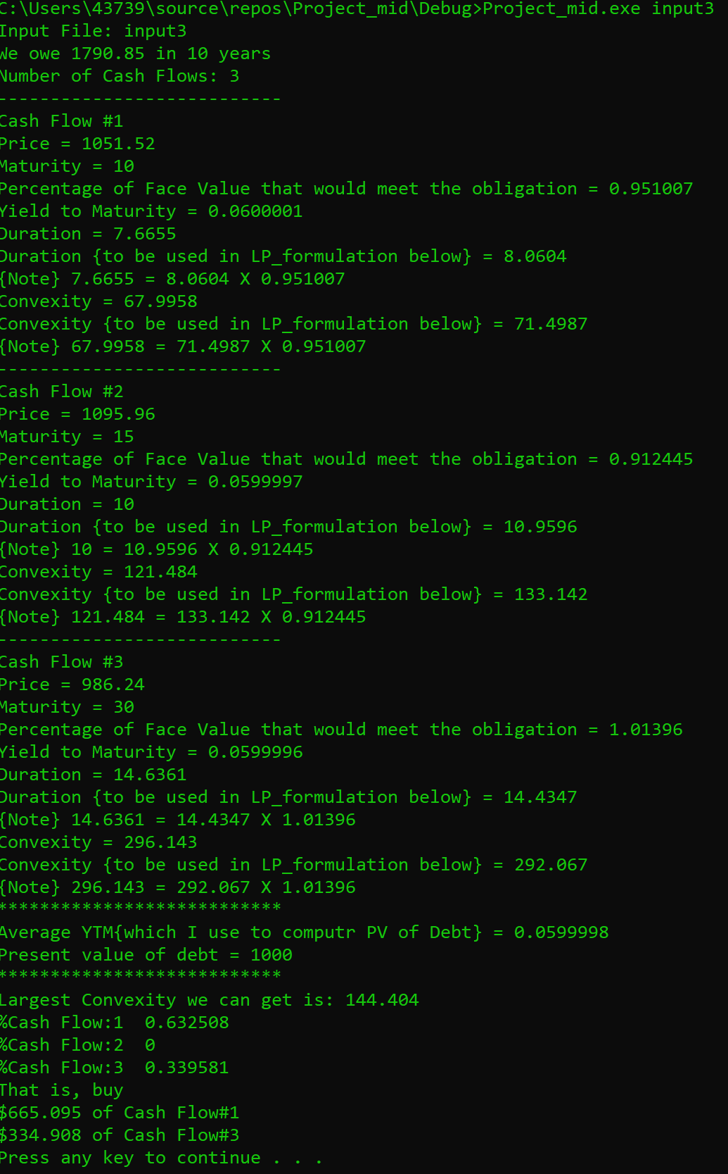

The result with input 3

3

1051.52 10 67 67 67 67 67 67 67 67 67 1067

1095.96 15 69.88 69.88 69.88 69.88 69.88 69.88 69.88 69.88 69.88 69.88 69.88 69.88 69.88 69.88 1069.88

986.24 30 59 59 59 59 59 59 59 59 59 59 59 59 59 59 59 59 59 59 59 59 59 59 59 59 59 59 59 59 59 1059

1790.85 10