The manuscript reports a study of the role of the covalent component of hydrogen bond (HB) interactions in liquid water. Simulations are carried out using two ab initio molecular dynamics (AIMD) models, the conventional Kohn-Sham density functional theory (DFT) approach and the constrained DFT method based on absolutely localized molecular orbitals (ALMO) which are referred to as reference and devalent models respectively. Comparison of the results derived from both models for different physical magnitudes (radial distribution functions, bulk density, number and lifetime of the HB, IR spectrum, ....) allows to evaluate the importance of the charge-transfer of HB.
The manuscript is well structured, the arguments are clearly exposed and the results are original and may have a significant impact. However some clarifications about the methodology are mandatory to make the manuscript acceptable. Specifically my main objections are:
1) I agree that with the authors that "ALMO DFT is able to confine each electron strictly to its own molecule and therefore completely removes the covalent component from intermolecular bonding". However, the use of ALMO not only removes the covalent component but also modifies the remaining (dipoles, polarization and dispersion) interactions. For example, the distribution of dipole moments in the reference and devalent models shown in Figure 6 are very different. In spite of this fact all the discussion is based on the assumption that the dipole, polarization and dispersion components are identical in the reference and devalent models and any difference is coming from the removal of the covalent contribution. I find this inconsistency unaceptable and therefore a well founded justification should be provided by the authors.

The remaining interactions are not modifies in the sense that their nature stays the same. However since in reality the different kind of interactions are not separated but have a significant influence on each other, it’s impossible to modify charge-transfer interactions while keeping other interactions quantitatively intact.
2) Two sets of independent simulations are carried out for the reference and devalent models in the NVT and NPT ensembles. According to the Computational Methods section, the system was equilibrated for 1.5 ps. I find this equilibraton time surprisingly short. Did the authors make any preliminary test to assure that their systems were equilibrated before running the subsequent 35 ps simulations?

We preequilibrated the trajectory for 3 ps, where the time constant of the canonical velocity re-scaling thermostat is set to be a small value of 50fs in order to equilibrate the system fast.
3) I also wonder about how the long range electrostatic interactions are described in these MD simulations: Ewald Sum, PME,.....?
4) In the Density subsection the manuscript states that "The 14% decrease in density should correspond to a 5% elongation in intermolecular distances, assuming a uniform increase." I wonder firstly about how the authors estimated the 5% elongation in intermolecular distances from the 14% decrease in density. Secondly, the maximum of the oxygen-oxygen RDF shifts from 2.8 to 3.1 Angstrom, what seems to be in clear contradiction with the previous estimation.
5) In the Infrared spectrum subsection we read “Unlike stretching modes, the intramolecular bending modes in the region of 1600 cm−1 are unaffected by intermolecular forces and remain approximately the same for the realistic, devalent, and ideal-gas systems.” However it is well-known that the frequency of the water bending mode blue-shifts significantly from gas phase to liquid. Does this inconsistency of the results reveal that the whole calculation of the IR spectrum should be questioned?
Overall I think that these questions should be addressed by the authors before the manuscript could be accepted for publication in Chemical Science.
Referee: 2
Recommendation: Reject
Comments:
This study investigates an interesting idea, i.e., the possibility to characterize the covalent character of the hydrogen bond network in water from computer simulations. Unfortunately, the execution does not live up to this idea.
Although I perfectly recognize the difficulties to carry out accurate AIMD simulations, the choice of dispersion-corrected BLYP is unfortunate. As noted by the authors, it is well known that BLYP suffers from serious limitations [e.g., see J. Chem. Phys. 144, 130901 (2016)], which are difficult to ignore. While a few years ago it would probably have been still OK to report BLYP simulations of water, several (better) functionals are nowadays available which are routinely used in AIMD simulations, some of which have already been reported in Chemical Science (e.g., Chem. Sci. 2017, 8, 3554-3565; PNAS 2017, 114, 10846; J. Chem. Theory Comput., 2018, 14, 884).
The reliability/credibility and, consequently, impact of the results reported in this study would be significantly higher If the authors could repeat the simulations with any of these more modern/accurate functionals.
Other comments:
1) Quantum dynamical methods should be used to properly calculate the infrared spectrum of water, since the IR spectrum is particularly sensitive to zero-point energy and anharmonicity, especially in the high frequency region of the OH stretches (e.g., see J. Chem. Theory Comput., 2015, 11, 1145; J. Phys. Chem. Lett., 2017, 8, 1545). As far as I understand, the simulations presented in this study were carried out at the classical level. The authors should discuss the implications of this choice for the calculated IR spectrum shown in Figure 5.
2) Related to 1), BLYP-D3 has been shown to perform poorly for vibrational frequencies of water (see Figure 2 of J. Chem. Phys. 2015, 143, 214103]. The authors should comment on this and provide some evidence that the IR spectrum shown in Figure 5 is physically meaningful. This is another reason why the simulations should be repeated with a better functional.
3) On the technical side, rigorously, both diffusion and IR spectrum should be calculated in the microcanonical ensemble, contrary to the canonical ensemble used in the present study, to avoid that the application of a thermostat could affect the actual molecular dynamics.
4) It is well known that the dielectric constant of water converges very slowly with respect of simulation time, which is usually on the order of ns. Values of 70 and 180 for the realistic and devalent models, respectively, are reported in this study from 35 ps of simulation. It would be important to report the statistical error associated with these estimates (as well as for the diffusion coefficient and viscosity). In this regard, the values for the dielectric constant are inverted between realistic and devalent models in Table 1.
The following figure shows the calculated dielectric constant as a function of simulation time. The errors of dielectric constants are estimated by the statistical fluctuation after entering equilibrium phase. The dielectric constant for realistic and devalent model are: 70±3, 180±5. We also note that relative short trajectories have been shown to be sufficient in evaluating the dielectric constant. For example in [Phys. Rev. Lett. 2007, 98, 247401] the authors reported a study using 20ps of simulation with PBE functional.

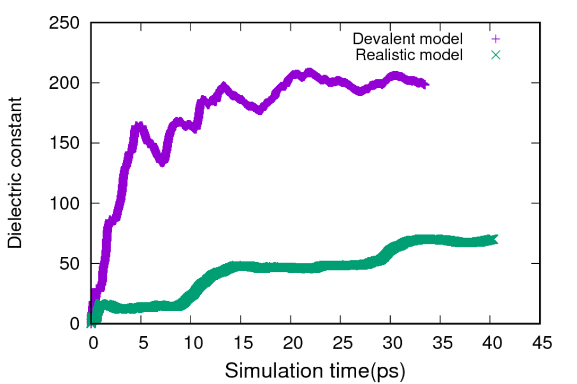

The MSD calculation with error bars are shown below:
