SwadharmaPath
User guide: Admin

Career counselling platform: from enquiry to a tracked career roadmap
Audience: Admins
Last updated: 2026-10-24
Source: docs/ in the SwadharmaPath repository (Markdown is the master copy)

For agency administrators. Your home page is /admin. Navigation: Dashboard | Leads | Counsellors | Careers | Instruments | Templates.
Last updated 2026-10-24. Procedures are in the Operations SOPs and Technical SOPs.
Contents
- 1. Dashboard (/admin)
- 2. Leads (/admin/leads)
- 3. Users and roles
- 4. Counsellors (/admin/counsellors)
- 5. Career library (/admin/careers)
- 6. Streams (/admin/streams)
- 7. Instruments (/admin/instruments)
- 8. Templates (/admin/templates)
- 9. Audit

1. Dashboard (/admin)
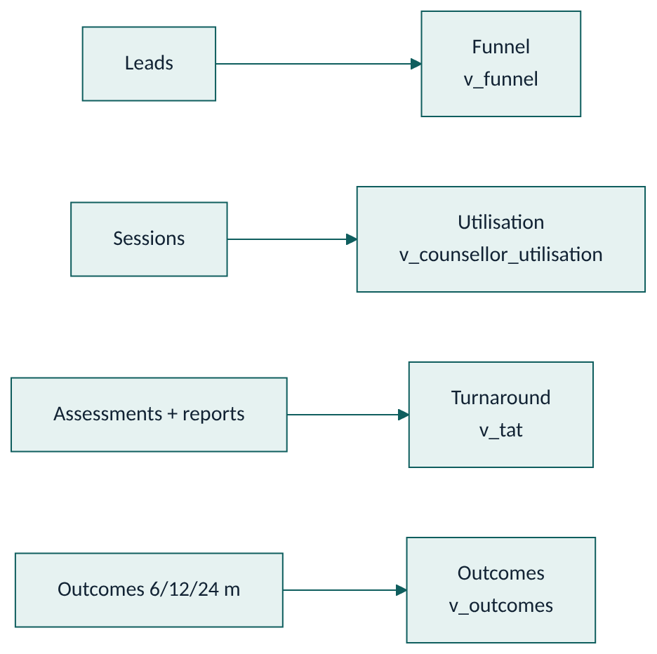
Widget | Source | Meaning
Funnel | v_funnel | Leads by stage and track, total and last 30 days
Revenue | lead stage paid | Manual paid flag in V1
Counsellor utilisation | v_counsellor_utilisation | Active candidates, sessions and attended minutes in 30 days
Report turnaround | v_tat | Days from last completed assessment to first candidate-facing report; pending count
NPS | survey responses | Net promoter score
Outcomes | v_outcomes | Per 6/12/24-month checkpoint: count, % in top 5, average satisfaction

2. Leads (/admin/leads)
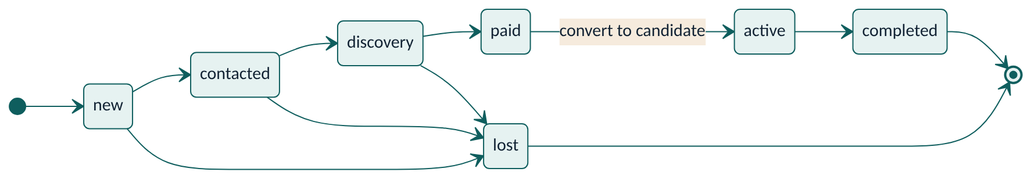
Pipeline board with stages new → contacted → discovery → paid → active → completed (or lost).
- Open a new lead and assign a counsellor.
- Set the next follow-up date.
- Move the card as the conversation progresses. Mark paid when payment is received (manual flag).
- Convert to a candidate: create the candidate account, link the lead, assign the counsellor and, for minors, link the parent account.
The public form is rate-limited: the same phone or email can submit 3 times an hour, and the whole form accepts 30 enquiries a minute.

3. Users and roles
- People who sign up themselves can only be candidates or parents.
- To create a counsellor or admin, invite the user and then change their role. Only an admin can change a role, and the change is enforced in the database.

4. Counsellors (/admin/counsellors)
Caseload and report SLA per counsellor. Reassign candidates when someone is overloaded or on leave.

5. Career library (/admin/careers)
Edit careers (family, RIASEC code, weights, aptitude minimums, work-style and values fit, description, day in the life, entry paths, salary band, outlook, automation exposure, adjacent emerging roles) and education pathways. When refreshing outlook, record the source and set last reviewed. You get a quarterly reminder. Seed content is marked "seed – verify before launch" and must be reviewed.

6. Streams (/admin/streams)
Edit stream options per board: subjects, career families each keeps open and closes, notes. CBSE is seeded with 8 streams.

7. Instruments (/admin/instruments)
Manage versions, upload norms and activate an instrument version. Only active versions are served. Test items, scoring keys and norms are never sent to candidates' browsers. See SOP-O9.

8. Templates (/admin/templates)
Roadmap templates and session-note templates (by ICCC stage).

9. Audit
Admins can read the audit log (consents, disclaimer acceptances, Swadharma releases). No one, including admins, can edit or delete audit entries or Swadharma releases.

