SwadharmaPath
User guide: Candidate

Career counselling platform: from enquiry to a tracked career roadmap
Audience: Students and professionals
Last updated: 2026-10-24
Source: docs/ in the SwadharmaPath repository (Markdown is the master copy)

For students (Class 8 to postgraduate) and working professionals using SwadharmaPath. Your home page is /me.
Last updated 2026-10-24. If something on screen does not match this guide, tell your counsellor, and see Self-help troubleshooting.
Contents
- 1. Your journey at a glance
- 2. Signing in
- 3. Onboarding (/me/onboard)
- 4. Taking assessments (/me/assess)
- 5. Your profile (/me/profile)
- 6. Your options
- 7. Sessions (/me/sessions)
- 8. Roadmap (/me/roadmap)
- 9. Reports (/me/reports)
- 10. Privacy
- 11. Disclaimer

1. Your journey at a glance
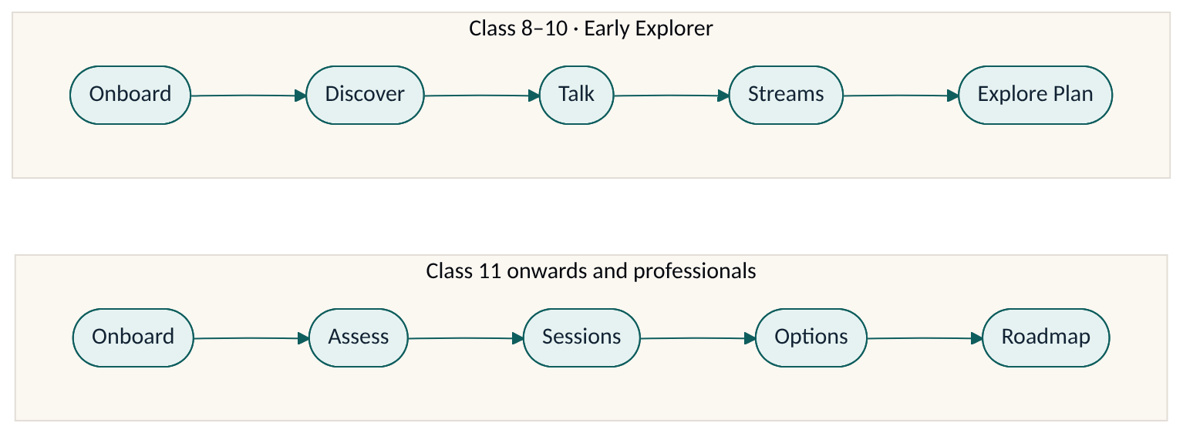
The progress bar at the top of /me shows where you are.
Class 11–12, college and professionals | Class 8–10 (Early Explorer)
Onboard → Assess → Sessions → Options → Roadmap | Onboard → Discover → Talk → Streams → Explore Plan
Early Explorer screens use bigger text and friendlier language, and help you choose a stream for Class 11–12 rather than a single career.

2. Signing in
- Go to /login.
- Sign in with your email and password, or with your phone number and the one-time code (OTP) sent by SMS.
- You land on /me.
Your counsellor or the agency usually creates your account after your enquiry. If you have not received a login, contact the agency.

3. Onboarding (/me/onboard)
- Profile — name, city, school or employer, class or years of experience.
- Academics — recent marks and subjects.
- Constraints — things that limit your choices, such as budget, location or timelines.
- Subject enjoyment (Class 8–10 only) — rate how much you enjoy each subject from 1 to 5 and add your marks.
- Disclaimer — read it and tick to accept. We record the time you accepted.
- Birth details (optional) — only if you want the Swadharma lens. Read the consent text and tick the box. You can skip this; it does not affect your psychometric results or options.
If you are under 18: a parent or guardian must be linked to your account and give consent before you can start any assessment. If you have not entered your date of birth, the system treats you as under 18.
Once submitted, birth details cannot be viewed again by you or your parent. Only your counsellor can see them. This protects your privacy.

4. Taking assessments (/me/assess)
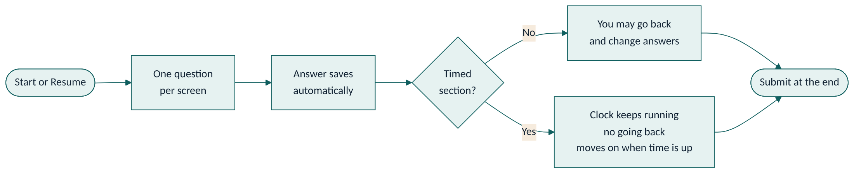
The list shows each assessment, its status (not started, in progress, completed) and an estimated time.
- One question is shown per screen, with a progress bar.
- Your answers save automatically every 30 seconds and when you move on. You can close the browser and come back; press Resume to continue where you left off.
- Some sections are timed. The timer starts when you see the first question of the section and keeps running even if you leave. In a timed section you cannot go back to earlier questions. When time runs out, you move to the next section.
- Answer honestly and at your natural pace. Answering very fast or picking the same option repeatedly is flagged to your counsellor and may mean the test is repeated.
Tips: use a stable internet connection, a quiet place, and set aside the estimated time for timed tests.

5. Your profile (/me/profile)
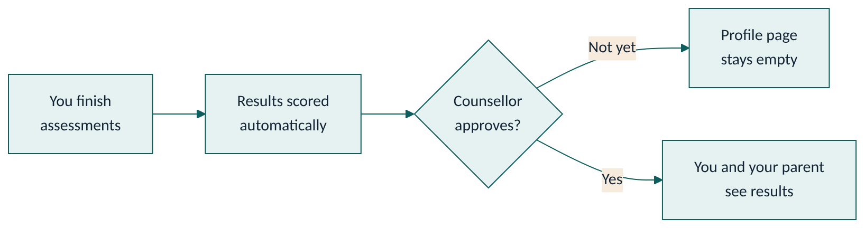
Your results appear after your counsellor has reviewed and approved them. You will see:
- Your interest code (for example "IAS"), aptitude bands (Low, Average, High, Very High), work-style graphs and your top values.
- A plain-language summary of strengths, things to watch and themes.
Results describe tendencies at a point in time. They are not a measure of your worth.

6. Your options
- /me/options (Class 11 onwards): a ranked list of careers with a fit score, why each fits, education pathways and the outlook to 2035. Open a career to see a day in the life, pathways by level, exams with dates, institutions by tier, salary band and the source of the outlook.
- /me/streams (Class 8–10): stream cards (for example Science PCM, Commerce, Humanities) showing which career families each stream keeps open or closes, with sample careers.
Options appear only after your counsellor publishes them.

7. Sessions (/me/sessions)
See upcoming sessions with date, time and meeting link, and past sessions with the summary and action items your counsellor shared.

8. Roadmap (/me/roadmap)
Your dated plan, grouped by kind: milestones, tasks, exams, skills and check-ins.
- Open an item you own.
- Change its status to In progress or Done.
- Upload evidence (for example a certificate or screenshot) if asked.
Items not done by their due date are marked Missed overnight and you get a reminder. You cannot mark an item as missed yourself; update it to In progress or Done, or talk to your counsellor.

9. Reports (/me/reports)
Only reports your counsellor has released to you appear here. Press Download; the link works for 15 minutes, so download again if it expires. Every report includes the disclaimer.
A Swadharma Report appears only if your counsellor releases it to you.

10. Privacy
- Your counsellor and the agency admin can see your case. Your parent can see your progress, published roadmap and released reports.
- Private counsellor notes are never shown to you or your parent.
- Birth details and Swadharma analysis are visible only to your counsellor and admin unless a Swadharma Report is released.

11. Disclaimer
"SwadharmaPath supports career decisions; it does not make them. Psychometric results describe tendencies at a point in time and are interpreted by a trained counsellor; they are not a measure of worth or a guarantee of success. The Swadharma (Vedic astrology) analysis is a traditional lens offered for reflection; it has no established scientific validity, is never used to rule out any career, and is shared only with your consent. Decisions remain yours and your family's."

