SwadharmaPath
User guide: Counsellor

Career counselling platform: from enquiry to a tracked career roadmap
Audience: Counsellors
Last updated: 2026-10-24
Source: docs/ in the SwadharmaPath repository (Markdown is the master copy)

For agency counsellors. Your home page is /cases. Navigation: Cases | Schedule | Reports | Library | Settings.
Last updated 2026-10-24. Step-by-step procedures are in the Operations SOPs.
Contents
- 1. Caseload (/cases)
- 2. Case workspace (/cases/:id)
  - Overview
  - Assessments
  - Profile
  - Swadharma 🔒
  - Options
  - Sessions
  - Roadmap
  - Reports
  - Documents
- 3. Schedule (/schedule)
- 4. Report queue (/reports/queue)
- 5. Leads assigned to you
- 6. Do and don't

1. Caseload (/cases)
The table lists every candidate assigned to you:
Column | Meaning
Name, Track | early_explorer, student or professional
Stage | ICCC stage from the latest session: know_self, know_world, decide, plan, act, review (default know_self)
Risk flag | Raised by validity issues, missed roadmap items or pending guardian consent
Next action | Next session or the next step needed
Report SLA | Due 7 days after the last completed assessment
You only see candidates where you are the assigned counsellor.

2. Case workspace (/cases/:id)
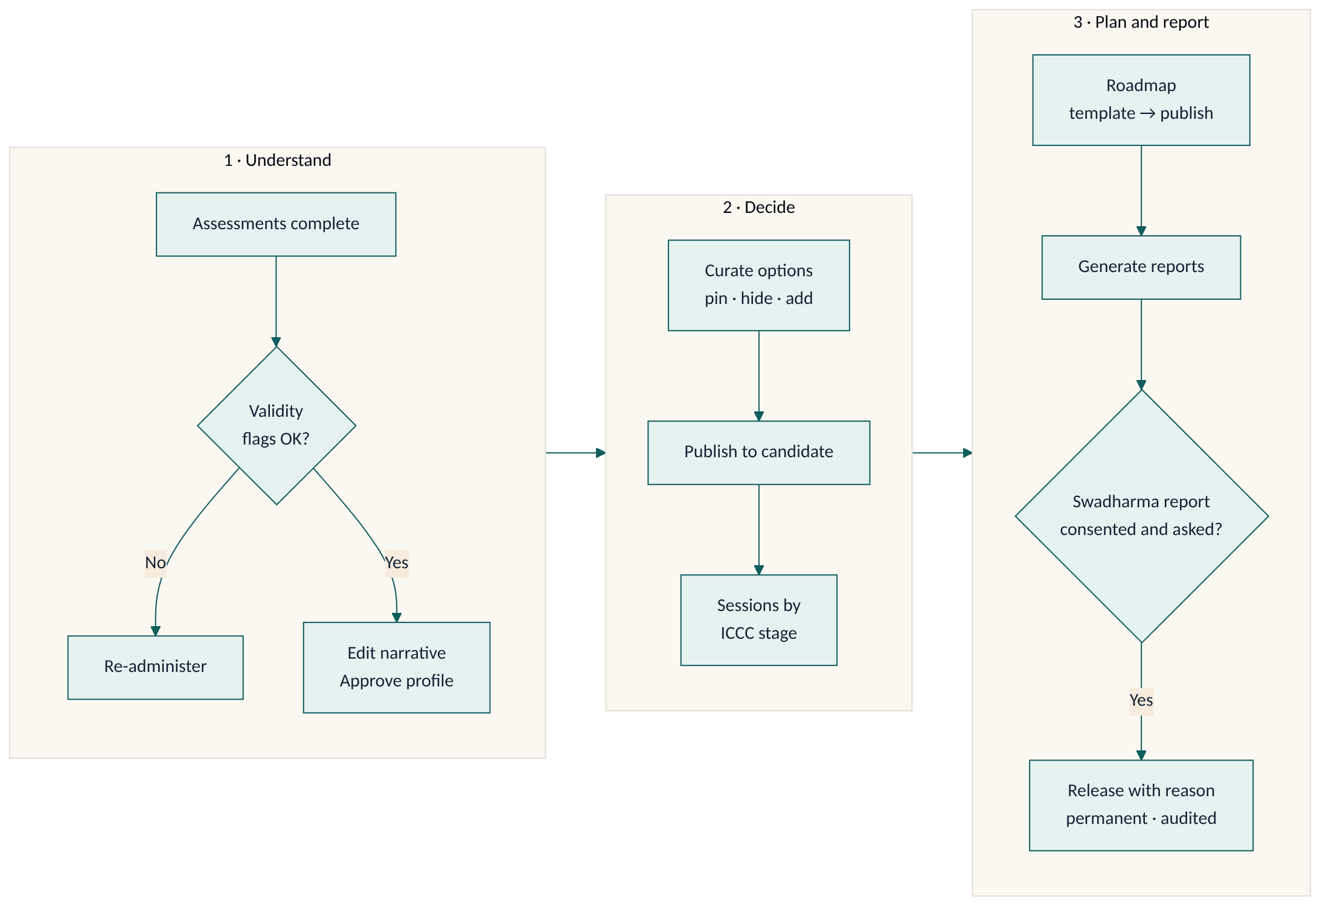
Tabs: Overview | Assessments | Profile | Swadharma 🔒 | Options | Sessions | Roadmap | Reports | Documents

Overview
Key facts, consent status (disclaimer, guardian, Swadharma), progress and upcoming items.

Assessments
- Status of each instrument and its validity flags: very fast answers (median < 1.5 s), straight-lining (10+ identical in a row), high social desirability, large self-vs-others gap.
- Re-administer an instrument when results are invalid: the old session is invalidated and the candidate gets a fresh one.

Profile
Edit the plain-language narrative (strengths, watch-outs, themes) and Approve. Until you approve, the candidate and parent cannot see any results.

Swadharma 🔒
Visible only to you and admins, and only if the candidate opted in with consent.
- Chart summary, the 15-family points table with component breakdown and confidence, personality lens, agreement matrix vs the psychometric top 5, favourable windows.
- Counsellor notes is the only field you can edit.
- Release Swadharma Report: choose candidate, parent or both and enter a reason. A release is permanent and logged; it cannot be undone. Generate the Swadharma report first. See SOP-O6.
Never use Swadharma to rule out a career, and never discuss health, marriage, longevity or wealth.

Options
- Ranked careers (student/professional) or streams (early_explorer) from the matching engine.
- Pin, Hide or Add options, then switch Publish to candidate on. Hidden options never show to the family. Swadharma points are stripped from everything the family sees.
- For early explorers, keep the widest "keep options open" stream in the list and never present a single career.

Sessions
Schedule (video, in person, phone) with a meeting URL. Use the ICCC-stage note template. Private notes are never visible to the family; write what they should see in Summary for candidate and add action items.

Roadmap
Pick a template (class8_10_exposure, class11_12, ug, pg_prep, transition, custom), edit items (kind, owner, due date), then Publish. The family sees the roadmap only after it is published. Overdue items become Missed overnight and you are notified.

Reports
Generate candidate, candidate_junior, parent, stream_choice, case_file or swadharma. Each generation creates a new version; reports cannot be edited or deleted. Case files and Swadharma reports stay counsellor-only (a Swadharma report reaches the family only through a release). Download through a signed link valid for 15 minutes.

Documents
Files shared with the case, including roadmap evidence uploaded by the candidate.

3. Schedule (/schedule)
Calendar of all your sessions.

4. Report queue (/reports/queue)
Pending generations and SLA status. Work the oldest breach first.

5. Leads assigned to you
You can view all leads and update the ones assigned to you (stage, follow-up date, notes).

6. Do and don't
Do | Don't
Approve the profile only after reviewing validity flags | Share results by WhatsApp or email outside the platform
Write family-facing text in Summary for candidate | Put anything sensitive in Summary for candidate
Record a clear reason for every Swadharma release | Release Swadharma to a family that did not consent or ask
Use "leanings" language with early explorers | Present a single career to an early explorer

