SwadharmaPath
High-Level Design

Career counselling platform: from enquiry to a tracked career roadmap
Audience: Developers, technical owner
Version: 1.0
Last updated: 2026-10-24
Source: docs/ in the SwadharmaPath repository (Markdown is the master copy)

Update this document in the same pull request as any change to components, integrations, deployment, data flow or the security model.

Contents
- 1. Architecture overview
- 2. Design principles
- 3. Components
  - 3.1 Web app (planned; scaffold exists)
  - 3.2 Supabase database (implemented in supabase/migrations/001_init.sql)
  - 3.3 Edge Functions (planned)
  - 3.4 Worker (planned)
- 4. Key flows
  - 4.1 Enquiry to candidate
  - 4.2 Assessment and scoring
  - 4.3 Curation, publish and release
  - 4.4 Nightly jobs
- 5. Security architecture
- 6. Deployment view
- 7. Data overview
- 8. Quality attributes and testing
- 9. Open items
- 10. Change history

1. Architecture overview
SwadharmaPath has three runtime parts around one Supabase project:
- Web app — React + TypeScript (Vite), shadcn/ui, Tailwind, Recharts. Reads and writes through Supabase with the user's JWT. It only displays scores; it never computes them.
- Supabase — PostgreSQL with row-level security (RLS) as the security boundary, Supabase Auth, private Storage buckets, Edge Functions, pg_net and pg_cron.
- Worker — a Python 3.12 package in /worker (pandas, numpy, pyswisseph, WeasyPrint, supabase-py, APScheduler) running on Railway with the service-role key. It does all scoring, matching, Swadharma computation, PDF reports and scheduled jobs.
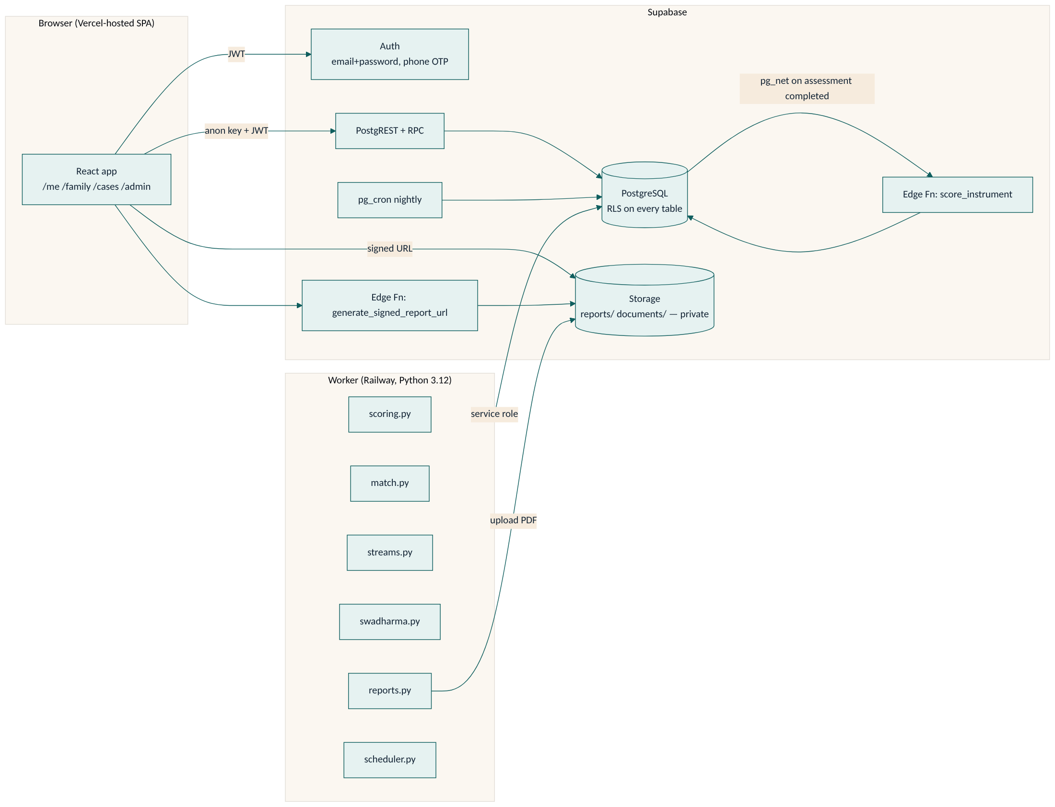

2. Design principles
Principle | How it shows up
The database is the security boundary | Every table has RLS. Visibility rules (Swadharma, approval gates, private notes, under-18) are enforced in SQL policies, views, triggers and column grants — the UI is not trusted.
Compute away from the client | Scoring keys, norms and items never reach the browser in bulk. The runner fetches one item at a time via next_item(). All scoring runs in the worker (mirrored in the Edge Function for instant feedback).
Counsellor in the loop | Results, profile, options and roadmap are drafts until a counsellor approves or publishes.
Append-only where trust matters | swadharma_releases and audit_log deny UPDATE/DELETE/TRUNCATE for every role; reports are write-once and versioned.
Track-aware UX | early_explorer gets junior instruments, stream recommendations, larger type and friendlier copy.

3. Components

3.1 Web app (planned; scaffold exists)
Area | Routes | Notes
Public | /, /enquire, /login, /about, /privacy | Lead form inserts with the anon key
Candidate | /me, /me/onboard, /me/assess, /me/assess/:instrument, /me/profile, /me/options, /me/options/:career, /me/streams, /me/roadmap, /me/sessions, /me/reports | Stepper differs by track
Parent | /family | Read-only views of linked children
Counsellor | /cases, /cases/:id (9 tabs), /schedule, /reports/queue | Swadharma 🔒 tab
Admin | /admin, /admin/leads, /admin/counsellors, /admin/careers, /admin/streams, /admin/instruments, /admin/templates
Route guard: everything except the public routes needs a session; after login the user is sent to the home for users.role (/me, /family, /cases, /admin). Supabase client: src/lib/supabase.ts, configured from VITE_SUPABASE_URL and VITE_SUPABASE_ANON_KEY.

3.2 Supabase database (implemented in supabase/migrations/001_init.sql)
- 24 tables (23 from the spec plus notifications), all with RLS.
- private schema of SECURITY DEFINER helper functions used by policies so they never recurse.
- Candidate-facing views that strip sensitive fields: v_candidate_matches, v_candidate_stream_matches, v_candidate_sessions.
- Admin/caseload views running with invoker rights: v_funnel, v_counsellor_utilisation, v_tat, v_outcomes, v_caseload.
- Candidate RPCs: my_instruments, next_item, save_responses, complete_assessment, accept_disclaimer, give_guardian_consent, submit_birth_details.
- Triggers for signup, role guard, lead rate limit, under-18 gate, scoring call, roadmap guard, report immutability and versioning, Swadharma release and append-only tables.
- Seed data: 20 careers with pathways, 8 CBSE stream options, junior and standard instrument versions with placeholder items.

3.3 Edge Functions (planned)
Function | Trigger | Responsibility
score_instrument | pg_net call from the assessment_completed trigger | Fast scoring of the completed session (mirror of worker/scoring.py) and write to assessment_results; enqueue the worker for full profile/matching
generate_signed_report_url | Called by the web app | Checks the caller may read the report (through RLS), then returns a 15-minute signed URL from the private reports bucket

3.4 Worker (planned)
Module | Responsibility
scoring.py | Interest, aptitude, work-style, Big Five, values; validity flags
match.py | Career fit for student/professional; top 15 into career_matches
streams.py | Stream fit for early_explorer into stream_matches
swadharma.py | Swiss Ephemeris (Lahiri) charts and family points into swadharma_charts/swadharma_scores
karakatwa.json | Editable planet → career-family map
reports.py | WeasyPrint PDFs for six report kinds into reports/ bucket
scheduler.py | APScheduler jobs: nightly nudges, SLA check, outcome reminders; quarterly outlook reminder

4. Key flows

4.1 Enquiry to candidate
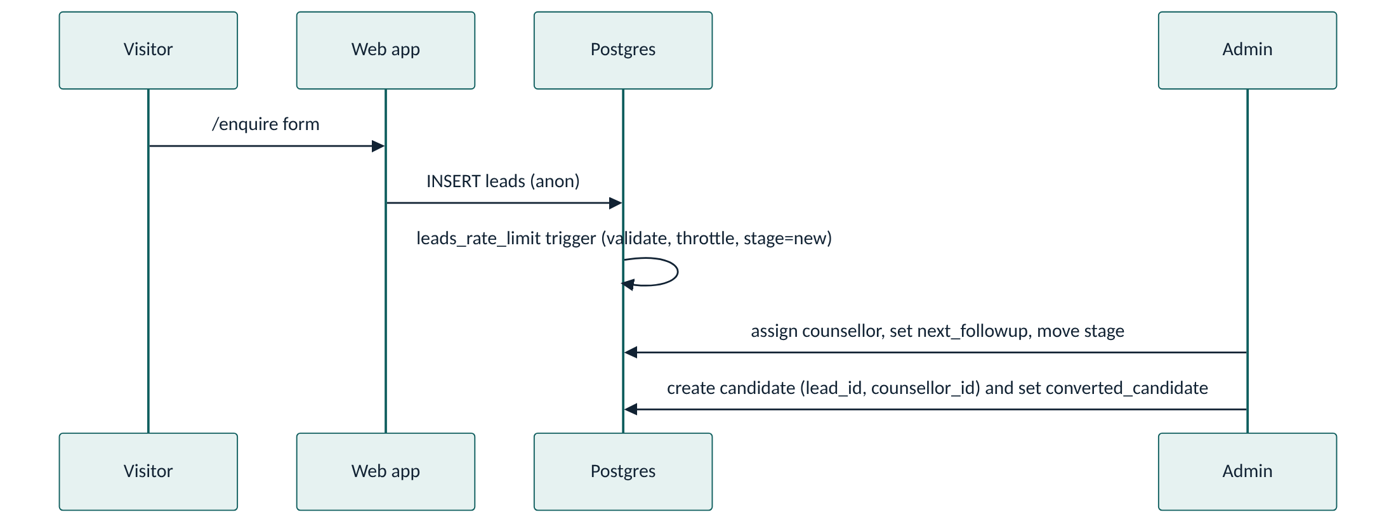

4.2 Assessment and scoring
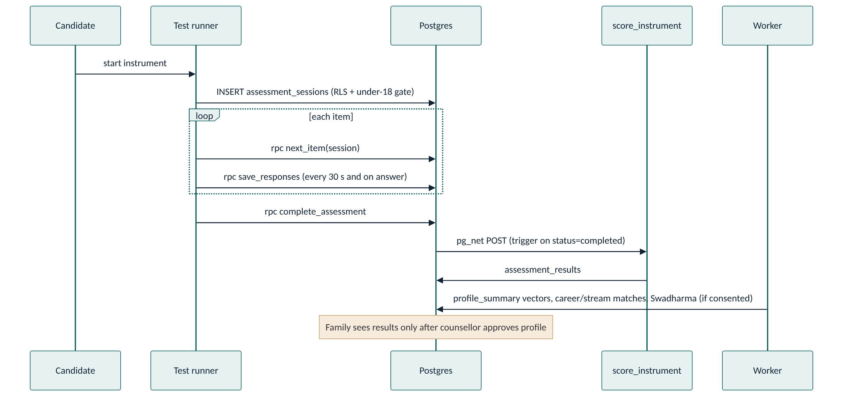

4.3 Curation, publish and release
- Worker writes career_matches / stream_matches with visible_to_candidate = false.
- Counsellor pins/hides/adds, then publishes. Candidates read only through v_candidate_* views, which drop breakdown.swadharma and hidden rows.
- Counsellor generates reports (worker renders the PDF, fills pdf_path once).
- For Swadharma: counsellor inserts a swadharma_releases row (target + reason). A trigger validates consent, widens reports.visible_to for that report and writes audit_log. The release cannot be undone.

4.4 Nightly jobs
Job | Where | Time
Mark overdue roadmap items missed and create notification rows | pg_cron → private.mark_missed_roadmap_items() | 02:00 IST (20:30 UTC)
Report SLA check, outcome checkpoint reminders (6/12/24 m) | Worker scheduler.py | Nightly
Outlook refresh reminder to admin | Worker scheduler.py | Quarterly

5. Security architecture
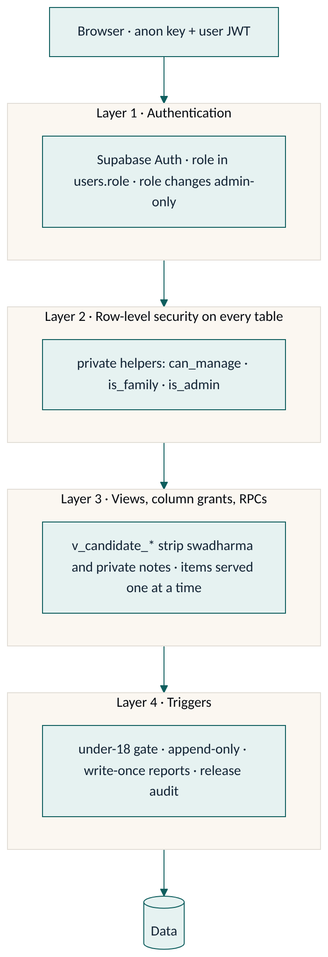
Concern | Control
Authentication | Supabase Auth (email/password, phone OTP). New auth users get a public.users row by trigger; self-signup role is limited to candidate or parent.
Authorisation | RLS on every table using private.* helpers: is_admin, is_staff, can_manage (assigned counsellor or admin), is_family (candidate or linked parent).
Role escalation | guard_users trigger: only admin or service role may change users.role.
Swadharma isolation | birth_details, swadharma_charts, swadharma_scores have no candidate/parent policy. Birth details are written through submit_birth_details() which never returns the row.
Test content | Column grants hide instruments.items, scoring_spec, norms; next_item() strips scoring keys.
Private notes | Family reads sessions only via v_candidate_sessions, which omits notes_private.
Reports | Private bucket with no client policy; 15-minute signed URLs. Write-once, versioned.
Append-only | Triggers and revoked privileges on swadharma_releases, audit_log; delete denied on reports.
Minors | assessment_gate trigger and RLS check guardian consent; unknown DOB fails closed.
Abuse | Lead form throttled per contact (3/hour) and globally (30/minute).
Secrets | Service-role key only in the worker and Edge Function environment and Supabase Vault (project_url, service_role_key). Never in VITE_* variables.

6. Deployment view
Component | Platform | Config
Web | Vercel | VITE_SUPABASE_URL, VITE_SUPABASE_ANON_KEY
Database, Auth, Storage, Edge Functions | Supabase | Migrations in supabase/migrations; Vault secrets project_url, service_role_key; extensions pgcrypto, pg_net, pg_cron
Worker | Railway | SUPABASE_URL, SUPABASE_SERVICE_ROLE_KEY (names to be confirmed when the worker lands)
Environments: local (Supabase CLI or plain Postgres for SQL tests) → staging Supabase project → production. See Release and deployment SOP.

7. Data overview
Core entities and ownership (full column list in the LLD):
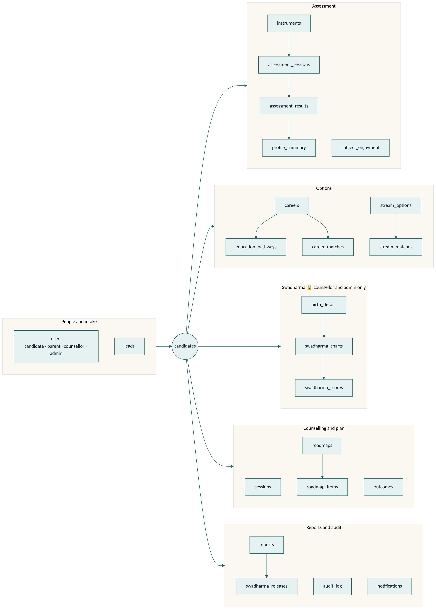

8. Quality attributes and testing
- SQL tests (supabase/tests/run.sh) build a throwaway database, apply the migration and run RLS tests as each role, plus owner-level tests. Run them on every database change.
- Frontend: Vitest (configured), Oxlint.
- Worker: unit tests per engine rule (to be added with the worker).
- Docs check: CI fails a pull request that changes code without updating /docs (CONTRIBUTING).

9. Open items
Item | Owner
Worker env variable names and job schedule times | Build thread, when /worker lands
Notification delivery channel (email/SMS/WhatsApp) | Business decision
Validated instrument items and norms | Agency
Report templates and branding assets | Agency
Candidate onboarding writes: the current migration has no candidate UPDATE policy on candidates and no onboarding RPC, so /me/onboard profile/academics/constraints/DOB need an RPC (or policy) | Build
Parent "message to counsellor" on /family has no table or RPC yet | Build
Re-administer flow (invalidate session, start new) has no dedicated RPC yet; counsellors can do it through asess_staff policy | Build

10. Change history
Version | Date | Change
1.0 | 2026-10-24 | Baseline from spec and feat/start-here database migration
1.1 | 2026-10-24 | Added security-layer and data-group diagrams; fixed lead-flow diagram; Word version

