SwadharmaPath
Low-Level Design

Career counselling platform: from enquiry to a tracked career roadmap
Audience: Developers
Version: 1.0
Last updated: 2026-10-24
Source: docs/ in the SwadharmaPath repository (Markdown is the master copy)

This document must change in the same pull request as any change to tables, columns, constraints, policies, functions, triggers, views, RPCs, engine formulas, report templates, jobs or environment variables.

Contents
- 1. Repository layout
- 2. Configuration
- 3. Data model
- 4. Authorisation
  - 4.1 Helper functions (private schema, SECURITY DEFINER, search_path = '')
  - 4.2 Access matrix (RLS policies)
  - 4.3 Column and privilege grants
- 5. Triggers
  - 5.1 Scheduled SQL
- 6. Views
- 7. RPC contracts (candidate-facing, SECURITY DEFINER, granted to authenticated)
- 8. Storage
- 9. Engine rules (worker; planned — source of truth until code lands)
  - 9.1 Scoring (worker/scoring.py, mirrored in score_instrument)
  - 9.2 Career matching (worker/match.py) — student, professional
  - 9.3 Stream recommendation (worker/streams.py) — early_explorer
  - 9.4 Swadharma (worker/swadharma.py)
  - 9.5 Reports (worker/reports.py)
  - 9.6 Jobs (worker/scheduler.py)
- 10. Frontend design (planned)
- 11. Testing
- 12. Change history

1. Repository layout
Path | Contents | Status
src/ | React app (Vite). src/lib/supabase.ts client | scaffold
supabase/migrations/001_init.sql | Schema, constraints, helpers, RLS, triggers, views, RPCs, storage, generated seed | implemented
supabase/seed/ | build_seed.py, instruments.py, library.py — regenerate the seed block of the migration | implemented
supabase/tests/ | run.sh, stub, fixtures, rls_test.sql, owner_test.sql | implemented
supabase/functions/score_instrument/ | Edge Function | planned
supabase/functions/generate_signed_report_url/ | Edge Function | planned
worker/ | scoring.py, match.py, streams.py, swadharma.py, reports.py, scheduler.py, karakatwa.json | planned
docs/ | This documentation set | implemented

2. Configuration
Variable / secret | Where | Purpose
VITE_SUPABASE_URL | Web (Vercel) | Supabase project URL
VITE_SUPABASE_ANON_KEY | Web (Vercel) | Public anon key (RLS applies)
Vault project_url | Supabase Vault | Base URL used by private.invoke_edge_function
Vault service_role_key | Supabase Vault | Bearer for Edge Function calls from triggers
Service-role key | Worker, Edge Functions | Full access; never in the browser
If the Vault secrets are missing, invoke_edge_function logs a warning and returns without failing the user's action (scoring will then not start; see troubleshooting).

3. Data model
All tables are in public, have id uuid default gen_random_uuid() unless keyed by candidate_id, and have RLS enabled. 🔒 = counsellor/admin only.
Table | Key columns and constraints
users | id = auth.users.id; role ∈ candidate, parent, counsellor, admin; full_name not null; phone, email, photo_url, language_pref default en
leads | source ∈ web, whatsapp, referral, school, walk_in; track ∈ early_explorer, student, professional; stage default new ∈ new, contacted, discovery, paid, active, completed, lost; assigned_counsellor → users; next_followup date; converted_candidate → candidates
candidates | user_id, lead_id, parent_user_id, counsellor_id; track; board, dob, gender, city, school_or_employer, class_or_years_exp, stream_or_function; academics, constraints jsonb; status default onboarding; swadharma_opted_in bool; disclaimer_accepted_at, guardian_consent_at
birth_details 🔒 | PK candidate_id; birth_date, birth_time, time_certainty ∈ exact, approx_15m, approx_1h, unknown; birth_place, lat, lng, tz; consent_given_by, consent_at, consent_text_version
instruments | code ∈ interest, aptitude, workstyle, bigfive, values, learning, school_values, subject_enjoyment; version; track_variant ∈ junior, standard; items, scoring_spec, norms jsonb (hidden from API roles); time_limit_min; is_active
assessment_sessions | candidate_id, instrument_id; started_at, completed_at; responses jsonb ({item_id: {a, rt}, _meta: {section_started: {code: ts}}}); status ∈ in_progress, completed, invalidated; device, duration_sec
assessment_results | raw, percentiles, derived, validity_flags jsonb; scored_at, scoring_version
profile_summary | PK candidate_id; interest_vector, aptitude_vector, workstyle_vector, values_vector numeric[]; narrative jsonb; approved_by, approved_at, updated_at (trigger)
subject_enjoyment | PK (candidate_id, subject); enjoyment 1–5; marks_pct; teacher_feedback
careers | name, family, riasec_code, interest_weights numeric[6], aptitude_min, workstyle_fit, values_fit jsonb; description, day_in_life; typical_entry_paths, india_salary_band, sources jsonb; outlook ∈ growing, stable, transforming, declining; automation_exposure ∈ low, medium, high; adjacent_emerging text[]; last_reviewed
education_pathways | career_id; level ∈ class11_12, ug, pg, diploma, certification, global; stream_required, exams jsonb, degrees text[], institutions jsonb, duration, alternative_routes, notes
stream_options | name, board, subjects text[], keeps_open_families, closes_families text[], notes
career_matches | candidate_id, career_id, fit_score, breakdown jsonb, rank; counsellor_action ∈ pinned, hidden, added; visible_to_candidate default false; match_version
stream_matches | as above with stream_option_id
swadharma_charts 🔒 | PK candidate_id; ayanamsa, d1, d9, d10, kp_cusps, ashtakavarga, dashas jsonb; computed_at, engine_version
swadharma_scores 🔒 | career_family, points, max_points default 100, components, favourable_windows jsonb; confidence ∈ high, medium, low; counsellor_notes
swadharma_releases (append-only) | candidate_id, released_by, released_to ∈ candidate, parent, both; reason not null; report_id; released_at
sessions | candidate_id, counsellor_id, scheduled_at, duration_min default 60, mode ∈ video, in_person, phone; meeting_url; iccc_stage ∈ know_self, know_world, decide, plan, act, review; notes_private, summary_for_candidate, action_items jsonb; attended
roadmaps | template ∈ class8_10_exposure, class11_12, ug, pg_prep, transition, custom; goal_career_id, goal_stream_id; start_date, end_date; status default draft ∈ draft, published, completed, paused; published_at
roadmap_items | kind ∈ milestone, task, exam, skill, checkin; owner ∈ candidate, counsellor, parent; status default todo ∈ todo, in_progress, done, missed; due_date, evidence_url, completed_at
reports | kind ∈ candidate, candidate_junior, parent, stream_choice, case_file, swadharma; version (trigger); generated_by; pdf_path; content jsonb; visible_to ∈ counsellor, candidate, parent, all
outcomes | checkpoint ∈ 6m, 12m, 24m; status, career_id, matched_top5, satisfaction 1–5, notes
audit_log (append-only) | actor, action, entity, entity_id, detail jsonb, at
notifications (additive) | user_id, candidate_id, kind, title, body, entity, entity_id, read_at, sent_at; unique (user_id, kind, entity_id) so a nudge is created once
Indexes: leads(stage), leads(assigned_counsellor), candidates(counsellor_id / user_id / parent_user_id), per-candidate indexes on child tables, sessions(counsellor_id, scheduled_at), reports(candidate_id, kind), swadharma_releases(report_id), notifications(user_id).

4. Authorisation

4.1 Helper functions (private schema, SECURITY DEFINER, search_path = '')
Function | Returns true when
my_role() | returns caller's users.role
is_admin() / is_staff() | caller is admin / counsellor or admin
is_service() | JWT role is service_role, or session user is postgres / supabase_admin
is_assigned_counsellor(c) | candidates.counsellor_id = auth.uid()
can_manage(c) | admin or assigned counsellor
is_own_candidate(c) / is_parent_of(c) / is_family(c) | caller is the candidate / linked parent / either
can_read_candidate(c) | family or can_manage
is_released(report) | a swadharma_releases row exists for the report
profile_approved(c) | profile_summary.approved_at is set
needs_guardian_consent(c) | (dob null or dob within 18 years) and guardian_consent_at null; missing candidate → true
write_audit(action, entity, id, detail) | inserts an audit row as the caller

4.2 Access matrix (RLS policies)
C = candidate (own), P = parent (linked), Co = assigned counsellor, A = admin, S = service role (bypasses RLS).
Table / view | C | P | Co | A
users | own row + their counsellor/parent | own + linked people | read all names | all
leads | insert only (anon too) | insert only | read all; update assigned | all
candidates | read own | read linked | read/update assigned; insert with self as counsellor | all
birth_details 🔒 | none (write via RPC) | none (write via RPC) | read | read
swadharma_charts / scores 🔒 | none | none | read; update counsellor_notes only | same
instruments | metadata of active only | same | metadata | all incl. items
assessment_sessions | read; insert own (gated) | read | all | all
assessment_results | read after profile approval | same | all | all
profile_summary | read when approved | same | all | all
subject_enjoyment | read; insert own | read | all | all
careers / education_pathways / stream_options | read | read | read | all
career_matches / stream_matches | via v_candidate_* only | same | all | all
sessions | via v_candidate_sessions only | same | all | all
roadmaps | read when published/completed/paused | same | all | all
roadmap_items | read when roadmap published; update own status/evidence | read | all | all
reports | read if visible_to ∈ candidate/all and (not swadharma or released) | read if visible_to ∈ parent/all and same rule | read; insert (generated_by = self) | same
swadharma_releases | none | none | read; insert (released_by = self) | same
outcomes | read | read | all | all
audit_log | insert own | insert own | insert own | insert own; read
notifications | own | own | own | own

4.3 Column and privilege grants
- instruments: API roles may select only id, code, name, version, track_variant, time_limit_min, is_active.
- swadharma_releases, audit_log: UPDATE, DELETE, TRUNCATE revoked from anon, authenticated and service_role.
- reports: DELETE, TRUNCATE revoked from anon and authenticated.
- anon: all table privileges revoked except INSERT on leads.

5. Triggers
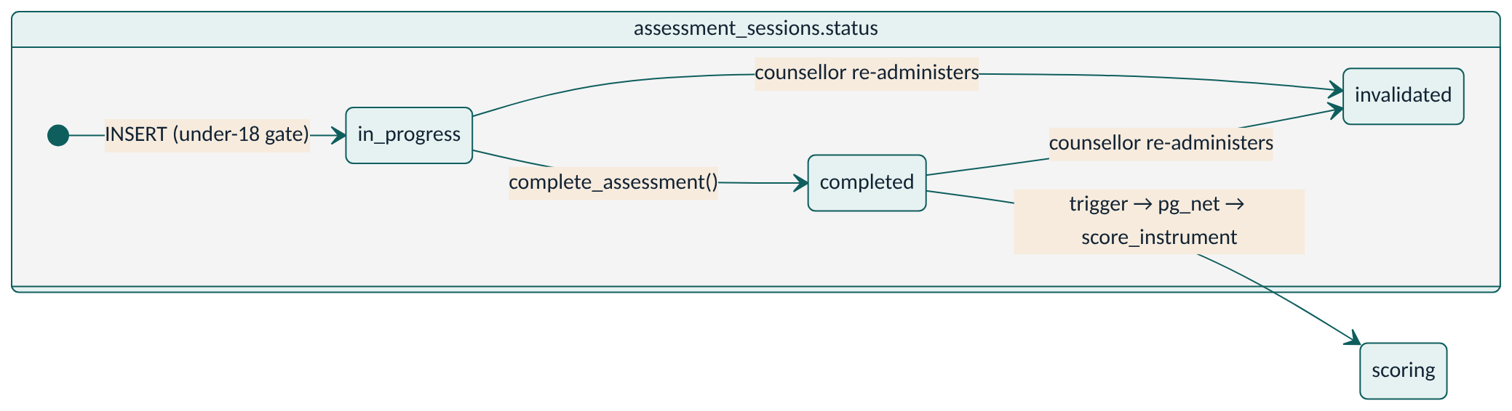
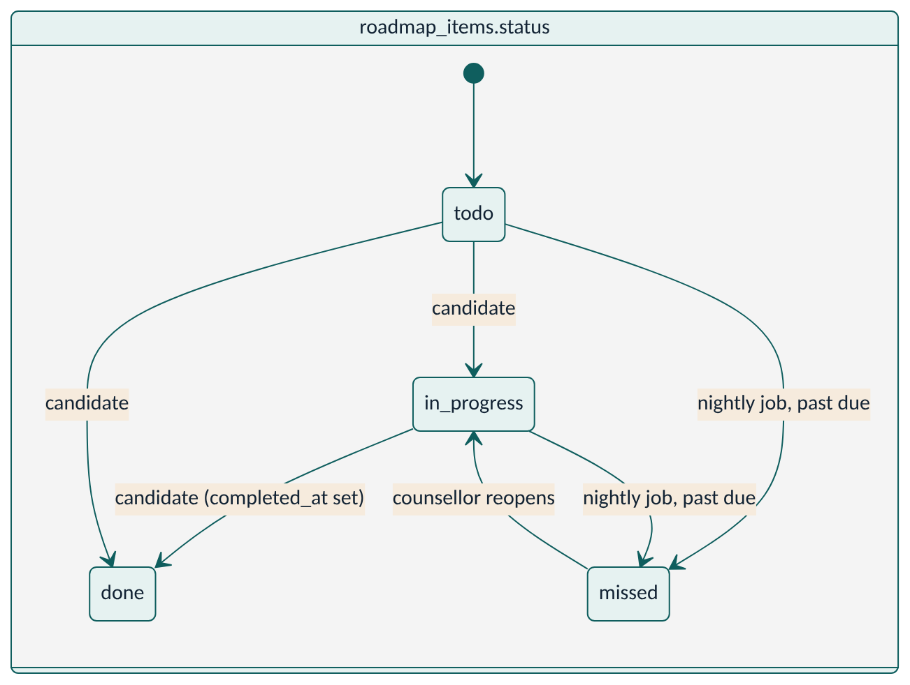
Trigger | Table / event | Behaviour | Error code
on_auth_user_created | auth.users AFTER INSERT | Creates public.users; role from metadata limited to candidate/parent; full_name from metadata or email/phone prefix | —
guard_users | users BEFORE UPDATE | Only admin/service can change role | 42501
leads_rate_limit | leads BEFORE INSERT | Non-staff: name 1–120 chars, notes ≤ 2000, phone or email required; max 3 per contact per hour; max 30 overall per minute; forces stage = new, default source = web | 22023, P0429
assessment_gate | assessment_sessions BEFORE INSERT | Rejects if needs_guardian_consent; defaults started_at, responses | 42501
assessment_completed | assessment_sessions AFTER UPDATE OF status → completed | pg_net POST to Edge Function score_instrument with {session_id, candidate_id, instrument_id}; never blocks | —
profile_touch | profile_summary BEFORE INSERT/UPDATE | Sets updated_at | —
guard_swadharma_scores | swadharma_scores BEFORE UPDATE | Non-service may change only counsellor_notes | 42501
guard_roadmap_item | roadmap_items BEFORE UPDATE | Non-managers may change only status, evidence_url, completed_at; cannot set missed; completed_at set when done, cleared otherwise | 42501
roadmap_published | roadmaps BEFORE UPDATE | Sets published_at on first publish | —
reports_before_insert | reports BEFORE INSERT | version = max+1 per (candidate, kind); default visible_to = counsellor; case_file and swadharma forced to counsellor | —
reports_guard_update | reports BEFORE UPDATE | Allows only (1) service filling pdf_path once (and content), (2) release trigger widening visible_to; else rejects | 42501
reports_no_delete | reports BEFORE DELETE | Deny | 42501
releases_append_only, audit_append_only (+ *_no_truncate) | BEFORE UPDATE/DELETE/TRUNCATE | Deny | 42501
swadharma_release_before | swadharma_releases BEFORE INSERT | Report must be this candidate's swadharma kind; candidate must be opted in with birth_details.consent_at; sets released_at, defaults released_by | 22023, 42501
swadharma_release_after | swadharma_releases AFTER INSERT | Widens reports.visible_to (both → all; candidate + parent over time → all); writes audit_log swadharma_release with before/after | —

5.1 Scheduled SQL
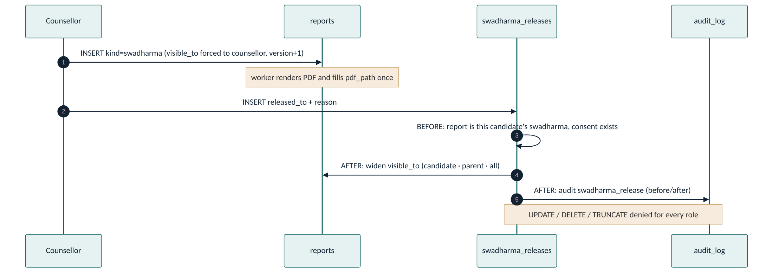
private.mark_missed_roadmap_items() via pg_cron job swadharmapath-missed-items at 30 20 * * * UTC (02:00 IST): published roadmaps' items with due_date < today and status todo/in_progress → missed; inserts one roadmap_missed notification per owner (candidate or parent) and the counsellor. Returns the count.

6. Views
View | Rights | Definition
v_candidate_matches | owner (filters by caller) | career_matches + career name/family/outlook/RIASEC; breakdown - 'swadharma'; only visible_to_candidate and not hidden; caller is family or can_manage
v_candidate_stream_matches | owner | same for streams with board, subjects, keeps_open/closes
v_candidate_sessions | owner | sessions without notes_private
v_funnel | invoker | leads by stage and track, total and last 30 days
v_counsellor_utilisation | invoker | per counsellor: active candidates, sessions and attended minutes in last 30 days
v_tat | invoker | last completed assessment → first candidate/candidate_junior/stream_choice report, tat_days, pending
v_outcomes | invoker | per checkpoint: count, % matched top 5, average satisfaction
v_caseload | invoker | per candidate: ICCC stage (latest past session, default know_self), next session, assessments done, validity issues, missed items, consent pending, profile approval, report_due_at = assessed_at + 7 days

7. RPC contracts (candidate-facing, SECURITY DEFINER, granted to authenticated)
RPC | Input | Output | Rules
my_instruments() | — | rows: instrument_id, code, name, track_variant, time_limit_min, item_count, est_minutes, session_id, status, answered | Active instruments for caller's track variant (early_explorer → junior); latest non-invalidated session; est = time limit or 12 s per item
next_item(session_id, position?) | uuid, int | {done, position, total, section{code,name,time_limit_sec,started_at,server_now,index,count}, item{id,type,prompt,options[{value,label}]}, answer} | Caller must own the session and it must be in progress. Null position = first unanswered. Timed section: clock starts on first served item; after limit + 5 s, skips to next section; going back before the furthest answered item raises 22023
save_responses(session_id, responses) | uuid, {item_id: {a, rt}} | int (saved count) | Drops unknown items and answers in timed sections whose clock is not started or ended more than 30 s ago
complete_assessment(session_id, device?) | uuid, text | void | Sets completed, completed_at, duration_sec; fires scoring trigger
accept_disclaimer() | — | timestamptz | Sets disclaimer_accepted_at on caller's candidate row; audit disclaimer_accepted
give_guardian_consent(candidate_id) | uuid | timestamptz | Caller must be the linked parent; audit guardian_consent
submit_birth_details(candidate_id, birth_date, birth_time, time_certainty, birth_place, lat, lng, tz, consent_text_version) | … | void | Caller must be family; consent version required; upsert; sets swadharma_opted_in; audit swadharma_consent; never returns the row
Error codes surfaced to the UI: 42501 not permitted, 22023 invalid input/state, P0429 rate limited.

8. Storage
Bucket | Public | Path | Access
reports | no | reports/<candidate_id>/<kind>-v<version>.pdf (convention, confirm with worker) | No client policy; read only via 15-minute signed URL from generate_signed_report_url
documents | no | <candidate_id>/<file> | Read: family, assigned counsellor, admin. Insert: the candidate or a manager. Used for roadmap evidence and case documents

9. Engine rules (worker; planned — source of truth until code lands)

9.1 Scoring (worker/scoring.py, mirrored in score_instrument)
Instrument | Rule
Interest | Sum per RIASEC scale → percentile by age band → 3-letter code (top 3) + normalised 6-vector
Aptitude | Raw per sub-test → percentile by age band (13–15, 16–18, 19–22, 23+) → Low < 25, Average 25–74, High 75–89, Very High ≥ 90
Work-style (R-A-P-D) | Forced choice most/least; 3 graphs standard (others, stress, self), 2 junior; each factor −19…+19; primary = highest above midline, secondary = next
Big Five | Standard only; BFI-2-S → 5 percentiles
Values | Pairwise choice → top 5 + vector; junior uses 12-item school-values
Work-style pattern flags: span (max−min ≥ 20 wide, ≤ 8 crunched); reversal (primary differs graph 1 vs 3); undershift (all ≤ 2); overshift (≥ 3 above midline); mercurial (A ≥ 8 above others); flick_up (P, D < 0 and D > P); flick_down (P, D < 0 and D < P). Stress: P moves ≥ 3 graph3→graph2 = personal; graph3→graph1 = performance; A moving with it = relationship. Strengths/limitations table per primary style across leadership, goal-setting, creativity, delegation, communication, decision-making from original template text.
Validity flags: median response time < 1.5 s; straight-lining ≥ 10 consecutive; social desirability > 80th percentile; self-vs-others divergence ≥ 12 on any factor.

9.2 Career matching (worker/match.py) — student, professional
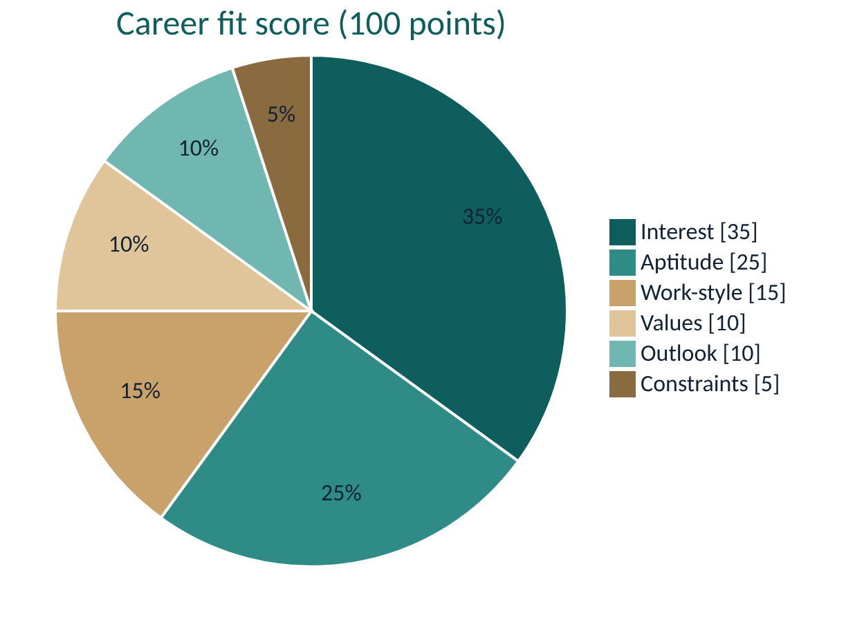
fit = 35·cosine(interest_vector, career.interest_weights)
+ 25·aptitude_fit + 15·workstyle_fit + 10·values_fit
+ 10·outlook_score + 5·constraints_feasible
outlook_score: growing 1.0, transforming 0.7, stable 0.6, declining 0.2 (i.e. 10/7/6/2 points)
aptitude_fit = share of career.aptitude_min bands met, +0.1 per band exceeded, max 1.0
workstyle_fit = 1 − normalised distance of candidate primary/secondary to career.workstyle_fit
values_fit = overlap of candidate top-5 values with career.values_fit
Top 15 → career_matches with breakdown {interest, aptitude, workstyle, values, outlook, constraints, swadharma} and templated explanation per dimension; visible_to_candidate = false.

9.3 Stream recommendation (worker/streams.py) — early_explorer
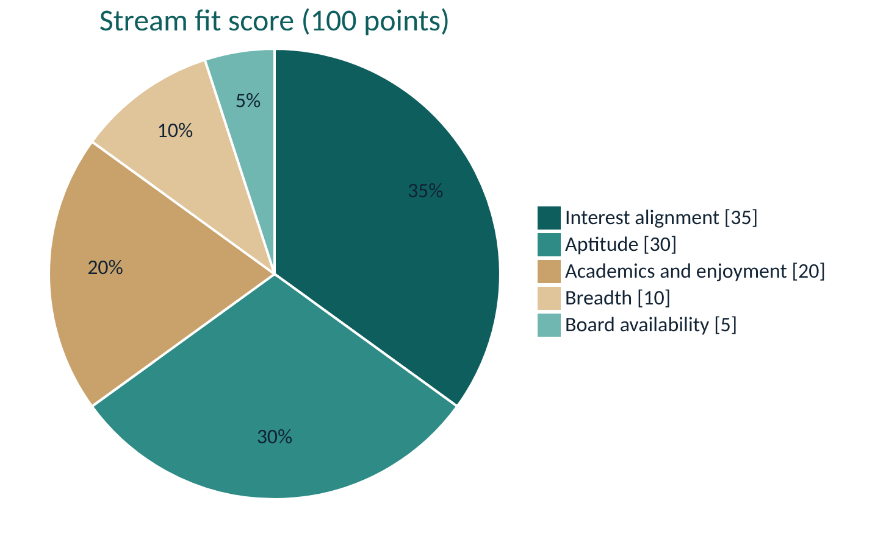
stream_fit = 35·interest alignment (RIASEC vector vs families the stream keeps open)
+ 30·aptitude fit (PCM numerical+abstract; PCB verbal+abstract;
Commerce numerical+verbal; Humanities verbal+abstract;
Design/vocational spatial+abstract)
+ 20·academics and subject enjoyment (maths, science, languages, social science, art)
+ 10·breadth (keeps_open count / max)
+ 5·board availability
Always include the widest "keep options open" combination; output keeps_open/closes and 3 sample careers per open family; never a single career.

9.4 Swadharma (worker/swadharma.py)
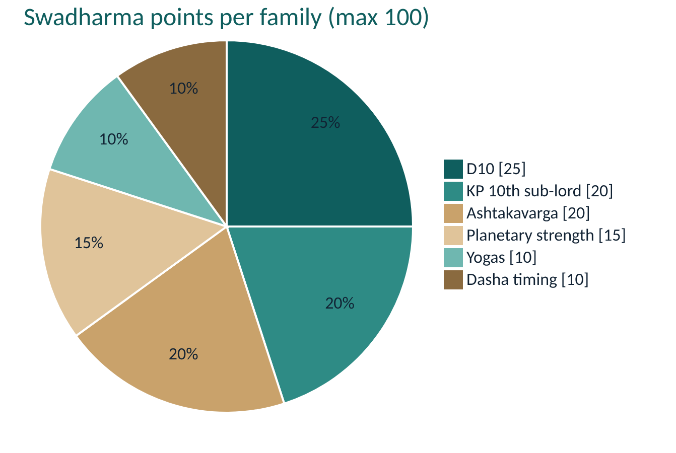
Runs only if swadharma_opted_in and birth_details.consent_at. Swiss Ephemeris, Lahiri; Placidus cusps for KP; whole-sign for Parashari. time_certainty = unknown → Moon-sign and dignity components only, confidence low.
Points per family (max 100): D10 (25) · KP 10th cusp sub-lord (20) · Ashtakavarga (20; SAV ≥ 28 full, 25–27 × 0.6, < 25 × 0.3) · planetary strength (15) · yogas (10) · dasha timing over next 10 years (10, plus favourable_windows). Planet → family map in worker/karakatwa.json.
15 families: Engineering & Technology · Medicine & Health · Pure Sciences & Research · Mathematics, Finance & Analytics · Law & Governance · Public Service & Defence · Business, Management & Entrepreneurship · Sales, Marketing & Media · Arts, Design & Performance · Writing, Communication & Languages · Education & Counselling · Social Work & Spirituality · Agriculture, Environment & Earth · Hospitality, Travel & Service · Skilled Trades & Crafts.
early_explorer: roll up per stream over keeps_open_families; lens phrased for parents of a 13–15-year-old; windows limited to board-exam years and Class 11 entry.
Outputs personality lens (never health, marriage, longevity, wealth; never prohibitions) and agreement matrix (Agree / Partial / Conflict) vs psychometric top 5. Writes only swadharma_charts, swadharma_scores and career_matches.breakdown.swadharma.

9.5 Reports (worker/reports.py)
Kind | Audience | Notes
candidate | Candidate (student/professional) | Full interpreted profile and options
candidate_junior | Early explorer | Visual, ~8 pages, written to the student, "leanings" not "types"
parent | Parent | 2 pages
stream_choice | Early explorer family | Stream cards, keeps-open/closes
case_file | Counsellor only | Everything incl. Swadharma; visible_to forced to counsellor
swadharma | Counsellor until released | Full disclaimer on page 1
Flow: counsellor inserts reports row → worker renders with WeasyPrint → uploads to reports/ → sets pdf_path once. Every PDF carries the disclaimer.

9.6 Jobs (worker/scheduler.py)
Nightly: missed-item nudges (complements the SQL job), report SLA check, outcome reminders at 6/12/24 months. Quarterly: outlook refresh reminder to admin.

10. Frontend design (planned)
Concern | Design
Routing | React Router; role guard reads users.role and redirects to role home
Data | supabase-js with RLS; candidates use v_candidate_* views and RPCs
Test runner | Calls my_instruments → insert session → next_item loop; local buffer flushed to save_responses every 30 s and on navigation; timer from section.started_at and server_now (server clock wins); no back button inside timed sections
Track switch | early_explorer → larger type scale, illustrations, friendlier copy, stepper Onboard → Discover → Talk → Streams → Explore Plan
Theme | Deep teal + warm sand, large readable type
Errors | Map 42501 → "You don't have access to this", 22023 → specific validation copy, P0429 → "Please try again in a while"

11. Testing
PGHOST=localhost PGUSER=postgres ./supabase/tests/run.sh
Creates swadharmapath_test, loads a Supabase stub (auth/storage/vault shims), applies the migration, loads fixtures, runs rls_test.sql as the authenticator role and owner_test.sql as owner. Any change to policies, triggers or RPCs needs a matching test.
Regenerating seed data:
python3 supabase/seed/build_seed.py # rewrites everything after "-- BEGIN GENERATED SEED"

12. Change history
Version | Date | Change
1.0 | 2026-10-24 | Baseline from 001_init.sql and the engine-rule spec
1.1 | 2026-10-24 | Added state, sequence and score-weight diagrams; Word version

