SwadharmaPath
Operations SOPs

Career counselling platform: from enquiry to a tracked career roadmap
Audience: Counsellors, admins
Last updated: 2026-10-24
Source: docs/ in the SwadharmaPath repository (Markdown is the master copy)

Standard operating procedures for counsellors and admins. Each SOP lists who does it, when, the steps and the record that proves it was done.
Last updated 2026-10-24. Change an SOP in the same pull request as the feature it describes.
ID | SOP | Owner
O1 | Lead intake and follow-up | Admin, counsellor
O2 | Converting a lead to a candidate | Admin
O3 | Onboarding and consent | Counsellor
O4 | Assessment administration and re-administration | Counsellor
O5 | Profile review, curation and publishing | Counsellor
O6 | Releasing a Swadharma report | Counsellor
O7 | Sessions | Counsellor
O8 | Reports and SLA | Counsellor, admin
O9 | Instrument version change | Admin
O10 | Career library and outlook refresh | Admin
O11 | Roadmap and missed items | Counsellor
O12 | Outcome follow-up | Counsellor
O13 | Staff onboarding and offboarding | Admin
O14 | Privacy requests and data incidents | Admin

Contents
- SOP-O1 Lead intake and follow-up
- SOP-O2 Converting a lead to a candidate
- SOP-O3 Onboarding and consent
- SOP-O4 Assessment administration and re-administration
- SOP-O5 Profile review, curation and publishing
- SOP-O6 Releasing a Swadharma report
- SOP-O7 Sessions
- SOP-O8 Reports and SLA
- SOP-O9 Instrument version change
- SOP-O10 Career library and outlook refresh
- SOP-O11 Roadmap and missed items
- SOP-O12 Outcome follow-up
- SOP-O13 Staff onboarding and offboarding
- SOP-O14 Privacy requests and data incidents

SOP-O1 Lead intake and follow-up
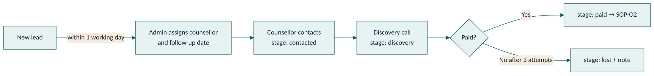
Trigger: a new lead appears (web form, WhatsApp, referral, school, walk-in).
- Within 1 working day, admin opens /admin/leads, assigns a counsellor and sets next follow-up.
- Leads from non-web sources are entered by staff with the correct source.
- The counsellor contacts the lead and moves the stage to contacted, then discovery after the discovery call.
- When payment is confirmed, move to paid (manual revenue flag in V1).
- If the lead declines or is unreachable after 3 attempts, move to lost with a note.
Record: lead stage, assigned counsellor, next follow-up date, notes.

SOP-O2 Converting a lead to a candidate
- Confirm stage is paid.
- Create or invite the candidate user (email or phone).
- Create the candidate record with track, linked lead and assigned counsellor. Set the lead's converted candidate and stage active.
- If the candidate is under 18 (or DOB unknown), invite the parent and link them as the candidate's parent.
- Send login instructions.
Record: candidates.lead_id, leads.converted_candidate, candidates.parent_user_id.

SOP-O3 Onboarding and consent
- Ask the candidate to complete /me/onboard, including the disclaimer.
- For under-18s, check the guardian has pressed Give consent. Until then the candidate cannot start assessments (the database blocks it).
- Swadharma is optional. Mention it neutrally; do not push it. If the family opts in, they tick the versioned consent and submit birth details.
- Check on the case Overview that disclaimer, guardian consent and (if any) Swadharma consent show as recorded.
Record: disclaimer_accepted_at, guardian_consent_at, birth_details.consent_at and consent_text_version, audit entries.

SOP-O4 Assessment administration and re-administration
- Tell the candidate the estimated time and that timed sections cannot be paused or revisited.
- Monitor /cases/:id → Assessments for completion.
- Within 1 working day of completion, check validity flags.
- If a result is invalid (for example straight-lining), discuss with the candidate, then press Re-administer. The old session is invalidated; a new session starts fresh.
Record: session status, validity flags, invalidated session.

SOP-O5 Profile review, curation and publishing
- Review results and validity flags.
- Edit the narrative: strengths, watch-outs, themes in plain language. For early explorers, use "leanings".
- Approve the profile. Only then can the family see results.
- Open Options. Pin strong fits, hide unsuitable ones (with a reason in your notes), add any missing career or stream.
- Early explorer: make sure the widest "keep options open" stream is present and no single career is presented as the answer.
- Switch Publish to candidate on.
Record: profile_summary.approved_by/approved_at, counsellor_action, visible_to_candidate.

SOP-O6 Releasing a Swadharma report
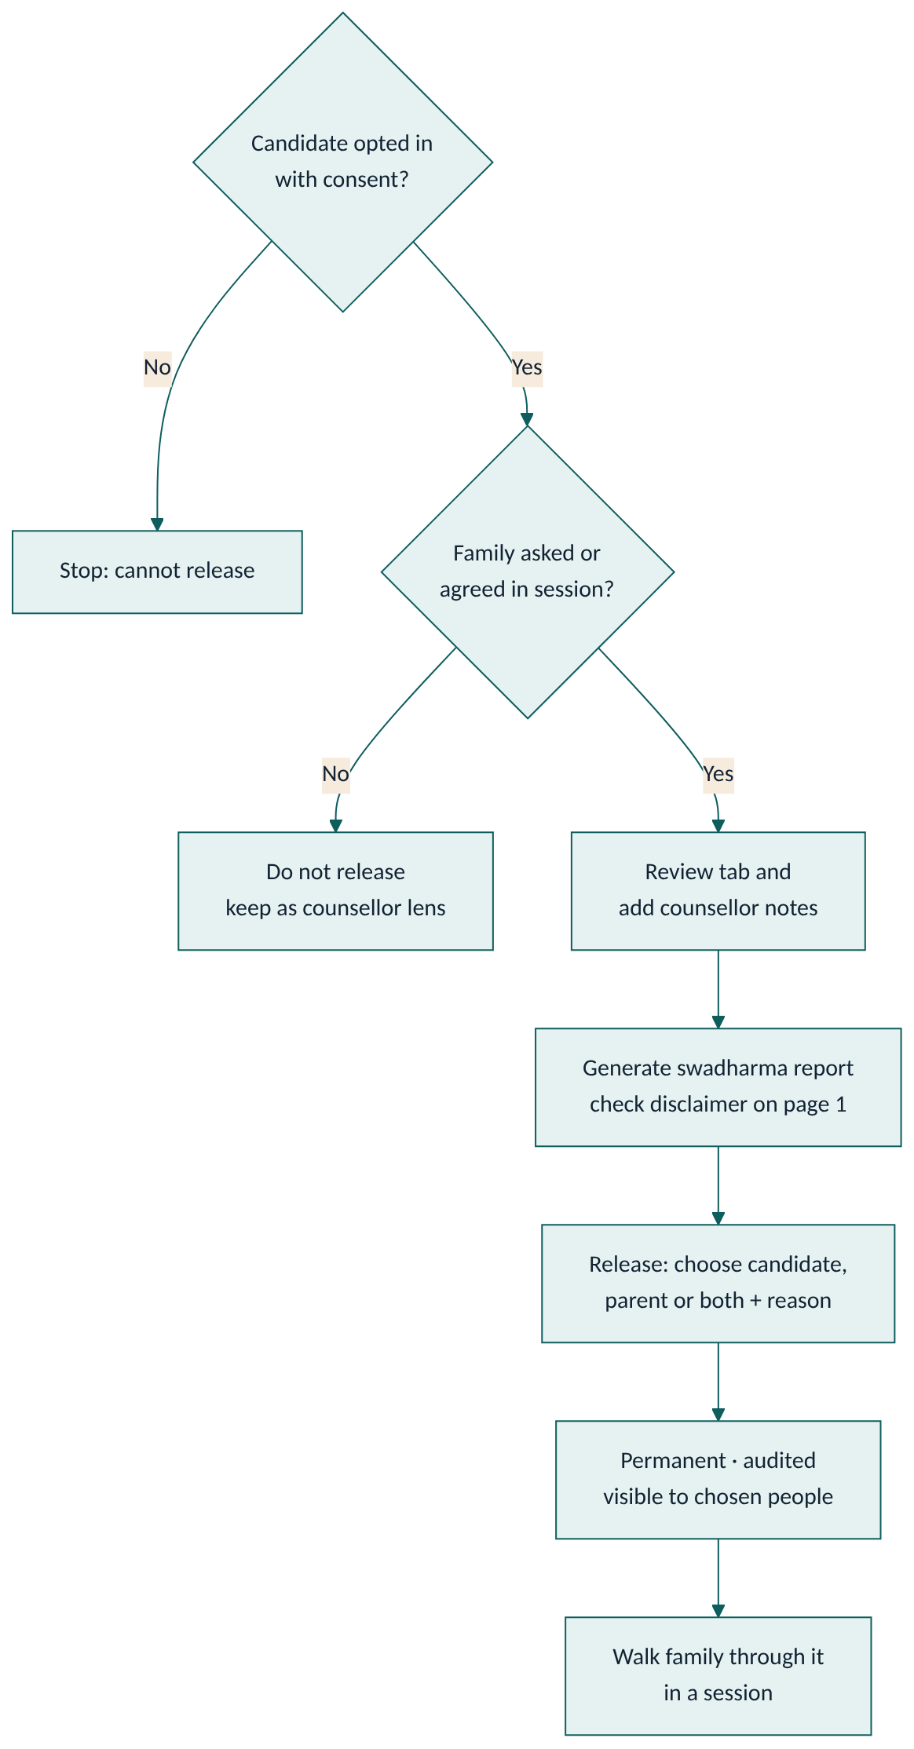
Only if the candidate (and guardian for minors) opted in, and the family has asked for it or agreed in a session.
- Review the Swadharma tab: confidence, agreement matrix, favourable windows. Add counsellor notes.
- Generate a swadharma report and check page 1 has the full disclaimer.
- Press Release Swadharma Report, choose candidate, parent or both, and write a clear reason (for example "Discussed in session 3; family requested the report").
- Confirm. The release is permanent and logged. It cannot be withdrawn.
- Walk the family through the report in a session; reinforce that it is a reflection lens only.
Never: release without consent, release a case file to a family, or use Swadharma to rule out a career.
Record: swadharma_releases row, audit_log entry swadharma_release, report visible_to.
If released to the wrong person: it cannot be reversed in the system. Inform the admin immediately and follow SOP-O14.

SOP-O7 Sessions
- Schedule in Sessions with mode and meeting URL. The family sees it on /me/sessions and /family.
- After the session, within 24 hours, fill the ICCC-stage template: private notes, Summary for candidate, action items, attended.
- Add any action items to the roadmap.
Record: sessions row with iccc_stage, attended, summary.

SOP-O8 Reports and SLA
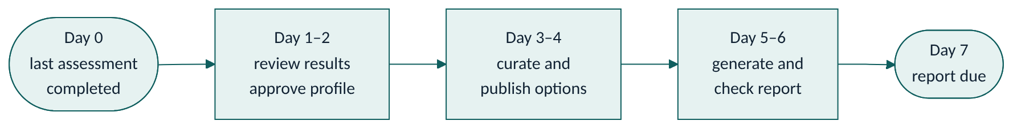
- The report SLA is 7 days from the last completed assessment.
- Check /reports/queue daily. Work the oldest due first.
- Generate the right kind: candidate (student/professional), candidate_junior and stream_choice (early explorer), parent, case_file (internal).
- Check the PDF: name, track, disclaimer present, no Swadharma content in non-Swadharma family reports.
- To correct a report, generate again; a new version is created. Old versions stay.
- Admin reviews SLA breaches weekly on /admin/counsellors.
Record: reports versions, v_tat.

SOP-O9 Instrument version change
- Prepare the new version (items, scoring spec, norms) outside production and test it in staging.
- In /admin/instruments, upload the new version and norms.
- Activate the new version and deactivate the old one at a quiet time. Candidates mid-test keep their existing session.
- Update the instrument section of the LLD if scoring rules change.
Record: instruments.version, is_active, change note in the PR.

SOP-O10 Career library and outlook refresh
Trigger: quarterly reminder, or new evidence.
- For each career due for review, check outlook, automation exposure, salary band and exams against current sources.
- Update the fields, add the source and set last reviewed to today.
- Replace any content still marked "seed – verify before launch".
Record: careers.sources, careers.last_reviewed.

SOP-O11 Roadmap and missed items
- Build from a template, adjust items, owners and due dates, then Publish.
- Each morning, review notifications for items marked Missed overnight.
- Contact the owner, agree a new date, update the item.

SOP-O12 Outcome follow-up
- At 6, 12 and 24 months after roadmap publish, the scheduler reminds you.
- Contact the candidate; record status, current career, whether it was in the top 5, and satisfaction 1–5.
Record: outcomes row per checkpoint.

SOP-O13 Staff onboarding and offboarding
Onboarding: invite the user, set role to counsellor (admin only), walk them through the Counsellor guide and these SOPs, assign a small caseload first.
Offboarding: reassign all their candidates and open leads, then change the role to a non-staff role or disable the auth user. Do not delete the user; audit history references them.

SOP-O14 Privacy requests and data incidents
Access or correction request: verify identity, then export or correct the data within 30 days. Birth details may be corrected only through a new consent submission.
Deletion request: admin coordinates with the technical owner; audit log and Swadharma releases are retained as a legal record of consent.
Incident (data shown to the wrong person, leaked link, wrong release):
- Admin records the incident with time, people affected and data involved.
- Contain: revoke sessions, rotate keys if needed (see SOP-T5).
- Inform affected families and, where required by the DPDP Act, the authorities.
- Write a short post-incident note and update docs or controls.

