SwadharmaPath
Technical SOPs

Career counselling platform: from enquiry to a tracked career roadmap
Audience: Developers
Last updated: 2026-10-24
Source: docs/ in the SwadharmaPath repository (Markdown is the master copy)

Procedures for developers and the technical owner.
Last updated 2026-10-24.
ID | SOP
T1 | Release and deployment
T2 | Database migration
T3 | Regenerating seed data
T4 | Worker operations
T5 | Secret rotation
T6 | Backup and restore
T7 | Incident response
T8 | Documentation maintenance
T9 | Word (.docx) versions of the docs

Contents
- SOP-T1 Release and deployment
- SOP-T2 Database migration
- SOP-T3 Regenerating seed data
- SOP-T4 Worker operations
- SOP-T5 Secret rotation
- SOP-T6 Backup and restore
- SOP-T7 Incident response
- SOP-T8 Documentation maintenance
- SOP-T9 Word (.docx) versions of the docs

SOP-T1 Release and deployment
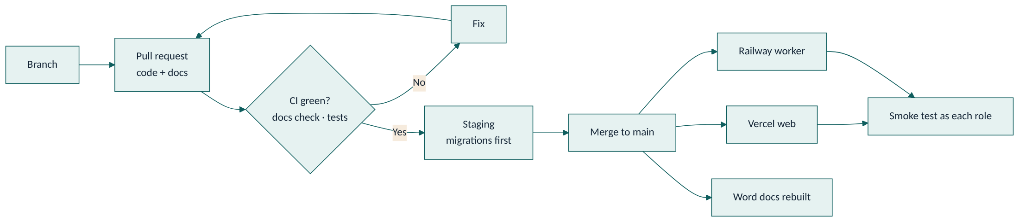
- Every change goes through a pull request to main.
- CI must be green, including the docs check (code changes need matching /docs changes).
- Database changes: run supabase/tests/run.sh locally; apply to staging first (SOP-T2).
- Merge. Vercel deploys the web app from main. Railway deploys the worker from main.
- Smoke test production: login as each role with test accounts, open /me, /family, /cases, /admin; submit a test enquiry.
- Note the release in the change history of any doc you changed.
Rollback: web — redeploy the previous Vercel deployment; worker — redeploy the previous Railway release; database — write a forward-fixing migration (never edit an applied migration).

SOP-T2 Database migration
- Add a new file supabase/migrations/NNN_description.sql. Do not edit an applied migration.
- Every new table: enable RLS and add policies. Sensitive tables get no candidate/parent policy.
- Add tests in supabase/tests/rls_test.sql or owner_test.sql.
- Run locally:
- PGHOST=localhost PGUSER=postgres ./supabase/tests/run.sh
- Apply to staging (supabase db push against the staging project), run smoke tests, then production.
- Update the LLD data model, access matrix, triggers and RPCs sections.

SOP-T3 Regenerating seed data
- Edit supabase/seed/library.py (careers, streams) or supabase/seed/instruments.py.
- Run python3 supabase/seed/build_seed.py. It rewrites everything after -- BEGIN GENERATED SEED in the migration.
- Run the SQL tests. Commit the generated SQL with the source change.

SOP-T4 Worker operations
- Railway service runs Python 3.12 with the service-role key.
- Check logs after deploy for scheduler start and a successful database connection.
- If scoring or reports stop: check Railway logs, then Supabase logs for score_instrument, then the Vault secrets used by invoke_edge_function.
- Re-run scoring for a session by re-triggering the worker job for that session (command to be documented when the worker lands).

SOP-T5 Secret rotation
- Rotate the service-role key in Supabase.
- Update it in Railway (worker), Edge Function secrets and Vault service_role_key.
- Rotate the anon key only if exposed; update VITE_SUPABASE_ANON_KEY in Vercel and redeploy.
- Verify scoring (complete a test assessment) and report download.
Never put the service-role key in a VITE_* variable or in the repo.

SOP-T6 Backup and restore
- Supabase daily backups (and point-in-time recovery if enabled on the plan).
- Storage buckets reports and documents: periodic export.
- Test a restore to a scratch project quarterly.

SOP-T7 Incident response
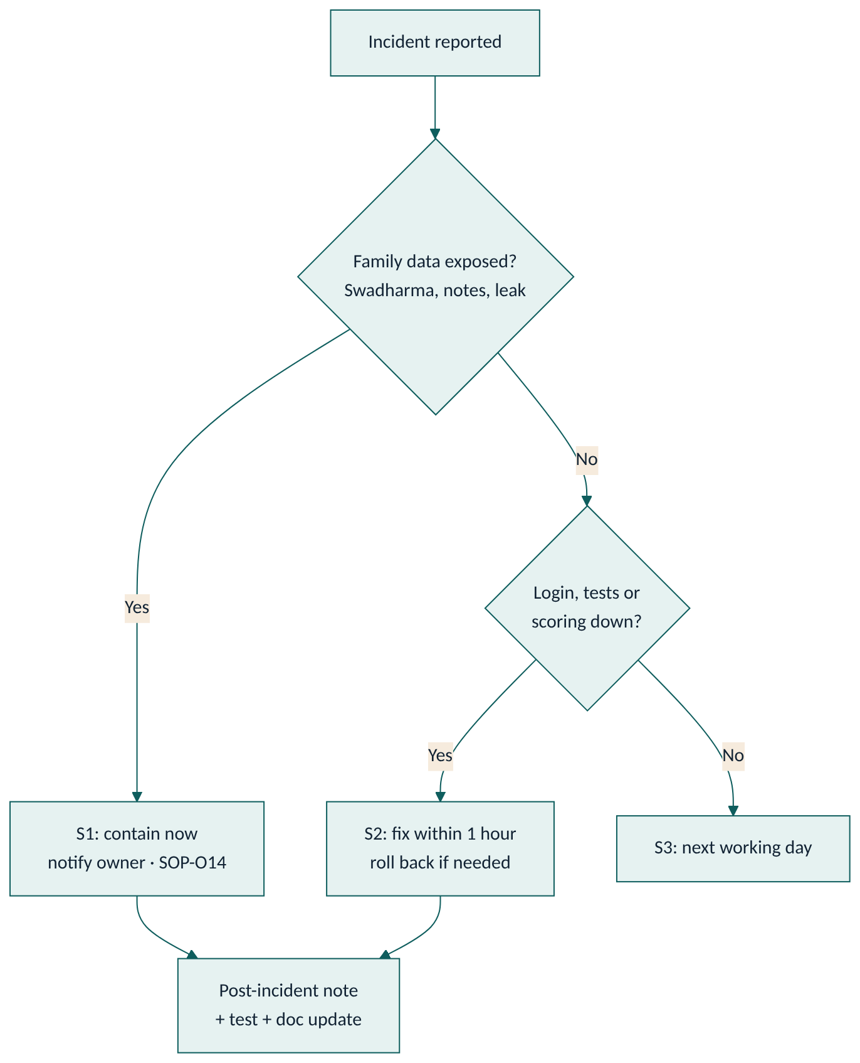
Severity | Example | Response
S1 | Swadharma or private notes visible to a family; data leak | Immediately: disable affected route or policy, notify owner, follow SOP-O14
S2 | Logins, test runner or scoring down | Within 1 hour: diagnose via Vercel, Supabase and Railway logs; roll back if a recent deploy caused it
S3 | A dashboard number wrong, a report layout issue | Next working day
After any S1/S2: short post-incident note, a test that would have caught it, and doc updates.

SOP-T8 Documentation maintenance
Rule: every code or spec change updates the matching docs in the same branch and pull request.
- Check the doc map to find which docs your change touches.
- Update them, and add a line to the doc's change history when behaviour changes.
- Tick the docs box in the PR template.
- CI runs scripts/check_docs.py. It fails when code changes have no /docs change, or when a mapped area (for example supabase/migrations/) changes without its mapped doc.
- For a change with genuinely no doc impact (formatting, dependency bump), add the label docs-not-required and say why in the PR description. Reviewers must agree.

SOP-T9 Word (.docx) versions of the docs
The Markdown files in /docs are the master copy. Branded Word versions live in docs/word/ and are generated, never edited by hand.
- Edit the Markdown. Draw diagrams as ```mermaid blocks; they render on GitHub and become images in Word. Prefer flowchart LR with direction TB subgraphs so diagrams stay readable on an A4 page, and avoid ; inside labels.
- After merge to main, the Build Word docs workflow (.github/workflows/docs-word.yml) runs scripts/docx/build_docx.py and commits the updated .docx files. It can also be run by hand from the Actions tab (Run workflow).
- To build locally (needs pandoc, Node 22, python-docx):
- npm ci --prefix scripts/docx
npx --prefix scripts/docx playwright install chromium
python3 scripts/docx/build_docx.py # all documents
python3 scripts/docx/build_docx.py SwadharmaPath-BRD # one document
- To add a new document, add a row to DOCS_TO_BUILD in scripts/docx/build_docx.py and to the table in docs/README.md.
Each Word file has a cover page, a clickable contents list, page headers and numbers, teal header rows on tables and all diagrams as images.

