# 1. Pre-Processing

--> noao

--> imred

imred/:

argus/ ctioslit/ hydra/ kpnocoude/ vtel/

bias/ dtoi/ iids/ kpnoslit/

ccdred/ echelle/ irred/ quadred/

crutil/ generic/ irs/ specred/

--> ccdred

ccdred/:

badpiximage ccdlist combine mkillumcor setinstrument

ccdgroups ccdmask darkcombine mkillumflat zerocombine

ccdhedit ccdproc flatcombine mkskycor

ccdinstrument ccdtest mkfringecor mkskyflat

NOTE:

(1) Change all the names to “.fits”, NOT “.fit”

(2) All the images should have header “BZERO” and “BSCALE”. IF THEY DON’T HAVE, type the following:

*** I HAVE ALREADY DONE THIS ***

ccdhedit *.fits BZERO 32768

ccdhedit *.fits BSCALE 1

cd bias/

ccdhedit *.fits BZERO 32768

ccdhedit *.fits BSCALE 1

cd ../dark/

ccdhedit *.fits BZERO 32768

ccdhedit *.fits BSCALE 1

cd ../flat/

ccdhedit *.fits BZERO 32768

ccdhedit *.fits BSCALE 1

cd ../ref/

ccdhedit *.fits BZERO 32768

ccdhedit *.fits BSCALE 1

cd ..

*** I HAVE ALREADY DONE THIS ***

The real pixel value should be

real value = pixel * BSCALE + BZERO

People sacrificed the 15th bit of 16-bit system, and used it as a “sign” bit. Usually, BZERO = 215 = 32768, and BSCALE=1.0. If you do not add these header keywords to the image header, you will result in many negative values from bias/dark/flat raw images, which eventually lead you to a wrong result.

## 1-1. BIAS

bias is also called zero or offset.

--> cd bias/

--> ls

bias1.fits bias2.fits bias3.fits

--> ls bias*.fits > bias.list

You now have a list file. You can open this with gedit bias.list or vi bias.list .

Quiz: Try what happens when you do ls bias* > bias.list (delete ‘.fits’). Open the bias.list file, and you will find something happened. Why?

Using ZEROCOMBINE

--> epar zerocombine

* You can always use IMCOMBINE and IMARITH, or COMBINE (different from IMCOMBINE). ZERO/DARK/FLATCOMBINE tasks are all small variants of COMBINE, and run through CCDPROC task.

Set parameters as in the figure.

--> zerocombine

List of zero level images to combine ('@bias.list'): (type enter)

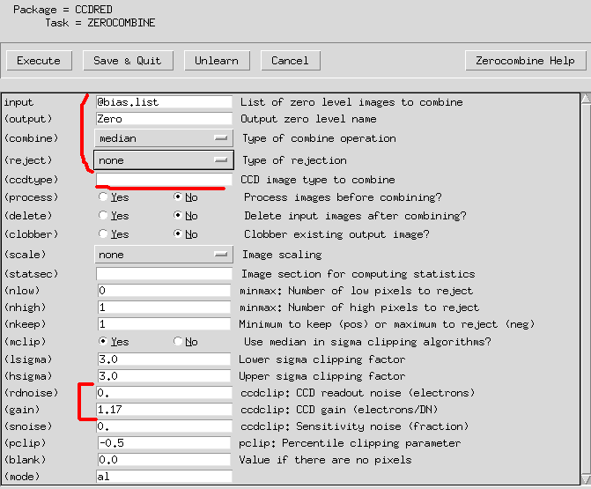

--> ls

bias1.fits bias2.fits bias3.fits bias.list logfile Zero.fits

--> !ds9 Zero.fits &

--> ls

bias1.fits bias2.fits bias3.fits bias.list logfile Zero.fits

--> imstat Zero.fits

# IMAGE NPIX MEAN STDDEV MIN MAX

Zero.fits 3214848 113.6 6.652 87. 6841.

--> imstat bias*

# IMAGE NPIX MEAN STDDEV MIN MAX

Error reading image bias.list ...

bias1.fits 3214848 114.1 8.653 79. 6841.

bias2.fits 3214848 112.9 8.715 78. 6872.

bias3.fits 3214848 113.9 8.673 78. 6838.

## 1-2. DARK

--> cd ../dark

--> cp ../bias/Zero.fits .

--> ls

dark-001_20.fits dark-002_20.fits Zero.fits

--> epar darkcombine

Set parameters as in the figure.

--> epar ccdproc

Set parameters as in the figure.

--> darkcombine

* If you do DARKCOMBINE, the input dark files may be changed (automatically zero subtracted). If you type CCDLIST, you can see [Z] to each dark files, which means the zero correction has already been done. This can be avoided by using CCDPROC:

epar ccdproc

input=dark*, (output)=Dark.fits, (zerocor)=yes, (zero)=Zero.fits.

Or COMBINE or IMCOMBINE to get the median-combined dark, and then subtract Zero.fits by IMARITH:

combine dark*.fits tmp.fits combine=median

imarith tmp.fits – Zero.fits Dark.fits

Of course (IM)COMBINE and IMARITH all can be controlled by using epar (epar combine, etc) as before. If you have better ways to do this, please let TA know T__T

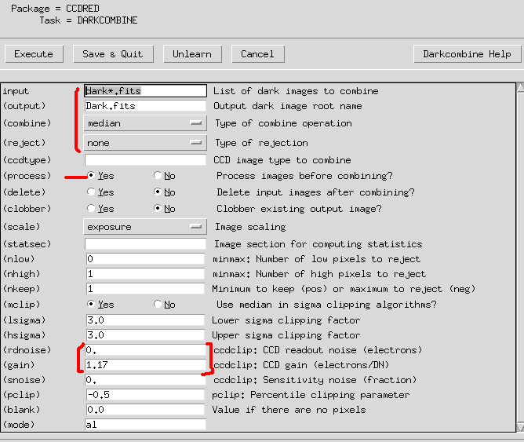

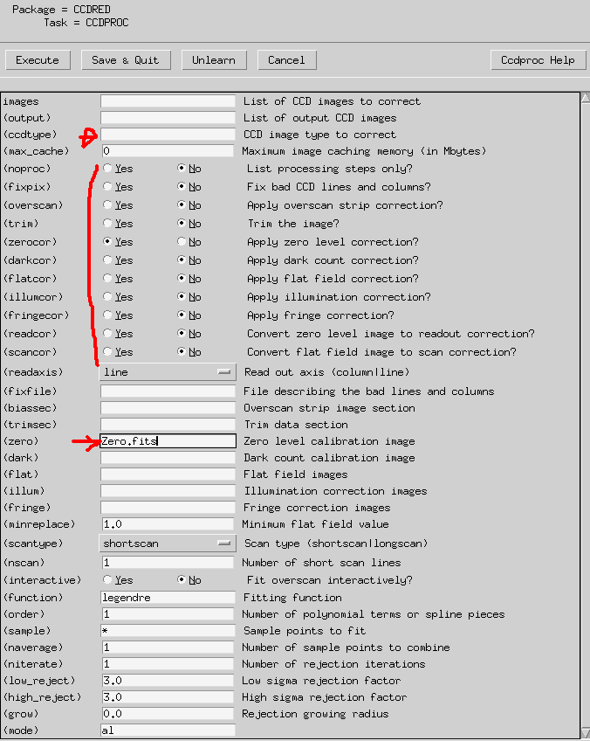

--> imstat *

# IMAGE NPIX MEAN STDDEV MIN MAX

Dark.fits 3214848 -0.8294 11.97 -36.5 13333.

Zero.fits 3214848 113.6 6.652 87. 6841.

dark-001_7.fits 3214848 -0.3927 13.14 -46. 13345.

dark-002_7.fits 3214848 -1.266 13.04 -47. 13322.

The zero-corrected dark may have negative values and the mean is around 0.

## 1-3. FLAT

--> cd ../flat/

--> cp ../dark/Zero.fits .

--> cp ../dark/Dark.fits .

--> ls

Dark.fits flat_30.fits Zero.fits

--> epar flatcombine

Set parameters as in the figure.

--> flatcombine

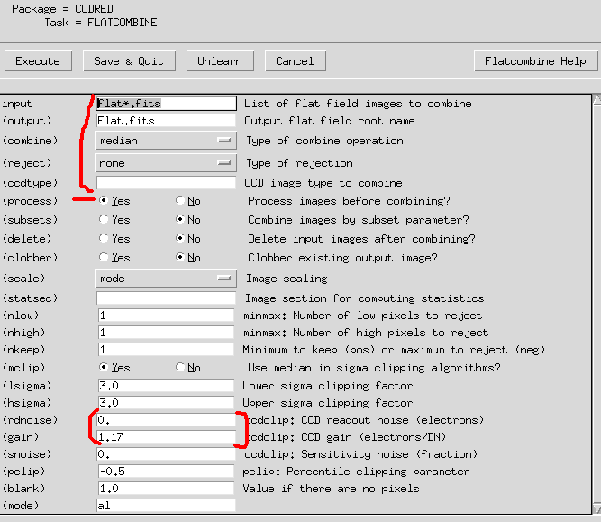

--> !ds9 Flat.fits &

Looks OK

--> imstat Flat.fits

# IMAGE NPIX MEAN STDDEV MIN MAX

Flat.fits 3214848 360.5 723.4 -18963. 24817.

## 1-4. PRE-PROCESS

--> cd ..

--> cp flat/Flat.fits .

--> cp flat/Dark.fits .

--> cp flat/Flat.fits .

--> implot Flat.fits

What we are going to do is to “trim” only the usable part of the image. By doing implot on flat image, you can find some plausible x, y range of the usable region.

Left image: :a 30 → :l 700

Right image: :a 30 → :c 500

On the right y axis, the small yellow tick shows at which column or line you are. Try many different col/line using :c and :l to get an idea how it works.

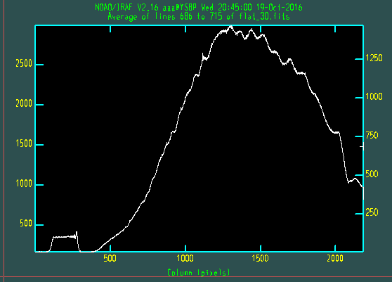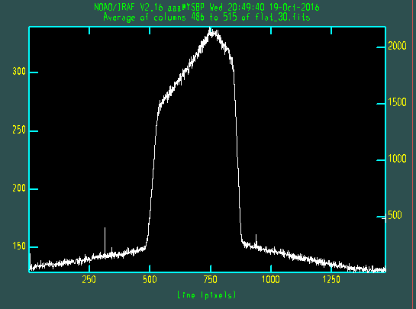

We may say that x(column): 500~2100 and y(line): 550~850 is reliable, and other pixels are useless. For smaller x values, there seems to be signal, but it is due to the higher order dispersion and/or due to the order sorting filter.

We can trim all the images (including the object) using the “trimcor” option in CCDPROC. The trim region can be specified at (trim) by [x1:x2,y1:y2], i.e., [500:2100,550:850], in our case.

Now we turn on zerocor, darkcor, and flatcor with Zero.fits, Dark.fits, and Flat.fits as follows:

--> epar ccdproc

Set parameters as in the figure.

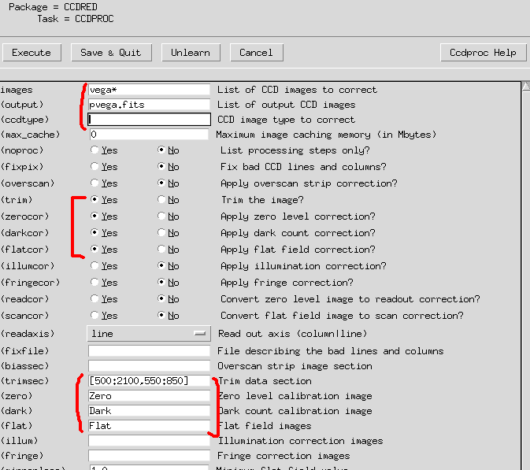

Click on Execute.

--> imstat

List of input images ('*.fits'):

# IMAGE NPIX MEAN STDDEV MIN MAX

Dark.fits 481901 -0.7664 8.627 -33.5 2321.

Flat.fits 481901 1804. 823.4 73.57 24817.

Zero.fits 481901 113.3 5.251 90. 829.

pvega.fits 481901 168.3 2541. -2224. 133972.

vega_7s.fits 481901 220.9 1254. 83. 35427.

--> ccdlist

CCD images to listed ('*.fits'):

Dark.fits[1601,301][real][unknown][][TZ]:dark

Flat.fits[1601,301][real][unknown][][TZD]:

Zero.fits[1601,301][real][unknown][][T]:

pvega.fits[1601,301][real][unknown][][TZDF]:

vega_7s.fits[2184,1472][ushort][unknown][]:

# 2. Wavelength Calibration

I want to make a separate directory to start from a clean directory. It is totally up to you.

--> !mkdir after_prep

--> cd after_prep/

--> !mv ../pvega.fits .

## 2-1. DISPAXIS

The dispersion axis should be saved in the header for the IRAF to work properly. We can manually correct this information:

check whether the header containing the information:

--> imhead pvega.fits long+ | grep DISPAXIS

edit header:

--> hedit pvega.fits DISPAXIS 1 add+

add vega.fits,DISPAXIS = 1

update vega.fits ? (yes):

vega.fits updated

--> imhead pvega.fits long+ | grep DISPAXIS

DISPAXIS= 1

Now the image has the DISPAXIS header keyword.

## 2-2. APALL

--> noao

--> onedspec

--> twodspec

twodspec/:

apextract/ longslit/

--> apextract

apextract/:

apall apedit apflatten apnormalize apscatter

apdefault@ apfind apmask aprecenter apsum

apdemos/ apfit apnoise apresize aptrace

--> epar apall

Set parameters as in the figure. If you want the IRAF to automatically find aperture(you can modify it later by yourself, but you can get an idea how it finds the aperture), you can just set everything as default.

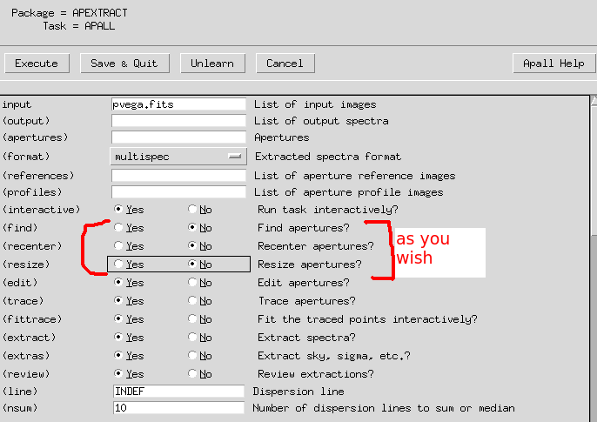

--> epar apextract

Set dispaxis = 1

--> apall

List of input images ('vega.fits'):

Edit apertures for vega? ('yes'):

If you hit ‘?’, the command will show you the help page. Hit ‘?’ again, and you may be able to get out of the help page.

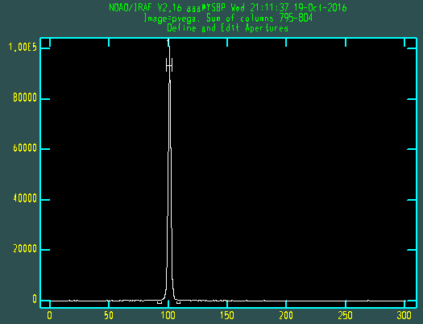Hit w for zoom, and e for the lower left and upper right corner to zoom in. hit w a to get to the default zoom.

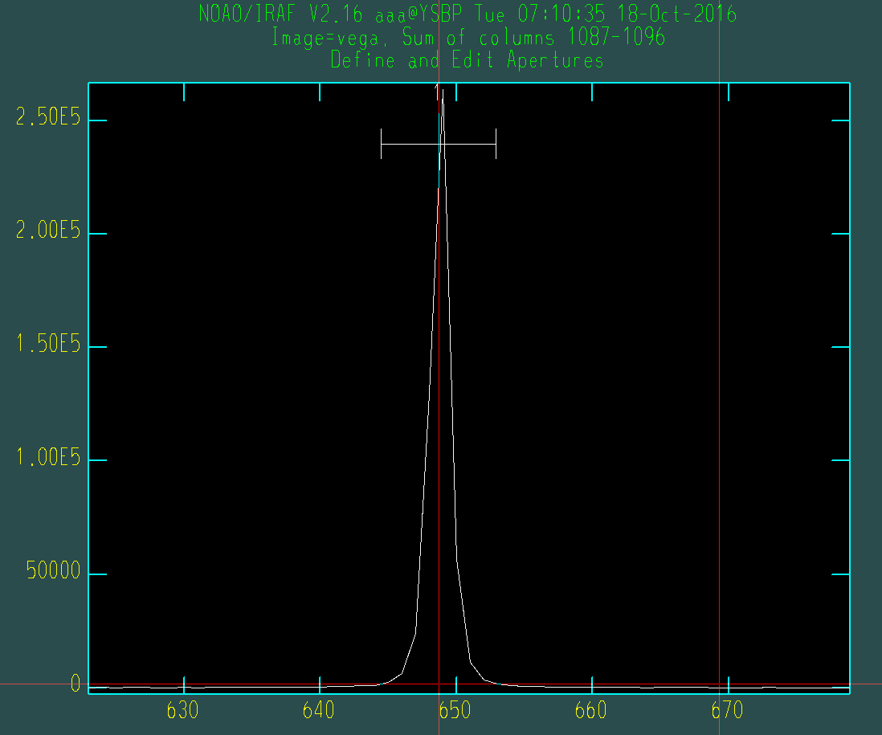

*(This screenshot may slightly differ from yours, but the general trand is the same)*

Type m after you put the cursor near the peak, and IRAF will automatically find aperture for the profile. Hit d to delete the recent ones. Hit y key so that you can define the aperture size as the width at the cursor.

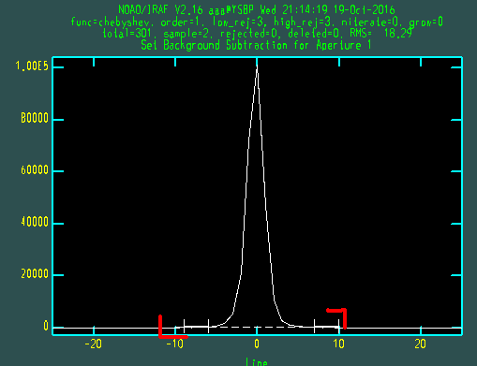Hit b → We now will fit the background. This is needed to subtract background from the source. Hit w a to go to the original zoom. Then do w e e to zoom. It is better to zoom small y range to see the background fluctuation as indicated in the figure (red marks).

The dashed line = fitted sky (background). As you can see, it is too high!

We need to adjust the sky sampling region. Hit s at the lower/upper for both sides (total 4 hits). Hit f to fit the sky.

Hit z key to undo, if you want.

*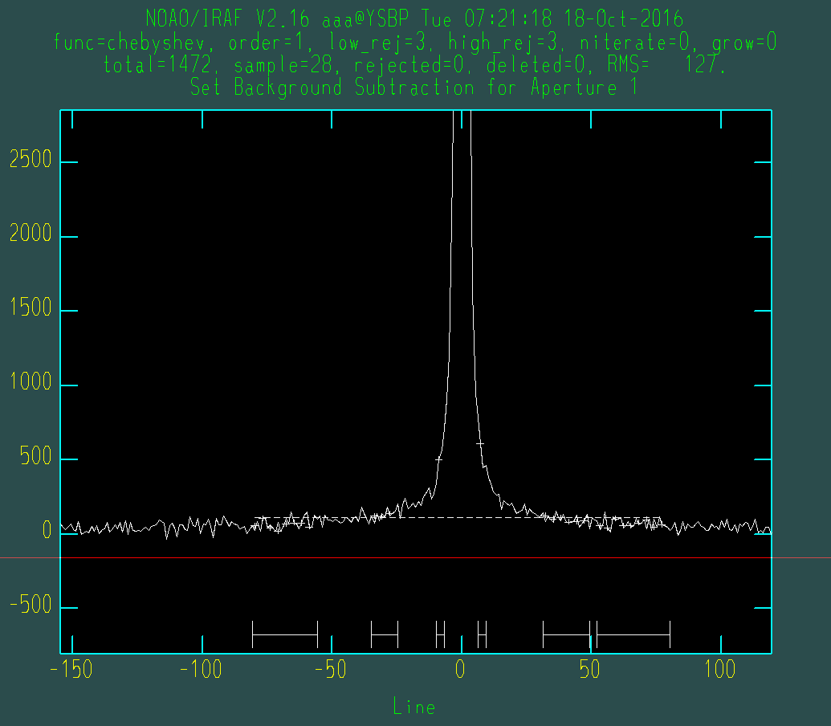(This screenshot may slightly differ from yours, but the general trand is the same)*

Now it seems better…

Hit q to get out.

Hit q again.

On the terminal, you will see some questions. Type “yes” to the GRAPHICS, NOT THE TERMINAL!

You may have to answer 2-3 times, depending on the APALL epar setting.

Type return again and again until you see the following figure:

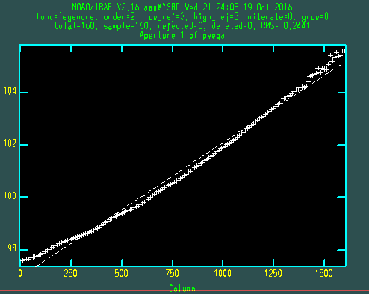The fitting does not look good, but if you see closely, the error is only few pixels order. But you may still want better fit.

Type :order *n* to fit the n-th order fitting line to the + signs. :order 10 or 5 will be enough for most of the cases.

Hit f to see newly fitted dashed line.

* Moving along columns, the center of the aperture should move, due to the imperfection of instruments. This “shift” is called the trace. The above image shows this “*trace*” value along the columns(x-axis).

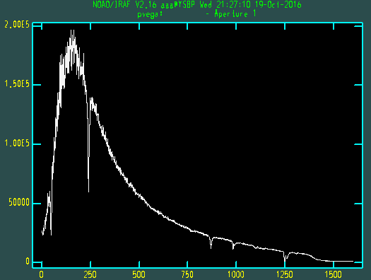Now you get this spectrum of Vega.

What is remaining?

We have to change the x value to wavelength.

## 2-3. IDENTIFY

First let’s trim the neon lamp file. Turn only trim on:

--> epar ccdproc

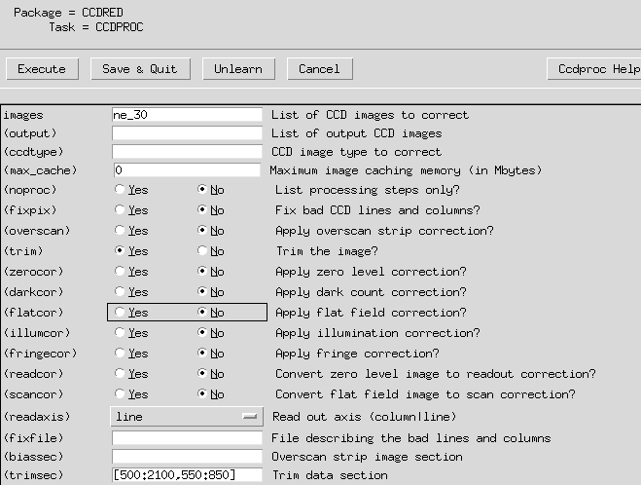

Then we have trimmed image for the lamp as any other images.

--> epar identify

(or identify ne_30.fits coordlist=Ne.dat)

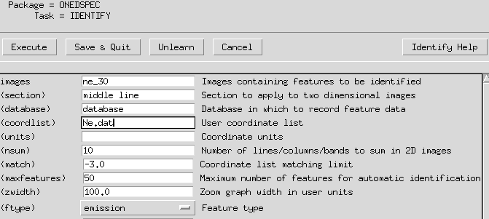

*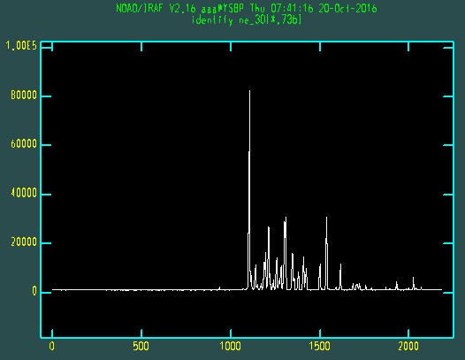(These screenshots may slightly differ from yours, but the general trand is the same)*

This shows the Ne lamp image’s spectrum.

The figure at the next page is the Ne spectrum. The numbers are in Angstrom unit.

You can see that the general features are the same as the IRAF (PyRAF) graphics.

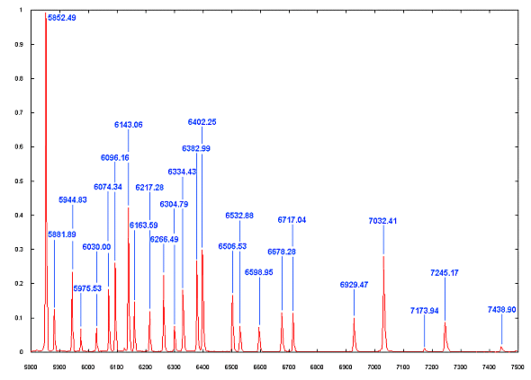

<http://www.astrosurf.com/buil/us/spe2/hresol4.htm>

(If the image is low resolution, you may find “low resolution lamp spectrum” more similar to your image, such as that in the following link:

<http://www.astrosurf.com/buil/us/spectro8/spaude5_us.htm> )

Now we have to let IRAF know what the wavelengths of about 2~3 peaks in the graphics. IRAF then automatically use the “peaks” data file to find all other peaks. Let’s see how it works:

Use w e e and w a to zoom the spectrum. Put the cursor near one of the peaks (e.g., the largest peak at 5852.49 Angstrom). Then type m (for mark). At the bottom of the graphics, type the rough wavelength value (e.g., “5852”). Hit return. At the bottom, there will be the found wavelength value. It is found from the Ne.dat file, using your input value.

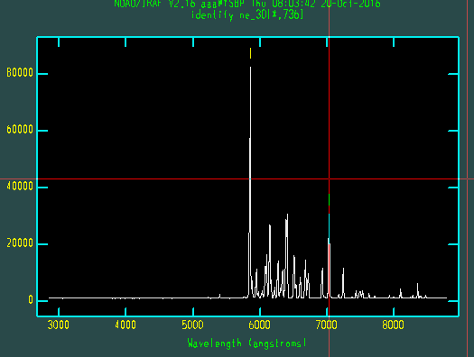Do the same thing about once more. (total two is enough since we have Ne.dat file)

Hit f will show you how well the fitting will be done. If it seems to have small errors, you are satisfied and hit f again. If you are not satisfied, do the marking again after hitting f.

Hit l. IRAF will automatically read the Ne.dat file (containing all possible line centers) and find all peak values. But this process is not always accurate, so you have to edit them.

After fitting, you can see the x axis is now in wavelength unit.

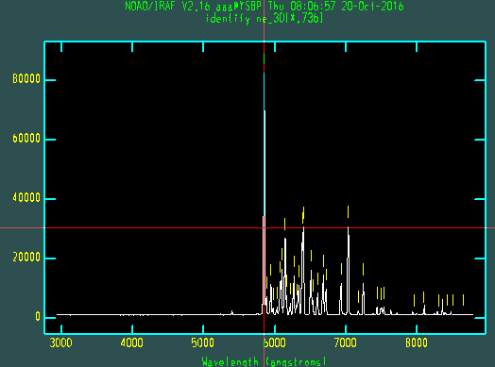

After hitting l, you may see a lot of identified lines as in the figure. The lines, however, are not always the real ones, since very small emission peaks are in the Ne.dat file, too.

You have to delete few of them, and re-fit few of them.

You can see the following link for help:

<http://stsdas.stsci.edu/cgi-bin/gethelp.cgi?identify>

Some are summarized below:

d (D)elete the feature nearest the cursor.

n Move the cursor or zoom window to the (n)ext feature (same as +).

p (P)an to the original window after (z)ooming on a feature.

z (Z)oom on the feature nearest the cursor. The width of the zoom window is determined by the parameter zwidth .

+ Move the cursor or zoom window to the (n)ext feature.

Instead of p and z, you can of course use w e e and w a as usual.

If you feel satisfied, hit f to see the residual plot. If there is any point with significant residual, hit d near it to delete it (X mark will appear). Hit f again and you will fit again. Hit q twice to quit identify.

## 2-4. Header and Dispersion Correction

The ne_30.fits now include the information of our calibration. We now have to implement the object image file that “*the image fits file has reference spectrum data as this neon fits file!*” To do so:

--> hedit pvega.ms REFSPEC1 "ne_30.fits" add+

add pvega.ms,REFSPEC1 = ne_30.fits

update pvega.ms ? (yes):

pvega.ms updated

For check:

--> imhead pvega.ms long+ | grep REFSPEC1

REFSPEC1= 'ne_30.fits'

So the IRAF now will be able to change the x-pixels into wavelengths based on this ne lamp fits data. This can be done by dispersion correction:

--> epar dispcor

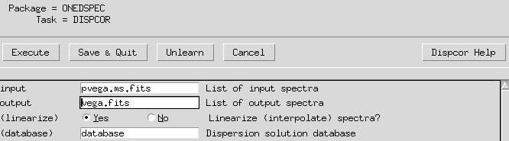

The splot task will show us the calibrated plot:

--> splot vega.fits

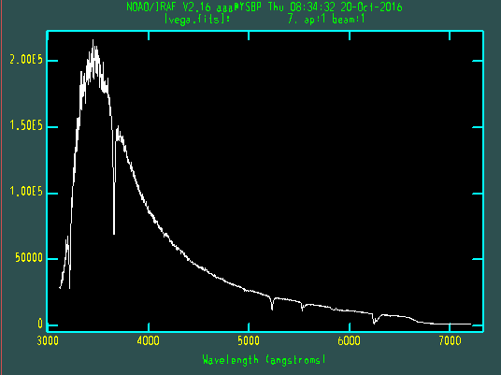

Hit space: you will see x, y, z values. Y is the cursor’s y-value and z is the actual y value of the plot.

You can use w e e and w a to zoom in/out.

## 2-5. Deblending

To study about a line (absorption, in our case), zoom into a certain region using w e e. We will fit the continuum, and fit the absorption line.

At the left- and right-most positions you want to fit the continuum, hit d at each edges.

At the bottom of the graphics, you will be asked about “Lines”. This means with which profile you want to fit the absorption. I will select Gaussian. Put the cursor near the absorption line, and hit g. There will appear a small vertical tick which indicates the center you selected.

After you selected all the lines you want to calculate within the zoomed window, hit q. Another question is Fit positions: just type a. The next is Fit Gaussian width question, just type a. Fit background? Oh yes: type y. Then you will see a green continuum fitting line and red fitting line (absorption fitting line).

You can see the center, flux, equivalent width, and gaussian FWHM value at the bottom of the graphics. +/- will show you the results at next/previous peaks. r will show you the RMS of the background after fitting.

Hit q to exit. The same question will be asked for if you have other things to fit. Just hit q to quit completely. You will see “Deblending Done” message. The process we’ve done is called *deblending*, since we “deblended” line from the continuum.

