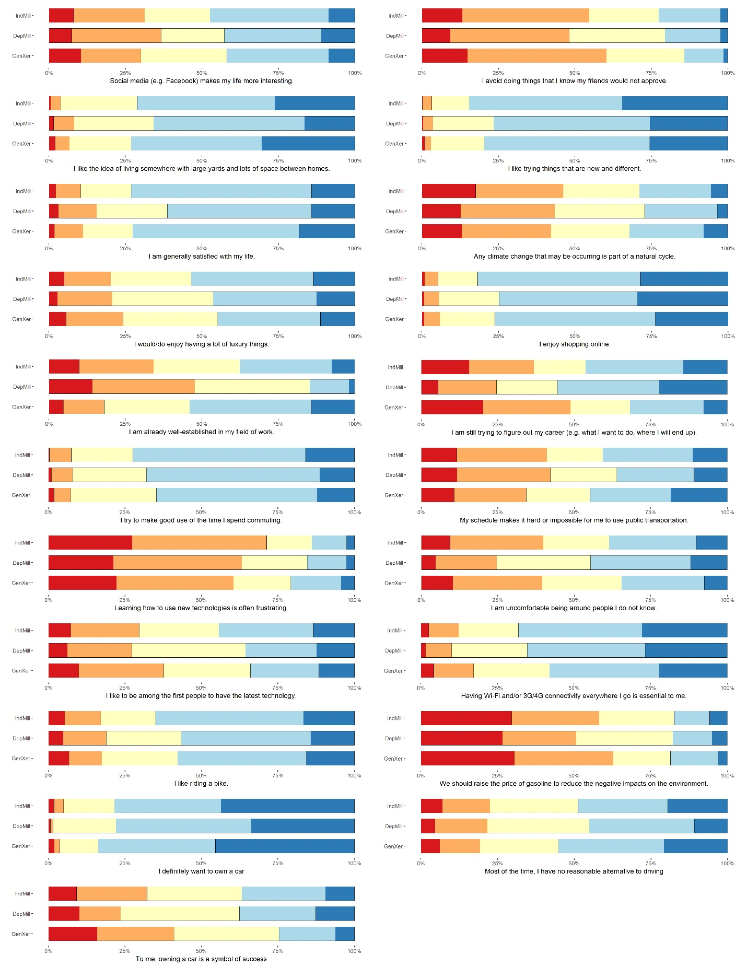

**Figure 2. Responses to Attitudinal Statements by Demographic Group (N=1,975, weighted)**

*Notes*: Colors indicate the extent to which respondents agreed with given statements. From left to right (i.e., from red to blue), they denote strongly disagree, disagree, neutral, agree, and strongly agree.