Doomscroll
UI Mockups — Lab 1 (Initial Draft)
The five screens below sketch the core flow: granting camera access, calibrating, configuring autoscroll, the live reading experience with its on-screen indicator, and the recalibration prompt. Each mockup is annotated (in red) with the HCI rationale behind its layout and the requirement(s) it addresses. These are low-fidelity wireframes, not final visual design — the goal at this stage is to elicit and refine the requirements (Section 3.4 of the Lab 1 manual), not to finalize the UI.

Screen 1 — Onboarding / Camera Permission
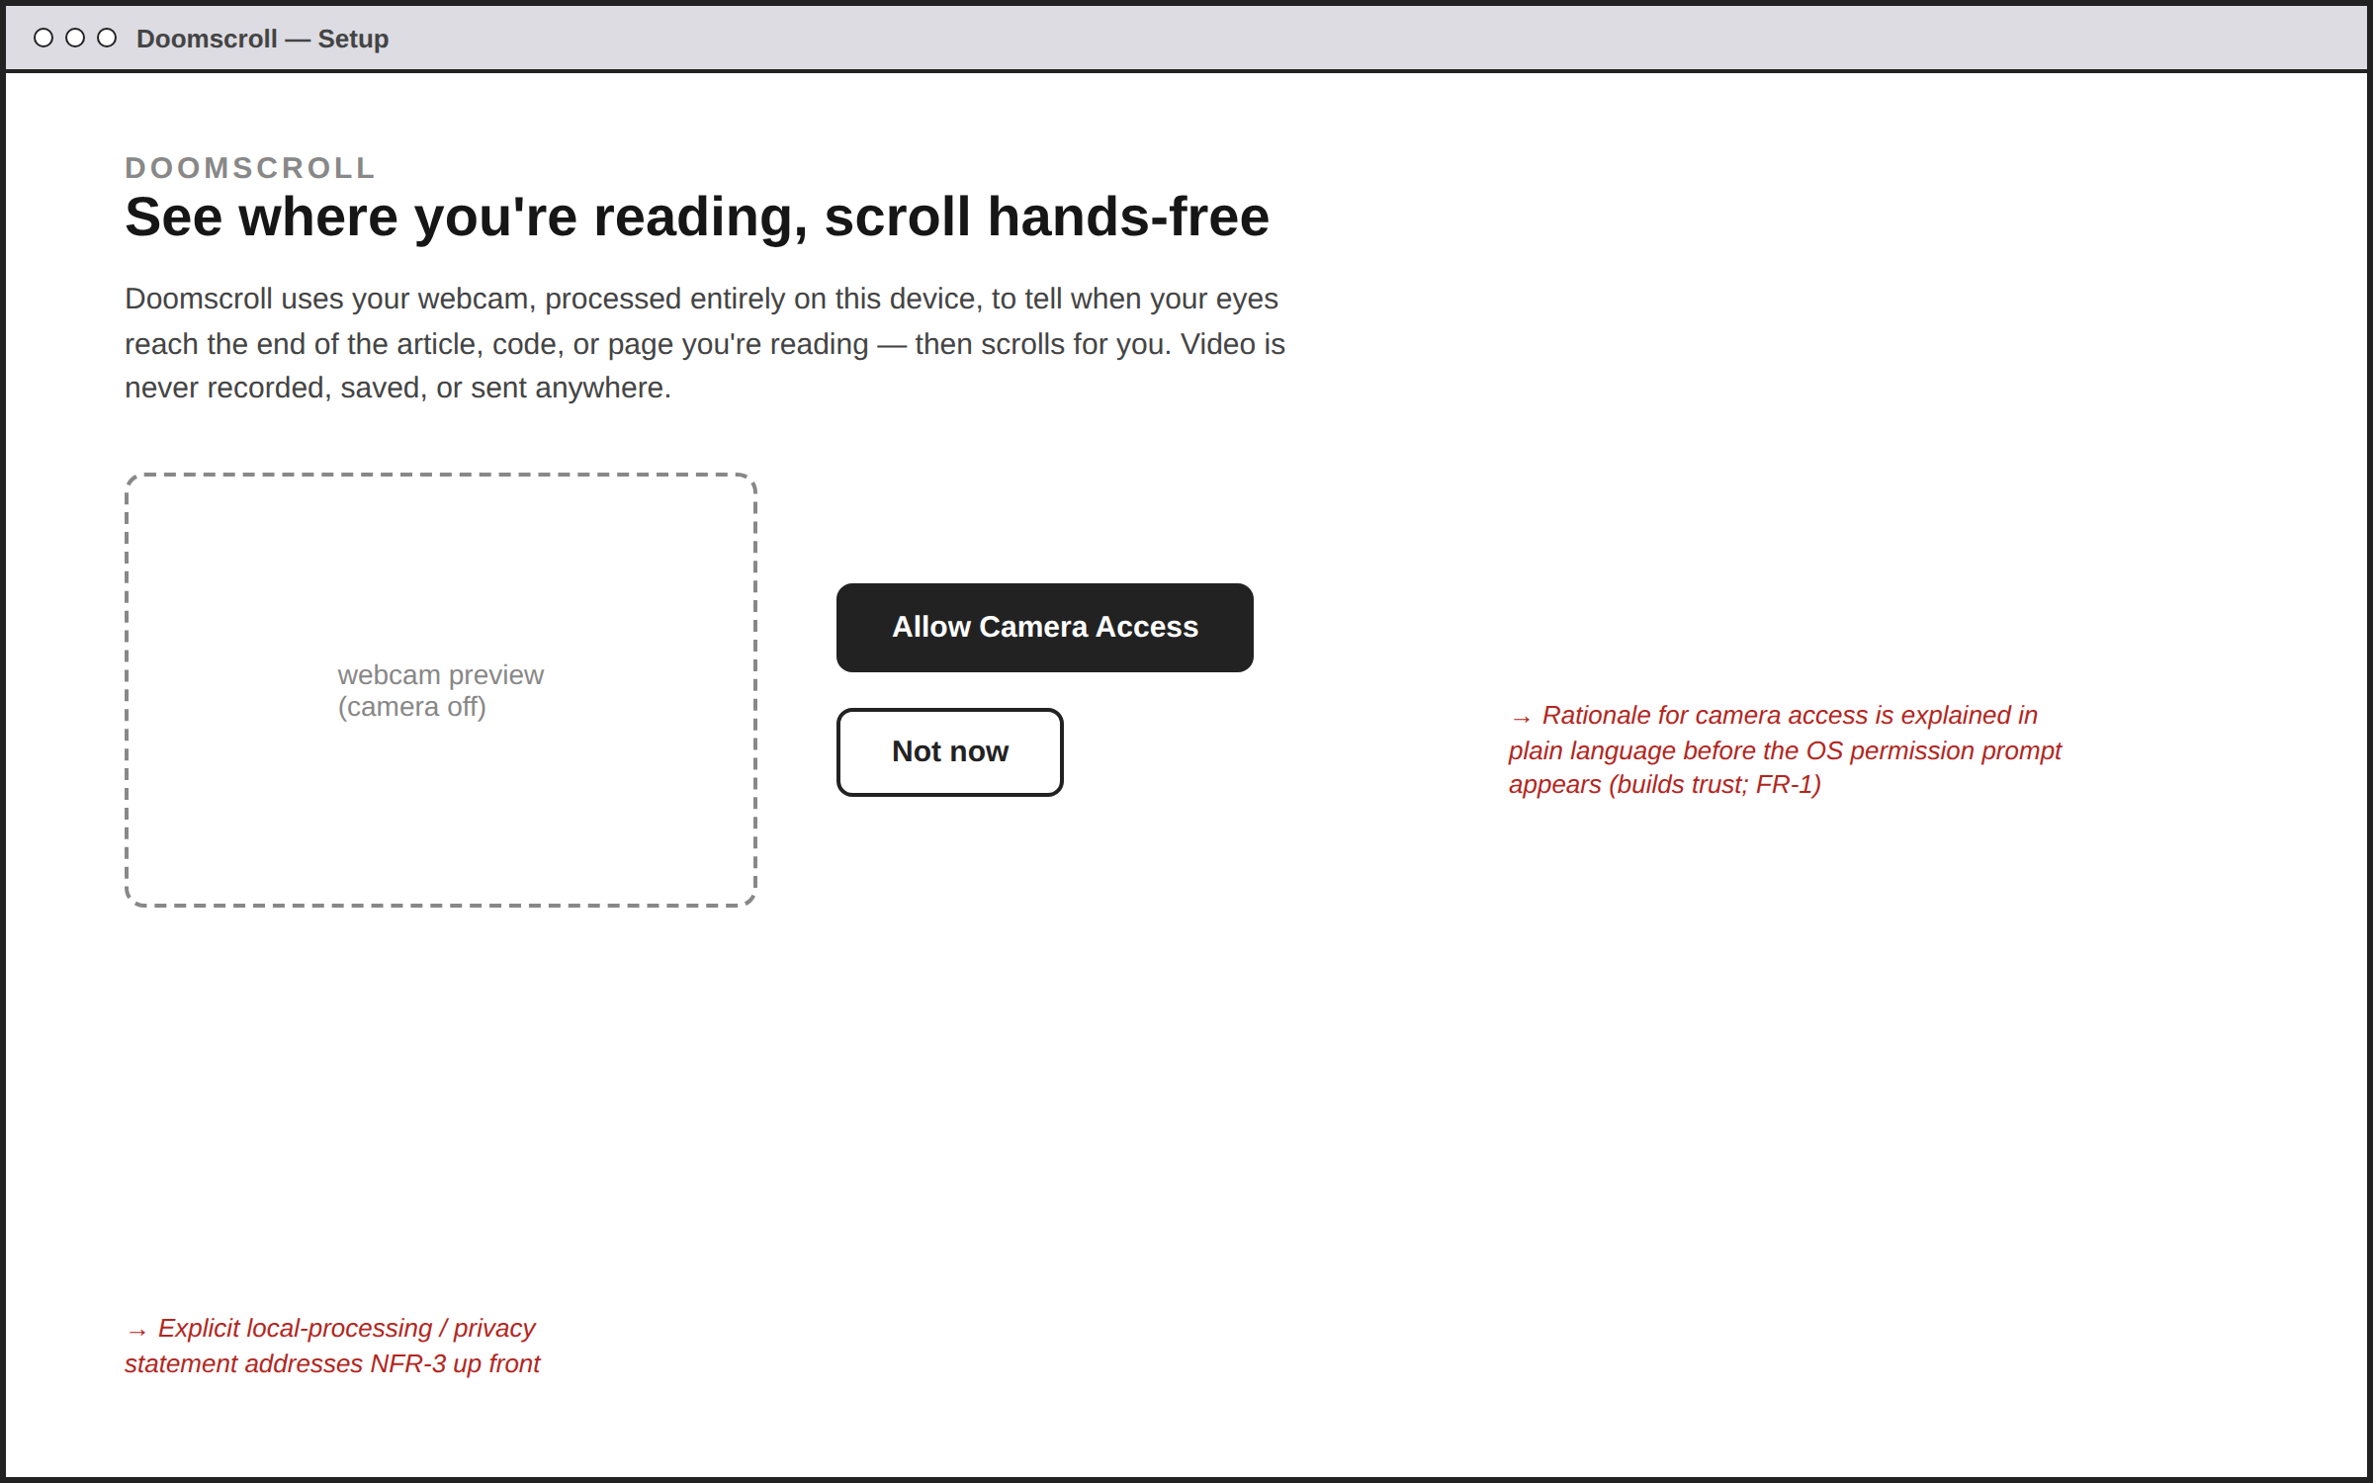
Explains, in plain language, why camera access is needed and how privacy is protected, before the OS permission dialog appears. Related: FR-1, FR-2, NFR-3.

Screen 2 — Calibration
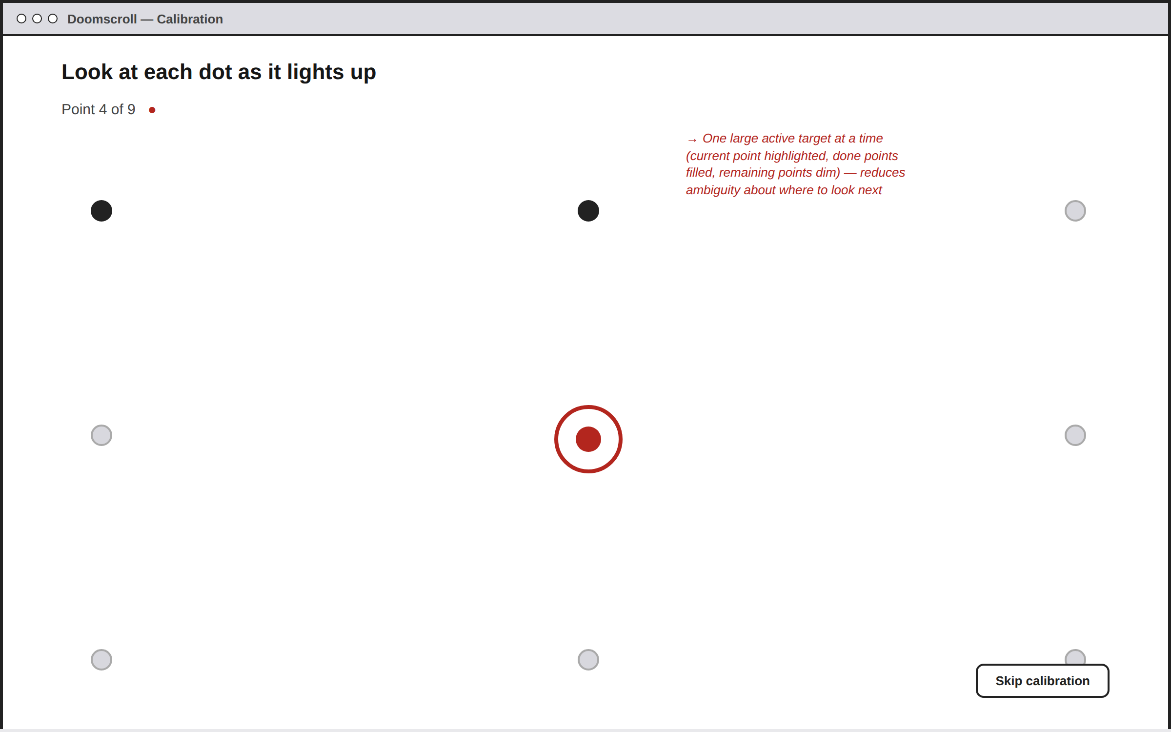
A 3×3 calibration grid: the current target is enlarged and highlighted, completed points are filled, and remaining points stay dim, so the user always knows where to look next. Related: FR-3, FR-4.

Screen 3 — Autoscroll Settings
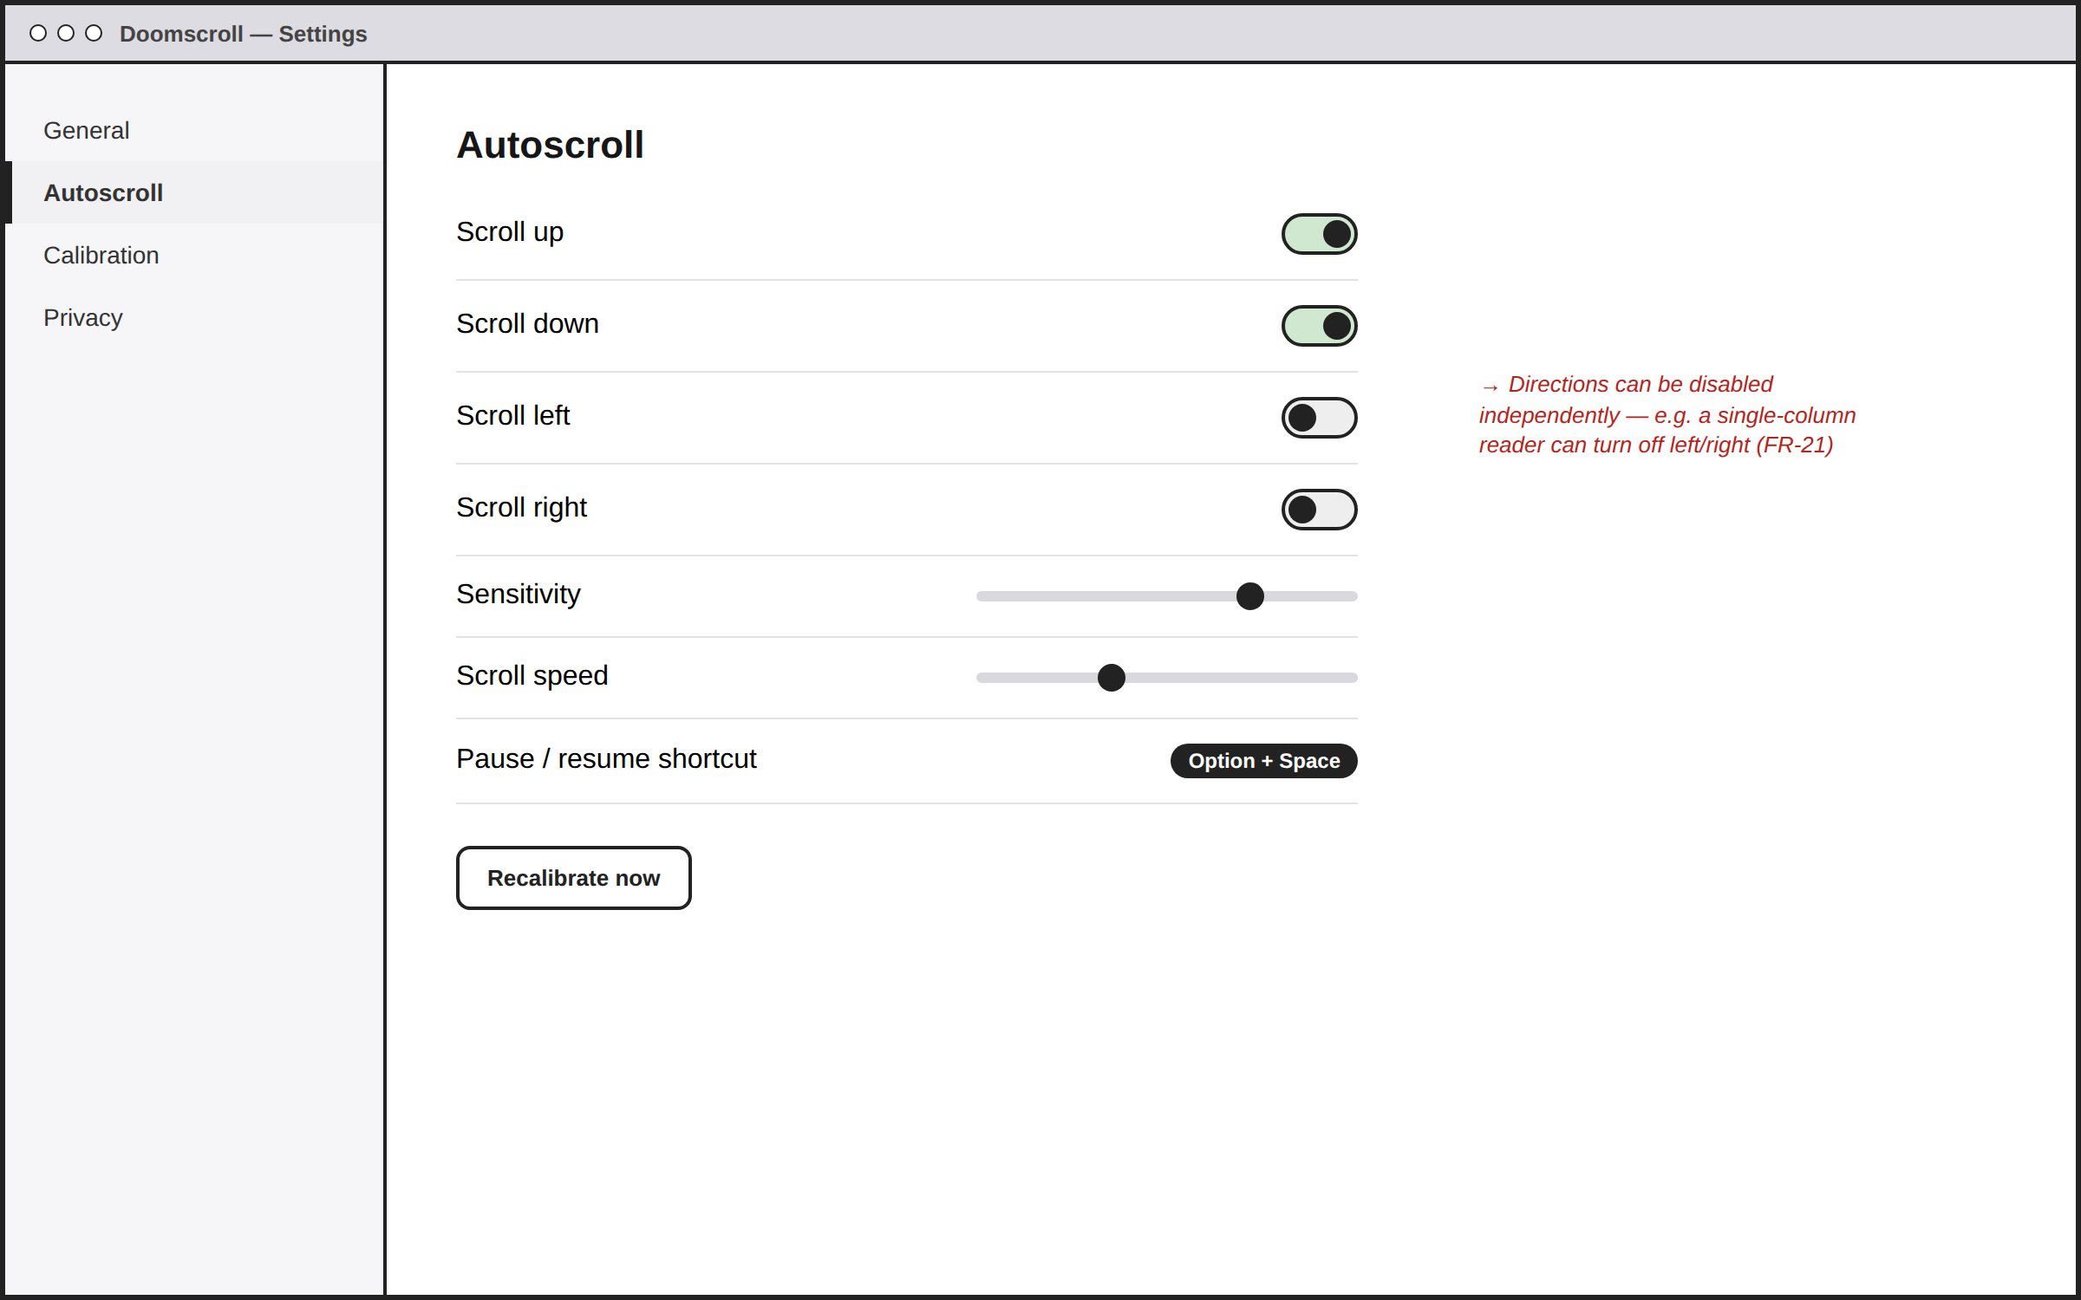
Each scroll direction can be toggled independently, alongside sensitivity, speed, and the pause/resume shortcut. Related: FR-21, FR-22, FR-23, FR-24, NFR-11.

Screen 4 — Live Overlay HUD While Reading
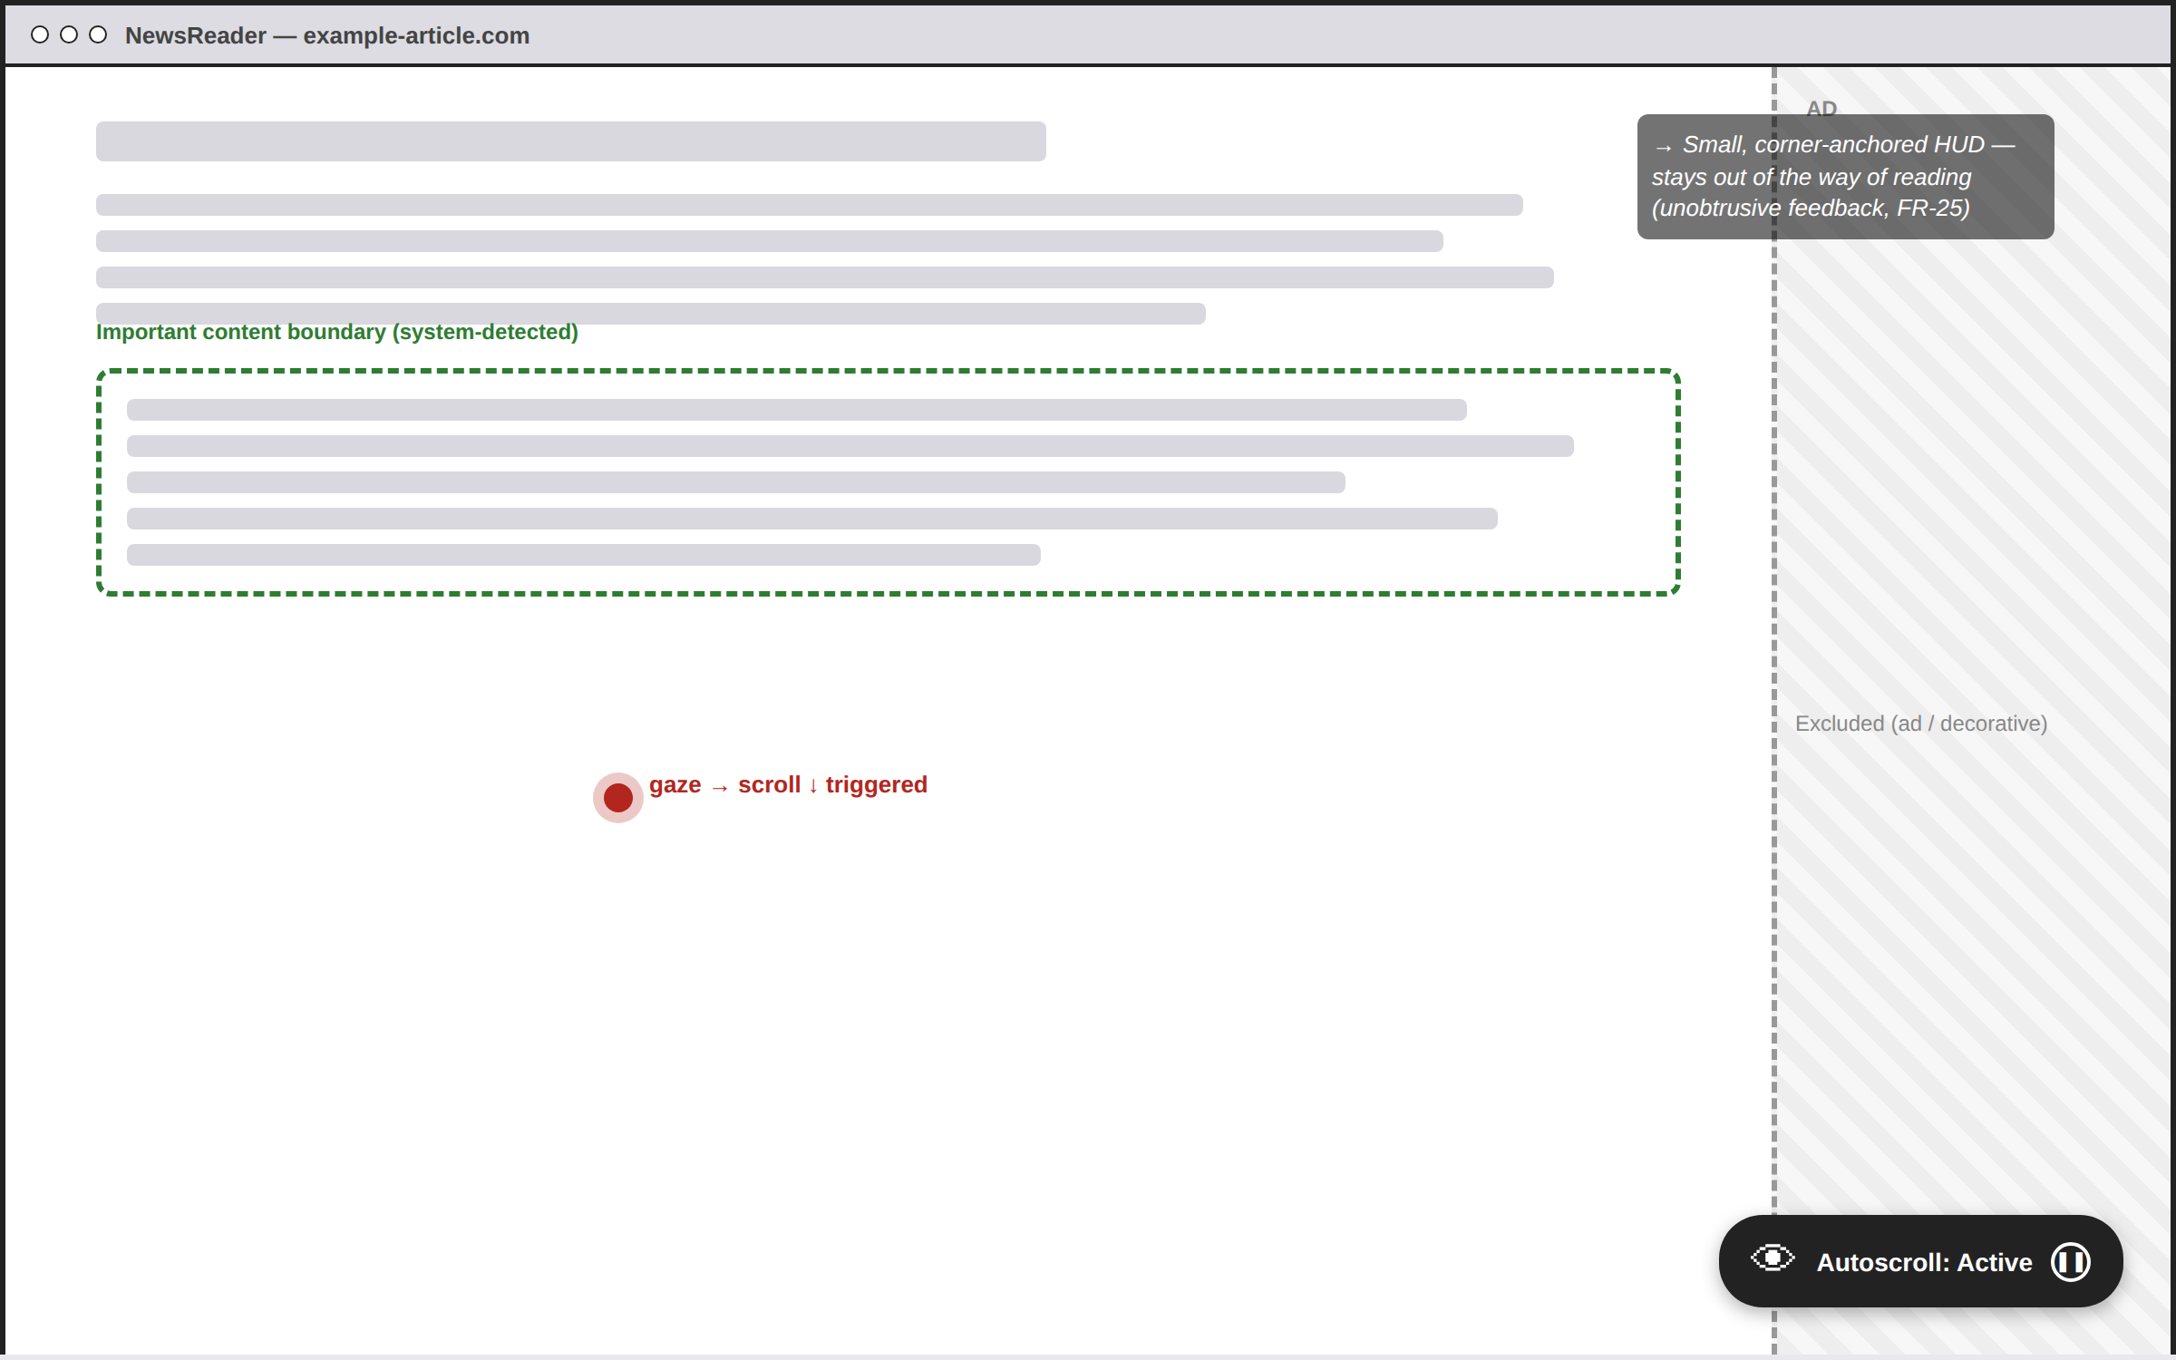
A small, corner-anchored status indicator keeps out of the way of reading. The dashed boundary marks the system-detected important content region; the hatched sidebar marks an excluded advertisement. The red dot marks the current gaze point reaching the lower boundary, triggering a downward scroll. Related: FR-13, FR-14, FR-16, FR-17, FR-25.

Screen 5 — Recalibration Prompt
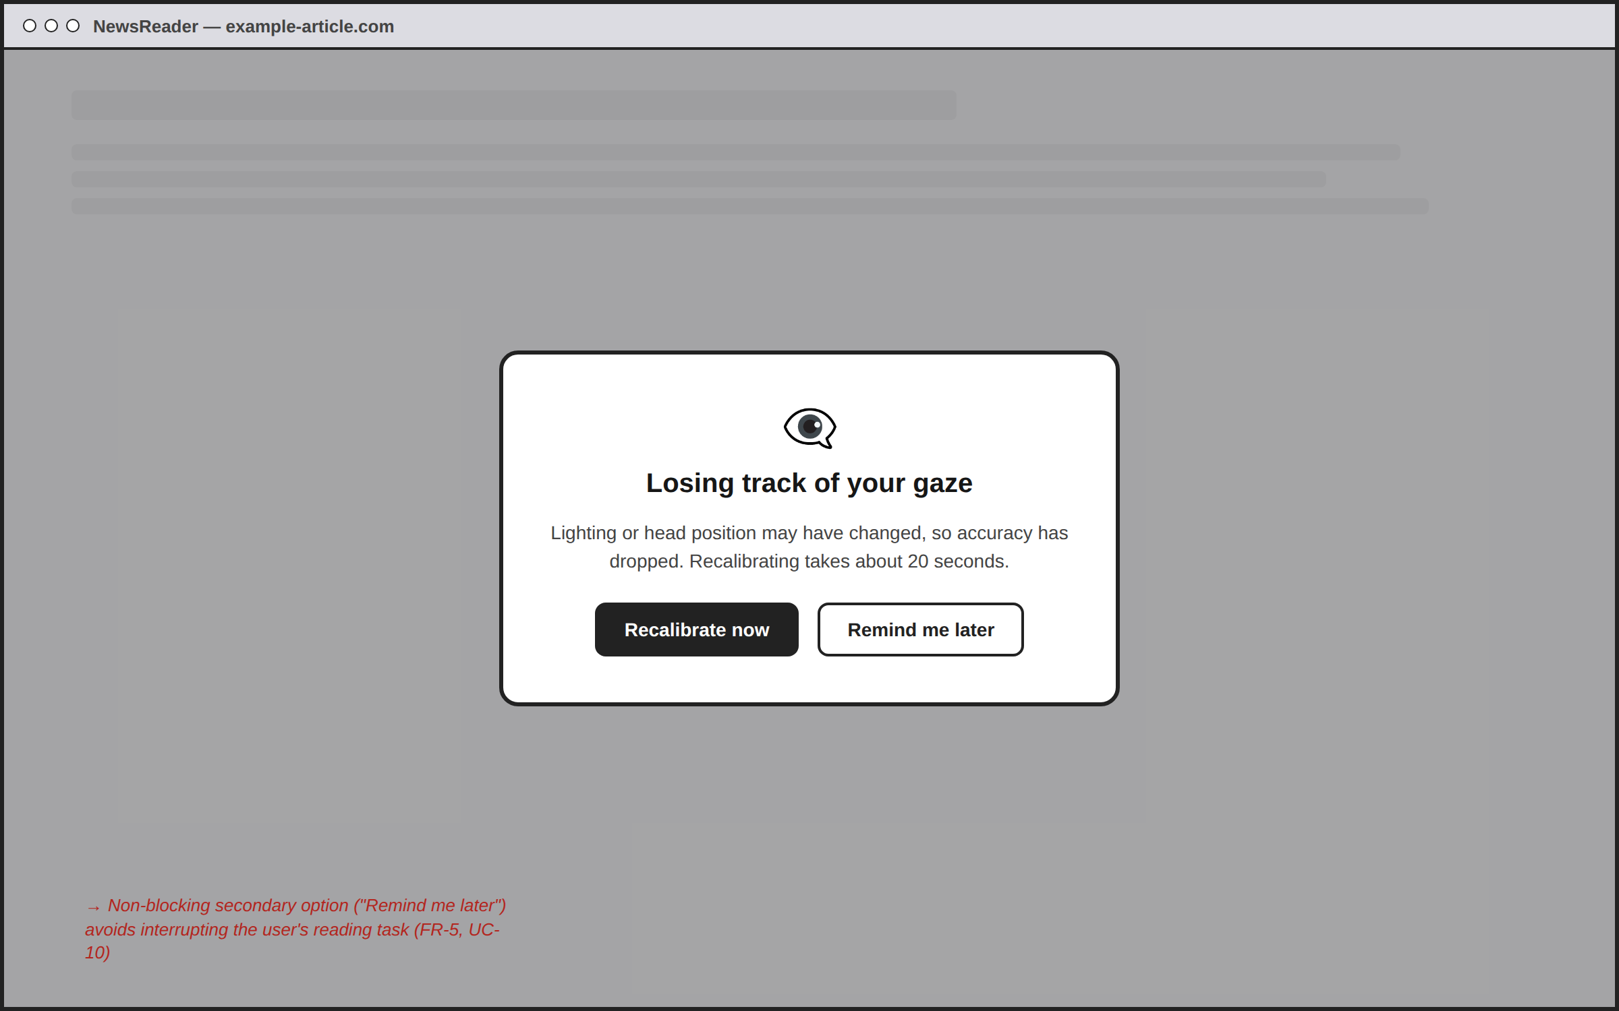
Shown when tracking confidence drops persistently. “Remind me later” avoids forcing an interruption mid-task. Related: FR-5, UC-10.

